DASTKARHUB

UI/UX Improvement Plan
A practical visual redesign guide for a premium Pakistani artisan marketplace

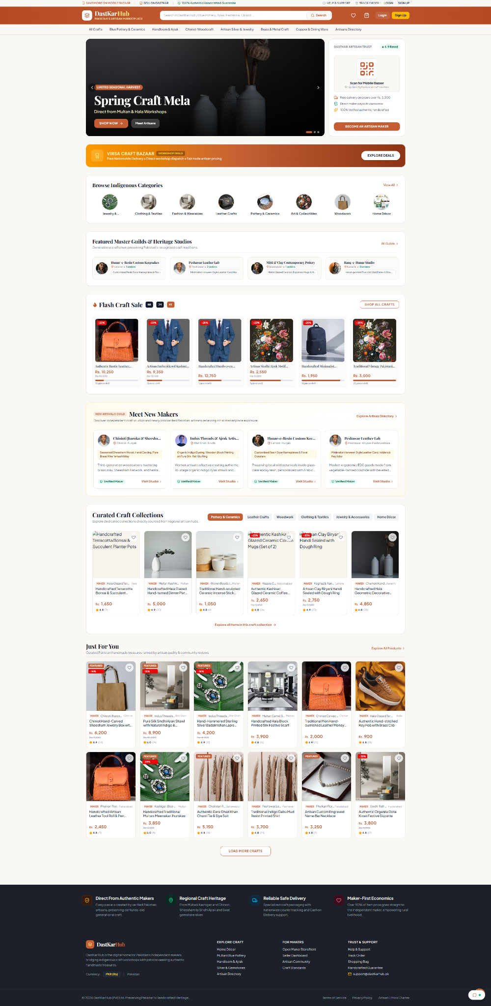
Current homepage screenshot supplied for review
Design direction: warm • premium • authentic • easy to shop

1. Executive Summary
DastKarHub already communicates its purpose: helping customers discover Pakistani handmade products and the makers behind them. The next step is to make the experience feel less compressed and more premium. This plan keeps the existing brand concept and marketplace sections while improving visual hierarchy, product presentation, trust, responsive behavior, accessibility, and shopping conversion.

Top priorities
- Make the hero banner larger and more photography-led, with a clear headline and two calls to action.
- Standardize product images and cards so prices, names, ratings, and actions are easy to scan.
- Reduce competing borders, badges, tiny text, and orange-heavy surfaces.
- Give artisan stories and curated collections more space to show the people and craft behind products.
- Improve mobile navigation, image loading, accessibility, and core shopping flows.

2. Current Homepage Review
The current page has a strong amount of useful content. The opportunity is not to remove everything, but to establish a clearer hierarchy.
Area | Observation and opportunity
Hero banner | The campaign is visible, but the headline and calls to action could be larger and easier to notice.
Header and navigation | Many utility links and categories compete for limited vertical space; search should be the primary interaction.
Product cards | Small text and uneven-looking image presentation make it difficult to compare products quickly.
Section density | Many content blocks appear close together, so the page feels long and visually busy.
Artisan discovery | The maker directory is a differentiator, but maker stories and portraits could be more prominent.
Trust and reassurance | Delivery, authenticity, returns, and secure checkout information should be clear without overwhelming the design.

3. Recommended Visual Design System
Use a premium editorial marketplace style: the warmth of traditional craft photography with the clarity of modern e-commerce. Retain terracotta/orange as the brand accent, but use it selectively rather than filling many large surfaces.
Color | Hex | Recommended use
Terracotta | #B94D28 | Primary buttons, links, active states, sale prices
Warm Ivory | #F8F5EF | Main page background and calm content areas
Charcoal | #20242B | Main text, footer, high-contrast elements
Brass Gold | #D5A45D | Small premium highlights and decorative details
Sage Green | #54745C | Verified-maker and trust indicators

Typography
- Headings: Lora or Playfair Display for a refined editorial/heritage feel.
- Interface and body text: Inter or Manrope for clear, modern readability.
- Use a consistent type scale; avoid tiny text for product names, prices, and essential navigation.

Spacing and shape
- Use a consistent content width and spacing scale rather than individually tuning every section.
- Desktop: typically 48–72 px between major sections; 24–32 px between cards where space permits.
- Use subtle shadows, restrained borders, and consistent 10–16 px corner radii.
- Maintain visible focus states and sufficient contrast for buttons, links, and secondary text.

4. Proposed Homepage Structure
01 — Utility strip: Shipping or service information, seller registration, help, and account links. Keep this slim.
02 — Main header: Logo, prominent search, account, wishlist, and cart. Search should be the strongest utility.
03 — Category navigation: A clear category row with dropdowns or a More menu for overflow.
04 — Hero campaign: Large craft/lifestyle image, headline, short supporting copy, primary CTA, secondary maker CTA.
05 — Shop by craft: Consistent category tiles with large images and short readable labels.
06 — Bestsellers / trending: A focused product grid with price, ratings, discount information, and useful actions.
07 — Meet the makers: Portraits, location, specialty, verified status, and links to artisan profiles.
08 — Curated collections: Seasonal or regional collections presented with larger editorial imagery.
09 — Personalized discovery: “Just for you” or recently viewed products, with a clear reason for recommendations.
10 — Trust and footer: Authenticity, delivery, payments, returns, customer support, and maker onboarding.

5. Hero Banner Recommendations
- Use one high-quality artisan or product photograph as the main visual anchor.
- Headline example: “Crafted by Hand. Rooted in Heritage.”
- Supporting copy example: “Discover distinctive handmade pieces from Pakistan’s independent makers.”
- Primary button: “Explore Handmade Crafts”. Secondary button: “Meet the Artisans”.
- Use a dark or softly shaded image overlay only where needed to keep text readable.
- Keep carousel controls subtle and ensure the hero works as a static banner if animation is unnecessary.

6. Product Card Specification
Use the same component rules across Flash Craft Sale, Curated Craft Collections, and Just For You.
- Image container: consistent 4:5 ratio; never allow image dimensions to vary between cards.
- Image fit: use object-fit: contain for isolated objects where full shape matters; use cover for lifestyle/editorial photography.
- Product name: 1–2 lines, readable size, consistent card height.
- Price: prominent and visually distinct; show original price and discount only when valid.
- Trust cues: rating/review count and verified maker status where actual data is available.
- Badges: one or two meaningful labels at most, such as Bestseller or Sale.
- Wishlist: accessible heart button with a clear selected state and an accessible label.
- Actions: card opens product details; add-to-cart is a separate functional action.
- Loading/error state: reserve image dimensions, show a graceful placeholder, and avoid broken-image icons.

7. Header, Search, and Navigation
- Keep the utility strip visually quiet and reduce the number of tiny links shown at once.
- Make the search bar wider and support suggestions for products, categories, and makers.
- Group categories logically; use dropdowns or a More menu instead of squeezing every category into one row.
- Keep cart count and wishlist state visible where useful, without oversized icons.
- On scroll, use a compact sticky header that does not consume too much screen height.
- On mobile, use a compact top bar, search access, a menu drawer, and optionally bottom navigation for Home, Categories, Wishlist, and Account.

8. Artisan and Collection Storytelling
- Use authentic maker portraits and real workshop images where available.
- Show the artisan’s name, region, craft specialty, and verified status.
- Give maker cards one clear action such as “Visit Studio”.
- Use editorial collection tiles to communicate a theme or region, not just another small product grid.
- Avoid making claims about authenticity, origin, or materials unless the marketplace data verifies them.

9. Responsive Layout Guidance
Viewport | Suggested layout | Checks
Desktop (≥1200 px) | 4–6 product cards depending on content width; full navigation | No tiny cards; stable max-width; balanced whitespace
Tablet (768–1199 px) | 3–4 product cards; condensed navigation | Avoid squeezed headers; wrap or collapse utility links
Mobile (<768 px) | 2 product cards per row; compact header | Touch targets ≥44 px; no horizontal overflow; readable prices

10. Motion and Interaction
- Use short, subtle transitions (around 150–250 ms) for hover, focus, and state changes.
- Lift product cards only slightly on hover; avoid large zooms or distracting animations.
- Show a clear success state when an item is added to cart or wishlist.
- Use skeletons for slow-loading product grids and a helpful retry state for failed requests.
- Respect reduced-motion preferences and ensure all actions work by keyboard and touch.

11. Accessibility, Performance, and SEO
- Maintain strong contrast for text and controls; do not use color as the only way to communicate sale or verification status.
- Use semantic headings in a logical order and descriptive alt text for meaningful product and artisan images.
- Provide visible keyboard focus and accessible names for icon-only buttons.
- Use responsive image sizes and modern formats such as WebP/AVIF where supported.
- Lazy-load below-the-fold images, but prioritize the hero image to avoid delaying the first impression.
- Reserve image aspect ratios to prevent layout shifts while images load.
- Ensure each product has a meaningful title, price, availability, and descriptive page metadata.

12. Implementation Roadmap
Phase 1 — Visual cleanup — Fix broken/misaligned images, text overflow, card sizing, spacing, and responsive breakpoints.
Phase 2 — Design system — Create shared color, typography, spacing, button, badge, card, and section-heading styles.
Phase 3 — Header and hero — Improve search, category navigation, campaign photography, copy hierarchy, and CTAs.
Phase 4 — Product discovery — Upgrade product cards, filters/sorting, wishlist states, product detail links, and add-to-cart behavior.
Phase 5 — Makers and collections — Improve artisan profiles, studio pages, editorial collection cards, and trust information.
Phase 6 — QA and measurement — Test mobile/tablet/desktop, accessibility, performance, broken links, and key shopping conversion events.

13. QA Checklist
- ☐ No broken product or category images.
- ☐ Product cards align consistently across all homepage sections.
- ☐ Product title and price remain readable at 100% browser zoom.
- ☐ All buttons and icons have working actions and accessible labels.
- ☐ Header and navigation do not overflow at common tablet/mobile widths.
- ☐ Search suggestions, filters, cart, and wishlist states work correctly.
- ☐ No horizontal page scrolling on mobile.
- ☐ Focus states are visible and color contrast is adequate.
- ☐ Images load efficiently and do not cause major layout shifts.
- ☐ Seller claims, ratings, prices, and discounts reflect real platform data.

14. Suggested Copy
UI location | Suggested copy
Hero headline | Crafted by Hand. Rooted in Heritage.
Hero supporting text | Discover distinctive handmade pieces from Pakistan’s independent makers.
Primary CTA | Explore Handmade Crafts
Secondary CTA | Meet the Artisans
Maker section heading | Meet the Makers Behind Every Piece
Collection section heading | Stories, Skills, and Objects Worth Keeping
Trust message | Shop directly from makers. Discover the story behind your next favourite piece.

15. Final Recommendation
Do not rebuild the entire marketplace just to make it look modern. Keep the existing business logic, product data, seller onboarding, and important shopping features. First establish a coherent design system, then improve the homepage section by section. The strongest visual differentiators should be authentic product photography, readable product cards, a clear search experience, and the stories of Pakistani artisans.
Recommended first sprint: fix image quality and card consistency, simplify the header, and redesign the hero banner before polishing lower sections.

16. Visual Redesign Concept
The concept below illustrates one possible direction for the redesigned homepage and its design system. It is a visual reference, not production-ready UI code. Replace illustrative product imagery and sample maker details with verified DastKarHub catalogue content before launch.
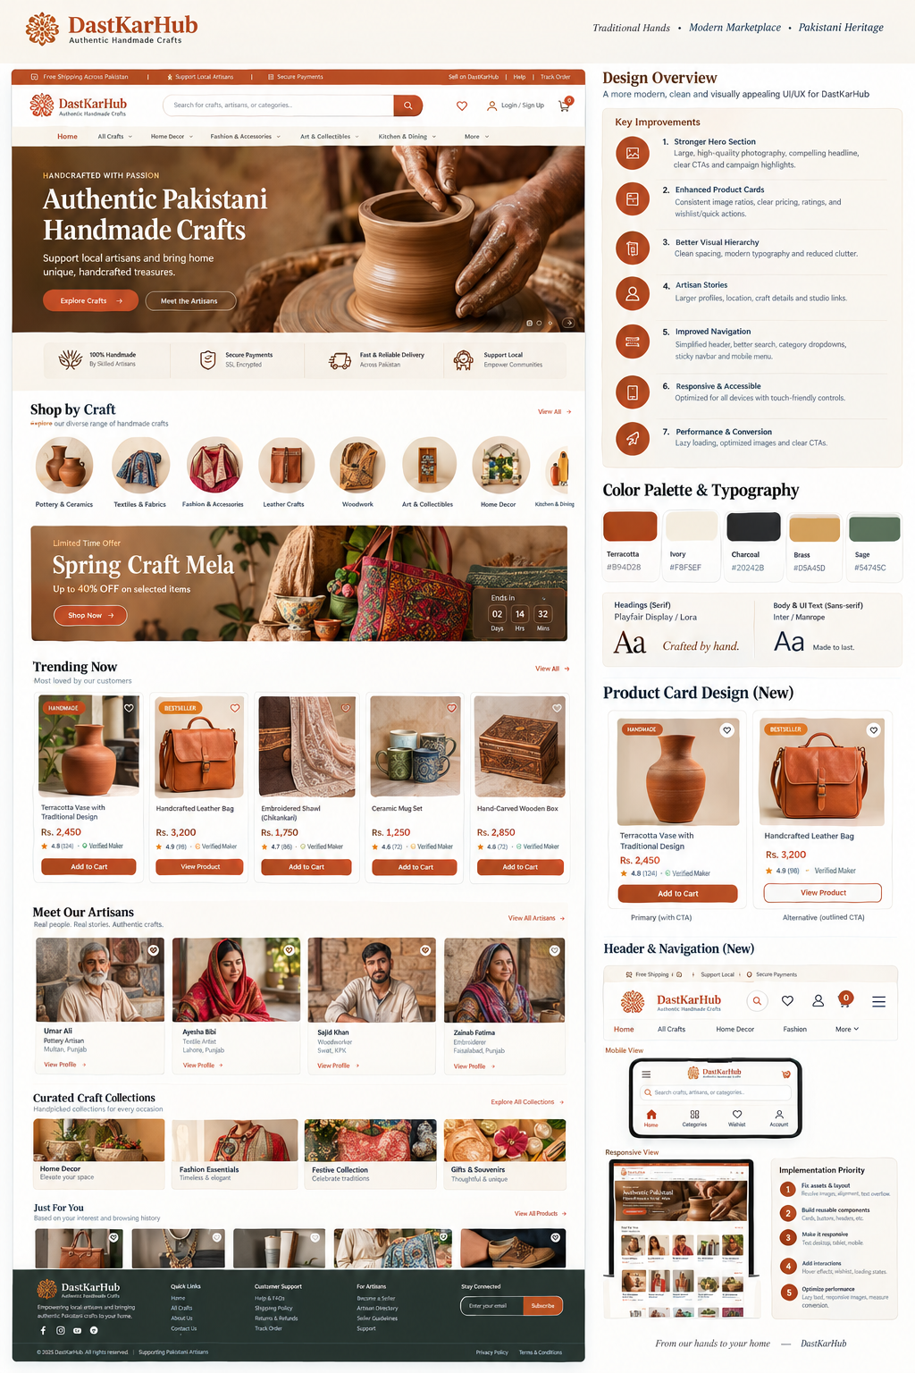
Concept mockup: desktop homepage, product cards, artisan storytelling, palette, and responsive direction.

How to use this concept
- Treat the layout, spacing, hierarchy, and palette as a design direction—not a literal final screenshot.
- Use the existing live product data, real prices, real ratings, and genuine artisan profiles.
- Keep the current backend and business logic wherever they already work; implement the visual changes in reusable frontend components.
- Check all typography and labels in the actual browser at desktop, tablet, and mobile sizes before release.

