**Report**

**ID: 22071343**

[**GitHub Code Link**](https://github.com/muhammadomer1live/22071343_sql_assignment)

**Creating a Fictional Online Bookstore Database**

**1. Data Generation Process:**

To generate the data for the fictional online bookstore database, Python along with the SQLite3 library and Faker library were utilized. The Faker library allowed for the creation of realistic randomized data. The data generation process involved creating tables for authors, genres, books, customers, orders, and order items. For each table, appropriate randomized data was generated using Faker's various data providers such as name, email, date, catch_phrase, and Others.

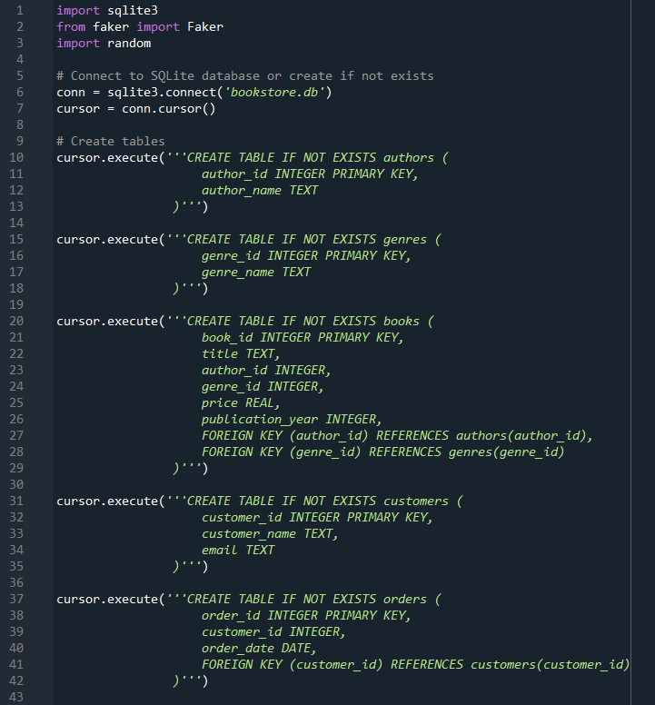

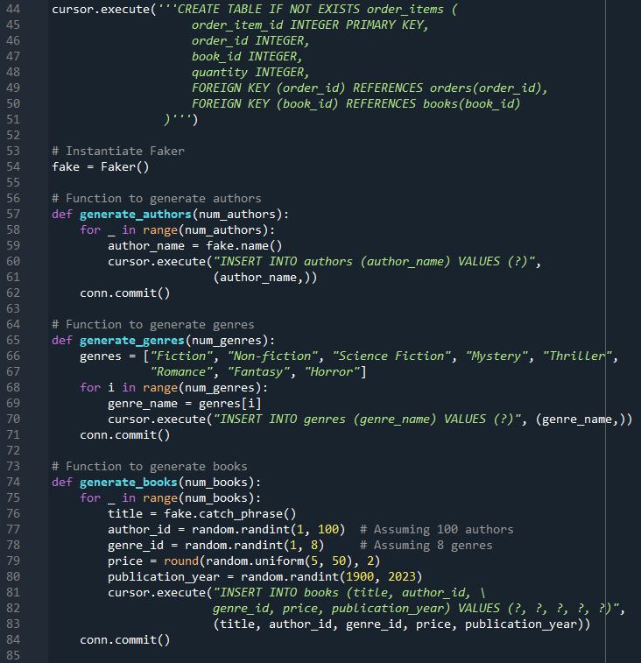

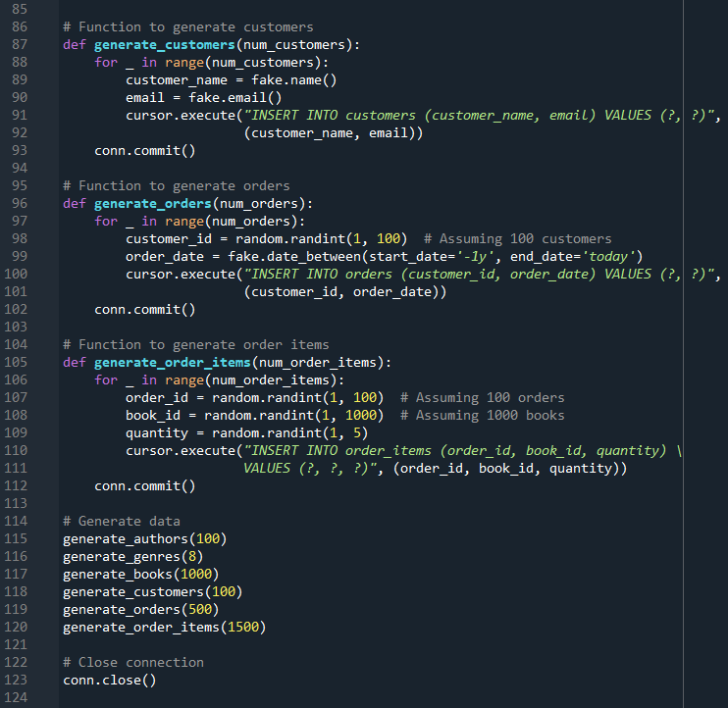

**2. Database Schema:**

The database schema comprises six tables:

* **Authors:** Contains information about book authors.
  + Columns: **author_id** (Primary Key), **author_name**.
* **Genres:** Contains different genres of books.
  + Columns: **genre_id** (Primary Key), **genre_name**.
* **Books:** Holds details about individual books.
  + Columns: **book_id** (Primary Key), **title**, **author_id** (Foreign Key), **genre_id** (Foreign Key), **price**, **publication_year**.
* **Customers:** Stores information about bookstore customers.
  + Columns: **customer_id** (Primary Key), **customer_name**, **email**.
* **Orders:** Contains details of orders placed by customers.
  + Columns: **order_id** (Primary Key), **customer_id** (Foreign Key), **order_date**.
* **Order Items:** Stores information about individual items within an order.
  + Columns: **order_item_id** (Primary Key), **order_id** (Foreign Key), **book_id** (Foreign Key), **quantity**.

**3. Justification for Separate Tables and Ethical Discussion:**

Separating the data into multiple tables enhances data integrity, allows for efficient querying, and follows the principles of database normalization. For instance:

* Authors and genres are kept in separate tables to prevent data redundancy and ensure each author/genre is stored only once.
* The orders and order items are separated to handle one-to-many relationships efficiently, where one order can contain multiple items.

Ethically, it's essential to consider privacy and consent when dealing with customer data. While the data generated by Faker is not real, in a real-world scenario, obtaining consent and ensuring data privacy would be paramount.

**4. Example Queries:**

Below are example queries demonstrating different data types and joins:

1. **Selecting all books with their titles, authors, and prices:**

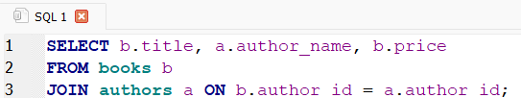

**Result:**

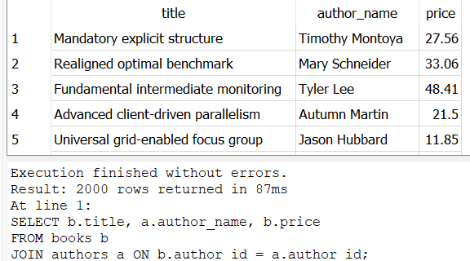

1. **Selecting orders placed by a specific customer:**

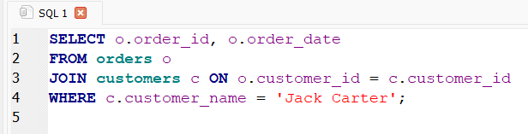

**Result:**

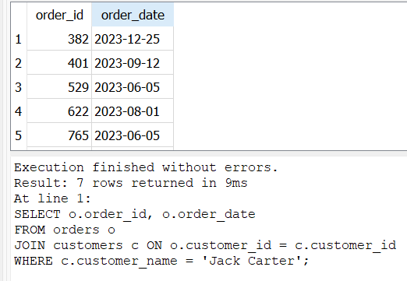

1. **Selecting books published after 2010 along with their genres:**

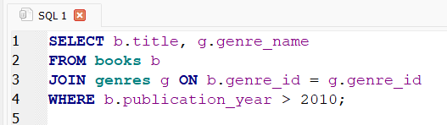

**Result:**

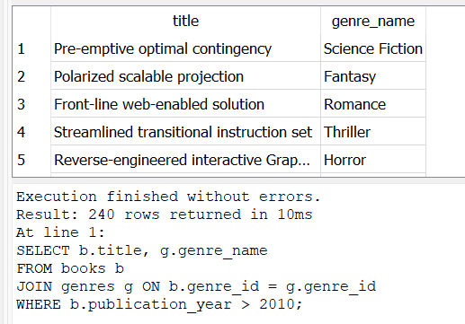

1. **Selecting total sales per genre:**

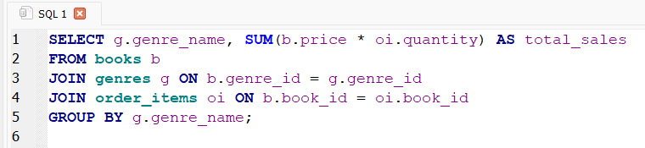

**Result:**

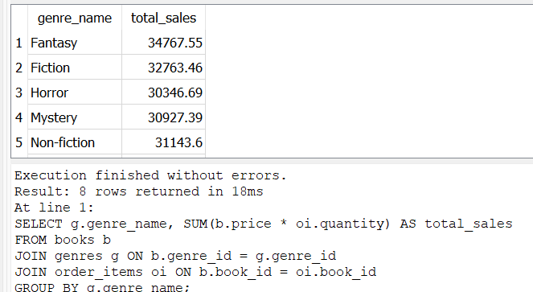

**Conclusion:**

In conclusion, the creation of the fictional online bookstore database involved thoughtful consideration of data generation, schema design, ethical considerations, and example queries. The database provides a robust foundation for managing and analyzing bookstore data effectively.

**Code Repository Link:**

<https://github.com/muhammadomer1live/22071343_sql_assignment>