Bahria University,

Karachi Campus



COURSE: SOFTWARE CONSTRUCTION

TERM: FALL 2021, CLASS: BSE- 5 (A/B)

PROJECT NAME

**GYM MANAGEMENT SYSTEM**

Dr Zakaria/ Engr. Ayesha Khan

Submitted By:

|  |  |  |
| --- | --- | --- |
| S.NO | Student Name | Enrollment # |
|  |  |  |
|  | MUHAMMAD OWAIS | 02-131202-050 |
|  | AREESHA | 02-131202-046 |

Submitted to:

Signed Remarks: Score:

TABLE OF CONTENTS

* Acknowledgment
* Project Overview And Problems
* Scope And Vision Statement
* Tools And Techniques
* Software Process Model
* Software Architecture
* Requirement Specifications
* Uml Diagrams
* Interfaces
* Conclusion

* ACKNOWLEDGMENTS

A special gratitude I give to our Lab Instructor, Miss Ayesha, whose contribution in stimulating suggestions and encouragement, helped us to coordinate our project.

* PROJECT OVERVIEW & PROBLEM

Gym management software is designed to simplify the running of a fitness club. From online gym scheduling and automated billing to administrative tasks, the software pulls all data into one place so that we can run our business more efficiently. In This Project, users don’t need to go to Gym House to Admit Manually. This project can help to reduce Time and record complete details of Gym subscriber.

Without gym member management software, all tasks will need to be carried separately. For example, you may manage billing through one piece of software, keep track of administrative tasks somewhere else, and use a spreadsheet for financial forecasting. You may have member management information online or offline in the office. Either way, there is no one centralized spot where you can find all the information about your business. Gym management software is designed to streamline operations so that all of these tasks can be in one place.

Gym Management System (GMS) is a web based application. In This Project, We don’t need to go to Gym House to Admit Manually. This project can help to reduce Time and record complete details of Gym subscriber. This is a whole process that will be started for member’s physical statistics. This Project Requires, which will stored data about members, employee, products, payrolls information and modify any record.

* ROLES AND RESPONSIBILITIES

OneFitnessVue is simple gym application which has different ends in it such as User, Admin and Superadmin.

OneFitnessVue this gym application with 3 roles in it.

1. User

2. Admin

3. SuperAdmin

**User**

This is a counter application where user will be filling application of new member and collect payment same way will renew membership and refund payment if user suddenly don’t want membership. User also has rights to See Renewal Report.

**Admin**

If you look at the admin end, Admin has responsibility to see reports.

1. Year wise

2. Month wise

3. Renewal

4. Refund

Along with report has rights to see Member details, Payment details, Renewal details and Refund details.

**SuperAdmin**

If you look at the superadmin end, superadmin has all application setting access.

* Menu
* Roles
* Creating Users
* Adding Workout
* Installment
* MembershipType
* General Settings
* SCOPE AND VISION STATEMENT

# PROJECT SCOPE

This project is designed to facilitate a gym and fitness center to automate its operations of keeping records and store them in form of a large and user friendly database further facilitating easy access to the personnel. Gym management system is meant to make running a ﬁtness center easier. From online gym planning to administrative tasks, this software pulls all the data in one place so you can run your business efficiently.

VISION STATEMENT

For gym members/trainers who need to maintain their record . The Gym Management System is one of the systems that will help the owner in managing its trainer, members, schedule and payments reports at the same time reducing the complexity. The system will perform the task like adding the new member to the gym, Removing the member , keeping the payments records and other stuff required in managing the gym properly.

* TOOLS AND TECHNIQUES

We used **ASP.net core mvc** application with C# language, html, xhtml and css.We also used Sql server management studio for database.

**Technologies Used**

• ASP.NET Core 3.1

• Entity Framework Core 3.1

**Install Tools**

• Visual Studio 2019

• SQL Server 2019

• .NET Core SDK 3.1

**NuGet Packages which are used in Project**

* AutoMapper.Extensions.Microsoft.DependencyInjection
* DNTCaptcha.Core
* EPPlus Version
* Microsoft.AspNetCore.Mvc.NewtonsoftJson Version
* Microsoft.AspNetCore.Mvc.Razor.RuntimeCompilation Version
* Microsoft.EntityFrameworkCore Version
* Microsoft.EntityFrameworkCore.SqlServer Version
* Microsoft.VisualStudio.Web.CodeGeneration.Design Version
* NLog.Web.AspNetCore Version
* Dapper Version
* Microsoft.AspNetCore.Mvc.ViewFeatures Version
* Microsoft.Data.SqlClient Version
* Microsoft.EntityFrameworkCore Version
* Microsoft.EntityFrameworkCore.Relational Version
* System.Data.SqlClient Version
* System.Linq.Dynamic.Core Version
* Software Process Model

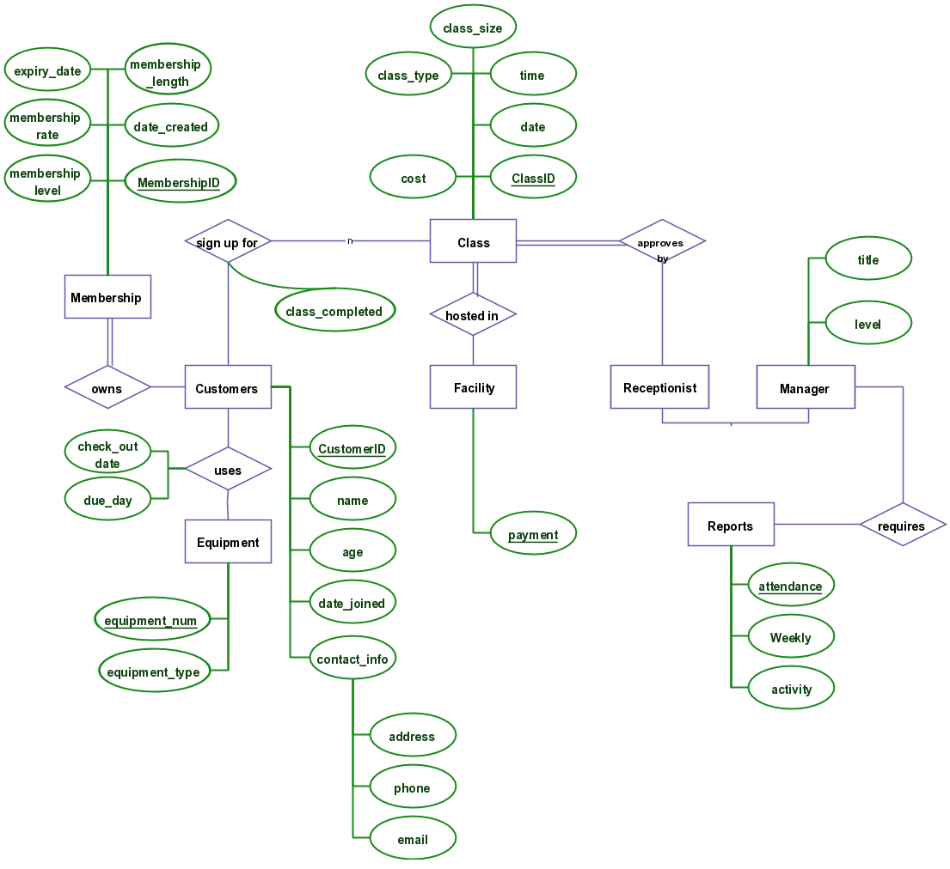

* Software Architecture

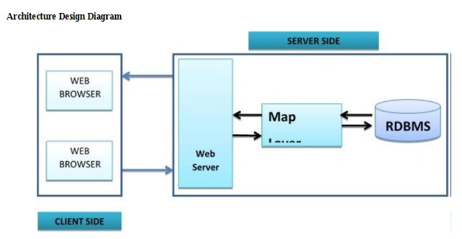

The Software Architecture we use is Client-Server Architecture( distributed processing) to take full advantge of a given computer system or network , oracle allows processing to be split between the database server and the client application programs . The computer running the database management system handles all of the database server responsibilities while the workstation running the database application concentrate on the interpretation and display of data . Gym Management System helps to keep records of members and their memberships and allow easy communication between you and your members.

* Requirement Specifications

**FUNCTIONAL REQUIREMENT\***

In Software engineering and systems engineering useful demand defines a perform of a system or its element. Useful necessities are chiefly calculations, technical details, knowledge manipulation and process and alternative specific practicality that outline what a system is meant to accomplish. In our project there also are some essential useful necessities.

**FR-1 RECORDING INCOME**

**DESCRIPTION :**

There are many income source of gym system network. All these things have to record on the database.

STAKEHOLDERS :

GMS members, Trainer, Admin,SuperAdmin

**FR-2 RECORDING EXPENSE**

Description:

Like Income, they have many field to expense money, such as they have programme, for arranging this programme they will expense in decoration, crest to give their members and etc. All this things should have to record.   
Stakeholders:

GMS members,Trainer,Students, gym related members,Admin.

**FR-3 MEMBERSHIP FEES**

Description :

All the members of GYM, have a monthly fees. This subscription fee has a specific amount on the members task wise. Members can give one or more membership fees altogether at a time.

Stakeholders :

GMS members,Trainer,Students, gym related members,Admin

**FR-4 SUMMARY OF INCOME AND EXPENSE**

Description:

Admin can see total amount and they will get an alert if the income amount is less then expense amount.

Stakeholders :

Super Admin,Admin,Trainer

**FR-5 MEMBER REGISTRATION**

Description:

They can add new members in their organization. To be a member, member have to be a police.

Stakeholders :

New GMS members, Trainer

**FR-6 MEMBER LIST**

Description:

Should have a field to see all members of GYM.

Stakeholders:

GYM members

**FR-7 ADDING CATEGORY**

Description: There will be some category which will be predefined. If the category will exist trainer can add it.

Stakeholders trainer

**FR-8 EQUIPMENT REGISTRATION**

Description :

There will be some equipment which will be predefined. If the category will exist trainer can add it.

Stakeholders:

Trainer,Admin

**FR-9 EDIT OPTION**

DESCRIPTION:

In the time of inserting the data trainer or admin can make mistake on typing, so there should have an option for correction the mistake.

STAKEHOLDERS :

GYM members, Trainer person.

**REQS-10** **PRINTING OPTION**

DESCRIPTION:

If the members of GYM want to print the detail and summary then they will be able to print.

STAKEHOLDERS:

GYM members, Trainer

**NONFUNCTIONAL REQUIREMENTS\***

**6.1 PERFORMANCE REQUIREMENTS**

The system manages facilities required by the casual users quickly and easily. It offers to take enquiries faster through online. It takes the enquiry details from customer and sends the feedback to the particular customer.

**6.2 SAFETY REQUIREMENTS**

In case the customer forgets or loses Password, the repair functionality helps by choosing “forgot password” option in the main login window.

To avoid any data loss backups can be taken.

While typing the password, if the caps lock is on it must be notified.

**6.3 SECURITY REQUIREMENTS**

This system is provided with authentication without which no user can pass. So only the legitimate users are allowed to use the application. If the legitimate user’s share the authentication information then the system is open to outsiders.

**6.4 SOFTWARE QUALITY ATTRIBUTES**

**RELIABILITY:** Good validations of user inputs will be done to avoid incorrect storage of records.

**MAINTAINABILITY:** During the maintenance stage, SRS document can be referred for any validations. This app is user friendly and in step with our project it's a decent UI therefore users area unit extremely affected regarding this app. In maintain this app user ought to sign on and later each specific matter can apprize the user. User will simply maintain it.

**PORTABILITY:** This system can be easily viewed in any browser.

**FLEXIBILITY:** The system keeps on updating the data according to the transactions that takes place.

**TIMELESS:** The system carries out all the operations with consumption of very less time.

**SECURITY:** Security of the system is maintained d by giving access to only authenticated user id and password.

**USABILITY**: Good UI, User friendly, Step by Step information make this application useable and user friendly.

**AVAILABILITY** : The System should be available 99% of the time.

* Uml Diagrams

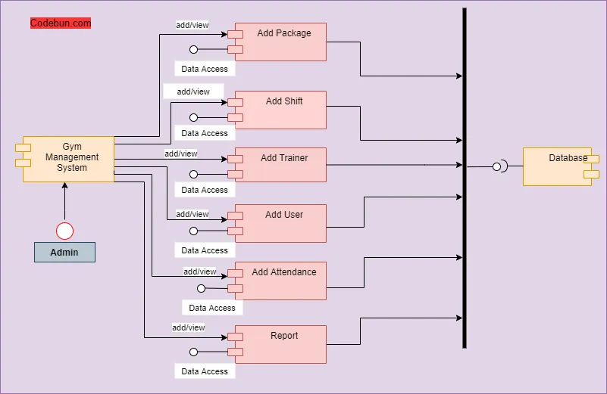

* INTERFACES

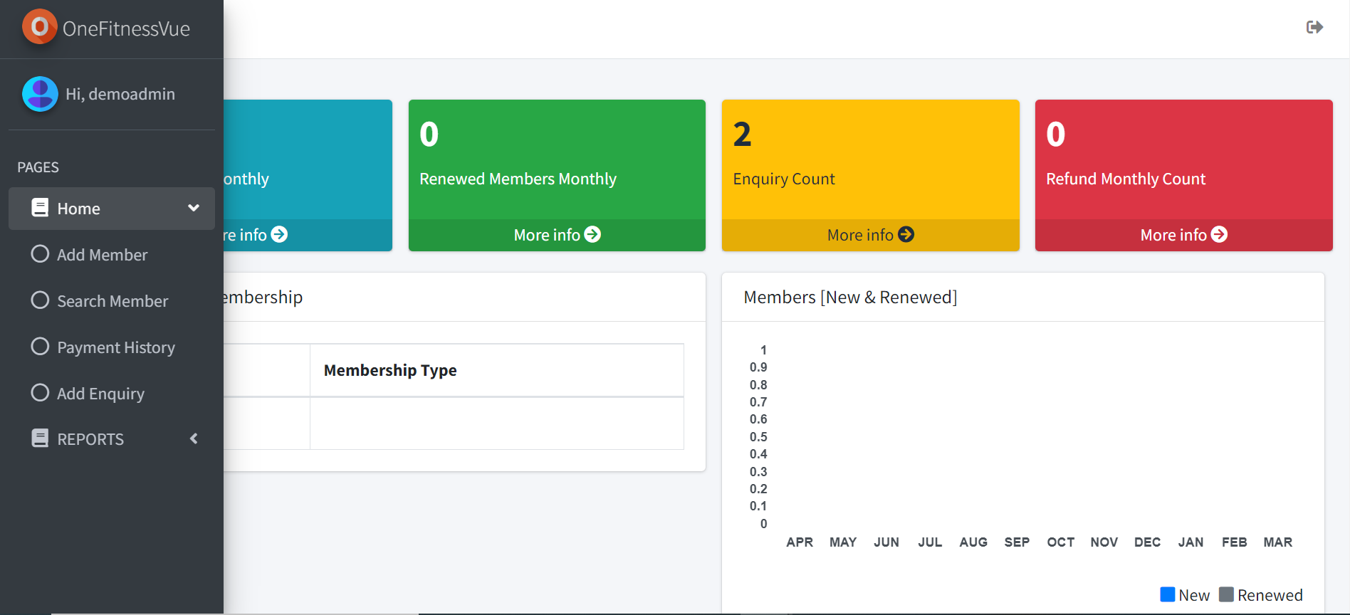

* CONCLUSION

The “**GYM MANAGEMENT SYSTEM**” is successfully designed and developed to fulfilling the necessary requirements, as identified in there requirements analysis phase, such as the system is very much user friendly, form level validation and field level validation are performing very efficiently.The new computerized system was found to be much faster and reliable and user friendly then the existing system, the system has been designed and developed step by step and tested successfully. It eliminates the human error that are likely to creep in the kind of working in which a bulk quantity of data and calculations as to be processed. The system results in quick retrieval of information that is very vital for the progress any organization. Cost is minimized in case of stationary. Burden of manual work is reduced as whenever transaction takes place, there isa no need to record it in many places manually.