

**2023**



|  |  |  |
| --- | --- | --- |
| Supervisor | Sir Mansoor Ahmed | |
| Batch | **PR2-202210B** | |
| Serial No. | **Enrollment Number** | **Student’s Name** |
| 1. | Student1418469 | Zain Naveed |
| 2. | Student1421716 | Sami Khan |
| 3. | Student1423626 | Muhammad Rabi |

**Table of Content**

Certificate of Completion 2

Acknowledgement 3

**Problem Statement…………………………………………………………………………………………………………………………4**

Functional Requirement 4

**Hardware and Software Requirements** **5**

Project Synopsis 6

**Website Features** **6**

**User Guide** **7**

Homepage (landing Page) 7-8

ABOUT US 9-10

**CONTACT US** 10-11

**GALLERY**12-16

**SITE MAP** 17-18

DEVELOPER'S GUIDE………………………………………………………………………………………………………………………………19-20

HOMEPAGE19

VIDEO 20

FOOTER20

TASK SHEET21

# **Certificate of Completion**

This is to certify that **Zain Naveed, Sami Khan, Muhammad Rabi** have successfully completed their ACCP Prime 2.0

Semester I E-Project.

Submitted to: **Aptech Computer Education**

On

**March 15th, 2023**

# **Acknowledgement**

First of all we would like to thank **Almighty Allah** for giving us strength and ability to complete this project.

And then, we would like to express my special thanks of gratitude to our teacher **Sir Mansoor Ahmed** who guided us on the project ***Cosy Air Conditioners***, which also helped us in doing a lot of new learning and we came to know about so many new things we are really thankful to him.

We are highly thankful to **Sir Mansoor Ahmed** for his guidance and constant supervision as well as for his support in completing the project.

Lastly, we would also like to thank our parents and friends who helped us a lot in finalizing this project within the limited time frame. We also express our sincere gratitude to I-Project team from Aptech Head Office, for their valuable guidance and support for the completion of this project. We earnestly hope that this project will provide all the necessary information required by the user to fulfill his/her inspiration. However, suggestion and Feedbacks for improvements will be thankfully welcomed & acknowledged*.*

# **Problems Statement:**

# COSY AIRCONDITIONERS is selling various types of AIR CONDITIONERS. The company advertises by distributing the pamphlets, advertising on television and so on. Due to rapid development in internet field, the company decides to launch a website where people will get all the information about the various products available with them easily.

# **Functional Requirement**

# The Web site is to be created based on the following requirements.

# 1) The Home Page should be created making use of Sections with a suitable logo.

# 2) Home Page should contain details of Air Conditioners with suitable images.

# 3) The site should display a menu which will contain the options for brief introduction about the various air conditioners available, location of the shop and any other information if required.

# 4) The information should be categorized according to the brand names of the products like if a User wants to see only “WHIRLPOOL” products or any other companies products then he/she can click on a Link/button/menu etc and can see only that Brand products.

# 5) When a user selects any particular brand, a list of products for that brand will be displayed

# 6) A brief summary of features of individual products should be displayed on the Web Page along with the product but detailed Features should be stored in Individual Word documents which can be downloaded or viewed by the User who wishes to see the same.

# 7) The user should also be able to compare the various products of different as well as similar brands.

# 8) There should be a “Contact Us” page which will have the Address of the Company which is as follows and the mail address which when clicked will invoke the local mail client from where they can send an email.

# **Hardware and Software Requirements**

**Hardware**

* A minimum computer system that will help you access all the tools in the courses is a Pentium 166 or better
* 64 Megabytes of RAM or better

**Software**

* Notepad/HTML editor
* Dreamweaver
* IE 5.0/ Netscape 6.0

# **Project Synopsis**

The Cosy Air Conditioners eProject is a website designed to offer customers the best air conditioning installation and repair services for multiple brands, including Carrier, LG, Mitsubishi Electric, Orient, and Sanyo. The website provides an easy-to-use interface that enables customers to browse through different categories of air conditioners, including split, cassette, and cabinet air conditioners.

# **Website Features**

This website Cosy Air Conditioner, providing multiple AC installation, repairing and maintenance. So, the development of this website gives people to get services i.e. Cooling and heating, Energy efficiency, Remote control, Programmable settings, Filters, Quiet operation, Easy installation, Smart features and much more by single click.

This site contains pictures and description along with the service prices of all those services which they were providing in their site.

**USER’S GUIDE**

HOME PAGE:

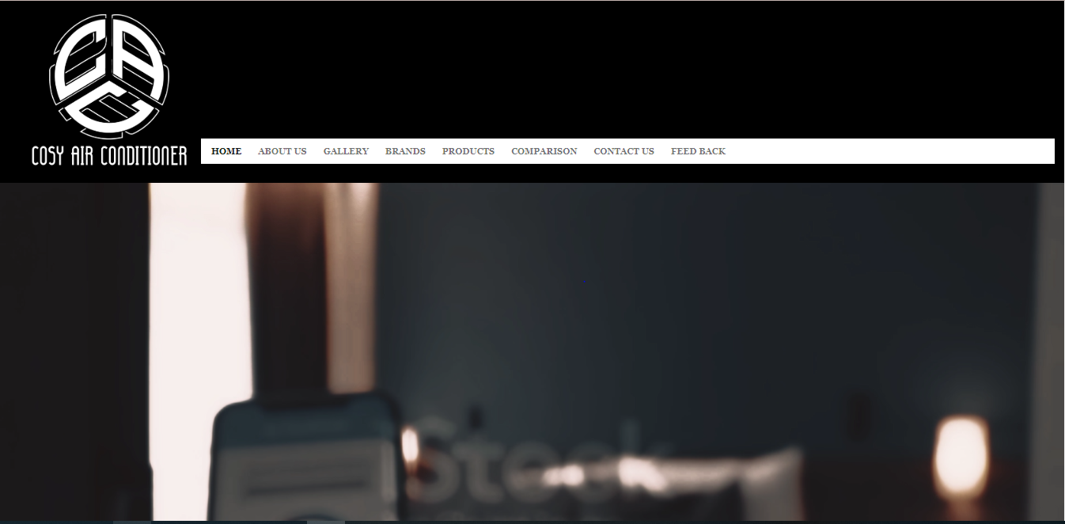

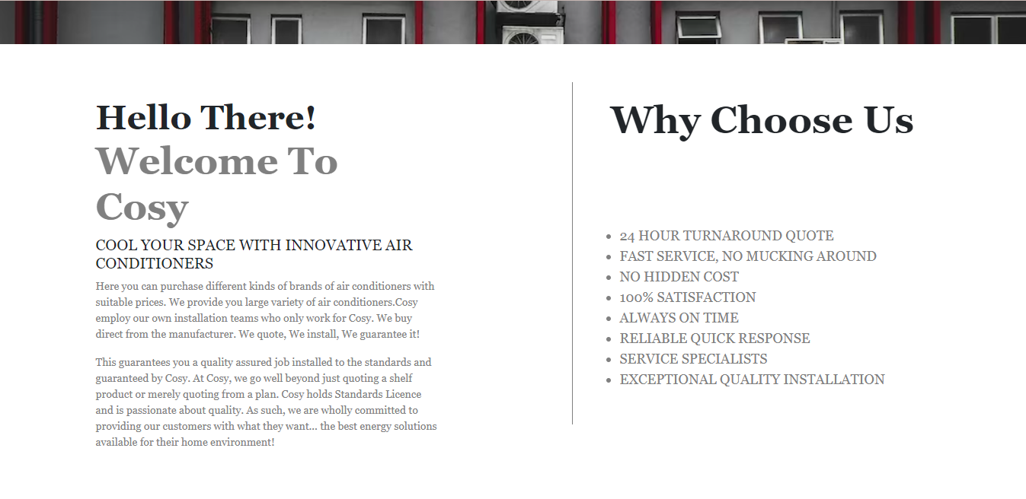

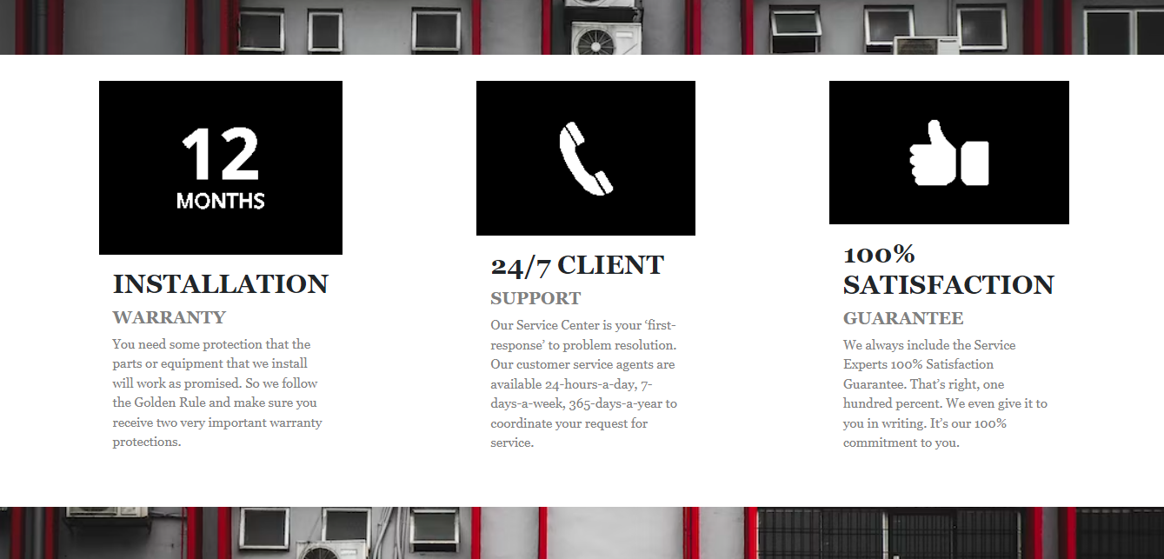

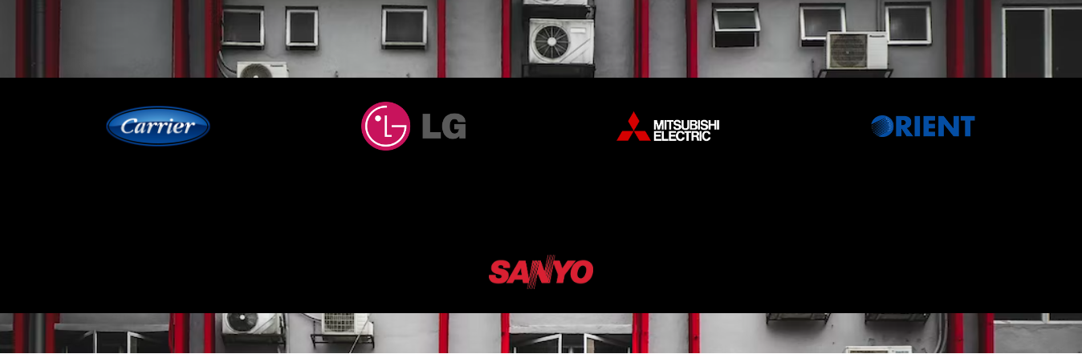

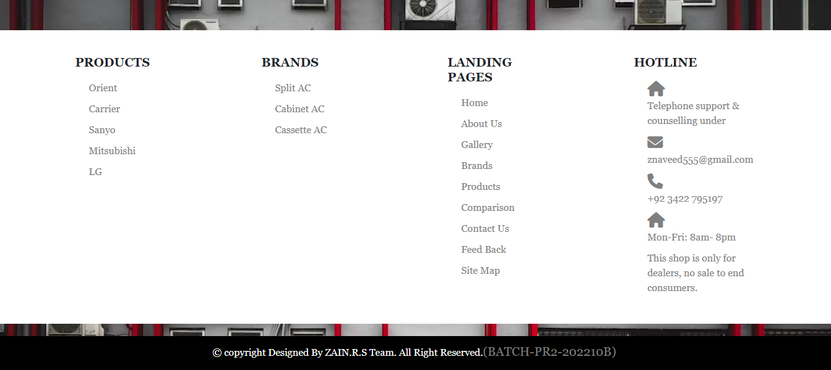

ABOUT US:

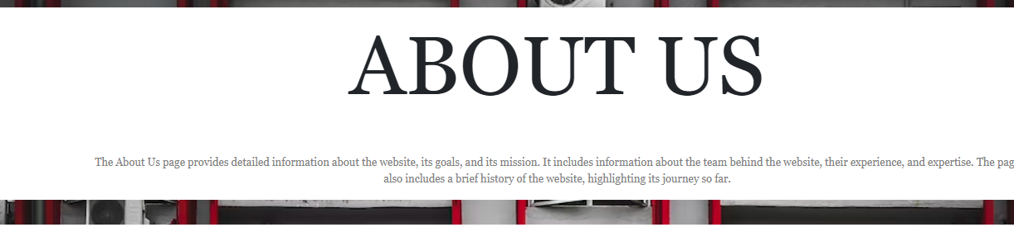

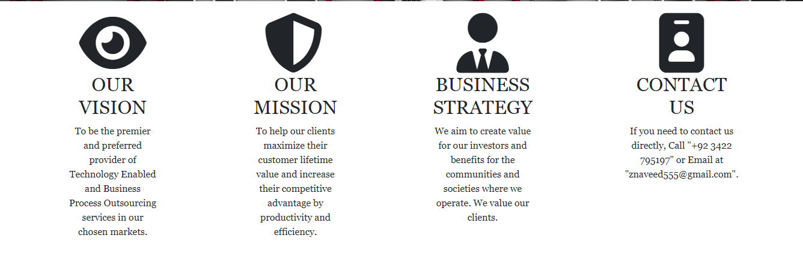

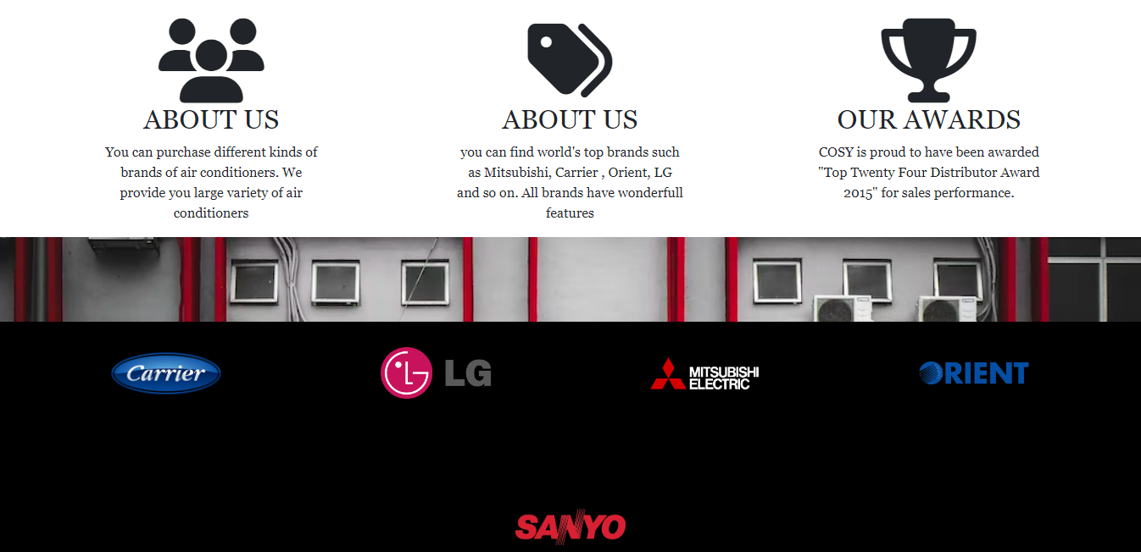



CONTACT US:

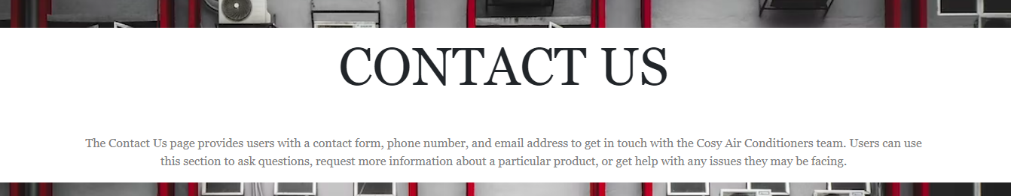

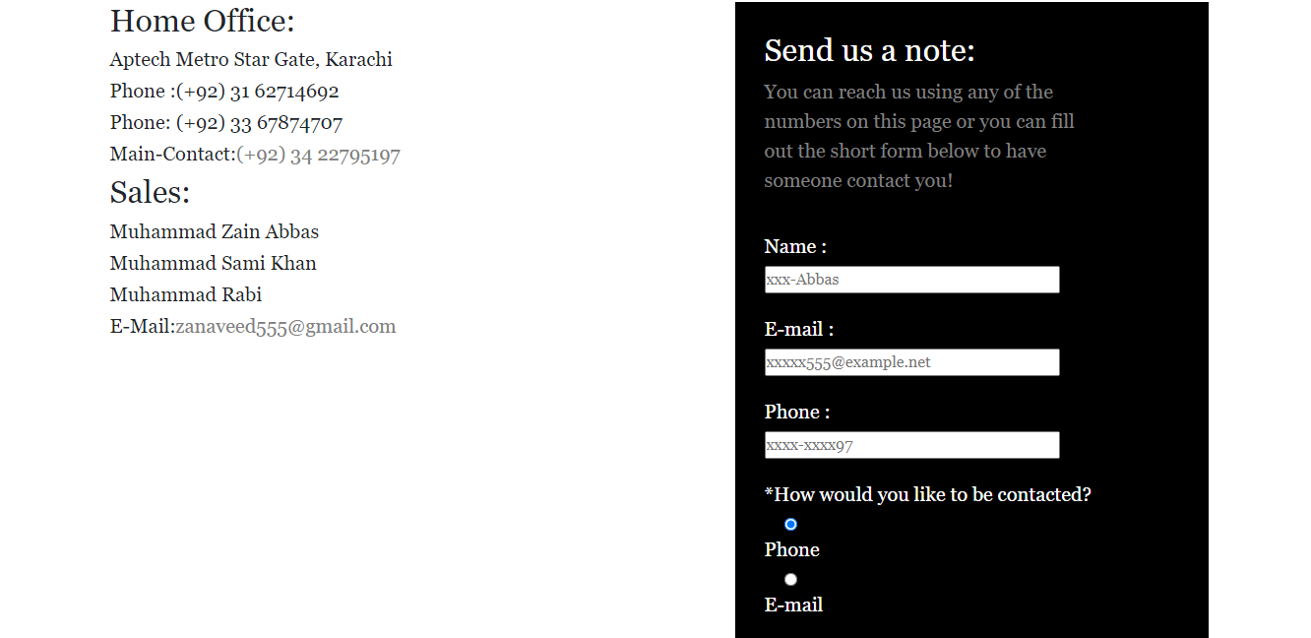

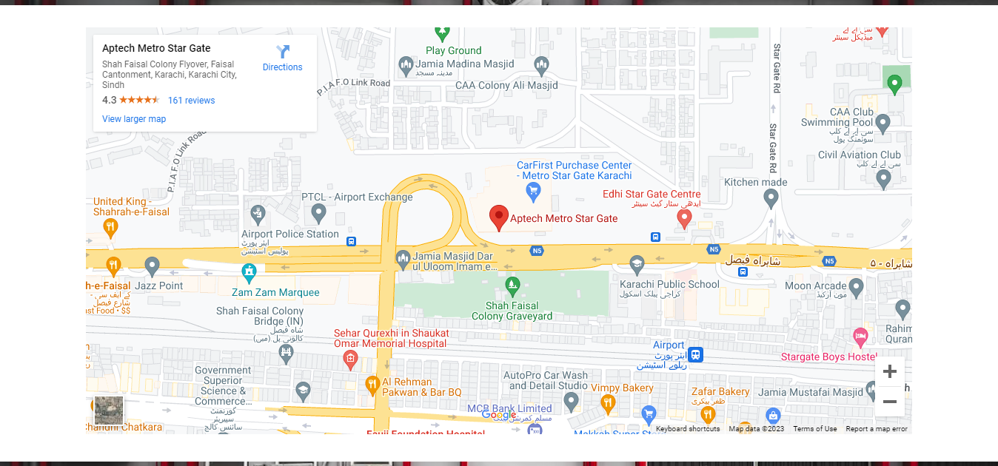



GALLERY:

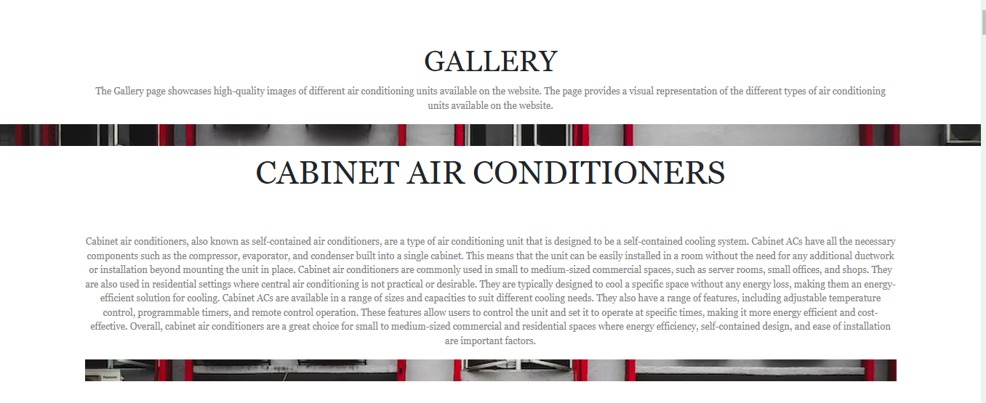

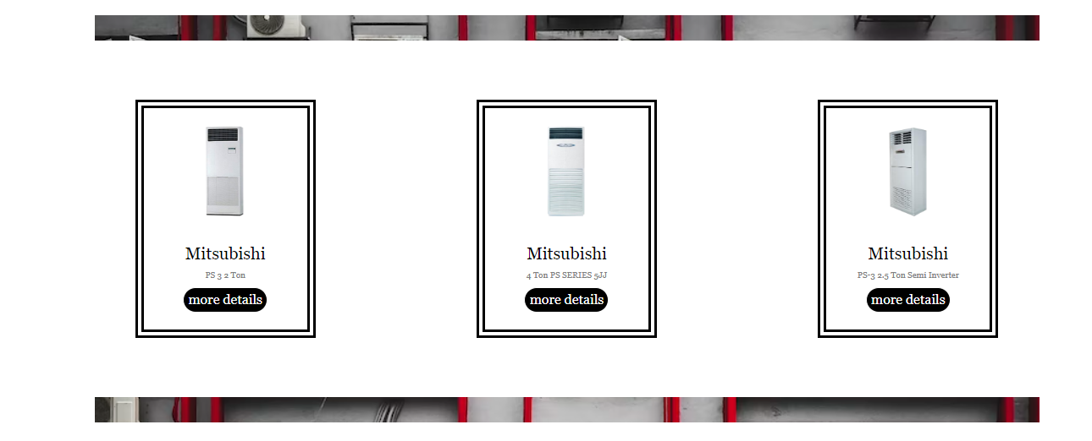

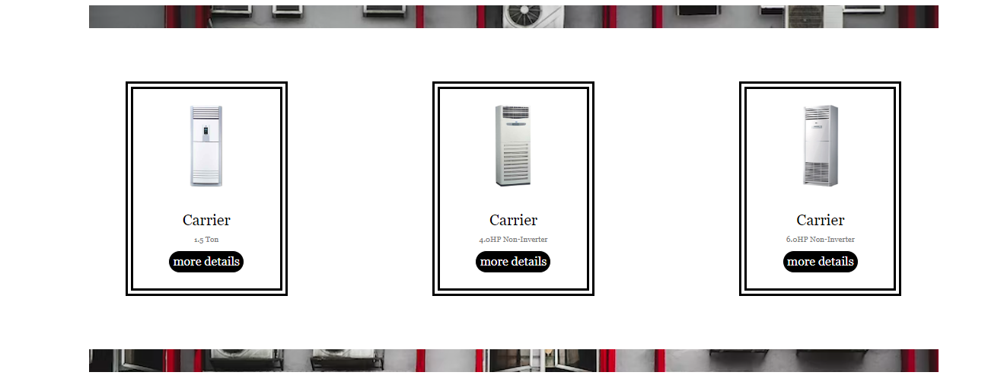

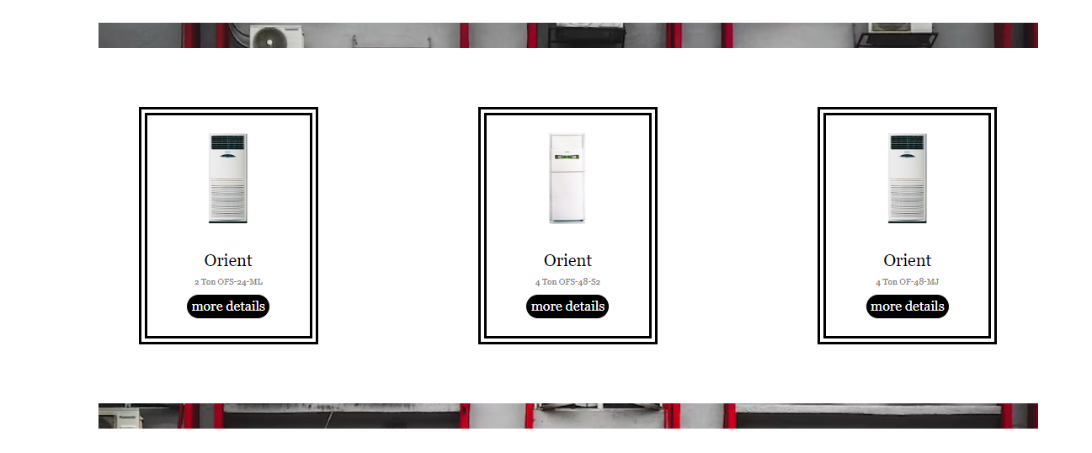

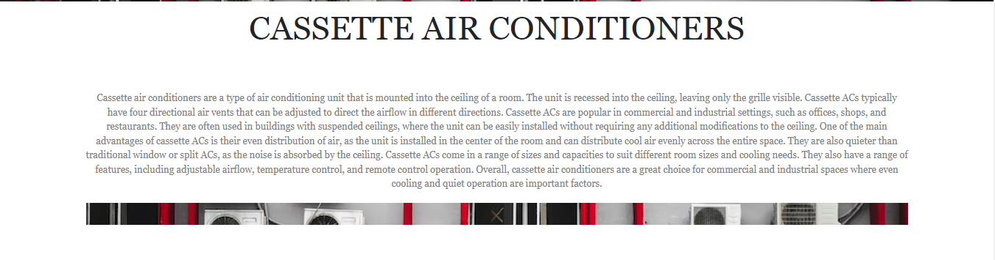

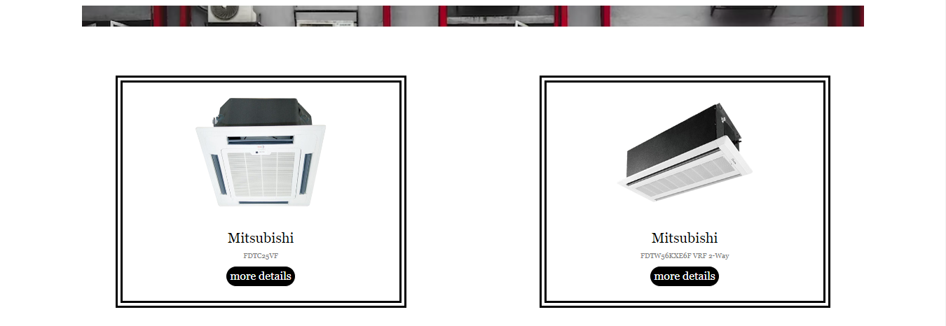

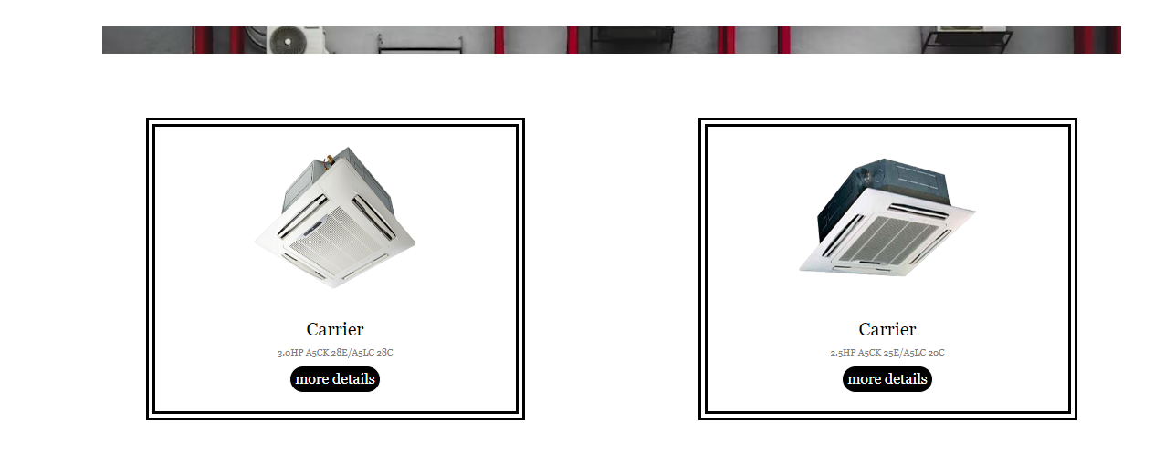

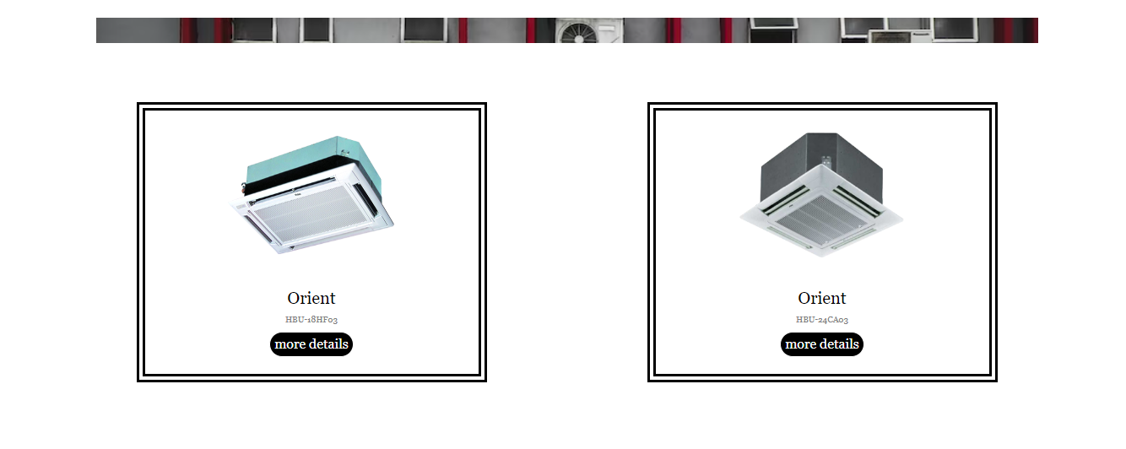

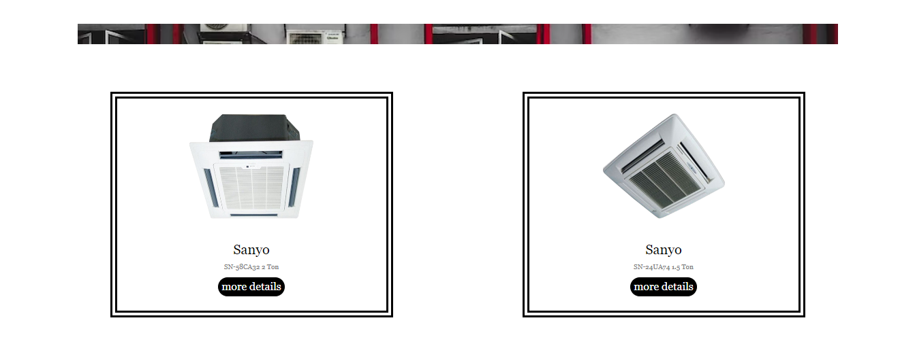

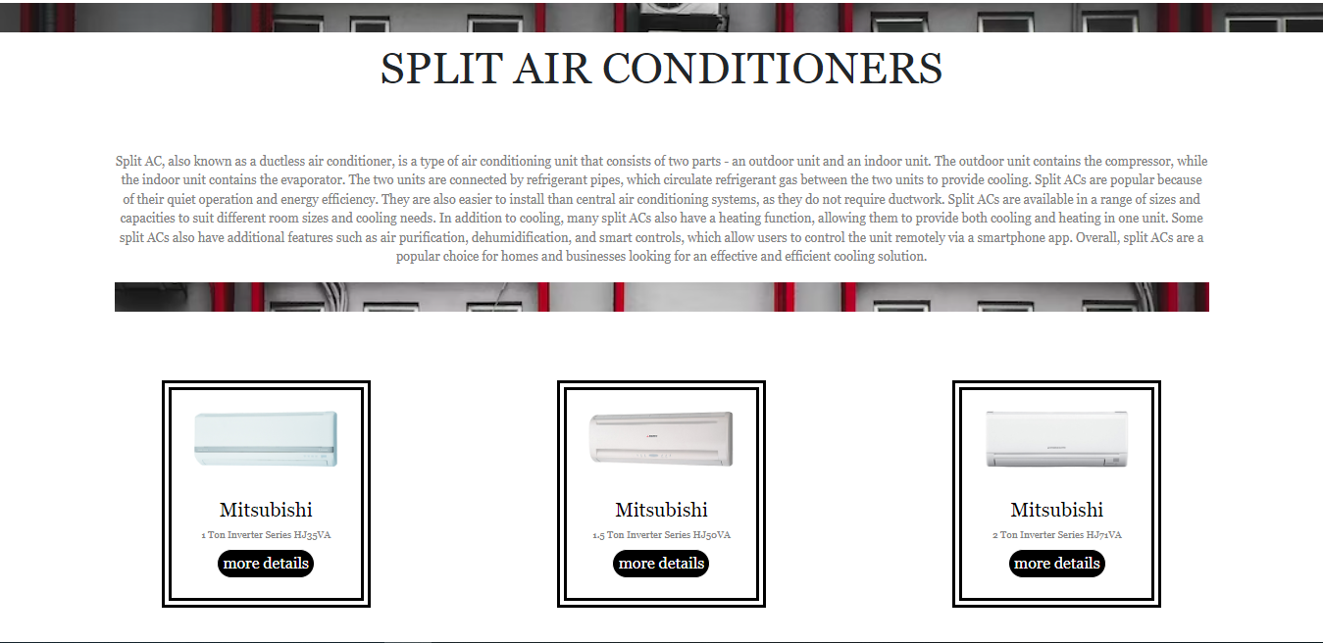

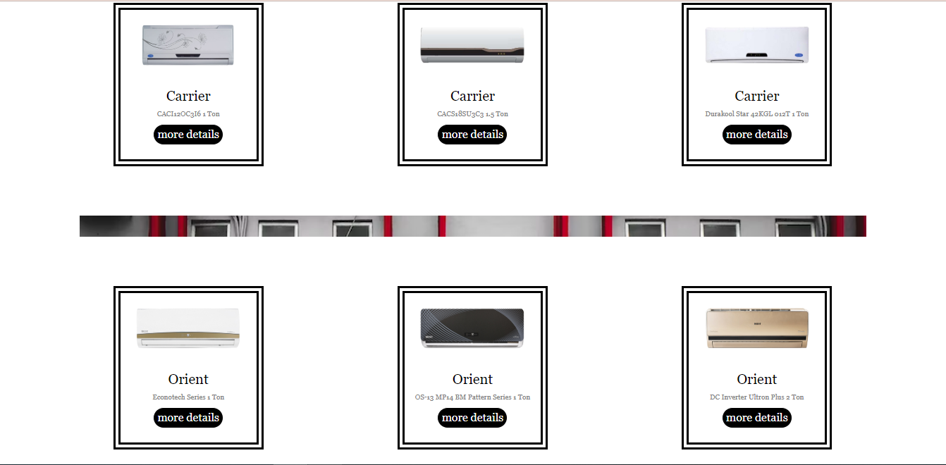





SITE MAP



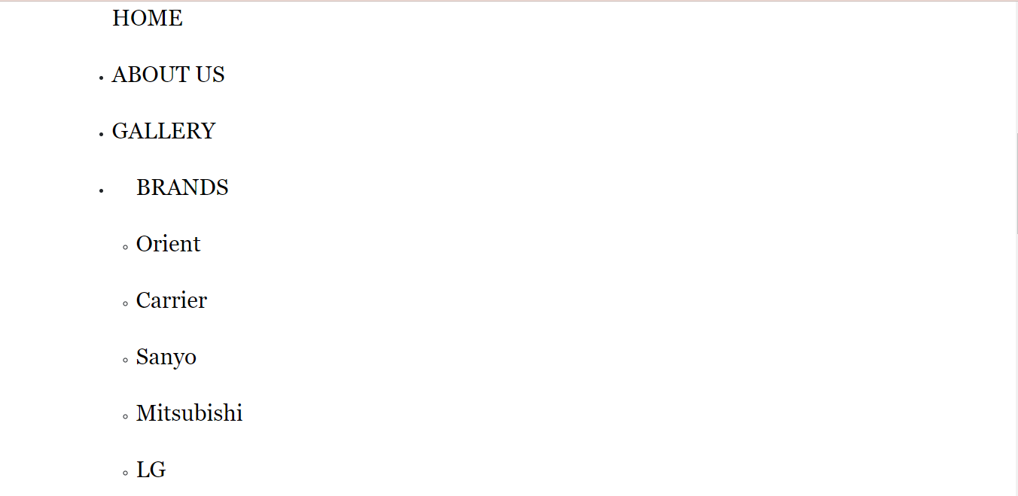

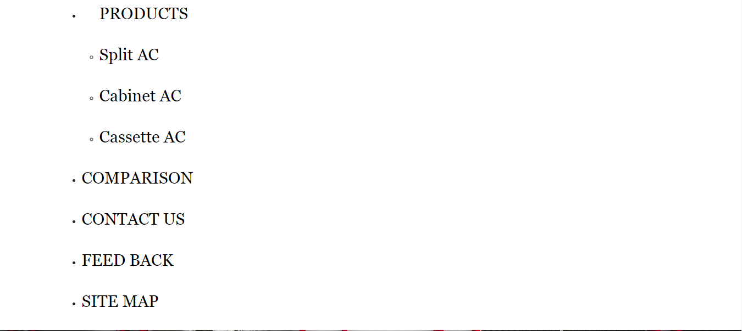





**DEVELOPER’S GUIDE:**

Homepage:

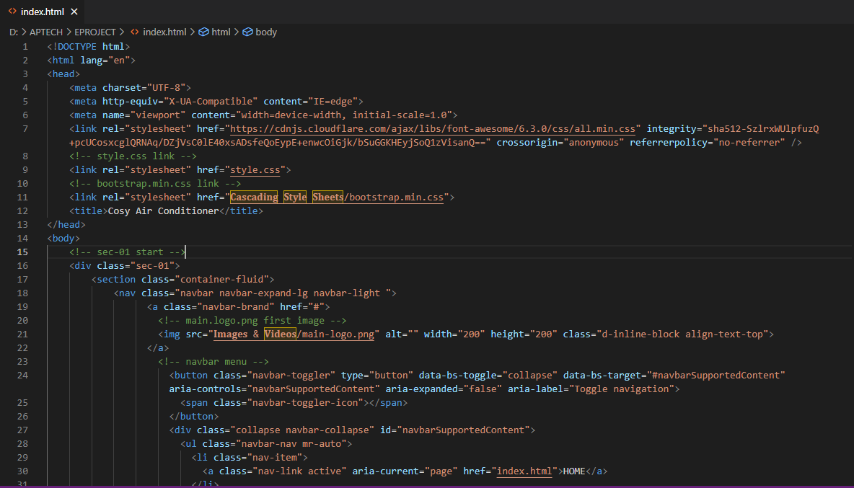

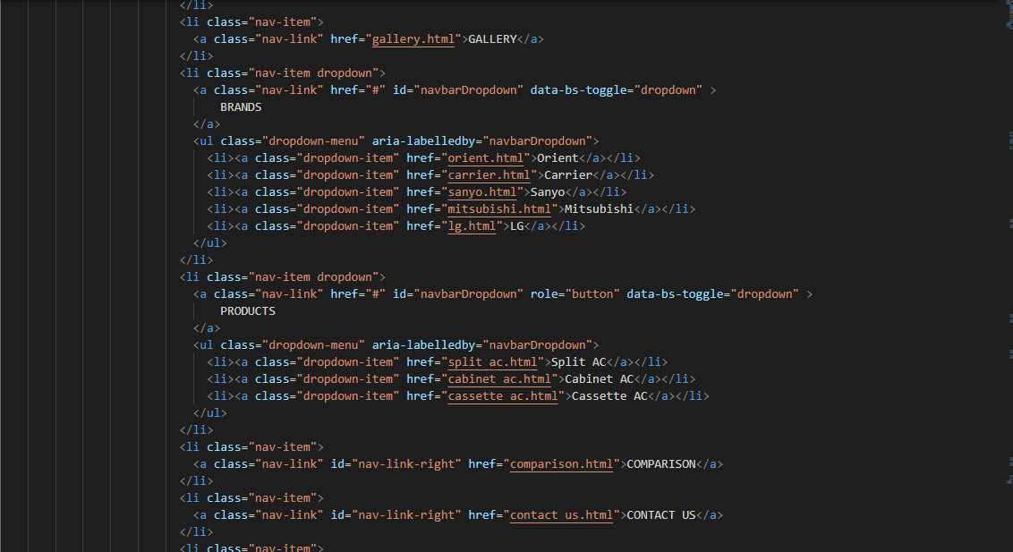

Video:

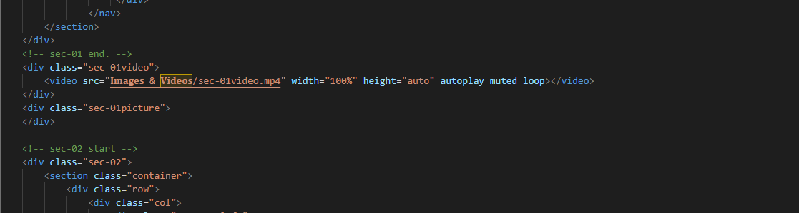

FOOTER:

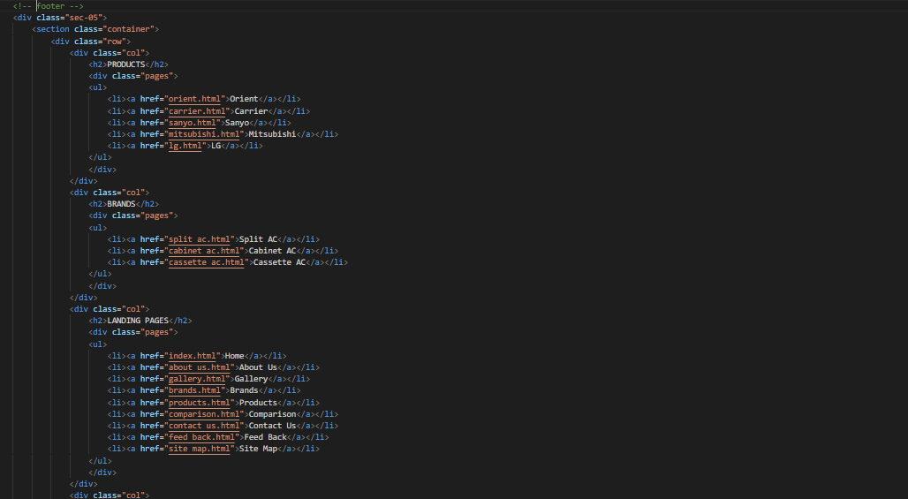

**Task Sheet**

|  |  |  |  |  |
| --- | --- | --- | --- | --- |
| Project Ref. No. | | Project Title | Date of Preparation of Activity Plan | |
| S.No. | Ta | **Handicrafts** | Actual Days | Status |
| 1 | Analysis | 2 | OK |
| 2 | Design | 4 | OK |
| 3 | Development | 7 | OK |
| 4 | Testing | 1 | OK |
| 5 | Documentation | 1 | OK |