TASK 9: Introduction to Statistics and Probability Distribution:
Muhammad Rauhan:

Statistics deals with the collection, presentation and analysis of the data:

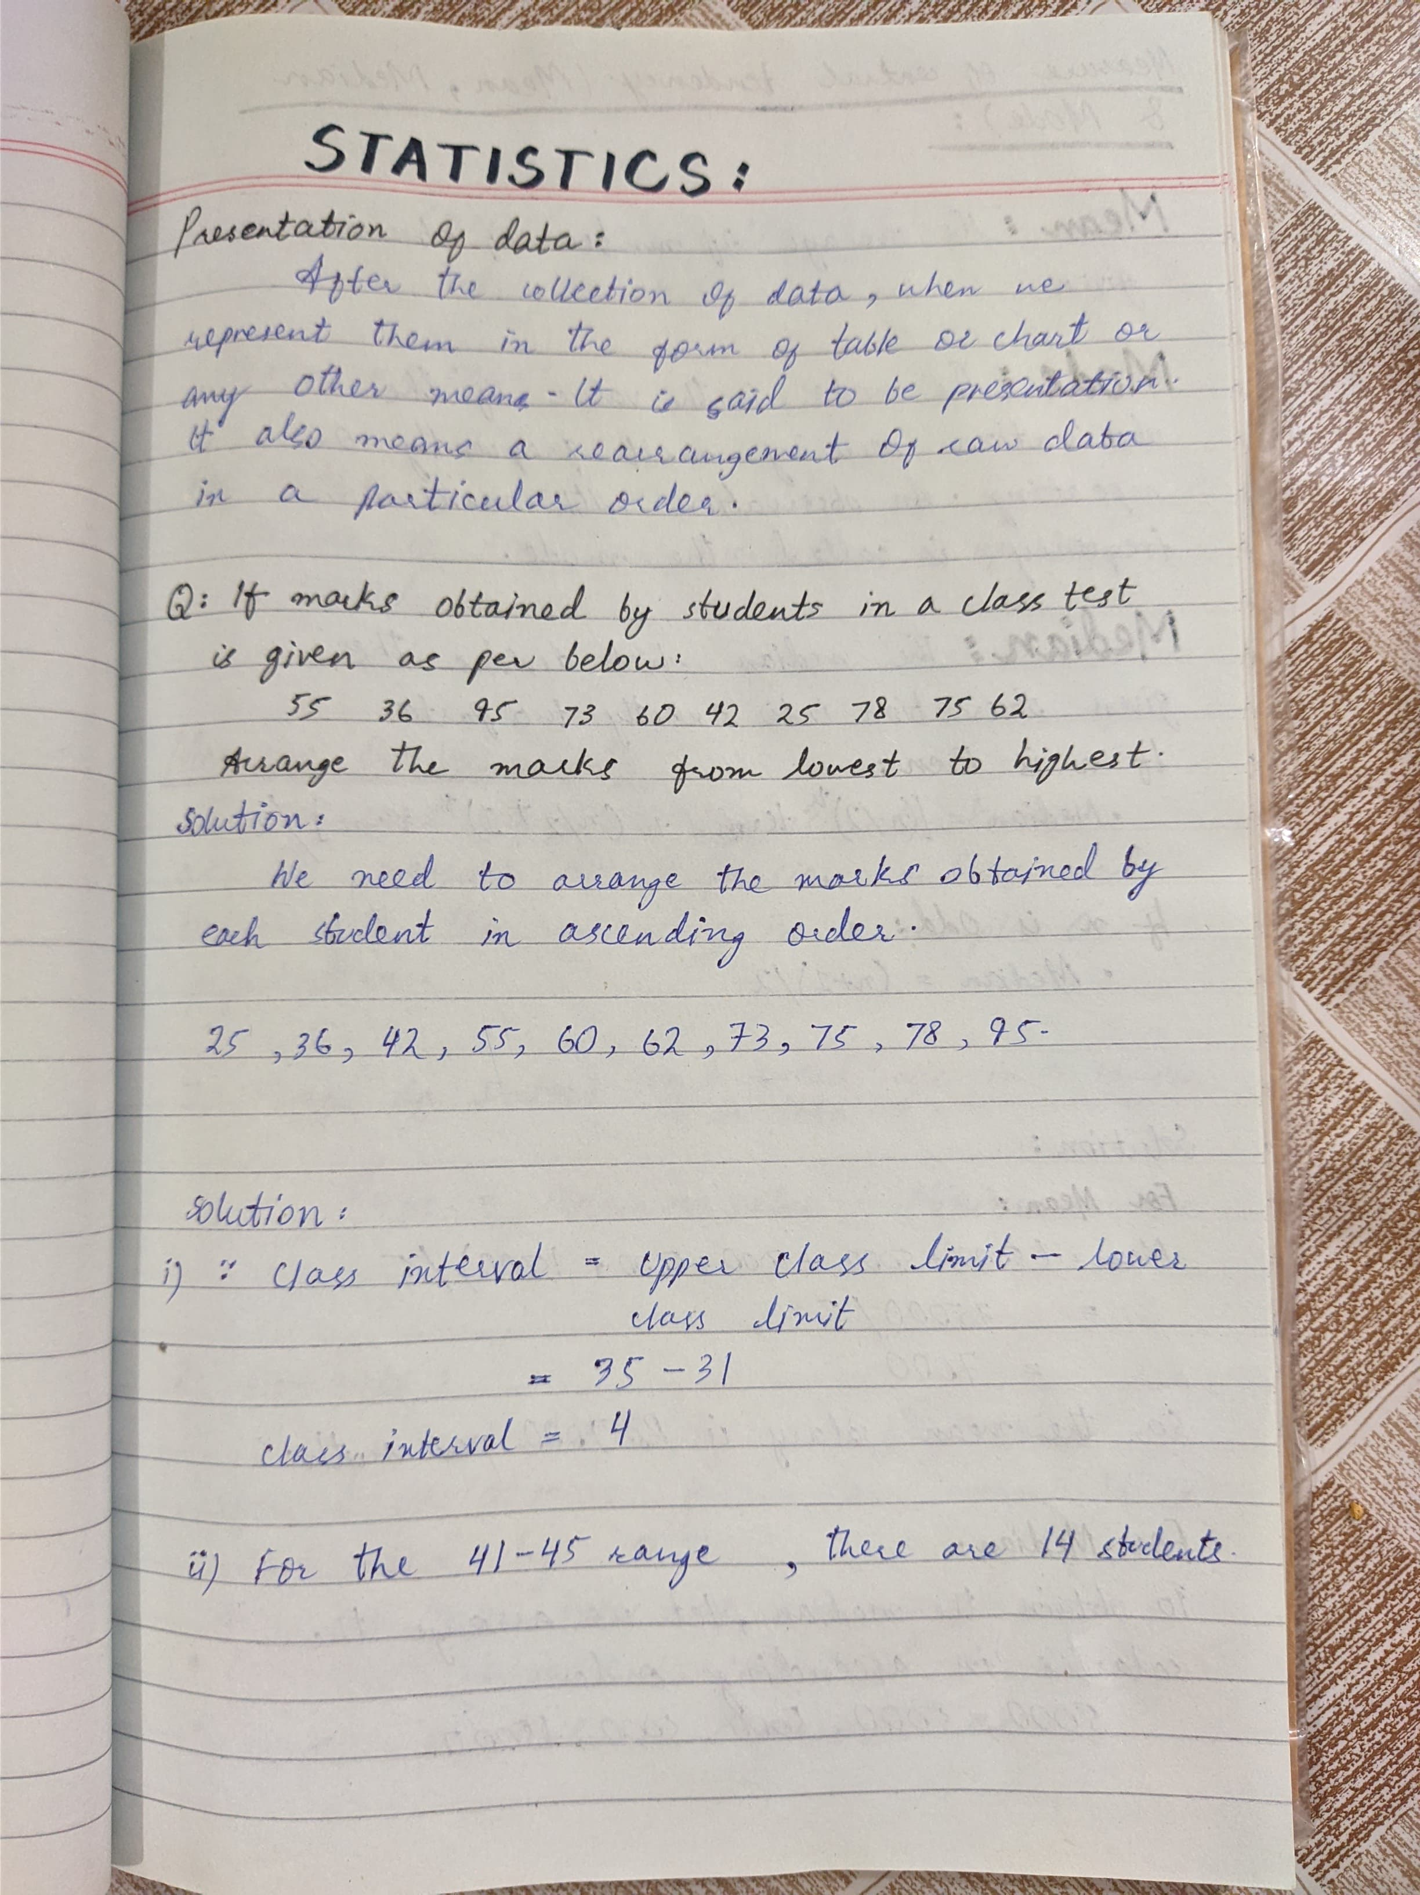

Types of Statistics:

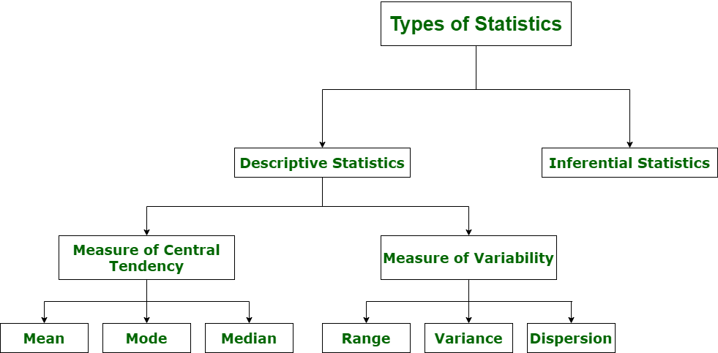

Some basic statistics questions:
Q NO: 1



Q NO: 2

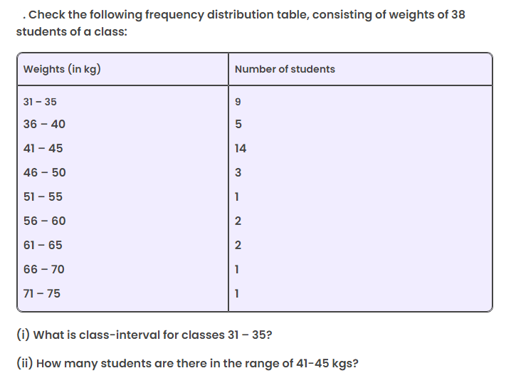



Measure of Central Tendency:

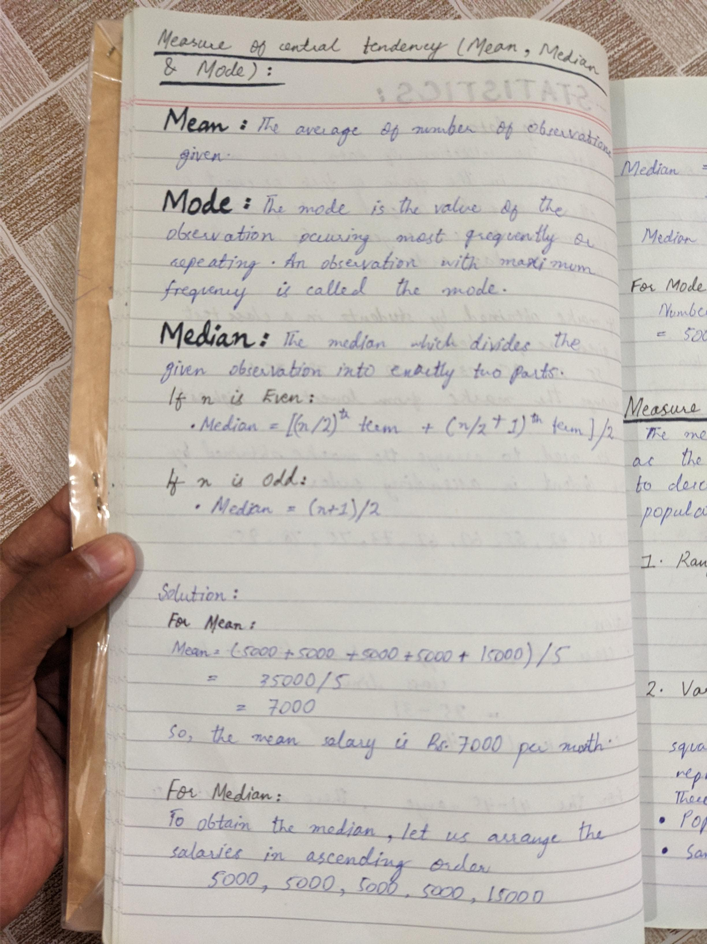

Q NO: 3

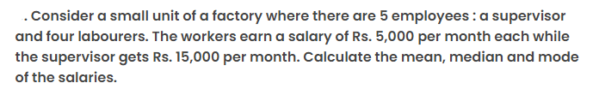



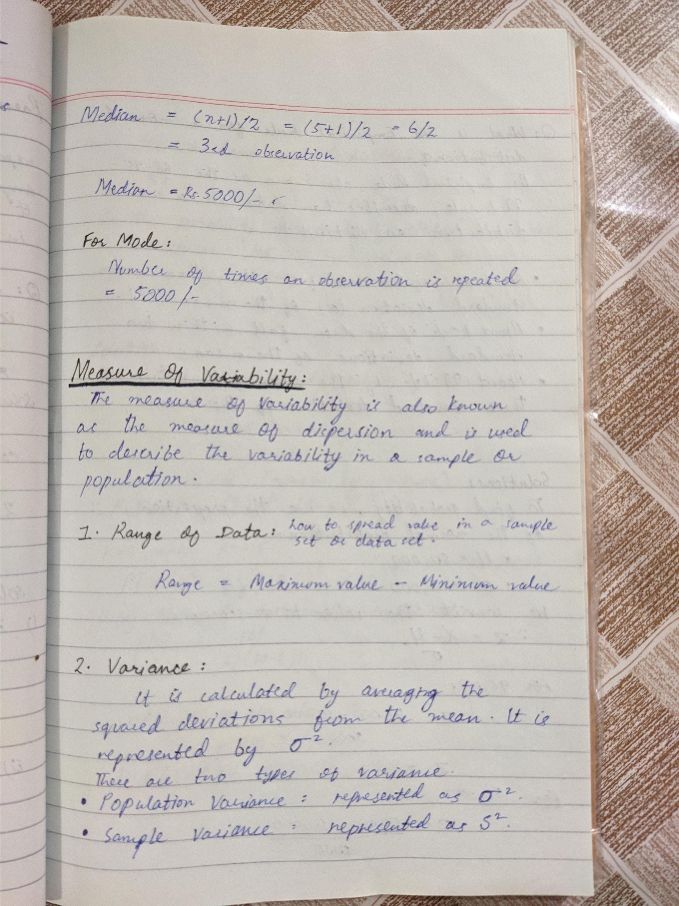

Measure of Variability:



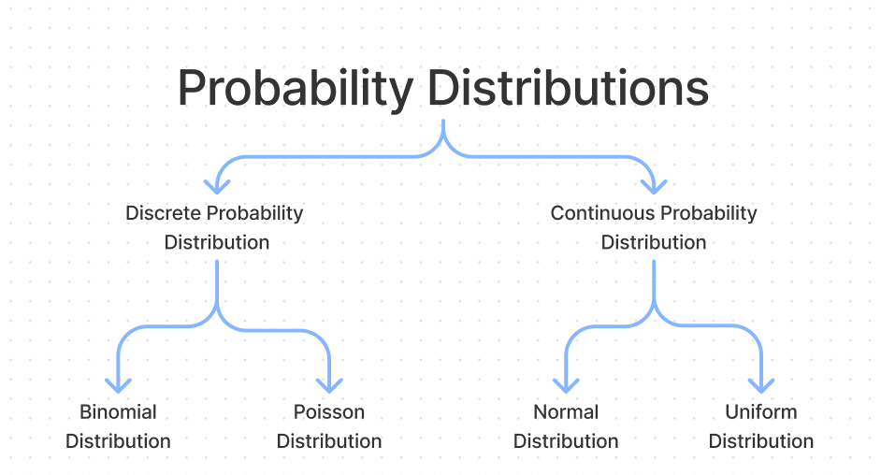
Normal Distribution:
Q NO: 4
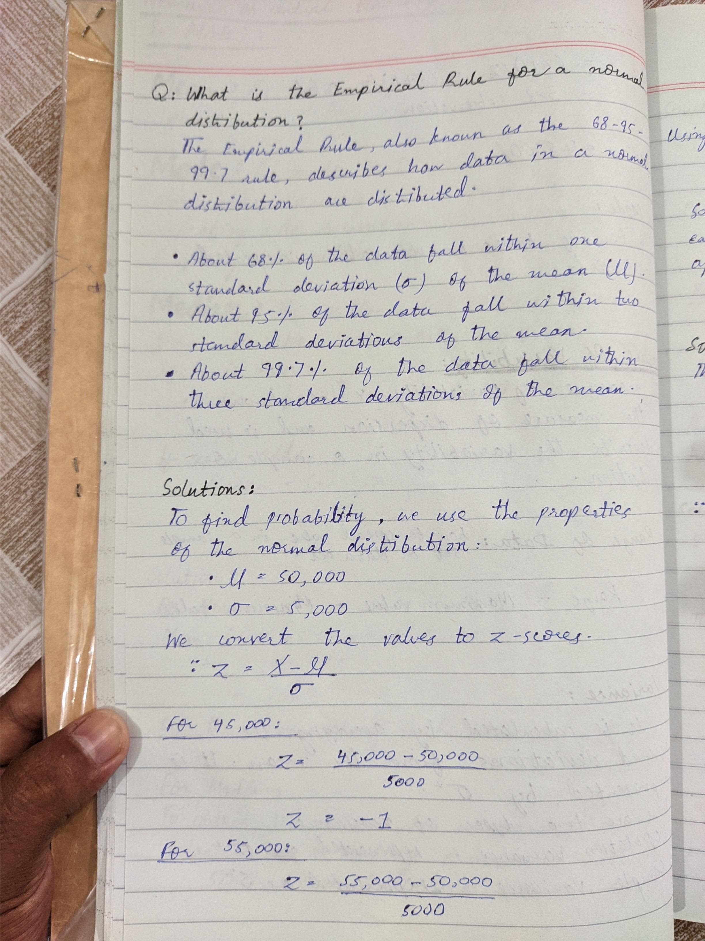

Q NO: 5
A company’s employee salaries are normally distributed with a mean of $50,000 and a standard deviation of $5,000. What is the probability that a randomly selected employee earns between $45,000 and $55,000?

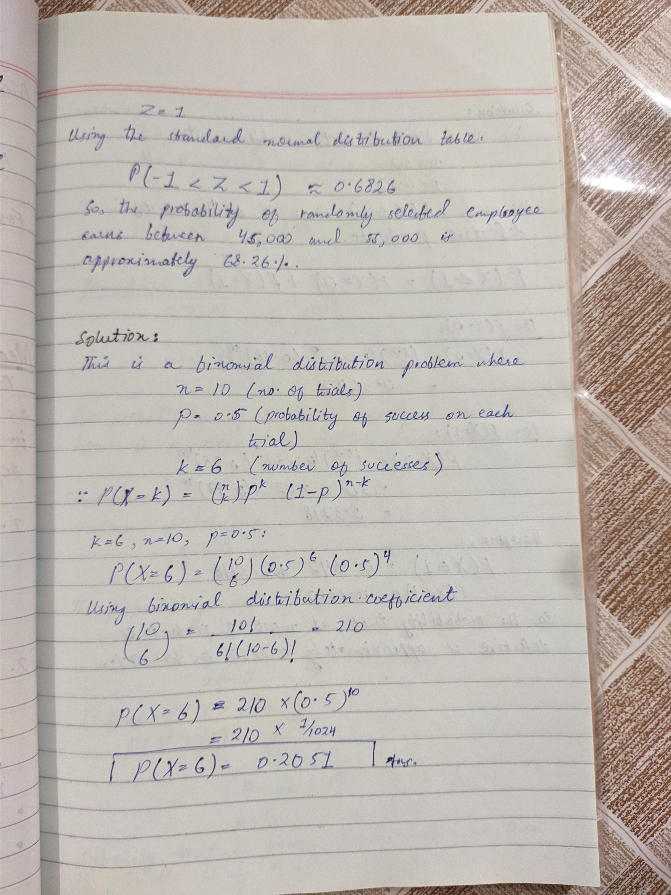

Binomial Distribution:
Q NO: 6
A coin is flipped 10 times. What is the probability of getting exactly 6 heads?


Q NO: 7
If the probability of a product being defective is 0.02, what is the probability that in a shipment of 50 products, at most 1 product is defective?

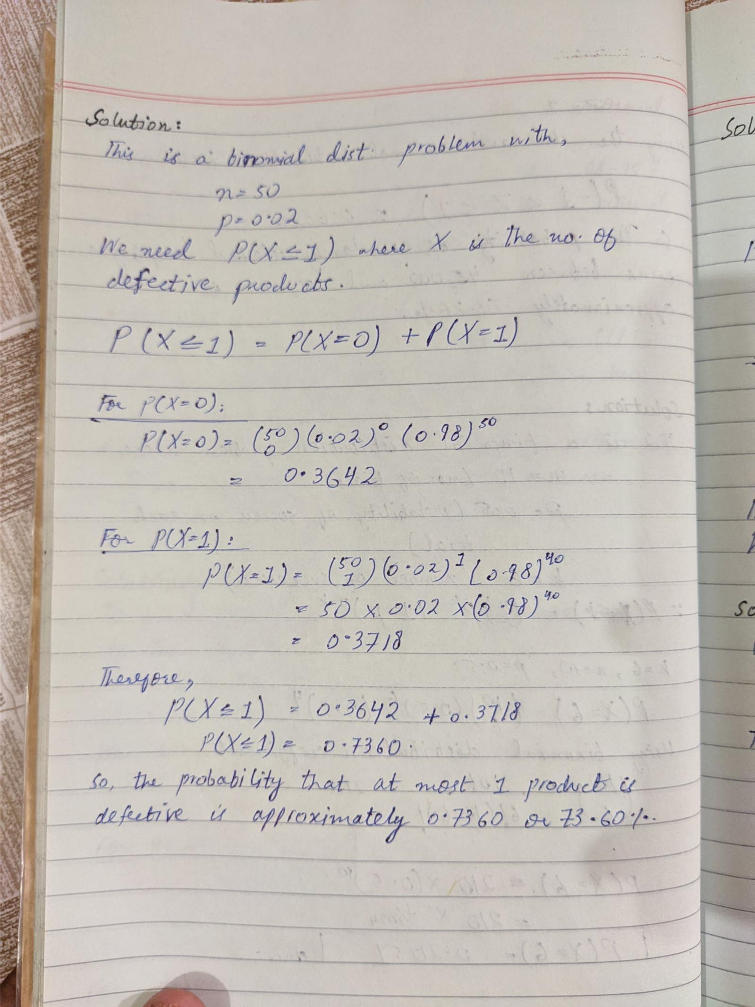

Poisson Distribution:

Q NO: 8
A call center receives an average of 10 calls per hour. What is the probability that they receive exactly 8 calls in a given hour?

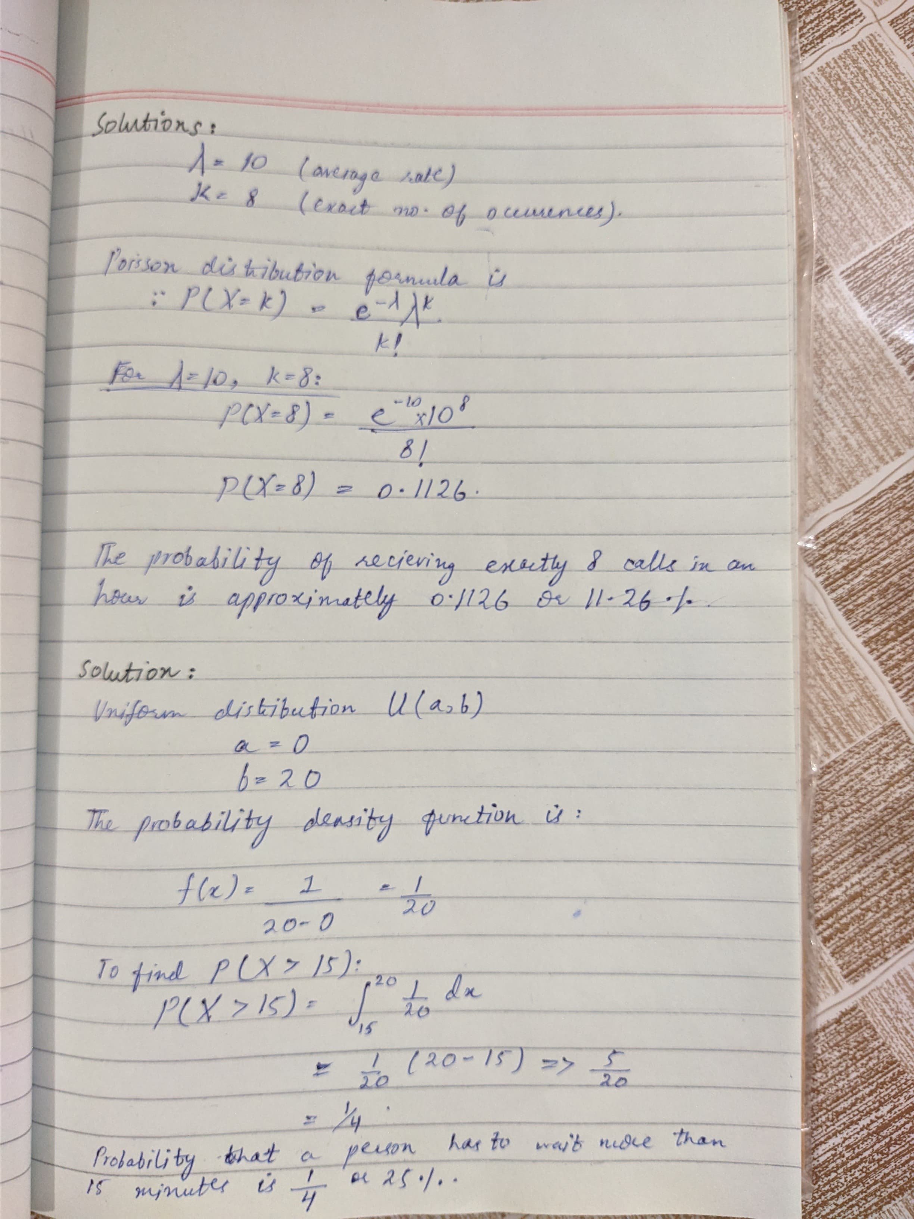

Uniform Distribution:

Q NO: 9
If the waiting time for a bus at a certain stop is uniformly distributed between 0 and 20 minutes, what is the probability that a person has to wait more than 15 minutes?


