**Currency Converter Program in C++**

**Introduction**

This is a currency converter program that allows users to convert from one currency to another using real-time exchange rates. The program is written in C++ and uses OOP concepts to create classes for the different currencies and conversions.

**Author Information**

* Name: Muhammad Saif
* Roll Number: 22SW129
* Contact: 03160032882
* Email: saif.shabir12@gmail.com

**Features**

The program offers the following features:

* Conversion between different currencies based on real-time exchange rates.
* Support for multiple currencies, including USD, EUR, GBP, JPY, AUD, and CAD.
* User-friendly interface with clear instructions and error messages.
* Easy-to-use object-oriented design.

**Implementation**

The program is implemented using the following classes:

* This program contains the currency code, exchange rate, and methods for getting and setting these values.
* **USD**, **EUR**, **PKR**, **IND**, and **RIYAL**: These are derived classes from the **Currency** class. Each class represents a specific currency and has its own exchange rate.
* This program handles the conversion process. It contains methods for converting from one currency to another, as well as a method for displaying the available currencies and their exchange rates.
* In main a do-while loop is used for multiple conversions

**Example Usage**

Here is an example of how to use the program:

1. Run the program by typing **./22SW129** in the command prompt or terminal.
2. Follow the instructions on the screen to select the currency from which you want to convert into.
3. The program will display the converted amount based on the real-time exchange rate.

**Conclusion**

This currency converter program is a simple and user-friendly tool for converting between different currencies. It uses an object-oriented design to make the code easy to read and maintain, and offers real-time exchange rates for accurate conversions. Thank you for using our program!

**Screenshots**

In the beginning there is a little animation after running the code when they are finished the code will look like this

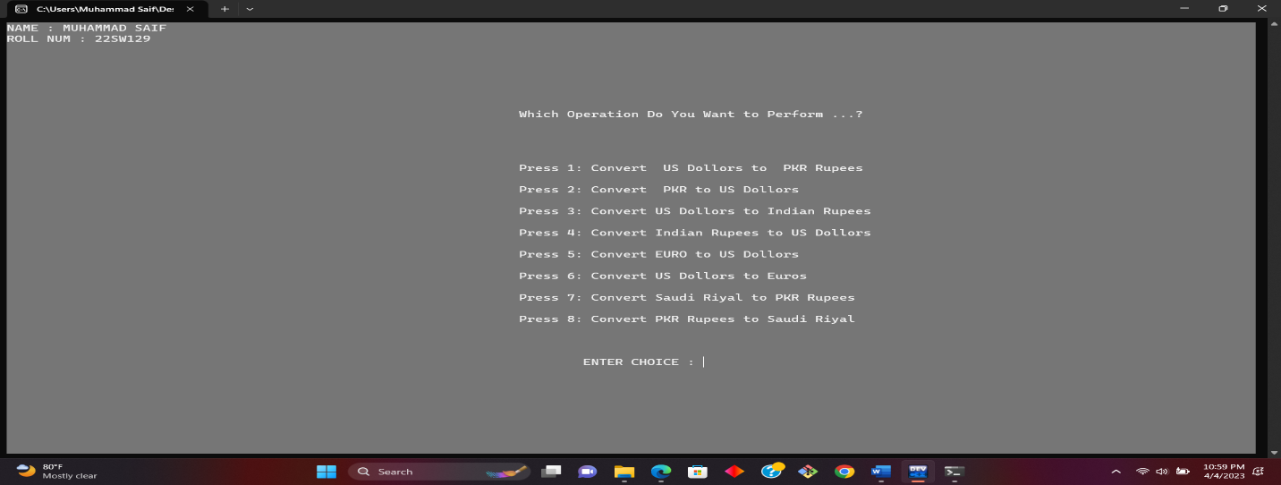

**THE OUTPUT OF THE PROGRAM**

**THE DO-WHILE LOOP WILL ASK AGAIN FROM THE USER THAT IF WANTS TO CONTINUE AGAIN**

