Supplementary Figure S1: Skilled Birth Attendance Status
Supplementary Figure S2. Class Distribution of Skilled Birth Attendance Before and After SMOTE

Supplementary Figure S3. Boruta Feature Importance and Selection of Predictors for Skilled Birth Attendance

Supplementary Figure S4. Cumulative SHAP Contribution of Predictors in the Random Forest Model for Skilled Birth Attendance.

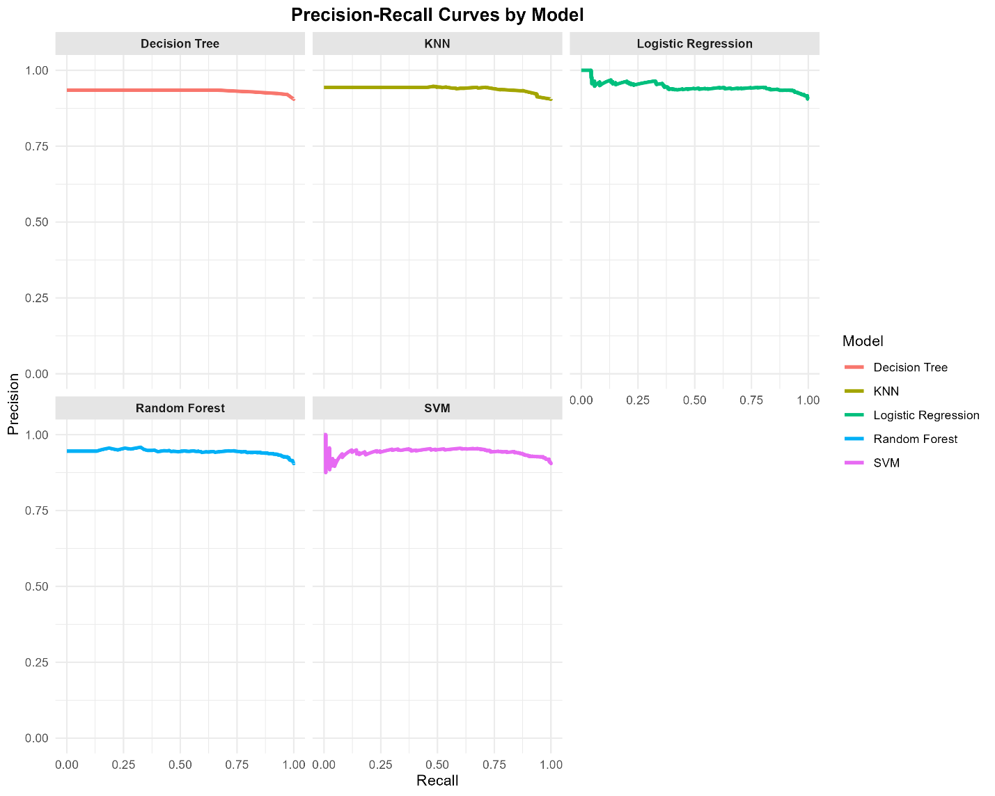
Supplementary Figure S5. Precision–Recall Curves of Machine Learning Models for Predicting Skilled Birth Attendance

Supplementary Figure S6. Confusion Matrix of the Random Forest Model for Predicting Skilled Birth Attendance

Supplementary Figure S7. Cramér’s V Correlation Heatmap of Boruta-Selected Predictors for Skilled Birth Attendance

Supplementary Figure S8. Performance Comparison of Random Forest Resampling Strategies for Predicting Skilled Birth Attendance
Supplementary Figure S9. Comparison of Receiver Operating Characteristic Curves Across Random Forest Resampling Strategies

Supplementary Figure S10. Comparison of Feature Importance Across Random Forest Resampling Strategies for Predicting Skilled Birth Attendance

Supplementary Figure S11. Calibration Performance of Random Forest Models Across Different Resampling Strategies

List of Supplementary Tables
Supplementary Table S1: Descriptive characteristics of women (N = 5,111)
Variable | Category | n | %
Skilled birth attendance (SBA) | Unskilled birth attendant | 489 | 9.57
 | Skilled birth attendant | 4,622 | 90.43
Province / Region | Boucle du Mouhoun | 299 | 5.85
 | Cascades | 253 | 4.95
 | Centre | 565 | 11.05
 | Centre Est | 503 | 9.84
 | Centre Nord | 427 | 8.35
 | Centre Ouest | 477 | 9.33
 | Centre Sud | 369 | 7.22
 | Est | 299 | 5.85
 | Hauts-Bassins | 477 | 9.33
 | Nord | 399 | 7.81
 | Plateau Central | 480 | 9.39
 | Sahel | 217 | 4.25
 | Sud-Ouest | 346 | 6.77
Age | <20 | 408 | 7.98
 | 20–34 | 3,604 | 70.51
 | >35 | 1,099 | 21.50
Education | No education | 3,285 | 64.27
 | Basic | 777 | 15.20
 | Secondary/Higher | 1,049 | 20.52
Residence | Urban | 1,602 | 31.34
 | Rural | 3,509 | 68.66
Ethnicity | Non-hill | 4,506 | 88.16
 | Hill | 605 | 11.84
Religion | Catholic | 3,370 | 65.94
 | Islam | 1,087 | 21.27
 | Zion | 372 | 7.28
 | Evangelical/Pentecostal | 216 | 4.23
 | Other | 66 | 1.29
Wealth | Poor | 1,900 | 37.17
 | Middle | 1,072 | 20.97
 | Rich | 2,139 | 41.85
Child category | Single child | 1,190 | 23.28
 | Multiple children | 3,921 | 76.72
Household size | ≤5 members | 1,496 | 29.27
 | >5 members | 3,615 | 70.73
Husband education | No education | 3,266 | 63.90
 | Basic | 630 | 12.33
 | Secondary/Higher | 761 | 14.89
 | Don't know / Missing | 454 | 8.88
Health insurance | No | 5,083 | 99.45
 | Yes | 28 | 0.55
Working status | Not working | 1,813 | 35.47
 | Working | 3,120 | 61.04
 | Missing | 178 | 3.48
Parity | Primiparous (1 birth) | 1,137 | 22.25
 | Multiparous (2+ births) | 3,974 | 77.75
ANC visits (≥4) | <4 | 1,422 | 27.82
 | ≥4 | 3,689 | 72.18
Delivery mode | Vaginal delivery | 4,752 | 92.98
 | Caesarean section | 352 | 6.89
 | Missing | 7 | 0.14
Birth size | Small / Unknown | 433 | 8.47
 | Average / Large | 4,678 | 91.53
PNC doctor | No | 4,959 | 97.03
 | Yes | 152 | 2.97
Maternal age at first birth | <20 years | 2,920 | 57.13
 | ≥20 years | 2,191 | 42.87
Pregnancy pressure | Not pressured | 4,607 | 90.14
 | Pressured | 250 | 4.89
 | Missing | 254 | 4.97
Age at first sex | <18 years | 3,460 | 67.70
 | ≥18 years | 1,651 | 32.30
Sexually active | Not active | 1,946 | 38.07
 | Active | 3,165 | 61.93
Fertility preference | Do not want more | 637 | 12.46
 | Want more | 4,474 | 87.54
Genital ulcer | No | 4,737 | 92.68
 | Yes | 358 | 7.00
 | Missing | 16 | 0.31
Media exposure | No | 572 | 11.19
 | Yes | 4,539 | 88.81
Internet use | Low usage | 4,677 | 91.51
 | Regular usage | 434 | 8.49
Decision-making | No | 4,150 | 81.20
 | Yes | 707 | 13.83
 | Missing | 254 | 4.97
Physical IPV | No | 4,989 | 97.61
 | Yes | 122 | 2.39
Sexual IPV | No | 5,076 | 99.32
 | Yes | 35 | 0.68
Emotional IPV | No | 4,833 | 94.56
 | Yes | 278 | 5.44
Any IPV | No | 4,770 | 93.33
 | Yes | 341 | 6.67

Supplementary Table S2. Model Training, Cross-Validation, and Hyperparameter Tuning Specifications
Model | Parameter | Description
All models | Cross-validation method | 10-fold cross-validation was applied to assess model robustness and reduce overfitting
All models | number = 10 | The dataset was divided into 10 folds; 9 folds were used for training and 1 fold for validation in each iteration
All models | classProbs = TRUE | Class probabilities were estimated to allow probabilistic prediction and AUROC calculation
All models | savePredictions = "final" | Final cross-validated predictions were saved for performance evaluation
All models | summaryFunction = defaultSummary | Standard performance metrics (Accuracy, Kappa) were computed during training
All models | verboseIter = TRUE | Training progress was displayed to monitor model convergence
Random Forest | tuneLength = 10 | A grid of 10 candidate hyperparameter combinations was explored to optimize model performance
Decision Tree (rpart) | tuneLength = 10 | Complexity parameters were tuned over 10 candidate values
K-Nearest Neighbors (KNN) | tuneLength = 10 | The number of nearest neighbors (k) was optimized through grid search
Support Vector Machine (Radial) | tuneLength = 10 | Cost and radial basis kernel parameters were tuned using a grid of 10 values
Logistic Regression | family = binomial | A binomial logistic regression model was fitted without hyperparameter tuning

Supplementary Table S3: Baseline Performance of Machine Learning Models on the Original Imbalanced Dataset (Without Class Rebalancing)
Model | Accuracy | Precision | Recall | F1_Score | MCC | Kappa | AUROC
Random Forest | 0.91 | 0.92 | 0.99 | 0.95 | 0.32 | 0.26 | 0.70
Decision Tree | 0.91 | 0.92 | 0.98 | 0.95 | 0.30 | 0.27 | 0.67
K-Nearest Neighbor | 0.91 | 0.92 | 0.99 | 0.95 | 0.32 | 0.25 | 0.72
Logistic Regression | 0.91 | 0.92 | 0.99 | 0.95 | 0.27 | 0.22 | 0.70
Support Vector Machine | 0.91 | 0.92 | 0.99 | 0.95 | 0.30 | 0.22 | 0.66

Supplementary Table S4: Survey-weighted logistic regression: Odds ratios for skilled birth attendance (SBA)
Variable / Category | Odds Ratio | 95% CI | p-value
Province
Boucle du Mouhoun (Ref.) | Reference | — | —
Cascades | 0.702 | 0.199 – 2.476 | 0.581
Centre | 0.478 | 0.183 – 1.247 | 0.131
Centre-Est | 0.226 | 0.083 – 0.616 | 0.004
Centre-Nord | 0.479 | 0.170 – 1.351 | 0.164
Centre-Ouest | 0.622 | 0.222 – 1.743 | 0.365
Centre-Sud | 0.871 | 0.321 – 2.365 | 0.786
Est | 0.268 | 0.089 – 0.806 | 0.019
Hauts-Bassins | 0.478 | 0.170 – 1.343 | 0.161
Nord | 1.088 | 0.404 – 2.932 | 0.867
Plateau Central | 0.971 | 0.360 – 2.615 | 0.954
Sahel | 0.035 | 0.013 – 0.092 | <0.001
Sud-Ouest | 0.151 | 0.058 – 0.392 | <0.001
Age
<20 (Ref.) | Reference | — | —
20–34 | 1.186 | 0.748 – 1.880 | 0.468
≥35 | 1.498 | 0.811 – 2.765 | 0.196
Education
None (Ref.) | Reference | — | —
Basic | 1.373 | 0.921 – 2.047 | 0.119
Secondary/Higher | 1.019 | 0.688 – 1.510 | 0.924
Residence
Urban (Ref.) | Reference | — | —
Rural | 0.950 | 0.570 – 1.581 | 0.842
Ethnicity
Non-Hill (Ref.) | Reference | — | —
Hill | 1.270 | 0.598 – 2.699 | 0.533
Religion
Christian (Ref.) | Reference | — | —
Islam | 0.851 | 0.579 – 1.250 | 0.410
Zion | 1.023 | 0.592 – 1.768 | 0.934
Evangelical/Pentecostal | 0.607 | 0.349 – 1.056 | 0.077
Other | 0.564 | 0.197 – 1.617 | 0.286
Wealth
Poor (Ref.) | Reference | — | —
Middle | 1.675 | 1.192 – 2.353 | 0.003
Rich | 1.357 | 0.869 – 2.120 | 0.180
Number of children
Single child (Ref.) | Reference | — | —
Multiple children | 0.795 | 0.320 – 1.975 | 0.620
Household size
≤5 members (Ref.) | Reference | — | —
>5 members | 0.688 | 0.509 – 0.928 | 0.014
Husband's education
None (Ref.) | Reference | — | —
Basic | 1.209 | 0.828 – 1.766 | 0.325
Secondary/Higher | 1.272 | 0.871 – 1.856 | 0.212
Don't know/Missing | 1.173 | 0.735 – 1.872 | 0.503
Health insurance
No (Ref.) | Reference | — | —
Yes | 0.638 | 0.087 – 4.647 | 0.656
Parity
Primiparous (Ref.) | Reference | — | —
Multiparous (2+ births) | 0.970 | 0.371 – 2.541 | 0.951
ANC visits
<4 visits (Ref.) | Reference | — | —
≥4 visits | 1.915 | 1.500 – 2.444 | <0.001
Birth size
Small (Ref.) | Reference | — | —
Average or Large | 1.291 | 0.879 – 1.896 | 0.193
Prenatal care provider
Non-doctor (Ref.) | Reference | — | —
Prenatal doctor | 0.682 | 0.289 – 1.608 | 0.381
Age at first birth
<20 years (Ref.) | Reference | — | —
≥20 years | 1.087 | 0.819 – 1.444 | 0.562
Age at first sex
<18 years (Ref.) | Reference | — | —
≥18 years | 0.900 | 0.622 – 1.303 | 0.577
Sexual activity
Not active (Ref.) | Reference | — | —
Active | 1.122 | 0.871 – 1.444 | 0.373
Fertility preference
Do not want more (Ref.) | Reference | — | —
Want more | 1.145 | 0.749 – 1.751 | 0.531
Media exposure
No exposure (Ref.) | Reference | — | —
Any media exposure | 0.973 | 0.708 – 1.338 | 0.867
Internet use
No/irregular (Ref.) | Reference | — | —
Regular usage | 0.962 | 0.494 – 1.875 | 0.910
Note. CI = confidence interval; OR = odds ratio; Ref. = reference category; SBA = skilled birth attendance.
N = 5,111; Survey-weighted analysis; Number of strata = 26; Number of PSUs = 511; Design df = 485.

Supplementary Table S5. Sensitivity analysis of Random Forest models using different imbalance-handling approaches
Model | Accuracy | Sensitivity | Specificity | Precision | F1-score | MCC | AUROC | Brier Score
SMOTE + RF | 89.50% | 96.10% | 26.80% | 92.60% | 0.943 | 0.281 | 0.716 | 0.091
Class-weighted RF | 67.00% | 68.40% | 53.60% | 93.30% | 0.789 | 0.137 | 0.663 | 0.222
Balanced RF | 77.00% | 79.70% | 51.50% | 94.00% | 0.862 | 0.216 | 0.703 | 0.179
Note: All models were trained using the respective imbalance-handling approaches on the training dataset only and were evaluated on the original independent test dataset without any resampling. Sensitivity and specificity were calculated using "Skilled" as the positive class.

