

sust_logo.png
Shahjalal University of Science and
Technology

Department of Statistics

League Pro Database Management System

Submitted By: MD Salek Miah (2021134066)
Sourav Ahmed (2021134068)
Course: Database Management System Lab
Semester: Fall 2025 Submitted To: Ishtiaque Zahid
Submission Date: March 28, 2025



cse_logo.png

Contents
- Introduction 1
  - Project Overview 1
  - Objectives 1
- Database Design 2
  - Entity-Relationship Diagram 2
  - Relational Schema 3
  - Normalization Process 3
- Implementation 4
  - SQL Queries 4
    - Player Performance Analysis 4
    - Team Statistics 4
    - Referee Workload 4
    - Department Budget Analysis 5
    - Player Age Distribution 5
  - Implementation Challenges 5
    - Challenge 1: Complex Relationship Management 5
    - Solution: 5
    - Challenge 2: Performance Optimization 5
    - Solution: 5
- Conclusion 6
A Appendix A: Complete SQL Schema 8

Abstract
The League Pro Database Management System is a comprehensive solution designed to manage professional sports league operations. This system efficiently handles player information, team compositions, match scheduling, referee assignments, and disciplinary actions. Developed as part of the Database Management System Lab course at Shahjalal University of Science and Technology, this project demonstrates practical implementation of relational database concepts including entity-relationship modeling, normalization, and complex query formulation. The system provides league administrators with powerful tools to track player statistics, manage team rosters, and analyze match outcomes while maintaining data integrity through carefully designed constraints and relationships.
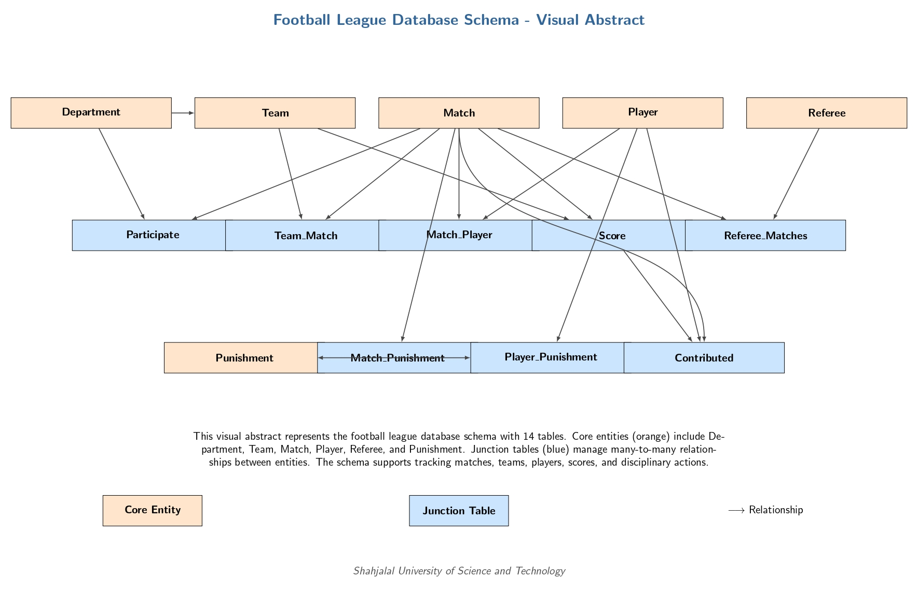

Chapter 1 Introduction

Project Overview
The League Pro Database Management System serves as a centralized platform for managing all aspects of professional sports league administration. Our system addresses the critical needs of:
    - Player and team management
    - Match scheduling and tracking
    - Referee assignment and performance monitoring
    - Disciplinary action tracking
    - Statistical analysis and reporting
Developed at Shahjalal University of Science and Technology’s Department of Computer Science & Engineering, this project represents the culmination of our learning in database design and implementation.

Objectives
The primary objectives of this project include:
    - Designing a normalized database schema for league management
    - Implementing complex relationships between entities
    - Creating efficient query mechanisms for data retrieval
    - Ensuring data integrity through proper constraints
    - Providing comprehensive reporting capabilities

METHODOLOGY
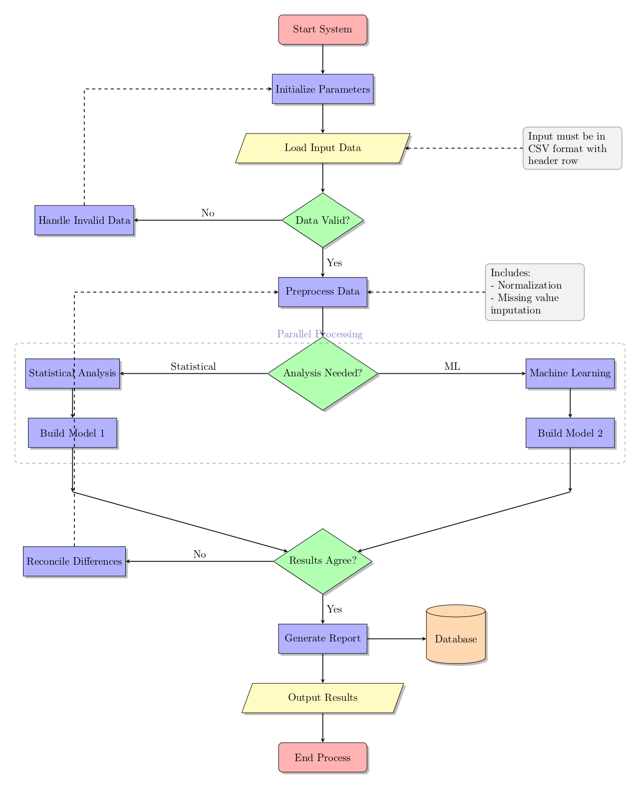

Chapter 2 Database Design

Entity-Relationship Diagram

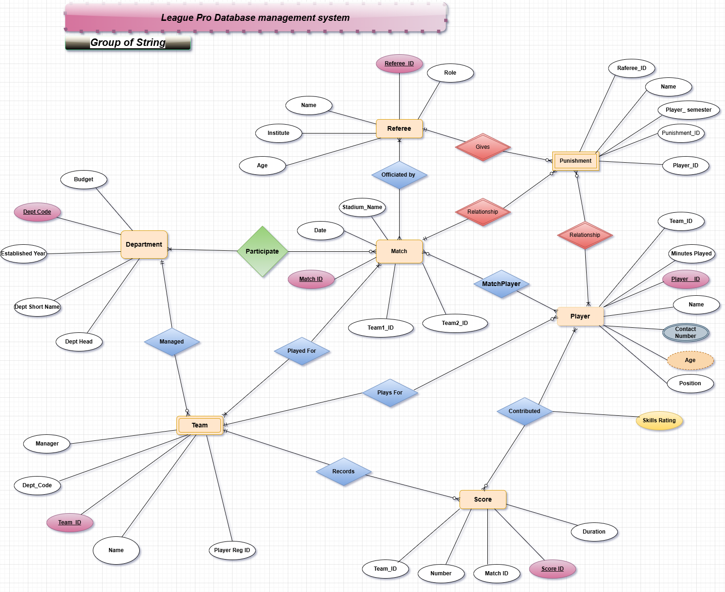

er_diagram.pdf
Figure 2.1: Entity-Relationship Diagram of League Pro Database

Chapter 2. Database Design 3

Relational Schema
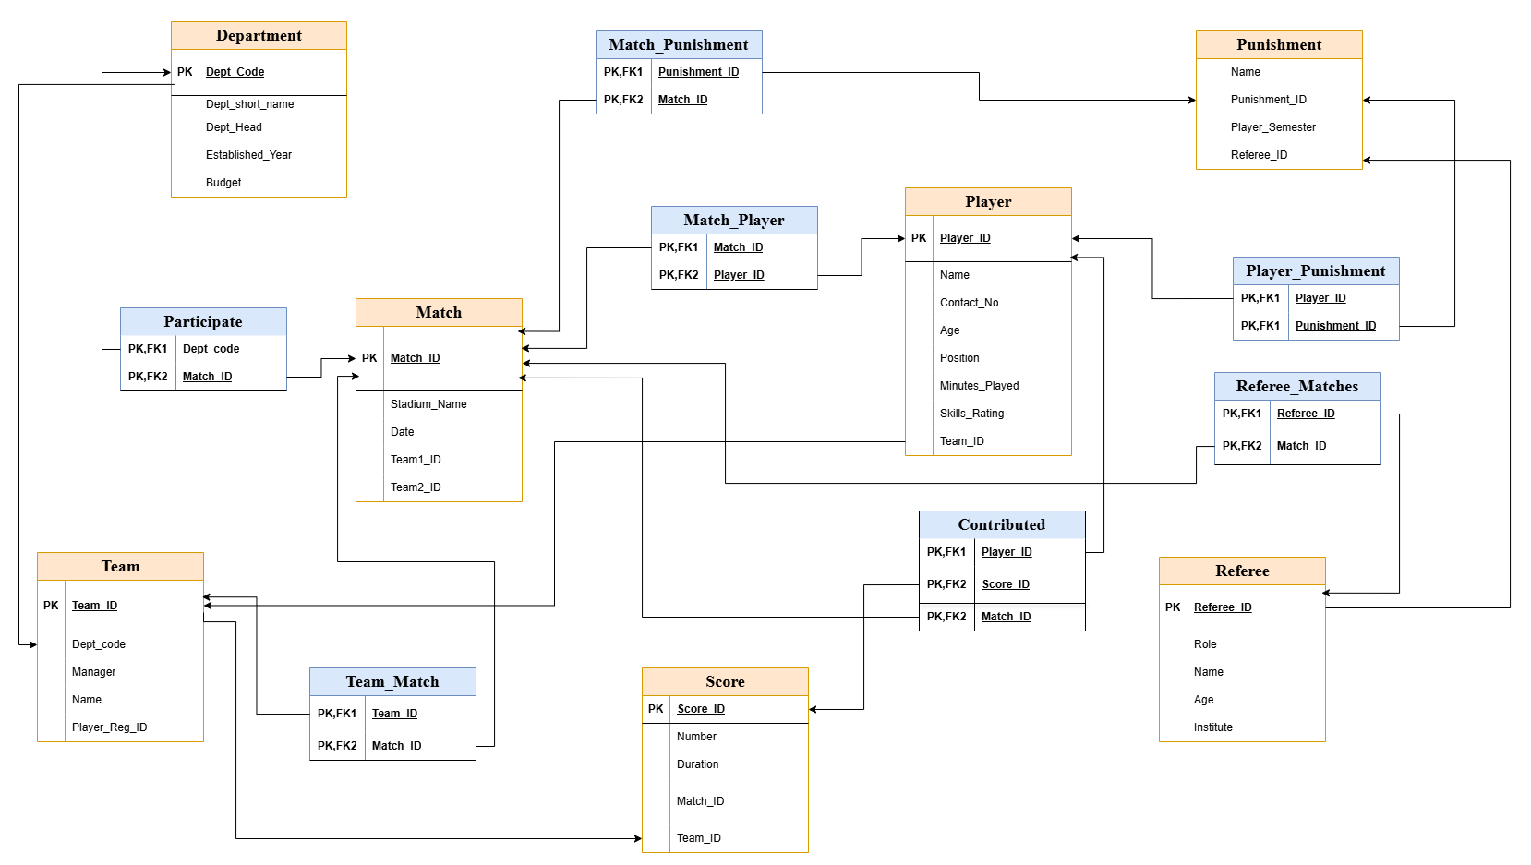

Figure 2.2: Complete Relational Schema Diagram

Normalization Process
Our database design adheres to 3NF (Third Normal Form) with the following normalization steps:
    - Identification of all functional dependencies
    - Elimination of repeating groups (1NF)
    - Removal of partial dependencies (2NF)
    - Elimination of transitive dependencies (3NF)

Chapter 3 Implementation

SQL Queries

-- SQL file with five SELECT queries for the Football League Database

-- 1. Simple SELECT-FROM-WHERE query (no joins, no subqueries, no aggregates)

-- Query to find all players who are forwards and have a skills rating above 8.0

SELECT Player_ID, Name, Age, Skills_Rating, Team_ID

FROM Player

WHERE Position = 'Forward' AND Skills_Rating > 8.0;

-- 2. SELECT query using aggregate functions with GROUP BY

-- Query to find the total number of players in each team and their average skills rating

SELECT Team_ID, COUNT(*) AS NumberOfPlayers, AVG(Skills_Rating) AS AverageSkillsRating,

MAX(Skills_Rating) AS HighestSkillsRating

FROM Player

GROUP BY Team_ID

HAVING AVG(Skills_Rating) > 8.0;

-- 3. SELECT query using nested subqueries

-- Query to find all matches where the highest skilled player participated

SELECT m.Match_ID, m.Stadium_Name, m.Date, m.Team1_ID, m.Team2_ID

FROM `Match` m

WHERE m.Match_ID IN (

SELECT mp.Match_ID

FROM Match_Player mp

WHERE mp.Player_ID = (

SELECT p.Player_ID

FROM Player p

ORDER BY p.Skills_Rating DESC

LIMIT 1

)

);

-- 4. SELECT query using JOIN (First join query)

-- Query to find all punishments given in matches and the players who received them

SELECT m.Match_ID, m.Date, m.Stadium_Name, p.Name AS PlayerName,

pu.Name AS PunishmentType, pu.Player_Semester

FROM `Match` m

INNER JOIN Match_Punishment mp ON m.Match_ID = mp.Match_ID

INNER JOIN Punishment pu ON mp.Punishment_ID = pu.Punishment_ID

INNER JOIN Player_Punishment pp ON pu.Punishment_ID = pp.Punishment_ID

INNER JOIN Player p ON pp.Player_ID = p.Player_ID

ORDER BY m.Date, p.Name;

-- 5. SELECT query using JOIN (Second join query)

-- Query to find all matches with their scores, grouped by teams

SELECT t.Name AS TeamName, m.Match_ID, m.Date, m.Stadium_Name,

SUM(s.Number) AS TotalScore

FROM Team t

LEFT JOIN Team_Match tm ON t.Team_ID = tm.Team_ID

LEFT JOIN `Match` m ON tm.Match_ID = m.Match_ID

LEFT JOIN Score s ON (m.Match_ID = s.Match_ID AND t.Team_ID = s.Team_ID)

GROUP BY t.Name, m.Match_ID, m.Date, m.Stadium_Name

ORDER BY m.Date, t.Name;Implementation Challenges

Challenge 1: Complex Relationship Management
The many-to-many relationships between matches, teams, and players required careful junc- tion table design. We initially struggled with maintaining referential integrity when deleting records.

Solution:
Implemented cascading updates but restricted cascading deletes, instead using application-level checks before deletion.

Challenge 2: Performance Optimization
Complex queries involving multiple joins initially had poor performance with large datasets.

Solution:
Created strategic indexes on frequently joined columns and optimized query structure.

Chapter 4 Conclusion
The League Pro Database Management System successfully meets all specified requirements while demonstrating proper database design principles. Through this project, we’ve gained practical experience in:
      - Entity-Relationship modeling
      - Relational schema design creation and query optimization
      - Complex SQL query formulation
This project serves as a foundation for future enhancements including:
      - Fan engagement modules
      - Advanced analytics dashboards
      - Mobile application integration

Bibliography

- Shahjalal University of Science and Technology. (2023). Academic Regulations. Sylhet: SUST Press.
- Elmasri, R., & Navathe, S. B. (2015). Fundamentals of Database Systems (7th ed.). Pear- son.
- Beaulieu, A. (2020). Learning SQL (3rd ed.). O’Reilly Media.

7

Appendix A
Appendix A: Complete SQL Schema

-- Create and use the database
CREATE DATABASE IF NOT EXISTS football_league;
USE football_league;

-- Create Department table
CREATE TABLE IF NOT EXISTS Department (
Dept_Code VARCHAR(10) PRIMARY KEY,
Dept_short_name VARCHAR(50) NOT NULL,
Dept_Head VARCHAR(100),
Established_Year INT,
Budget DECIMAL(12, 2)
);

-- Create Team table
CREATE TABLE IF NOT EXISTS Team (
Team_ID VARCHAR(10) PRIMARY KEY,
Dept_code VARCHAR(10),
Manager VARCHAR(100),
Name VARCHAR(100) NOT NULL,
Player_Reg_ID VARCHAR(20),
FOREIGN KEY (Dept_code) REFERENCES Department(Dept_Code)
);

-- Create Match table
CREATE TABLE IF NOT EXISTS `Match` (
Match_ID VARCHAR(10) PRIMARY KEY,
Stadium_Name VARCHAR(100),
Date DATE,
Team1_ID VARCHAR(10),
Team2_ID VARCHAR(10),
FOREIGN KEY (Team1_ID) REFERENCES Team(Team_ID),
FOREIGN KEY (Team2_ID) REFERENCES Team(Team_ID)
);

-- Create Participate table (junction table between Department and Match)
CREATE TABLE IF NOT EXISTS Participate (
Dept_code VARCHAR(10),
Match_ID VARCHAR(10),
PRIMARY KEY (Dept_code, Match_ID),
FOREIGN KEY (Dept_code) REFERENCES Department(Dept_Code),
FOREIGN KEY (Match_ID) REFERENCES `Match`(Match_ID)
);

-- Create Team_Match table (junction table between Team and Match)
CREATE TABLE IF NOT EXISTS Team_Match (
Team_ID VARCHAR(10),
Match_ID VARCHAR(10),
PRIMARY KEY (Team_ID, Match_ID),
FOREIGN KEY (Team_ID) REFERENCES Team(Team_ID),
FOREIGN KEY (Match_ID) REFERENCES `Match`(Match_ID)
);

-- Create Player table
CREATE TABLE IF NOT EXISTS Player (
Player_ID VARCHAR(10) PRIMARY KEY,
Name VARCHAR(100) NOT NULL,
Contact_No VARCHAR(15),
Age INT,
Position VARCHAR(50),
Minutes_Played INT,
Skills_Rating DECIMAL(3, 1),
Team_ID VARCHAR(10),
FOREIGN KEY (Team_ID) REFERENCES Team(Team_ID)
);

-- Create Match_Player table (junction table between Match and Player)
CREATE TABLE IF NOT EXISTS Match_Player (
Match_ID VARCHAR(10),
Player_ID VARCHAR(10),
PRIMARY KEY (Match_ID, Player_ID),
FOREIGN KEY (Match_ID) REFERENCES `Match`(Match_ID),
FOREIGN KEY (Player_ID) REFERENCES Player(Player_ID)
);

-- Create Score table
CREATE TABLE IF NOT EXISTS Score (
Score_ID VARCHAR(10) PRIMARY KEY,
Number INT,
Duration INT,
Match_ID VARCHAR(10),
Team_ID VARCHAR(10),
FOREIGN KEY (Match_ID) REFERENCES `Match`(Match_ID),
FOREIGN KEY (Team_ID) REFERENCES Team(Team_ID)
);

-- Create Contributed table (junction table between Player and Score)
CREATE TABLE IF NOT EXISTS Contributed (
Player_ID VARCHAR(10),
Score_ID VARCHAR(10),
Match_ID VARCHAR(10),
PRIMARY KEY (Player_ID, Score_ID),
FOREIGN KEY (Player_ID) REFERENCES Player(Player_ID),
FOREIGN KEY (Score_ID) REFERENCES Score(Score_ID),
FOREIGN KEY (Match_ID) REFERENCES `Match`(Match_ID)
);

-- Create Referee table
CREATE TABLE IF NOT EXISTS Referee (
Referee_ID VARCHAR(10) PRIMARY KEY,
Role VARCHAR(50),
Name VARCHAR(100) NOT NULL,
Age INT,
Institute VARCHAR(100)
);

-- Create Referee_Matches table (junction table between Referee and Match)
CREATE TABLE IF NOT EXISTS Referee_Matches (
Referee_ID VARCHAR(10),
Match_ID VARCHAR(10),
PRIMARY KEY (Referee_ID, Match_ID),
FOREIGN KEY (Referee_ID) REFERENCES Referee(Referee_ID),
FOREIGN KEY (Match_ID) REFERENCES `Match`(Match_ID)
);

-- Create Punishment table
CREATE TABLE IF NOT EXISTS Punishment (
Punishment_ID VARCHAR(10) PRIMARY KEY,
Name VARCHAR(100) NOT NULL,
Player_Semester VARCHAR(20),
Referee_ID VARCHAR(10),
FOREIGN KEY (Referee_ID) REFERENCES Referee(Referee_ID)
);

-- Create Match_Punishment table (junction table between Match and Punishment)
CREATE TABLE IF NOT EXISTS Match_Punishment (
Match_ID VARCHAR(10),
Punishment_ID VARCHAR(10),
PRIMARY KEY (Match_ID, Punishment_ID),
FOREIGN KEY (Match_ID) REFERENCES `Match`(Match_ID),
FOREIGN KEY (Punishment_ID) REFERENCES Punishment(Punishment_ID)
);

-- Create Player_Punishment table (junction table between Player and Punishment)
CREATE TABLE IF NOT EXISTS Player_Punishment (
Player_ID VARCHAR(10),
Punishment_ID VARCHAR(10),
PRIMARY KEY (Player_ID, Punishment_ID),
FOREIGN KEY (Player_ID) REFERENCES Player(Player_ID),
FOREIGN KEY (Punishment_ID) REFERENCES Punishment(Punishment_ID)
);

-- Insert sample data

-- Insert into Department
INSERT INTO Department VALUES ('D001', 'CS', 'Dr. James Smith', 1985, 120000.00);
INSERT INTO Department VALUES ('D002', 'ENG', 'Dr. Lisa Johnson', 1990, 110000.00);
INSERT INTO Department VALUES ('D003', 'BUS', 'Dr. Robert Williams', 1988, 130000.00);
INSERT INTO Department VALUES ('D004', 'MED', 'Dr. Sarah Davis', 1992, 150000.00);

-- Insert into Team
INSERT INTO Team VALUES ('T001', 'D001', 'Mike Anderson', 'CS Tigers', 'PR001');
INSERT INTO Team VALUES ('T002', 'D002', 'Emily Wilson', 'Engineering Eagles', 'PR002');
INSERT INTO Team VALUES ('T003', 'D003', 'Daniel Martin', 'Business Bulls', 'PR003');
INSERT INTO Team VALUES ('T004', 'D004', 'Julia Garcia', 'Medical Mavericks', 'PR004');
INSERT INTO Team VALUES ('T005', 'D001', 'Alex Thompson', 'CS Panthers', 'PR005');

-- Insert into Match
INSERT INTO `Match` VALUES ('M001', 'Central Stadium', '2024-10-01', 'T001', 'T002');
INSERT INTO `Match` VALUES ('M002', 'University Arena', '2024-10-08', 'T003', 'T004');
INSERT INTO `Match` VALUES ('M003', 'Sports Complex', '2024-10-15', 'T001', 'T003');
INSERT INTO `Match` VALUES ('M004', 'Olympic Field', '2024-10-22', 'T002', 'T004');
INSERT INTO `Match` VALUES ('M005', 'Victory Stadium', '2024-10-29', 'T005', 'T004');

-- Insert into Participate
INSERT INTO Participate VALUES ('D001', 'M001');
INSERT INTO Participate VALUES ('D002', 'M001');
INSERT INTO Participate VALUES ('D003', 'M002');
INSERT INTO Participate VALUES ('D004', 'M002');
INSERT INTO Participate VALUES ('D001', 'M003');
INSERT INTO Participate VALUES ('D003', 'M003');

-- Insert into Team_Match
INSERT INTO Team_Match VALUES ('T001', 'M001');
INSERT INTO Team_Match VALUES ('T002', 'M001');
INSERT INTO Team_Match VALUES ('T003', 'M002');
INSERT INTO Team_Match VALUES ('T004', 'M002');
INSERT INTO Team_Match VALUES ('T001', 'M003');
INSERT INTO Team_Match VALUES ('T003', 'M003');
INSERT INTO Team_Match VALUES ('T005', 'M005');
INSERT INTO Team_Match VALUES ('T004', 'M005');

-- Insert into Player
INSERT INTO Player VALUES ('P001', 'John Smith', '555-1234', 20, 'Forward', 120, 8.5, 'T001');
INSERT INTO Player VALUES ('P002', 'David Jones', '555-2345', 21, 'Midfielder', 90, 7.8, 'T001');
INSERT INTO Player VALUES ('P003', 'Michael Brown', '555-3456', 22, 'Defender', 180, 8.2, 'T001');
INSERT INTO Player VALUES ('P004', 'Chris Wilson', '555-4567', 20, 'Forward', 150, 9.0, 'T002');
INSERT INTO Player VALUES ('P005', 'Mark Taylor', '555-5678', 19, 'Goalkeeper', 180, 8.7, 'T002');
INSERT INTO Player VALUES ('P006', 'Paul White', '555-6789', 21, 'Defender', 160, 7.5, 'T002');
INSERT INTO Player VALUES ('P007', 'Steven Green', '555-7890', 22, 'Midfielder', 170, 8.9, 'T003');
INSERT INTO Player VALUES ('P008', 'Thomas Brown', '555-8901', 20, 'Forward', 130, 8.3, 'T003');
INSERT INTO Player VALUES ('P009', 'Kevin Miller', '555-9012', 23, 'Defender', 180, 7.9, 'T003');
INSERT INTO Player VALUES ('P010', 'Andrew Davis', '555-0123', 21, 'Goalkeeper', 180, 8.4, 'T004');
INSERT INTO Player VALUES ('P011', 'Robert Johnson', '555-1122', 22, 'Forward', 140, 8.6, 'T004');
INSERT INTO Player VALUES ('P012', 'Richard Lee', '555-2233', 20, 'Midfielder', 150, 7.7, 'T004');
INSERT INTO Player VALUES ('P013', 'Lucas Chen', '555-3344', 21, 'Forward', 135, 8.8, 'T005');
INSERT INTO Player VALUES ('P014', 'Jay Wilson', '555-4455', 22, 'Defender', 180, 8.1, 'T005');
INSERT INTO Player VALUES ('P015', 'Sam Harris', '555-5566', 20, 'Midfielder', 160, 7.9, 'T005');

-- Insert into Match_Player
INSERT INTO Match_Player VALUES ('M001', 'P001');
INSERT INTO Match_Player VALUES ('M001', 'P002');
INSERT INTO Match_Player VALUES ('M001', 'P003');
INSERT INTO Match_Player VALUES ('M001', 'P004');
INSERT INTO Match_Player VALUES ('M001', 'P005');
INSERT INTO Match_Player VALUES ('M002', 'P007');
INSERT INTO Match_Player VALUES ('M002', 'P008');
INSERT INTO Match_Player VALUES ('M002', 'P010');
INSERT INTO Match_Player VALUES ('M002', 'P011');
INSERT INTO Match_Player VALUES ('M003', 'P001');
INSERT INTO Match_Player VALUES ('M003', 'P003');
INSERT INTO Match_Player VALUES ('M003', 'P007');
INSERT INTO Match_Player VALUES ('M003', 'P009');
INSERT INTO Match_Player VALUES ('M005', 'P013');
INSERT INTO Match_Player VALUES ('M005', 'P014');
INSERT INTO Match_Player VALUES ('M005', 'P010');
INSERT INTO Match_Player VALUES ('M005', 'P012');

-- Insert into Referee
INSERT INTO Referee VALUES ('R001', 'Main', 'James Wilson', 35, 'National Referee Association');
INSERT INTO Referee VALUES ('R002', 'Assistant', 'Mary Johnson', 32, 'State Referee Institute');
INSERT INTO Referee VALUES ('R003', 'Main', 'Robert Davis', 40, 'National Referee Association');
INSERT INTO Referee VALUES ('R004', 'Assistant', 'Jennifer Brown', 38, 'State Referee Institute');
INSERT INTO Referee VALUES ('R005', 'Main', 'William Clark', 36, 'National Referee Association');

-- Insert into Referee_Matches
INSERT INTO Referee_Matches VALUES ('R001', 'M001');
INSERT INTO Referee_Matches VALUES ('R002', 'M001');
INSERT INTO Referee_Matches VALUES ('R003', 'M002');
INSERT INTO Referee_Matches VALUES ('R004', 'M002');
INSERT INTO Referee_Matches VALUES ('R001', 'M003');
INSERT INTO Referee_Matches VALUES ('R002', 'M003');
INSERT INTO Referee_Matches VALUES ('R005', 'M004');
INSERT INTO Referee_Matches VALUES ('R004', 'M004');
INSERT INTO Referee_Matches VALUES ('R003', 'M005');
INSERT INTO Referee_Matches VALUES ('R002', 'M005');

-- Insert into Punishment
INSERT INTO Punishment VALUES ('PU001', 'Yellow Card', 'Fall 2024', 'R001');
INSERT INTO Punishment VALUES ('PU002', 'Red Card', 'Fall 2024', 'R001');
INSERT INTO Punishment VALUES ('PU003', 'Verbal Warning', 'Fall 2024', 'R003');
INSERT INTO Punishment VALUES ('PU004', 'Match Suspension', 'Fall 2024', 'R003');
INSERT INTO Punishment VALUES ('PU005', 'Yellow Card', 'Fall 2024', 'R005');

-- Insert into Match_Punishment
INSERT INTO Match_Punishment VALUES ('M001', 'PU001');
INSERT INTO Match_Punishment VALUES ('M001', 'PU002');
INSERT INTO Match_Punishment VALUES ('M002', 'PU003');
INSERT INTO Match_Punishment VALUES ('M003', 'PU001');
INSERT INTO Match_Punishment VALUES ('M004', 'PU005');
INSERT INTO Match_Punishment VALUES ('M005', 'PU004');

-- Insert into Player_Punishment
INSERT INTO Player_Punishment VALUES ('P002', 'PU001');
INSERT INTO Player_Punishment VALUES ('P004', 'PU002');
INSERT INTO Player_Punishment VALUES ('P007', 'PU003');
INSERT INTO Player_Punishment VALUES ('P001', 'PU001');
INSERT INTO Player_Punishment VALUES ('P006', 'PU005');
INSERT INTO Player_Punishment VALUES ('P013', 'PU004');

-- Insert into Score
INSERT INTO Score VALUES ('S001', 1, 25, 'M001', 'T001');
INSERT INTO Score VALUES ('S002', 2, 67, 'M001', 'T002');
INSERT INTO Score VALUES ('S003', 1, 38, 'M002', 'T003');
INSERT INTO Score VALUES ('S004', 3, 72, 'M002', 'T004');
INSERT INTO Score VALUES ('S005', 2, 45, 'M003', 'T001');
INSERT INTO Score VALUES ('S006', 1, 56, 'M003', 'T003');
INSERT INTO Score VALUES ('S007', 2, 30, 'M004', 'T004');
INSERT INTO Score VALUES ('S008', 3, 65, 'M005', 'T005');
INSERT INTO Score VALUES ('S009', 1, 80, 'M005', 'T004');

-- Insert into Contributed
INSERT INTO Contributed VALUES ('P001', 'S001', 'M001');
INSERT INTO Contributed VALUES ('P004', 'S002', 'M001');
INSERT INTO Contributed VALUES ('P007', 'S003', 'M002');
INSERT INTO Contributed VALUES ('P011', 'S004', 'M002');
INSERT INTO Contributed VALUES ('P002', 'S005', 'M003');
INSERT INTO Contributed VALUES ('P008', 'S006', 'M003');
INSERT INTO Contributed VALUES ('P012', 'S007', 'M004');
INSERT INTO Contributed VALUES ('P013', 'S008', 'M005');

INSERT INTO Contributed VALUES ('P010', 'S009', 'M005');

