**COMPUTER SCIENCE PROJECT  
 “FASHION STORE”**



**CERTIFICATE**

It Is Hereby To Certify That, The Original And Genuine Investigation Work Has Been Carried Out To Investigate About The Subject Matter And The Related Data Collection And Investigation Has Been Completed Solely, Sincerely And Satisfactorily By **MD SAQUEB HUSSAIN SIDDIQUE** Of **CLASS XII**, Kendriya Vidyalaya Suranussi Regarding His Project Titled **“FASHION STORE”.**

**ACKNOWLEDGEMENT**

It would be my utmost pleasure to express my sincere thanks to my chemistry teacher **Mr. SUNIL KUMAR**, in providing a helping hand in the project. Their valuable guidance , support and supervision all through this project titled **“FASHION STORE”**, are responsible for attaining its present.

DBMS: MySQL

Host: localhost

User: root

Pass:2251824

DataBase: fashion

Table Structure: (Images Bellow)

1. Product Table:

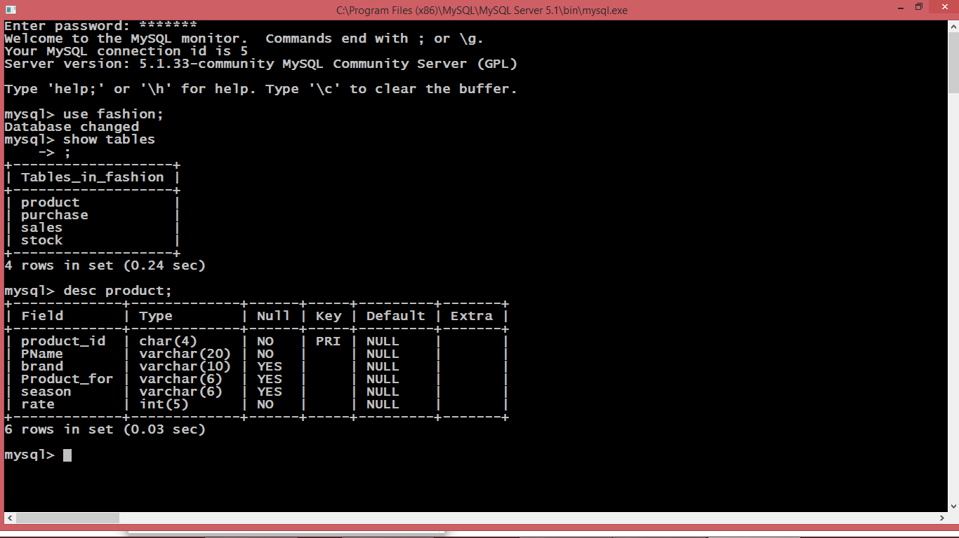

1. Purchase Table:

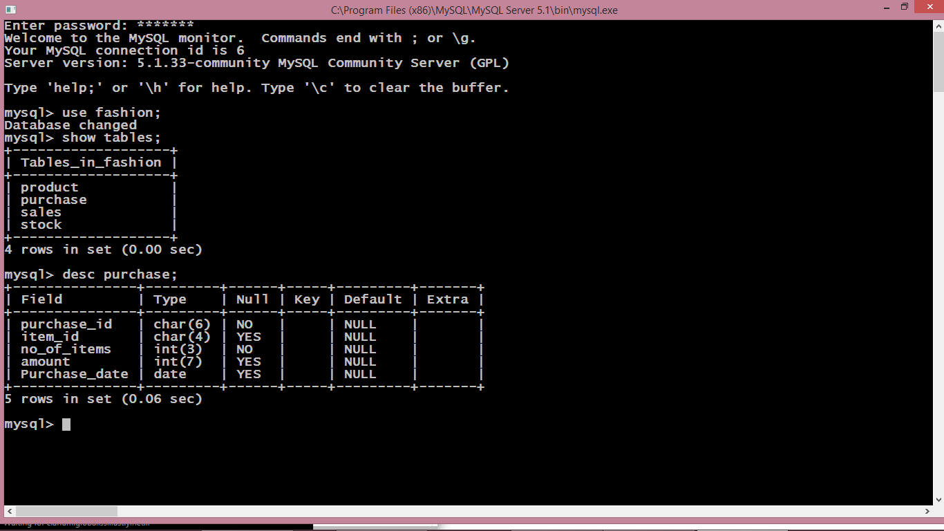

1. Stock Table:

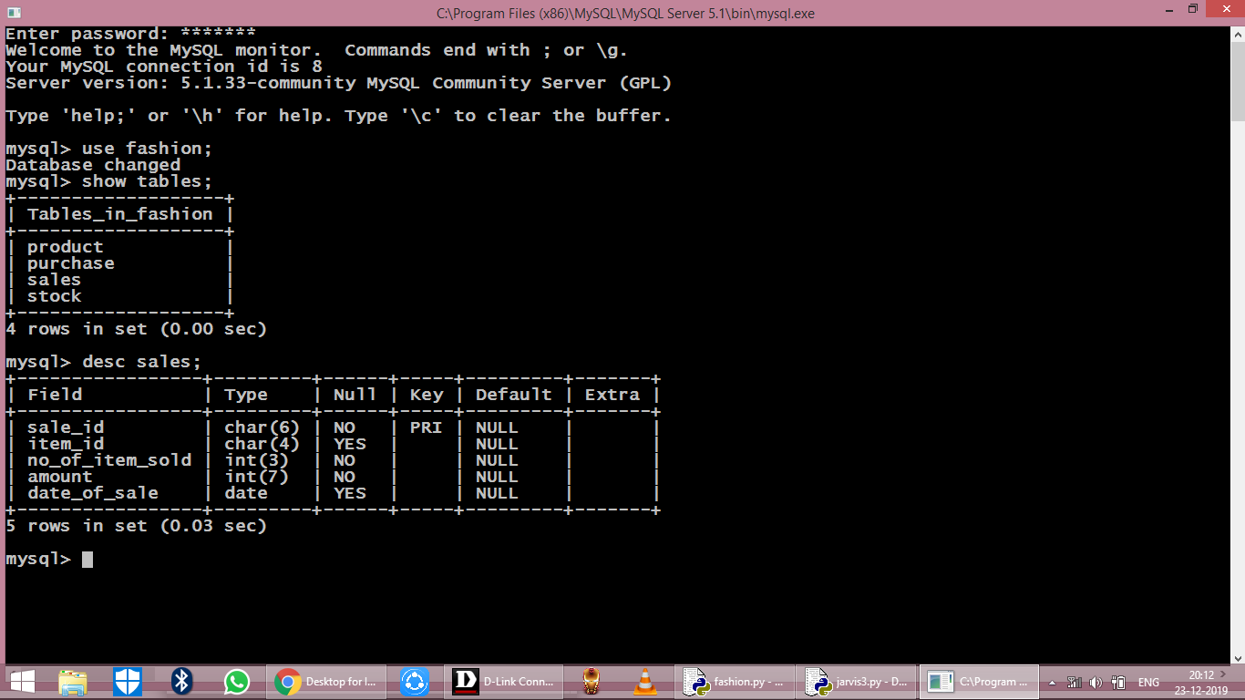

1. Sales Table:

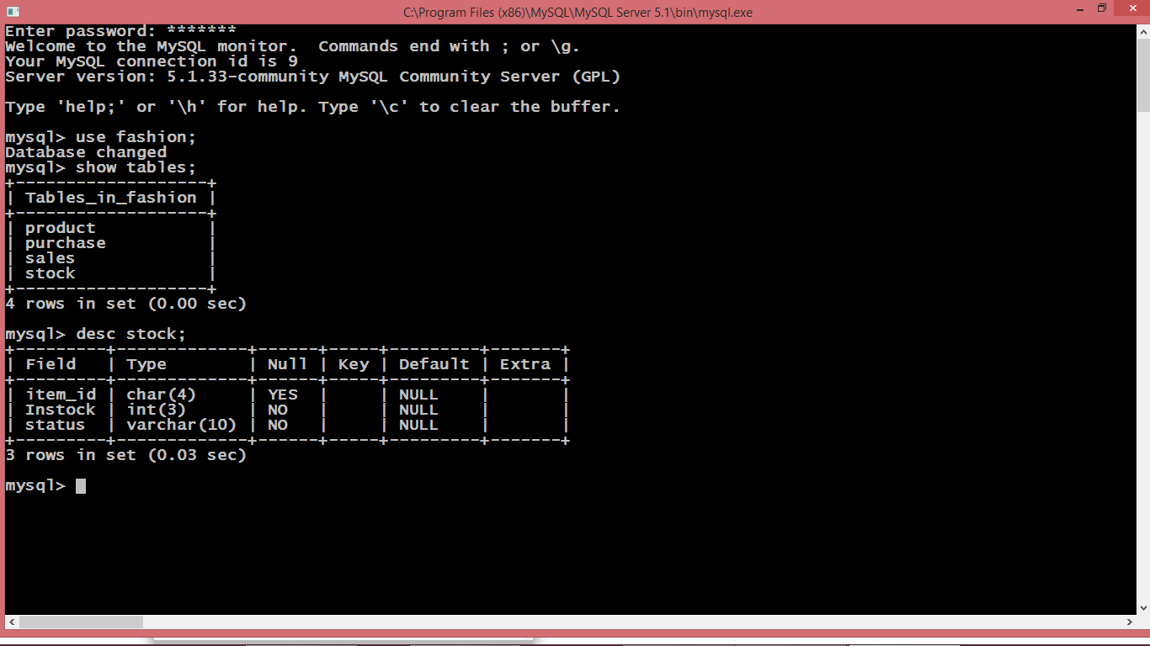

**Python Code:**

import os

import platform

import mysql.connector

#import pandas as pd

import datetime

mydb=mysql.connector.connect(host="localhost",user="root",passwd="2251824",database="fashion",charset="utf8")

mycursor=mydb.cursor()

sql=""

def AddProduct():

L=[]

stk=[]

pid=input("Enter the Product ID : ")

L.append(pid)

IName=input("Enter the Product Name : ")

L.append(IName)

brnd=input("Enter the Product Brand Name : ")

L.append(brnd)

fr=input("Enter Male/Female/Kids : ")

L.append(fr)

sn=input("Enter Winter/Summer : ")

L.append(sn)

rate=input("Enter the Rates for Product :")

L.append(rate)

product=(L)

print(L)

sql="Insert into product values('"+pid+"','"+IName+"','"+brnd+"','"+fr+"','"+sn+"','"+rate+"'); "

print(sql)

mycursor.execute(sql)

mydb.commit()

stk.append(pid)

stk.append(0)

stk.append("No")

st=(stk)

sql="insert into stock(item_id, Instock, status) values(%s,%s,%s)"

mycursor.execute(sql,st)

mydb.commit()

print("One Product inserted ")

def EditProduct():

pid=input("Enter product ID to be edited : ")

sql="select * from product where product_id=%s"

ed=(pid,)

mycursor.execute(sql,ed)

res=mycursor.fetchall()

for x in res:

print(x)

print("")

fld=input("Enter the field which you want to edit : ")

val=input("Enter the value you want to set : ")

sql="Update product set " + fld +"='" + val + "' where product_id='" + pid + "'"

sq=sql

mycursor.execute(sql)

print("Editing Don : ")

print("After correction the record is : ")

sql="select * from product where product_id=%s"

ed=(pid,)

mycursor.execute(sql,ed)

res=mycursor.fetchall()

for x in res:

print(x)

mydb.commit()

def DelProduct():

pid=input("Enter the Product)id to be deleted : ")

sql="delete from sales where item_id=%s"

id=(pid,)

mycursor.execute(sql,id)

mydb.commit()

sql="delete from purchase where item_id=%s"

mycursor.execute(sql,id)

mydb.commit()

sql="delete from stock where item_id=%s"

mycursor.execute(sql,id)

mydb.commit()

sql="delete from product where product_id=%s"

mycursor.execute(sql,id)

mydb.commit()

print("One Item Deleted")

def ViewProduct():

print("Display Menu: Select the category to display the data")

print("1. All Details")

print("2. Product Name:")

print("3. Product Brand:")

print("4. Product For:")

print("5. Product Season:")

print("6. Product ID:")

x=0

ch=int(input("Enter your choice to display : "))

if ch==1:

sql="select * from product"

mycursor.execute(sql)

res=mycursor.fetchall()

for x in res:

print(x)

x=1

elif ch==2:

var='PName'

val=input("Enter the name of Product : ")

elif ch==3:

var='brand'

val=input("Enter the name of Brand : ")

elif ch==4:

var='Product_for'

val=input("Enter Male/Femal/Kids : ")

elif ch==5:

var='season'

val=input("Enter the Season : ")

elif ch==6:

var='product_id'

val=input("Enter the Product_id : ")

if x==0:

sql="select * from product where " + var + " = %s"

sq=sql

tp=(val,)

mycursor.execute(sq,tp)

res=mycursor.fetchall()

for x in res:

print(x)

def PurchaseProduct():

mn=""

dy=""

now=datetime.datetime.now()

purchaseID="P"+str(now.year)+str(now.month)+str(now.day)+str(now.hour)+str(now.minute)+str(now.second)

L=[]

Lst=[]

L.append(purchaseID)

itemId=input("Enter Product ID : ")

L.append(itemId)

itemNo=int(input("Enter the number of Items : "))

L.append(itemNo)

sql="select rate from product where product_id=%s"

pid=(itemId,)

mycursor.execute(sql,pid)

res=mycursor.fetchone()

for x in res:

print("rate is : ", x)

amount=x*itemNo

print("Amount is :", amount)

L.append(amount)

mnth=now.month

if mnth<=9:

mn="0"+str(mnth)

else:

mn=str(mnth)

day=now.day

if day<=9:

dy="0"+str(day)

else:

dy=str(day)

dt=str(now.year)+"-"+mn+"-"+dy

L.append(dt)

tp=(L)

sql="insert into purchase(purchase_id,item_id,no_of_items,amount,Purchase_date)values(%s,%s,%s,%s,%s)"

mycursor.execute(sql,tp)

mydb.commit()

sql="Select Instock from stock where item_id=%s"

mycursor.execute(sql,pid)

res=mycursor.fetchall()

status="No"

for x in res:

print(x)

instock=x[0]+itemNo

if instock>0:

status="Yes"

Lst.append(instock)

Lst.append(status)

Lst.append(itemId)

tp=(Lst)

sql="update stock set instock=%s,status=%s where item_id=%s"

mycursor.execute(sql,tp)

mydb.commit()

print("1 Item purchased and saved in Database")

def ViewPurchase():

item=input("Enter Product Name : ")

sql="select product.product_id","product.PName,product.brand,purchase.no_of_items,purchase.purchase_date,purchase.amount from productINNER JOIN purchase ON product.product_id=purchase.item_id and product.PName=%s"

itm=(item,)

mycursor.execute(sql,itm)

res=mycursor.fetchall()

for x in res:

print(x)

def ViewStock():

item=input("Enter Product Name : ")

sql="select product.product_id,product.PName,stock.Instock,\

stock.status from stock, product where \

product.product_id=stock.item_id and product.PName=%s"

itm=(item,)

mycursor.execute(sql,itm)

res=mycursor.fetchall()

for x in res:

print(x)

def SaleProduct():

now=datetime.datetime.now()

saleID="S"+str(now.year)+str(now.month)+str(now.day)+str(now.hour)+str(now.minute)+str(now.second)

L=[]

L.append(saleID)

itemId=input("Enter Product ID : ")

L.append(itemId)

itemNo=int(input("Enter the number of Items : "))

L.append(itemNo)

sql="select rate from product where product_id=%s"

pid=(itemId,)

mycursor.execute(sql,pid)

res=mycursor.fetchall()

for x in res:

print("The rate of item is :",x)

dis=int(input("Enter the discount : "))

saleRate=x[0]-(x[0]*dis/100)

L.append(saleRate)

amount=itemNo*saleRate

L.append(amount)

mnth=now.month

if mnth<=9:

mn="0"+str(mnth)

else:

mn=str(mnth)

day=now.day

if day<=9:

dy="0"+str(day)

else:

dy=str(day)

dt=str(now.year)+"-"+mn+"-"+dy

L.append(dt)

tp=(L)

sql="insert into sales (sale_id, item_id,no_of_item_sold,\

sale_rate,amount,date_of_sale) values(%s,%s,%s,%s,%s,%s)"

mycursor.execute(sql,tp)

mydb.commit()

sql="Select Instock from stock where item_id=%s"

mycursor.execute(sql,pid)

res=mycursor.fetchall()

for x in res:

print("Total Items in Stock are : ",x)

instock=x[0]-itemNo

if instock>0:

status="Yes"

tp=(instock,status,itemId)

sql="update stock set instock=%s,status=%s where item_id=%s"

print("Remaining Items in Stock are : ",instock)

mycursor.execute(sql,tp)

mydb.commit()

def ViewSales():

item=input("Enter Product Name : ")

sql="select product.product_id, product.PName,product.brand,\

sales.no_of_item_sold,sales.date_of_sale,sales.amount \

from sales, product where product.product_id=sales.item_id \

and product.PName=%s"

itm=(item,)

mycursor.execute(sql,itm)

res=mycursor.fetchall()

for x in res:

print(x)

def MenuSet(): #Function For The SFashion Store System

print("Enter 1 : To Add Product ")

print("Enter 2 : To Edit Product ")

print("Enter 3 : To Delete Product ")

print("Enter 4 : To View Product ")

print("Enter 5 : To Purchase Product")

print("Enter 6 : To View Purchases")

print("Enter 7 : To View Stock Detials")

print("Enter 8 : To Sale the item")

print("Enter 9 : To View Sales Detials")

try: #Using Exceptions For Validation

userInput = int(input("Please Select An Above Option: ")) #Will Take Input From User

print("\n") #Print New Line

if(userInput == 1):

AddProduct()

elif(userInput == 2):

EditProduct()

elif (userInput==3):

DelProduct()

elif (userInput==4):

ViewProduct()

elif (userInput==5):

PurchaseProduct()

elif (userInput==6):

ViewPurchase()

elif (userInput==7):

ViewStock()

elif (userInput==8):

SaleProduct()

elif (userInput==9):

ViewSales()

else:

print("Enter correct choice. . . ")

except ValueError:

exit("\nHy! That's Not A Number") #Error Message

else:

print("thanks")

print("*"*80)

print("* * * * * * * Welcome to the Project of Fashion Store * * * * * * * ")

print("* * * Under The Guidance , Support And supervision Of Mr. Sunil Kumar * * * ")

print("*"*80)

print("")

MenuSet()

def runAgain():

runAgn = input("\nwant To Run Again Y/n: ")

while(runAgn.lower() == 'y'):

if(platform.system() == "Windows"):

print(os.system('cls'))

else:

print(os.system('clear'))

MenuSet()

runAgn = input("\nwant To Run Again Y/n: ")

runAgain()

**OUTPUT:**

1. (Main Menu):

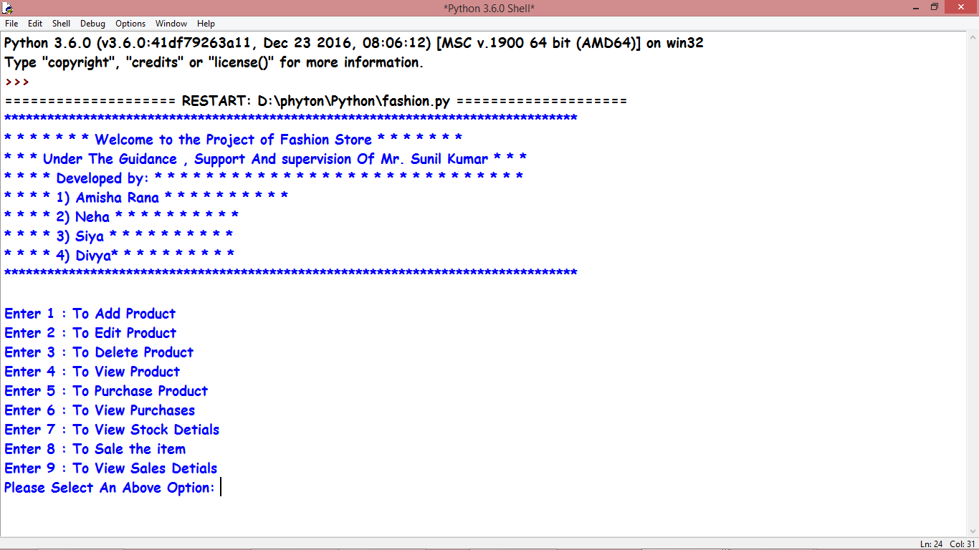

1. (Add Product):

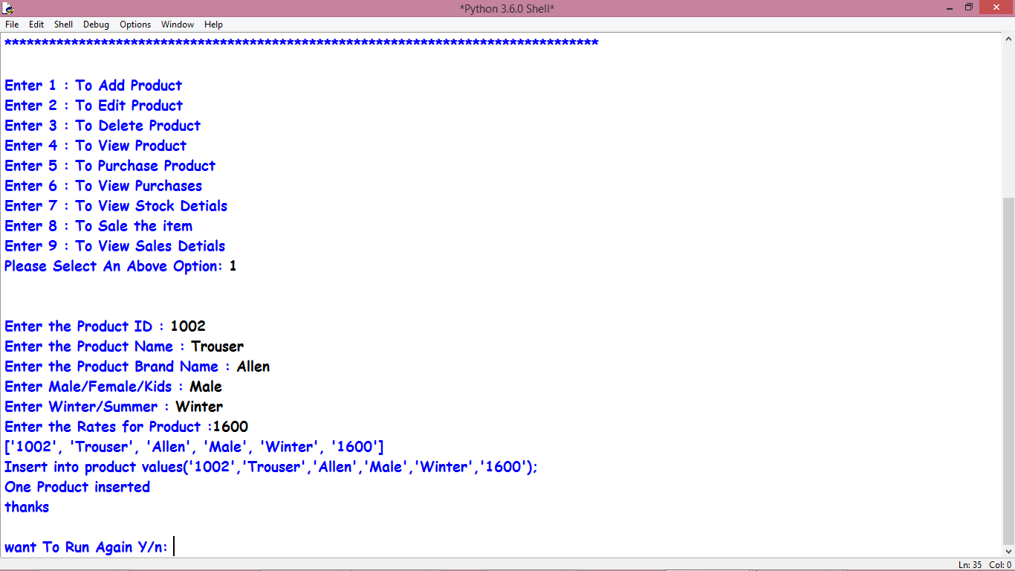

1. (Edit Product):

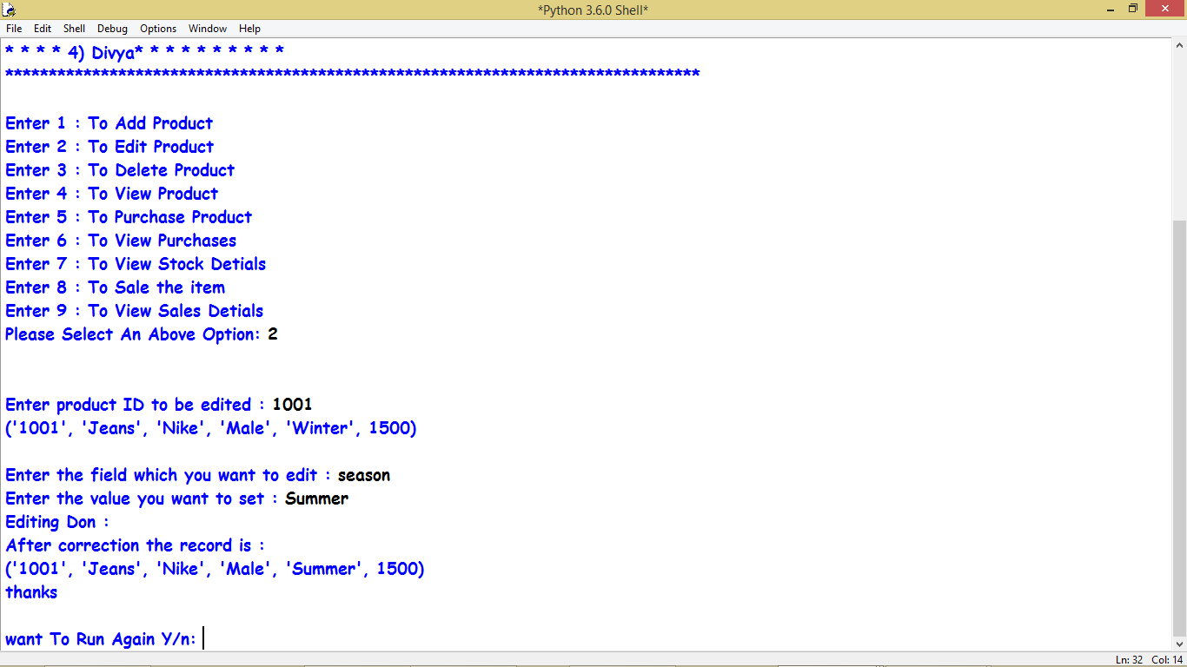

1. (Delete Product):

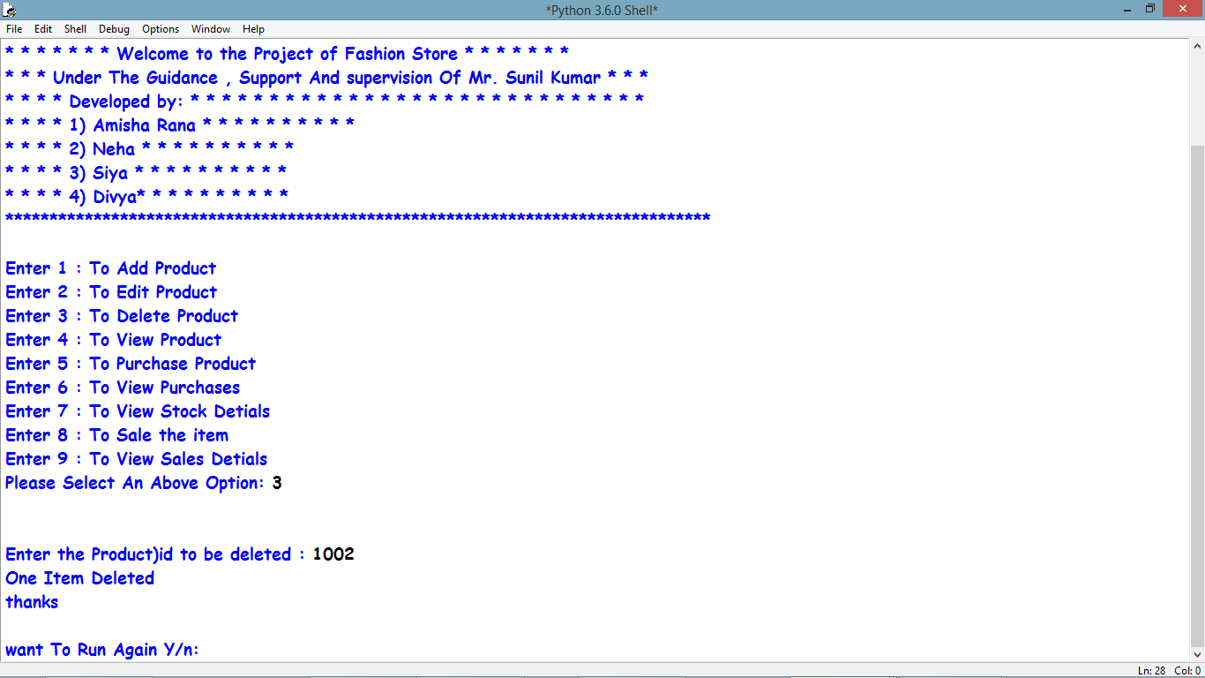

1. (View Product):

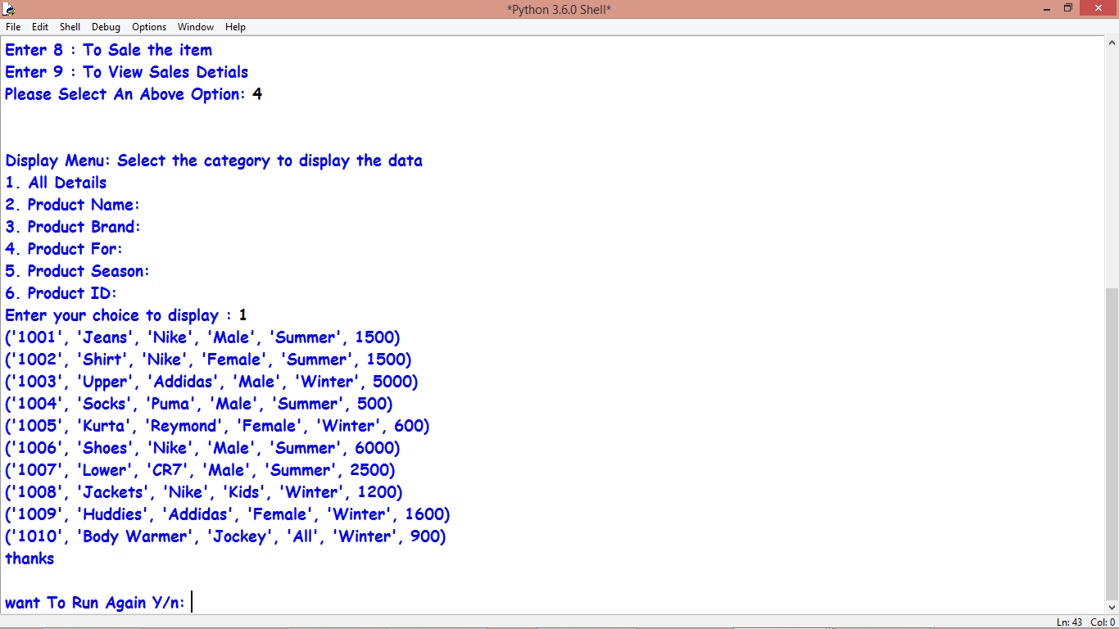

1. (Purchase Product):

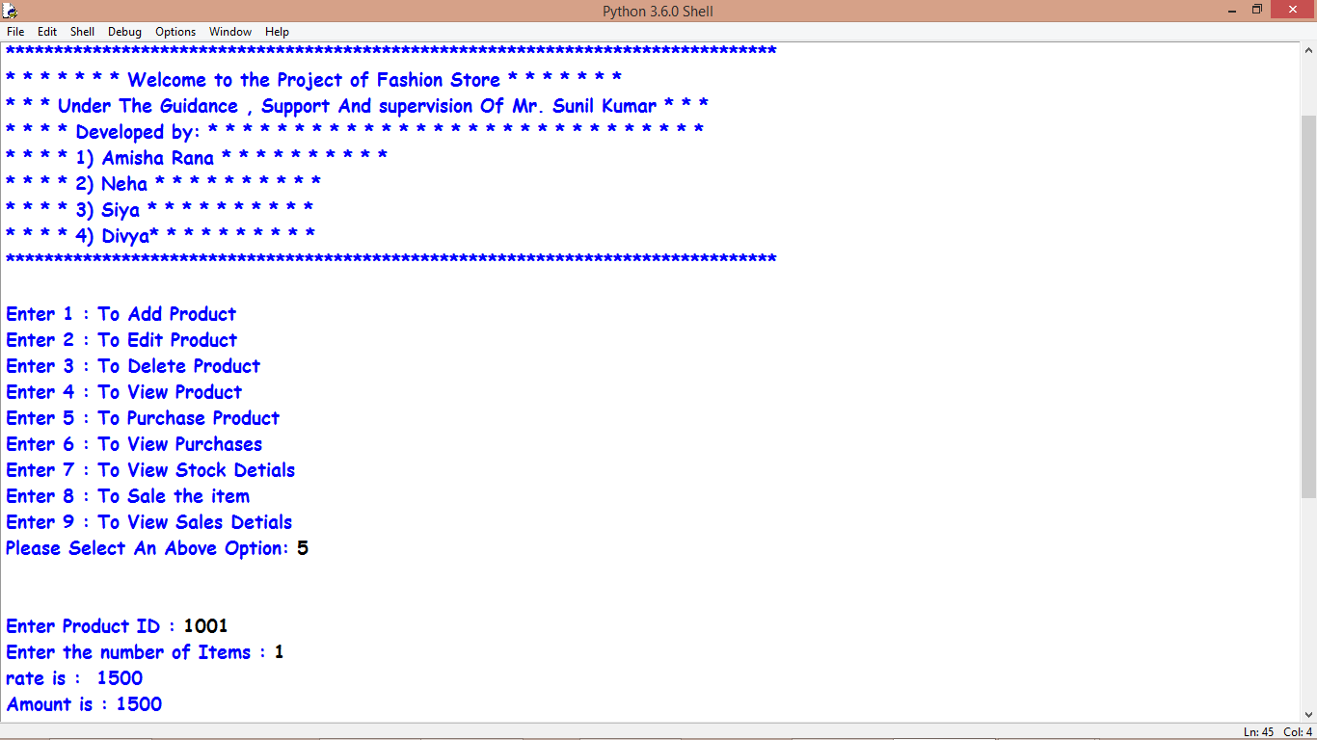

1. (View Purchase):



1. (View Stock Details):

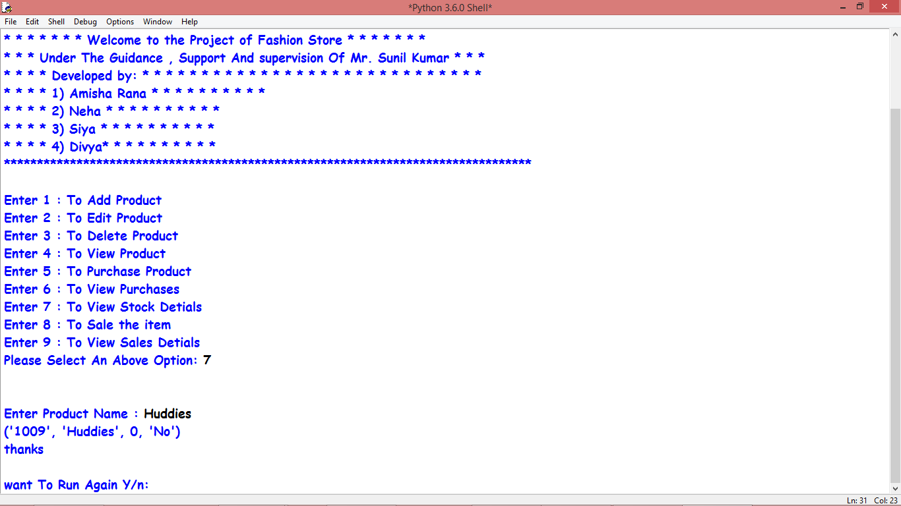

1. (Sale Item):

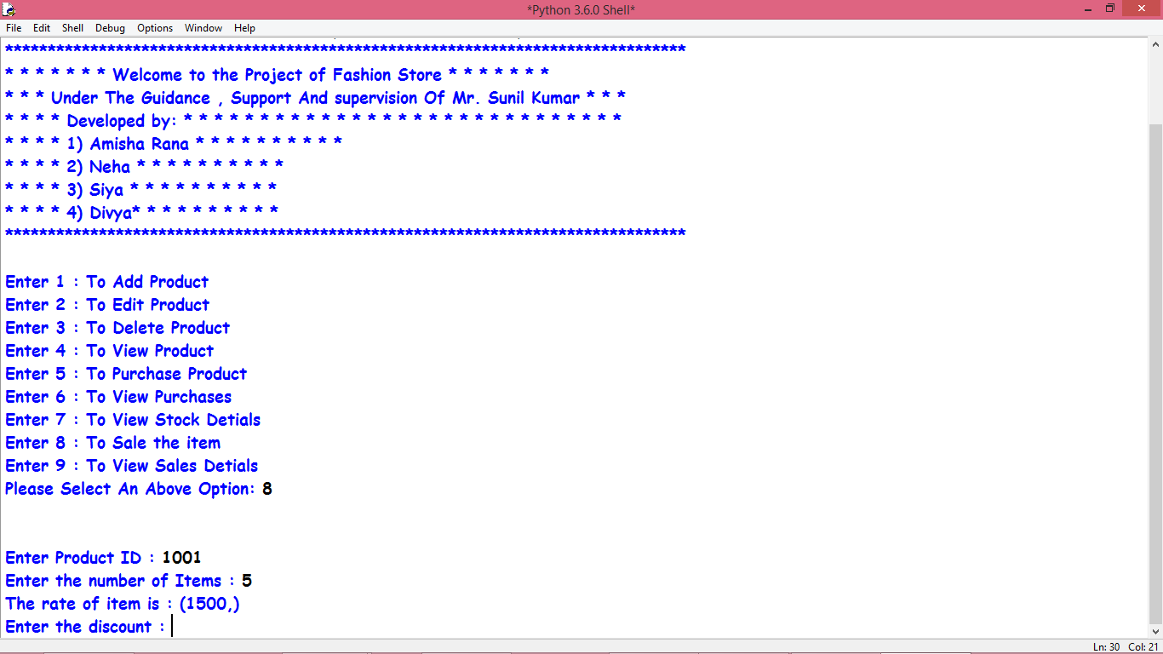

1. (View Sales Details):

