1. Normalisasi

|  |  |  |  |  |  |  |  |
| --- | --- | --- | --- | --- | --- | --- | --- |
| Tanggal | No_Transaksi | Operator | Kode_Barang | Nama_Barang | Qty | Harga_Barang | Total |
| 14-05-2012 | 20120514001 | Admin | 0000009 | Natur-E | 4 | 5000 | 20000 |

1NF

2NF

Tabel Barang

|  |  |  |
| --- | --- | --- |
| Kode_Barang | Nama_Barang | Harga |
| 0000009 | Natur-E | 5000 |

Tabel Transaksi

|  |  |  |  |  |
| --- | --- | --- | --- | --- |
| Kode_Transaksi | Tanggal | Kode_Barang | Qty | Total |
| 201205014001 | 14-05-2012 | 0000009 | 4 | 20000 |

3NF

Tabel Barang

|  |  |  |
| --- | --- | --- |
| Nama_Barang | Kode_Barang | Harga |
| Natur-E | 0000009 | 5000 |

Tabel Transaksi

|  |  |  |
| --- | --- | --- |
| Tanggal | Qty | Total |
| 14-05-2012 | 4 | 20000 |

Tabel Detail Transaksi

|  |  |  |
| --- | --- | --- |
| Kode_Transaksi | Kode_Barang | Total |
| 201205014001 | 0000009 | 20000 |

: Primary Key

2. Laporan Final

Pembuatan Database

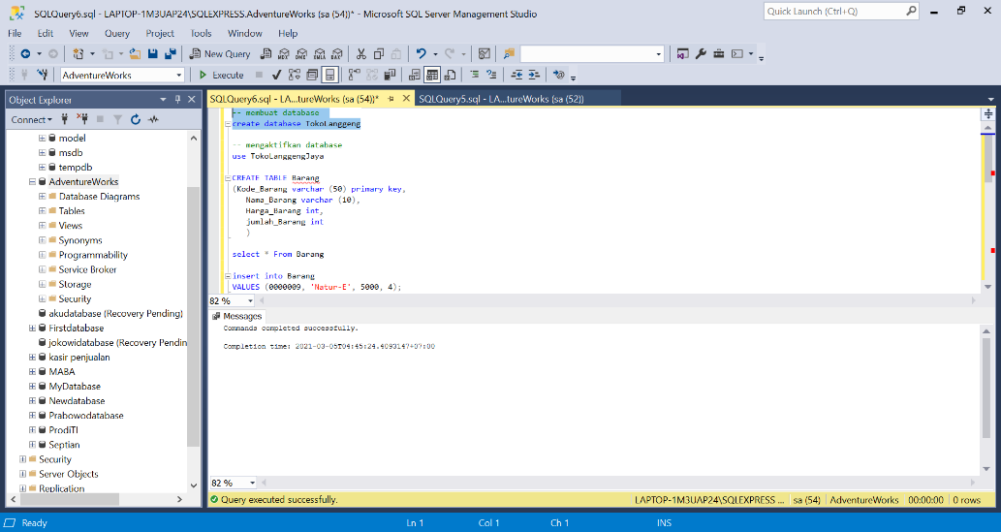

Menggunakan database yang telah di buat

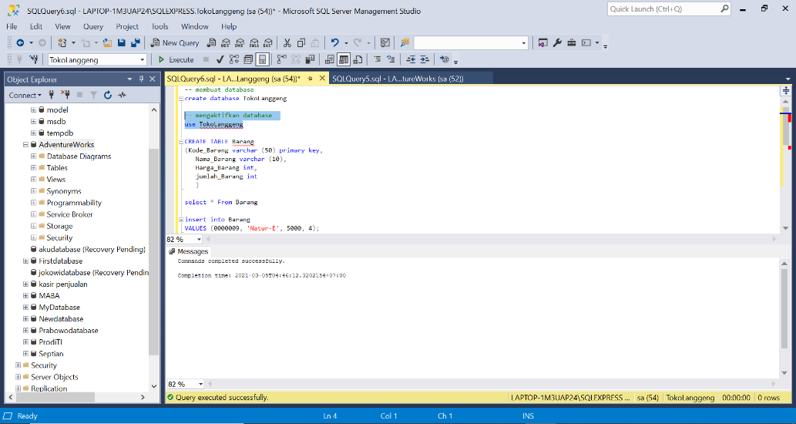

Pembuatan Table Barang

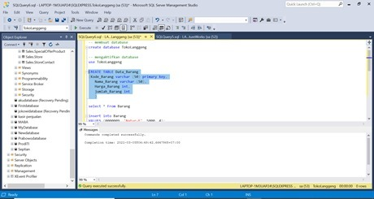

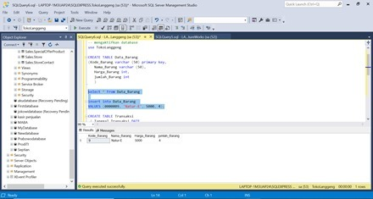

Pembuatan Tabel Pembayaran

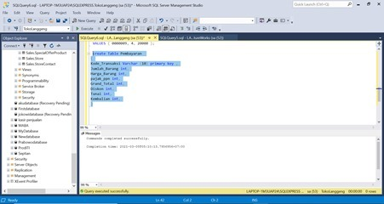

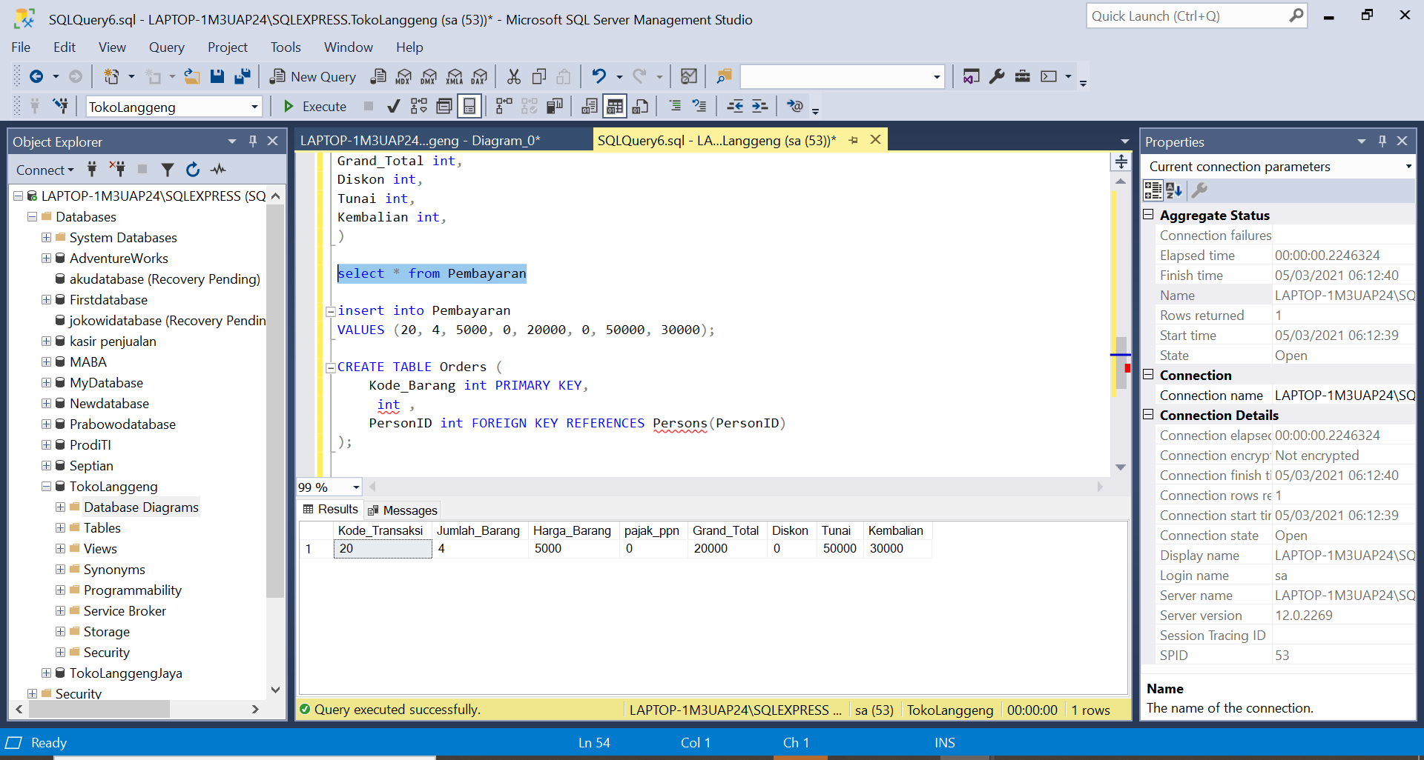

Pembuatan Table Admin

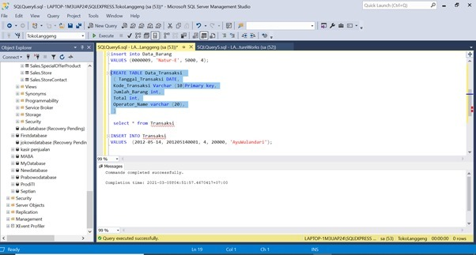

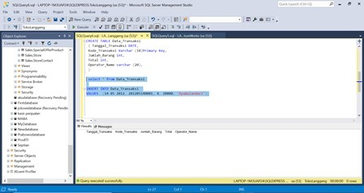

Membuat Tabel Pembelian

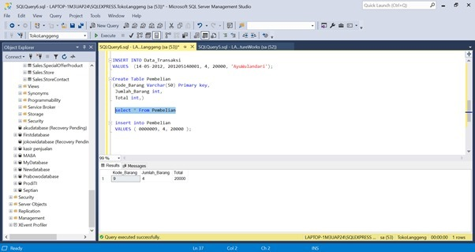

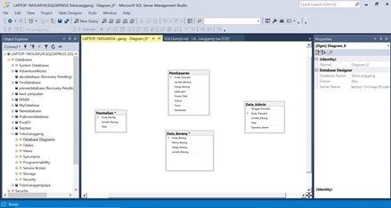Tabel Tabel

Query – Query :

-- membuat database

create database TokoLanggeng

-- mengaktifkan database

use TokoLanggeng

--membuat Tabel

CREATE TABLE Data_Barang

(Kode_Barang varchar (50) primary key,

Nama_Barang varchar (50),

Harga_Barang int,

jumlah_Barang int

)

select * From Data_Barang

insert into Data_Barang

VALUES (0000009, 'Natur-E', 5000, 4);

CREATE TABLE Data_Transaksi

( Tanggal_Transaksi DATE,

Kode_Transaksi Varchar (10)Primary key,

Jumlah_Barang int,

Total int,

Operator_Name varchar (20),

)

select * from Data_Transaksi

INSERT INTO Data_Transaksi

VALUES (14-05-2012, 20, 4, 20000, 'AyuWulandari');

Create Table Pembelian

(Kode_Barang Varchar(50) Primary key,

Jumlah_Barang int,

Total int,)

select * From Pembelian

insert into Pembelian

VALUES ( 0000009, 4, 20000 );

create Table Pembayaran

(

Kode_Transaksi Varchar (10) primary key ,

Jumlah_Barang int,

Harga_Barang int,

pajak_ppn int,

Grand_Total int,

Diskon int,

Tunai int,

Kembalian int,

)

select * from Pembayaran

insert into Pembayaran

VALUES (20, 4, 5000, 0, 20000, 0, 50000, 30000);