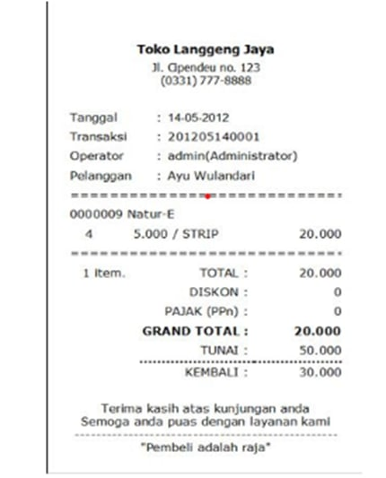

|  |  |  |  |  |  |  |  |
| --- | --- | --- | --- | --- | --- | --- | --- |
| Tanggal | No_Transaksi | Operator | Kode_Barang | Nama_Barang | Qty | Harga_Barang | Total |
| 14-05-2012 | 20120514001 | Admin | 0000009 | Natur-E | 4 | 5000 | 20000 |

1NF

2NF

Tabel Barang

|  |  |  |
| --- | --- | --- |
| Kode_Barang | Nama_Barang | Harga |
| 0000009 | Natur-E | 5000 |

Tabel Transaksi

|  |  |  |  |  |
| --- | --- | --- | --- | --- |
| Kode_Transaksi | Tanggal | Kode_Barang | Qty | Total |
| 201205014001 | 14-05-2012 | 0000009 | 4 | 20000 |

3NF

Tabel Barang

|  |  |  |
| --- | --- | --- |
| Nama_Barang | Kode_Barang | Harga |
| Natur-E | 0000009 | 5000 |

Tabel Transaksi

|  |  |  |
| --- | --- | --- |
| Tanggal | Qty | Total |
| 14-05-2012 | 4 | 20000 |

Tabel Detail Transaksi

|  |  |  |
| --- | --- | --- |
| Kode_Transaksi | Kode_Barang | Total |
| 201205014001 | 0000009 | 20000 |

: Primary Key