Part A: Linux Utilities

Question 1: TCPDUM
Its a packet analyzer package. It is used to sniff data traffic on particular interface and particular port
Syntax is as bellow

shahid@ubuntu:~$ sudo tcpdump -w shahid.txt -i wlan0 dst www.jinnah.edu.pk and port 80

here we need superuser access.
Command to read data from file using tcpdum
sudo tcpdump -r shahid.txt
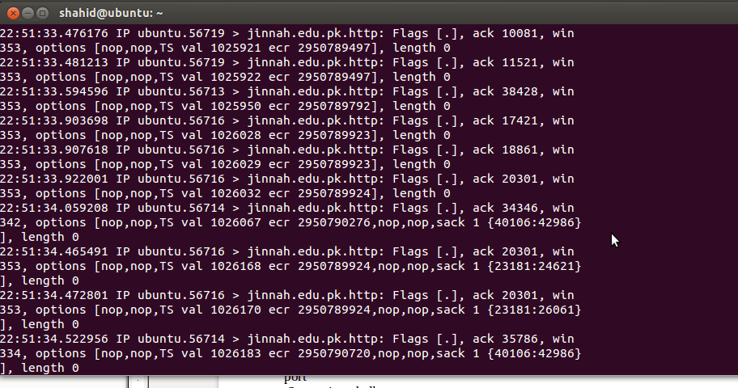

Question 2: What is the use of ifconfig command? Briefly describe the behavior of ifconfig

command with the following options on your computer interface:

ifconfig is used to configure the system's kernel-resident network interfaces. It is used at boot time to set up interfaces as necessary. After that, it is usually only needed when debugging or when system tuning is needed.
If no arguments are given, ifconfig displays the status of the currently active interfaces. If a single interface argument is given, it displays the status of the given interface only; if a single -a argument is given, it displays the status of all interfaces, even those that are down. Otherwise, it configures an interface.
What happens in normal mode, when a packet received by a network card, it verifies that the packet belongs to itself. If not, it drops the packet normally, but in the promiscuous mode is used to accept all the packets that flows through the network card.
ifconfig eth0 promisc
Result:
shahid@ubuntu:~$ ifconfig wlan0 promisc

SIOCSIFFLAGS: Operation not permitted

ARP
arp manipulates or displays the kernel's IPv4 network neighbour cache. It can add entries to the table, delete one, or display the current content.
ARP stands for Address Resolution Protocol, which is used to find the address of a network neighbor for a given IPv4 address.

