H.264 Decoder Optimization



by

Muhammad Shahid CE131001
Usman Zafar MT133001

A Project Report submitted to the
DEPARTMENT OF ELECTRONIC ENGINEERING
in partial fulfillment of the requirements for the degree of
Master OF SCIENCE IN ELECTRONIC ENGINEERING

Faculty of Engineering
Mohammad Ali Jinnah University
Islamabad
January 2014

DECLARATION
It is declared that this is an original piece of our own work, except where otherwise acknowledged in text and references. This work has not been submitted in any form for another degree or diploma at any university or other institution for tertiary education and shall not be submitted by me in future for obtaining any degree from this or any other University or Institution.

Muhammad Shahid CE131001
Usman Zafer MT133001

January 2014

1. H.264 Decoder Optimization 3
  - Introduction 3
1.2 H.264 Decoding Process…………………..……………………………….3
1.2.1 Inverse Prediction ……………………………………….………………..3
1.2.2 Inverse Transform and Quantization………………………………………….3
1.2.3 De-blocking Filter…………………………………………………………….4

2.1 TI's DSP C64x+ C Optimizations………………………………………………4

2.1.1 Optimization Methodology…………………………………………………...4

2.1.2 Optimization Techniques in C Language……………………………………..5

2.1.3 Optimization Inverse Discrete Cosine Transform…………………………….6

2.1.4 Loop Filter…………………………………………………………………….7

2.1.5 Motion Compensation…………………………………………………………8

1.1 Introduction
H.264/AVC is an advanced digital video codec standard that can deliver high resolution video even at low bit rates. To provide high throughput and high compression ratio context-based, an adaptive variable length decoding (CAVLD) is adopted as an entropy decoding method in H.264/AVC video compression standard for baseline profile. Variable length coding (VLC) is a widely technique used in many image and video compression applications. The main idea of VLC is to reduce data redundancy and to minimize the average code word length by exploiting data statistics. Shorter code words are assigned to frequently occurred data while longer code words are assigned to less occurred symbols. In the CAVLD decoder, look-up tables are used to decode syntax element. Typically decoding process, based on look-up table, requires multiple memory accesses until the desired code word is found. It is well known that memory access induces a higher power consumption in hardware platform, and reduces the speed in software platform. In addition, CAVLD process uses variable-length technique. Consequently there is no boundary information for detecting the end or the beginning of the code word. This characteristic substantially complicates the decoder design and decreases its performance. Thus efficient CAVLD algorithm and implementation optimizations are necessary to improve decoder speed.
1.2 H.264 Decoding Process
The H.264/AVC decoder receives a compressed bit stream as input for the entropy decoding module that includes CAVLD. The prime focus in this work is CAVLD, which is highlighted in Figure 1. Outputs data of CAVLD are then reordered and will be inverse quantized and inverse transformed. Resulting block is added to the previously predicted one in order to reconstruct frame blocks after a de-blocking filter process. Two kinds of prediction can be used in H.264: intra prediction and inter prediction.
1.2.1 Inverse Prediction
Using header information decoded from the bit stream for each macro block, the decoder creates a predicted block that is identical to the original resulted by the encoder prediction. According to the predictor parameter, Intra or Inter mode prediction may be selected. Inter coding uses motion vectors to exploit temporal statistical dependencies between different pictures. Intra coding uses various prediction modes to exploit spatial statistical dependencies in the same picture. Motion vectors and intra prediction modes may be specified for a variety of block sizes in the picture. The predicted block is added to the residual block generated by inverse transform and inverse quantization to reconstruct a version of the original block.
1.2.2 Inverse Transform and Quantization
The result block of CAVLD is inverse quantized through a quantization parameter (Qp) deducted from bit stream. H.264 defines 52 quantization parameters in order to manage the trade of between video quality and bitrate. Then, an inverse Integer Cosines Transform (ICT) is applied to remove spatial correlation inside a block of samples. The purpose of the transform stage is to convert residual data into frequency domain. The inverse transform reconstructs the block into temporal domain. The ICT is an evolution of the Discrete Cosines Transform (DCT). Like ICT, inverse ICT is also a 2D integer matrix multiplication.
It is applied on each 4x4 block output of the inverse quantization. A non-integer matrix multiplication part of transform is interned in the inverse quantization step to keep an integer transform.H.264/AVC defines also a supplementary Hadamard transform for DC coefficients in 16x16 intra mode prediction case.
1.2.3 De-blocking Filter
The de-blocking filter is applied to each decoded macro block to reduce blocking distortion. It is applied after the inverse transform and the inverse quantization. It is the last step to reconstruct and display the macro block. In order to improve the appearance of decoded video frames, the de-blocking filter smoothest edges of blocks that transform and quantization process can cause. Filter is applied to vertical and horizontal edges of 4x4 blocks in a macro block.
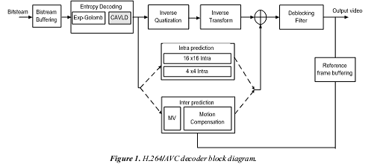

2.1 TI's DSP C64x+ C Optimizations
Compilers are very user friendly. They allow Programmers to program in abstract languages without caring for processor Architecture. Complier generated Assembly works quite well for GPPs but this does not generate efficient Assembly for VLIW Architectures. In order to maximize the decoded number of FPS for implemented H.264 on this platform, the most crucial and time critical blocks of decoder have to be implemented and optimized using Hand Coded Assembly language. We can fully exploit parallelism in VLIW Architectures through Hand Coded Assembly programming. This helps in speed up of real time applications by 2 to 3 times. Hand coding entire application in Assembly is time consuming and never recommended. Only critical and time consuming blocks in application should be hand coded in Assembly. So we have optimized c code.
Following blocks in H.264 decoder were Optimized in C.

- Intra prediction
- Motion Compensation
- Inverse Discrete Cosine Transform (IDCT)
- Loop Filter

2.1.1 Optimization Methodology
Following is the step by step approach for optimization. If the performance and results of code are satisfactory after any of these particular steps, the objective has been achieved and there is no need to continue with the next optimization steps.
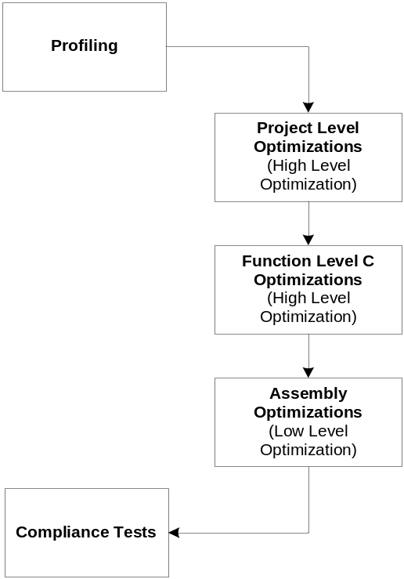
Figure 2. Stages in Application Assembly Optimizations

- Profiling is the first step in application optimization which identifies hot-spots in application.
- Functions should be first optimized in high level languages such as C-Language.
- Optimize code in low level assembly language.

2.1.2 Optimization Techniques in C Language

Following are the techniques that we have applied in C optimization.

Loop Unrolling

Declaring Register Pointer and variable

Loop Merging

Removing unnecessary function arguments

2.1.3 Optimization Inverse Discrete Cosine Transform
All the residual blocks of luma and chroma are transformed using 4x4 residual transform. This transform is based on DCT but it is integer based DCT transform. This transform is an approximation of DCT. For the case of 16x16 intra prediction, whole macroblock is predicted from neighboring pixels. First, 4x4 transformation is applied to the residual block. Next, Hadamard transform is applied on the DC coefficients of the recently transformed 4x4 blocks. Each chroma component residual block is transformed using 4x4 residual transform. After this, DC coefficients of each 4x4 transformed block are further transformed using 2x2 DC transform.
Table 1. C Optimization of IDCT Function
function name | C cycles beFORE OPt | Optimized C cycles
asm_add4x4_idct | 1842 | 1347

2.1.4 Loop Filter
One particular characteristic of block-based coding is visible block structures. Block edges are typically reconstructed with less accuracy than interior pixels and “blocking” is generally considered to be one of the most visible artefacts with the present compression methods. For this reason H.264/AVC defines an adaptive in-loop deblocking filter, where the strength of filtering is controlled by the values of several syntax elements. The blockiness is reduced without much affecting the sharpness of the content. Consequently, the subjective quality is significantly improved.
Table 2. C Optimization of Deblocking Filter Functions
function name | C cycles | Optimizd cycles
deblock_luma_c | 3580 | 3570
deblock_edge | 3350 | 3200

2.1.5 Motion Compensation
In addition to the Intra macroblock coding types, various predictive or motion-compensated coding types are specified for P-slice macroblocks. Each P-type macroblock corresponds to a specific partitioning of the macroblock into fixed-size blocks used for motion description. Partitions with luma block sizes of 16×16, 16×8, 8×16 and 8×8 samples are supported by the syntax corresponding to the Inter-16×16, Inter-16×8, Inter-8×16 and Inter-8×8 P macroblock types, respectively. In cases where the Inter-8×8 macroblock mode is chosen, one additional syntax element for each 8×8 sub-macroblock is transmitted. This syntax element specifies if the corresponding sub-macroblock is The prediction signal for each predictive-coded m×n luma block is obtained by displacing an area of the corresponding reference picture, which is specified by a translational motion vector and a picture reference index. Thus, if the macroblock is coded using the Inter-8x8 macroblock type, and each sub-macroblock is coded using the Inter-4x4 sub-macroblock type, a maximum of sixteen motion vectors may be transmitted for a single P-slice macroblock. The accuracy of motion compensation is a quarter of a sample distance.
Table 1. Assembly Optimization of MC Functions
function name | C cycles | optimized cycles
pixel_avg_h264_h_O | 8994 | 1402
pixel_avg_h264_h_hv | 27010 | 2182
pixel_avg_h264_h_v | 9968 | 4853
pixel_avg_h264_hv_v | 27890 | 4930

