The Islamia University of Bahawalpur
Department of Information Technology



SOFTWARE REQUIREMENTS SPECIFICATION
(SRS DOCUMENT)

Software Requirements Specification (SRS)
Stationery E-Commerce Website Online Buy & Sell Platform for Students and Teachers
Submitted by
Muhammad Sufyan
Roll No:
F22BINFT1E02140
Submitted to Dr. Rizwan Ali Shah
Department of Information Technology
The Islamia University of Bahawalpur

Summary
This SRS describes a dedicated online marketplace exclusively for students and teachers to buy and sell new/used stationery items (notebooks, pens, markers, geometry boxes, registers, art supplies, calculators, etc.). The platform promotes reuse, reduces waste, and helps students earn/saves money. It includes full e-commerce features: product listing, search, cart, Cash on Delivery, user profiles (buyer + seller mode), ratings, chat, wishlist, and admin panel.

Table of Contents
- Introduction 1.1 Purpose 1.2 Scope 1.3 Product Perspective 1.User Characteristics 1.5 Similar Systems & Literature Review 1.6 Proposed Technologies
- Overall Description 2.1 Functional Requirements (FR001 – FR020) 2.2 Non-Functional Requirements
- Use Cases & Process Flow 3.1 Use Case Diagram 3.2 Detailed Use Cases + Activity Diagrams
- System Architecture & Database Schema
- References

1. Introduction

1.1 Purpose
To develop a secure, fast, and user-friendly web platform where university/school students and teachers can:
- Sell their unused/new stationery
- Buy quality second-hand or new items at low prices
- Reduce stationery waste and promote circular economy within campus

1.2 Scope
In Scope
- User registration & login (Student / Teacher / Admin)
- Seller dashboard to upload products with images, price, condition (New/Used)
- Buyer features: search, filters, add to cart, wishlist, COD checkout
- Cash on Delivery only (no online payment)
- Product categories & sub-categories
- Rating & review system
- Simple messaging between buyer & seller
- Admin panel for approval and monitoring
Out of Scope
- Online payment gateway
- Delivery/Shipping integration
- Mobile app

1.3 Product Perspective
This is a niche campus-focused alternative to OLX/Daraz but only for stationery and only for educational community.

1.4 User Characteristics
User | Education | Technical Skill | Frequency
Student Buyer | Intermediate+ | Low–Medium | Daily
Student Seller | Intermediate+ | Medium | Weekly
Teacher | Graduate+ | Medium | Occasional
Admin | Graduate | High | Daily

1.5 Similar Systems
Platform | Pros | Cons
OLX | Huge reach | Full of fake users, no campus focus
Daraz | Trust & logistics | High prices, no used items
Facebook Marketplace | Free | No proper filters, scams common
Our System | Only students/teachers, verified university email, clean UI, fast | Limited only to stationery

1.6 Proposed Technologies
Layer | Technology
Frontend | React.js, Tailwind CSS, React Router
Backend | Node.js + Express.js
Database | MongoDB
Authentication | JWT + Google OAuth (university email only)
Image Upload | Cloudinary
Hosting | Vercel (frontend) + Render (backend)

2. Functional Requirements (Detailed)
ID | Title | Description | Actor
FR001 | User Registration & Login | Signup with university email (.edu.pk), role selection, profile completion | All Users
FR002 | Product Upload (Sell) | Add title, description, price, condition, category, 5+ images | Seller
FR003 | Product Approval by Admin | Admin approves/rejects products before going live | Admin
FR004 | Advanced Search & Filters | Search by keyword, category, price range, condition (new/used), campus/location | Buyer
FR005 | Product Detail Page | Show images, description, seller info, reviews, “Contact Seller” button | Buyer
FR006 | Add to Cart & Wishlist | Standard cart + wishlist functionality | Buyer
FR007 | Checkout (Cash on Delivery) | Buyer fills name, phone, campus delivery point, notes | Buyer
FR008 | Order Management | Seller sees incoming orders, mark as “Sold/Delivered” | Seller
FR009 | Rating & Review System | After delivery, buyer can rate seller (1–5 stars) + review | Buyer
FR010 | Seller Dashboard | Total earnings, active listings, sold items, ratings | Seller
FR011 | Buyer Order History | View past orders, status, reorder option | Buyer
FR012 | Simple Chat (Buyer↔Seller) | In-app messaging for negotiation & meetup coordination | Both
FR013 | Admin Dashboard | Approve products/users, view analytics, block users | Admin
FR014 | Campus/Location Filter | Filter products by university or city | Buyer
FR015 | Notifications | Email/SMS when product sold, new message, order confirmed | All
FR016 | Report User/Product | Flag inappropriate content | All

3. Use Cases & Diagrams

3.1 System Level Use Case Diagram (Text version – bana lena draw.io mein)

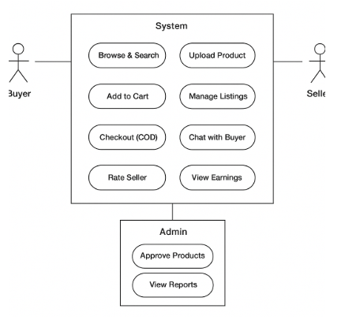

3.2 Activity Diagram – “Student Sells a Notebook”

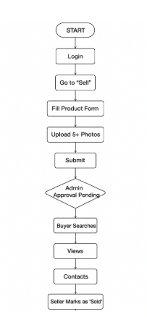

3.3 Sequence Diagram – Buyer Places Order

Buyer → Frontend → Backend → Database
| | | |
| Search →| | |
|<----- Products ----| |
| Add to Cart →| | |
| Checkout →| | |
| |→ Save Order (Pending) →|
| |← Order ID --------------|
|<--- Success + Order Confirmation ----|
| Email/SMS Notification --------------→ Seller

4. Database Schema (MongoDB Collections)
Users → { _id, name, email, phone, role("buyer"/"seller"/"admin"), university, avatar, rating }

Products → {
_id,
title,
description,
price,
category,
condition: "new"|"slightly used"|"good",
images: [url],
sellerId,
status: "pending"|"approved"|"sold",
campusLocation,
createdAt
}

Orders → {
_id,
buyerId,
sellerId,
productId,
quantity: 1,
totalPrice,
deliveryPoint,
status: "pending"|"confirmed"|"delivered",
orderedAt
}

Reviews → { _id, productId, sellerId, buyerId, rating, comment, images[] }

5. Non-Functional Requirements
- Page load time < 2 seconds
- Support 10,000+ products and 5,000 users
- 99% uptime
- Mobile responsive (80% users on mobile)
- Images optimized (WebP, lazy loading)
- University email verification only
- Daily backup

6. References
https://stationers.pk/

