
COMSATS University Islamabad
Abbottabad Campus
Department of Management Sciences

Project Title

Beyond the Numbers: Financial Performance Analysis of Non-Financial Sectors Listed on the Pakistan Stock Exchange (2005–2023)

Submitted by: Registration No:
Muhammad Sulaiman SP25-BDA-004
Haris Jamil SP25-BDA-009
Abuzar Paracha SP25-BDA-002

Submitted to: Dr. Jamil Anwar

Submission Date: July 12, 2026
Objectives:
- To analyze the financial performance of non-financial sectors listed on the Pakistan Stock Exchange (PSX) from 2005 to 2023.
- To prepare a clean, structured, and analysis-ready dataset through data cleaning and extraction.
- Extracting the required financial records using SQL for further statistical analysis and visualization.
- To perform statistical analysis using R to identify relationships among different financial ratios.
- Providing an overview of performance of all the sectors from 2005-23.
- Identifying the top-performing sector based on selected financial indicators and their key findings.
- To evaluate the financial performance of the leading company within the top-performing sector.
- To develop an interactive Tableau dashboard for visualizing financial trends, sector performance, and company-level insights.
- Providing an overview of how our project relates to Sustainable Development Goals (SDGs).

Abstract
This project analyzes the financial performance of non-financial sectors listed on the Pakistan Stock Exchange (PSX) over the period 2005 to 2023. The primary objective is to evaluate sector-level financial performance, identify the top-performing sector, and assess the performance of the leading company within that sector. The study aims to provide meaningful insights into financial trends using a data-driven analytical approach.
The methodology consisted of four major stages. First, the raw financial dataset was cleaned and transformed by standardizing financial indicators, removing inconsistencies, reshaping the data into a wide format, merging multiple worksheets, handling missing values, and standardizing column names. Second, SQL was used to extract organizations with complete financial records for the entire study period, producing a consistent dataset for analysis. Third, statistical analysis was performed in R to examine relationship between key financial ratios. Finally, Tableau was used to develop an interactive dashboard for visualizing overview performance, top-sector performance, and leading company performance.
The analysis provides a comprehensive overview of the non-financial sectors listed on the PSX. It highlights sector-level trends, identifies the top-performing sector and evaluates the contribution of leading companies within that sector. The findings demonstrate how integrating data analysis process can support effective financial analysis.
Keywords: Financial Analysis, Data Analysis, Tableau, Dashboard

TABLE OF CONTENTS
1 INTRODUCTION 1
2 DATA COLLECTION 1
2.1 Introduction 1
2.2 Source and Method of Data Collection 1
2.3 Structure of the Dataset 2
2.4 Columns Captured 2
3 DATA CLEANING 3
3.1 Data Cleaning Process 3
3.2 Initial Data Assessment 3
3.3 Data Cleaning Steps 3
3.4 Data Cleaning Outcome 5
4 DATA EXTRACTION 6
4.1 Data Extraction Using SQL 6
4.2 Data Extraction Summary 6
4.3 SQL Data Extraction Process 6
4.4 Data Extraction Query 6
5 STATISTICAL ANALYSIS 8
5.1 Tool for Statistical Analysis: 8
5.2 R-Code for Correlation 8
5.3 Correlation Matrix 8
6 FINANCIAL ANALYSIS DASHBOARDS 10
6.1 Overview Dashboard 10
6.2 Key Findings 10
6.3 Sector Analysis (Coke & Refined Petroleum) 11
6.4 Key Findings 11
6.5 Company Analysis (PSO - Top Company) 12
6.6 Key Findings 12
6.7 Dashboard Link 12
7 HOW ARE PROJECT SUPPORT SDGS 13
7.1 SDG 8: Decent Work and Economic Growth 13
7.2 SDG 9: Industry, Innovation and Infrastructure 13
7.3 SDG 17: Partnerships for the Goals 13
8 Conclusion 14

INTRODUCTION
The Pakistan Stock Exchange (PSX) maintains financial information for companies operating in various non-financial sectors. This data provides an opportunity to examine how different sectors have performed over time. However, due to the large volume of financial records spanning multiple years, it is difficult to identify overall performance trends and determine which sectors and companies have demonstrated the strongest financial performance through simple observation.
This project addresses this challenge by analyzing the financial performance of non-financial sectors listed on the Pakistan Stock Exchange (PSX) from 2005 to 2023. The analysis focuses on evaluating the overall performance of all non-financial sectors, identifying the top-performing sector, and examining the leading companies within that sector based on selected financial indicators.
To achieve these objectives, the project applies a complete data analytics workflow, including data cleaning, SQL-based data extraction, statistical analysis using R, and interactive visualization using Tableau. This approach transforms raw financial data into meaningful analytical results, enabling a clear understanding of sector performance over the study period.

DATA COLLECTION

Introduction
Data collection is the systematic process of gathering, measuring, and recording information from various sources so it can later be analyzed and used for decision-making. This document describes the source, method, and structure of a real financial dataset collected from the State Bank of Pakistan (SBP), covering listed non-financial companies also registered on the stock market.

Source and Method of Data Collection
The dataset is obtained from SBP's official publication, "Financial Statements Analysis of All Listed Non-Financial Companies." This is secondary data: SBP does not generate new data itself, but compiles figures already reported by companies in their audited annual financial statements (a form of desk/documentary research), then standardizes and consolidates them sector-wise before publishing on its website.
- Publishing Authority: State Bank of Pakistan (SBP)
- Companies Covered: Listed non-financial companies, also listed on the Pakistan Stock Exchange
- Nature of Data: Secondary, compiled from audited annual reports
- Time Period: 2005 – 2023 (19 years)

Structure of the Dataset
The workbook contains three sheets with actual financial data:
Sheet. No | Sheet Name | Period | Content
1 | 2005-08 | 2005–2008 | Data under the earliest SBP reporting format
2 | 2009-13 | 2009–2013 | Data under a revised presentation format
3 | 2014-23 | 2014–2023 | Latest format, incl. IFRS adoption from 2018

Columns Captured
Each data sheet shares a consistent structure: the first four columns classify the record, and the remaining columns hold yearly financial values (in PKR thousands).
Column | Description
Sector / Sub-Sector | Industry classification (e.g., Textile, Cement, Sugar, Fuel & Energy)
Sector/Organization Name | Code and name of the sector or organizational group
Item Name | Financial statement line item (Assets, Liabilities, Equity, Revenue, etc.)
Year Columns (2005–2023) | Reported value of that item for the given year
Financial items are grouped as: A. Non-Current Assets, B. Current Assets, C. Shareholders' Equity, D. Non-Current Liabilities, E. Current Liabilities, F. Operations (sales/revenue), G. Cash Flow Statement, and H/I. Miscellaneous & Key Performance Indicators (profitability, liquidity, solvency ratios). Coverage spans 15 major sectors, from All Sector (aggregate) down to individual industries such as Textile, Cement, and Fuel and Energy.

DATA CLEANING

Data Cleaning Process
Before performing data extraction, statistical analysis and visualization, the raw dataset was cleaned and transformed to ensure consistency, accuracy, and compatibility with analytical tools. The data cleaning process consisted of the following steps.
Sector | Sub-Sector | Sector/Organization | Item Name | 2005 | 2006
All Sector | All Sector | 703-All Sector | A.Current Assets(A+B+C) | 86,017,307 | 132,804,755
Textile Sector | Textile Sector | 704-Textile Sector | 1. Sales | 57,101,164 | 79,237,136
Food | Food | 727- Food | E. Current Liabilities | 31,207,472 | 43,401,030
Cement | Cement | 729- Cement | 2. Inventories | 1,569,618 | 1,569,618
Sample of Raw Data

Initial Data Assessment
The dataset was initially examined to understand its structure and identify data quality issues. It was observed that the data was distributed across three worksheets, financial indicators had inconsistent naming conventions, the dataset was stored in a long format, and several fields contained missing values.
Issue | Description
Multiple Worksheets | Data was distributed across three worksheets.
Inconsistent Indicator Names | Similar financial indicators had different names across worksheets.
Long Data Format | Financial indicators were stored as row values in the Item Name column.
Organization Naming Issues | Organization names contained unnecessary numeric prefixes.
Missing Values | Several financial indicator fields contained null values.
Table 3.1 Initial Data Assessment

Data Cleaning Steps
The following data cleaning procedure was performed to prepare the dataset for analysis.
Step 1: Standardization of Financial Indicators
Financial indicator names were standardized separately within each worksheet to remove naming inconsistencies. For example, the Non-Current Assets indicator appeared under different names, such as A. Non Current Asset (A1+A2), A. Non Current Asset (A1+A2+A3), and A. Non Current Asset (A1+A2+A3+A4+A5). These variations were standardized into a single, consistent indicator name.
Step 2: Removal of Non-Common Indicators
Indicators that were not common across the worksheets were identified and removed. Retaining only common indicators ensured structural consistency after merging the data.
Step 3: Reshaping the Dataset
The dataset was originally stored in a long format where financial indicators appeared as row values under the Item Name column. Each worksheet was transformed into a wide format by pivoting the Item Name column so that each financial indicator became an individual column.
Step 4: Merging the Worksheets
After restructuring, the three worksheets were merged into a single consolidated dataset containing financial information for the complete study period.
Step 5: Standardization of Column Names
The generated indicator columns were renamed using shorter and more meaningful names. Spaces were replaced with underscores (_) to maintain a consistent naming convention and improve compatibility with SQL, R, and Tableau. A separate reference sheet was also created to document the mapping between the original indicator names and the standardized column names.
Step 6: Cleaning Organization Names
The Organization column contained numeric prefixes attached to organization names (e.g., 703-All Sector). These prefixes were removed to retain only the organization names, resulting in a cleaner and more consistent dataset.
Step 7: Handling Missing Values
Null values within the financial indicator columns were replaced with 0, where appropriate. This eliminated missing values in numeric fields and enabled the columns to be converted to the Integer data type for efficient processing and analysis.

Data Cleaning Outcome
After completing the data cleaning process, the dataset was transformed into a structured and analysis-ready format. The three worksheets were consolidated into a single dataset with standardized financial indicators, consistent column names, cleaned organization names, and no null values in numeric indicator columns.
sector | sub_sector | organization_name | year | current_assets | sales | inventory
All Sector | All Sector | 703-All Sector | 2005 | 842482436 | 132,804,755 | 206467704
Textile Sector | Textile Sector | 704-Textile Sector | 2006 | 1031847650 | 79,237,136 | 240567907
Food | Food | 727- Food | 2012 | 1196256010 | 43,401,030 | 271532643
Cement | Cement | 729- Cement | 2020 | 1493811874 | 1,569,618 | 362026984
Sample of Clean Data

DATA EXTRACTION

Data Extraction Using SQL
Following the data cleaning stage, the cleaned dataset was imported into BigQuery to extract the records required for analysis. SQL query was executed to identify organizations with complete financial records for the entire study period (2005–2023). Only organizations having data available for all nineteen years were retained. After identifying these organizations, all corresponding financial records for the selected period were extracted.

Data Extraction Summary
Extraction Task | Description
Study Period | Financial data from 2005 to 2023
Organization Selection | Only organizations with complete records for all nineteen years were selected.
Data Extraction | Complete financial records of the selected organizations were retrieved.
Data Organization | Records were sorted by organization name and year.
Output | A consistent dataset prepared for analysis in R and visualization in Tableau.
Table 4.1 Data Extraction

SQL Data Extraction Process
The SQL data extraction process includes the SQL query used to extract the required dataset and the corresponding output table containing the extracted records.

Data Extraction Query
SELECT *
FROM `business-data-analytics-495303.psx_financial.psx`
WHERE organization_name IN (
SELECT organization_name
FROM `business-data-analytics-495303.psx_financial.psx`
WHERE year BETWEEN 2005 AND 2023
GROUP BY organization_name
HAVING COUNT(DISTINCT year) = 19
)
AND year BETWEEN 2005 AND 2023
ORDER BY organization_name, year;

Row | sector | sub_sector | organization_name | year | non_current_assets | fixed_assets_cost | net_fixed_assets
1 | All Sector | All Sector | All Sector | 2005 | 867439430 | 1448725243 | 851080892
2 | All Sector | All Sector | All Sector | 2006 | 1040091047 | 1671976688 | 1016570378
3 | All Sector | All Sector | All Sector | 2007 | 1211065825 | 1863049694 | 1160345245
4 | All Sector | All Sector | All Sector | 2008 | 1388602765 | 2090354493 | 1329647148
5 | Cement | Cement | Power Cement | 2005 | 1505768 | 2217064 | 1505768
6 | Cement | Cement | Power Cement | 2006 | 3198261 | 3970271 | 3197844
7 | Cement | Cement | Power Cement | 2007 | 3867044 | 4705282 | 3866835
8 | Cement | Cement | Power Cement | 2008 | 4236771 | 5143264 | 4236771
Output table
The extracted dataset served as the final input for statistical analysis and visualization in the subsequent stages of the project.

STATISTICAL ANALYSIS
After data preparation, statistical analysis was performed to examine the relationships among the selected financial ratios for the fourteen sectors. Since the objective of this study was to identify relationship among financial ratios so the correlation analysis was performed. This analysis provides an overview of the strength and direction of the linear relationships between variables.

Tool for Statistical Analysis:
The correlation analysis was conducted using the R programming language within the RStudio integrated development environment (IDE). R was selected due to its extensive statistical capabilities, reproducibility, and efficient handling of financial datasets.

R-Code for Correlation

cor_data <- ratios_w %>% select(all_of(ratio_vars)) %>% na.omit()
cor_mat <- cor(cor_data, use = "complete.obs")

print(round(cor_mat, 2))

png("01_correlation_heatmap.png", width = 1100, height = 1100, res = 130)
corrplot(cor_mat, method = "color", type = "upper", tl.col = "black",
tl.cex = 0.75, addCoef.col = "grey40", number.cex = 0.55,
title = "Correlation Matrix of Financial Ratios", mar = c(0, 0, 2, 0))
dev.off()

Correlation Matrix
The correlation matrix shows relationships among the selected financial ratios across the fourteen PSX sectors. Strong positive correlations are observed among Net Profit Margin, Gross Profit Margin, and Operating Margin, indicating that these variables consistently measure similar aspects of corporate profitability. Return on Assets (ROA) demonstrates moderate positive associations with profitability measures, whereas Return on Equity (ROE) exhibits relatively weak correlations, suggesting that it is influenced by additional factors such as financial leverage. Furthermore, leverage ratios, particularly the liabilities-to-assets ratio, display negative relationships with profitability indicators, implying that firms with higher debt levels generally tend to achieve lower profitability. Likewise, the Current Ratio and Quick Ratio are highly positively correlated, reflecting their similar role in assessing short-term liquidity.
Conversely, Inventory Turnover and Receivables Turnover exhibit only weak correlations with the remaining financial ratios, indicating that operational efficiency is largely independent of profitability, leverage, and liquidity within the sampled firms. Firm size, measured as the natural logarithm of total assets, shows weak positive relationships with profitability and a weak negative association with leverage. Overall, the correlation analysis indicates expected financial relationships while revealing no evidence of severe multicollinearity among the variables, thereby supporting the suitability of the dataset for subsequent financial interpretation
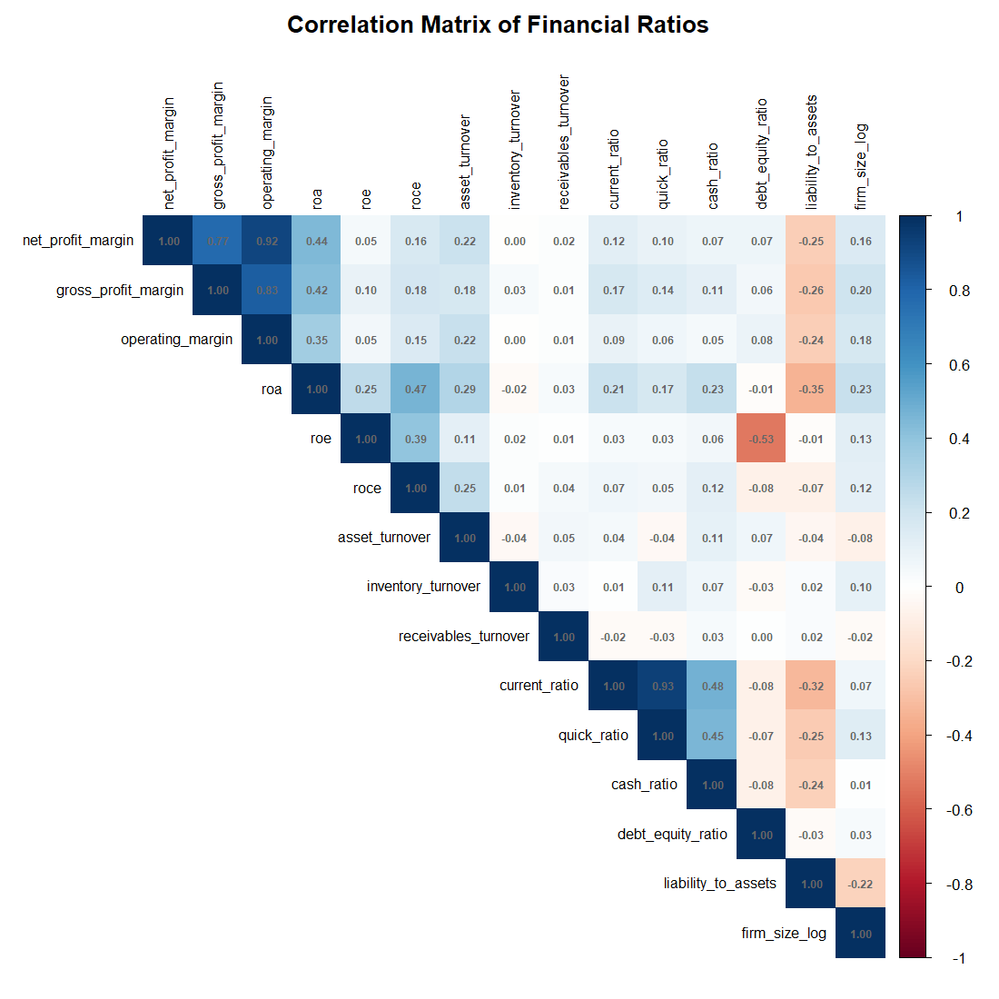

FINANCIAL ANALYSIS DASHBOARDS

Overview Dashboard
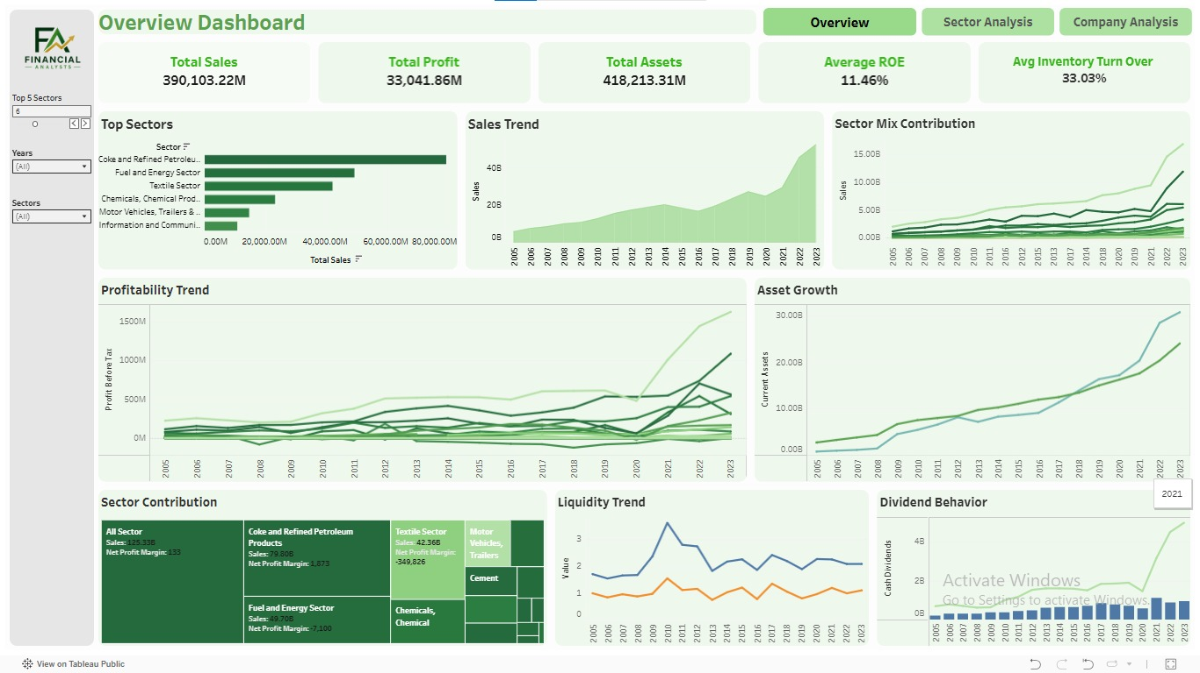

Key Findings
- Total sales across the portfolio stand at 390,103.22M, against total assets of 418,213.31M — a healthy asset-to-sales ratio that reflects efficient use of the asset base to generate revenue.
- Average ROE of 11.46% indicates that, on the whole, companies are converting shareholder equity into returns at a reasonably efficient rate, though this varies widely by sector.
- The Coke and Refined Petroleum Products sector clearly leads total sales, well ahead of Fuel and Energy and the Textile sector, making it the backbone of the overall portfolio's performance.
- Both sales and profitability show a sharp upward trend from 2020 onward, a pattern most likely tied to post-COVID economic recovery combined with currency devaluation effects on nominal revenue figures.

Sector Analysis (Coke & Refined Petroleum)
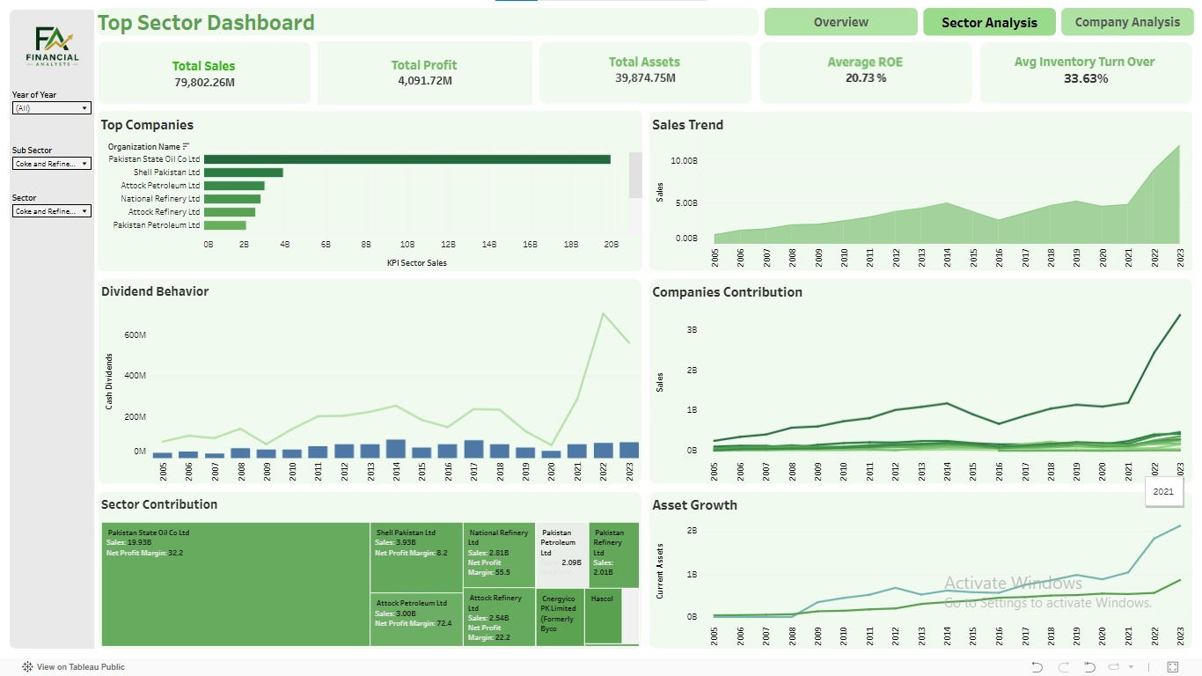

Key Findings
- The sector generated 79,802.26M in total sales, making it a major contributor to the overall portfolio and confirming its position as the strongest-performing segment.
- Average ROE of 20.73% is well above the overall portfolio average of 11.46%, reflecting the sector's strong ability to generate returns on shareholder equity relative to other industries.
- Pakistan State Oil (PSO) is the clear market leader within the sector, comfortably ahead of Shell Pakistan, Attock Petroleum, National Refinery, and Attock Refinery in terms of sales volume.
- Sales trend shows steep growth between 2021 and 2023, pointing toward sector-wide expansion, favorable pricing conditions, or a combination of both driving revenue upward sharply.
- Dividend behavior across the sector mirrors the broader portfolio pattern, with a marked increase in cash dividends from 2021 onward, indicating improved profitability being passed on to shareholders.
Total assets of 39,874.75M alongside average inventory turnover of 33.63% suggest the sector maintains an efficient balance between asset deployment and inventory cycling.

Company Analysis (PSO - Top Company)
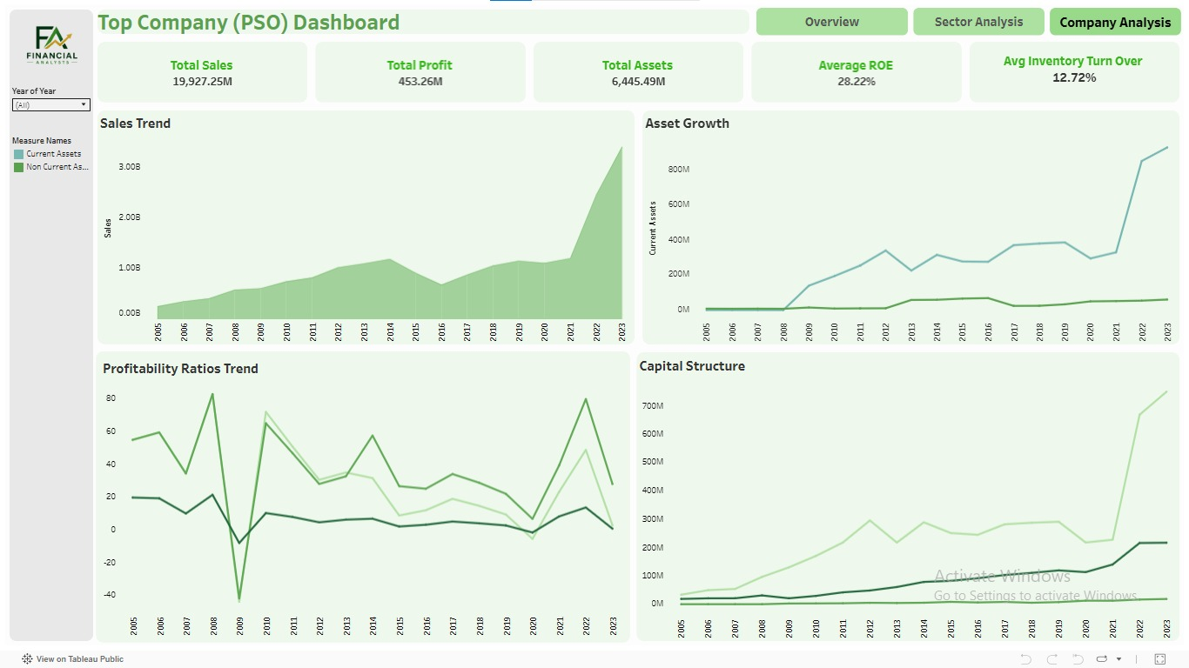

Key Findings
- PSO's total sales of 19,927.25M make up roughly 25% of the entire sector's revenue, confirming its position as the dominant player among all companies analyzed.
- An ROE of 28.22% outperforms both the sector average of 20.73% and the overall portfolio average of 11.46%, reflecting particularly strong returns being generated for shareholders.
- Current assets rise sharply during 2022–2023, a clear signal of improving liquidity and stronger short-term financial flexibility compared to prior years.
- Profitability ratios show a sharp dip around 2009, most likely tied to the global financial crisis, but the company demonstrates a consistent and steady recovery in the years that follow.
- Capital structure expands noticeably after 2021, with both current and non-current assets growing, suggesting the company has entered an aggressive growth and reinvestment phase.
- Total assets of 6,445.49M combined with an inventory turnover of 12.72% suggest a more capital-intensive operating structure compared to the broader sector average.


Dashboard Link
Link

HOW ARE PROJECT SUPPORT SDGS
The project's outcomes connect meaningfully with three United Nations Sustainable Development Goals (SDGs): SDG 8, SDG 9, and SDG 17.

SDG 8: Decent Work and Economic Growth
The project evaluates the financial health-profitability, liquidity, and solvency-of non-financial companies across 15 major sectors of Pakistan’s economy, directly reflecting the state of corporate growth and economic productivity that SDG 8 promotes.

SDG 9: Industry, Innovation and Infrastructure
The dataset spans 15 major non-financial sectors, including Textile, Cement, Food, and Fuel & Energy-core pillars of industrial activity-making the project directly relevant to tracking industrial development and infrastructure-related sectors.

SDG 17: Partnerships for the Goals
SDG 17 emphasizes strengthening data, monitoring, and accountability to support the achievement of all other goals. This project transforms scattered, inconsistent SBP data into a clean, structured, and analysis-ready dataset-exactly the kind of reliable data infrastructure SDG 17 calls for.

Conclusion
This project analyzed the financial performance of non-financial sectors listed on the PSX (2005–2023) using SBP data. The work began with cleaning scattered, inconsistent raw data into an analysis-ready format, followed by SQL extraction of only those organizations with complete 19-year records.
Correlation analysis in R showed that profitability measures are strongly related to each other, while companies with higher leverage tend to have lower profitability. Liquidity ratios were also strongly correlated.
Key dashboard findings:
- The overall portfolio had an average ROE of 11.46%, with sales and profitability showing sharp growth from 2020 onward.
- The Coke & Refined Petroleum sector emerged as the top performer, with a ROE of 20.73%.
- PSO (Pakistan State Oil) was the leading company within that sector, achieving an ROE of 28.22%.
Overall, the project demonstrates how combining data analysis technique with tools like Excel, SQL, R, and Tableau can transform messy financial data into meaningful, data-driven insights - findings that also align with SDG 8, SDG 9, and SDG 17.

