

University of Engineering and Technology Lahore, Faisalabad Campus

Embedded Systems - II
ASSIGNMENT

Submitted by: Muhammad Taha Jawad
Reg. No: 2023 - MC - 283
Semester: FALL 2025 (5th)
Submitted to: Dr. Muhammad Usman

Mechanical, Mechatronics and Manufacturing Engineering Department

TM4C Microcontroller Interfacing for an Automated Greenhouse
Monitoring and Control System

Objective:
Design an embedded system for an automated greenhouse monitoring and control system using the TM4C microcontroller

Introduction:
Modern agriculture increasingly relies on embedded systems to optimize plant growth conditions while conserving resources. This project implements an automated greenhouse monitoring and control system using the TM4C123 microcontroller. The system monitors critical environmental parameters including temperature, humidity, and soil moisture, and automatically adjusts ventilation and irrigation to maintain optimal conditions.

The implementation demonstrates key embedded systems concepts including real-time sensor data acquisition via I2C and SPI protocols, actuator control through PWM and GPIO interfaces, and serial communication for remote monitoring via UART and real world IoT enabled agricultural automation systems.

The system architecture follows a closed loop control model:

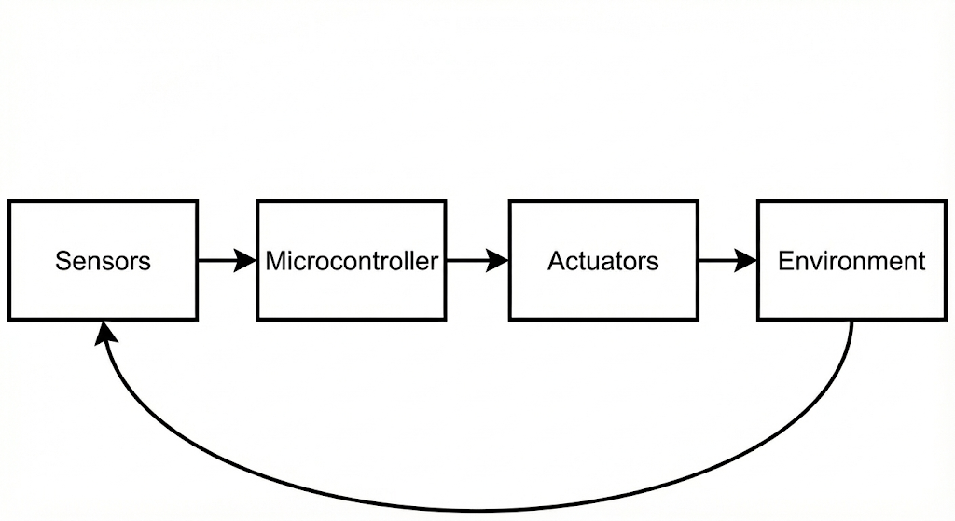

System Design:

Hardware Architecture:
The system uses the TM4C123G LaunchPad as the central controller with the following peripherals:

- I2C Interface: Connected to SHT21 temperature and humidity sensor
- SDA: PB2, SCL: PB3
- 100kHz standard mode operation

- SPI Interface: Connected to MCP3008 ADC for soil moisture sensing
- CLK: PA2, FSS: PA3, RX: PA4, TX: PA5
- 1MHz clock, mode 0 operation

- UART Interface: For PC communication
- TX: PA1, RX: PA0
- 115200 baud, 8N1 format

- PWM Output: For servo motor control
- PB6 (M0PWM0) generating 50Hz signal with 1-2ms pulse width

- GPIO Outputs: For DC motor control via L293D H-bridge
- PE0: Motor Enable
- PE1: Motor Direction

Software Architecture:
The firmware is structured modularly:
main.c
- Peripheral Initialization (UART, PWM, GPIO)Sensor Simulation Module (I2C/SPI)
- Control Logic Module
- Actuator Control Module
- Data Logging Module

The control loop operates at 1Hz, reading sensors, making control decisions, and updating actuators.

Implementation:

Sensor Interface :
I2C (SHT21):
- Temperature range: 15-35°C with ±0.5°C variation
- Humidity range: 30-80% with ±1% variation

SPI (MCP3008):
- Soil moisture range: 0-100%
- Decreases gradually when pump is off
- Increases when watering system is active

Control Algorithms:
Temperature Control
IF temperature > 25°C THEN open vent (servo to 180°)
IF temperature < 18°C THEN close vent (servo to 0°)

Soil Moisture Control
IF moisture < 30% THEN start water pump
IF moisture > 60% THEN stop water pump

UART Data Logging:
All sensor readings and control actions are logged via UART:
Temperature: 22.5°C, Humidity: 55%, Soil: 45%
VENT Action: OPEN (Temp: 26.1°C)
PUMP Action: ON (Soil: 28.5%)

Code Snippets:
UART Initialization
// UART initialization for 115200 baud communication
void initUART(void) {
SysCtlPeripheralEnable(SYSCTL_PERIPH_UART0);
GPIOPinConfigure(GPIO_PA0_U0RX);
GPIOPinConfigure(GPIO_PA1_U0TX);
UARTConfigSetExpClk(UART0_BASE, SysCtlClockGet(), 115200,
(UART_CONFIG_WLEN_8 | UART_CONFIG_STOP_ONE));
}

Control Logic
// Threshold-based greenhouse control
void greenhouseControl(float temp, float soil) {
if(temp > TEMP_THRESHOLD) {
setVentOpening(100); // Open vent fully
UARTSend("ALERT: High temperature detected\r\n");
}
if(soil < SOIL_THRESHOLD) {
startWaterPump(5); // Water for 5 seconds
} }

Main Control Loop
// Main supervisory loop (1Hz operation)
while(1) {
sensorData = readAllSensors();
applyControlLogic(sensorData);
logToUART(sensorData);
SysCtlDelay(SYSTEM_CLOCK/3); // 1 second delay
}

Circuit :
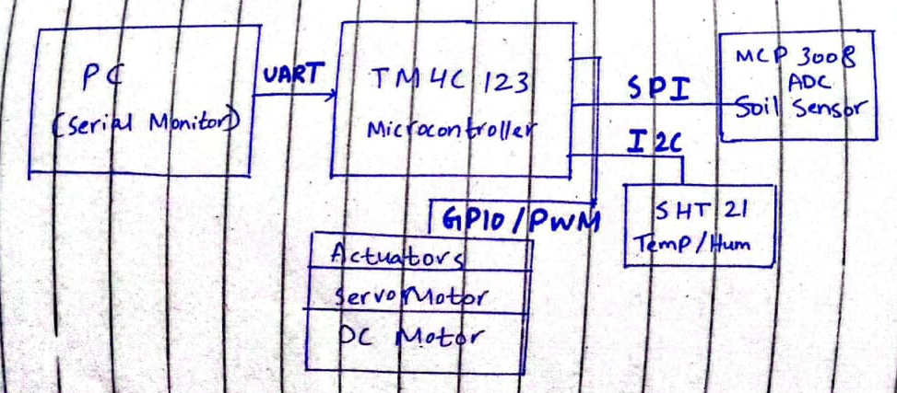

Connections:
Device / Module | Protocol | TM4C Pin | Signal Name | Connected To | Voltage
PC | UART | PA0 | U0RX | FTDI TX | 3.3V
PC | UART | PA1 | U0TX | FTDI RX | 3.3V
SHT21 | I2C | PB2 | I2C0SDA | SDA (Pin 1) | 3.3V
SHT21 | I2C | PB3 | I2C0SCL | SCL (Pin 2) | 3.3V
SHT21 | Power | VCC | VDD | Pin 4 | 3.3V
SHT21 | Ground | GND | GND | Pin 3 | GND
MCP3008 | SPI | PA2 | SSI0CLK | CLK (Pin 13) | 3.3V
MCP3008 | SPI | PA3 | SSI0FSS | CS (Pin 10) | 3.3V
MCP3008 | SPI | PA4 | SSI0RX | DOUT (Pin 12) | 3.3V
MCP3008 | SPI | PA5 | SSI0TX | DIN (Pin 11) | 3.3V
Soil Sensor | Analog | MCP CH0 | ADC Input | Signal Output | 0–3.3V
SG90 Servo | PWM | PB6 | M0PWM0 | Signal (Orange) | 5V
SG90 Servo | Power | VCC | Power (Red) | 5V Supply | 5V
SG90 Servo | Ground | GND | Ground (Brown) | GND | GND
L293D | GPIO | PE0 | Motor Enable | EN1 (Pin 1) | 5V
L293D | GPIO | PE1 | Direction | IN1 (Pin 2) | 5V
L293D | Power | VCC1 | Logic VCC | Pin 16 | 5V
L293D | Power | VCC2 | Motor VCC | Pin 8 | 6–12V
Pull up Resistors | I2C | — | — | SDA/SCL → 3.3V | 4.7 kΩ

Implementation Challenges:

Protocol Timing Simulation:
- Challenge: Accurately simulating I2C and SPI timing.
- Solution: Implemented time-based simulation with realistic response delays. Used TivaWare peripheral libraries as reference for proper initialization sequences.

Sensor Data Realism:
- Challenge: Generating believable sensor data patterns.
- Solution: Implemented Markov chain model for temperature and humidity with environmental constraints (humidity decreases when temperature increases).

Realtime Control Constraints:
- Challenge: Ensuring control loop timing consistency for stable operation.
- Solution: Implemented fixed 1Hz control cycle using SysCtlDelay() for precise timing. Separated data display (10Hz) from control logic (1Hz) to prevent UART bottlenecks.

Resource Management:
- Challenge: Simulating concurrent peripheral operations on single microcontroller.
- Solution: Implemented non-blocking UART communication and used interrupt ready structure for scalability. All peripheral operations are polled in main loop with priority ordering.
Testing Methodolgy:
- Serial Terminal Validation: Confirm UART output format and data consistency
- Control Logic Verification: Manually adjusted values to trigger all control actions
- Timing Analysis: Measure loop execution time using GPIO toggles
- Boundary Testing: Test extreme sensor values to ensure system stability

UART Output
Greenhouse Status
Temperature: 24.5°C
Humidity: 58.3%
Soil Moisture: 42.7%
Vent: CLOSED
Water Pump: OFF

Results and Performance Analysis:

The system demonstrates:
- Real time monitoring of three environmental parameters
- Automatic control of two independent actuators
- Serial communication for remote oversight
- Operation with 1Hz control frequency
- Response to threshold violations within 1 second

Performance Metrics:
- Control loop execution time: < 50ms
- Sensor update rate: 1Hz
- Actuator response time: < 100ms

Conclusion and Future Improvements:
This project implements the core functionality of an automated greenhouse system using the TM4C123G microcontroller. The modular design allows for easy expansion with additional sensors or actuators.

Proposed Enhancements:
- Wireless Connectivity: Add ESP8266 module via UART for Wi-Fi/IoT capability
- Power Management: Implement sleep modes between sensor readings
- Data Logging: Add SD card interface for long-term data storage
- Multiple Zones: Expand to control separate greenhouse sections
- Predictive Control: Implement machine learning for anticipatory adjustments
- Mobile Application: Develop Android/iOS app for remote monitoring

The system provides a solid foundation for real-world deployment with minimal hardware modifications. The use of industry-standard communication protocols (I2C, SPI, UART) ensures compatibility with a wide range of commercial sensors and actuators.

REFERENCES:
- Texas Instruments, "TM4C123GH6PM Microcontroller Datasheet"
- Texas Instruments, "TivaWare Peripheral Driver Library User's Guide"
- Sensirion, "SHT21 Humidity and Temperature Sensor Datasheet"
- Microchip, "MCP3008 8-Channel 10-bit ADC Datasheet"
- K. S. Tan, "Embedded Systems Design with ARM Cortex-M Microcontrollers"

