

NED UNIVERSITY

OF ENGINEERING AND TECHNOLOGY
KARACHI, SINDH, PAKISTAN

DEPARTMENT OF CSIT
Course Name:
Programming For AI
Course Code:
CT-264
Semester: Fall 2026 | Batch: 2024
Section: “E (Cyber Security)”
COMPLEX COMPUTING ACTIVITY (CCA)

AI-BASED PATIENT ADMISSION PREDICTION SYSTEM

SUBMITTED BY:
MUHAMMAD HAMZA SIDDIQUI (CT-24033)
SAIF UR REHMAN (CT-24044)
MUHAMMAD TALHA BIN SUHAIL (CT-24312)

SUBMITTED TO:

Miss Amna Ahmed
TABLE OF CONTENTS
Abstract 4
1. Introduction 4
1.1 Background 4
1.2 Problem Statement 4
1.3 Objectives 4
1.4 Real-World Significance 5
1.5 Scope 5
2. Problem Analysis 6
2.1 Inputs and Outputs 6
2.2 Alternative Solution Strategies 6
2.3 Success Criteria 7
3. Datasets 7
3.1 Dataset 1 - Emergency Department Patient Flow (USA) 7
3.2 Dataset 2 - Korean Triage and Acuity Scale (KTAS) 8
3.3 Relevance to the Problem 9
4. Methodology 9
5. Data Preprocessing 11
5.1 Data Quality Problems Found 11
5.2 Handling Missing Values 12
5.3 Encoding, Scaling and Pipelines 12
6. Exploratory Data Analysis 13
7. Class Imbalance 19
8. Models Used 20
8.1 Logistic Regression 20
8.2 Decision Tree 20
8.3 Random Forest 20
8.4 Gradient Boosting (HistGradientBoostingClassifier) 20
8.5 Hyperparameter Tuning 20
8.6 Ensemble (Soft Voting) 21
9. Results and Evaluation 21
9.1 Model Comparison 21
9.2 ROC and Precision-Recall Curves 22
9.3 Confusion Matrices 23
9.4 Decision-Threshold Tuning 23
9.5 Feature Importance 24
9.6 Data-Leakage Check 24
10. Dataset 2 and Cross-Dataset Validation 25
10.1 Korean KTAS Dataset 25
10.2 External Validation (USA → Korea) 26
11. Visualization and User Interface 26
11.1 Admission Prediction App 27
11.2 Bed-Demand Forecast 28
12. Challenges and Solutions 29
13. Ethical Considerations and Limitations 29
14. Conclusion and Future Work 30
References 30
Appendix A: Project Files and How to Run 31
Appendix B: Key Code 31

Abstract
Emergency departments (EDs) are crowded because the decision to admit a patient is usually made hours after arrival, and only then does the search for a hospital bed begin. This project builds an AI-Based Patient Admission Prediction System that predicts, at the moment of triage, whether a patient will be admitted or discharged. Two public, de-identified datasets are used: an ED patient-flow dataset from the Yale New Haven Health System (100,000 visits sampled from 560,486) and the Korean Triage and Acuity Scale (KTAS) dataset (1,267 visits). The data was cleaned (placeholder answers, inconsistent spelling, impossible vital signs, text inside numeric columns, missing values) and explored with statistical summaries and 19 charts. The class imbalance (29.8% admitted) was handled with stratified splitting, balanced class weights and threshold tuning. Four classifiers (Logistic Regression, Decision Tree, Random Forest, Gradient Boosting) were trained and improved by hyperparameter tuning and a soft-voting ensemble. The final Tuned Gradient Boosting model reached ROC-AUC 0.885, recall 0.829, F1-score 0.703 and accuracy 0.792 on 20,000 unseen visits. A data-leakage problem (home-medication lists completed during the admission) was detected and removed. The model was also validated on the Korean dataset (ROC-AUC 0.760) and a desktop interface was built for ED staff that shows the risk level, a recommended action and a calibrated bed-demand forecast.

1. Introduction

1.1 Background
Emergency departments work around the clock and receive patients with very different needs: some only need a prescription, while others need intensive care. When an ED becomes crowded, waiting times grow, ambulances may be diverted and patients who need a ward bed wait for hours on ED trolleys ("boarding"). Studies have linked crowding and boarding with delayed treatment and worse outcomes. A major cause is that bed management only starts after the doctor has finished the assessment, which can take several hours after arrival.
At triage, a nurse already records the patient's age, arrival mode, chief complaint, vital signs and an urgency level (ESI in the USA, KTAS in Korea). Hospital records also contain the patient's history, such as previous visits and known diseases. If a machine-learning model can use this early information to estimate who is likely to be admitted, the hospital can request beds, call specialists and plan staff much earlier.

1.2 Problem Statement
Given the information that is available at triage (demographics, arrival details, triage level, vital signs, chief complaint and hospital history), predict whether the ED visit will end in hospital admission (1) or discharge (0). This is a supervised binary classification problem on tabular data with a moderately imbalanced target.

1.3 Objectives
• Collect and describe suitable real-world datasets for ED admission prediction (two datasets).
• Clean the data: handle missing values, placeholders, inconsistent categories and impossible values.
• Perform exploratory data analysis (EDA) to find the factors linked to admission.
• Check and handle class imbalance.
• Train and compare several classification models and improve them with tuning and ensembling.
• Evaluate the models with suitable metrics (precision, recall, F1, ROC-AUC, PR-AUC, confusion matrix).
• Test how well the approach generalises to a second hospital system in another country.
• Provide a simple, user-friendly interface that turns predictions into actions for hospital staff.

1.4 Real-World Significance
Early admission prediction supports hospital operations: bed managers can reserve ward beds, nurses can start the admission paperwork, and managers can schedule staff based on the expected number of admissions per shift. Low-risk patients can be moved to a fast-track area, which shortens waiting time for everyone. The same idea is relevant to busy public hospitals in Pakistan, where emergency rooms are often over capacity and beds are limited.

1.5 Scope
The system is a decision-support prototype built within the scope of an introductory Programming for AI course. It uses classical machine-learning models in Python (scikit-learn) and a Tkinter desktop interface. It does not replace clinical judgement; real deployment would need local validation, ethics approval and integration with the hospital information system.

2. Problem Analysis

2.1 Inputs and Outputs
Table 1: Inputs and outputs of the system
Group | Inputs used by the model | Data type
Patient | Age, gender, race, ethnicity, language, marital & employment status, insurance | Numeric / categorical
Arrival | ED site, arrival mode (car, ambulance, walk-in...), month, weekday, time band | Categorical
Triage | ESI level 1-5, chief complaint (top 30 + other) | Ordinal / categorical
Vital signs | Heart rate, systolic & diastolic BP, respiratory rate, SpO2, temperature, oxygen device | Numeric (with missing values)
History | ED visits, admissions, surgeries, imaging tests and ECGs in previous records, previous ED outcome | Numeric / categorical
Comorbidities | Number of past conditions + 10 flags (hypertension, diabetes, heart failure, COPD...) | Numeric / binary
OUTPUT | Admission score (0-1), predicted class (Admit / Discharge), calibrated probability, risk band (LOW / MODERATE / HIGH) and a recommended action | Probability + class

2.2 Alternative Solution Strategies
Several strategies were compared before choosing the final approach:
Table 2: Alternative strategies that were evaluated
Strategy | Advantages | Disadvantages | Decision
Triage level only (rule) | Very simple; already used by nurses | Ignores age, history and vitals; ROC-AUC only 0.71 on the KTAS data | Used as baseline
Logistic Regression | Fast, interpretable coefficients | Assumes linear effects | Implemented
Decision Tree | Easy to explain as rules | Unstable, over-fits | Implemented
Random Forest | Strong on tabular data, robust | Slower, larger model | Implemented
Gradient Boosting | Usually the best accuracy on tabular data, handles interactions | Needs tuning | Implemented + tuned (final)
Ensemble (voting) | Combines strengths of models | More complex | Implemented
Deep neural network | Flexible | Needs more data/tuning, less interpretable, small gain on tabular data | Not chosen (scope)

2.3 Success Criteria
• ROC-AUC above 0.85 on unseen test data (good discrimination).
• Recall of at least 0.80 for admitted patients, because missing an admission (false negative) is more harmful for bed planning than a false alarm.
• Only information available at triage is used (no data leakage).
• The full pipeline runs on a normal laptop in a few minutes.

3. Datasets
The project brief requires at least two relevant datasets or one sufficiently large dataset. This project uses both: one large dataset for model development and a second, independent dataset from another country for validation.

3.1 Dataset 1 - Emergency Department Patient Flow (USA)
Source: Hong, Haimovich and Taylor (2018), "Predicting hospital admission at emergency department triage using machine learning", PLOS ONE 13(7). The de-identified data was released publicly on GitHub/Zenodo (yaleemmlc/admissionprediction) and is also shared on Kaggle. It covers adult ED visits to three emergency departments of the Yale New Haven Health System (2014-2017).
The original file contains 560,486 visits and 972 columns (one column per chief complaint, medication class, lab test, etc.). The script 01_prepare_datasets.py turned it into a manageable analysis file: the 200 chief-complaint columns were merged into one categorical column, 281 diagnosis columns were summarised into a comorbidity count and ten clinically important flags, and a random sample of 100,000 visits was taken (random seed 42) so the project runs on a laptop. The admission rate of the sample (29.8%) matches the full dataset (29.7%).
Table 3: Structure of Dataset 1 (ed_patient_flow.csv, 100,000 rows x 42 columns)
Group | Columns | Type | Meaning
Identifier | visit_id | Integer | Row number (not used for learning)
Demographics | age, gender, race, ethnicity, language, marital_status, employment_status, insurance_status | Numeric / text | Who the patient is
Arrival | ed_site, arrival_mode, arrival_month, arrival_day, arrival_hour_bin | Text | How and when the patient came
Triage | esi_level, chief_complaint | Ordinal / text | Urgency and main problem
Vital signs | heart_rate, systolic_bp, diastolic_bp, respiratory_rate, oxygen_saturation, on_supplemental_oxygen, temperature_f | Float | Physiological condition
History | previous_disposition, prior_ed_visits, prior_admissions, prior_surgeries, prior_imaging_tests, prior_ekgs, home_medications | Numeric / text | Past use of the hospital
Comorbidities | num_comorbidities, hypertension, diabetes, heart_failure, coronary_disease, arrhythmia, copd_asthma, kidney_disease, cancer_history, mental_health_disorder, substance_use_disorder | Integer / binary | Chronic illness burden
Target | disposition (Admit / Discharge) | Text | What we predict

3.2 Dataset 2 - Korean Triage and Acuity Scale (KTAS)
Source: Moon, Shim, Park and Park (2019), "Triage accuracy and causes of mistriage using the Korean Triage and Acuity Scale", PLOS ONE 14(9) - supporting data file S1 (also on Kaggle as "Emergency Service - Triage Application"). It contains 1,267 adult ED visits from two emergency departments in Korea (October 2016 - September 2017) with 24 columns.
Table 4: Structure of Dataset 2 (ktas_triage.csv)
Group | Columns | Type
Patient | Sex, Age, Group (local / regional ED) | Coded integers / float
Arrival | Arrival mode (walking, 119 ambulance, private car...), Patients number per hour | Coded integers
Clinical | Injury, Mental state, Pain, NRS_pain, SBP, DBP, HR, RR, BT, Saturation | Mixed (numbers stored as text)
Triage | KTAS_RN (nurse), KTAS_expert, Error_group, mistriage, KTAS duration | Integers
Free text | Chief_complain, Diagnosis in ED | Text
Outcome | Disposition: 1 discharge, 2 ward, 3 ICU, 4 AMA discharge, 5 transfer, 6 death, 7 operation | Coded integers

The target was defined as admitted = 1 for ward admission, ICU admission or operation from ED, and 0 for discharge or discharge against medical advice. Transfers to another hospital and deaths (41 visits) were removed because they are neither an admission here nor a discharge. This leaves 1,226 visits, of which 403 (32.9%) were admitted. Columns that are only known after the visit (Diagnosis, Length of stay, KTAS_expert, mistriage) were not used as features to avoid leakage.

3.3 Relevance to the Problem
Both datasets record what is known when the patient arrives and what finally happened (admission or discharge), which is exactly the input-output relationship the system must learn. Dataset 1 is large and rich, which is ideal for training and comparing models. Dataset 2 comes from a different country, triage scale and hospital system, so it shows whether the approach is general and reveals real data-quality problems (such as text inside numeric columns).

4. Methodology
Figure 1 shows the complete workflow. Each block corresponds to a section of the main script 02_admission_prediction.py, and every step is implemented with pandas and scikit-learn Pipelines so that the same transformations are applied during training, testing and in the user interface.
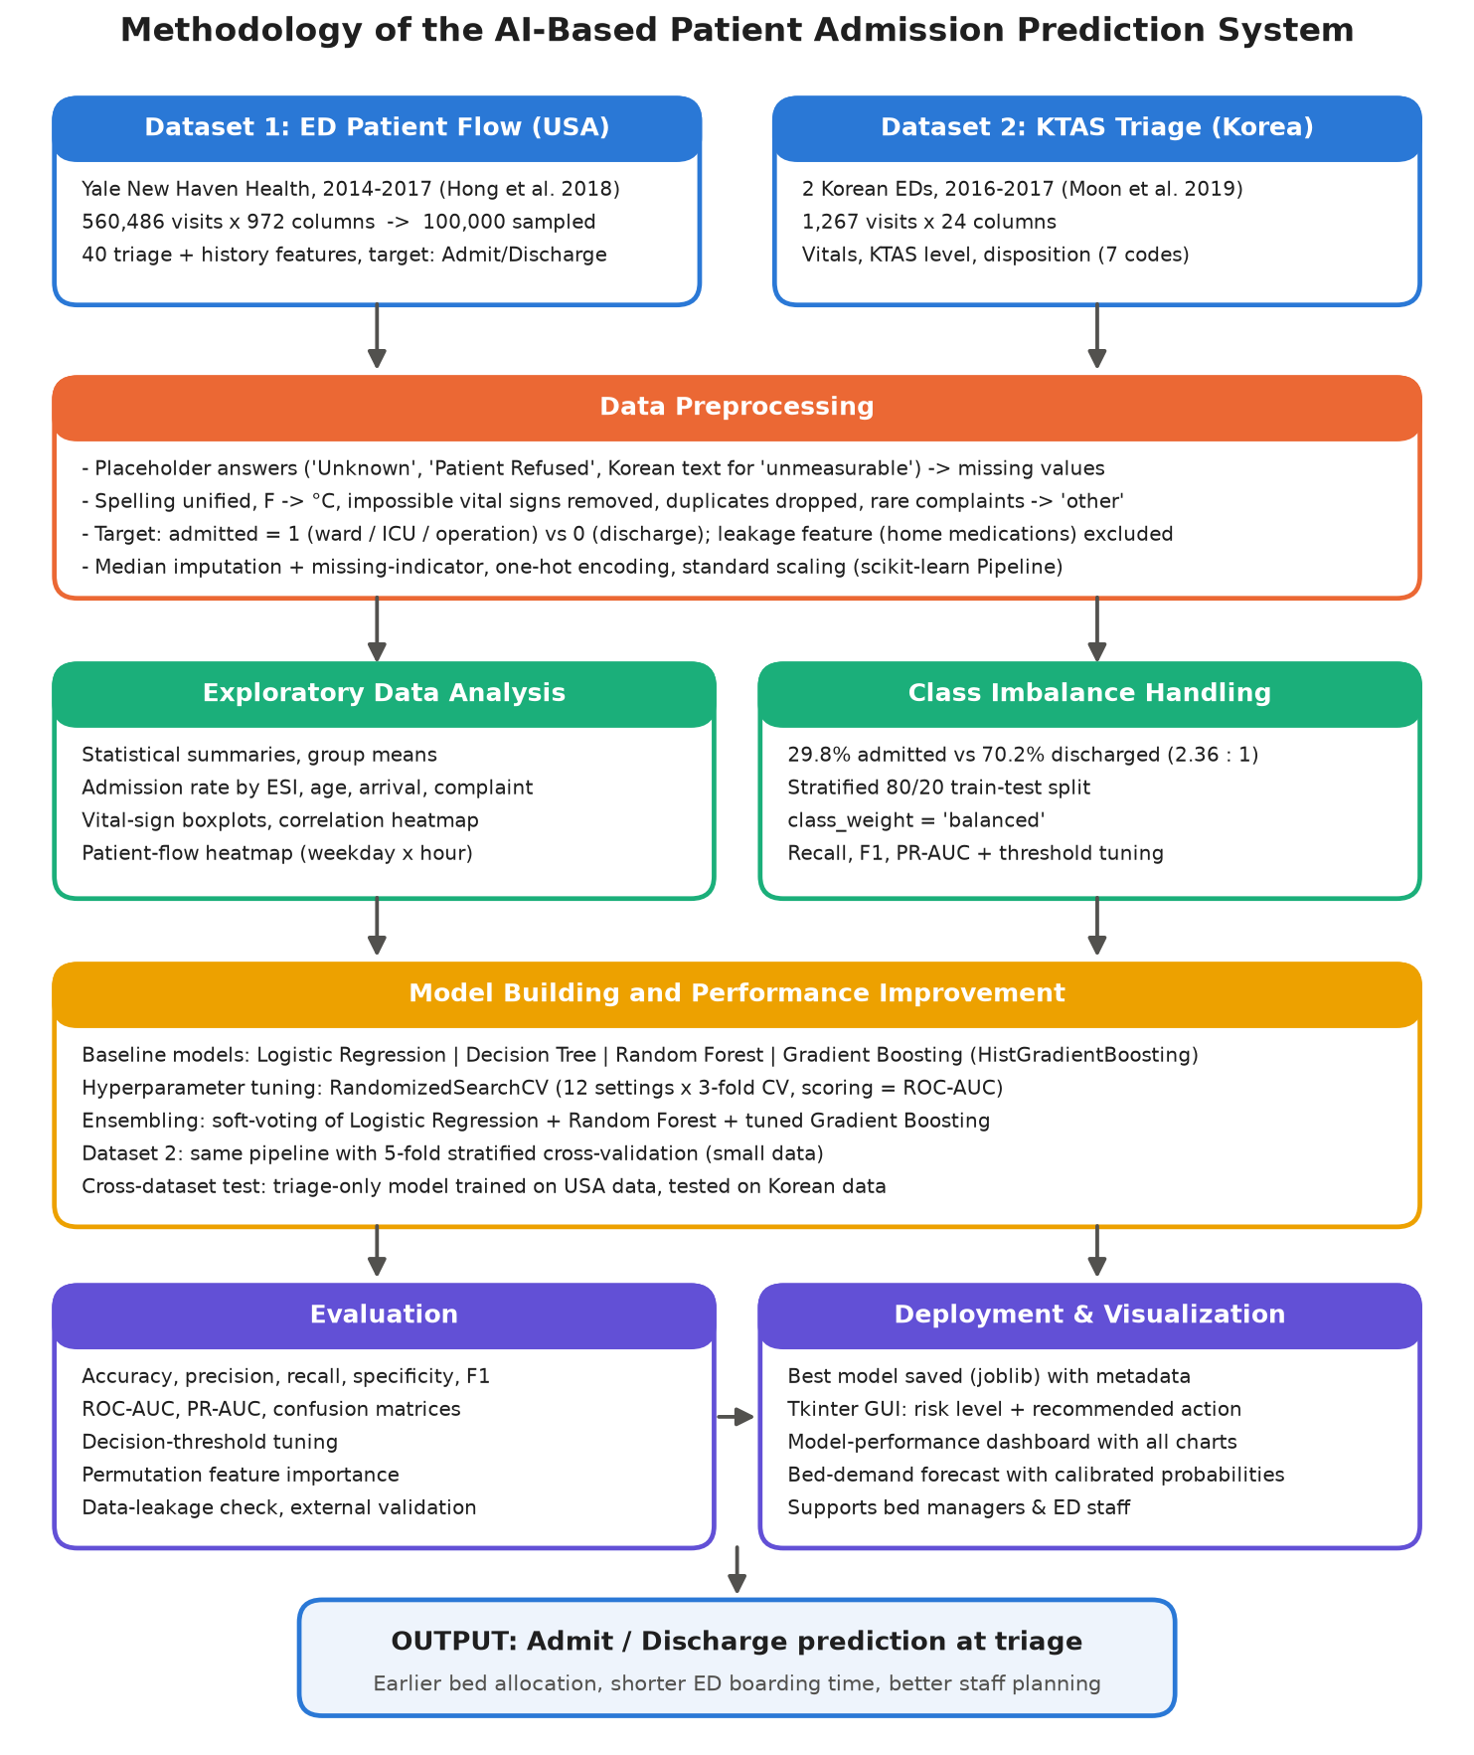
Figure 1: Methodology of the AI-Based Patient Admission Prediction System
Table 5: Summary of the methodology steps
Step | Description
1. Data acquisition | Download both datasets; 01_prepare_datasets.py converts them to CSV files.
2. Data understanding | Shape, types, duplicates, missing values, placeholders, value ranges.
3. Preprocessing | Clean categories and numbers, convert units, build target, impute, encode, scale.
4. EDA | Statistics and 11 charts showing how each factor relates to admission.
5. Imbalance handling | Stratified split, balanced class weights, minority-focused metrics, threshold tuning.
6. Modelling | Logistic Regression, Decision Tree, Random Forest, Gradient Boosting (80% training data).
7. Improvement | RandomizedSearchCV tuning + soft-voting ensemble; data-leakage check.
8. Evaluation | Test set of 20,000 unseen visits; ROC/PR curves, confusion matrices, feature importance.
9. Validation | Dataset 2 cross-validation and USA-to-Korea external validation.
10. Deployment | Model saved with joblib; Tkinter GUI and bed-demand forecast for hospital staff.

Tools and libraries: Python 3.14.6, pandas 3.0.3, NumPy 2.4.6, scikit-learn 1.9.1, matplotlib 3.11.0, seaborn 0.13.2, joblib (model saving) and Tkinter (graphical interface).

5. Data Preprocessing

5.1 Data Quality Problems Found
A data-quality report was produced before any modelling. Figure 2 shows the percentage of missing values per column in Dataset 1. Vital signs are missing for about 30% of visits and oxygen saturation for almost half, because not every vital sign is recorded for every patient at triage.
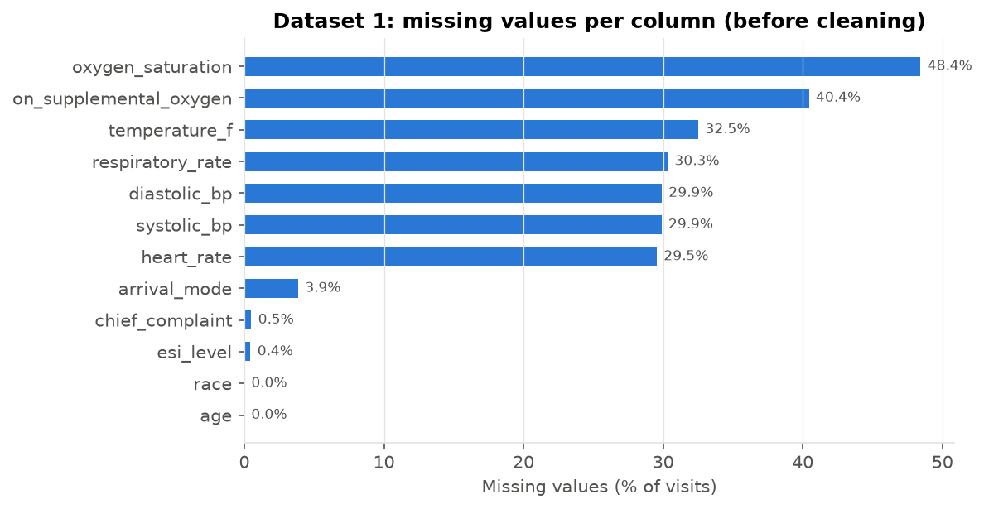
Figure 2: Missing values per column in Dataset 1 (before cleaning)
Table 6: Data-quality problems and how they were handled
Problem | Example / amount | Solution
Missing vital signs | heart_rate 29.5%, oxygen_saturation 48.4% missing | Median imputation + 'was missing' indicator column
Missing triage / arrival data | esi_level 0.4%, arrival_mode 3.9% missing | Median (numbers) or the category 'Missing' (text)
Placeholder answers | 'Unknown' and 'Patient Refused' in race, ethnicity, marital and employment status | Converted to missing values
Inconsistent spelling | 'ambulance' (lower case) next to 'Car', 'Walk-in' | Unified to title case ('Ambulance', 'Walk-In')
Different units | Temperature in °F (USA) vs °C (Korea) | Converted to °C
Impossible values | Heart rate 280 bpm, respiratory rate 69/min, DBP 214 mmHg | Values outside physiological limits set to missing (8 values)
Duplicates | Identical visit records | 1 duplicate removed
Too many categories | 200 different chief complaints | Top 30 kept, rest grouped as 'other'
Text in numeric columns (Dataset 2) | Korean word '측불' (= unmeasurable) in vital signs, e.g. SBP 25, DBP 29, HR 20 rows | Converted to numbers; text becomes missing
Structural missing (Dataset 2) | NRS pain score empty when patient has no pain | Filled with 0 when Pain = 'no pain'
Data leakage | home_medications: 6.1 for admitted vs 0.5 for discharged | Excluded from the model (see Section 9.6)

5.2 Handling Missing Values
Rows with missing values were not deleted, because that would remove about half of the data and bias the sample. Numeric columns were filled with the median (robust to outliers), and for every column with missing values an extra missing-indicator column was added. This is important because missingness itself carries information: patients without a recorded heart rate were admitted in 43.6% of cases, compared with 24.0% when it was recorded, and for oxygen saturation the figures are 34.7% vs 25.2%. Missing text values received their own category 'Missing'.

5.3 Encoding, Scaling and Pipelines
Text columns were converted with one-hot encoding (unknown categories in new data are ignored), and numeric columns were standardised (mean 0, standard deviation 1), which Logistic Regression needs. All steps were placed inside a scikit-learn ColumnTransformer + Pipeline. The pipeline is fitted on the training data only, so no information from the test set leaks into the medians or scaling, and the saved model applies exactly the same preprocessing to new patients in the GUI.
Code 1: preprocessing pipeline (02_admission_prediction.py)
def make_preprocessor(numeric_features=NUMERIC_FEATURES):
numeric = Pipeline([
("impute", SimpleImputer(strategy="median", add_indicator=True)),
("scale", StandardScaler()),
])
categorical = Pipeline([
("impute", SimpleImputer(strategy="constant", fill_value="Missing")),
("onehot", OneHotEncoder(handle_unknown="ignore", sparse_output=False)),
])
return ColumnTransformer([
("num", numeric, numeric_features),
("cat", categorical, CATEGORICAL_FEATURES),
])

6. Exploratory Data Analysis
EDA was carried out on the cleaned Dataset 1 (99,999 visits). Table 7 compares the average values of important features for admitted and discharged patients.
Table 7: Mean feature values by outcome
Feature | Admitted (mean) | Discharged (mean)
age | 61.64 | 44.85
esi_level | 2.43 | 3.27
prior_admissions | 1.62 | 0.64
num_comorbidities | 8.15 | 4.71
heart_rate | 88.89 | 84.54
oxygen_saturation | 96.62 | 97.47
temperature_c | 36.76 | 36.70

Admitted patients are on average 17 years older, have a more urgent triage level (lower ESI), more previous admissions, nearly twice as many past conditions, a faster heart rate and lower oxygen saturation.
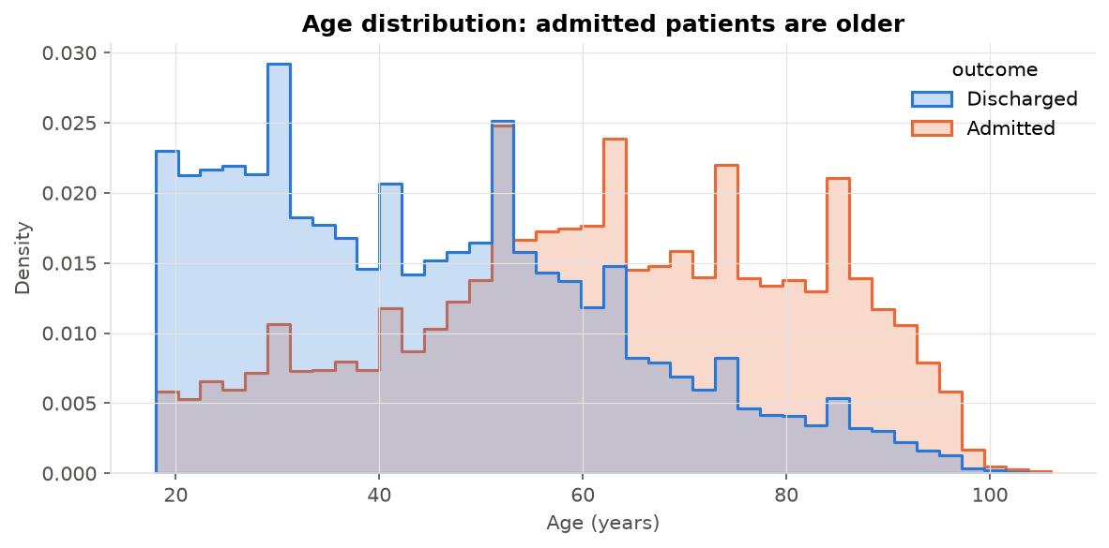
Figure 3: Age distribution of admitted and discharged patients
Figure 3 shows that most discharged patients are young adults, while the admitted group peaks after 60 years. The admission rate rises steadily with age: 11.0% for 18-30 year olds, 30.1% for 46-60 and 61.6% for patients aged 76 or older.
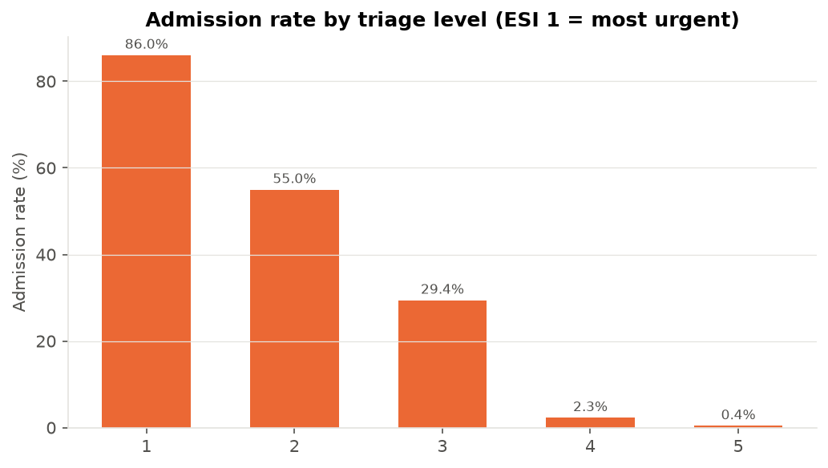
Figure 4: Admission rate by triage level (ESI)
The triage level is the strongest single signal (Figure 4): 86% of ESI-1 patients (resuscitation) were admitted, 55% of ESI-2, 29% of ESI-3 and less than 3% of ESI-4 and ESI-5 patients. However, ESI-3 is the largest group and its outcome is uncertain (about one in three admitted) - this is where the model adds most value.
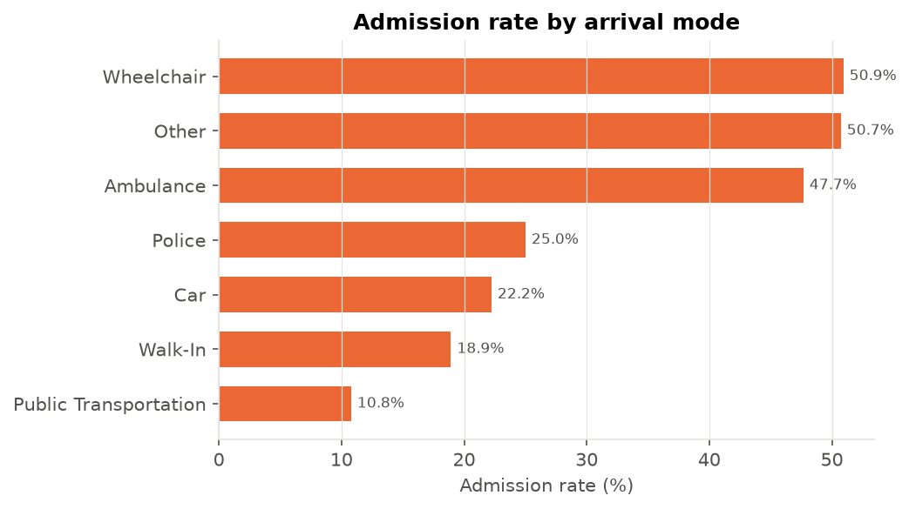
Figure 5: Admission rate by arrival mode
Patients arriving by ambulance were admitted in 47.7% of cases, compared with 18.9% for walk-in patients and 22.2% for those arriving by car (Figure 5). Arrival mode therefore reflects how sick the patient is.
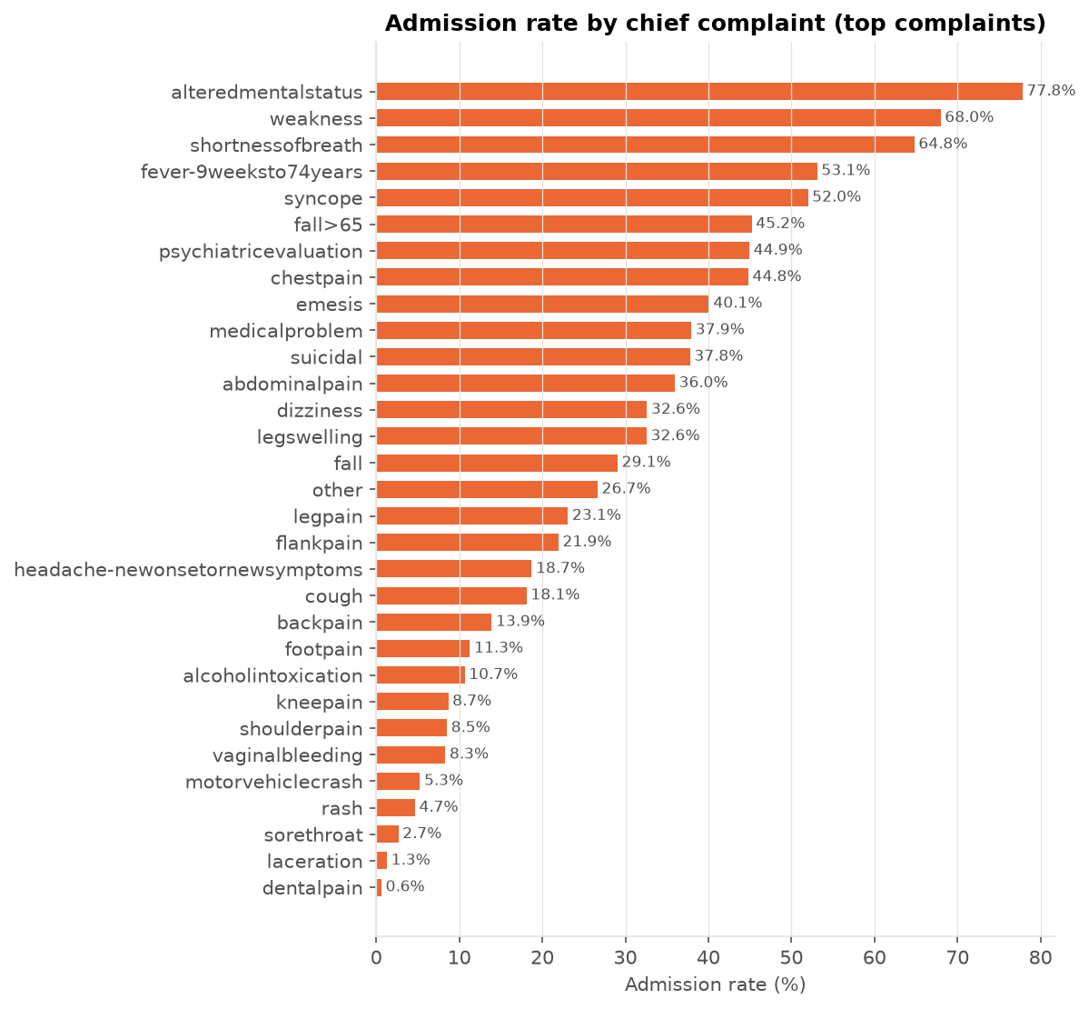
Figure 6: Admission rate by chief complaint
The chief complaint strongly changes the risk (Figure 6). Complaints such as alteredmentalstatus (78%), weakness (68%), shortnessofbreath (65%) lead to admission much more often than dentalpain (1%), laceration (1%), sorethroat (3%).
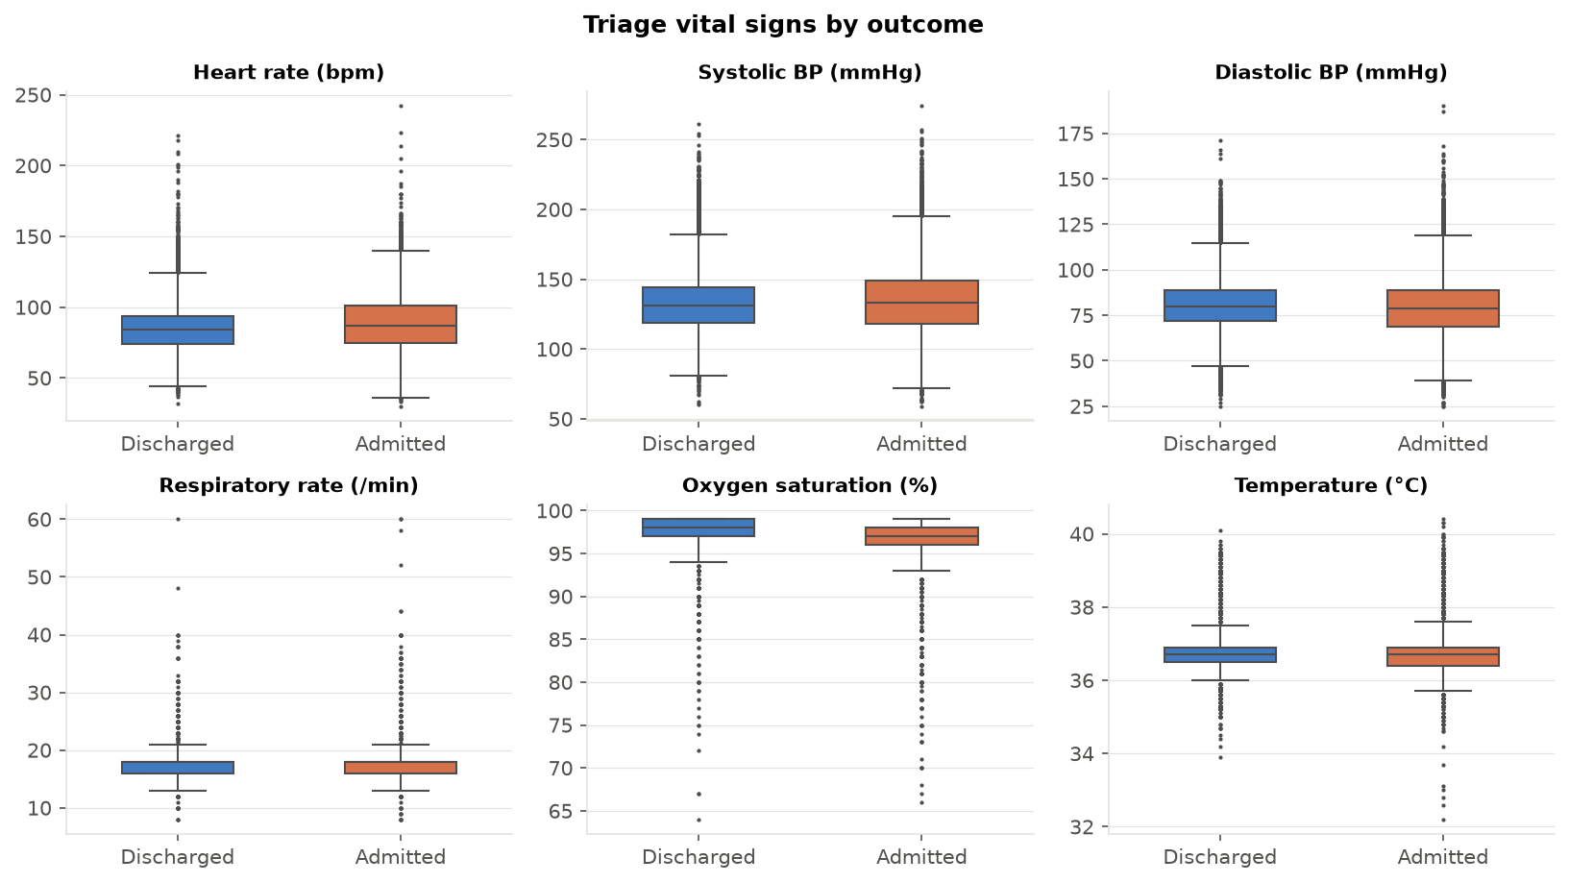
Figure 7: Triage vital signs by outcome
Figure 7 shows that admitted patients tend to have a higher heart rate and respiratory rate and lower oxygen saturation. The boxes overlap a lot, so a single vital sign cannot separate the two groups; the model must combine many weak signals.
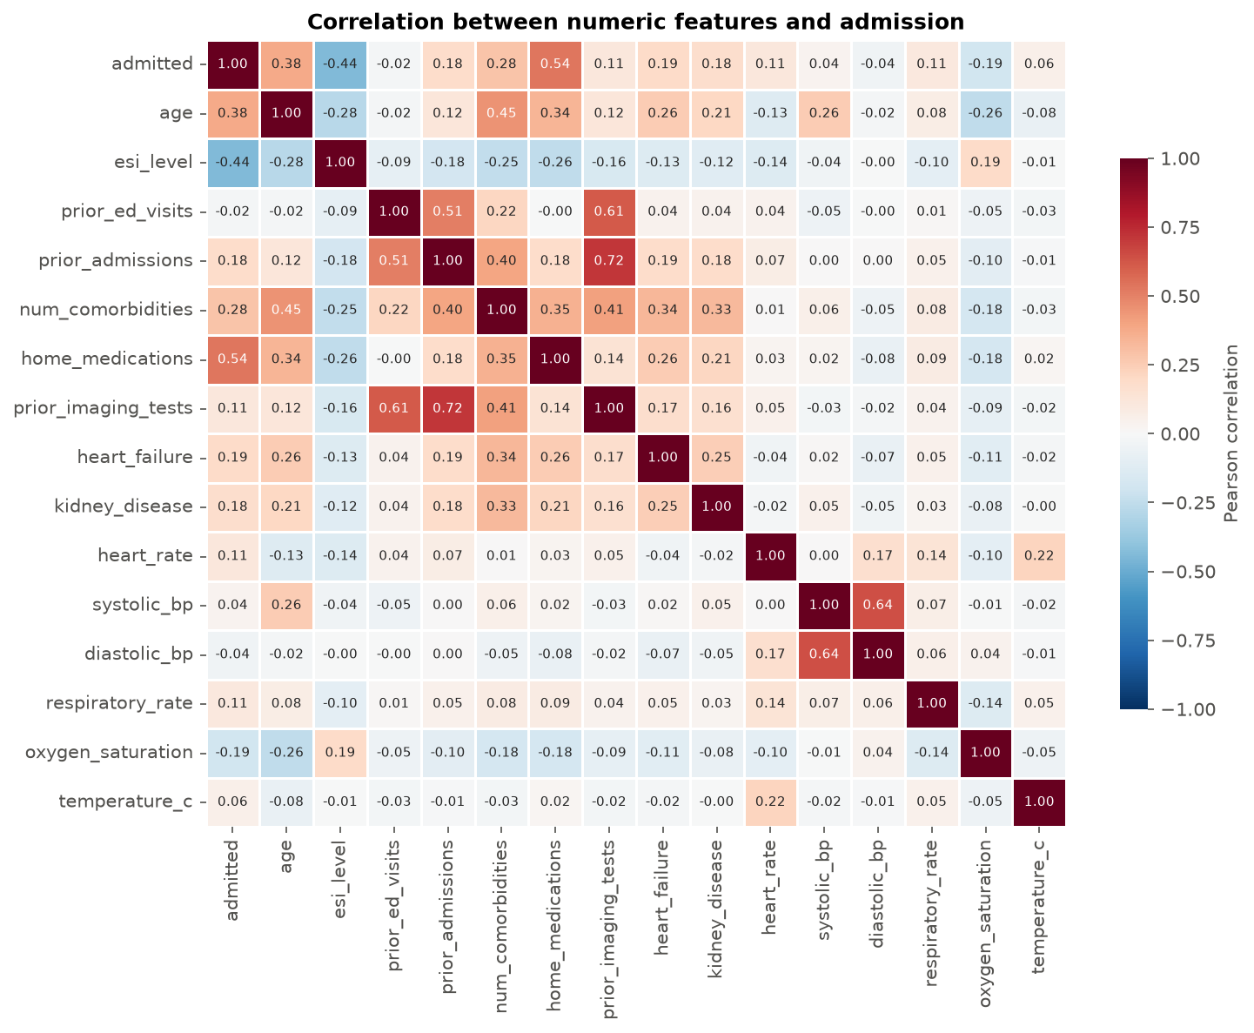
Figure 8: Correlation heatmap of numeric features
The correlation heatmap (Figure 8) confirms these findings: admission is negatively correlated with ESI level (r = -0.44, because ESI 1 is the most urgent) and positively with age (r = 0.38) and the number of comorbidities (r = 0.28). The home-medication count shows a suspiciously high correlation (r = 0.54), which was investigated as possible data leakage. History variables (prior ED visits, admissions, imaging) are correlated with each other, so tree-based models that cope well with correlated inputs are a good choice.
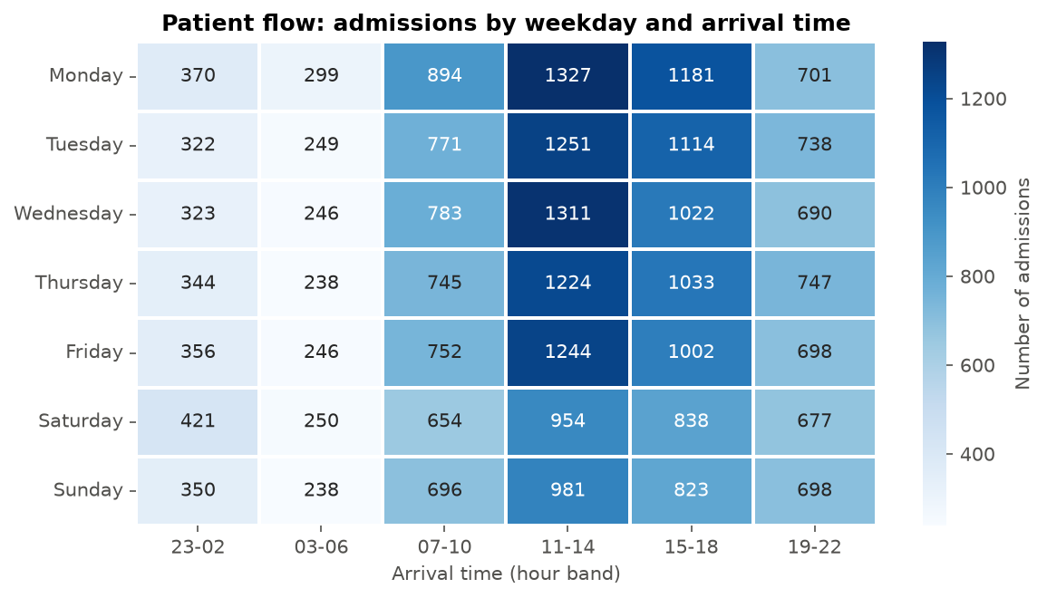
Figure 9: Patient flow: number of admissions by weekday and arrival time
Figure 9 is an operational view of patient flow. Most admissions come from patients who arrive between 11:00 and 18:59, and weekdays (especially Monday) are busier than weekends. Night arrivals (03:00-06:59) produce the fewest admissions. Bed managers can use this pattern to plan staff and discharges from wards before the afternoon peak.
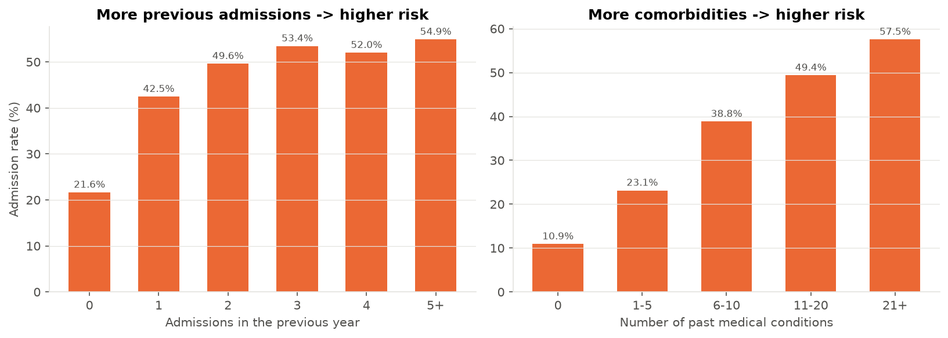
Figure 10: Admission rate by previous admissions and number of past conditions
Hospital history matters (Figure 10): patients with no admission in the previous year were admitted 21.6% of the time, but those with three or more previous admissions were admitted 53.9% of the time. The admission rate also grows with the number of chronic conditions.
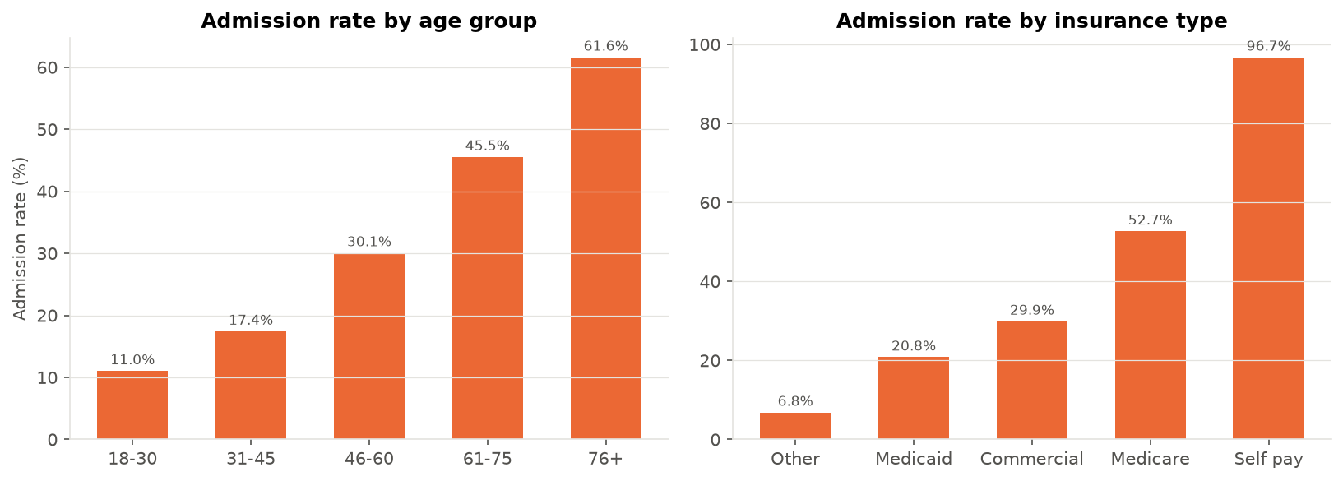
Figure 11: Admission rate by age group and insurance type
Figure 11 shows that Medicare patients (mostly elderly) have a high admission rate (52.7%). The very high rate of the 'Self pay' group (96.7%) is based on only 306 visits and probably reflects billing practice (insurance is registered after admission), so it is interpreted with caution.

7. Class Imbalance
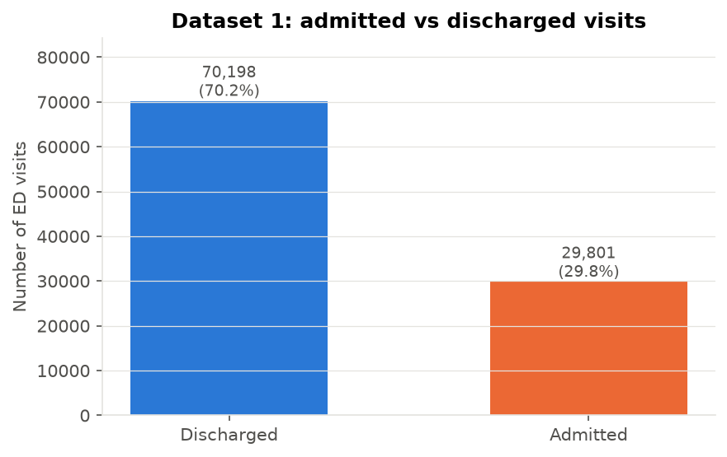
Figure 12: Class distribution of Dataset 1
Only 29.8% of visits end in admission, so there are 2.36 discharged patients for every admitted patient (Figure 12). This is a moderate imbalance. A useless model that always predicts 'discharge' would already be 70.2% accurate, so accuracy alone is misleading. The following techniques were used:
• Stratified train/test split (80/20) so both sets keep the same 29.8% admission rate.
• class_weight = 'balanced' in every model, so an error on an admitted patient costs about 2.4 times more than an error on a discharged patient during training.
• Minority-focused metrics: recall, precision, F1-score and PR-AUC in addition to accuracy.
• Decision-threshold tuning to choose the best trade-off between recall and precision.
The effect is clear for Logistic Regression: without balancing, recall for admitted patients was only 0.607; with balanced weights it rose to 0.805 and the F1-score improved from 0.659 to 0.696. Accuracy dropped slightly (0.812 to 0.790), which is acceptable because detecting admissions is the real goal. Oversampling methods such as SMOTE were not needed because the imbalance is moderate and the dataset is large.

8. Models Used
Training used 79,999 visits (80%) and testing used 20,000 unseen visits (20%). Four different classification algorithms were implemented, followed by two performance-improvement methods.

8.1 Logistic Regression
A linear model that estimates the log-odds of admission as a weighted sum of the features and converts it to a probability with the sigmoid function. It is fast, easy to interpret and a strong baseline. Settings: max_iter = 2000, class_weight = 'balanced'.

8.2 Decision Tree
A tree of if-then rules that splits patients into groups with similar outcomes using Gini impurity. To avoid over-fitting the depth was limited (max_depth = 10, min_samples_leaf = 50).

8.3 Random Forest
An ensemble of 200 decision trees, each trained on a bootstrap sample with a random subset of features; the final prediction is the average vote. Averaging reduces variance and over-fitting. Settings: n_estimators = 200, max_depth = 18, min_samples_leaf = 5, class_weight = 'balanced'.

8.4 Gradient Boosting (HistGradientBoostingClassifier)
Trees are added one at a time, each new tree correcting the errors of the previous ones. The histogram-based version in scikit-learn bins numeric values, which makes training on 80,000 rows fast and also supports missing values natively. It is usually the most accurate algorithm for tabular data.

8.5 Hyperparameter Tuning
The Gradient Boosting model was tuned with RandomizedSearchCV: 12 random combinations of hyperparameters were evaluated with 3-fold stratified cross-validation on the training set, using ROC-AUC as the score (195 seconds). Table 8 lists the search space and the best values found.
Table 8: Hyperparameter search space and result
Hyperparameter | Values searched | Best value
learning_rate | 0.03, 0.05, 0.08, 0.1, 0.15 | 0.08
max_iter | 200, 300, 400, 600 | 400
max_leaf_nodes | 15, 31, 63, 127 | 31
min_samples_leaf | 20, 50, 100, 200 | 100
l2_regularization | 0, 0.1, 1, 5 | 5.0

Best mean cross-validation ROC-AUC: 0.8794 (standard deviation 0.0022), which shows that the result is stable across folds.

8.6 Ensemble (Soft Voting)
A soft-voting ensemble averages the predicted probabilities of Logistic Regression, Random Forest and the tuned Gradient Boosting model (weights 1 : 1 : 2). Combining different types of models can reduce individual errors.
Code 2: hyperparameter tuning with RandomizedSearchCV
search = RandomizedSearchCV(
Pipeline([("prep", make_preprocessor()),
("model", HistGradientBoostingClassifier(class_weight="balanced",
random_state=RANDOM_STATE))]),
param_distributions=param_dist, n_iter=12, scoring="roc_auc",
cv=StratifiedKFold(n_splits=3, shuffle=True, random_state=RANDOM_STATE),
n_jobs=-1, random_state=RANDOM_STATE, verbose=0)

9. Results and Evaluation

9.1 Model Comparison
Table 9: Performance of all models on the test set (20,000 visits, threshold 0.5)
Model | Accuracy | Precision | Recall | Specificity | F1 | ROC-AUC | PR-AUC
Logistic Regression (no balancing) | 0.812 | 0.719 | 0.607 | 0.899 | 0.659 | 0.877 | 0.744
Logistic Regression | 0.790 | 0.613 | 0.805 | 0.784 | 0.696 | 0.877 | 0.743
Decision Tree | 0.751 | 0.556 | 0.813 | 0.724 | 0.660 | 0.855 | 0.693
Random Forest | 0.789 | 0.612 | 0.792 | 0.787 | 0.691 | 0.875 | 0.728
Gradient Boosting | 0.790 | 0.608 | 0.826 | 0.774 | 0.701 | 0.884 | 0.757
Tuned Gradient Boosting | 0.792 | 0.611 | 0.829 | 0.776 | 0.703 | 0.885 | 0.758
Voting Ensemble | 0.794 | 0.616 | 0.821 | 0.782 | 0.703 | 0.885 | 0.753

All balanced models reach a recall of about 0.80 and a ROC-AUC between 0.855 and 0.885. The single Decision Tree is the weakest. Tuned Gradient Boosting achieved the best ROC-AUC (0.885) and was selected as the final model. Tuning improved the ROC-AUC of Gradient Boosting from 0.8845 to 0.8853; the voting ensemble (0.8848) performed almost identically, so the simpler single model was preferred. The final model meets both success criteria (ROC-AUC > 0.85 and recall > 0.80).
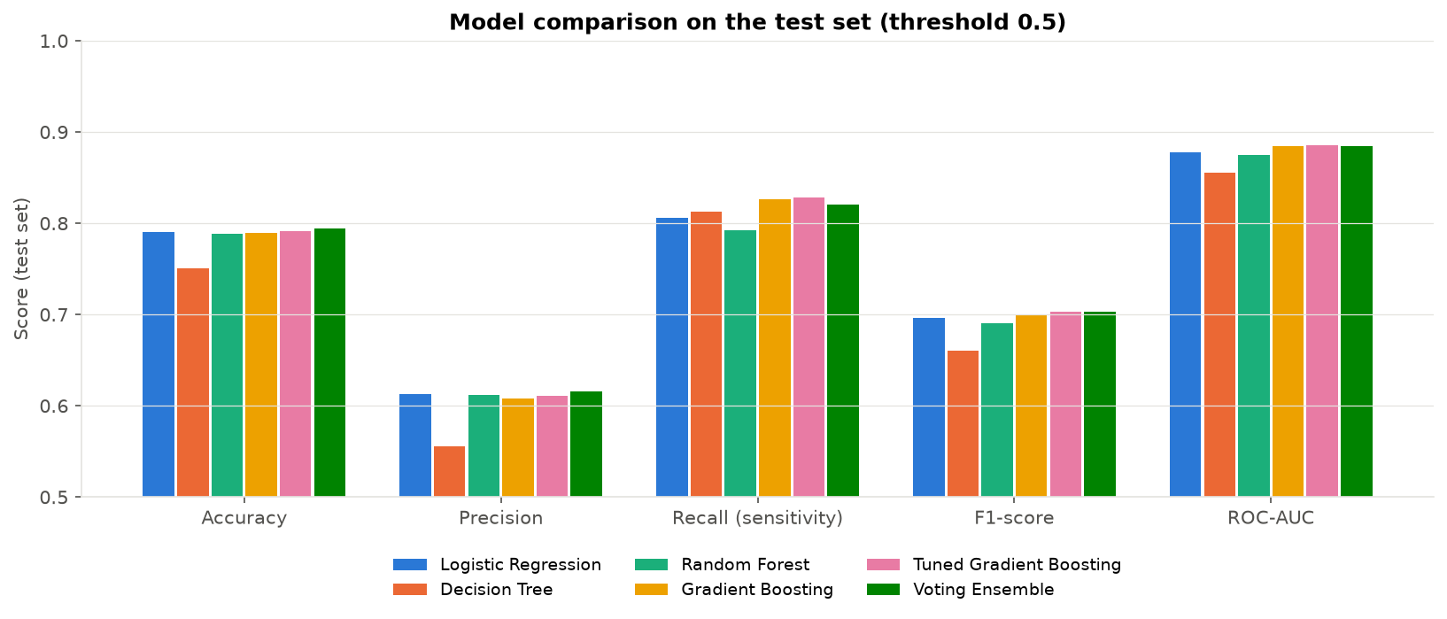
Figure 13: Comparison of the main models on the test set

9.2 ROC and Precision-Recall Curves
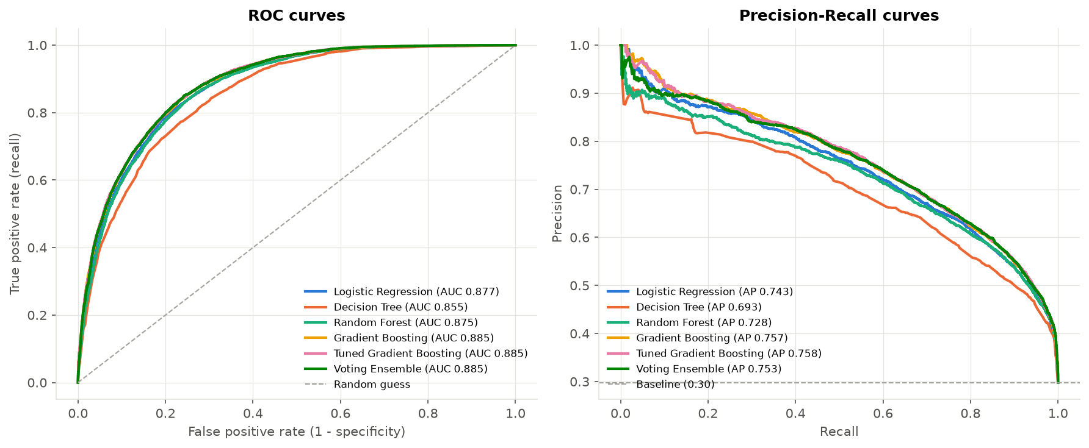
Figure 14: ROC curves (left) and Precision-Recall curves (right)
The ROC curve (Figure 14, left) shows the trade-off between catching admissions (true positive rate) and false alarms (false positive rate) for every threshold. All curves are far above the diagonal (random guessing, AUC 0.5). The Precision-Recall curve (right) is more informative for imbalanced data; the best model's PR-AUC of 0.758 is much higher than the baseline of 0.30 (the admission rate).

9.3 Confusion Matrices
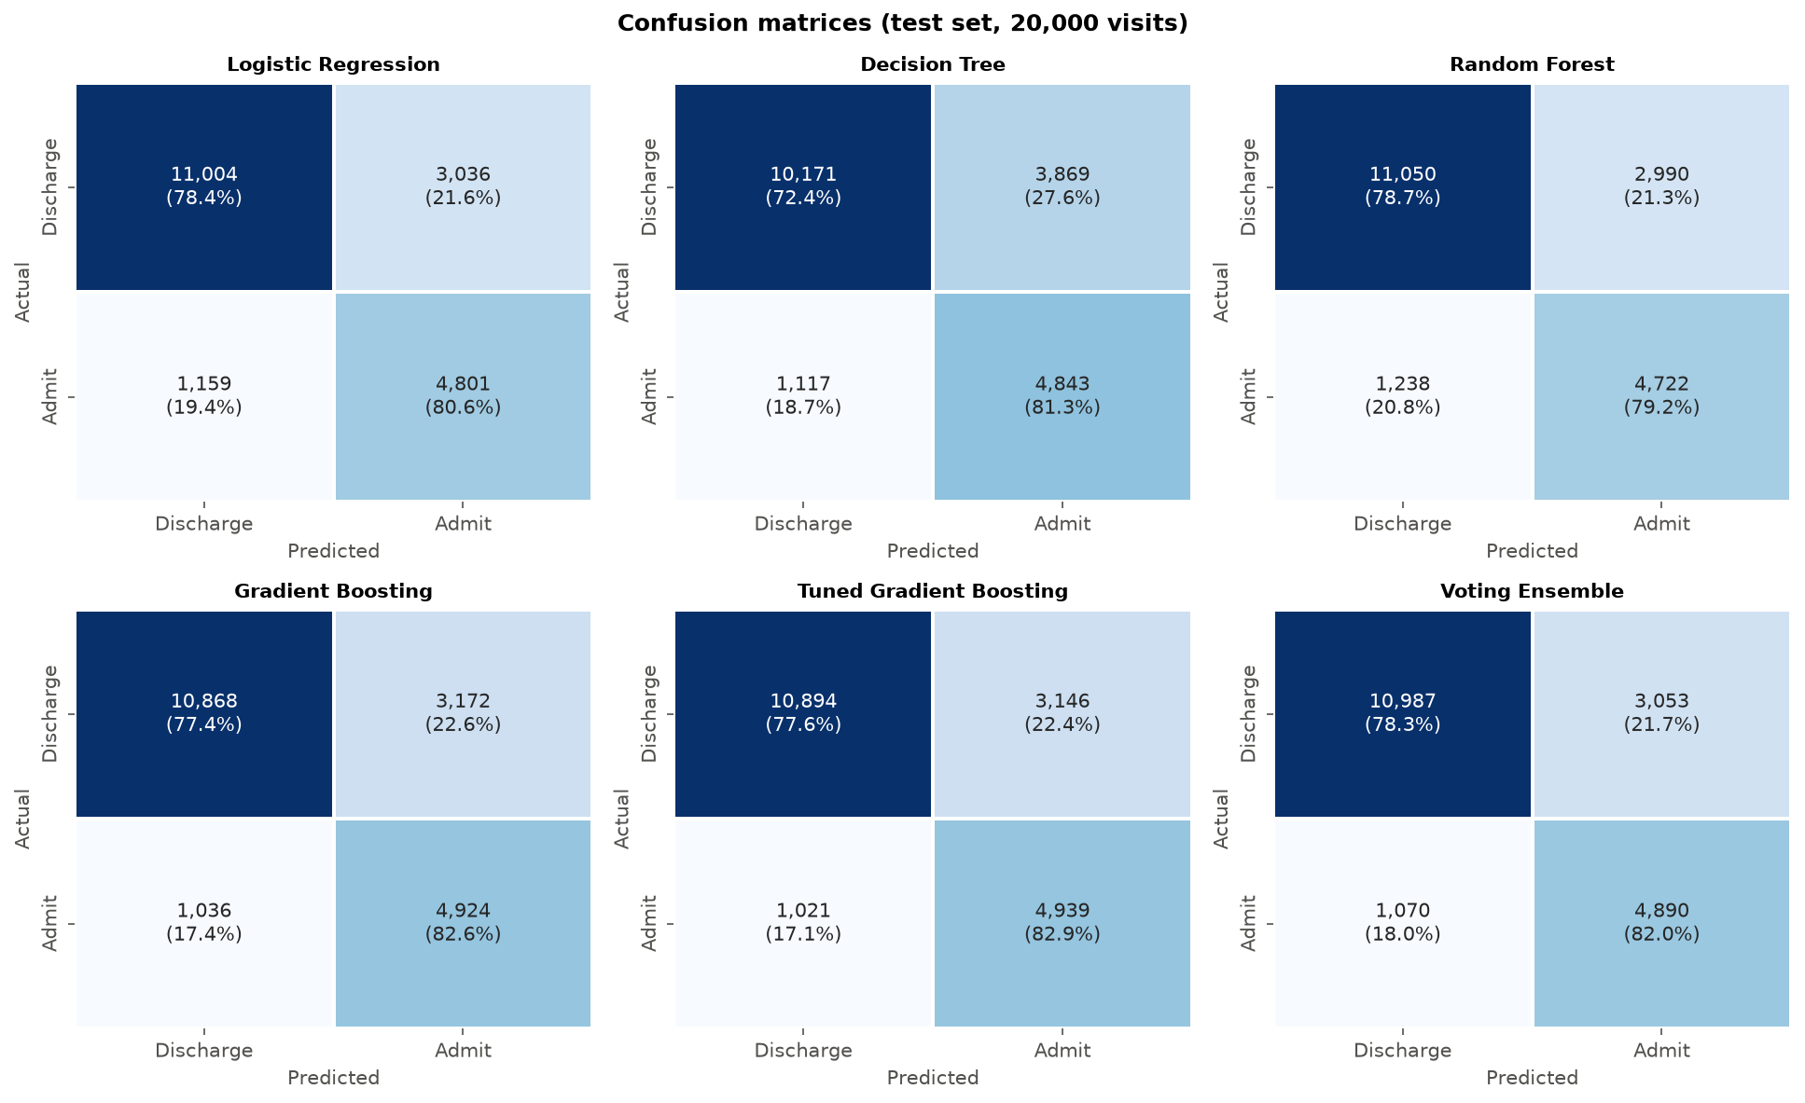
Figure 15: Confusion matrices of all main models (test set)
For the final model, about 4,939 of 5,960 admitted patients were correctly identified (recall 82.9%) and about 10,894 of 14,040 discharged patients were correctly identified (specificity 77.6%). The remaining errors are mostly borderline cases (ESI 3 patients with moderate vital signs) where even clinicians need test results before deciding.

9.4 Decision-Threshold Tuning
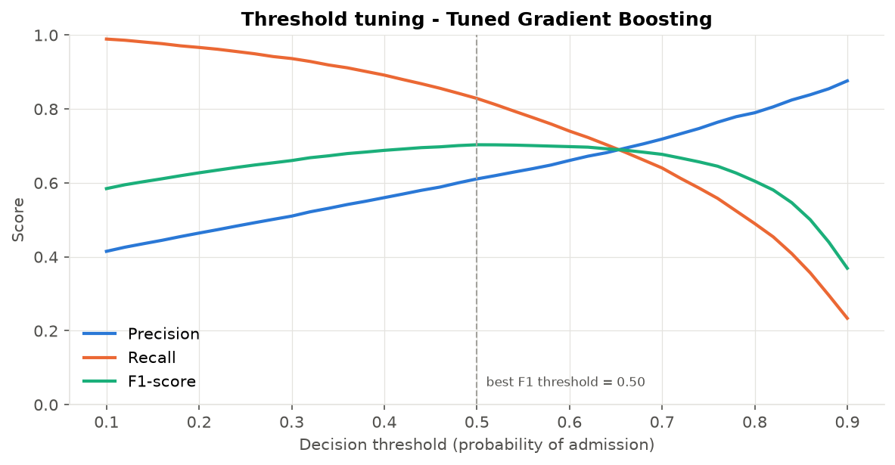
Figure 16: Precision, recall and F1-score for different decision thresholds
The default threshold of 0.5 is not always the best choice. Figure 16 shows that the F1-score is highest at a threshold of 0.50. A hospital can move the threshold depending on its goal: at 0.40 the model catches 89% of admissions (precision 56%), useful for early bed requests; at 0.70 precision rises to 72% but recall falls to 64%. The GUI uses three risk bands (LOW < 0.40, MODERATE 0.40-0.50, HIGH ≥ 0.50) based on this analysis.

9.5 Feature Importance
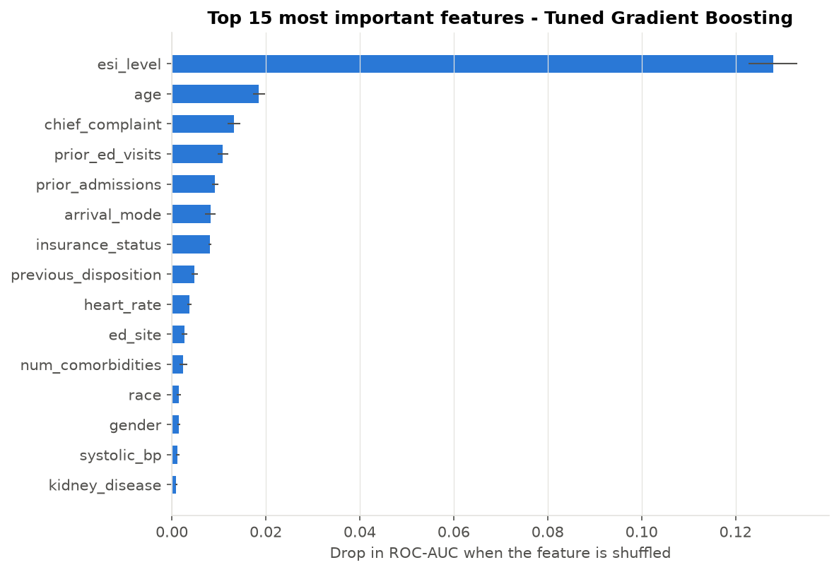
Figure 17: Permutation feature importance of the final model
Permutation importance measures how much the test ROC-AUC drops when the values of one feature are randomly shuffled. The most important features are esi_level (0.128), age (0.019), chief_complaint (0.013), prior_ed_visits (0.011), prior_admissions (0.009). This agrees with clinical intuition and with the EDA: urgency, age, the main complaint and past hospital use drive admission decisions.

9.6 Data-Leakage Check
During EDA the number of home medications showed an unusually strong relationship with admission (admitted patients: 6.1 medications on average, discharged: 0.5). In hospitals the medication list is completed during medication reconciliation, which happens as part of the admission process. The feature therefore partly records the outcome itself and would not be reliably available at triage.
Table 10: Effect of the leaky feature on model performance
Feature set (tuned Gradient Boosting) | Test ROC-AUC
With home_medications (leaky) | 0.9271
Final model (without) | 0.8853

Adding the feature increases ROC-AUC from 0.885 to 0.927, an over-optimistic result that would not hold in real use. The feature was therefore excluded, and all results in this report are for the honest model. The final performance is in line with the original study by Hong et al. (2018), which reported ROC-AUC values between about 0.87 and 0.92 depending on which variables were used.

10. Dataset 2 and Cross-Dataset Validation

10.1 Korean KTAS Dataset
Dataset 2 was cleaned with the same principles: the Korean text '측불' (unmeasurable) found in the vital-sign columns (for example 25 systolic BP and 20 heart-rate values) was converted to missing values, the pain score was set to 0 for patients without pain, and transfers/deaths were removed. Figure 18 shows the class distribution (32.9% admitted), the admission rate by nurse KTAS level (from 91% for KTAS 1 to 8% for KTAS 5) and the age difference between the groups.
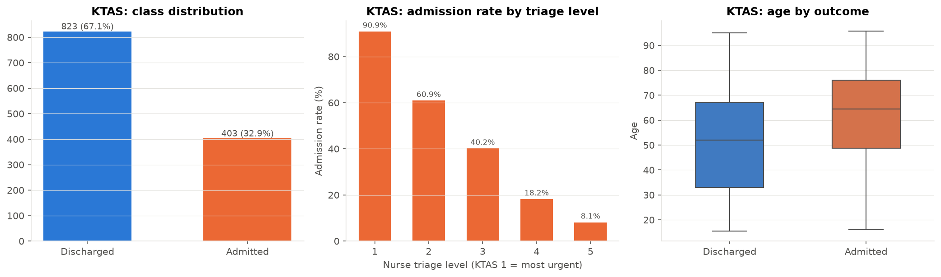
Figure 18: EDA of the Korean KTAS dataset
Because the dataset is small, models were evaluated with 5-fold stratified cross-validation instead of a single split, which gives a more reliable estimate.
Table 11: KTAS models - 5-fold stratified cross-validation
Model | Accuracy | Precision | Recall | F1 | ROC-AUC | AUC std
Nurse KTAS level only (baseline) | 0.644 | 0.473 | 0.759 | 0.583 | 0.711 | ± 0.045
Logistic Regression | 0.737 | 0.584 | 0.715 | 0.642 | 0.799 | ± 0.045
Random Forest | 0.745 | 0.601 | 0.682 | 0.638 | 0.808 | ± 0.028
Gradient Boosting | 0.746 | 0.605 | 0.682 | 0.639 | 0.794 | ± 0.030

Using only the nurse's KTAS level gives a ROC-AUC of 0.711. Adding age, vital signs, arrival mode, mental state and pain information raises it to 0.808 (Random Forest), and accuracy from 0.644 to 0.745. This proves that machine learning adds value over the triage scale alone, also in a second country.

10.2 External Validation (USA → Korea)
To test generalisation, a model was trained on the USA data using only the ten triage features that both datasets share (age, sex, triage level, ambulance arrival, heart rate, systolic and diastolic BP, respiratory rate, temperature in °C and oxygen saturation). ESI and KTAS are both five-level scales where 1 is the most urgent, so they were mapped directly. The model was then tested on the Korean patients, which it had never seen.
Table 12: External validation of the triage-only model
Test data | ROC-AUC
USA test set (same hospital system) | 0.848
Korea KTAS (external, never seen) | 0.760

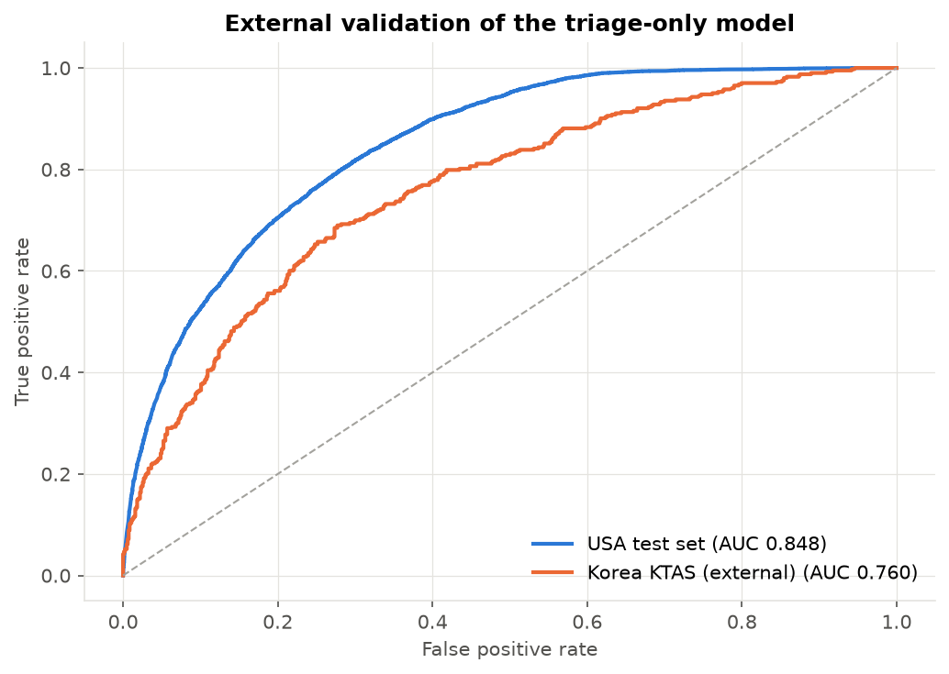
Figure 19: ROC curves of the triage-only model on USA and Korean data
The model keeps useful discrimination on Korean patients (ROC-AUC 0.760) although it was trained in another country with another triage scale, but performance drops from 0.848. Differences in patient populations, triage practice and admission policies explain the gap. In practice, a model should therefore be fine-tuned and re-calibrated on local data before deployment.

11. Visualization and User Interface
The brief asks for a simple, user-friendly visualization or interface. The project provides three levels of visualization: (1) 19 charts saved automatically in outputs/figures, (2) a desktop application (03_admission_app.py) for ED staff and bed managers, and (3) a bed-demand forecast.

11.1 Admission Prediction App
The app was built with Tkinter, which is included with Python, so no extra installation is needed. The 'Predict Admission' tab contains a form grouped like a triage sheet (patient, arrival & triage, vital signs, history, known conditions). After pressing Predict, the app shows the risk level (LOW / MODERATE / HIGH) in a coloured box, the decision, the model score as a progress bar, a calibrated probability and a recommended action. The button Load random test patient fills the form with a real visit from the unseen test set and shows its true outcome, which is useful for demonstrations. Invalid input (for example letters in the age field) is caught and explained.
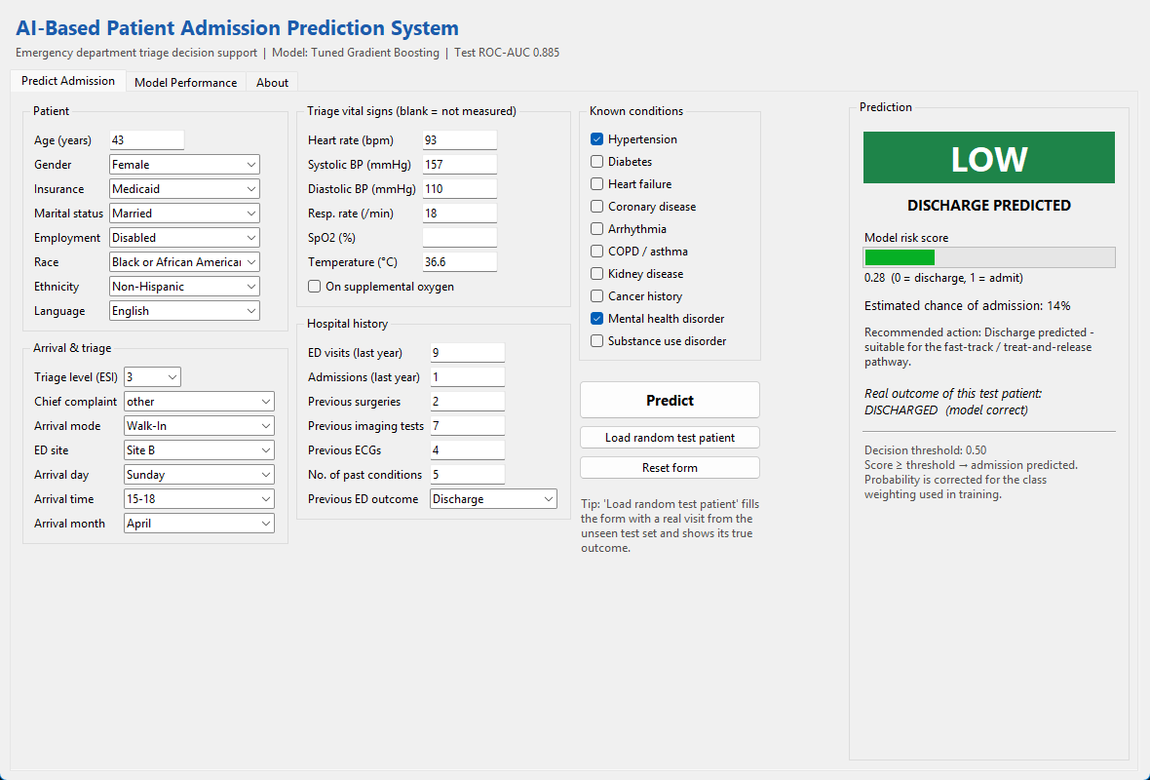
Figure 20: Prediction tab of the Admission Prediction App
The 'Model Performance' tab shows the comparison tables for both datasets and a chart viewer for all project figures, so users can understand how reliable the model is. The 'About' tab lists the datasets, the group members and a clinical disclaimer.
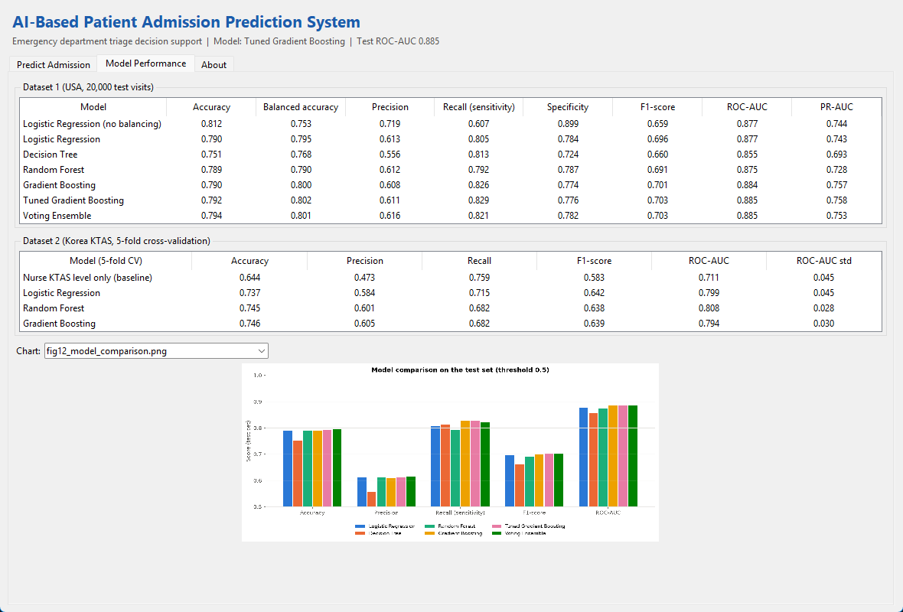
Figure 21: Model Performance tab with tables and chart viewer

11.2 Bed-Demand Forecast
Because the model is trained with balanced class weights, its raw scores are shifted upwards (the sum of raw scores over the test set predicts 8,134 admissions while only 5,960 happened). The scores were therefore calibrated by dividing the predicted odds by the class ratio (2.36). Summing the calibrated probabilities gives a forecast of 5,891 admissions - within 1.2% of the real number.
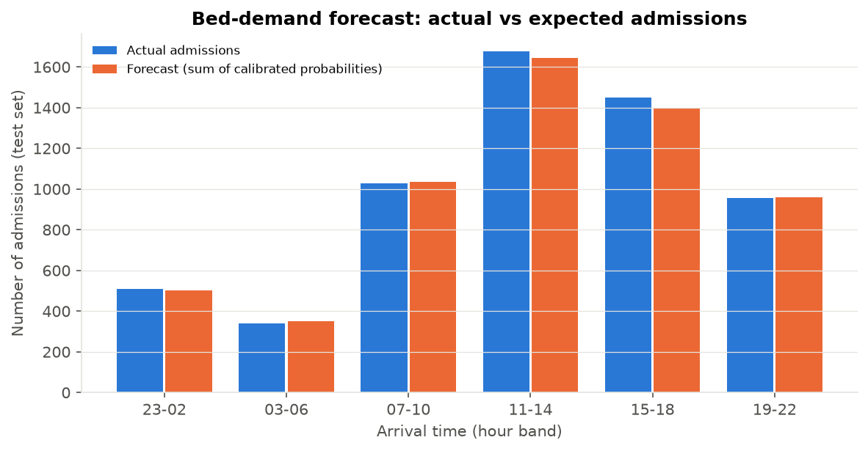
Figure 22: Actual vs forecast admissions per arrival time band
Table 13: Bed-demand forecast by arrival time band (test set)
Arrival time | Actual admissions | Forecast | Error
23-02 | 509 | 501 | -1.6%
03-06 | 340 | 351 | +3.2%
07-10 | 1028 | 1036 | +0.8%
11-14 | 1678 | 1643 | -2.1%
15-18 | 1449 | 1401 | -3.3%
19-22 | 956 | 959 | +0.3%

A bed manager can add up the calibrated probabilities of all patients currently waiting in the ED to estimate how many beds will be needed in the next hours - a direct, actionable use of the model for better hospital operations.

12. Challenges and Solutions
Table 14: Main challenges and how they were solved
Challenge | Solution
Very large raw file (972 columns, 560k rows, 7.4 GB in memory) | Summarised related columns and sampled 100,000 visits; preparation done once in a separate script.
Data stored in R format (.RData) | Read in Python with the pyreadr package and saved as CSV.
Many missing vital signs (30-48%) | Median imputation with missing-indicator columns instead of deleting rows.
Text in numeric columns (Korean '측불') | Converted with pd.to_numeric(errors='coerce') after inspecting the values.
Inconsistent categories and units | Standardised spelling, converted °F to °C, unified placeholders.
Class imbalance | Stratified split, class weights, PR-AUC/F1, threshold tuning.
Data leakage (home medications) | Detected in EDA, confirmed with an experiment, excluded from the model.
Over-confident probabilities after class weighting | Prior-correction calibration for the bed-demand forecast.
Long training time for tuning | RandomizedSearchCV (12 settings) instead of a full grid; fast histogram boosting; n_jobs = -1.
Different triage scales and units in two countries | Built a harmonised set of 10 shared features for external validation.

13. Ethical Considerations and Limitations
• Privacy: both datasets are de-identified and publicly released for research; no names, dates of birth or record numbers are present. The project runs locally and no data is sent to external services.
• Fairness: demographic variables (race, insurance) were included because they were in the source data, but they have low importance. A real system should audit performance per group so that no group is disadvantaged.
• Human in the loop: the system only supports decisions. The final admission decision remains with clinicians, and the GUI shows a clear disclaimer.
• Limitations: data from 2014-2017 and from specific hospitals; admission policies differ between hospitals and change over time; the external validation showed a drop in performance; lab results and free-text notes were not used.

14. Conclusion and Future Work
This project developed a complete AI-based patient admission prediction system in Python. Two real-world datasets were cleaned and analysed, the main factors behind admission were identified (triage level, age, chief complaint, hospital history, arrival mode and vital signs), and several machine-learning models were trained, tuned and compared. The final Tuned Gradient Boosting model predicts admission at triage with a ROC-AUC of 0.885, recall of 82.9% and accuracy of 79.2% on 20,000 unseen visits, after removing a leaky feature that would have inflated the results. Validation on a Korean dataset showed that the approach generalises, with some loss in accuracy. The Tkinter application and the calibrated bed-demand forecast turn the model output into information that ED staff and bed managers can act on.
Future work:
• Add early laboratory results and free-text triage notes (natural language processing).
• Re-train and calibrate the model on data from a local (for example Karachi) hospital.
• Explain individual predictions with SHAP values in the interface.
• Integrate the model with the hospital information system for real-time bed dashboards.
• Monitor fairness and model drift over time.

References
• Hong WS, Haimovich AD, Taylor RA. Predicting hospital admission at emergency department triage using machine learning. PLOS ONE. 2018;13(7):e0201016. Data: https://github.com/yaleemmlc/admissionprediction (Zenodo record 1308993).
• Moon SH, Shim JL, Park KS, Park CS. Triage accuracy and causes of mistriage using the Korean Triage and Acuity Scale. PLOS ONE. 2019;14(9):e0216972. Supporting information S1 Data.
• Pedregosa F, et al. Scikit-learn: Machine Learning in Python. Journal of Machine Learning Research. 2011;12:2825-2830.
• McKinney W. Data Structures for Statistical Computing in Python. Proceedings of the 9th Python in Science Conference. 2010.
• Hunter JD. Matplotlib: A 2D Graphics Environment. Computing in Science & Engineering. 2007;9(3):90-95.
• Waskom ML. seaborn: statistical data visualization. Journal of Open Source Software. 2021;6(60):3021.
• Chen T, Guestrin C. XGBoost: A Scalable Tree Boosting System. Proceedings of KDD. 2016 (gradient boosting background).

Appendix A: Project Files and How to Run
Table 15: Project files
File / folder | Purpose
01_prepare_datasets.py | Builds the two CSV files from the raw downloads (run once; CSVs already included)
02_admission_prediction.py | Main project: preprocessing, EDA, imbalance, models, tuning, evaluation, validation
03_admission_app.py | Tkinter user interface for predictions and results
admission_utils.py | Shared cleaning functions and constants used by the scripts and the app
data/ed_patient_flow.csv | Dataset 1 - 100,000 ED visits (USA)
data/ktas_triage.csv | Dataset 2 - 1,267 ED visits (Korea)
outputs/figures/ | All 19 charts produced by the main script
outputs/metrics/ | Result tables (CSV): model comparison, tuning, feature importance, etc.
outputs/models/ | Saved final model, model information and demo patients for the app
requirements.txt / README.md | Library list and instructions

Steps to run:
pip install -r requirements.txt
python 02_admission_prediction.py # about 5.4 minutes, creates outputs/
python 03_admission_app.py # opens the prediction interface

Appendix B: Key Code
Code 3: cleaning of the Korean KTAS dataset (admission_utils.py)
def clean_ktas(df):
"""Clean Dataset 2 (Korean KTAS emergency department records)."""
df = df.copy()
df.columns = [c.strip() for c in df.columns]

# Vital signs contain the Korean word '측불' (= "unmeasurable") -> NaN
for col in ["SBP", "DBP", "HR", "RR", "BT", "Saturation"]:
df[col] = pd.to_numeric(df[col], errors="coerce")

limits = {"SBP": (50, 300), "DBP": (20, 200), "HR": (20, 250), "RR": (5, 60),
"BT": (32, 43), "Saturation": (50, 100)}
for col, (low, high) in limits.items():
df.loc[(df[col] < low) | (df[col] > high), col] = np.nan

# Pain score is only recorded when the patient has pain; no pain -> score 0
df.loc[df["Pain"] == 2, "NRS_pain"] = df.loc[df["Pain"] == 2, "NRS_pain"].fillna(0)

# Transfers and deaths are neither 'admitted here' nor 'sent home' -> removed
df = df[df["Disposition"].isin(KTAS_ADMIT_CODES + KTAS_NOT_ADMIT_CODES)].copy()
df[TARGET] = df["Disposition"].isin(KTAS_ADMIT_CODES).astype(int)
return df

Code 4: evaluation function with all metrics
def evaluate(y_true, prob, threshold=0.5):
pred = (prob >= threshold).astype(int)
tn, fp, fn, tp = confusion_matrix(y_true, pred).ravel()
return {
"Accuracy": accuracy_score(y_true, pred),
"Balanced accuracy": balanced_accuracy_score(y_true, pred),
"Precision": precision_score(y_true, pred),
"Recall (sensitivity)": recall_score(y_true, pred),
"Specificity": tn / (tn + fp),
"F1-score": f1_score(y_true, pred),
"ROC-AUC": roc_auc_score(y_true, prob),
"PR-AUC": average_precision_score(y_true, prob),
}

Code 5: prediction of one patient in the app
def predict(self, patient):
row = pd.DataFrame([{c: patient.get(c, np.nan) for c in FEATURES}])
row, _ = clean_patient_flow(row, self.info["top_complaints"])
score = float(self.model.predict_proba(row[FEATURES])[:, 1][0])
probability = float(calibrate_probability(score, self.info["prior_ratio"]))
band, action = risk_band(score, self.threshold)
return {"score": score, "probability": probability, "band": band, "action": action,
"admit": score >= self.threshold}



