**Alberto Clocks**

*User Guide*

|  |  |  |
| --- | --- | --- |
| **Supervisor.** | **Sir Ebad Uddin** | |
| **Batch.** | **2210E1** | |
| **Group.** | A | |
| **Serial No.** | **Enrollment Number** | **Student Name** |
| 1. | 1424649 | Tayyaba Muslim |
| 2. | 1426353 | Mutayba Kamran |
| 3. | 1425430 | Muhammad Talha |
| 4. | 1425319 | Khula Amjad |



1. **Home** (*index (1).html*)

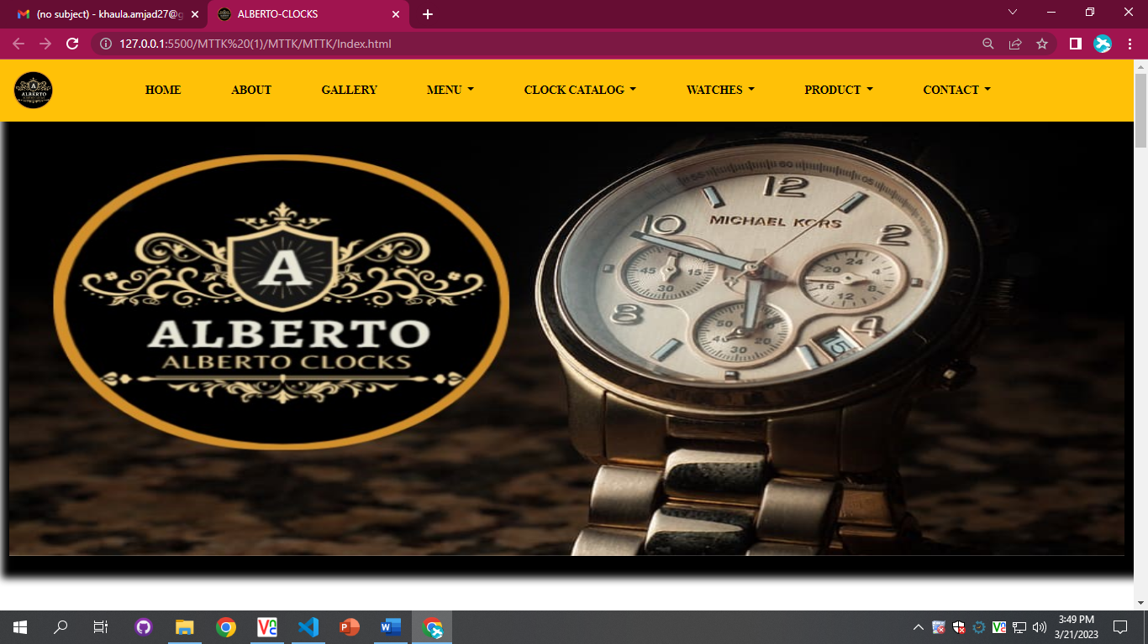

***Figure 1: Home page of Alberto Clocks***

 Our Slogan has given to the peoples toward our website. “TO BUY WATCHES AND CLOCKS AT THE CHEAPEST PRICE ”.

* OUR HOME PAGE WELCOME OUR CUSTUMERS WITH BEAUTIFUL QOUTE.

**Code of Home page**

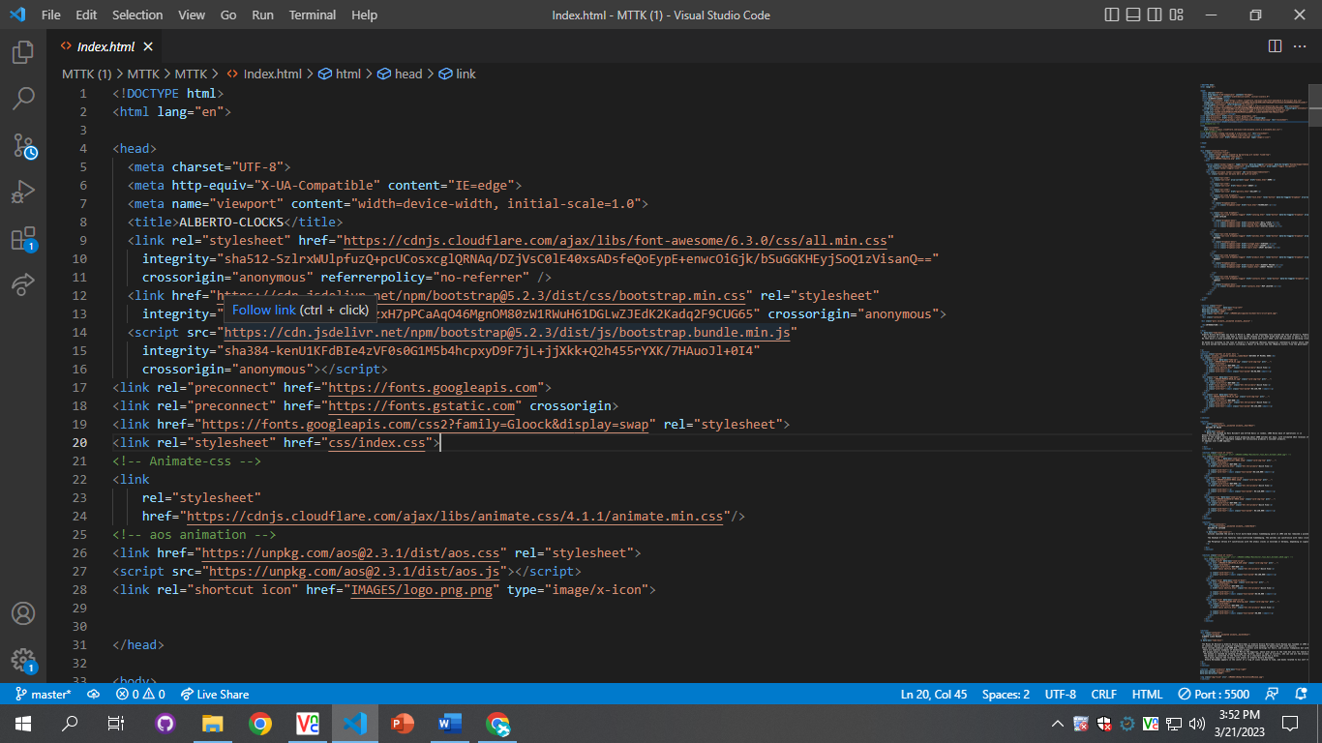

1. **Navbar (index.html)**

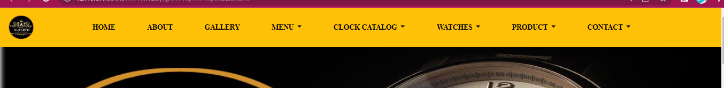

***Figure 2: Navbar***

We have given Eight tabs. By clicking any of the essential’s and redirect to the linked page. (Index.html)

**Code of Navbar**

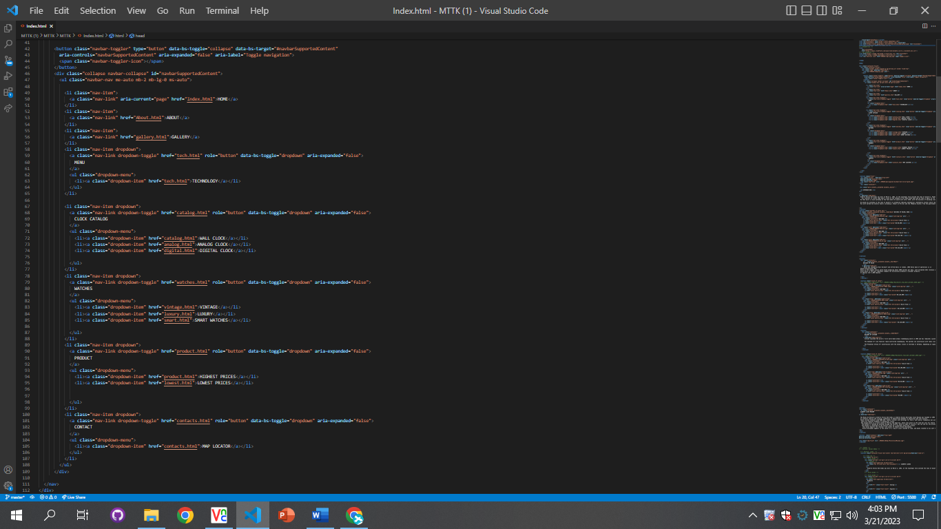

1. **MENU (index .html)**

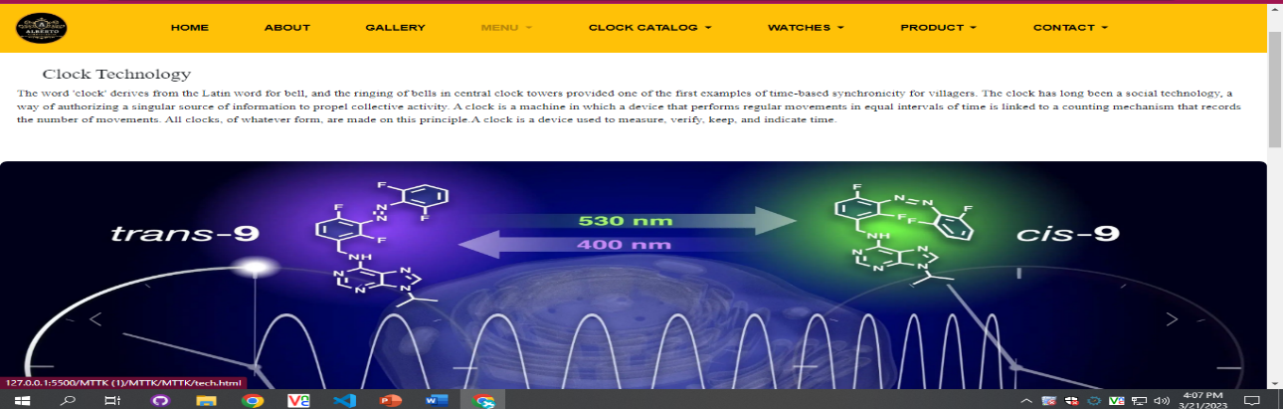

***Figure 3: Menu***

**



* We give discount offers to our clients.
* They see different kinds of offers in which watches and clocks they interested.

***Code of MENU***

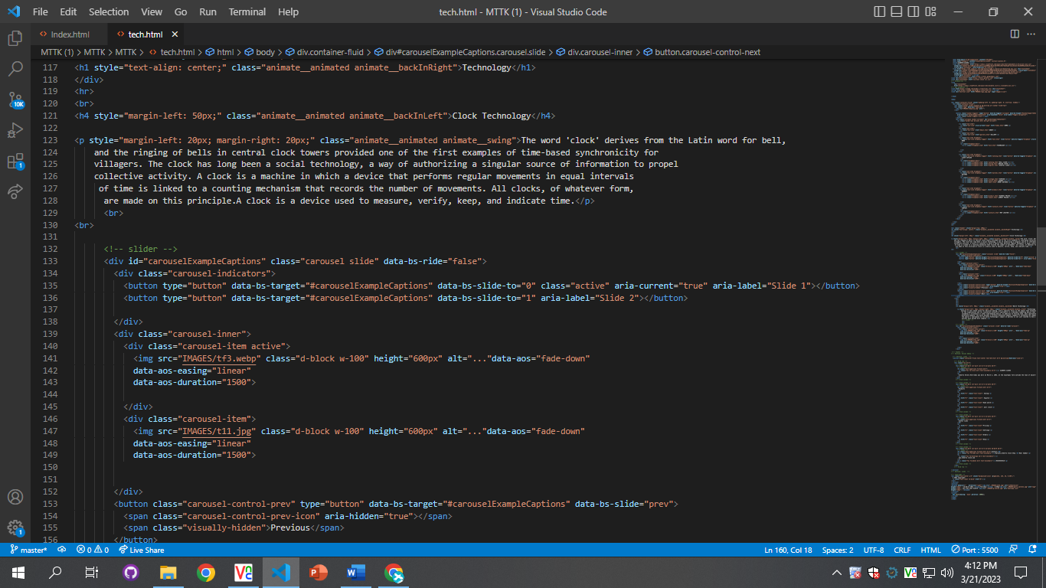

***Figure 4: Products***

*We have mentioned our basic products to make people known about the products we provide.*

* ***There we show such our comfortable clocks and watches.***
* ***There our clients also see our premium quality watches ,Rolex and some brands etc***
* ***There is a button given them to apply shopping online.by clicking on the button “Quick-view”***
* ***We also provide a highest and lowest prices of watches.***

***Code of products***

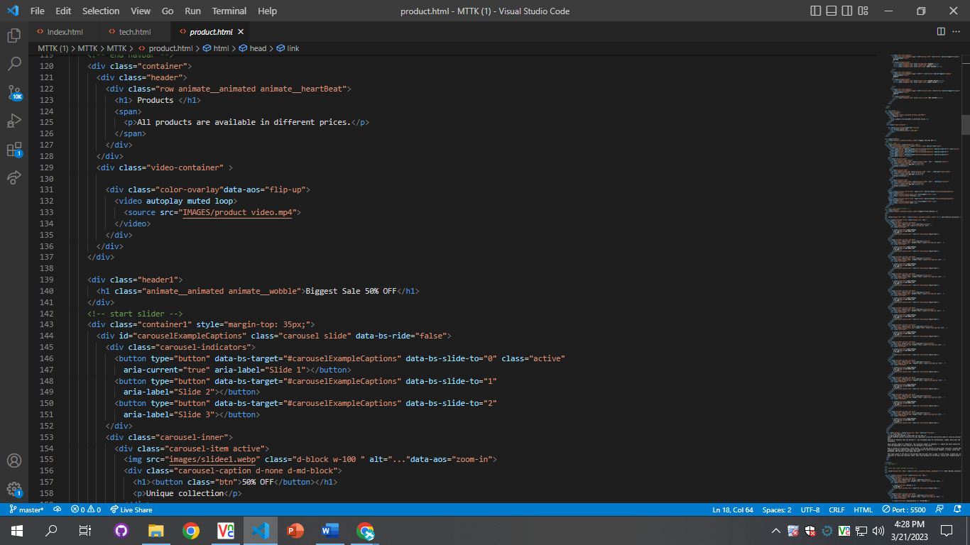

***5.NEW Brands of watches (product.html)***

***Figure 5:***

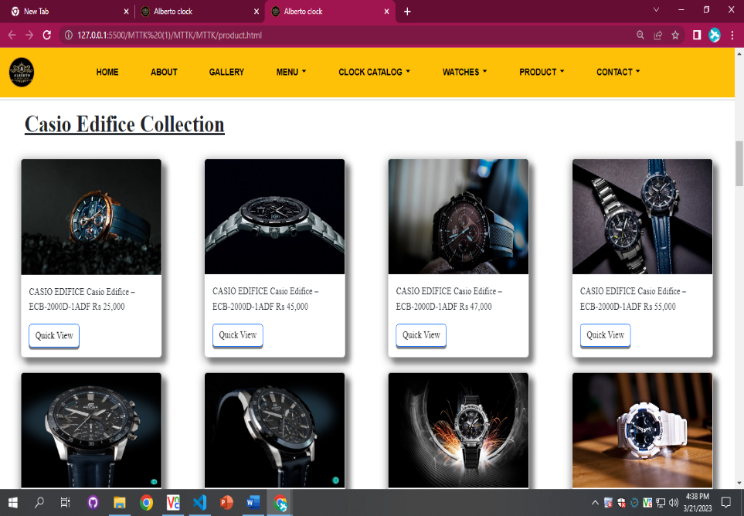

***New arrivals***

*We have given some unique kind of products in our arrival page And provide hover to highlight the multi functional product so that people who are visiting our website can gain knowledge. We give a option there to add to cart ,add in favourites.and like options by hovering on them and then there they show some kinds of options there*

* ***Multiple type of Laxuary watches.***
* ***Multiple type of Vintage watches.***
* ***Multiple type of Smart watches.***
* ***Multiple type of Brand watches.***

***6.Our team review(about .html) :***

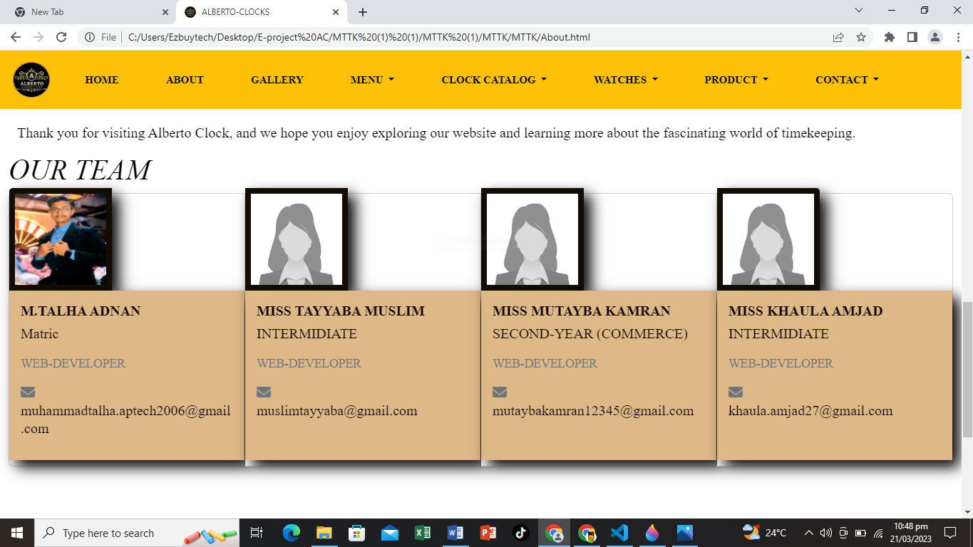

***8.Contact section(contact .html):***

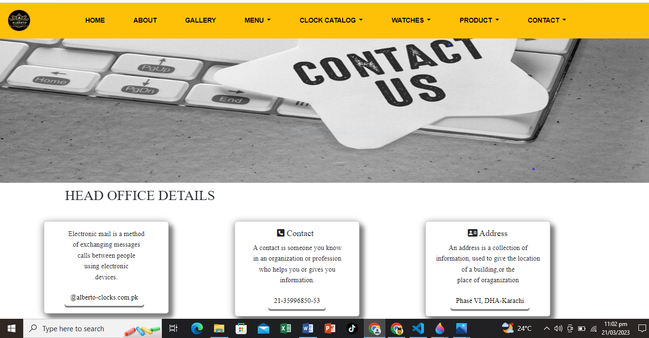

***Figure 7: Contact section***

*Our contact section* is designed to notify about our cutomers to contact us for buy products and our prices and other watches are also mentioned in **Products** page.

***9.footer (index .html):***

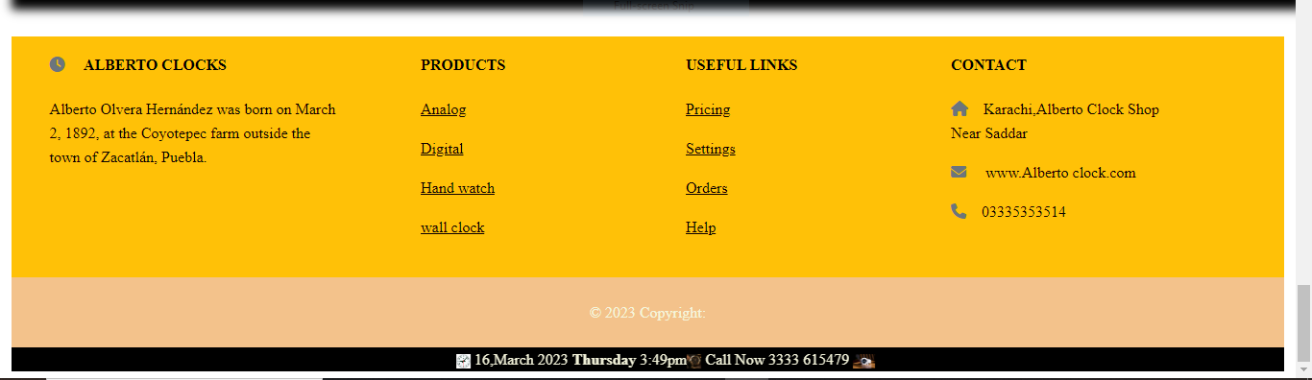

***Figure 14: Footer***

We have given some hover effects in footer to make our website more relaxing.

