=> use of let in linq
Used to create a range variable to hold a value for reuse in the query.
var result = from s in students
let total = s.Marks1 + s.Marks2
where total > 100
select new { s.Name, total };
=> Why should override Tostring() ?
To provide meaningful string representation.
public override string ToString() => $"Name: {Name}, Age: {Age}";
=> Why should override Equal()?
To compare objects by value, not reference.
public override bool Equals(object obj) => this.Id == ((Person)obj).Id;
=> Difference between Convert.tostring() and Tostring()
Convert.ToString() handles nulls safely. ToString() throws NullReferenceException if the object is null.
string a = null;
Convert.ToString(a); // ""
a.ToString(); // Exception
=> Difference between == Operator and Equal()
== compares reference for objects, value for primitives.
Equals() can be overridden for value comparison.
string a = "test", b = new string("test".ToCharArray());
a == b; // True
a.Equals(b); // True

=> If a class has two construtors one is public and other is private . Can we create objects from outside of a class.
Yes, you can create objects only via the public constructor. Private constructor used in patterns like Singleton.
=> database locks and its types
A lock is a mechanism that prevents conflicts when two or more transactions attempt to access the same resource (like a table or row) at the same time.
Locks are used to:
- Prevent dirty reads, lost updates, or inconsistent data.
- Ensure ACID properties of transactions.

| Lock Type | Allows Read? | Allows Write? | Blocks Others? |
| ------------------ | ------------ | ------------- | ---------------------------------- |
| Shared (S) | ✅ Yes | ❌ No | Blocks writers |
| Exclusive (X) | ✅ Yes | ✅ Yes | Blocks readers & writers |
| Update (U) | ✅ Yes | 🔄 Potential | Blocks other updates or exclusives |
| Intent (IS/IX/SIX) | ❌ No | ❌ No | Just signals locking intent |
=> linq query with joins

1. Basic Inner Join (Query Syntax)
var result = from o in orders
join c in customers on o.CustomerId equals c.Id
select new { o.Id, c.Name };

2. Basic Inner Join (Lambda Syntax)
var result = orders
.Join(customers,
o => o.CustomerId,
c => c.Id,
(o, c) => new { o.Id, c.Name });

3. Join on Multiple Keys
var result = from o in orders
join c in customers
on new { o.CustomerId, o.Region } equals new { c.Id, c.Region }
select new { o.Id, c.Name, c.Region };

4. Group Join (One-to-Many Relationship)
var result = from c in customers
join o in orders on c.Id equals o.CustomerId into orderGroup
select new
{
CustomerName = c.Name,
Orders = orderGroup
};

5. Left Join (Include Even If No Match)
var result = from o in orders
join c in customers on o.CustomerId equals c.Id into gj
from subCustomer in gj.DefaultIfEmpty()
select new
{
OrderId = o.Id,
CustomerName = subCustomer != null ? subCustomer.Name : "Unknown"
};

6. Join With Filtering
var result = from o in orders
join c in customers on o.CustomerId equals c.Id
where c.Region == "East"
select new { o.Id, c.Name };

7. Join With Ordering
var result = from o in orders
join c in customers on o.CustomerId equals c.Id
orderby c.Name
select new { o.Id, c.Name };

8. Multiple Joins (Join 3 Tables)
var result = from o in orders
join c in customers on o.CustomerId equals c.Id
join p in products on o.ProductId equals p.Id
select new { OrderId = o.Id, CustomerName = c.Name, ProductName = p.Name };
=> static vs non static class
• Static: Can't be instantiated, all members static.
• Non-Static: Requires object instance.
=> abstract class vs interface
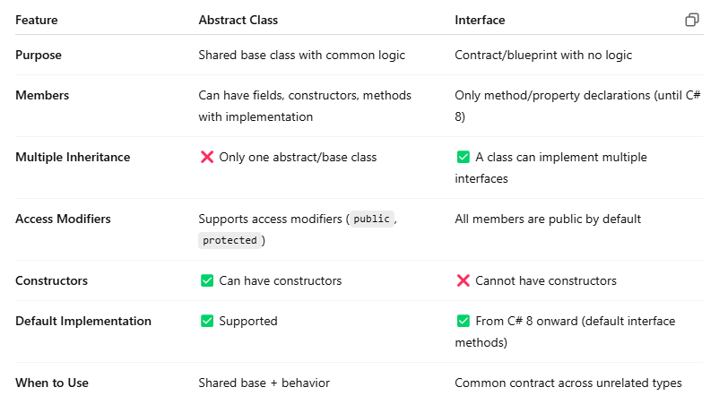
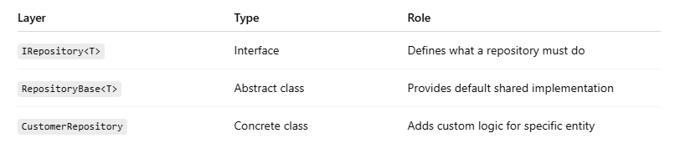
=> primitive vs non primitive
In C#, data types are categorized as primitive (also called value types) and non-primitive (also called reference types).
Primitive (Memory Location: Stack, Contains: Actual Value, Copies value, Not nullable by default, fast, int, bool, float)
Non-primitive (Heap, Reference, Copies reference, Nullable, Slower, string, class, array)
=> class vs struct
• Class: Reference type, heap
• Struct: Value type, stack
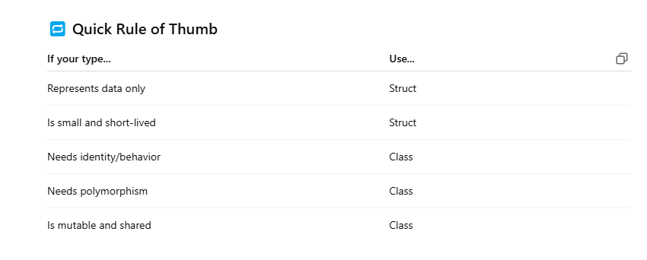
=> Extension methods
Add methods to existing types.
public static class StringExtensions
{
public static bool IsEmail(this string s) => s.Contains("@");
}

=> DI()
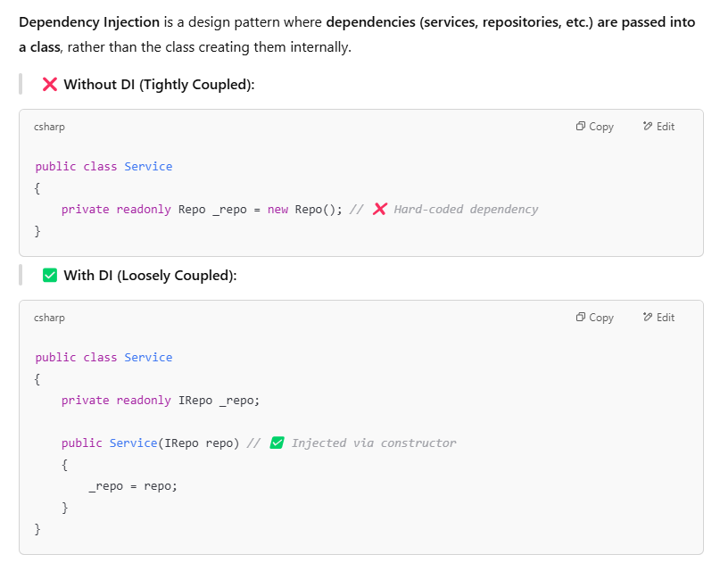
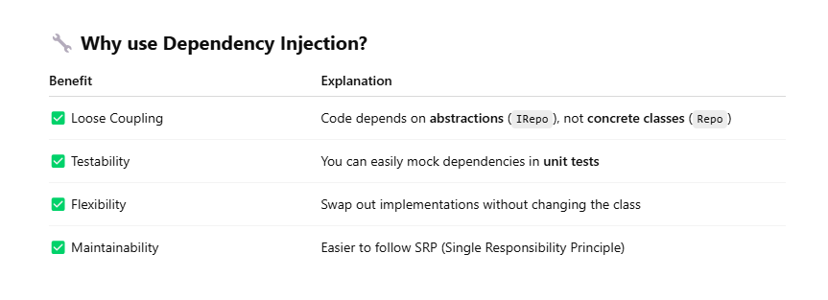
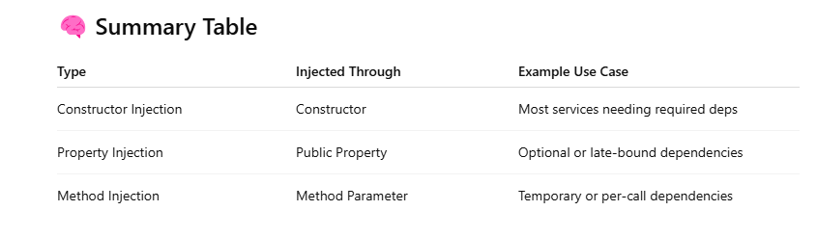
=> Design Pattern(Singleton,Factory,Repository)
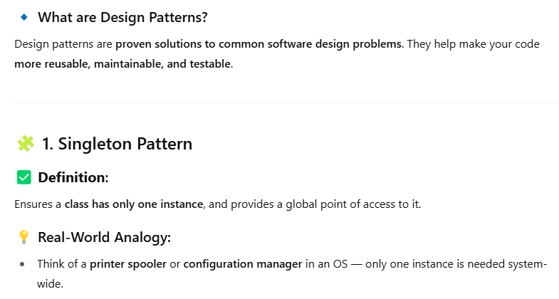
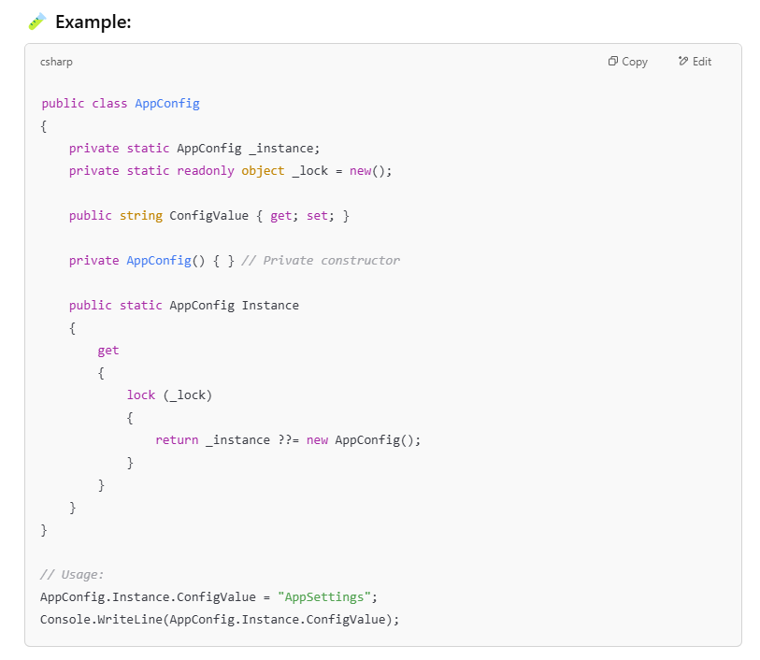
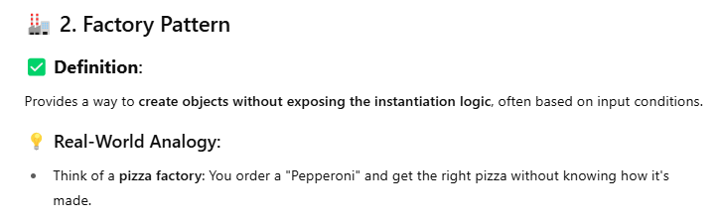
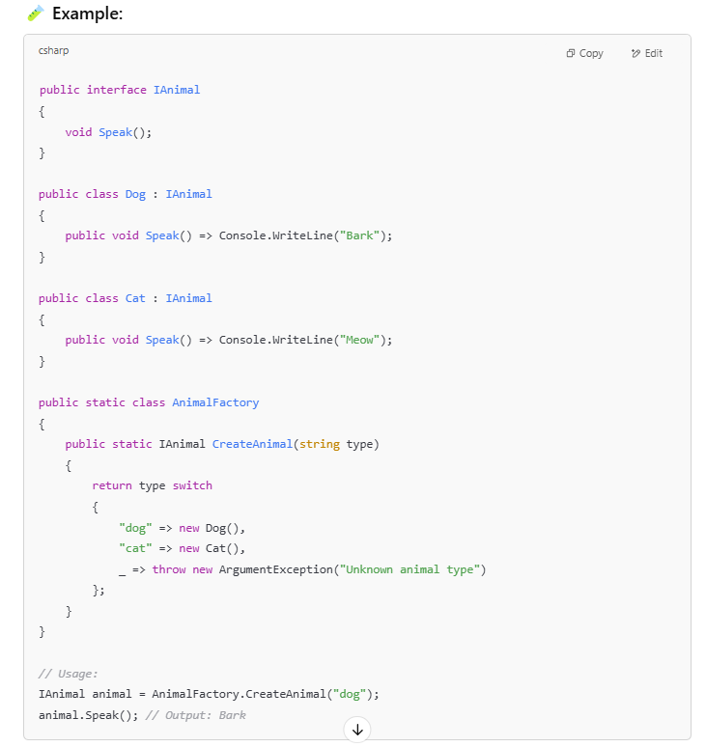
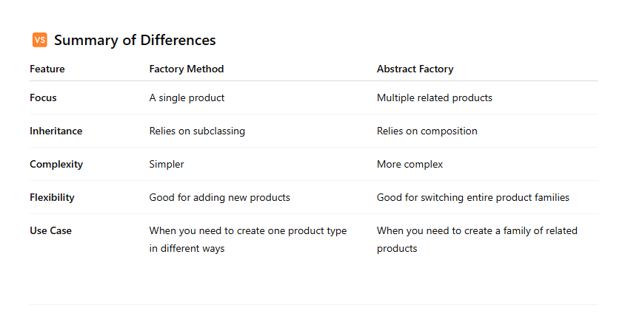
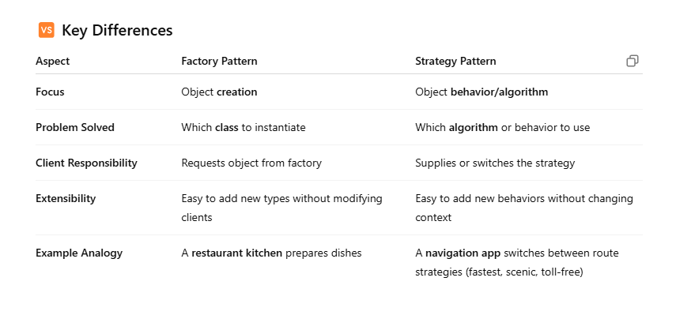
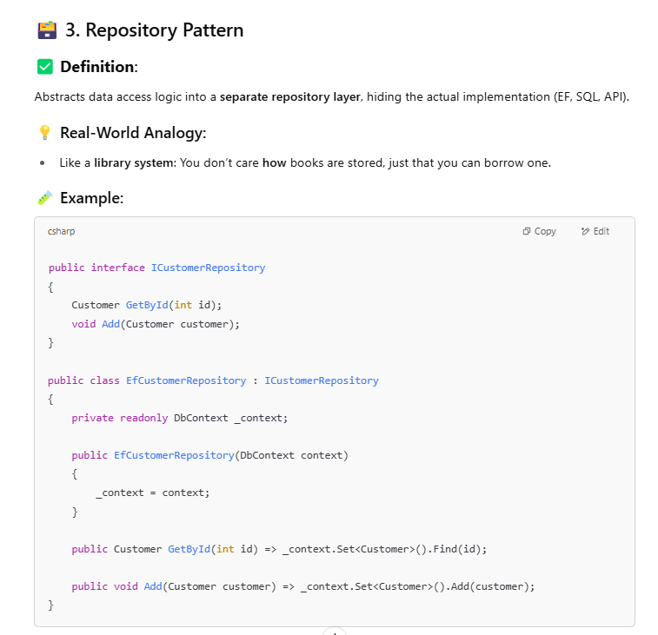
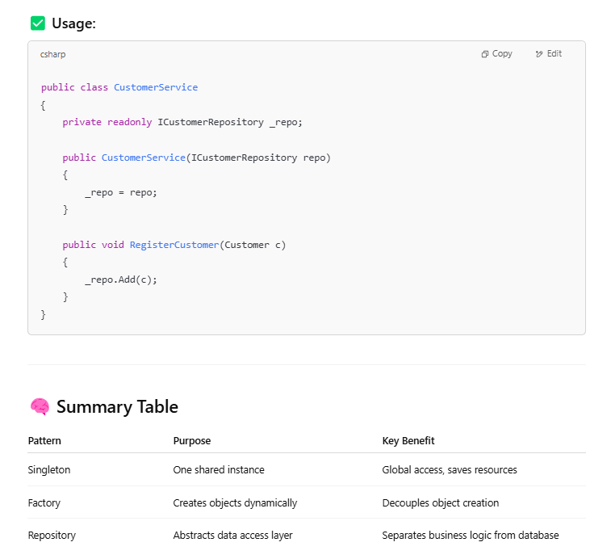

=> Threading (async,await,task,Cancellation token,Cpu vs I/0 bound)
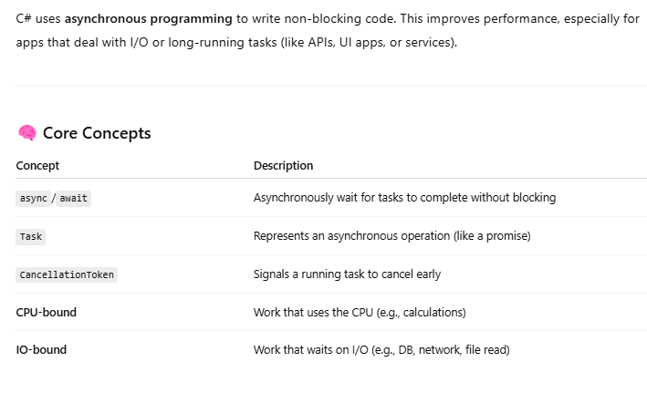
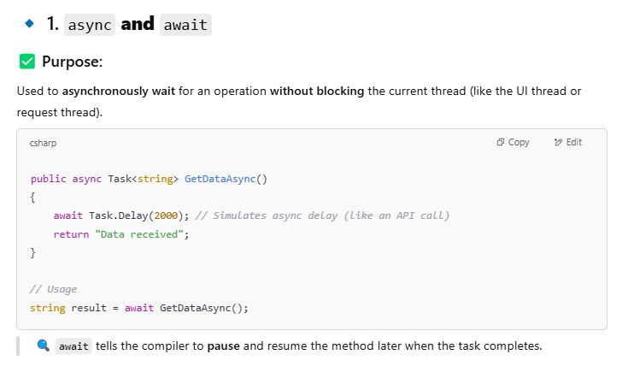
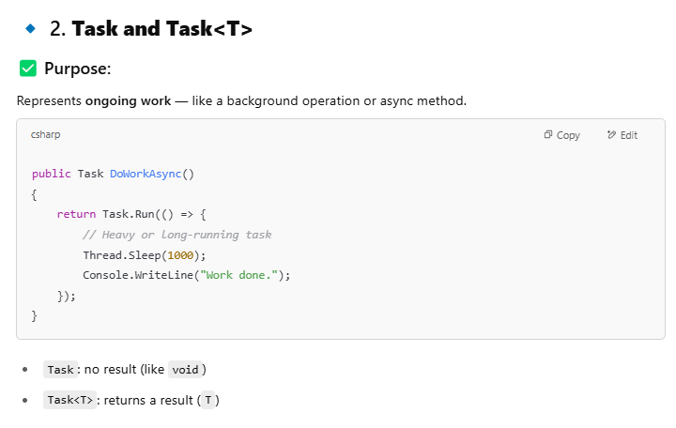
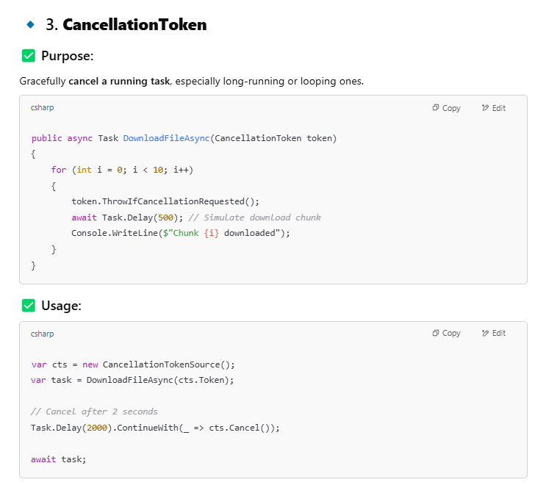
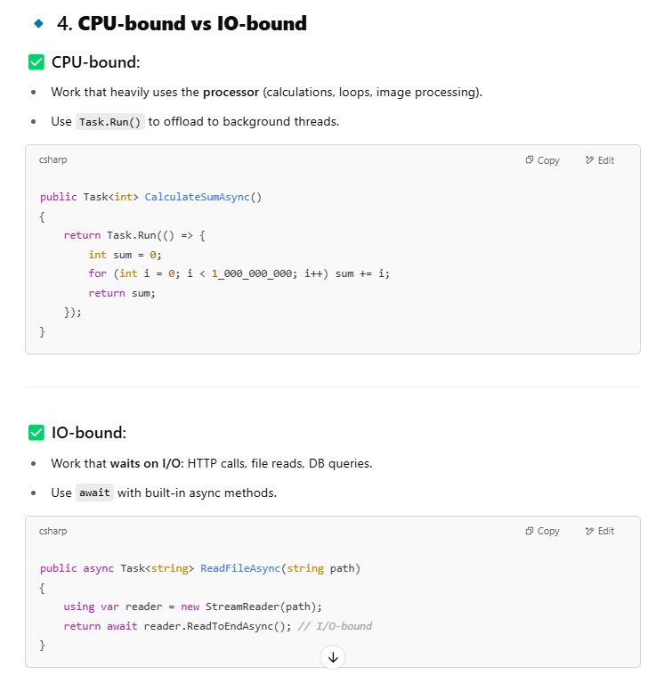
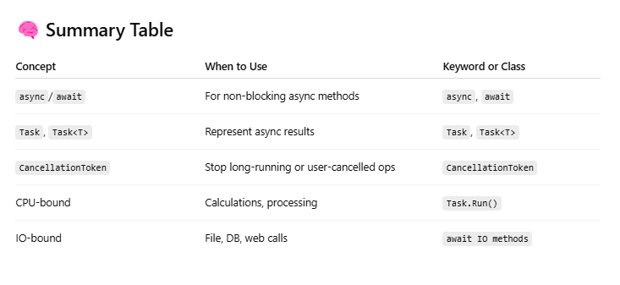
=> Aggregation in sql
Combines rows (e.g., SUM(), COUNT())
SELECT COUNT(*) FROM Orders WHERE Status = 'Delivered';
=> Tabular,scalar,aggregation(sql function)
• Tabular: Return tables (e.g., TABLE type function)
• Scalar: Return single value
• Aggregate: Operate on sets (e.g., SUM())
=> DataReader vs Dataset vs DataAdopter
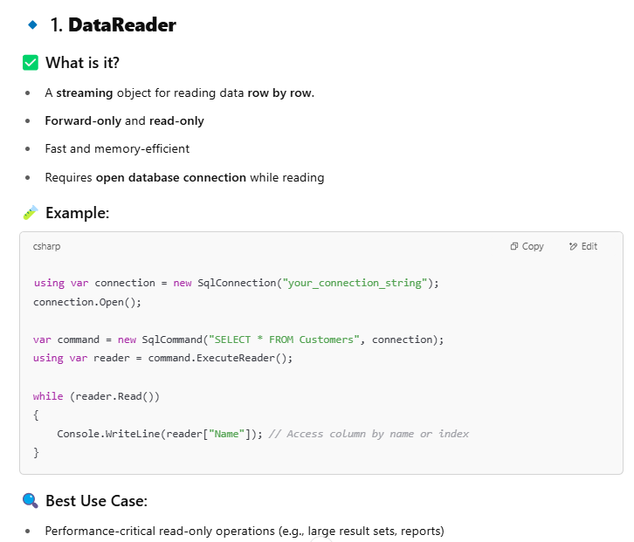
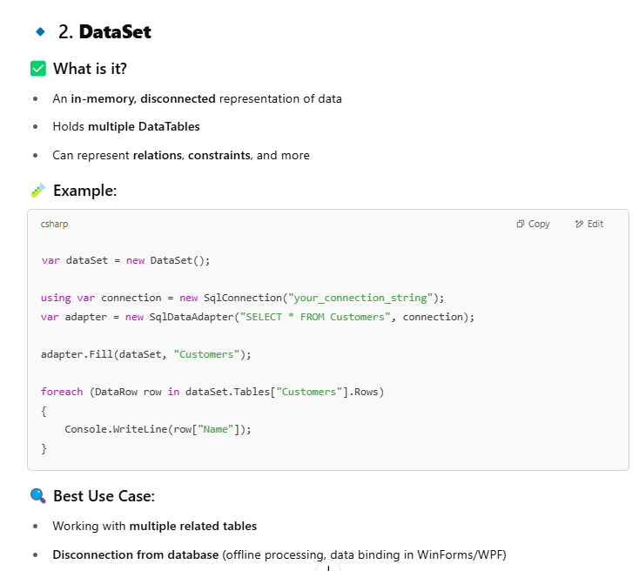
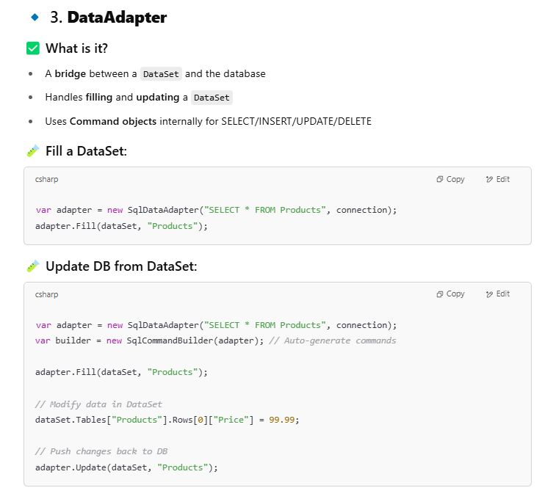
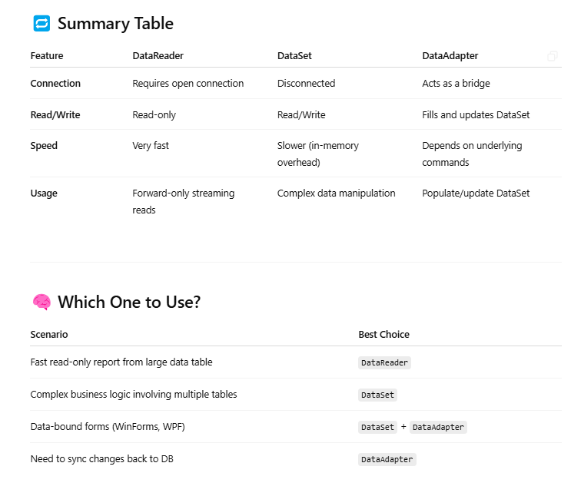

=> EF Core vs ADO.NET
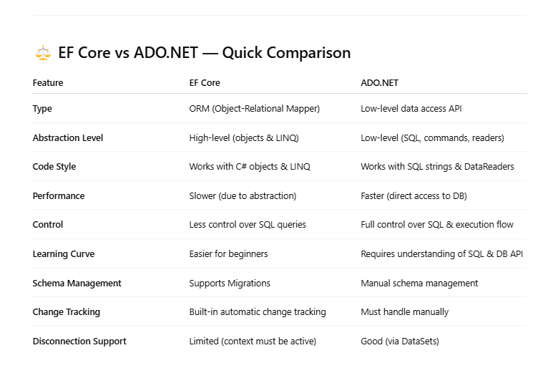
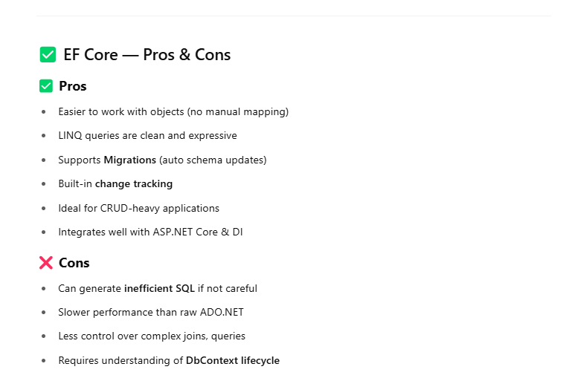
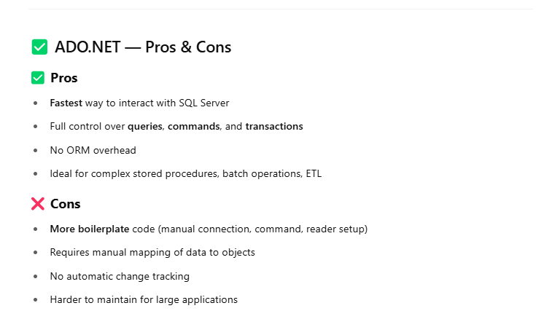
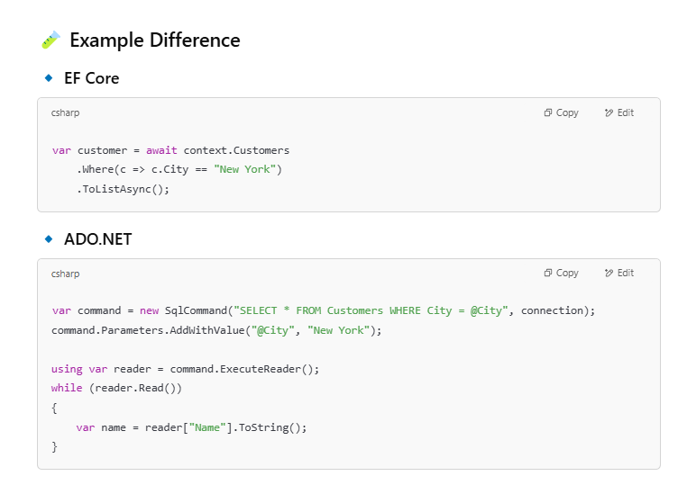
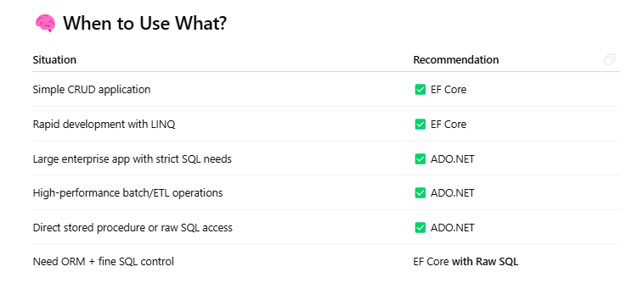
=> Unit of Work
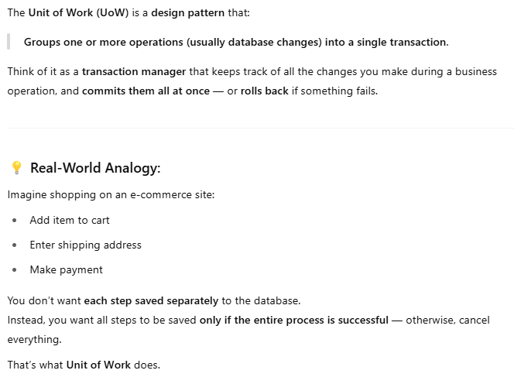
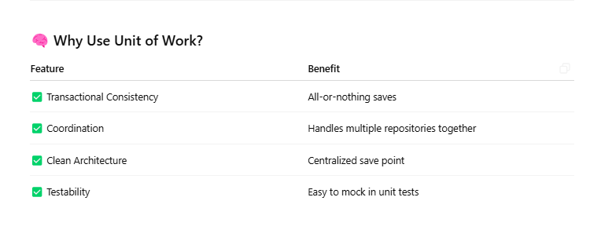
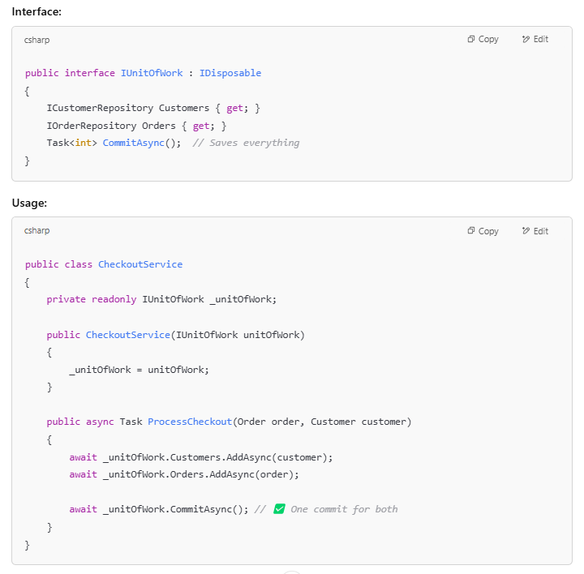
=> How to pass output parameter in store procedure (scope_identity()=> return newly created record)
CREATE PROCEDURE InsertUser @Id INT OUTPUT AS
INSERT INTO Users (...) VALUES (...);
SET @Id = SCOPE_IDENTITY();

=> Complex Linq query
var result = from o in orders
join c in customers on o.CustomerId equals c.Id
where o.Total > 100
group o by c.Name into g
select new { Customer = g.Key, TotalSpent = g.Sum(x => x.Total) };
=> How to use Factory pattern in EF
public interface IProductFactory { Product Create(string type); }
public class ProductFactory : IProductFactory
{
public Product Create(string type) =>
type == "A" ? new ProductA() : new ProductB();
}
=> Partial Classes
Allow splitting a class into multiple files.
// File1.cs
public partial class Person { public string Name; }

// File2.cs
public partial class Person { public int Age; }
=> Mutable vs unmutable
• Mutable: Can be changed after creation (e.g., List<T>)
• Immutable: Cannot be changed (string, DateTime)

=> IDisposible (to dispose object)
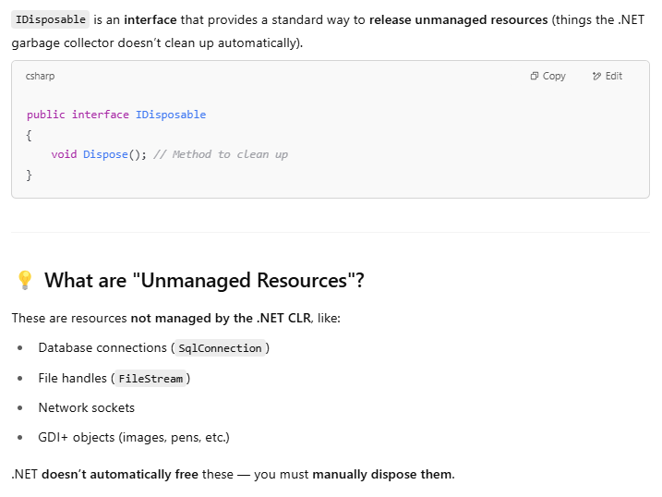
=> Garbage Collector
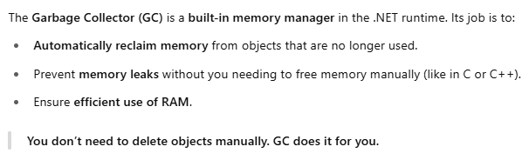
=> Generic vs Non Generic
• Generic: Type-safe (e.g., List<T>)
• Non-Generic: Uses object (e.g., ArrayList)

=> IEnumerable vs IQuerable
• IEnumerable: In-memory, LINQ to Objects
• IQueryable: Translates to SQL, used in EF
=> Solid Principle
• Single Responsibility Principle (A class should have only one reason to change.)
• Open/Closed Principle (Software entities should be open for extension, but closed for modification.)
• Liskov Substitution Principle (Subtypes must be substitutable for their base types. Subclasses should never break the behavior of their base class.)
• Interface Segregation Principle (Clients should not be forced to depend on methods they do not use.)
• Dependency Inversion Principle (Depend on abstractions, not concrete implementations.)
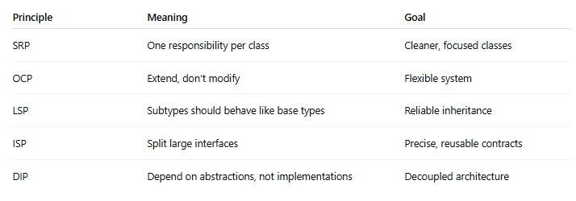
=> cookies vs session
• Cookies: Client-side, limited size
• Session: Server-side, per-user data
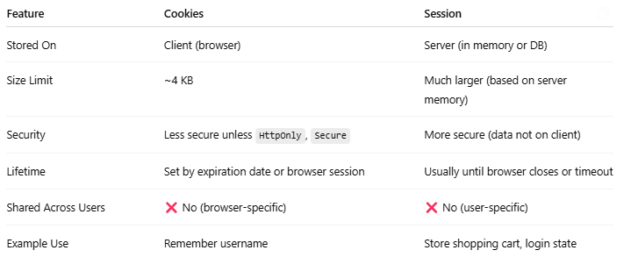

=> Ilist vs icollection
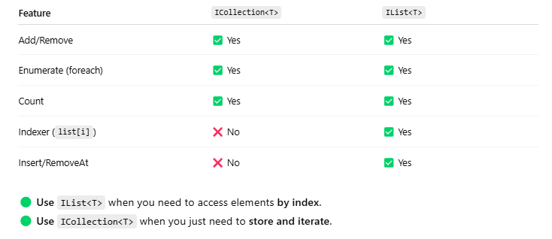
=> bubble sort
for(int i=0; i<arr.Length; i++)
for(int j=0; j<arr.Length - i - 1; j++)
if(arr[j] > arr[j+1])
(arr[j], arr[j+1]) = (arr[j+1], arr[j]);

=> heap vs stack
• Stack: Stores value types, method calls
• Heap: Stores reference types
=> static Readonly
- static: One value per type
- readonly: Assigned once, at runtime

public static readonly string AppName = "MyApp";
=> Linkdlist vs Array
• LinkedList: Fast inserts/deletes
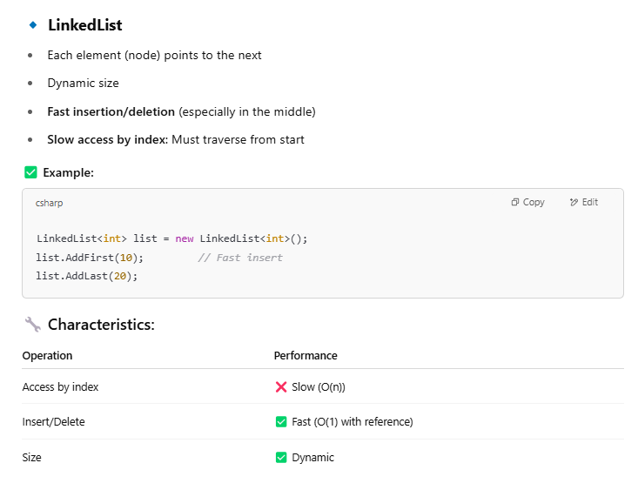

• Array: Fast access by index
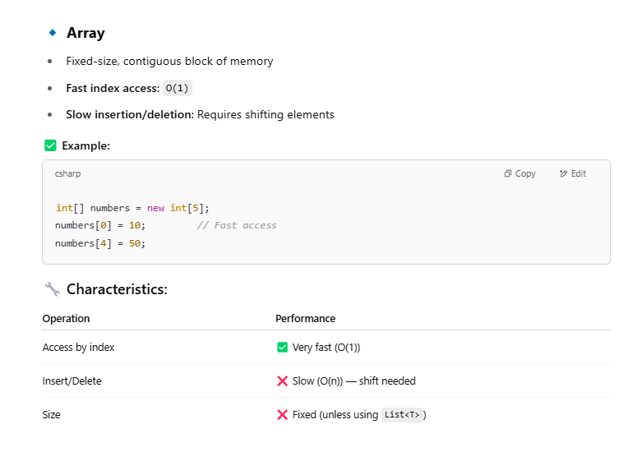
=> Ref & out Diff
Both ref and out allow you to pass variables by reference to a method — so the method can modify the original variable. But there's a key difference in when they must be initialized.
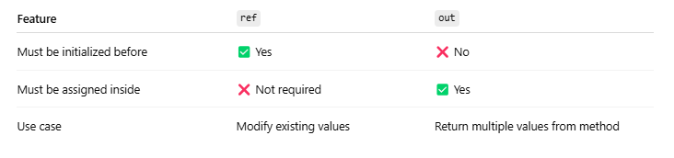

=> Types of Event Handler
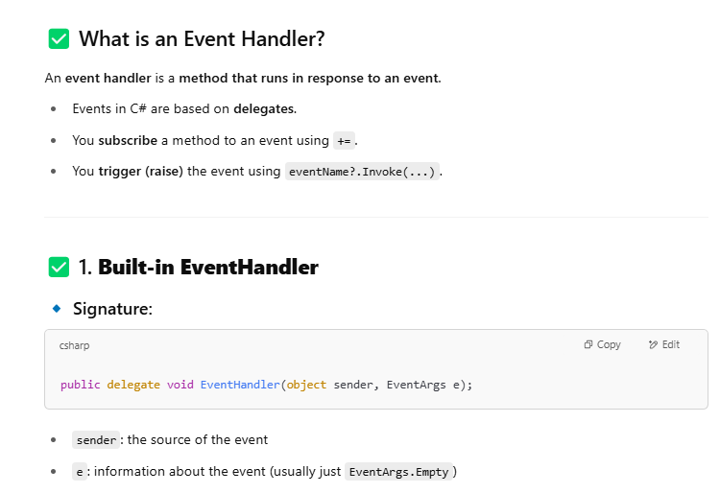
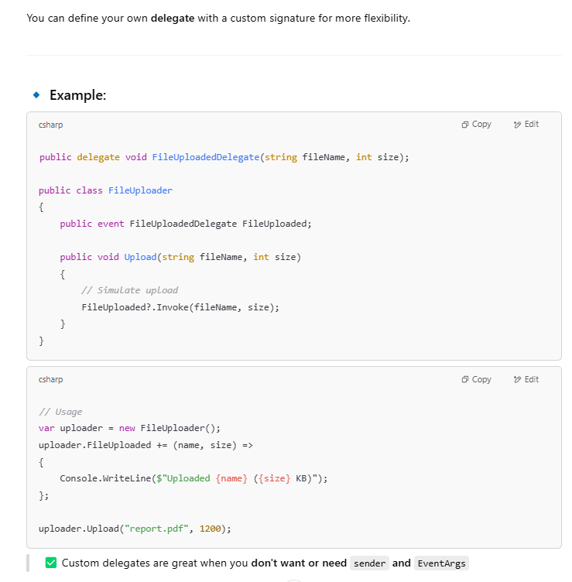
=> managed and unmanaged code
• Managed: CLR handles memory (C#)
• Unmanaged: Manual memory (C/C++)
=> DLL
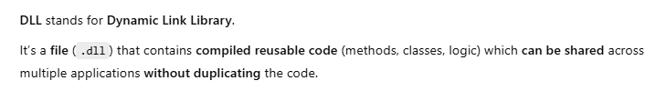
=> DLL vs Library
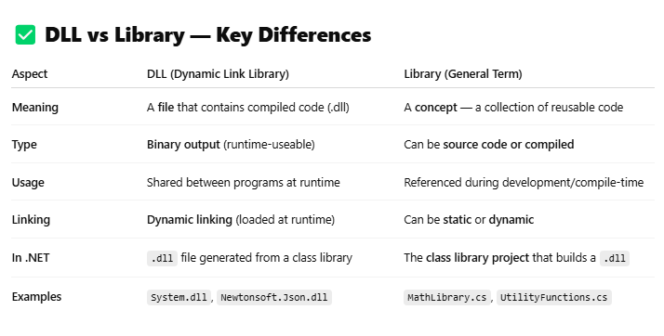
=> authorization techniques
• Role-based
• Claims-based
• Policy-based

=> microservercies architecture
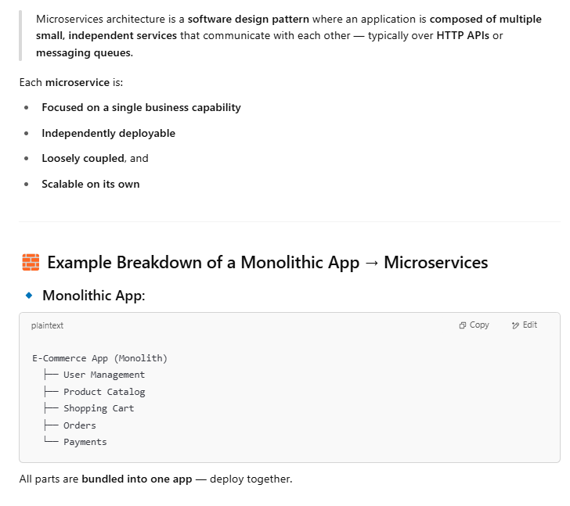
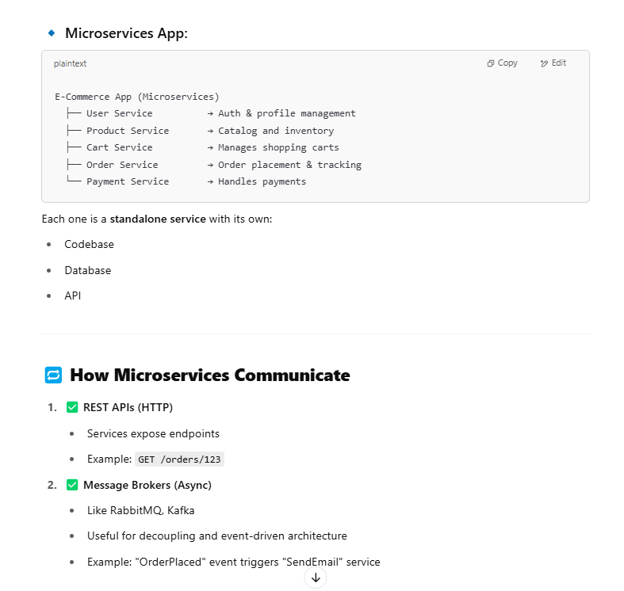
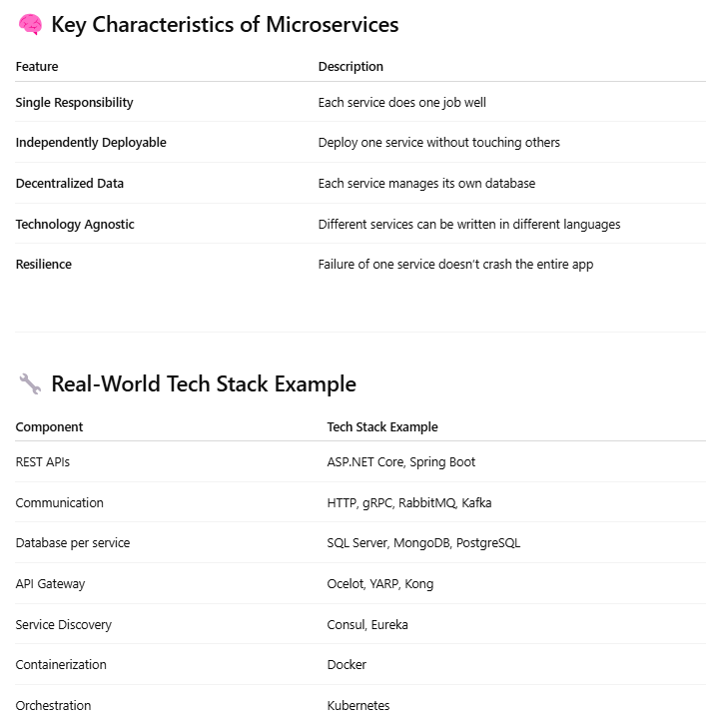
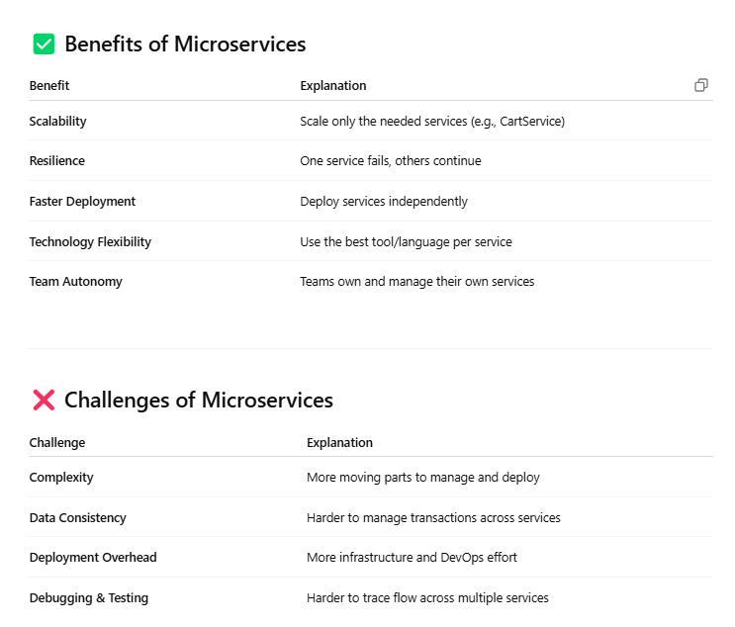
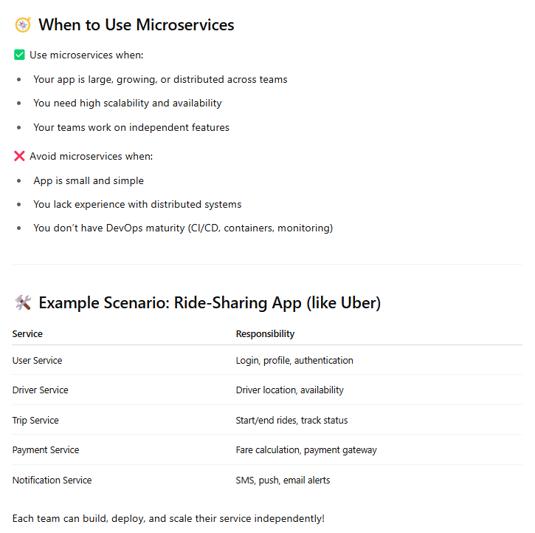
Explicit loading
Manual loading of related data in EF.
context.Entry(order).Reference(o => o.Customer).Load();
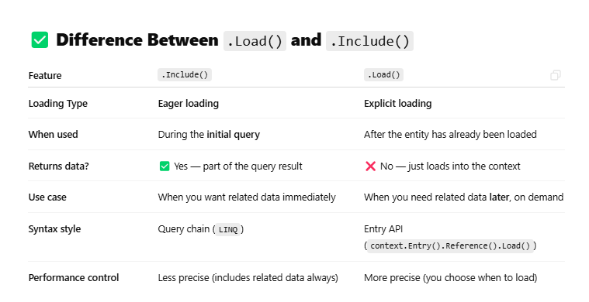
Deferred execution Vs immediate execution
• Deferred: Query not executed until enumerated (IQueryable, IEnumerable)
• Immediate: ToList(), Count() force execution
First()Vs firstordefault() vs SingleOrDefault()
• First(): First element; throws if none
• FirstOrDefault(): Returns first or default (null/0)
• SingleOrDefault(): Expects only one; throws if >1
Find() Vs where()
- Find(): Only in EF, finds by primary key
- Where(): Filters based on condition
context.Users.Find(1);
context.Users.Where(u => u.Id == 1);

Union Vs Union All
• Union: Removes duplicates
• Union All: Keeps all, including duplicates
Truncate Vs delete Vs drop
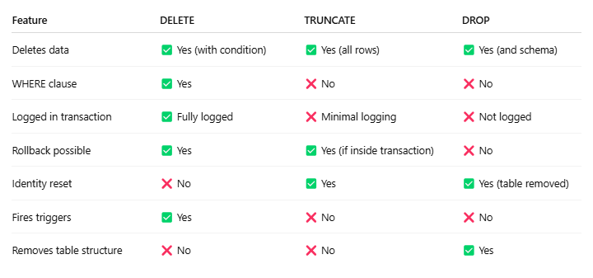
JIT Compilation
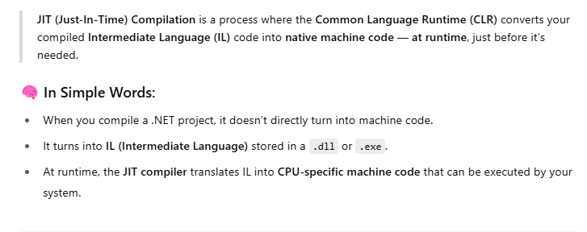
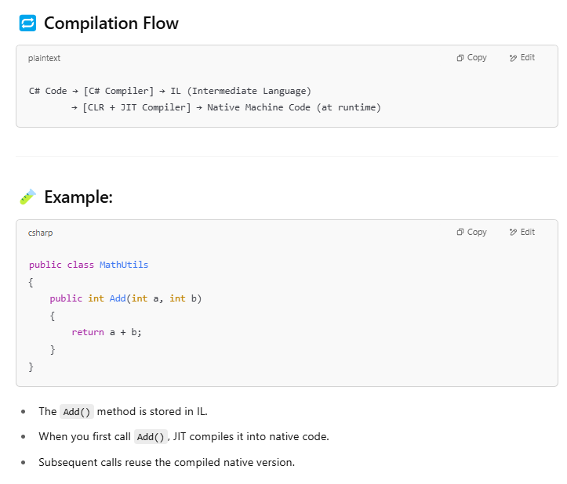
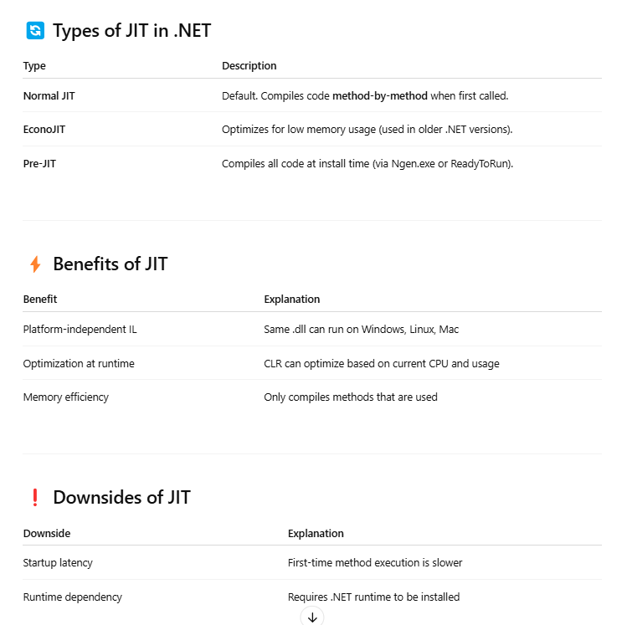
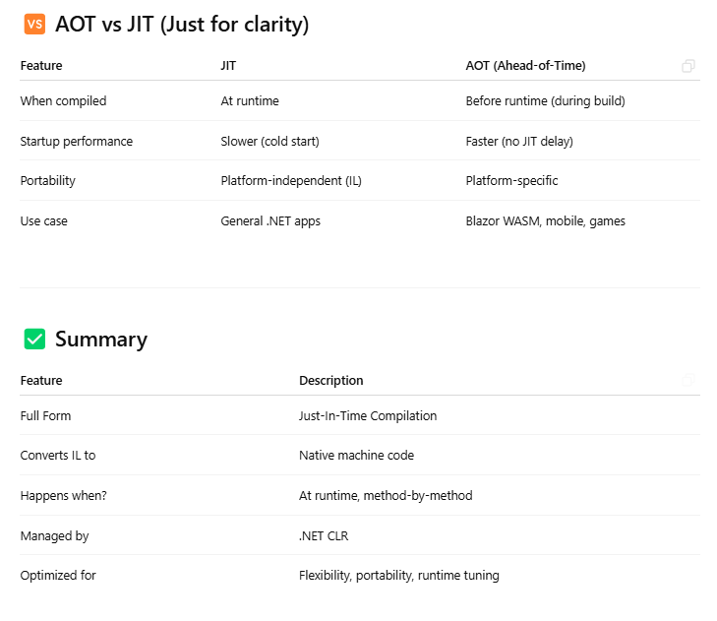
Execution plan
SQL Server’s plan of how queries will run;
Coalesce () Vs IsNull()
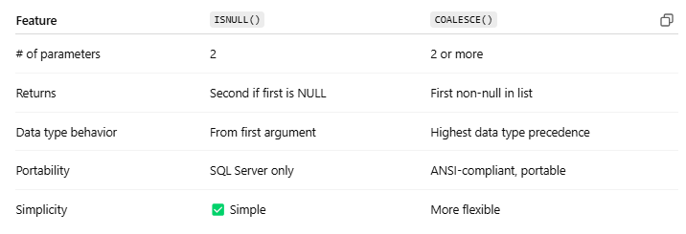
ACID properties in DB
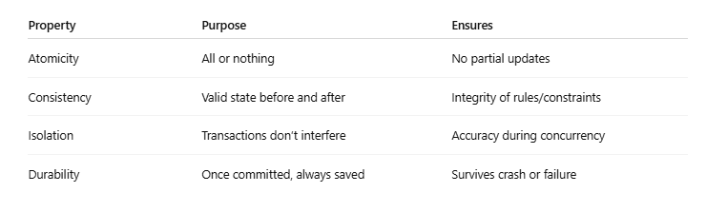
Clean Architecture
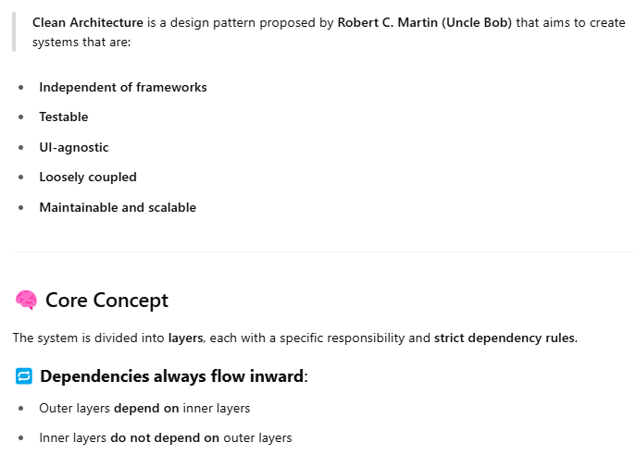
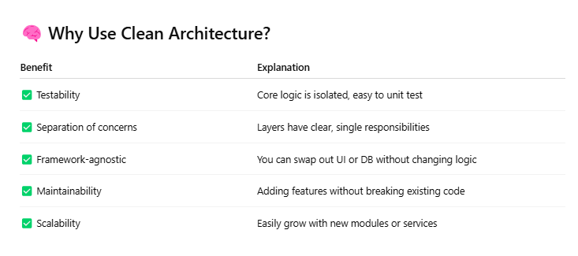
Local Vs global temp table
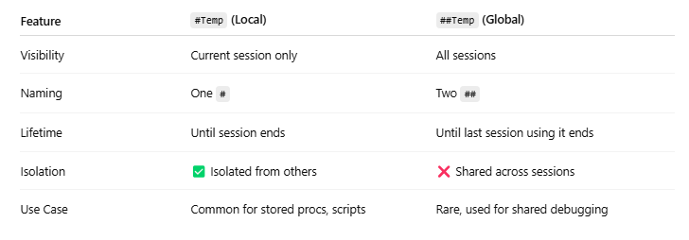
Magic tables
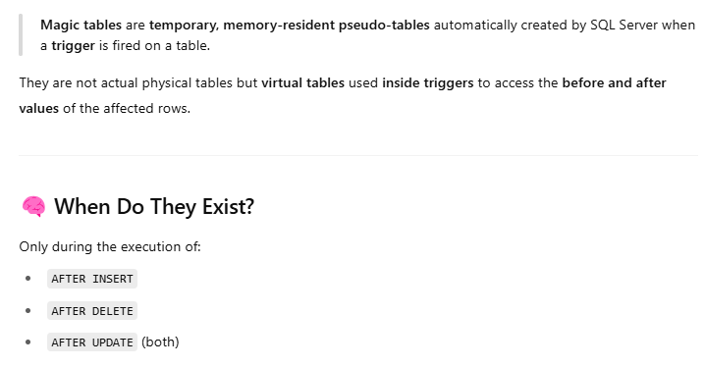
=> In building application what is application doing during compiling code
Code is compiled to IL by compiler → JIT compiles to native code at runtime.
=> reverse proxy
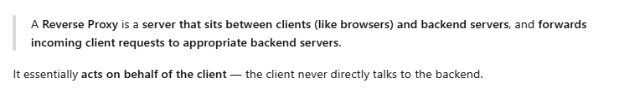
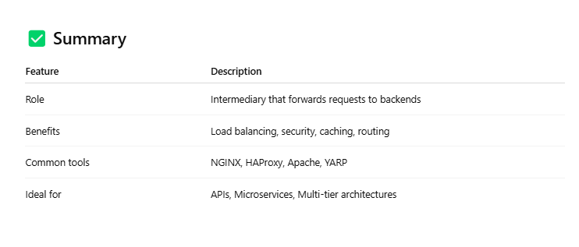
=> load balancer
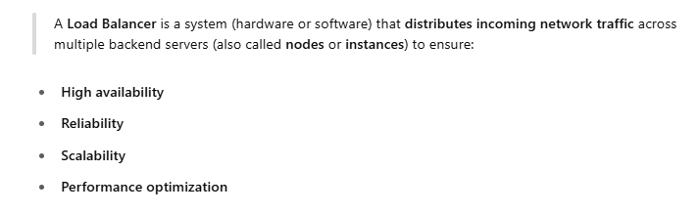
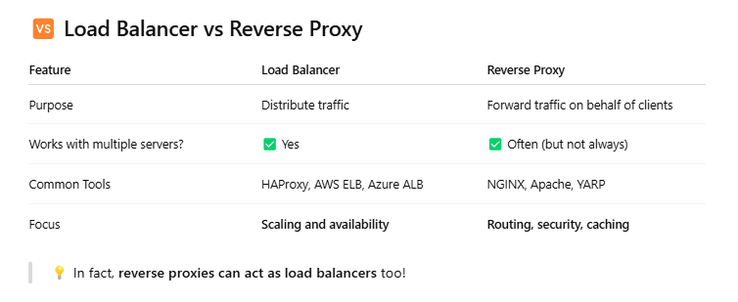
=> Why use overriding
To change or extend base class behavior in derived class.
public override void Speak() => Console.WriteLine("Dog barks");
=> Sql functions
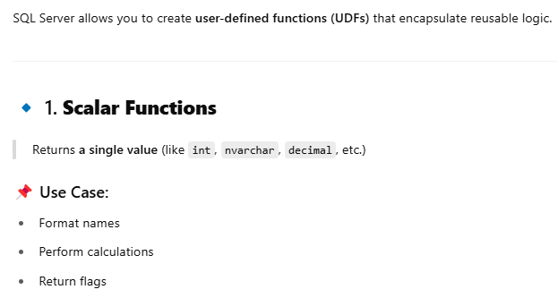
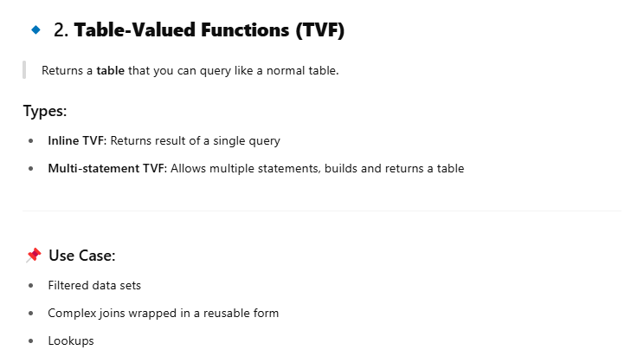

=> Sql indexes
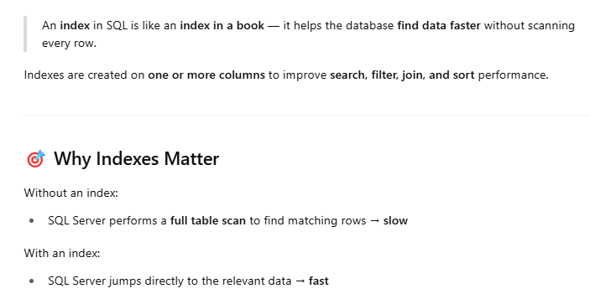
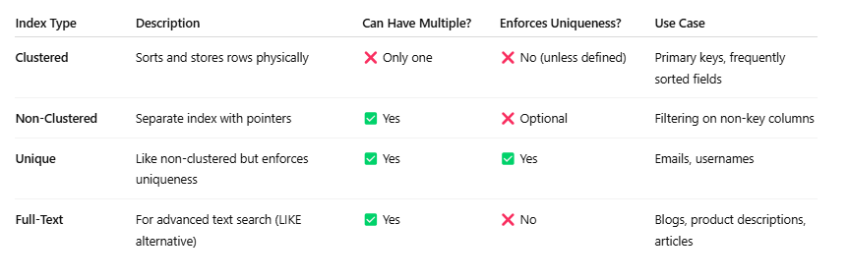
=> Add scope
Lifetime per request; same instance during one HTTP request.
=> Add transit
New instance every time it’s requested.
=> Add singleton
Same instance used throughout app lifetime.
=> Implementation of singleton
public sealed class Singleton
{
private static readonly Singleton _instance = new Singleton();
private Singleton() {}
public static Singleton Instance => _instance;
}

=> Mediator
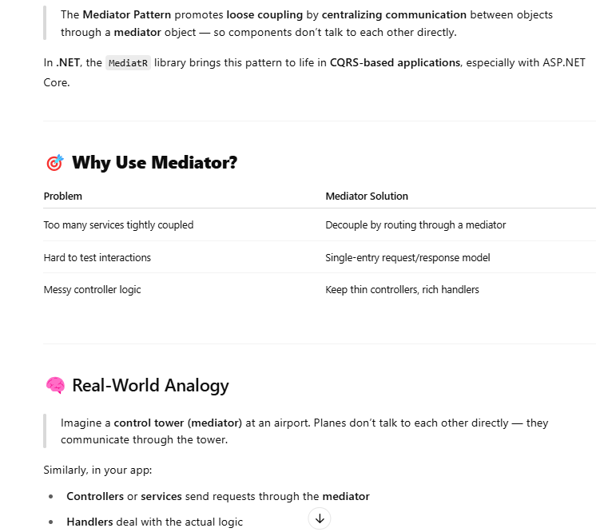
=> CQRS
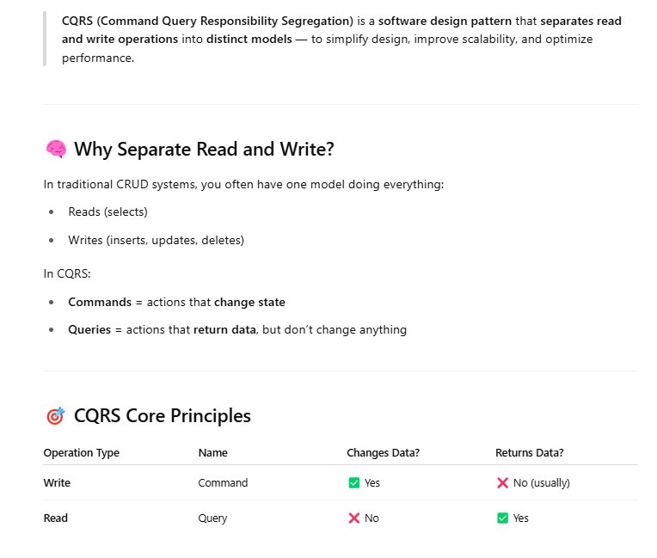

=> Clean code architecture
Layered structure:
- Entities → Use Cases → Interface Adapters → Frameworks
Separation of concerns and testability.
=> Pholymorphism with example
Same method behaves differently based on object.
public virtual void Speak() {}
public override void Speak() => Console.WriteLine("Dog barks");
=> Default end point of api
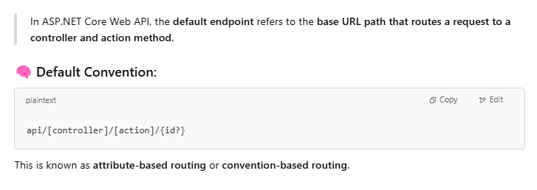
=> Types of Api Routing
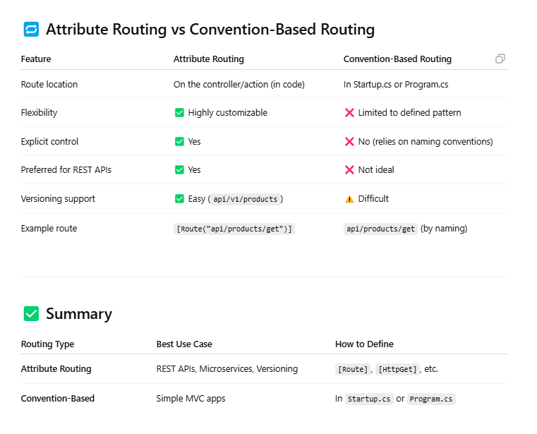

=> Rest vs soap
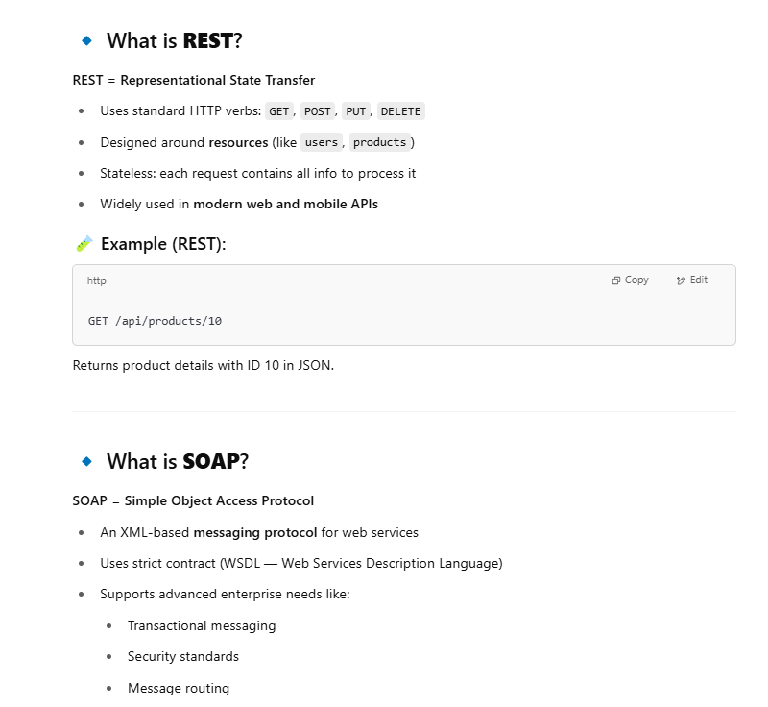
=> Rest vs simple api
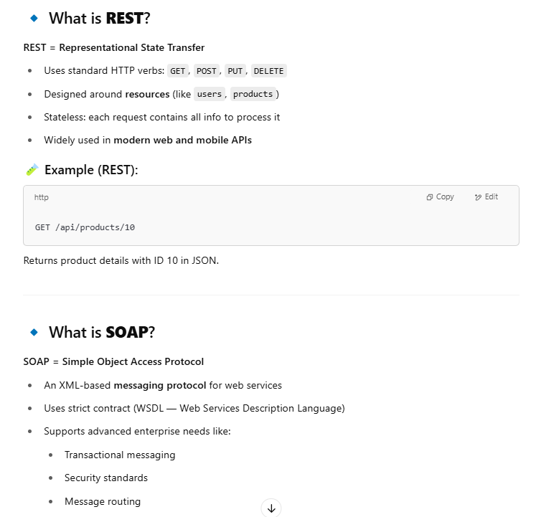

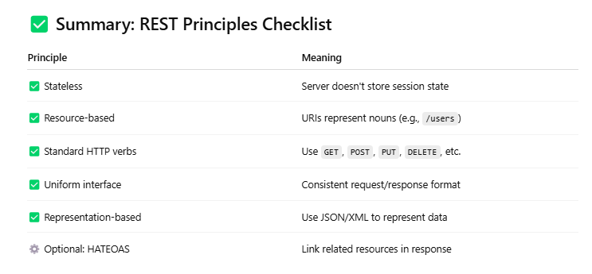
=> Orm
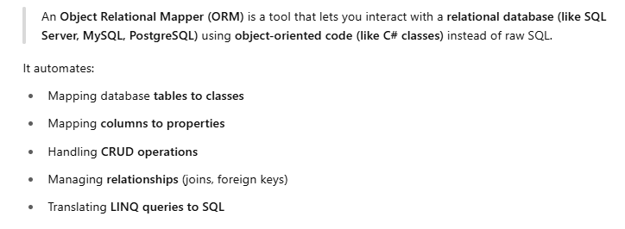

=> Types of orm
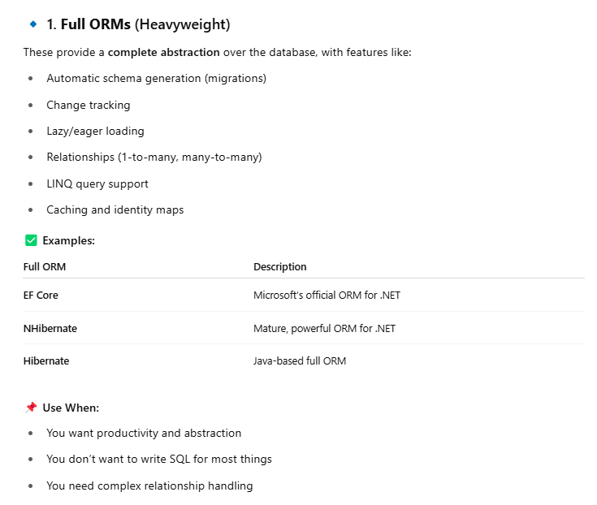

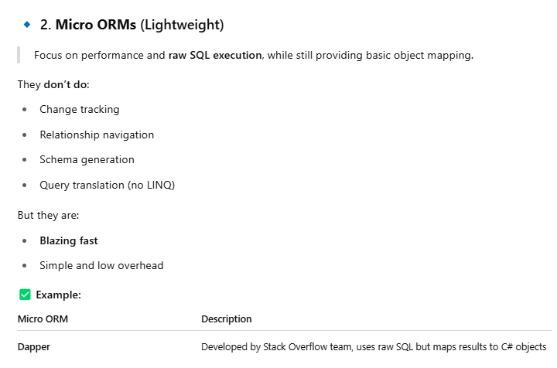

=> Methods of linq
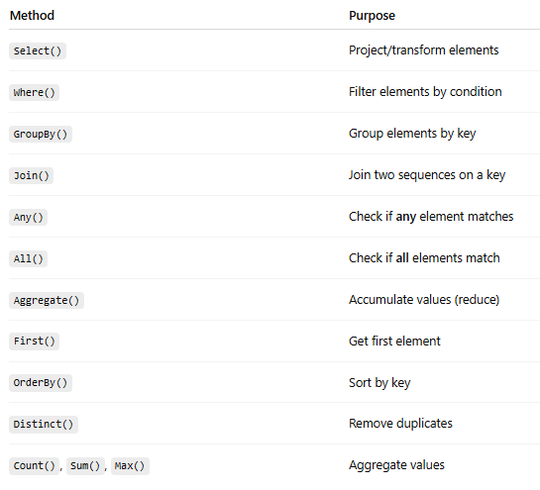
=> 1 to 1 and 1 to many Relationship
• 1:1 → One entity has exactly one related entity
• 1:M → One entity has many related entities
=> Const vs Readonly
• const: Compile-time constant
• readonly: Runtime constant
=> MediatorR
Library that implements Mediator pattern. Decouples request handling in CQRS.
=> Why use design pattern
Promote code reusability, readability, and maintainability.
=> Lazy Loading in EF
• It delays loading related data until it’s needed.
• Saves initial query cost, but may result in multiple small queries (N+1 issue).
=> Encapsulation vs abstraction detail questions
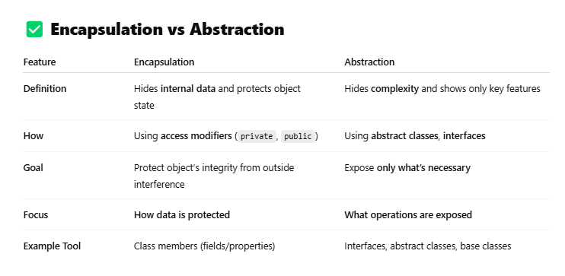
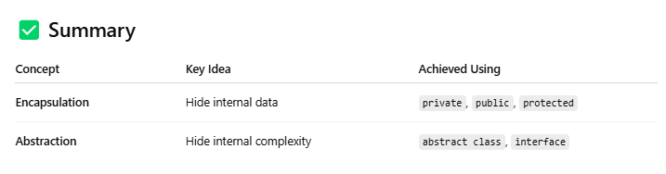
=> Static vs void
• static: Method belongs to class, not instance
• void: Return type of method
=> Why use static class
When no instance data is needed — utility/helper methods.
public static class MathHelper { public static int Add(int x, int y) => x + y; }
=> Diff fuction and store procedure
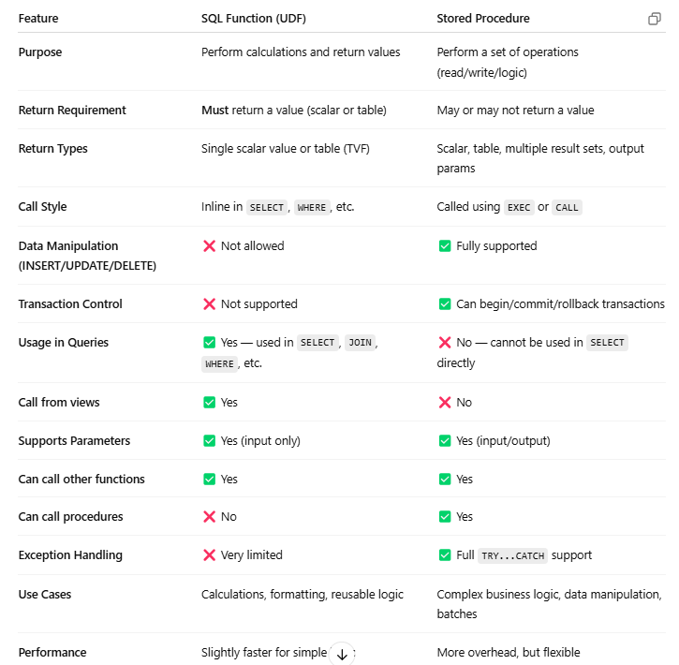
=> Flow of mvc
• Request → Controller
• Controller → Model
• Model → Data
• Return → View

=> Session managment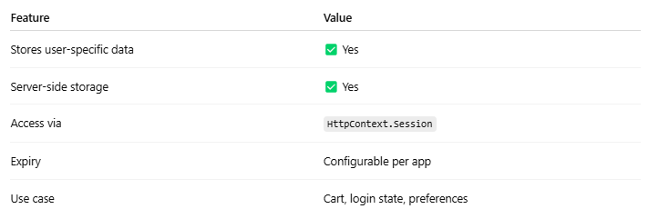
=> Reverse string array logic
public static string ReverseString(string input){
char[] reversed = new char[input.Length];
for (int i = 0; i < input.Length; i++) { reversed[i] = input[input.Length - 1 - i]; }
return new string(reversed);}
=> SP vs Views
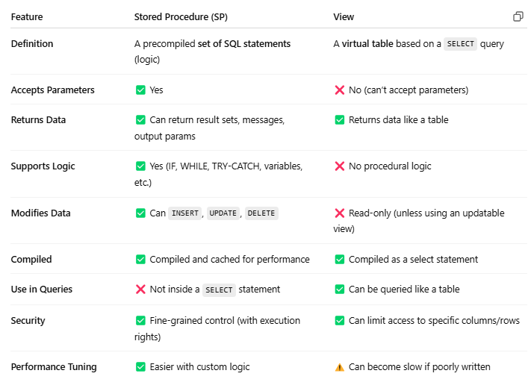
=> Web Api Detail Questions
• RESTful services
• HTTP verbs (GET/POST/PUT/DELETE)
• Uses [HttpGet], [HttpPost] etc.
=> Association Aggregation Composition
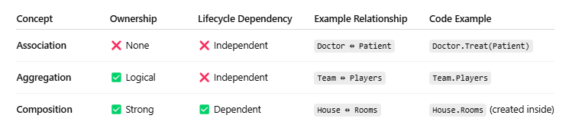
=> Up and Down Methods in .Net
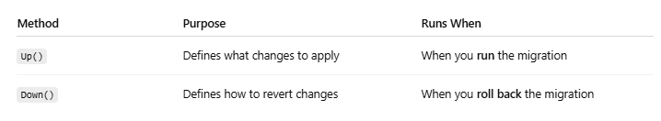
=> Delegates
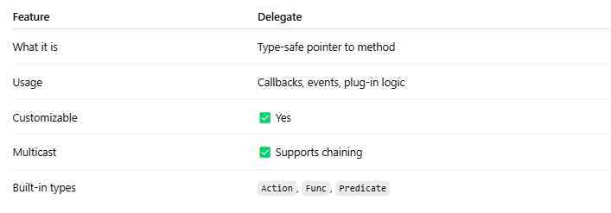

=> Action Filters in mvc
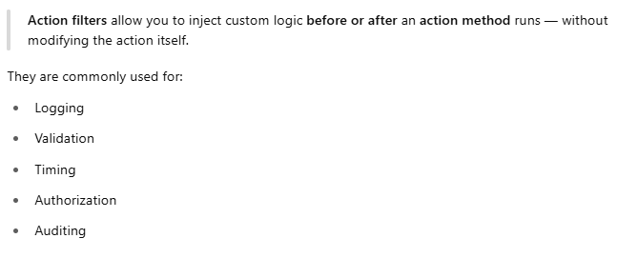
=> Action Methods
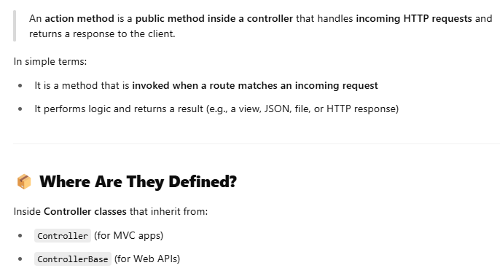
=> we have 3 routes in attribute so which one will call first in api
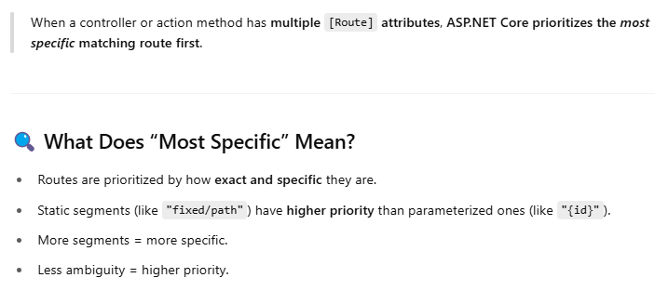
=> Palindrom String logic
bool IsPalindrome(string s) => s == new string(s.Reverse().ToArray());
=> IsAnagram
public static bool IsAnagram(string str1, string str2){
if (str1.Length != str2.Length) return false;
str1 = str1.Replace(" ", "").ToLower();
str2 = str2.Replace(" ", "").ToLower();
char[] arr1 = str1. ToCharArray();
char[] arr2 = str2. ToCharArray();
Array.Sort(arr1);
Array.Sort(arr2);
return arr1.SequenceEqual(arr2); }
=> we want to execute a logic first time when app run what we will do in mvc .net
Use Application_Start() in Global.asax or Startup.cs for .NET Core.
=> Diff between select and selectmany in linq
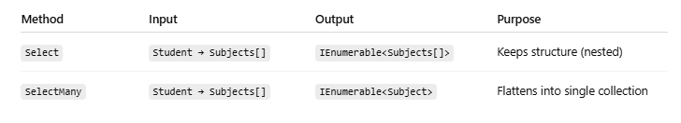

=> Sql Injection
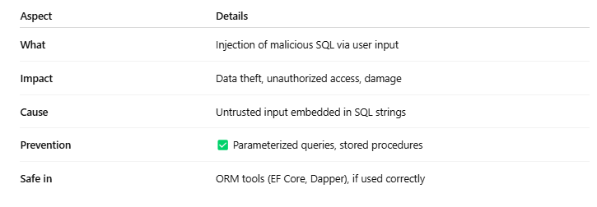
=> What is sequence in Database
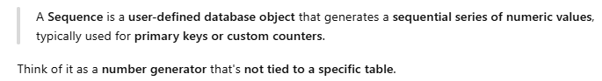
=> session object and application object difference?
• Session: Per-user
• Application: Shared across all users
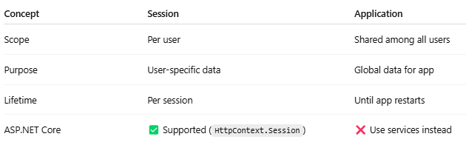
=> default time out for session? where u can define it?
- Default: 20 minutes
- Defined in web.config:
<sessionState timeout="30" />

=> customs error on /off,
Defined in web.config:
<customErrors mode="On" />
=> where view state data stored?
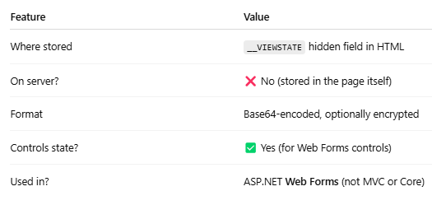
=> master pages in MVC?
MVC uses Layouts, not master pages. Defined in _Layout.cshtml.
=> how can i avoid cross side scripting?
• Use HTML encoding (@Html.Encode)
• Validate input
• Use CSP (Content Security Policy) headers
=> what is a use of finally block?
Always executes, even if an exception occurs. Ideal for cleanup.
csharp
CopyEdit
finally { conn.Close(); }
=> what kind of operation in finally block?
Closing connections, disposing objects, logging.

=> difference b/w authentication /authorization ? patientSlot
• Authentication: Who you are (login)
• Authorization: What you can access (roles/permissions)
=> default pages in MVC>?
Usually Index() in HomeController, mapped via route config.
=> boxing/unboxing definition?
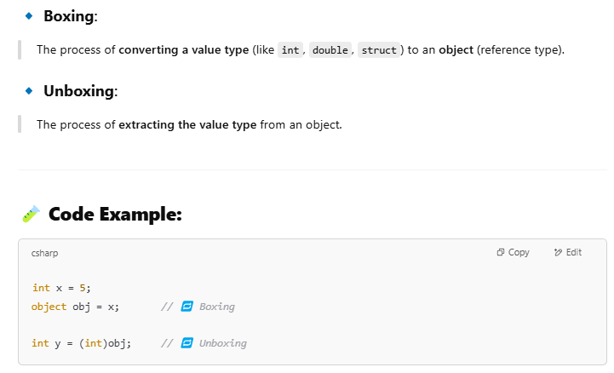
=> BST Traversal
void InOrder(TreeNode node) {
if (node == null) return;
InOrder(node.Left);
Console.Write(node.Value + " ");
InOrder(node.Right);
}
=> shared and private assembly ?
• Shared: GAC-deployed, used by multiple apps
• Private: App-specific, stored in app folder
=> java script vs jquery?
• JavaScript: Core language
• jQuery: JS library for DOM manipulation, Ajax, animations
=> difference between unique /primary key?
• Primary Key: One per table, not null
• Unique Key: Multiple allowed, allows null
=> what is recursive stored procedures ?
A procedure calling itself.
sql
CopyEdit
CREATE PROC GetHierarchy AS
BEGIN
EXEC GetHierarchy;
END
=> purpose of floor function?
Rounds down to nearest integer.
sql
CopyEdit
SELECT FLOOR(10.75); -- returns 10
=> how 2 implement push notification?
Via Web Push APIs (JavaScript) or services like Firebase Cloud Messaging (FCM).
=> hows signal R works? hows fetching data?
Real-time communication over WebSocket, Server-Sent Events or Long Polling.
=> how u secure web APIs?
• HTTPS
• JWT
• API Keys
• Role/Policy-based auth
• Input validation
=> types of autentication?
• Basic
• JWT Bearer
• OAuth
• Windows Auth
• Cookie Auth
=> JW token?
JSON Web Token – secure, stateless auth.
=> How JW token works?
• Server generates a token with user claims
• Client sends token in Authorization header
• Server validates token on each request

=> how JW token expire forcefully?
• Maintain a blacklist on the server
• Change user’s SecurityStamp (in Identity)
=> how can we prevent different sort of security attacks?
• SQL Injection → Use parameterized queries
• XSS → Encode inputs
• CSRF → Use Anti-forgery tokens
• HTTPS → Encrypt data in transit
=> what is hashing?
One-way function to convert data into fixed hash. Irreversible.
using SHA256.Create()
=> Difference between encryption and hashing?
• Hashing: One-way, can't decrypt
• Encryption: Two-way, can decrypt with a key
=> Which is faster Inner Join or Outer in SQL?
• Inner Join is faster — only matches
• Outer Join retrieves all rows (more expensive)
=> what is normalization?
Process of structuring DB to reduce redundancy and improve integrity.

=> What are iframes?
HTML tag to embed another page inside a page:
<iframe src="page.html"></iframe>
=> how can we access session in web API?
By enabling session in Startup.cs, then use:
HttpContext.Session.SetString("Key", "Value");
=> dependency injection in mvc?
Configured in Startup.cs:
services.AddScoped<IService, Service>();
=> what is access modifier? Controls scope: public, private, protected, internal.
=> what is virtual method? Can be overridden in derived class.
=> can we write dynamic query in sql? Yes, using EXEC or sp_executesql
=> Any challenging or complicated task in last 6 month?
=> what is MSM queue? Microsoft Message Queuing — sends messages between apps asynchronously.
=> difference between post and put?
• POST: Create new
• PUT: Replace existing or create if not exists (idempotent)
=> what is sub domain? A division of a domain.
=> hows bootstrap design work? Uses CSS classes and grid system for responsive design:
=> what is agile mythology? Uses CSS classes and grid system for responsive design:
=> hows Https work?
• SSL/TLS encrypts traffic
• Handshake exchanges keys
• Server presents certificate (identity)

=> how web API works end to end?
• Request → Controller
• Controller → Service
• Service → Repository
• Repository → DB
• Response → JSON to Client
=> hows security maintain in web api?
• HTTPS
• Authentication ([Authorize])
• Token-based (JWT)
• Input validation
• CORS
=> difference ADO.NET and OLAD? 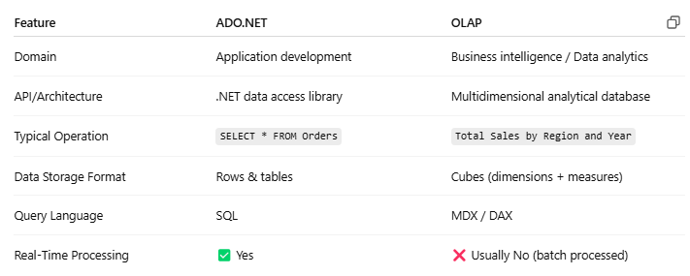
=> what is DB connection pool? Manages and reuses DB connections instead of creating new ones repeatedly.
=> what is BloB? Binary Large Object — stores large data like images, videos in DB.
=> what is A-sync wait? Asynchronous programming to avoid blocking threads.
=> how u implement role based authentication? [Authorize(Roles = "Admin")]
=> what is Var key word?
=> what is Trigger? Auto-executed procedure on INSERT, UPDATE, or DELETE.
=> what is Antiforgenic token and how to validate it?
Prevents CSRF.
- Add token in view: @Html.AntiForgeryToken()
- Validate using [ValidateAntiForgeryToken]
=> What is authorize attribute?
=> where u define default configuration?
=> How to optimize long running query?
• Use indexes
• Avoid subqueries
• Use proper joins
• Check Execution Plan
=> What are aggregate functions in LinkQ?
=> how u handle errors in MVC>?
=> how u maintain the log?
Use ILogger, Serilog, NLog, etc.
=> having vs where clause difference ?
• WHERE: Filters rows before grouping
• HAVING: Filters after GROUP BY
=> what is CORS in web application?
Cross-Origin Resource Sharing — allows APIs to be accessed from different domains.
=> What is query execution plan?
=> Difference between Primary and unique key?
=> How to write For loop in SQL?
DECLARE @i INT = 1;
WHILE @i <= 10
BEGIN
PRINT @i;
SET @i = @i + 1;
END

multiple interfaces implemented in a single service all of them have the method with same name how can we call the method for either of the service in a controller if we inject the service

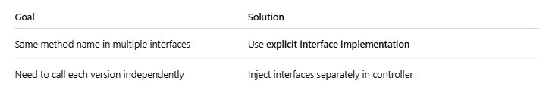

DESIGN PATTERNS
Scenario:
You need a logging service that ensures only one instance exists throughout the application's lifecycle. Currently,
the Logger class is instantiated multiple times, causing conflicts in the log file.
Question:
Refactor the Logger class to ensure only one instance exists. Which design pattern should you use?
Expected Answer: Singleton Pattern.
---------------------------------------------------------
---------------------------------------------------------
Scenario:
You have a Vehicle base class with subclasses Car and Bike.
The Main method contains logic to instantiate these classes based on user input, leading to tightly coupled code.
Question:
Which design pattern can help decouple the instantiation logic from the client code?
Expected Answer: Factory Method.
---------------------------------------------------------
---------------------------------------------------------
Scenario:
In a stock market application, multiple modules (e.g., alerts, dashboards) need to respond to price changes in real-time.
Currently, each module polls the stock data at intervals, causing performance issues.
Question:
Which design pattern can allow modules to receive updates automatically without polling?
Expected Answer: Observer Pattern.
---------------------------------------------------------
---------------------------------------------------------
Scenario:
A payment system supports different payment methods (Credit Card, PayPal, Bank Transfer).
The payment processing logic is implemented in a single PaymentProcessor class with multiple if-else conditions.
Question:
How can you refactor the code to make it easier to add new payment methods without modifying existing code?
Expected Answer: Strategy Pattern.
---------------------------------------------------------
---------------------------------------------------------
Scenario:
You have a legacy XmlParser class that needs to work with a new system expecting data in JSON format.
Modifying the legacy class is not an option.
Question:
Which design pattern can help integrate the XmlParser with the new system?
Expected Answer: Adapter Pattern.
---------------------------------------------------------
---------------------------------------------------------
Scenario:
Explain the difference between AddSingleton, AddScoped, and AddTransient in dependency injection.
Expected Answer:
AddSingleton: Creates a single instance for the entire application lifecycle.
AddScoped: Creates one instance per request.
AddTransient: Creates a new instance every time it's requested.
---------------------------------------------------------
---------------------------------------------------------
ENTITY FRAMEWORK
Scenario:
You have a Course entity with a navigation property Students, and each student has a navigation property Address.
You want to load the Course, its Students, and their Addresses in one query.
Question:
Write the LINQ query to achieve this.
Expected Answer:
var course = _context.Courses
.Include(c => c.Students)
.ThenInclude(s => s.Address)
.FirstOrDefault(c => c.Id == courseId);
---------------------------------------------------------
---------------------------------------------------------
Scenario:
Two users simultaneously update the same Product record, and you want to handle concurrency conflicts gracefully.
Question:
How would you configure EF Core to handle optimistic concurrency?
Expected Answer:
Step 1)
Add a RowVersion property to the entity:
public byte[] RowVersion { get; set; }
Step 2)
Configure the property in OnModelCreating:
modelBuilder.Entity<Product>()
.Property(p => p.RowVersion)
.IsRowVersion();
Step 3)
Handle DbUpdateConcurrencyException during SaveChangesAsync.
---------------------------------------------------------
---------------------------------------------------------
Scenario:
You have a one-to-many relationship between Author and Book. Deleting an Author should also delete all their Books.
Question:
How would you configure this cascade delete behavior in EF Core?
Expected Answer:
Configure it in the OnModelCreating method:
modelBuilder.Entity<Author>()
.HasMany(a => a.Books)
.WithOne(b => b.Author)
.OnDelete(DeleteBehavior.Cascade);
---------------------------------------------------------
---------------------------------------------------------
Scenario:
You have a large dataset with related entities (e.g., Course and Students).
Using Include to load the data causes a Cartesian explosion and performance issues.
Question:
How would you optimize the query to avoid the Cartesian explosion?
Expected Answer: Use split queries:
var courses = _context.Courses
.Include(c => c.Students)
.AsSplitQuery()
.ToList();
---------------------------------------------------------
---------------------------------------------------------
Scenario:
You want to map a database view to an entity, but the view does not have a primary key.
Question:
How would you configure this in EF Core?
Expected Answer: Use a keyless entity:
modelBuilder.Entity<MyView>()
.HasNoKey()
.ToView("MyDatabaseView");

