**Qissa Khwani Bazar:**

In ancient times traders used to come here, they used to do both daytime and nighttime. As they sat round the fire at night, they used to tell stories by sipping Qahwa. Thus the bazar got its name “Story Tellers bazaar.”

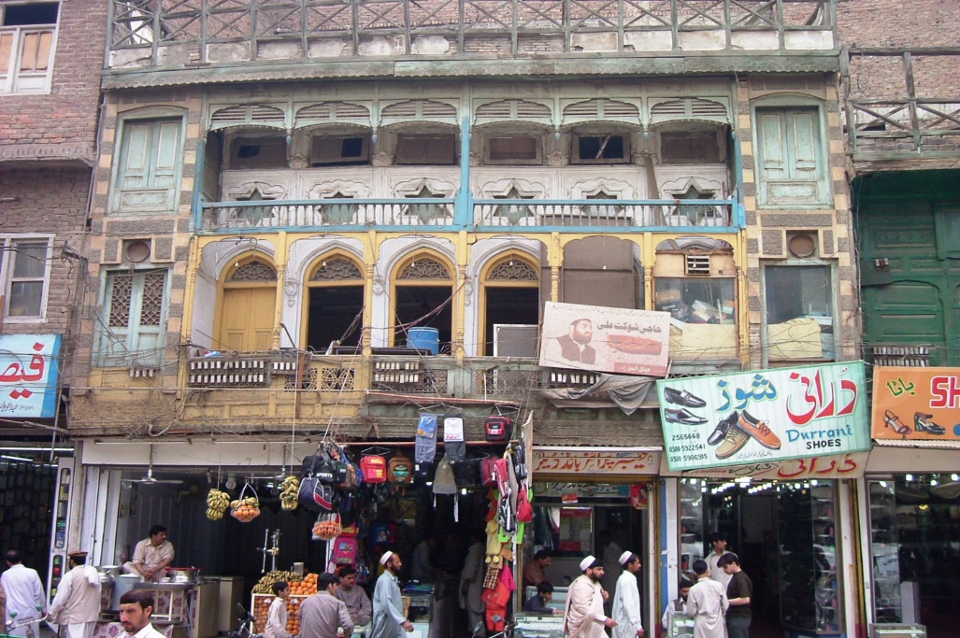

**My Story with Picture:**

It was the scene of the Qissa Khwani bazaar attack, when British armored cars and troops surrounded and shot a large crowd of unarmed local demonstrators.

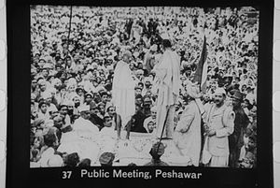

**Famous Actors:**

Indian actor of film Dilip Kumar was born on or about 11 December 1922 in Qissa Khwani Bazaar and belongs to the Awan tribe. Family of Actor Shah Rukh Khan still lives in the area.

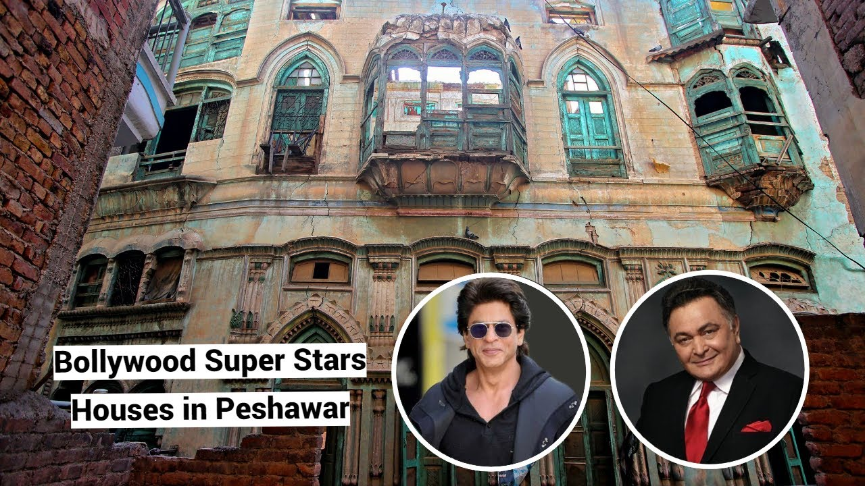

**British Killed Unarmed Protestors:**

On 23 April 1930, nearly 400 unarmed protesters were shot dead in the Qissa Khwani Bazaar massacre by troops from the British colonial government. The massacre sparked riots across British India, and gave attention to the newly formed Khudai Khidmatgar movement.

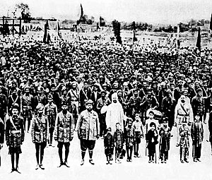

**Khudai Khidmatgar:**

Literally translates as the servants of God. It represented a non-violent freedom struggle against the British Emprire by the Pashtuns (also known as Pathans, Pakhtuns or Afghans) of the North West Frontier Province. The movement was led by Khan Abdul Ghaffar Khan, known locally as Bacha Khan or Badshah Khan.

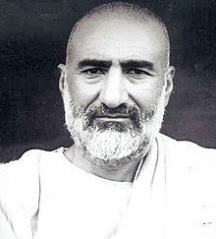

**Pushtuns Limitations:**

Education opportunities were strictly limited. Pashtuns are Muslims; and religious leaders and Mullahs were known to have told parents that if their children went to school, they would go to hell. Khan stated that “the real purpose of this propaganda” was to keep Pashtuns “illiterate and uneducated”, and hence his people “were the most backward in India” with regard to education.

**Overcoming of Bacha Khan:**

Bacha Khan as its founder seemed to be influenced by the realization that whenever British troops were faced with an armed uprising they eventually always overcame the rebellion. The same could not be said when using nonviolence against the troops.

**Ideology of Khudai Khidmatgar Movement:**

“The Holy Prophet Mohammed came into this world and taught us ‘That man is a Muslim who never hurts anyone by word or deed, but who works for the benefit and happiness of God's creatures.’ Belief in God is to love one's fellow men.” – Khan Abdul Ghaffar Khan.

**Tactics of British Against Khudai Khidmatgar:**

1. British troops employed a wide variety of tactics against KK activists.

"The British used to torture us, throw us into ponds in wintertime, shave our beards, but even then Badshah Khan told his followers not to lose patience. He said 'there is an answer to violence, which is more violence. But nothing can conquer nonviolence. You cannot kill it. It keeps standing up. The British sent their horses and cars to run over us, but I took my shawl in my mouth to keep from screaming. We were human beings, but we should not cry or express in any way that we were injured or weak.

1. Another tactic employed against non-violent protesters who were blocking roads was to charge them with cars and horses.