VERTICAL-DRIVEN ARCHITECTURES · AVIATION & AEROSPACE MANUFACTURING · DESIGNED WITH PRAXIS · NOVEMBER 2026
Physical AI System Design for Composite Part Inspection in an Aviation MRO in Saudi Arabia
Damage Draft: Sovereign AI Reference Architectures for Composite Repair in Aviation and Aerospace Manufacturing
Muhammad Umar, Cofounder, CodeNinja
For the shop's accountable engineering leader, the certifying and design engineers who approve and sign, and the platform, data and edge engineers who would build and run it.

Vertical-Driven Architectures is a CodeNinja series of system designs. Every design in the series is driven by a real-world problem and scenario in a single industry, and every one is designed on Praxis, CodeNinja's platform for designing physical AI systems. Operations are described by class, never by name.

ABSTRACT
Physical AI System Design Begins at the Inspection Bench
A physical AI system design for an aircraft maintenance, repair and overhaul provider in Saudi Arabia that repairs radomes, flight control surfaces, nacelle panels and fan cowls for commercial single aisle and wide body fleets starts from one question at the bench: does this damage on this part fall inside the allowable limit, and what has this part type suffered in the same place before? Today that question is assembled by hand from photographs stapled to a paper traveller, scan files stranded on the scanner's own computer and a findings log joined to nothing, so the same disbond on the same panel type is assessed from scratch every time, and no query the shop would recognize as simple can be run at all; the physical AI system design that would fix this must keep customer records, scan images and licensed manual content inside the shop's own network, on the operator's own hardware.
The design is a sovereign system of context built over the shop's existing systems of record: seven sources enter through two adapter families into a governed ontology of sixteen objects, five services run over that model, and eight surfaces carry the work to the people who sign; six models serve the whole, with zero-shot and anomaly vision models on sealed fanless edge units at one inspection bench and one scan station, a dense multimodal reader and a retrieval embedding model on a 48 GB-class site inference card, and a 753B-parameter frontier model served at FP8 on one node of eight 141 GB-class GPUs inside the shop network; three named agents draft damage maps, repair schemes and release paperwork while certifying engineers decide and sign, and every confirmed outcome is kept as memory the next decision reads rather than trained into weights.
The paper covers the industry problem and the join failure in the shop's systems, the constraints that shape the design, the stack and the object model, ingestion through adapters, the placement of inference, the models and their licenses, the rollout in two phases with their item counts and gates, and who owns what the design builds, before closing with how Praxis contextualized and reasoned the design from recorded reading.

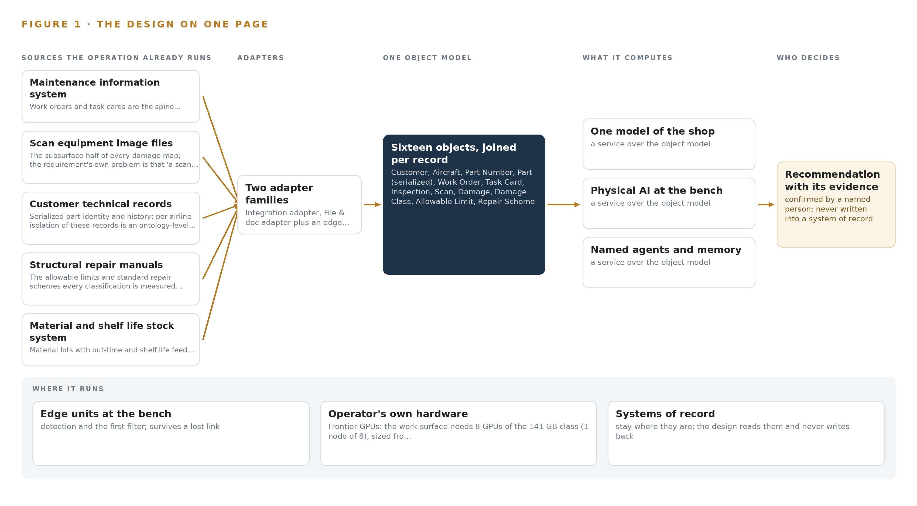
Figure 1. Damage Draft on one page: the sources the operation already runs, one object model, what it computes, and the person who decides.

Contents
Each chapter is tagged for the reader it serves most directly: Executive, Team Lead, FDE, Reference.
 | Abstract · Physical AI System Design Begins at the Inspection Bench | ● Executive
PART I · THE PROBLEM
1 | Damage Assessment Is the Slowest Step Nobody Can Query | ● Executive
2 | Six Systems Hold the Evidence, None the Argument | ● Executive ● Team Lead
PART II · THE DESIGN
3 | Sovereignty and the Signature Constrain Every Layer | ● Team Lead
4 | One Stack Runs From Records to the Bench | ● Team Lead ● FDE
5 | Sixteen Objects Turn Shop Data Into One Argument | ● FDE
6 | Every Source Enters Through an Adapter | ● FDE
7 | Vision Runs at the Bench, Reasoning In-Country | ● FDE
8 | The License Decides What the Shop Can Own | ● FDE ● Executive
PART III · THE ROLLOUT
9 | Shadow Mode Comes Before Any Draft Is Trusted | ● Team Lead ● Executive
10 | The Intelligence Stays with the Shop | ● Executive
PART IV · HOW IT WAS DESIGNED
 | Conclusion · The Shop Owns the Argument It Produces | ● Executive
11 | How Praxis Contextualized and Reasoned This Design | ● Team Lead ● FDE
 | Sources | ● Reference

PART I · CHAPTER 1
Damage Assessment Is the Slowest Step Nobody Can Query
The most skilled step in a composite repair shop produces evidence that cannot be searched the next time the same part type arrives, which is why turnaround time suffers and training stalls.
The abstract promised a physical AI system design that drafts damage maps, repair schemes and release paperwork while certifying engineers decide and sign. This chapter starts at the bench, with the question the shop actually needs answered, the evidence it already holds but cannot reach, and the regulatory ground any answer must stand on.
1.1 The Question and the Data It Requires
When a fan cowl arrives with a disbond near a hinge fitting, the certifying engineer needs two answers at once: does the measured extent fall inside the allowable limits for that part number at that location, and what happened the previous times this part type showed the same damage in the same place. The first answer requires the scan file, the serialized part's identity, the licensed structural repair manual and the inspection record all resolved to one location on the part. The second requires every confirmed damage map, finding and release for that part type over the last year, and today that evidence lives in photographs stapled to a paper traveller, so the question cannot be asked at all. The regulatory ground is layered: the national civil aviation regulations govern the repair quality system, the qualification of certifying staff and the release of parts to service; the personal data protection law governs records that name technicians and inspectors; and the structural repair manuals are held under license whose terms constrain what may be extracted from them. A system that answers the question must satisfy all three at once, which rules out most of what the market sells as an inspection assistant.
1.2 The Documented Cost
The cost of fragmented maintenance evidence is documented publicly, and it is not specific to one shop. One aerospace structures and precision components manufacturer with 85 million dollars in revenue and 340 employees found its data trapped in 7 disconnected systems, so the shop described here is in recognized company (RYSHE n.d.). The American Society for Nondestructive Testing states that standards are vital to the ability of different digital systems to exchange data in maintenance, repair and overhaul, which is precisely the exchange this shop cannot perform today (ASNT n.d.). IATA's TechOps group has published a white paper proposing a more efficient maintenance data standard and a lifelong digital maintenance record for aviation assets, an industry-level admission that the record, not the tooling, is the bottleneck (Aircraftit n.d.). And when an accident occurs, maintenance evidence is read closely by investigators, as the maintenance group factual report following a freighter accident shows (NTSB 2025). Inside this shop the fragmentation costs three things the airlines measure: turnaround time on damage assessment, the scarce hours of the few senior engineers who approve schemes, and the pace at which engineers in training can be shown precedent.
1.3 The Operation as a Scenario
The operator is an aircraft maintenance, repair and overhaul provider in Saudi Arabia serving commercial single aisle and wide body fleets, with a composite repair shop expanding under the national program to localise aviation maintenance. The shop repairs radomes, flight control surfaces, nacelle panels, fan cowls and cabin monuments, removed from aircraft in its own hangars and sent in by airlines. Shops of this class handle hundreds of parts a year, and the number is rising with the fleets based in the country. Each part arrives with a work order, is inspected visually and with tap testing, ultrasonic scanning and thermography, has its damage mapped against the manufacturer's structural repair manual, is repaired by laminating technicians under a certifying engineer, is inspected again and released to service. The people in the loop are the laminating technicians, the inspectors who perform and record each inspection, the certifying engineers who confirm damage maps and decide whether a standard repair applies, the design engineers who approve repair schemes or take the question to the manufacturer, and the certifying staff who sign the release. The physical environments are the hangars, the shop floor with its rack, the inspection bench, the scan station and the material store with its freezer. The systems of record number six: the maintenance information system holding work orders and task cards, the scan equipment's own image files, the airlines' technical records, the structural repair manuals under license, the material and shelf life stock system, and the quality findings log.

PART I · CHAPTER 2
Six Systems Hold the Evidence, None the Argument
Every system of record sees one slice of the part, and the question that matters needs all of them joined, which none of them can do today.
Chapter 1 named the question and the six systems that hold its evidence. This chapter walks those systems one at a time, because the design's whole case rests on what each sees and, more precisely, what each misses.
2.1 What Each System Sees
The maintenance information system sees the spine of the work: which part serial arrived, for which airline, under which task cards, and when it is due back. It sees workflow and not damage; a disbond reaches it only as a task description, and the scan that defines the disbond's extent is a file on another computer. The scan equipment's image files hold the subsurface truth, ultrasonic and thermography images with their method and scanner identity, and they miss everything around the scan: which work order it belongs to, which allowable limit it must be measured against, and what the previous scan of the same part type showed. The airlines' technical records hold serialized part identity and history, isolated per airline because records of different carriers mix in one shop, and they miss the shop's own inspection evidence entirely. The structural repair manuals hold the allowable damage limits and the standard repair schemes by part number and location on part, and they miss the actual damage on the bench; their license terms also constrain extraction. The material and shelf life stock system holds lots, cure dates, shelf life ends and accumulated out-time, and cannot see which repair scheme will need which kit. The quality findings log holds findings joined to part serials, and misses the scans and confirmed maps that would explain them.
2.2 What None of Them See Together
The question that matters crosses all six: how many fan cowls of one part number showed a disbond at the same hinge fitting in the last year, and did a standard repair apply each time. Answering it means traversing from part number to serialized part, to work order, to inspection, to scan, to damage, to damage class, to allowable limit, a path along which no system holds more than one hop, and the middle hops exist only as photographs on a traveller. Figure 2 sets the six systems side by side and shows the same convergence. The cost in practice is the one the operator stated: the same disbond on the same panel type is assessed from scratch each time, because the precedent is unreachable; repair scheme approval queues on a few senior engineers, because the precedent that would let others judge is unreachable too; engineers in training cannot be shown the shop's own history of a damage class; and turnaround time, the measure the airlines use, stretches exactly at the most skilled step. Investigators have shown the same reach matters after an event, when a maintenance data computer's records must be reconstructed by hand (NTSB 2013).
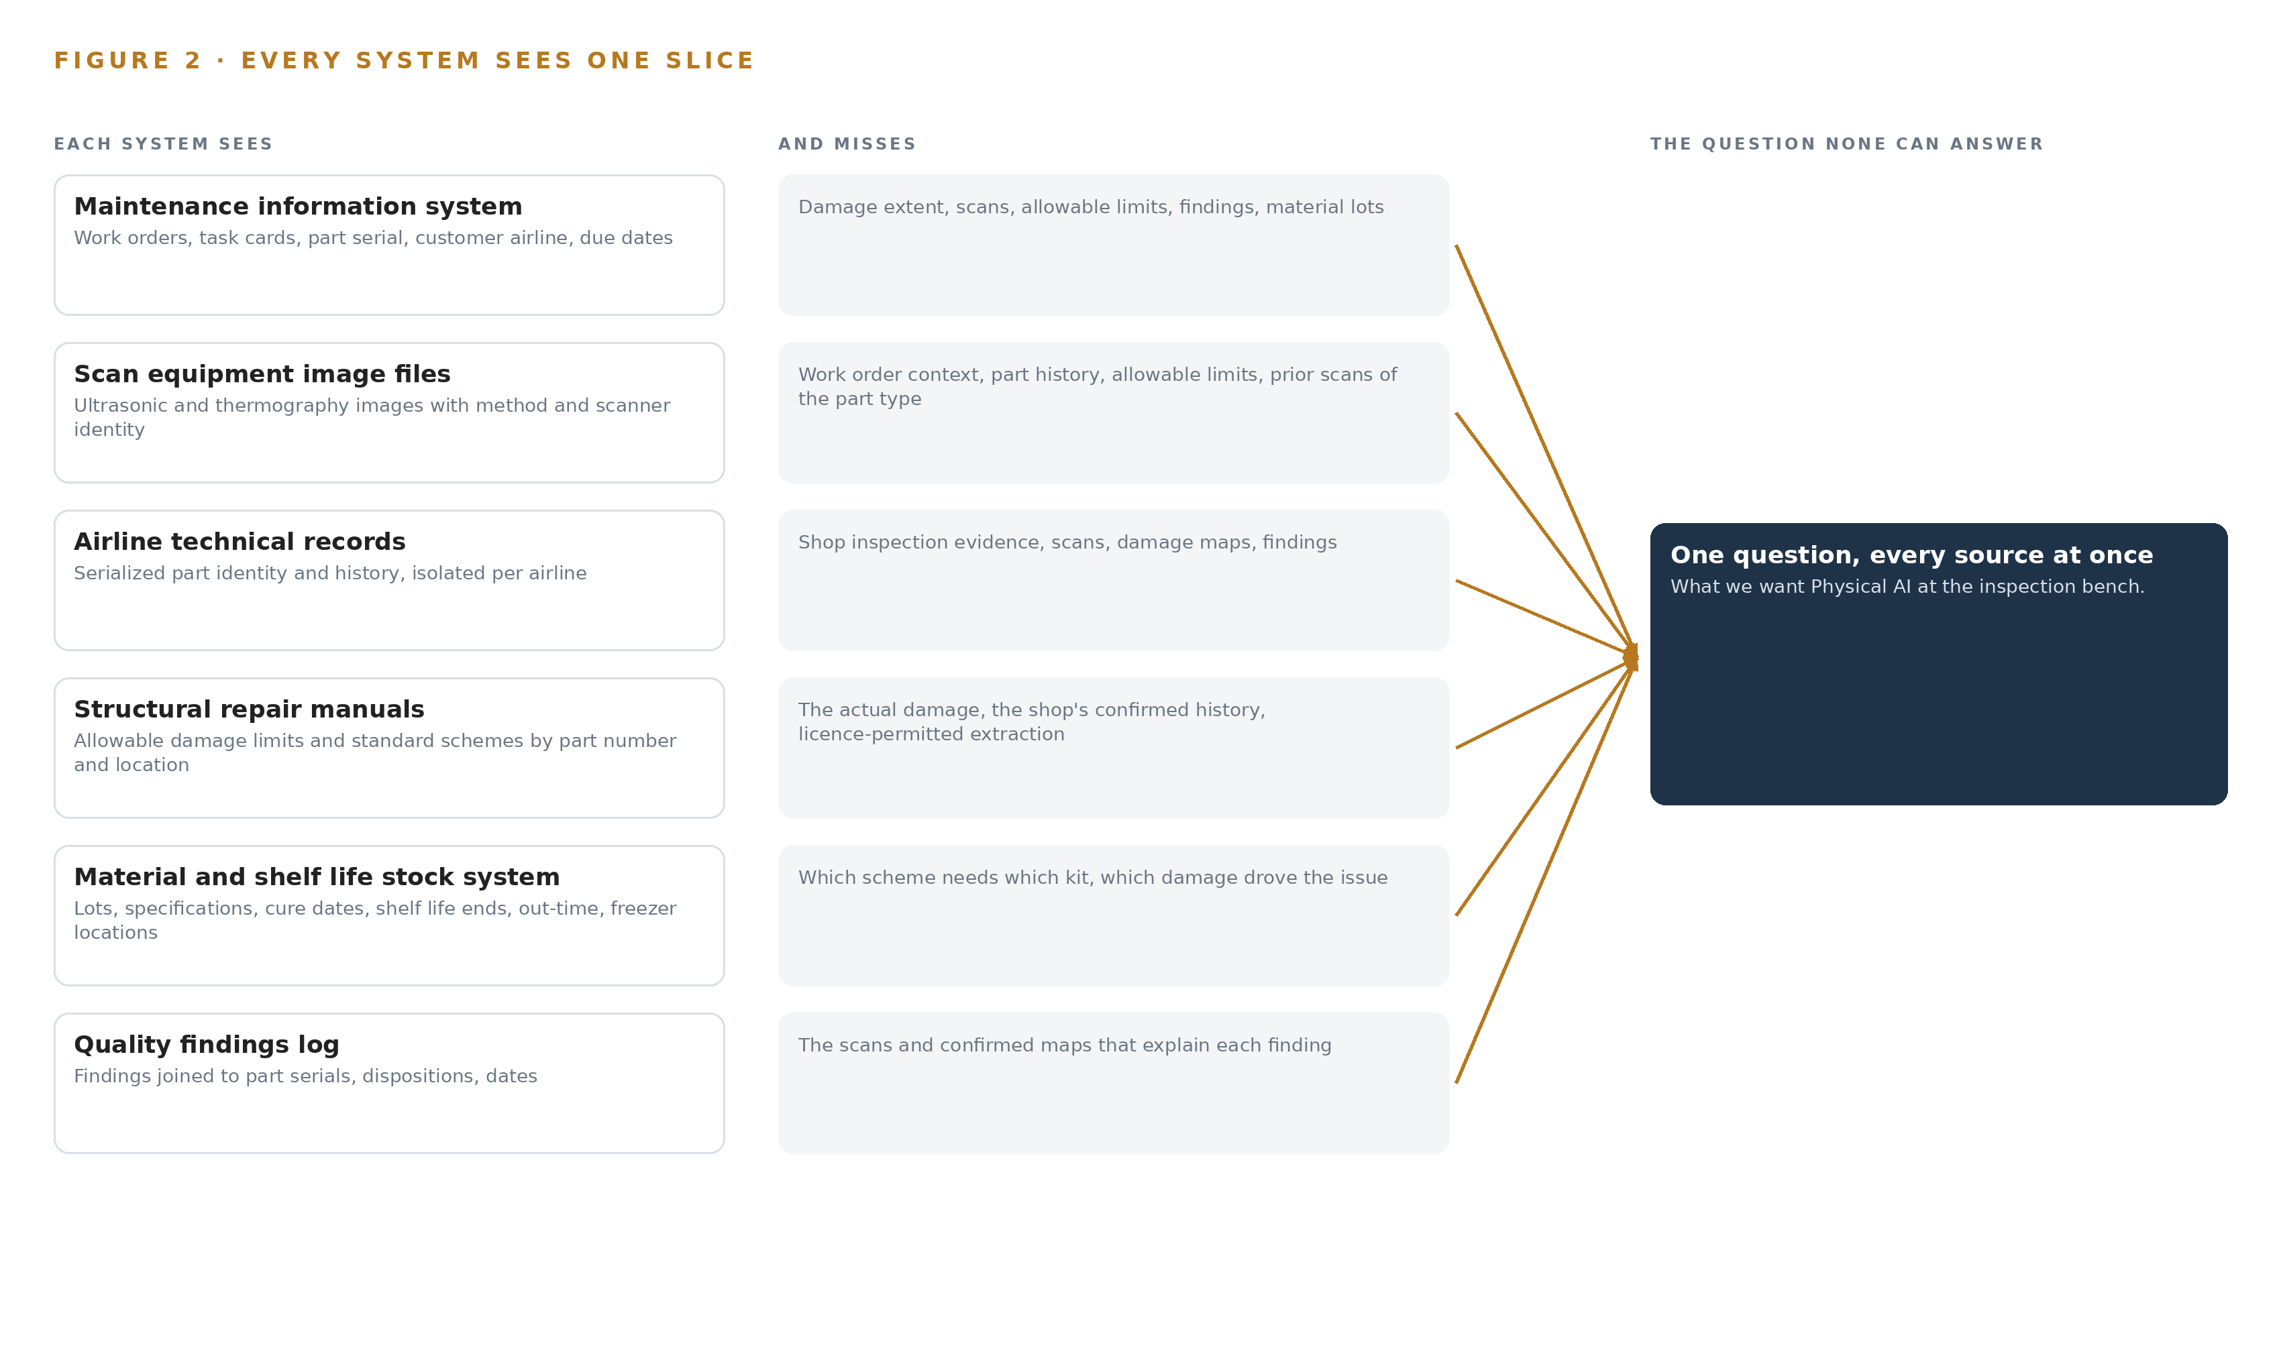
Figure 2. Six systems, each seeing one part of the answer. The question needs all of them in one place at once.

PART II · CHAPTER 3
Sovereignty and the Signature Constrain Every Layer
Licensed manuals, a regulator-approved quality system, personal data law and a hard network boundary shape the design before any model is chosen.
Chapter 2 showed the join failure: six systems of record, each holding one slice, with no traversable path between them. This chapter states the goals any design must satisfy before a single component is chosen, because in this industry the constraints, not the models, decide the architecture.
3.1 Everything Stays Inside the Shop Network
The first goal is that records, scan images and manual content never leave the shop network, on the operator's own hardware, with no data center or colocation entertained. This is hard in this industry because the reasoning the shop needs, drafting schemes against manual limits with citations, is frontier-class work, and the easy way to obtain it is an external model API that carries the evidence out with every request. Meeting the goal self hosted means the design stands on sovereign infrastructure of its own: one GPU node of the 141 GB class inside the shop network running the work surface, and edge units at the bench and scan station, with no third boundary ever crossed.
3.2 The Signature Stays with Named People
The second goal is that agents map and draft while certifying engineers decide and sign, with no autonomous damage classification and no autonomous release. This is hard because the quality system under the national civil aviation regulations assigns release responsibility to named certifying staff, and any system output that holds a required record is a change to that system, which must be filed and approved before it carries weight. Guidance for software management programs during aircraft maintenance exists and shows the shape of that approval path (FAA 2023). Until the change lands, every agent draft runs advisory beside the existing process, and the design accepts that a draft is never a decision.
3.3 Nothing Is Trained on the Shop's Records
The third goal is that every confirmed damage map and every approved scheme is kept so the next assessment of the same part type is faster, without training a model on the fly. This is hard because the obvious artificial intelligence play in a damage inspection shop is fine-tuning vision models on accumulated damage images, and that would bake licensed manual content and airline records into weights, crossing both the license and the boundary. The design instead holds memory of confirmed outcomes as retrievable records read before each run, which costs retrieval engineering and buys compounding speed with no retraining pipeline at all.
3.4 Two Laws Gate the Records
The fourth goal is to satisfy the personal data protection law and the manual license before anything holds a record. A personal data assessment covers records naming technicians, inspectors and certifying staff; it is filed in the first phase, before the system holds such a record. The manual license is harder: the whole classification comparison depends on extracting allowable limits as queryable objects, and the license terms may not permit it, so written confirmation is required first, with the fallback of citing the manual revision in each draft rather than holding limit objects.
3.5 Scoping Decisions
Scope is a constraint like the rest, and Table 1 records the three decisions that bound the first phase, each with what it buys and what it costs.
Table 1 · Scoping Decisions
DECISION | WHAT IT BUYS | WHAT IT COSTS
Phase one covers fan cowls and nacelle panels only | A bounded, measured first phase on the part family the requirement names first | Flight control surfaces and cabin monuments wait for a later phase
Agents draft, certifying engineers decide and sign | A path that changes no decision rights and needs no new signatory | A confirmation step on every agent output, by design
Memory of confirmed outcomes, never weights | Compounding assessment speed with no retraining pipeline | Retrieval engineering over the kept record instead of model updates

3.6 What the Design Chose Against
Each layer carries a rejected alternative, and Table 2 records them, ending with what is out of scope and why.
Table 2 · What the Design Chose Against
WHERE | WHAT WAS PICKED | INSTEAD OF, AND WHY
Reasoning placement | GLM 5.3 self hosted on one node of eight 141 GB-class GPUs inside the shop network | A cloud model API, because the boundary keeps records, scans and manual content off any external network
Bench vision | Zero-shot and anomaly models on edge units at one bench and one scan station | A whole-shop camera rollout, because the value concentrates where damage is mapped and the NPU loads are unmeasured until the gate
Site reading | A 27B dense multimodal model on a 48 GB site card | Sending images to the frontier node, keeping the reading beside the data it came from
Manual limits | Allowable limit objects extracted from the licensed manuals, pending written confirmation | Citing the manual revision in each draft only, the stated fallback if the license refuses extraction
Integration | Bespoke read connectors against the six named systems | An integration product, because the maintenance information system exposes its own API and the scanner exports files
Out of scope | Autonomous damage classification or release, and any change to who signs | Anything that removes the certifying engineer from the decision, which the quality system does not permit and the design does not seek

PART II · CHAPTER 4
One Stack Runs From Records to the Bench
The design keeps the systems of record below, one governed object model in the middle, and applications and agents above, all inside the shop network.
Chapter 3 fixed the four constraints that shape everything downstream: no data leaves the shop network, no system of record is replaced, every required record keeps a named human signature, and nothing is trusted before it is shadowed. This chapter lays the stack that satisfies those constraints, stage by stage, from the records the shop already trusts to the surfaces its engineers already work at.
4.1 The Pattern and Why It Fits
The design uses one architectural pattern end to end: systems of record below, one governed object model in the middle, applications and agents above, all inside the shop network. The pattern fits this industry because the records below are already certified, licensed and audited, and the design has no authority to change them; an aerospace structures manufacturer of comparable scale reports its data trapped in disconnected systems, which is the condition this pattern exists to remove (RYSHE n.d.). Nothing in the design writes back to a maintenance information system, a stock system or a licensed manual; every one of them is read, joined and reasoned over, never modified. The middle layer, a single object model of the shop, is where the join happens, and because it is governed, every draft an agent produces can be traced to the record and the scan it came from. Above it sit the five services and the eight surfaces, and the agents that draft while certifying engineers decide and sign. Figure 3 shows the layered stack with the count at each layer: six named systems of record below, two adapter families as the sole path in, one object model of sixteen objects, five services, eight surfaces and six models across three inference tiers. The Federal Aviation Administration's guidance on managing software used during maintenance treats the integrity of such tooling as part of the maintenance process itself, not as an accessory to it, and the stack is built to that standard (FAA 2023). Table 7, printed by the platform from the plan, carries the layer by layer technology choices with the reason each was picked, from Apache Kafka in KRaft mode to Keycloak for on-site identity.
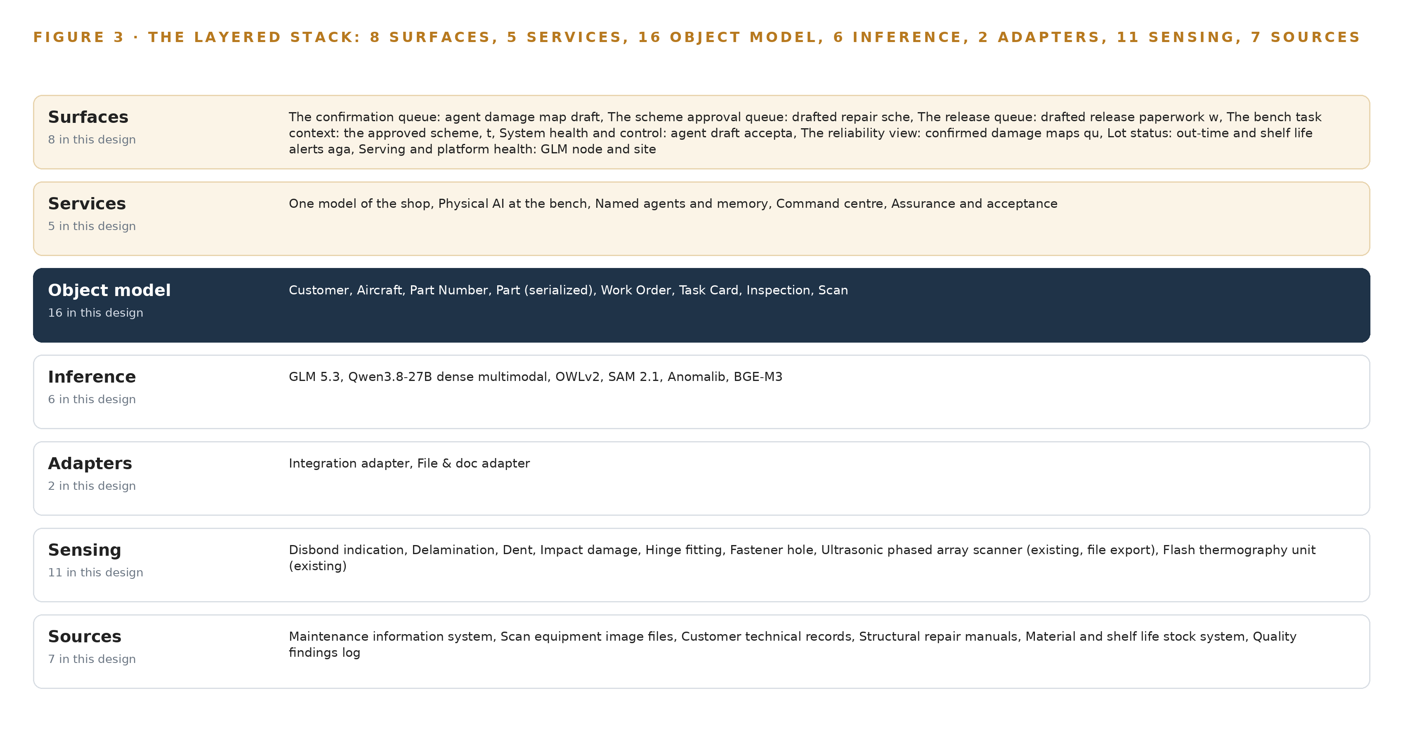
Figure 3. The layered stack: 7 sources, 2 adapter families, 16 objects, 5 services and 8 surfaces.
Table 7 · Architecture, Layer by Layer
LAYER | COMPONENT | CHOICE | WHY
Event streaming and messaging | by class, no product named | Product | Apache Kafka (KRaft mode)
The ontology or graph store | by class, no product named | Product | Hyper Ontology v0.9 (Semantics plus Kinetics)
Time series and telemetry storage | by class, no product named | Product | PostgreSQL 18
Video ingest, recording and management | by class, no product named | Product | Frigate NVR
Edge model serving | by class, no product named | Product | ONNX Runtime
On site language model serving | by class, no product named | Product | vLLM
Object tracking and trajectory forecasting | by class, no product named | Not needed | Parts are static on the bench and scan station; this design maps damage extent on a stationary fan cowl, and nothing in the requirement asks for trajectory forecasting.
Edge orchestration of containers | by class, no product named | Product | Docker Engine
An air gapped artifact and model registry | by class, no product named | Product | Harbor (offline installer)
Labelling and retraining | by class, no product named | Not needed | The requirement's own words: 'Every confirmed damage map and every approved scheme is kept so the next assessment of the same part type is faster, without training a model on the fly'; under system of context nothing is trained into weights, so there is no retraining pipeline, and the reference panels serve capability demonstration instead.
Time synchronisation across sensors and systems | by class, no product named | Product | Chrony (NTP) with linuxptp available
Observability of the running system | by class, no product named | Product | Prometheus 3.13 LTS (with Grafana dashboards)

4.2 The Stack Stage by Stage
Each stage has one responsibility and named components that carry it, so that a fault, an upgrade or an audit question lands in one place. Table 3 states the stages in order, what each is responsible for, and how it meets that responsibility; the stages run from the sources through sensing, adapters, the object model and inference to the services and surfaces where people act.
Table 3 · The Stack, Stage by Stage
STAGE | WHAT IT IS RESPONSIBLE FOR | HOW
Sources | Holding the records the shop already trusts | Six named systems read only: the maintenance information system, scanner image files, airline technical records, licensed structural repair manuals, the material and shelf life stock system, the quality findings log
Sensing | Instrumenting the bench and the scan station | Inspection bench, bench overhead and scan station cameras on Frigate NVR, beside the existing ultrasonic phased array scanner, flash thermography unit and recorded tap tests
Adapters | Being the sole path data takes into the model | Two families: an integration adapter against the maintenance information system API, and a file and document adapter lifting scanner exports and parseable manual content
Object model | Holding the governed model of the shop | Hyper Ontology v0.9 over PostgreSQL 18, with Apache Kafka in KRaft mode moving events between stages
Inference | Running the six models where the data sits | ONNX Runtime on the fanless edge units, vLLM on the 48 GB site card and on the 141 GB-class, eight-GPU node
Services | Doing the shop's work | Five: one model of the shop, physical AI at the bench, named agents and memory, command center, assurance and acceptance
Surfaces | Putting drafts in front of named people | Eight surfaces on the work surface, from the confirmation queue and scheme approval queue to lot status and serving and platform health

4.3 A Reusable Pattern
A team carrying a similar brief can reuse the whole shape: records read and never replaced below, two adapter families as the sole entry path, one governed object model in the middle, agents that draft and named people who confirm and sign above, and a shadow period before any draft carries weight. What they swap is the content: their own named systems of record in the sources stage, their own object set and typed links, their own detection vocabulary at the bench, and models sized to their own hardware. What they keep regardless of industry is the part that carries the constraints: the adapter-only entry, the single write path through human confirmation, hosting inside their own boundary, and the assurance workstream that files the quality system change before anything holds a required record.

PART II · CHAPTER 5
Sixteen Objects Turn Shop Data Into One Argument
Sixteen typed objects with governed links turn work orders, scans, damage, schemes and releases into one queryable argument that no document store can hold.
Chapter 4 described the stack that carries the design from records to surfaces. This chapter describes what the middle of that stack holds: the sixteen governed objects and their typed links that turn the shop's scattered records into one queryable argument.
5.1 Sixteen Objects and the Links Between Them
The object model holds sixteen objects: Customer, Aircraft, Part Number, Part (serialized), Work Order, Task Card, Inspection, Scan, Damage, Damage Class, Allowable Limit, Repair Scheme, Material Lot, Technician Qualification, Finding and Release. Each is anchored in a system of record the shop already runs, and each carries a status vocabulary that mirrors the shop's real states, so a serialized part moves through Received, In assessment, Awaiting scheme approval, In repair, Final inspection, Released or Scrapped exactly as it does on the floor. Figure 4 shows every object and its typed links, with the Damage object in the focal position because it is where the slowest and most skilled step happens. The links are typed, which is what makes the model an argument rather than a pile of documents: a damage event points to the serialized part it sits on, the damage class it is measured against, and the scan that evidences it, while the part number points to the allowable limits that govern the comparison. The question the shop cannot ask today, how many fan cowls of one part number showed a disbond at the same hinge fitting in the last year, is answered by walking four links: from the part number to its serialized instances, to the damage events confirmed on them, to the scans and hinge fitting locations that evidence each one, and out to the findings log. A document store holds each of those facts somewhere, but it holds no path between them, and the industry's own work on a lifelong digital maintenance record argues for exactly this joined form (Aircraftit n.d.). Investigations reconstruct maintenance history from whatever fragments systems happened to keep, which is the failure a governed model prevents (NTSB 2013). Table 8, printed by the platform from the plan, lists every object with the record it is anchored in and its typed links.
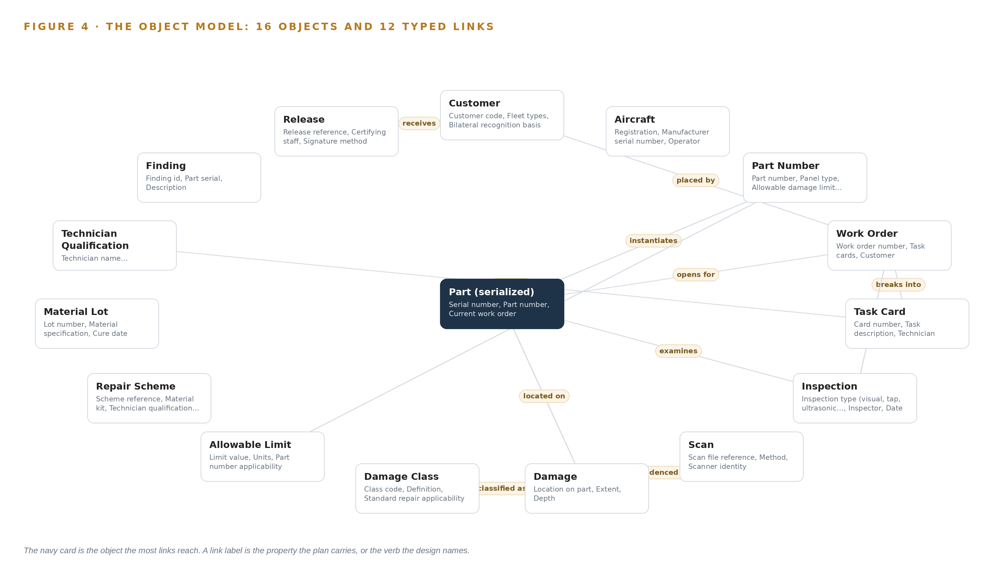
Figure 4. The sixteen objects of the model and the typed links that let a query reach across them.
Table 8 · The Object Model
OBJECT | ANCHORED IN | TYPED LINKS
Customer | The technical records of each customer's parts | receives: Release
Aircraft | The maintenance information system (work order header) | no typed link recorded
Part Number | The structural repair manuals under license | limited by: Allowable Limit
Part (serialized) | The technical records of each customer's parts | instantiates: Part Number
Work Order | The maintenance information system | opens for: Part (serialized); placed by: Customer; breaks into: Task Card
Task Card | The maintenance information system | requires: Technician Qualification
Inspection | event | examines: Part (serialized); belongs to: Work Order
Scan | The scan equipment's own computer | no typed link recorded
Damage | event | located on: Part (serialized); classified as: Damage Class; evidenced by: Scan
Damage Class | The structural repair manuals under license | no typed link recorded
Allowable Limit | The structural repair manuals under license | no typed link recorded
Repair Scheme | The structural repair manuals under license | no typed link recorded

5.2 The Human Loop and the Hosting Posture
The human loop lives in the status vocabularies and in three of the eight surfaces: the confirmation queue where a certifying engineer confirms, amends or rejects an agent's damage map draft, the scheme approval queue where a design engineer approves or supersedes a drafted repair scheme, and the release queue where certifying staff sign the release paperwork. An agent never moves an object past its drafted status; only a named person's confirmation does, and that confirmation is the single write path into the model for anything that becomes a required record. The hosting posture follows the boundary constraint: the ontology, the memory of confirmed outcomes and the model node all run on the operator's own hardware inside the shop network, in Saudi Arabia, with identity handled by Keycloak on site. No external links leave the boundary except the one-way update path through a hardware data diode, which lets artifacts in and nothing out, and the personal data protection assessment is filed before any record is held. Per-airline isolation of technical records is a property of the model itself, because records of different airlines mix in one shop and must not mix in one query.
5.3 One Object in Its Recorded Form
The Customer record below shows the identifier, label, kind, properties, status vocabulary and links the platform prints for every object; the Damage object, the one every assessment turns on, is recorded the same way.
{ "id": "customer", "label": "Customer", "kind": "actor", "anchored_in": "The technical records of each customer's parts", "properties": [ "Customer code", "Fleet types", "Bilateral recognition basis", "Release certificate format" ], "status_vocabulary": [], "links": [ { "to": "release", "label": "receives" } ] }

PART II · CHAPTER 6
Every Source Enters Through an Adapter
Seven sources of record enter through two adapter families, so no source system is modified and no data path bypasses the governed model.
Chapter 5 described what the object model holds and how its links carry an argument. This chapter describes how data gets into it: seven sources, two adapter families, and an event backbone that keeps every arrival ordered, buffered and traceable.
6.1 Seven Sources and Their Provenance
Seven sources feed the model: the six named systems of record plus the camera stream from the bench and scan station. The maintenance information system, which holds work orders and task cards and exposes a live API, is read through the integration adapter and is the spine every scan, damage map and scheme resolves to. The scan equipment image files, the subsurface half of every damage map, are lifted from the scanner's own computer by the file and document adapter together with whatever metadata each scan carries. The airline technical records supply serialized part identity and history, with per-airline isolation enforced at the ontology. The structural repair manuals, held as licensed digital manuals confirmed parseable at intake, supply the allowable limits and standard repair schemes, with license permission to extract confirmed in writing before go live. The material and shelf life stock system feeds material lots with cure dates, shelf life ends and accumulated out-time. The quality findings log supplies the findings that make the repeat-finding question answerable. Figure 5 shows each named system, its provenance class and its adapter path; all six systems of record carry operator provenance and read-only direction. The nondestructive testing community's own position is that shared standards are what let different digital systems exchange inspection data at all, which is the gap the adapter tier is built to close (ASNT n.d.).
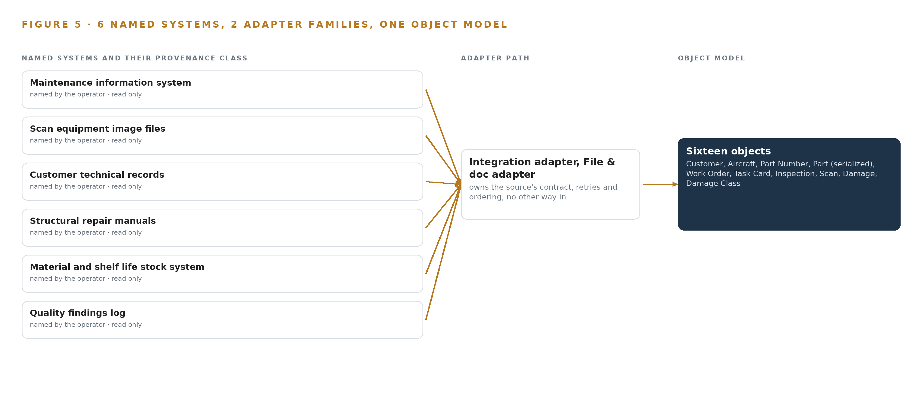
Figure 5. The 7 named systems, the adapter path each one takes, and the object model they all map into.
6.2 What the Adapter Tier Guarantees
The adapter tier guarantees four things. First, no source system is modified: every connection is read-only, so the certified systems of record stay exactly as their auditors last saw them, in line with guidance that treats software touching maintenance data as part of the managed process (FAA 2023). Second, provenance is recorded on arrival: every work order, scan file and manual clause enters carrying the system, the timestamp and the extraction method it came from, and where a scanner's export lacks the calibration reference the evidence chain needs, the gap is recorded and shown rather than hidden. Third, per-airline isolation is applied as data lands, so records of one airline never enter a query path for another. Fourth, ingestion is idempotent, so a re-read of the same work order or the same scan file produces the same objects rather than duplicates, which is what lets the pipeline be replayed after any interruption without corrupting the model.
6.3 The Event Backbone
Apache Kafka in KRaft mode carries every arrival from the adapters to the object model and every downstream service. Ordering is keyed by work order, so all events for one part arrive in the order the shop generated them, which matters when a damage confirmation must not overtake the inspection that precedes it. Delivery is at least once, paired with the idempotent consumers above, so a repeated event is recognized and dropped rather than double-counted. Buffering absorbs the shop's natural bursts: a scanner export, a batch of task card updates and a camera clip set can arrive together without loss, because Kafka retains them until every consumer has acknowledged. Replication keeps a copy of the stream inside the shop network, so a node restart does not lose an in-flight damage map, and Chrony time synchronization with an OCP Time Card grandmaster keeps sensor and system clocks aligned, which is what makes the evidence chain's timestamps mean the same thing everywhere. Updates to the running system itself arrive the same one way, through the data diode, so the backbone never opens an outbound path.

PART II · CHAPTER 7
Vision Runs at the Bench, Reasoning In-Country
Zero-shot and anomaly vision run on edge units at the bench and scan station, multimodal reading runs on a site card, and the frontier model runs on one GPU node inside the shop.
Chapter 6 showed every source entering through one of two adapter families and landing in the object model as typed, provenance-carrying records. This chapter fixes where inference runs, because in a shop whose records, scan images and licensed manual content must never leave its network, placement is a boundary decision before it is a performance one: the same weights that are cheap to serve from a data center are impossible to serve there once the evidence they read cannot follow them.
7.1 Three Tiers and Their Memory Arithmetic
Figure 6 places the work on three tiers. At the edge sit two units of the on-device class the design carries: an octa-core SoC with a 6 TOPS neural processing unit in a fanless sealed housing, one at the inspection bench and one at the scan station. They run the vision models, whose weights are small enough to state exactly: OWLv2 at about 310 MB for the base checkpoint and about 875 MB for the large at 16 bit, SAM 2.1 at about 78 MB for tiny and about 449 MB for large at 16 bit, and an Anomalib model whose size is model dependent, typically tens to hundreds of MB at 32 bit, with memory bank methods such as PatchCore also growing with the number of reference images. Capacity is therefore not the open question at this tier; rate is, because loads on the neural processing unit are unmeasured, and measurement with the actual models on a development board is the phase one gate before any unit is committed, with the ONNX Runtime CPU provider and a small GPU at the bench as the stated fallbacks.
The site tier is a single card of the 48 GB PCIe inference GPU class on a server inside the shop. It holds the multimodal reader, a 27 billion parameter dense vision-language model at about 28 GB of weights at 8 bit, which leaves the rest of the card for the key-value cache and the visual tokens that scan reading generates. Beside it sits the retrieval embedding model at about 1.1 GB at FP16, small enough that it never competes with the reader for the card.
The central tier is one node of 8 GPUs of the 141 GB class, self-hosted inside the shop network with no data center and no colocation, because the boundary constraint keeps records, scans and manual content on site. The arithmetic comes from the frontier model's filed parameter count: 753 billion parameters at FP8, at one byte per parameter, give 753 GB of weights; multiplying by 1.2 for the key-value cache and activations gives 904 GB the GPUs must hold; and the node offers 8 times 141 GB, or 1,128 GB, which holds it with headroom for the cache ceiling that long drafting sessions push toward.
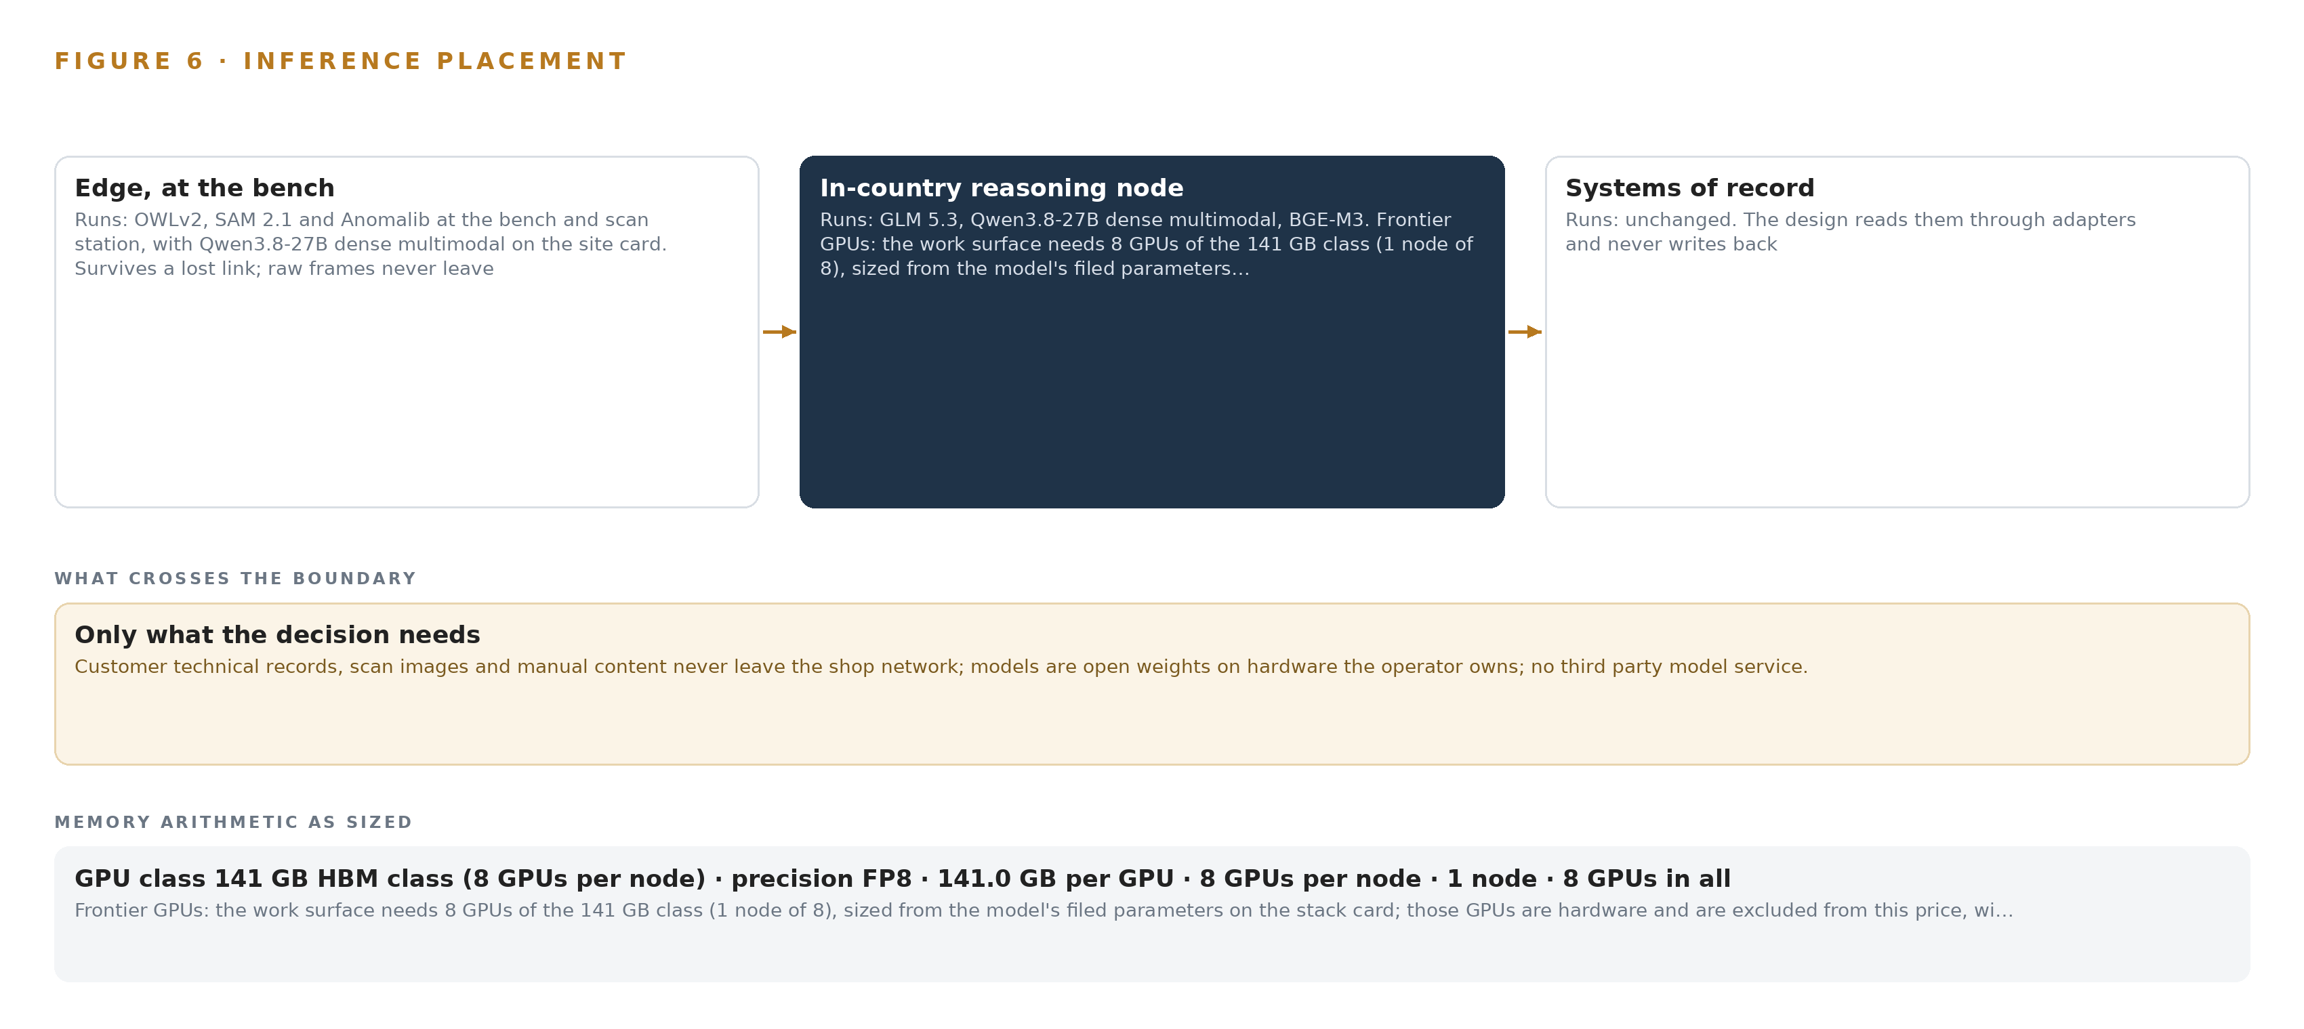
Figure 6. Where each tier runs, what runs there, and the narrow set of outputs that cross the boundary.
7.2 The Latency Budget
The budget is set by the shop's work rather than by any model's benchmark, and each tier has its own clock. At the bench, detection runs on selected frames rather than every frame, so the constraint is that an indication surfaces while the part is still under the technician's hands and the lighting and framing that produced it can be repeated. At the scan station, anomaly mapping of an exported file must finish inside the same inspection slot the scan already occupies, or the operator will read the raw image first and the draft becomes a check rather than a head start. The multimodal reader must turn one scan into a structured damage draft while the work order is still open, and the frontier model's draft must be waiting in the confirmation queue by the time the certifying engineer opens it, because a draft that arrives after the decision has been made is worth less than none. Every tier is therefore sized so that the slowest step a person waits on is the person's own judgement, which is the step the design protects rather than compresses.
7.3 What Crosses the Boundary, and What Fails
Nothing crosses outward. The technical records of the airlines' parts, the scan images and the manual content stay on the shop network, and the single write path, a named person's confirmation or signature, lands in the object model and never in a system of record. What crosses inward is the update stream: container images and model weights arrive through a one-way transfer, Lidi over a hardware data diode, into the on-site registry installed from Harbor's offline installer, and the diode's direction is what guarantees that shop data cannot follow an update back out.
The failure paths follow from that shape. If the link between an edge unit and the site server fails, the edge units keep detecting and segmenting against the models they already hold, drafts queue locally, and the queues resynchronize when the link returns; the shop's existing process is unaffected because every draft is advisory until an engineer signs it. If power fails, the NUT-managed UPS carries the edge units and the site server through the interruption, and the systems of record are the shop's own in any case. If the update path fails, the units run the versions already in the on-site registry, and the absence of a new version is a condition the system health surface shows rather than hides, alongside agent draft acceptance and the weekly count of engineer disagreement reports.

PART II · CHAPTER 8
The License Decides What the Shop Can Own
Six models under permissive or bespoke terms let the operator hold every weight it runs, on hardware whose export path is settled before any order.
Chapter 7 placed the three tiers and sized their memory from the models' filed weights. This chapter states what runs at each tier and on what terms, because the license behind a model, not its benchmark, decides whether the operator can hold the weights its inspection process comes to depend on.
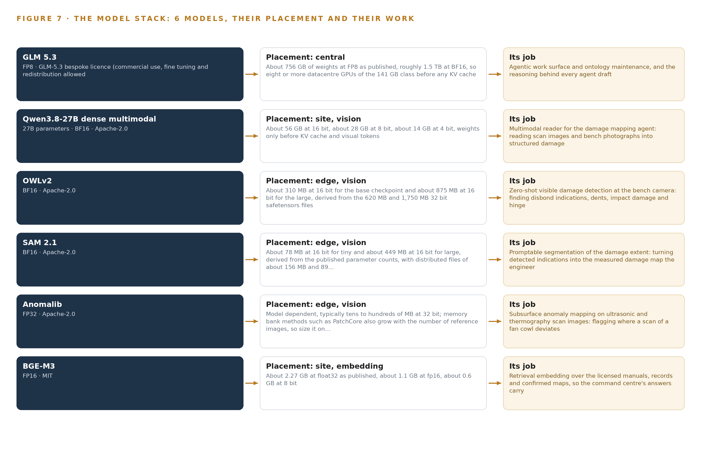
Figure 7. The six models, their placement, and the work each one does.
8.1 Six Models the Shop Holds Outright
Figure 7 stacks the six models against the three tiers. At the center sits GLM 5.3, a frontier-class model with about 753 billion filed parameters served at FP8 on the one GPU node. Its role is the agentic work surface and ontology maintenance, and the reasoning behind every agent draft. It carries a bespoke GLM-5.3 license whose terms permit commercial use, fine tuning and redistribution, which is what lets the operator hold and change the weights it runs rather than rent them, and it was chosen because the command center the requirement names, with parts in work, open assessments, approvals waiting and a conversational interface that answers with citations, needs reasoning weight that smaller models cannot supply.
At the site tier, Qwen3.8-27B dense multimodal reads scan images and bench photographs into structured damage for the mapping agent. It is a 27 billion parameter dense vision-language model under Apache-2.0, at about 28 GB of weights at 8 bit on the 48 GB card, and it was chosen to keep the reading of images beside the data while the frontier reasoning stays on its own node.
Three vision models run at the edge. OWLv2 is a zero-shot, text-conditioned detector under Apache-2.0, at about 310 MB for the base checkpoint and about 875 MB for the large at 16 bit; it was chosen because it needs no training for this shop, so the bench unit detects the damage vocabulary the shop already uses, from disbond indication to hinge fitting, without any labelled local damage data, and it runs on selected frames rather than every frame. SAM 2.1 is promptable segmentation under Apache-2.0 on checkpoints, inference and training code with no field of use restriction, at about 78 MB for tiny and about 449 MB for large at 16 bit; the damage map needs masks and extents rather than boxes, and it is driven by the detector's boxes or an operator click. Anomalib, under Apache-2.0, maps subsurface anomalies on ultrasonic and thermography scan images, flagging where a scan of a fan cowl deviates from reference panels; its size is model dependent, typically tens to hundreds of MB at 32 bit, and memory bank methods grow with the reference set, so it is sized on the chosen model.
BGE-M3, under MIT, is the retrieval embedding over the licensed manuals, records and confirmed maps. Its dense, sparse and multi-vector output from a single pass keeps part numbers and clause references retrievable as exact strings, with an 8,192-token window, at about 1.1 GB at FP16 on the site card. The two accelerator purchases carry their own term: the 141 GB class node and the 48 GB site card are US-origin accelerators whose export to the operator needs a license determination before any order, with in-country sourcing weighed as the alternative.
8.2 The Model and Equipment Register
Table 4 gathers every choice this chapter and the last rest on: each model, the hardware classes and sizing rules the tiers are built from, the sensing that feeds them, the patterns the design stands on, and the ground the whole system runs on. Read together, the rows show that the intelligence in this design is held, not borrowed: every weight runs on the operator's own hardware inside the shop network, under licenses that permit it, on equipment whose export path is settled before anything is ordered.
Table 4 · Model and Equipment Register
THE CHOICE | WHAT WAS PICKED | WHY HERE
Frontier reasoning | GLM 5.3, about 753B filed parameters, FP8, bespoke GLM-5.3 license | Commercial use, fine tuning and redistribution permitted, so the operator holds and changes the weights its work surface runs on
Multimodal reading | Qwen3.8-27B dense multimodal, Apache-2.0 | Reads scans and bench photographs into structured damage beside the data, at about 28 GB of weights at 8 bit on the site card
Zero-shot detection | OWLv2, Apache-2.0 | Text-conditioned and untrained, so the bench detects the shop's own damage vocabulary with no labelled local data, on selected frames
Promptable segmentation | SAM 2.1, Apache-2.0 | Turns boxes or an operator click into the masks and extents the damage map needs, with no field of use restriction
Subsurface anomaly mapping | Anomalib, Apache-2.0 | Flags where ultrasonic and thermography scans deviate from reference panels; sized on the chosen model as the memory bank grows
Retrieval embedding | BGE-M3, MIT | Dense, sparse and multi-vector output keeps part numbers and clause references retrievable, with an 8,192-token window
Frontier node sizing | GLM 5.3 Node Count By GPU Class | One node of 8 GPUs holds 904 GB of weights, cache and activations from the filed parameter count
Frontier GPU class | 141 GB HBM GPU Class | 8 times 141 GB gives 1,128 GB, enough for the FP8 weights and the KV cache ceiling
Site inference card | 48 GB PCIe Inference GPU Class | Carries the reader at about 28 GB of weights with the rest of the card for cache and visual tokens
Inspection equipment | Non Destructive Testing Equipment Classes | Existing ultrasonic, thermography and tap test capability, lifted with its metadata rather than replaced
Bench sensing | Inspection bench camera, bench overhead camera, scan station camera | Fixed framing of the part, the damage and the traveller tag at the two edge units
Subsurface sensing | Ultrasonic phased array scanner and flash thermography unit (existing, file export), tap test on the task card | The subsurface half of every damage map, exported with scanner identity and calibration reference

PART III · CHAPTER 9
Shadow Mode Comes Before Any Draft Is Trusted
A measured first phase on fan cowls and nacelle panels runs a baseline and then shadow mode before any draft carries weight, with the quality system change filed in parallel.
Chapter 8 settled the model stack and the licenses that let the shop hold every weight it runs. This chapter sets out how the design arrives in the shop: two phases, what each carries, what the rollout measures, and the gates that stop the work cheaply when a premise fails.
9.1 Phases, Items and Gates
Phase one carries 17 items across five workstreams: One model of the shop, Physical AI at the bench, Named agents and memory, Command center, and Assurance and acceptance. The first workstream builds the shop ontology from the systems of record, and its items include the maintenance information system read integration and the scanner file export integration; the last workstream carries the assurance work that must land before anything holds a required record. Phase one runs on fan cowls and nacelle panels only. Its exit gate is the bench and scan station edge units: a dev-board run with the actual vision models, because whether they fit the 6 TOPS NPU class at a usable rate decides whether the edge tier is viable at all. Phase two carries a single item, the extension design to flight control surfaces and the remaining part families, under the Assurance and acceptance workstream, and it begins only when the phase one gate has been passed.
Within phase one the order is fixed by what the shop must trust first: the baseline before the drafts, shadow mode before any draft carries weight, and a capability demonstration on reference panels before the quality system change is relied on. The quality system change under the national civil aviation regulations and the personal data protection assessment are filed in phase one, in parallel with the build, because the approval path and not the technology sets the schedule; a precedent recorded in the plan's own risk register makes exactly that point. Figure 8 shows both phases with their item counts, workstreams and gates, and carries the coverage of the 22 requirements, each traced to a workstream and a gate rather than left as a claim.
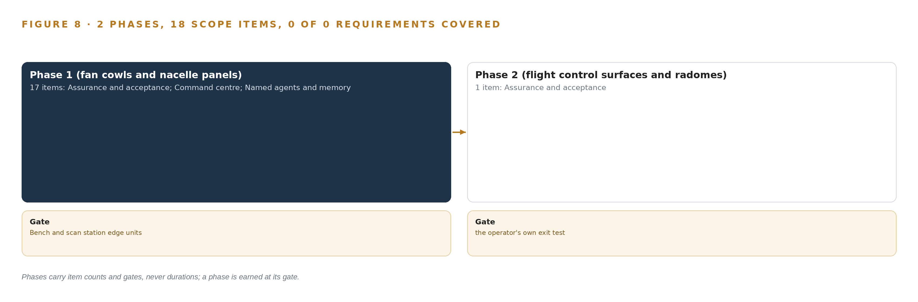
Figure 8. The two phases and their gates, and coverage of the 22 requirements across them.
9.2 What the Rollout Measures
The rollout measures the shop, not the models. The baseline comes first: how long an assessment takes today from received part to confirmed damage map, how often the certifying engineer escalates to the manufacturer, and how many assessments start from scratch for a part type the shop has seen before. Shadow mode comes second, with agent drafts running beside the existing process and no draft holding a required record. Its measures are how often a draft is confirmed without amendment, how often the engineer amends the location, the extent or the class, and how often a draft is rejected outright.
Alongside these the rollout tracks the time from scan ingested to map confirmed, the count of out-time alerts acted on before a material lot expires, and whether the repeat-finding question the shop cannot ask today, how many fan cowls of one type showed a disbond at the same hinge, becomes answerable from confirmed maps joined to part serials.
9.3 Failure Modes
Table 5 lists what the design accepts can fail and what it does about each. Every row is a recorded risk with a named answer, and the first two are gates in their own right.
Table 5 · Failure Modes
WHAT FAILS | WHAT THE DESIGN DOES
The structural repair manual license may not permit extracting allowable limits into the ontology | Written confirmation from the manual holder before go live; if refused, drafts cite the manual revision instead of holding limit objects
Vision model loads may not fit the on-device NPU at a usable rate | Dev-board measurement with the actual models is the phase one gate; the ONNX Runtime CPU provider and a small GPU at the bench are the stated fallbacks
The quality system change under the national civil aviation regulations may land after the build | The change is filed in phase one in parallel with the build; drafts run as advisory beside the existing process until it lands
The 141 GB class node and the 48 GB site card are US-origin accelerators needing an export license determination | The determination sits at a phase one checkpoint before any GPU is quoted; in-country sourcing is weighed as the alternative
Scan file quality, format and metadata vary by scanner and may not carry the calibration reference | A scanner survey is an early phase one item; provenance gaps are recorded per scan and left visible rather than hidden
Certifying engineers find drafts slower to check than to redo | Shadow mode with disagreement review beside the engineers; the disagreement path is built first and the count of engineer reports is published each week

9.4 Lessons From the Build
Shadow the drafts before anyone trusts them. A draft that reaches a certifying engineer before its agreement rate is known transfers risk to the signature, which is the one place the design cannot afford it. Shadow mode on fan cowls and nacelle panels buys the evidence, and the reference panels buy the demonstration, without either touching a required record.
Build the disagreement path before the agreement path. The instructive signal in advisory drafting is where the engineer and the agent diverge, because each divergence is either a model finding or an engineer precedent the memory should hold. Publishing the count of engineer reports each week turns quiet non-use into a visible finding instead of a slow failure that reads as a technology problem.
File the paperwork with the build. The quality system change and the data protection assessment run in parallel with the engineering from the first item of phase one, because the recorded precedent in the plan's risk register is that the approval path, not the technology, sets the schedule.
9.5 What Is Still Open
Four questions remain open, and settling each changes something concrete. The manual license permission, once confirmed in writing, decides whether allowable limit objects exist in the ontology or every draft cites a manual revision instead. The export license determination decides the sourcing route for the 141 GB HBM class node and the 48 GB site card, and an in-country answer would change the hardware plan rather than the design. The scanner survey decides which provenance fields the evidence chain can rely on and where the gaps will sit. The survey of PoE ports and switch budget at the bench and scan station decides whether the edge units land where the design places them or the shop's existing network constrains the placement.

PART III · CHAPTER 10
The Intelligence Stays with the Shop
The object model, the weights, the memory of confirmed outcomes and the boundary all belong to the shop, and nothing that compounds ever leaves it.
Chapter 9 ended on the open questions the rollout must settle. This chapter settles the question underneath all of them: who owns what the design builds, and what never leaves the shop that produced it.
10.1 What the Shop Owns
The object model is the shop's outright. Its 16 objects are anchored in systems of record the shop already holds: the work order spine in the maintenance information system, the serialized part identity in the per-airline technical records, the allowable limits in the licensed manuals, the material lots in the stock system. Because the ontology is governed and self-contained, it can be exported, audited and rebuilt inside the shop's boundary without any vendor's continuing presence, and the per-airline isolation of technical records is a property of the model itself, since records of different airlines mix in one shop.
The weights are the shop's too. GLM 5.3 runs under a license that permits commercial use, fine tuning and redistribution, so the operator may hold, tune and even redistribute the weights it serves on its own node; the vision and embedding models carry Apache-2.0 and MIT terms with no field of use restriction. Nothing in the stack rents intelligence from outside the boundary.
The decision record, every confirmed damage map, approved scheme and signed release with its signature method and retention expiry, belongs to the shop as evidence. The memory of confirmed outcomes is a record the next decision reads, and nothing in it updates model weights. The boundary itself is owned and enforced: records, scans and manual content never leave the shop network, updates arrive one way over a hardware data diode, and the reasoning node sits inside the shop, self-hosted. This is the shape a physical AI system design takes in practice when the operator owns it, and the shop that produced the intelligence keeps all of it.
10.2 The Offer Behind the Design
CodeNinja designed this system on Praxis, its platform for designing physical AI systems, and each element of it maps to the offer behind the design. The bench and scan station sensing, the cameras and the zero-shot and anomaly detection of physical damage, are Adaptive Operations. The confirmation, scheme approval and release queues, where ranking and drafting end in a named person's decision, are Decision Systems. The governed object model of 16 objects is Hyper Ontology, and the command center where certifying engineers, design engineers and certifying staff act on agent drafts is Hyper Pragma, the work surface where the shop's own people build and run their agents. The whole footing, own hardware in the shop, open-weight licenses, in-country self-hosted serving with a data diode at the edge, is Sovereign Infrastructure.

PART IV · CONCLUSION
The Shop Owns the Argument It Produces

In one view the design is a single governed argument built from records the shop already holds: a part arrives, its scans and photographs join its serialized history and the licensed manual limits, agents draft the damage map, the scheme and the release papers over that joined context, and a named engineer signs each one, with every confirmed outcome kept so the next assessment of the same part type starts from evidence instead of from zero.
Running the same shape elsewhere takes the same four things it took here: systems of record that can be read without being replaced, a boundary the data never crosses and hardware the operator holds inside it, licenses that let the operator keep every weight it runs, and a regulator-approved path in which agents draft and people sign; any operation with serialized assets, a skilled assessment bottleneck and a hard sovereignty constraint can swap its objects, sources and damage vocabulary for its own and keep the shape.

PART IV · CHAPTER 11
How Praxis Contextualized and Reasoned This Design
Every choice in this design traces to recorded reading, from the ask and its family to the eight lenses and the patterns they returned.
Chapter 10 established that everything the design builds stays with the shop. This chapter turns the design around and shows how it was produced, so any choice in it can be traced back to what justified it. Every design in this series is produced on Praxis, the design team platform for designing physical AI systems, and this chapter lets a reader follow the reasoning the way the platform recorded it. Figure 9 shows the path from the ask to the equipment classes: the ask and its assigned family and industry, what it read, the eight lenses and what each returned, the patterns adopted and set aside, and the ground the design runs on.
11.1 Contextualizing the Ask
The ask, in the operator's own words, was a physical AI system design for composite part inspection in a composite repair shop: radomes, flight control surfaces, nacelle panels, fan cowls and cabin monuments, assessed visually and with tap testing, ultrasonic scanning and thermography against allowable limits in licensed manuals. Praxis assigned the family system of context and the industry Aviation and Aerospace Manufacturing, which pinned the architecture before any component was chosen: a governed ontology over the systems of record, agents that draft while certifying engineers decide and sign, and memory of confirmed outcomes instead of any training into weights. What Praxis read was the operator's requirement, written in its own voice and dated 7 November 2026, together with the corpus shelf of each lens, and nothing beyond the published sources cited in this paper's register was consulted.
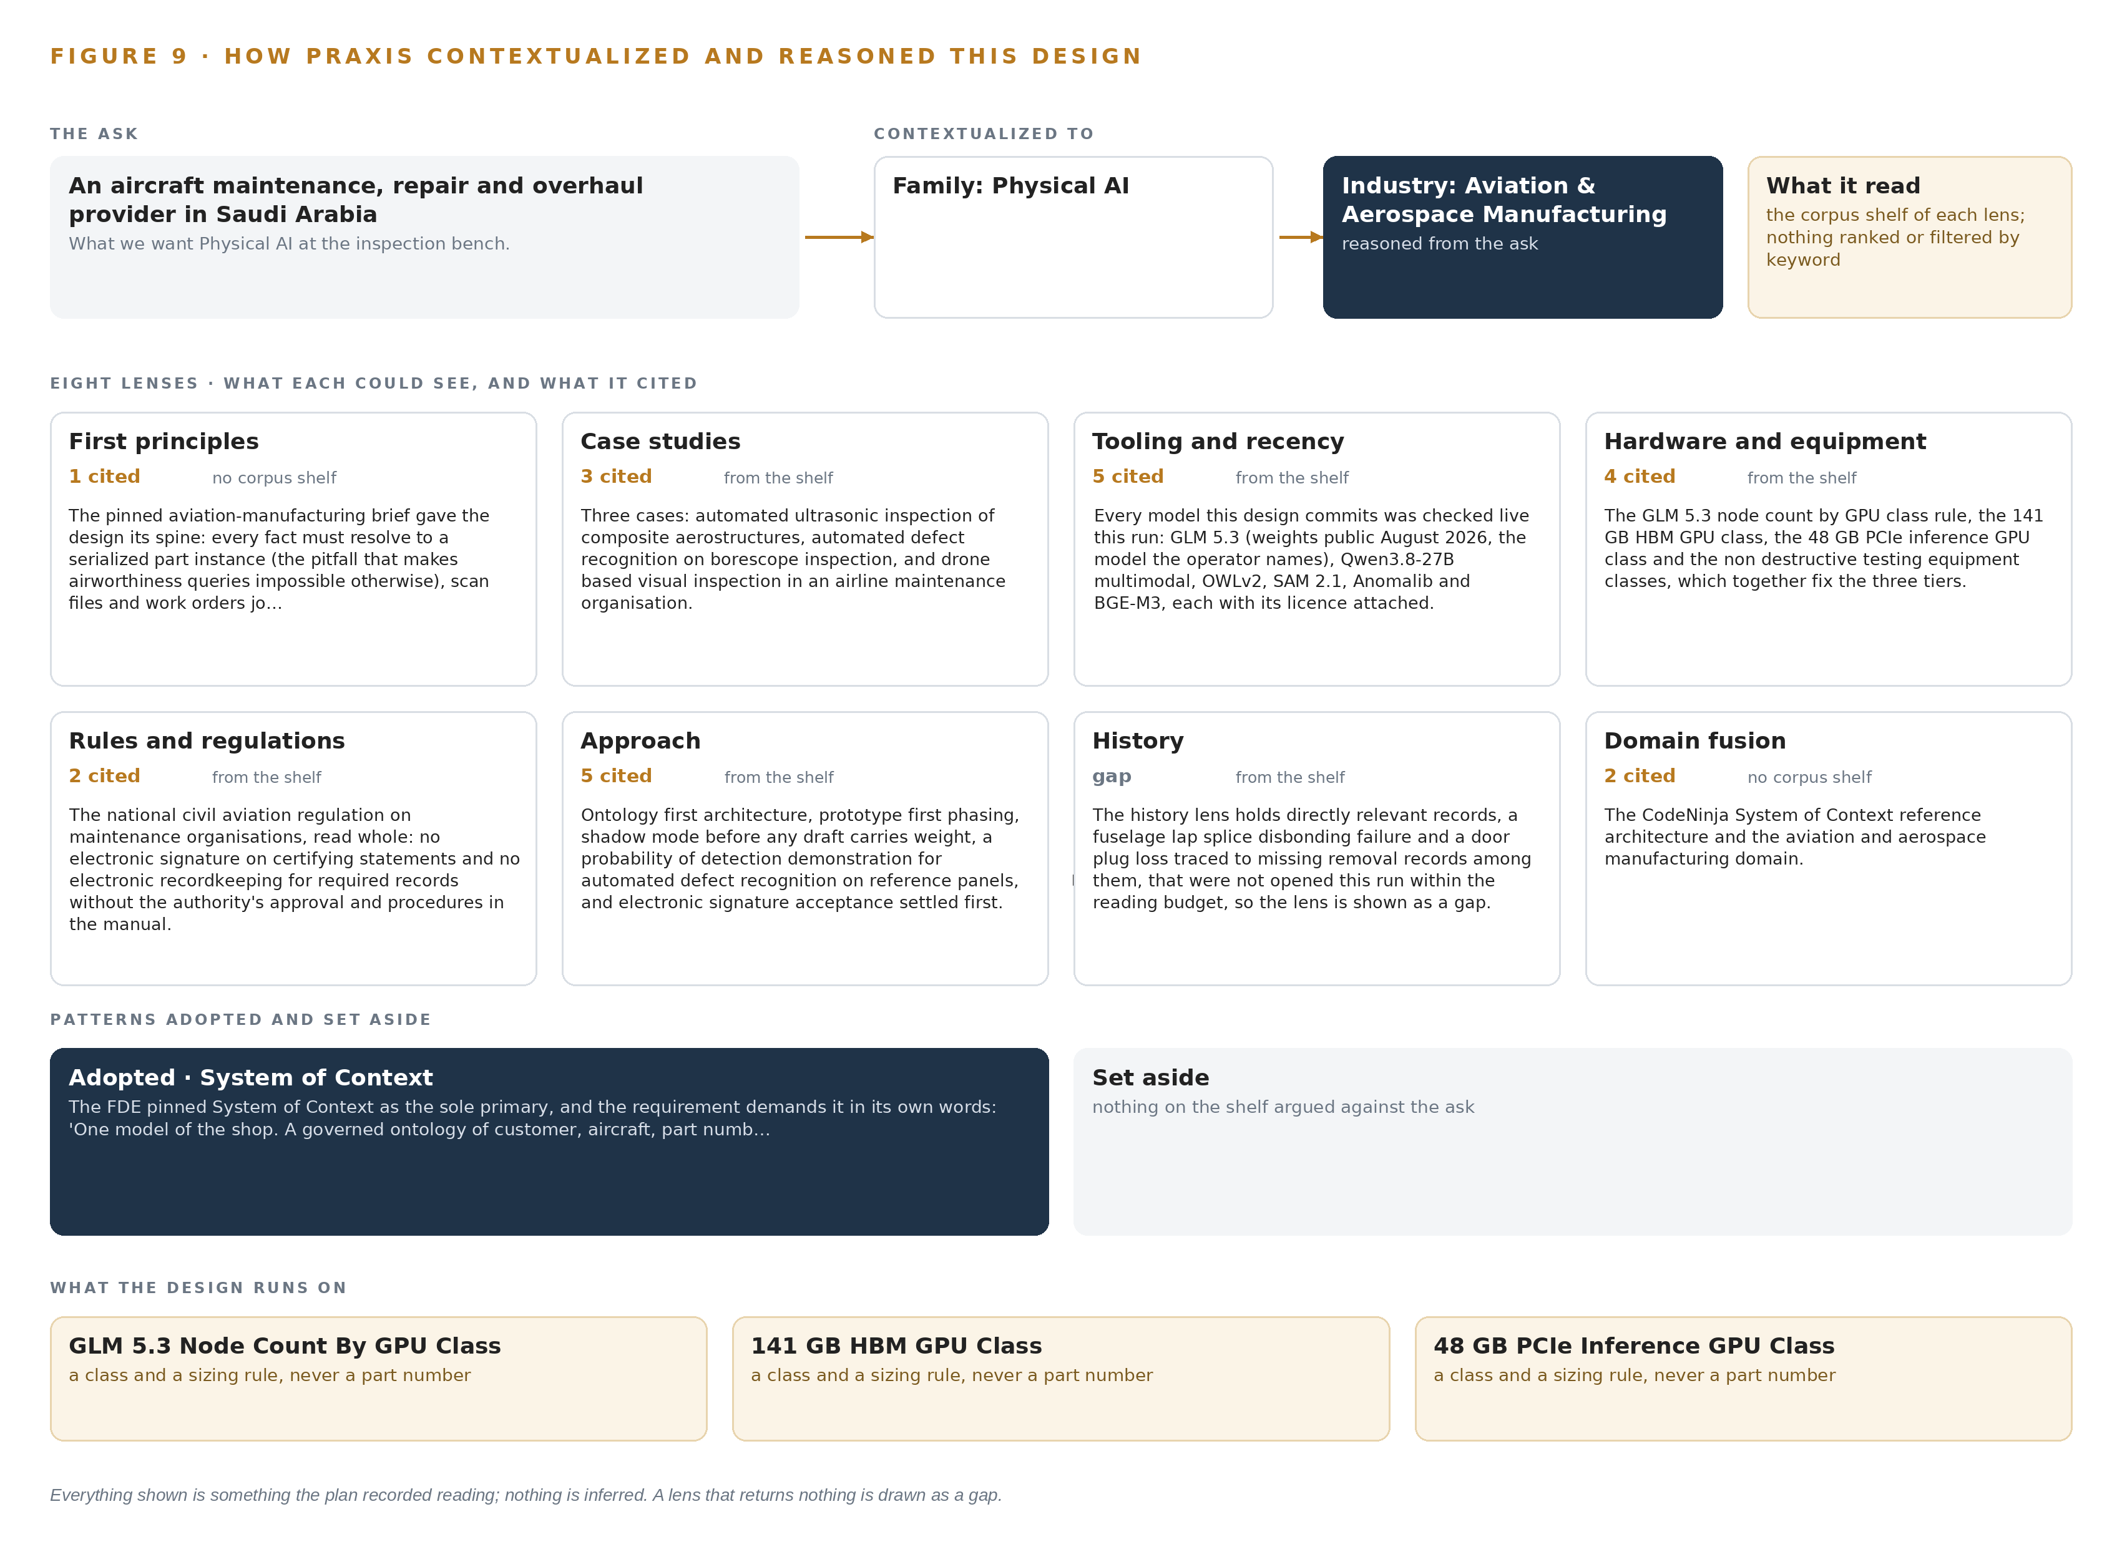
Figure 9. From the ask to the design: the family and industry Praxis assigned, the eight lenses and what each cited, the patterns adopted and set aside, and the equipment the design lands on.
11.2 The Lenses
Table 6 shows all eight lenses, what each could see, what it cited and what it contributed to the design. One lens returned nothing the others had not already carried, and it is shown as a gap rather than folded into a neighbour.
Table 6 · The Lenses and What They Contributed
LENS | COULD SEE | CITED | WHAT IT CONTRIBUTED
First principles | no corpus shelf | 1 | The pinned aviation and aerospace manufacturing brief gave the design its spine: every fact must resolve to a serialized part instance, because a fact that does not is the pitfall that makes an airworthiness question impossible to answer; scan files and work orders join on that instance.
Case studies | the case study shelf | 3 | Three cases: automated ultrasonic inspection of composite aerostructures, automated defect recognition on borescope inspection, and drone based visual inspection in an airline maintenance organisation.
Tooling and recency | the tooling and recency shelf | 5 | Every model this design commits was checked live this run: GLM 5.3 (weights public August 2026, the model the operator names), Qwen3.8-27B multimodal, OWLv2, SAM 2.1, Anomalib and BGE-M3, each with its licence attached.
Hardware and equipment | the hardware and equipment shelf | 4 | The GLM 5.3 node count by GPU class rule, the 141 GB HBM GPU class, the 48 GB PCIe inference GPU class and the non destructive testing equipment classes, which together fix the three tiers.
Rules and regulations | the rules and regulations shelf | 2 | The national civil aviation regulation on maintenance organisations, read whole: no electronic signature on certifying statements and no electronic recordkeeping for required records without the authority's approval and procedures in the manual, which is why the quality system change is filed in phase one.
Approach | the approach shelf | 5 | Ontology first architecture, prototype first phasing, shadow mode before any draft carries weight, a probability of detection demonstration for automated defect recognition on reference panels, and electronic signature acceptance settled first.
History | the history shelf | 0 | The history lens holds directly relevant records, a fuselage lap splice disbonding failure and a door plug loss traced to missing removal records among them, that were not opened this run within the reading budget, so the lens is shown as a gap.
Domain fusion | no corpus shelf | 2 | The CodeNinja System of Context reference architecture and the aviation and aerospace manufacturing domain.

11.3 Patterns Adopted and Set Aside
Four patterns were adopted. Agents draft and engineers sign, because the signature is the airworthiness instrument and the design protects it. Every source enters through an adapter, never directly, so the systems of record stay untouched and provenance is a property of the connection rather than a promise. Vision runs at the edge and reasoning runs on one in-country node, because scan images and bench photographs should never cross the network boundary to be read. Memory of confirmed outcomes substitutes for training, so the shop compounds experience without ever touching weights.
Three patterns were set aside with reasons. Object tracking and trajectory forecasting were rejected because parts are static on the bench and the scan station, and the design maps damage extent on a stationary fan cowl. A labelling and retraining pipeline was rejected because nothing in the architecture trains into weights; the reference panels serve capability demonstration instead. A new network segment was rejected because the shop network already exists and the constraint is that nothing leaves it.
11.4 Where the Reasoning Lands
The reasoning lands on equipment classes rather than named hardware where no shelf entry supported a specific part: the octa-core 6 TOPS NPU SoC class in a fanless sealed housing at the bench and scan station, the 48 GB PCIe inference GPU class for the multimodal reader, the 141 GB HBM class node of eight GPUs for GLM 5.3 sized from its filed 753B parameters at FP8, the OCP Time Card grandmaster class for time synchronisation, and the non-destructive testing equipment classes already in the shop. Every figure in this paper, from the 17 items of phase one to the eight lenses of this table, traces to recorded reading, and nothing in it is inferred beyond that record.

SOURCES
Source Register
NTSB. 2025. Maintenance Group Chair’s Factual. https://data.ntsb.gov/Docket/Document/docBLOB?FileExtension=pdf&FileName=11A+-+Maintenance+Group+Chairman%27s+Factual+Report-Rel.pdf&ID=20310561
NTSB. 2013. Maintenance Data Computer Factual Report. https://data.ntsb.gov/Docket/Document/docBLOB?FileExtension=.PDF&FileName=Maintenance+Data+Computer+Factual+Report-Master.PDF&ID=40430089
FAA. 2023. AC 43-216A. https://www.faa.gov/documentLibrary/media/Advisory_Circular/AC_43-216A.pdf
ASNT. n.d.. DATA-SHARING STANDARDS FOR MRO. https://source.asnt.org/cdn-1756908315941/24tvpoe.pdf
Aircraftit. n.d.. White Paper: A more efficient maintenance data standard. https://www.aircraftit.com/articles/white-paper-a-more-efficient-maintenance-data-standard/
RYSHE. n.d.. Data Foundations for Aerospace: From 7 Disconnected Systems to Predictive Quality, Ryshe. https://ryshe.com/case-studies/aerospace-data-foundations/

About CodeNinja
CodeNinja is a Middle Eastern American artificial intelligence lab and system of context company. It builds sovereign self-improving systems that organizations own, run inside their own boundary and improve with every decision they make.
https://codeatoms.ai

