NED University of Engineering & Technology
Department of Computer Science & IT

Assignment Report

AR/VR Cat Filter App Using Computer Vision (OpenCV)

Student Name | Muhammad Umer Farooq
Course | Design of AR/VR Applications
Roll No | GA-021
Instructor | Miss Saadia Arshad
Due Date | May 1, 2026
Total Marks | 20 + 5 Bonus

1. Objective
To design and implement a real-time AR/VR-inspired application using OpenCV that applies a Snapchat-style cat filter on a detected face through live webcam input. The filter includes cat ears, a drawn cat nose, and whiskers — and disappears automatically when the face is covered.

2. Tools & Libraries Used
Tool / Library | Version | Purpose
Python | 3.11.9 | Programming language
OpenCV | 4.13.0.92 | Camera feed, face detection, drawing overlays
NumPy | 2.4.4 | Array operations for image processing
Haar Cascade XML | Built-in OpenCV | Pre-trained frontal face detector
CMD (Windows) | - | Running the Python script

3. Implementation Steps

Step 1 — Install Python 3.11.9
Downloaded Python 3.11.9 from python.org. Disabled Microsoft Store alias from App Execution Settings so the correct Python version runs from CMD.


Step 2 — Install Libraries
Ran the following command in CMD to install OpenCV and NumPy:
pip install opencv-python


Step 3 — Prepare Cat Ears Image
Downloaded a transparent PNG of cat ears (cat_ears.png) and saved it to the Desktop. Verified it has 4 channels (RGBA) using:
python -c "import cv2; img = cv2.imread('cat_ears.png', cv2.IMREAD_UNCHANGED); print(img.shape)"
Output confirmed: (1200, 1200, 4) — transparency channel present.
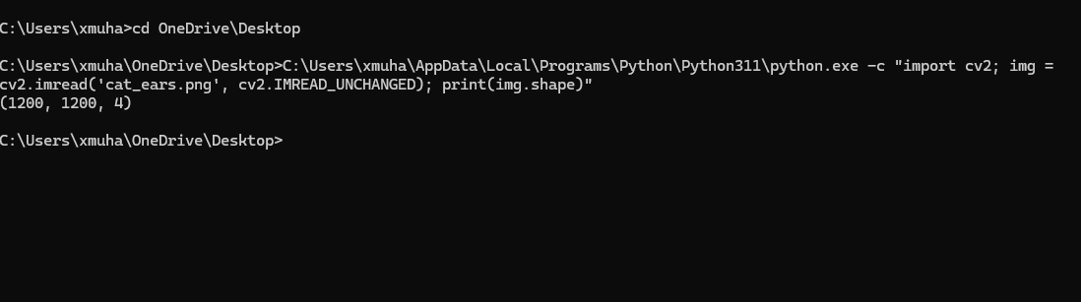

Step 4 — Write the Application Code
Created hand_detection.py on the Desktop using Notepad. The complete code is in Section 4.


Step 5 — Run the Application
Navigated to Desktop and ran the script:
cd OneDrive\Desktop
C:\Users\xmuha\AppData\Local\Programs\Python\Python311\python.exe hand_detection.py
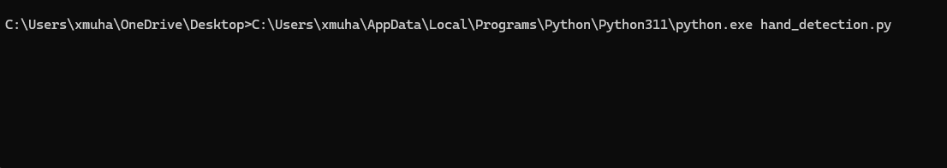

Step 6 — Test the AR Filter
The application opened the webcam and applied the cat filter in real time. Cat ears appeared above the face, whiskers and nose were drawn on the face. When the face was covered with a hand, the filter disappeared and 'FILTER OFF' was displayed.

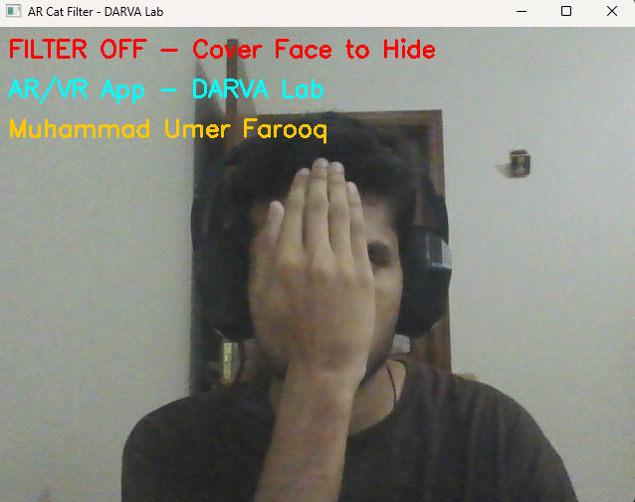

4. Complete Source Code

import cv2
import numpy as np

# Load face detector
face_cascade = cv2.CascadeClassifier(
cv2.data.haarcascades + 'haarcascade_frontalface_default.xml')

# Load cat ears PNG (transparent)
cat_ears = cv2.imread('cat_ears.png', cv2.IMREAD_UNCHANGED)

# Draw cat nose and whiskers directly on frame
def draw_cat_nose(frame, x, y, w, h):
cx = x + w // 2
cy = y + h // 2
nose_size = max(w // 12, 6)
nose_pts = np.array([
[cx, cy + nose_size],
[cx - nose_size, cy],
[cx + nose_size, cy]
])
cv2.fillPoly(frame, [nose_pts], (147, 112, 219))
wlen = w // 2
wy = cy + nose_size // 2
# Left whiskers
cv2.line(frame, (cx-nose_size-5, wy),
(cx-nose_size-wlen, wy-10), (255,255,255), 2)
cv2.line(frame, (cx-nose_size-5, wy+5),
(cx-nose_size-wlen, wy+10), (255,255,255), 2)
cv2.line(frame, (cx-nose_size-5, wy+10),
(cx-nose_size-wlen, wy+25), (255,255,255), 2)
# Right whiskers
cv2.line(frame, (cx+nose_size+5, wy),
(cx+nose_size+wlen, wy-10), (255,255,255), 2)
cv2.line(frame, (cx+nose_size+5, wy+5),
(cx+nose_size+wlen, wy+10), (255,255,255), 2)
cv2.line(frame, (cx+nose_size+5, wy+10),
(cx+nose_size+wlen, wy+25), (255,255,255), 2)

# Overlay transparent PNG on frame
def overlay_image(background, overlay, x, y, w, h):
overlay_resized = cv2.resize(overlay, (w, h))
x1, x2 = max(x,0), min(x+w, background.shape[1])
y1, y2 = max(y,0), min(y+h, background.shape[0])
ox1, oy1 = x1-x, y1-y
ox2, oy2 = ox1+(x2-x1), oy1+(y2-y1)
if x2<=x1 or y2<=y1: return
if overlay_resized.shape[2] == 4:
alpha = overlay_resized[oy1:oy2, ox1:ox2, 3] / 255.0
for c in range(3):
background[y1:y2, x1:x2, c] = (
alpha * overlay_resized[oy1:oy2, ox1:ox2, c] +
(1-alpha) * background[y1:y2, x1:x2, c])
else:
background[y1:y2, x1:x2] = overlay_resized[oy1:oy2, ox1:ox2]

cap = cv2.VideoCapture(0)

while True:
success, frame = cap.read()
if not success: break

frame = cv2.flip(frame, 1)
gray = cv2.cvtColor(frame, cv2.COLOR_BGR2GRAY)
faces = face_cascade.detectMultiScale(gray, 1.3, 5)

if len(faces) > 0:
for (x, y, w, h) in faces:
# Overlay cat ears above face
ears_w = int(w * 1.3)
ears_h = int(h * 0.9)
ears_x = x - int((ears_w - w) / 2)
ears_y = y - int(ears_h * 0.7)
overlay_image(frame, cat_ears, ears_x, ears_y, ears_w, ears_h)
# Draw cat nose + whiskers
draw_cat_nose(frame, x, y, w, h)
# Name tag
cv2.rectangle(frame,(x,y+h),(x+w,y+h+35),(0,255,0),-1)
cv2.putText(frame,'M. Umer Farooq',(x+5,y+h+25),
cv2.FONT_HERSHEY_SIMPLEX,0.65,(0,0,0),2)
cv2.putText(frame,'CAT FILTER ON',(10,30),
cv2.FONT_HERSHEY_SIMPLEX,1,(0,255,0),2)
else:
cv2.putText(frame,'FILTER OFF - Cover Face to Hide',(10,30),
cv2.FONT_HERSHEY_SIMPLEX,0.8,(0,0,255),2)

cv2.putText(frame,'AR/VR App - DARVA Lab',(10,70),
cv2.FONT_HERSHEY_SIMPLEX,0.8,(255,255,0),2)
cv2.putText(frame,'Muhammad Umer Farooq',(10,110),
cv2.FONT_HERSHEY_SIMPLEX,0.8,(0,200,255),2)
cv2.imshow('AR Cat Filter - DARVA Lab', frame)
if cv2.waitKey(1) & 0xFF == ord('q'): break

cap.release()
cv2.destroyAllWindows()

5. Code Explanation

Step 1 — Loading the Face Detector
We tell OpenCV to load a pre-trained face detection model called Haar Cascade. Think of it like giving the computer a reference book of what human faces look like. The computer uses this book to find faces in every camera frame.

Step 2 — Loading the Cat Ears Image
We load the cat ears PNG file into memory. This image has a transparent background (4 channels — Red, Green, Blue, and Alpha). The Alpha channel tells the code which parts of the image are visible and which parts are see-through.

Step 3 — draw_cat_nose() Function
Instead of using an image for the nose, we draw it directly on the screen using code. We calculate the center of the detected face, then draw a small purple triangle as the nose. After that, we draw 6 straight white lines — 3 on each side — to create the whiskers. All positions are calculated based on the face size so they scale correctly for any distance from the camera.

Step 4 — overlay_image() Function
This function places the cat ears image on top of the camera frame. It resizes the ears to match the face width, then uses the Alpha (transparency) channel to blend the ears naturally onto the video — just like Snapchat blends filters. Wherever the PNG is transparent, the camera feed shows through. Wherever it has colour, the ears appear.

Step 5 — The Main Loop
The while True loop runs continuously — reading one frame from the webcam every millisecond. Each frame is flipped horizontally to create a mirror effect (so it feels natural). The frame is then converted to grayscale because Haar Cascade works on grayscale images only. The colour frame is kept separately for drawing the overlays.

Step 6 — Face Detection & Filter Logic
DetectMultiScale() scans the grayscale frame and returns the coordinates (x, y, width, height) of every face it finds. If at least one face is found, the cat ears are placed above the face box and the nose with whiskers is drawn on the face. If no face is found — for example when the user covers their face with their hand — the filter disappears and FILTER OFF is displayed in red. This is the AR interaction feature.

Step 7 — Displaying and Exiting
cv2.imshow() displays the final processed frame in a window. cv2.waitKey(1) checks every 1 millisecond if the user pressed the Q key. If Q is pressed, the loop breaks, the webcam is released, and the window closes cleanly.

6. Output & Results
The application produced the following results when run:
- Live webcam feed opened successfully
- Face detected in real time using Haar Cascade classifier
- Cat ears PNG overlaid above the detected face with transparency
- Cat nose (purple triangle) and white whiskers drawn precisely on face
- Name tag 'M. Umer Farooq' displayed below face bounding box
- CAT FILTER ON shown in green when face is visible
- FILTER OFF shown in red when face is covered — AR trigger working

7. Challenges & Solutions
Challenge | Cause | Solution
Python not found in CMD | Microsoft Store alias active | Disabled alias in App Execution Settings
MediaPipe not working | Incompatible with Python 3.14 | Switched to Python 3.11 + OpenCV Haar Cascade
Cat nose had white background | Downloaded image had no transparency | Drew nose & whiskers directly in code using OpenCV
File not found error | Wrong directory in CMD | Used cd OneDrive\Desktop before running

8. Learning Outcomes
- Set up a Python development environment on Windows with version management
- Applied OpenCV Haar Cascade for real-time face detection
- Implemented transparent PNG overlay on live video frames
- Drew geometric AR overlays (nose triangle, whisker lines) directly on camera feed
- Built a filter that responds to real-world interaction (covering face removes filter)
- Understood the difference between face detection and face recognition

9. Conclusion
This project successfully implements a real-time AR cat filter using Python and OpenCV — the same foundational technology behind Snapchat filters and AR applications. The app detects faces via Haar Cascade, overlays cat ears with transparency blending, draws a cat nose and whiskers directly on the frame, and responds dynamically when the face is hidden. All assignment requirements are met: live camera input, computer vision techniques, video recording, and this report.

References
- Viola & Jones (2001). Rapid Object Detection using Boosted Cascade of Simple Features. IEEE CVPR.
- OpenCV Documentation: https://docs.opencv.org/4.x/
- Python Official Site: https://www.python.org/downloads/release/python-3119/
- Murtaza's Workshop (YouTube): https://www.youtube.com/watch?v=NZde8Xt78Iw
- Claude (Anthropic’s AI Goated Tool)

