 | NED UNIVERSITY OF  ENGINEERING AND TECHNOLOGY  Department of Computer Science and Information Technology  Karachi, Pakistan | 

PROJECT REPORT
Intelligent Medical Diagnosis
Expert System
Shifa • Rule-based diagnosis. Every answer explained.
Forward chaining • Backward chaining • MYCIN certainty factors
Course code | CT-361
Course title | Artificial Intelligence and Expert Systems (AIES)
Assessment | Complex Computing Problem (CCP)
Course teacher | Dr. Usman Amjad
Semester | 7th semester, Fall 2026
Submission date | 12 November 2026

# | Group member | Roll number | Section
1 | Muhammad Umer Farooq | CTGA-021 | GA
2 | Fizza Aman | CTGA-018 | GA
3 | Naverah Farhat | CTGA-04 | GA

1. Introduction and Requirements
Shifa is a rule-based expert system for medical diagnosis. The user enters symptoms (buttons, or a typed sentence in English or Roman Urdu). The system returns a ranked list of possible diseases with a confidence level, the reasons, treatment and preventive measures. All medical knowledge is in one JSON file; the Python code has no disease names.
Table 1. Project at a glance.
Item | Value | Detail
Diseases | 6 | 3 severe (pneumonia, dengue, malaria), 2 moderate (typhoid, influenza), 1 mild (common cold)
Symptoms | 20 | 16 answered by intensity (mild / moderate / severe), 4 answered yes / no
Rules | 23 | 20 diagnostic rules (R1–R20) and 3 red-flag rules (RF1–RF3), plus 7 intermediate facts
Reasoning | 2 modes | Forward chaining always; backward chaining when two diseases are close
Uncertainty | MYCIN CF | Certainty factor 0 to 1 per disease, shown as confidence %
Interfaces | CLI + GUI | Command line and a Streamlit app (4-step wizard)
Testing | 132 | Automated checks, all pass (14 clinical cases, 7 regression, 8 hybrid cases)

1.1 Requirement coverage
Table 2. Every CCP requirement and deliverable, where it is covered, and the file that implements it.
CCP requirement | How we meet it | Section | File
Symptoms (min 8–10) | 20 symptoms | 3.1 | knowledge_base.json
Diseases (min 3–4) | 6 diseases | 2 | knowledge_base.json
Rules combining symptoms | 20 AND-rules + 3 red flags | 3.3–3.4 | knowledge_base.json
Severity mild/moderate/severe | Per disease and per symptom | 2, 3.2 | knowledge_base.json
Treatments, preventive measures | Every disease has both | 2 | knowledge_base.json
Possible diseases from symptoms | Forward chaining | 4.2 | engine.py
Severe over mild | Priority + severity-first ranking | 4.4 | engine.py
Justification per diagnosis | Rule chain, why / why-not | 4.5 | engine.py, cli.py
Confidence levels (A 70%, B 30%) | Confidence % + evidence strength | 4.6 | engine.py
CLI or GUI | Both | 5 | main.py, app.py
Chosen diseases description | Tables with source | 2 | Report
Facts and rules used | All tables | 3 | Report
Inference reasoning explained | Traces, formulas, figures | 4 | Report
Example queries + screenshots | 5 queries, 8 screenshots | 5 | Report
Assumptions and limitations | Tables | 7 | LIMITATIONS.md
Python source code | In the zip file | Appendix | Whole project
Title page | Course, title, members, roll no. | Page 1 | Report

2. Chosen Diseases
Six diseases cover all three severity levels. Dengue and malaria share early symptoms (fever, headache, nausea), which tests backward chaining. Cough appears in three diseases with different strength, and typhoid needs fever for more than 3 days, which needs a 3-level rule chain. WHO and CDC publish a symptom list for each, so every rule has a source.
Table 3. The six diseases: description, treatment and prevention (knowledge base entries, shortened). Sources: WHO, CDC.
Disease | Severity | Cause and spread | Main symptoms | Treatment / recommendation | Prevention | Source
Pneumonia | Severe | Lung infection (bacteria, virus or fungus) | Cough, shortness of breath, fever, chest pain | See a doctor promptly. Antibiotics if bacterial (amoxicillin preferred by WHO), hospital care if severe, rest and fluids. | Vaccines (pneumococcal, Hib, measles, flu), handwashing, less indoor smoke, no smoking. | WHO
Dengue | Severe | Virus, spread by Aedes mosquitoes | High fever, pain behind the eyes, body aches, nausea, rash | No specific medicine. Rest, plenty of fluids, paracetamol. Do NOT take aspirin or ibuprofen (bleeding risk). See a doctor and watch for warning signs. | Mosquito repellent, long sleeves, window screens and nets, remove standing water. | WHO, CDC
Malaria | Severe | Plasmodium parasite, spread by Anopheles mosquitoes | Fever, headache, chills | Blood test to confirm. Artemisinin-based combination therapy (ACT) prescribed by a doctor. Always needs medicine; severe signs need emergency care. | Treated bed nets, repellent after dusk, protective clothing, preventive medicine for travellers, vaccines for young children in high-risk areas. | WHO
Typhoid | Moderate | Salmonella Typhi bacteria, spread by contaminated food and water | Prolonged high fever, abdominal pain, constipation or diarrhoea | Blood test to confirm. Antibiotics for the full course. Wash hands after the toilet; do not prepare food for others until cleared. | Safe (boiled) water, sanitation, well-cooked hot food, hand hygiene, typhoid vaccine. | WHO
Influenza | Moderate | Influenza virus, respiratory infection | Sudden fever, dry cough, headache, muscle and joint pain, tiredness | Rest, fluids, treat fever. Seek care if worse. Antivirals early for high-risk or severe cases (doctor-prescribed). | Yearly vaccine, handwashing, cover coughs and sneezes, stay home when ill. | WHO
Common Cold | Mild | Virus of the nose and throat | Sneezing, runny nose, sore throat; usually no fever | Rest and fluids; saline spray, humidifier, lozenges; honey for cough (age 1+). Antibiotics do not help. See a doctor if breathing is hard, fever lasts over 4 days, or symptoms last over 10 days. | Wash hands, avoid touching the face, avoid close contact with sick people. | CDC

Table 4. Severity levels and how the engine uses them.
Level | Meaning | Diseases | Rule priority
Severe | Can be life-threatening; needs urgent care. | Pneumonia, Dengue, Malaria | 30
Moderate | Serious but treatable; complications if untreated. | Typhoid, Influenza | 20
Mild | Usually clears without treatment. | Common cold | 10

3. Facts and Rules Used
Knowledge was taken from 9 WHO and CDC pages (see References) and written as data in knowledge_base.json. Three kinds of facts are used: user facts (symptoms), intermediate facts (signs) and conclusions (diseases).

3.1 Symptoms (20 user facts)
Table 5. Symptoms with answer type and synonyms used by the text parser (* asked only after fever is reported).
# | Symptom | ID in file | Answer | Synonyms (English, Roman Urdu)
1 | Fever | fever | intensity | temperature, high temperature, feverish, bukhar
2 | Fever lasting more than 3 days | fever_more_than_3_days | yes / no * | prolonged fever, fever for days
3 | Chills | chills | intensity | shivering, rigors, kapkapi
4 | Sweating | sweating | intensity | night sweats, paseena
5 | Headache | headache | intensity | head pain, sir dard
6 | Body / muscle / joint pain | body_aches | intensity | muscle pain, joint pain, body pain, badan dard
7 | Fatigue | fatigue | intensity | tiredness, weakness, malaise, kamzori
8 | Cough | cough | intensity | dry cough, khansi
9 | Sore throat | sore_throat | intensity | throat pain, gala kharab
10 | Runny nose | runny_nose | intensity | nasal discharge, blocked nose, zukam
11 | Sneezing | sneezing | intensity | sneeze, cheenk
12 | Skin rash | rash | yes / no | red spots, skin spots
13 | Pain behind the eyes | pain_behind_eyes | intensity | eye pain, retro-orbital pain
14 | Bleeding gums or nose | bleeding_gums | yes / no | gum bleeding, nose bleed
15 | Nausea or vomiting | nausea_vomiting | intensity | nausea, vomiting, ulti
16 | Abdominal pain | abdominal_pain | intensity | stomach pain, belly pain, pait dard
17 | Diarrhoea or constipation | diarrhea_or_constipation | intensity | loose motions, diarrhea, constipation
18 | Shortness of breath | shortness_of_breath | intensity | breathlessness, difficulty breathing, saans phoolna
19 | Chest pain | chest_pain | intensity | chest tightness, seene mein dard
20 | Confusion | confusion | yes / no | disorientation, drowsiness, altered consciousness

3.2 Severity values and intermediate facts
Table 6. Symptom intensity becomes a certainty factor (CF).
User answer | CF | Meaning
Mild | 0.4 | weak evidence
Moderate (default) | 0.7 | usual evidence
Severe, or yes (yes/no symptom) | 1.0 | strongest evidence
No | 0 | absent; not passed to the engine

Table 7. Seven intermediate facts: conclusions that are not diseases but let rules chain.
Fact | Meaning | Produced by | Used by
Pneumonia signs | Evidence pattern consistent with pneumonia | R1, R2 | R3
Dengue signs | Evidence pattern consistent with dengue | R4, R5, R6 | R7
Malaria signs | Evidence pattern consistent with malaria | R8, R20, R9 | R10
Typhoid signs | Evidence pattern consistent with typhoid | R12 | R13
Prolonged fever | Fever persisting more than 3 days | R11 | R13
Flu signs | Evidence pattern consistent with influenza | R14, R15 | R16
Cold signs | Evidence pattern consistent with the common cold | R17, R18 | R19

3.3 Diagnostic rules R1–R20 (heuristic knowledge)
Table 8. The 20 rules: IF (AND of conditions) THEN fact or disease, with certainty factor (CF) and priority (Pri.). Disease conclusions are bold.
Rule | IF | THEN | CF | Pri. | Reason / evidence
R1 | Cough AND Shortness of breath | Pneumonia signs | 0.80 | 30 | Lower respiratory pattern
R2 | Chest pain | Pneumonia signs | 0.50 | 30 | Chest pain listed for pneumonia
R3 | Fever AND Pneumonia signs | Pneumonia | 0.85 | 30 | Fever + lower respiratory signs
R4 | Skin rash AND Pain behind the eyes | Dengue signs | 0.85 | 30 | Most specific dengue pair
R5 | Body / muscle / joint pain AND Nausea or vomiting | Dengue signs | 0.60 | 30 | Dengue: aches + nausea/vomiting
R6 | Bleeding gums or nose | Dengue signs | 0.70 | 30 | Dengue warning sign
R7 | Fever AND Dengue signs | Dengue | 0.90 | 30 | High fever + ≥2 dengue symptoms
R8 | Chills | Malaria signs | 0.60 | 30 | Chills is one of the three most common early malaria symptoms
R9 | Headache AND Nausea or vomiting | Malaria signs | 0.60 | 30 | Early malaria symptoms
R10 | Fever AND Malaria signs | Malaria | 0.90 | 30 | Fever + malaria signs
R11 | Fever AND Fever lasting more than 3 days | Prolonged fever | 0.90 | 20 | Lecture heuristic: fever 3+ days → test for infection
R12 | Abdominal pain AND Diarrhoea or constipation | Typhoid signs | 0.75 | 20 | Typhoid GI pattern
R13 | Prolonged fever AND Typhoid signs | Typhoid | 0.85 | 20 | Prolonged high fever + GI symptoms
R14 | Cough AND Body / muscle / joint pain | Flu signs | 0.70 | 20 | Dry cough + muscle pain
R15 | Headache AND Fatigue | Flu signs | 0.50 | 20 | Headache + severe malaise
R16 | Fever AND Flu signs | Influenza | 0.85 | 20 | Sudden fever + flu signs; cf. CDC ILI definition
R17 | Runny nose AND Sneezing | Cold signs | 0.80 | 10 | Typical cold pattern
R18 | Sore throat | Cold signs | 0.50 | 10 | Sore throat
R19 | Cold signs | Common Cold | 0.80 | 10 | Most colds have no fever
R20 | Sweating | Malaria signs | 0.40 | 30 | Sweating stage of the malaria paroxysm; weak evidence on its own

3.4 Red-flag rules (factual knowledge, priority 100)
Table 9. A red flag shows an emergency message as soon as its symptoms are present. It does not add a disease.
Rule | IF | Alert message | Source
RF1 | Bleeding gums or nose | Bleeding gums or nose can be a warning sign of severe dengue. Seek emergency medical care now. | WHO, CDC
RF2 | Chest pain AND Shortness of breath | Chest pain with shortness of breath needs urgent assessment. Seek emergency medical care now. | WHO (pneumonia)
RF3 | Confusion | Confusion or reduced consciousness can signal a severe infection such as severe malaria. Seek emergency medical care now. | WHO (malaria, pneumonia)

Knowledge types: 29 factual items (6 diseases, 20 symptoms, 3 red flags) and 20 heuristic rules. Eight checks in kb_verify.py run at every start-up (known symptoms, complete diseases, valid CFs, no unreachable disease, no rule cycle, and others).

4. Explanation of Inference Reasoning

4.1 Architecture
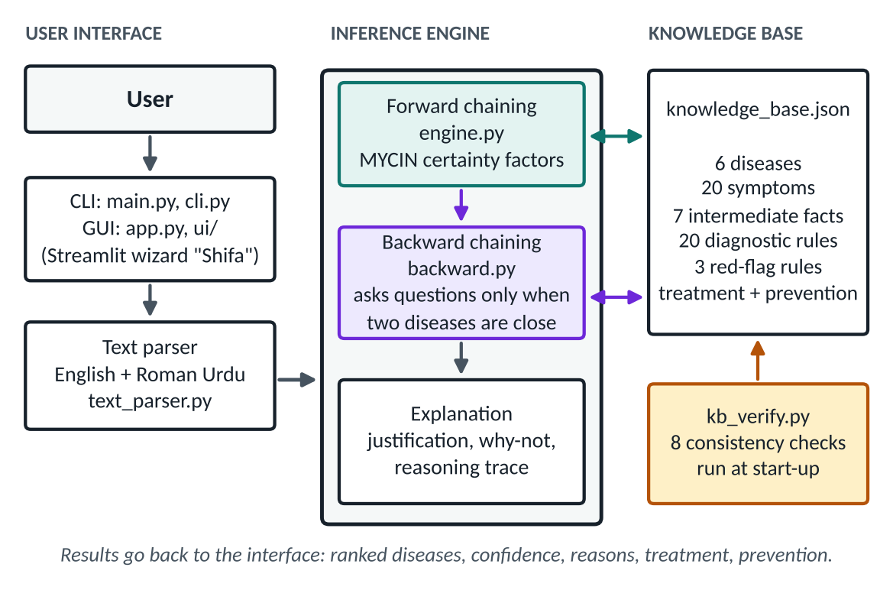
Figure 1. Architecture: knowledge base, inference engine (forward + backward), explanation, interfaces.

4.2 Forward chaining
Start from the user's facts; fire one rule per cycle until no rule can fire. Certainty factors follow MYCIN (Shortliffe and Buchanan, 1975).
Table 10. Forward-chaining method and certainty-factor formulas.
Step | How it works | Value
Working memory | Dictionary {fact: CF}; starts with the user's symptoms | —
Conflict set | Rules whose IF parts are all in memory with min CF ≥ threshold | threshold 0.2
Conflict resolution | Highest priority, then lowest rule depth, then file order | red flag 100 > severe 30 > moderate 20 > mild 10
AND of conditions | Weakest part decides | min(CFs)
Rule conclusion | Rule CF × min of its IF CFs | c = CF × min
Same fact, two rules | Evidence adds up, never above 1 | new = old + c × (1 − old)
Stop | No rule left to fire (kb_verify forbids cycles, so it always stops) | fixed point
Show a disease | CF at or above the display threshold | 0.30

Worked trace: Fever (moderate), Skin rash (yes), Pain behind the eyes (moderate).
Table 11. Engine trace for the dengue query (2 cycles, a 2-level chain).
Cycle | Conflict set | Fired | Calculation | New value
1 | R4 | R4 | min 0.700, c = 0.595 | Dengue signs: 0.000 → 0.595
2 | R7 | R7 | min 0.595, c = 0.536 | Dengue: 0.000 → 0.536

4.3 Severe before mild
Rules of severe diseases have priority 30 and mild ones 10, so dangerous diseases are processed first. The final list sorts by severity, then CF. Example: fever, skin rash, pain behind the eyes, runny nose, sneezing, sore throat.
Table 12. Mixed case: the cold scores higher (0.57 against 0.54), but severity decides the order.
Rank | Disease | Severity | Evidence (CF) | Confidence | Why this place
1 | Dengue | Severe | 0.54 | 48.4% | severe goes first
2 | Common Cold | Mild | 0.57 | 51.6% | mild, though CF is higher

4.4 Justification (explanation) of each diagnosis
Each diagnosis carries the rule chain down to the user's symptoms. The CLI prints it under "Why this was suggested"; the GUI shows it under "Why this?". A why-not output also explains diseases that were not shown.
Dengue: CF 0.536
R7 [Fever 0.700, Dengue signs 0.595] -> min 0.595 x rule CF 0.90 = 0.536
Dengue signs: CF 0.595
R4 [Skin rash 1.000, Pain behind the eyes 0.700] -> min 0.700 x rule CF 0.85 = 0.595

4.5 Backward chaining on close calls
If the top two diseases are almost tied (gap = (A − B) / (A + B) × 100 ≤ 15 points), each becomes a goal. The engine finds the rules that conclude it, checks their IF parts and turns unknown symptoms into questions (max 3). Questions are generated from the rules, not typed by hand.
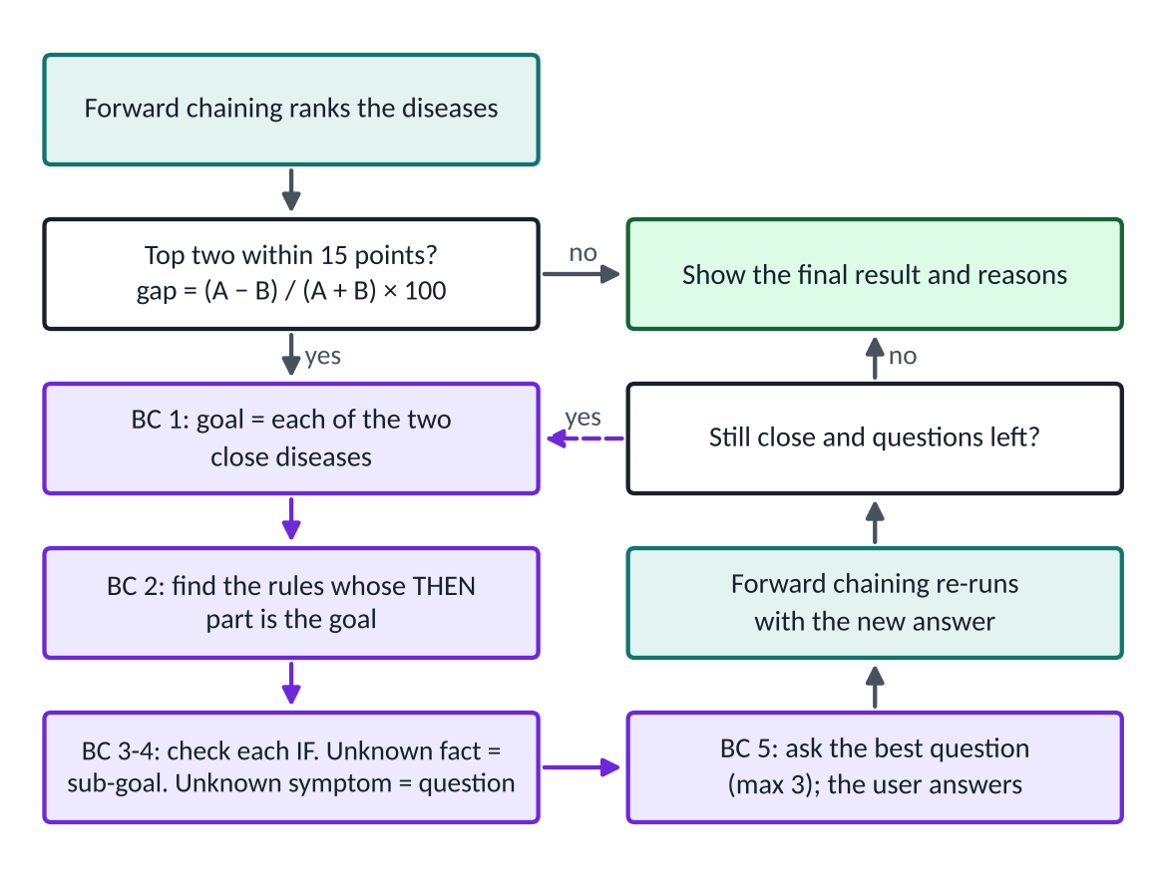
Figure 2. Hybrid reasoning: forward chaining first, backward chaining on close calls.
Table 13. Example: fever, headache, nausea, body aches (all moderate) gives Dengue 0.378 and Malaria 0.378, a 50/50 tie. What each answer does:
Answers | Questions | Dengue | Malaria | Outcome
None (tie) | 0 | 0.378 (50.0%) | 0.378 (50.0%) | tie
Bleeding gums: Yes | 1 | 0.630 (62.5%) | 0.378 (37.5%) | separated; RF1 alert
Bleeding gums: No, Chills: moderate | 2 | 0.378 (38.8%) | 0.597 (61.2%) | separated
No, No, No | 3 | 0.378 (50.0%) | 0.378 (50.0%) | still tied; limit reached

4.6 Confidence levels
Table 14. Two numbers are shown per disease.
Number | Meaning | Formula
Confidence % | Share among the diseases shown (adds up to 100%), like Disease A 62.5%, Disease B 37.5% | CF ÷ sum of shown CFs × 100
Evidence strength | How strong the evidence is on its own (raw CF, 0 to 1) | from the rules

Example: Dengue 0.630 and Malaria 0.378 sum to 1.008, so Dengue = 62.5% and Malaria = 37.5%. A single weak match would show 100%, so the evidence strength is shown next to it.

5. Example Queries and Screenshots
The system has a CLI (python main.py) and a GUI (python -m streamlit run app.py). All numbers below come from the running engine. The table below lists the five queries; the screenshots follow.
Table 15. Five example queries and their results.
# | User input | Result (ranked) | CF | Confidence | Alert / note
Q1 | fever, skin rash, pain behind the eyes | Dengue (severe) | 0.54 | 100% | no alert; forward chaining
Q2 | fever, headache, nausea, body aches | Dengue vs Malaria tie; after Bleeding gums = Yes: Dengue, Malaria | 0.63 / 0.38 | 62.5% / 37.5% | backward chaining; RF1
Q3 | fever, cough, shortness of breath, chest pain | Pneumonia (severe) | 0.60 | 100% | RF2 fires in cycle 1
Q4 | fever, skin rash, pain behind eyes, runny nose, sneezing, sore throat | Dengue, then Common cold | 0.54 / 0.57 | 48.4% / 51.6% | close call (1 question); severe listed first
Q5 | fever (alone) | Not enough evidence | — | — | needs 2+ symptoms

5.1 Q1: forward chaining (dengue)
Input: fever, skin rash, pain behind the eyes. R4 proves Dengue signs (0.595), then R7 proves Dengue (0.536). Treatment shown: rest, fluids, paracetamol, no aspirin or ibuprofen, see a doctor. Prevention: repellent, screens, remove standing water.
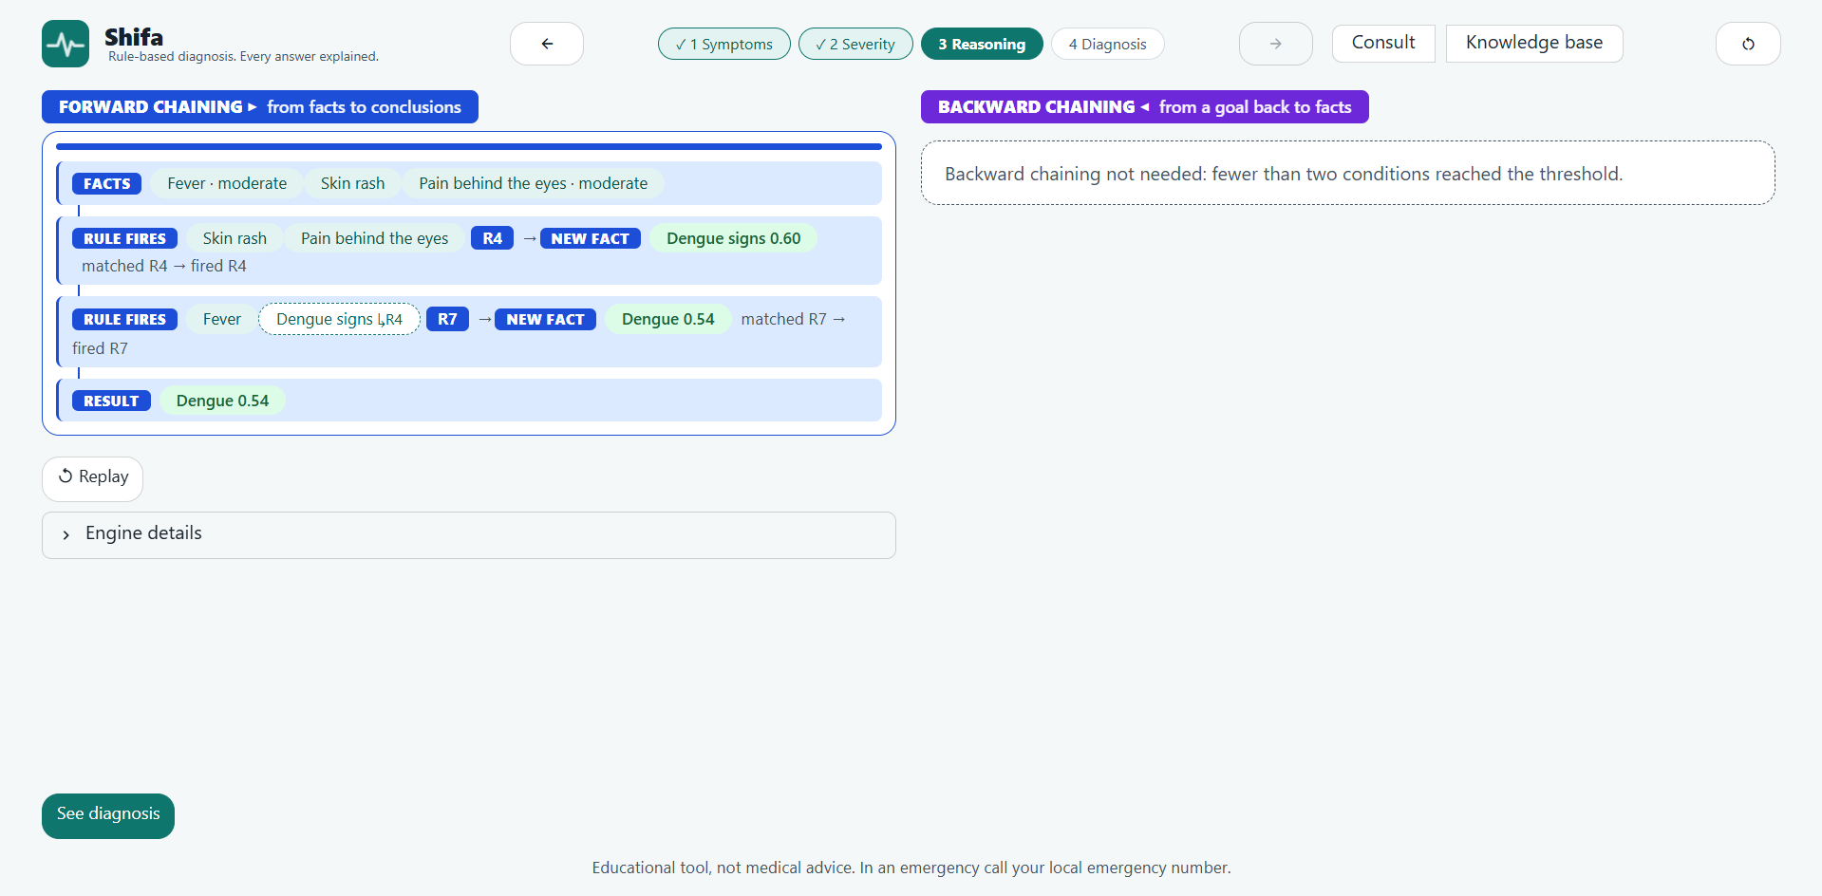
Figure 3. GUI Step 3: forward-chaining panel (FACTS, RULE FIRES, NEW FACT, RESULT).
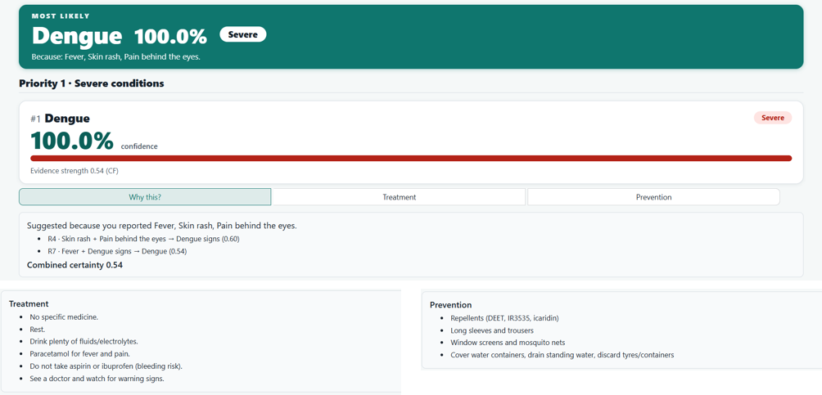
Figure 4. GUI Step 4: diagnosis with Why this?, Treatment and Prevention open.
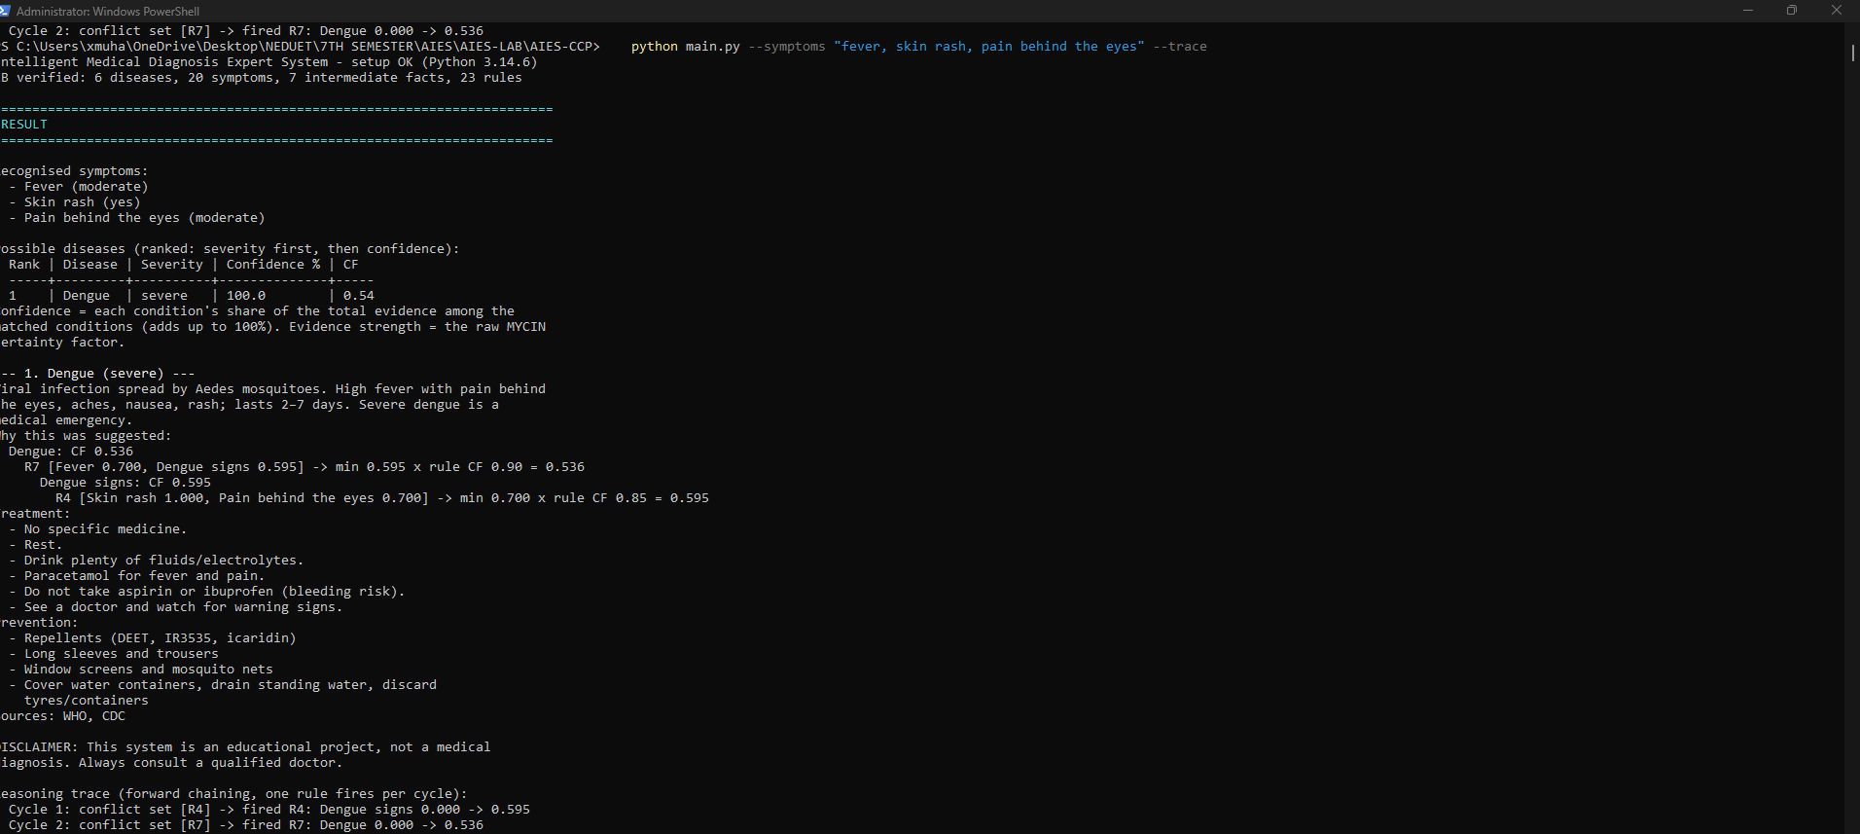
Figure 5. CLI output with the reasoning trace (Q1).

5.2 Q2: backward chaining on a close call
Input: first example button (fever, headache, nausea, body aches). Forward result is a 50/50 tie, so backward chaining asks: "Bleeding gums or nose?" (Dengue ← R7 ← R6). Answer Yes: Dengue 62.5%, Malaria 37.5%, red flag RF1. Answer No then Chills: Malaria 61.2%, Dengue 38.8%.
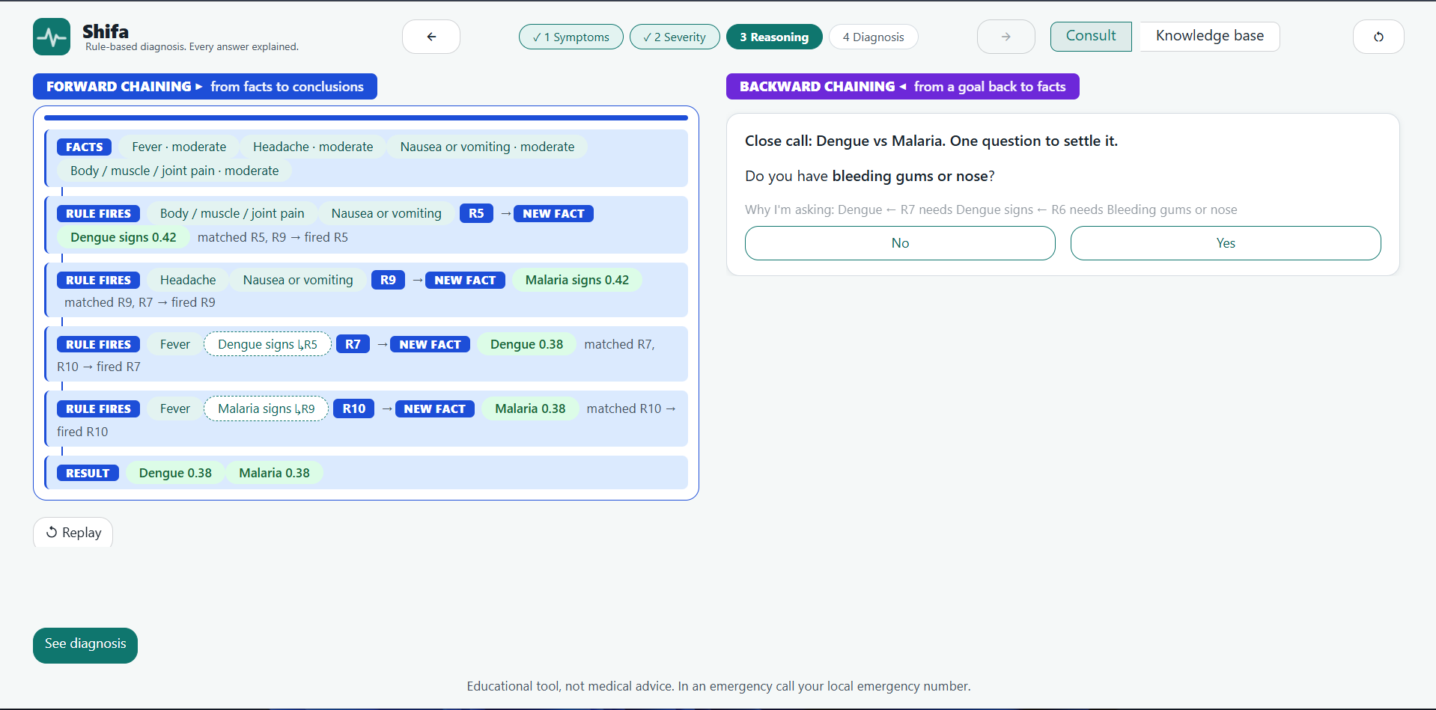
Figure 6. GUI Step 3: backward-chaining panel (violet) with the question card.
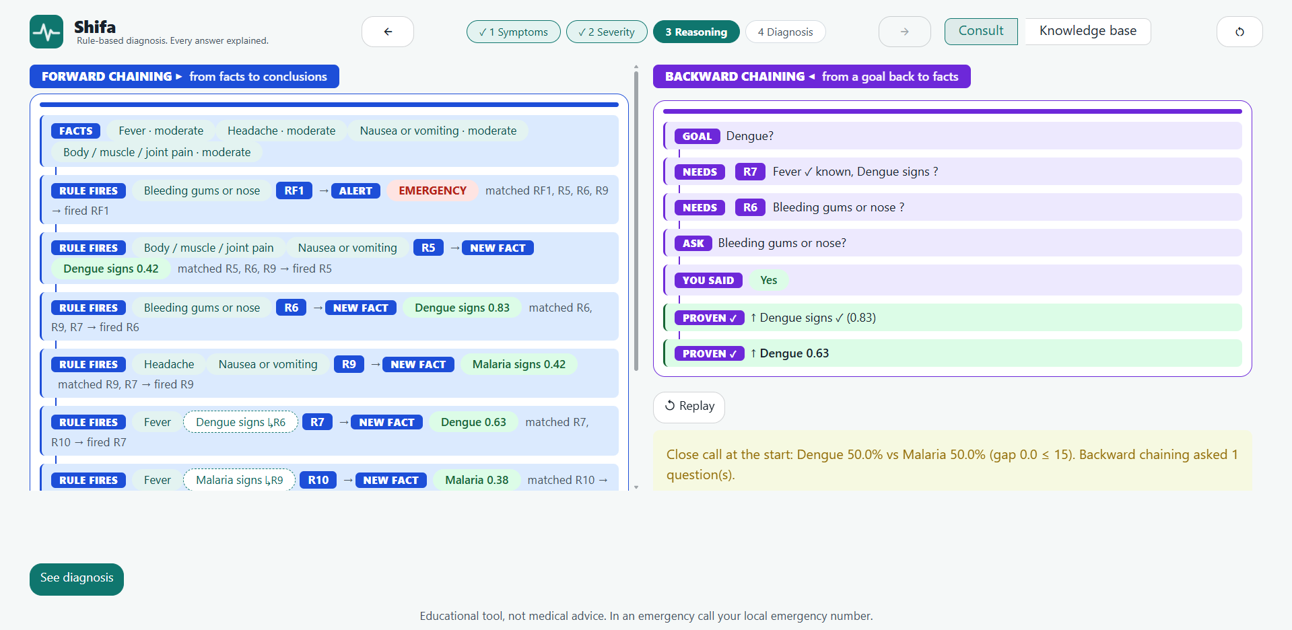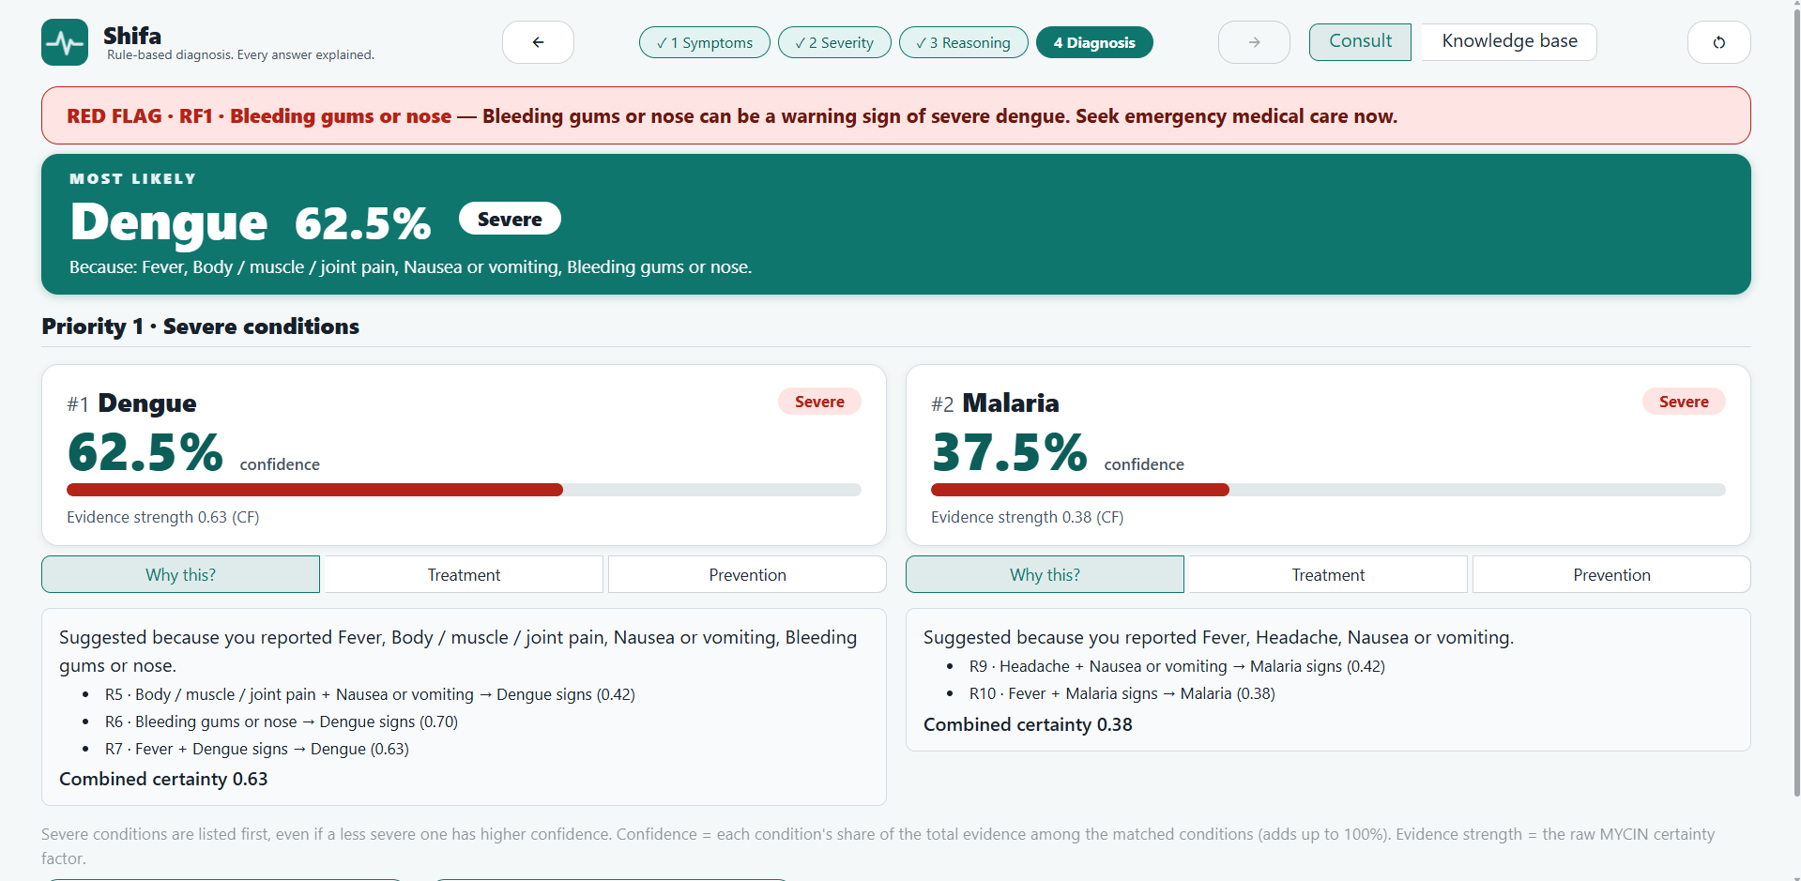
Figure 7. GUI Step 4: after answering Yes, red alert, Dengue 62.5%, Malaria 37.5%.

5.3 Q3: red-flag (emergency) warning
Input: fever, cough, shortness of breath and chest pain. RF2 has priority 100 and fires in cycle 1, before any diagnosis; then R1, R2 and R3 give Pneumonia 0.595. Without fever, the alert still appears but no disease is shown.
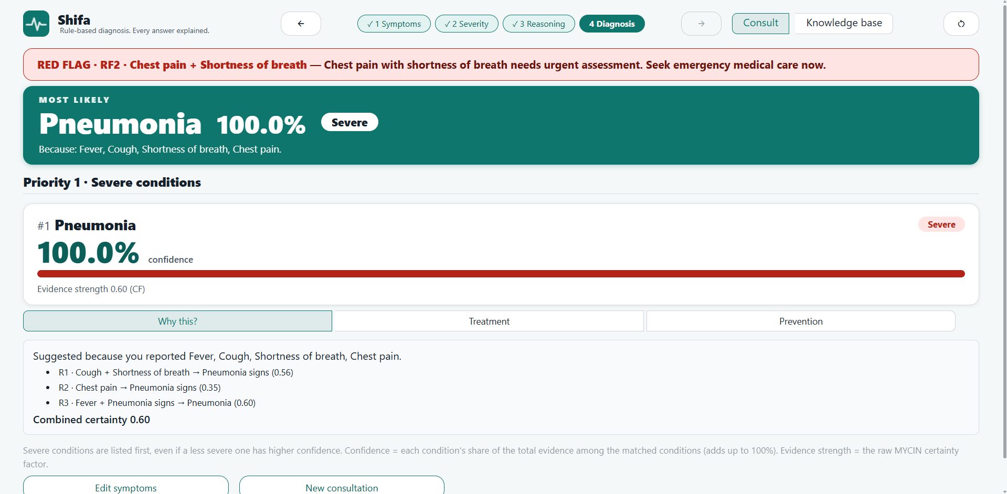
Figure 8. GUI Step 4: red-flag banner (RF2) above the Pneumonia verdict.

5.4 Q4: severe disease listed before a mild one
Input: fever, skin rash, pain behind the eyes, runny nose, sneezing, sore throat. The cold has the higher CF (0.57 against 0.54), so this is also a close call: backward chaining asks "Bleeding gums or nose?" and we answer No. Dengue is still listed first because it is severe (Section 4.3).
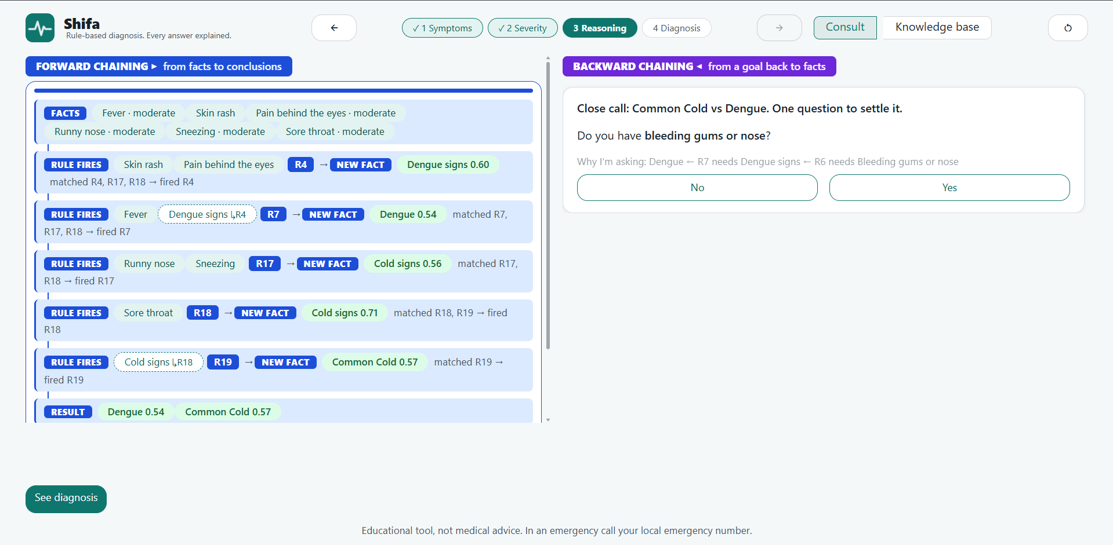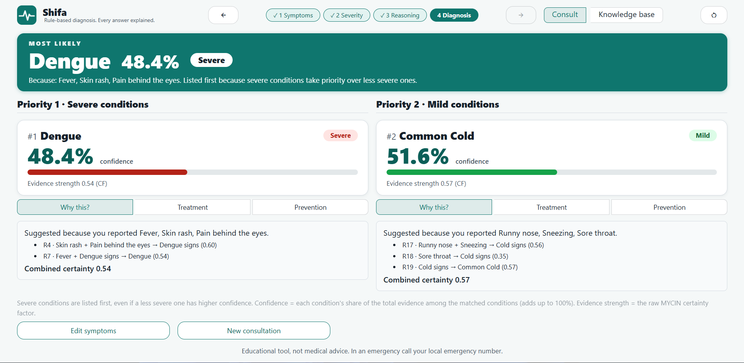
Figure 9. GUI Step 4: priority tiers, Dengue (severe) above Common cold (mild).

5.5 Q5: not enough evidence
Input: fever alone. Fever is required for five of the six diseases, but one symptom does not reach the 0.30 threshold. The system says "not enough evidence" instead of guessing. The same happens in the GUI.

6. Testing and Validation
python run_tests.py runs nine groups and prints a summary. All 132 checks pass.
Table 16. Test groups.
# | Group | Checks | What it proves
1 | Knowledge-base verification | 1 | 8 consistency checks pass (6 diseases, 20 symptoms, 7 facts, 23 rules)
2 | Clinical cases T01–T14 | 14 | WHO/CDC symptom lists give the expected disease, ranking and alerts
3 | Regression A–G | 7 | Exact CF values stay the same (tolerance 0.001)
4 | CLI input parsing | 4 | Separators, synonyms, "did you mean" hints
5 | Verifier self-tests | 3 | Deliberately broken knowledge bases are caught
6 | Order independence | 50 | 50 random rule orders give identical results
7 | Hybrid backward chaining | 8 | Close calls, generated questions, scripted answers, no repeated question
8 | GUI smoke tests | 31 | Wizard order, replay, red-flag banner, priority tiers, knowledge-base view
9 | Text parser | 14 | English and Roman Urdu, negation, intensity, duration, typos
 | Total | 132 | All passed

Table 17. Clinical cases (expected disease from WHO/CDC text, and the result).
ID | Case | Result | Source | Status
T01 | Dengue | Dengue 0.54 | WHO WPRO dengue | PASS
T02 | Malaria, early symptoms | Malaria 0.38 | WHO malaria | PASS
T03 | Typhoid | Malaria 0.38, Typhoid 0.45 | WHO typhoid | PASS
T04 | Influenza | Influenza 0.57 | WHO influenza | PASS
T05 | Pneumonia | Pneumonia 0.60, Malaria 0.38; alert RF2 | WHO pneumonia | PASS
T06 | Common cold | Common Cold 0.52 | CDC common cold | PASS
T07 | Mixed severe + mild (severe ranked first) | Dengue 0.54, Common Cold 0.57 | CCP requirement | PASS
T08 | Edge: fever only | no disease shown | Edge case | PASS
T09 | Edge: no symptoms | no disease shown | Edge case | PASS
T10 | Edge: unknown symptom | no disease shown | Edge case | PASS
T11 | Dengue warning sign | Dengue 0.74; alert RF1 | CDC dengue | PASS
T12 | Severe malaria | Malaria 0.52; alert RF3 | WHO malaria | PASS
T13 | Edge: weak evidence near the threshold | no disease shown | Edge case | PASS
T14 | Edge: many severe symptoms but no fever | no disease shown; alert RF1+RF2+RF3 | Edge case | PASS

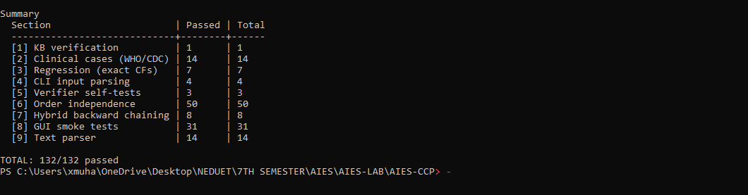
Figure 10. Terminal: kb_verify and run_tests.py, TOTAL 132/132 passed.

7. Assumptions and Limitations
Medical disclaimer: educational project, not a medical diagnosis. Consult a qualified doctor.
Table 18. Assumptions.
# | Assumption
1 | Certainty factors are values chosen by the group from WHO/CDC descriptions, not clinically validated probabilities.
2 | The patient has one of the six diseases in the knowledge base (confidence % is a share among them).
3 | Severity is fixed per disease; intensity (mild / moderate / severe) is chosen by the user, default moderate.
4 | Only confirming evidence is modelled; an absent symptom never lowers a CF.
5 | "Fever for more than 3 days" is asked only after fever is reported.
6 | Symptoms not in the knowledge base are reported to the user and ignored.

Table 19. Main limitations (full list of 32 in docs/LIMITATIONS.md).
ID | Limitation | How it is handled | Possible fix
L01 | Fever is required for 5 of 6 diseases; cases without fever (e.g. elderly pneumonia) are missed. | Follows WHO/CDC text; the system reports that fever is missing. | Add rules without fever after doctor review.
L02 | Dengue with moderate fever cannot exceed CF 0.63. | MYCIN: a conclusion is never stronger than its weakest part. | Review intensity values.
L03 | CFs are expert-assigned, not learned. | They rank evidence; they are not probabilities. | Calibrate with clinician or data.
L04 | No interview with a doctor. | WHO/CDC sources shown on every rule. | Medical review.
L05 | Confidence % is a share; one weak match shows 100%. | Evidence strength shown next to it. | Warn when best CF is low.
L11 | Free text is keyword matching; English and Roman Urdu only. | Standard library; every reading is traceable. | More synonyms; Urdu script.
L17 | Very little evidence gives "not enough evidence". | Refusal is safer than a guess; hint names what is missing. | Targeted questions.
L29 | Layout tuned for 1366×768 and larger, not phones. | Demo on laptop or projector. | Single-column layout.

8. Conclusion and Future Work
Shifa meets every requirement of the CCP: a knowledge base of 20 symptoms, 6 diseases and 23 rules with severity, treatments and prevention; a forward-chaining engine with certainty factors, severe-first ranking, per-diagnosis justification and confidence levels; backward chaining for close calls; a CLI and a GUI; and 132 passing tests. Keeping knowledge in data and reasoning in code made the system easy to test and explain. Future work: doctor review and CF calibration, rules for cases without fever, negative evidence, more diseases (JSON only), Urdu script input.

References and Appendix: Python Source Code

References
[1] WHO. Malaria fact sheet, 4 Dec 2025. who.int/news-room/fact-sheets/detail/malaria
[2] WHO. Typhoid fact sheet, 30 Mar 2023. who.int/news-room/fact-sheets/detail/typhoid
[3] WHO. Influenza (seasonal) fact sheet, 28 Feb 2025. who.int/news-room/fact-sheets/detail/influenza-(seasonal)
[4] WHO. Pneumonia health topic. who.int/health-topics/pneumonia
[5] WHO Western Pacific. Dengue and severe dengue. who.int/westernpacific/health-topics/dengue-and-severe-dengue
[6] CDC. Dengue symptoms and treatment. cdc.gov/dengue
[7] CDC. Common cold fact sheet (2026) and Flu quick reference guide.
[8] Shortliffe, E. H. and Buchanan, B. G. (1975). A model of inexact reasoning in medicine. Mathematical Biosciences, 23, 351–379.
[9] Russell, S. and Norvig, P. Artificial Intelligence: A Modern Approach, 2nd ed., Sec. 7.5 and 14.7.
[10] Course lecture notes, CT-361 AIES: Expert Systems, Fundamentals (NED University, Fall 2026).

Appendix: Python source code (in the submission zip)
Table 20. Project files.
File | Purpose
main.py | Entry point: verifies the knowledge base, starts the CLI
app.py, ui/theme.py, ui/components.py | Streamlit GUI "Shifa" (entry point, theme, render functions)
expert_system/engine.py | Forward chaining with certainty factors (386 lines, no medical names)
expert_system/backward.py | Backward chaining: question generation (242 lines)
expert_system/cli.py | Command-line interface (574 lines)
expert_system/text_parser.py | English / Roman Urdu text to symptoms (180 lines)
expert_system/kb_verify.py | The 8 knowledge-base checks (240 lines)
data/knowledge_base.json | All medical knowledge
run_tests.py, tests/*.json | Test runner and test data (132 checks)
docs/kb_design.md, docs/LIMITATIONS.md, README.md | Design, limitations, instructions

Table 21. How to run (Python 3.11+ for the GUI).
Command | Result
python main.py | Interactive CLI
python main.py --symptoms "fever, skin rash" --trace | One query with trace
pip install -r requirements.txt | Installs Streamlit (GUI only)
python -m streamlit run app.py | GUI in the browser (offline)
python run_tests.py | All 132 checks

