In-Distribution Gains Do Not Transfer: Leakage-Free Evaluation of Retrieval Interventions for Low-Resource Legal Question Answering
Muhammad Usama
Department of Computer Science
COMSATS University Islamabad, Islamabad, Pakistan
muhammadusamahoyrr@gmail.com

Abstract—Retrieval interventions for legal question answering are almost always reported on evaluation sets drawn from the same distribution as fine-tuning data. We report what happens when they are not. Fine-tuning a multilingual retriever on 4,692 verified citation pairs for Pakistani law gains +26.5 Hit@1 on held-out questions from its own generator and +2.4 when the question style changes; a second model, trained on a tenth as much data from a different source, collapses identically in the opposite direction (+16.5 / −0.3). Sorting every intervention by whether its effect survived a style change produces a clean split: those encoding legal or document structure transferred; those learning question phrasing did not, including a cross-encoder that demoted the correct statute from rank 3 to rank 10 where a deterministic statutory-scope rule placed it first in under a millisecond. Three contaminations—an index containing its own test answers, a wrong gold-label join, and target leakage between train and test—each inflated a headline number; the flattering version was wrong every time. The measurement protocol determined the conclusions more than any technique did.
Index Terms—legal informatics, retrieval-augmented generation, retrieval evaluation, distribution shift, data contamination, low-resource NLP, code-switching, Urdu
I. INTRODUCTION
Access to legal information is unevenly distributed. In Pakistan, where legal counsel is scarce outside major urban centres and court backlogs leave disputes unresolved for years, a litigant who cannot afford counsel often cannot establish even the threshold facts of their position: which statute governs, which forum has jurisdiction, or whether a limitation period has already expired.
Retrieval-augmented generation (RAG) [1] is the standard response, and legal question answering is now an active area [2],[3]. Applying it to Pakistan is not a matter of swapping the corpus. Queries arrive in English, Urdu script, and most commonly in Roman Urdu; applicable law combines codified statute with Islamic personal law and varies by province; users routinely cite Indian codes when Pakistani ones govern. Each is a retrieval problem before it is a generation problem, and none has an established benchmark.
When no independent evaluation set exists, a system’s developers build one, tune against it, and report the number. We set out to improve retrieval for this jurisdiction and measured each intervention twice: on questions from the distribution it was developed against, and on questions written by a different generator. The gap between those two measurements exceeded the gap between any two techniques we tried.
We report this as a negative result with positive structure. Interventions divide by what they encode: those capturing a property of the law or documents survived the style change; those learning a mapping from question phrasing to passage did not. Our contributions:
• Transfer measurement of retrieval fine-tuning over two independently trained models at a tenfold scale difference, with an account of why this predicts which interventions transfer (Sections III–IV).
• Three contaminations and how each was found: a leaking index, a systematically wrong gold-label join, and target leakage between test and training—none visible in the metrics (Section V).
• Verified citation supervision for a jurisdiction with no query/passage training data, built from citations because a citation is checkable (Section III-B).
Scope of claims. Several results below are defects we found in our own system, reported as findings rather than apology: each was invisible to the metric meant to catch it, and each generalises past this system. What we do not claim is equally definite — no end-to-end improvement in answer correctness, and no Pakistan-wide coverage. Section VII states each limit and what it bears on.
II. RELATED WORK
Legal NLP and RAG. Domain-adapted encoders such as LEGAL-BERT [2] showed legal text benefits from in-domain pretraining; LegalBench [3] benchmarks legal reasoning. RAG [1] over dense passage retrieval [4] is the standard grounding architecture. Self-RAG [5] adds self-reflection over retrieval quality. This line targets English and common-law material almost exclusively, and reports in-domain evaluation on benchmarks it did not construct—a luxury this jurisdiction does not afford.
Low-resource and hybrid retrieval. Multilingual dense encoders [6] make a single index viable across scripts; hybrid lexical–dense retrieval with rank fusion [7],[8] remains strong where exact terminology matters, as it does for statute references. BEIR [9] and MTEB [10] evaluate zero-shot generalisation across datasets but have no analogue for a low-resource jurisdiction where the developer must build the only evaluation set that exists.
Generalisation and contamination in evaluation. That a retriever’s gain may not survive a change of domain is established for English: BEIR [9] and MTEB [10] find in-domain strength a poor predictor of out-of-domain strength. Neither has an analogue for a low-resource jurisdiction, where the developer must build the only evaluation set that exists; and neither reports what fusion does to a dense channel fine-tuned on the domain, which Section V-C measures. Contamination is likewise recognised [11],[12], though that literature concentrates on pretraining corpora; we report the retrieval-specific case, in which the index is itself a system component and can leak (Section V-D).
III. EXPERIMENTAL SETUP
A. Corpus and Retrieval
The statute corpus is drawn from 969 Pakistani legal documents [19] (Ministry of Law and Justice PDFs, ODC-BY licence), segmented by section into four domain collections: civil, criminal, family, and constitutional. Supplemented by instruments from the official consolidated legislation service [20]—including the Code of Civil Procedure 1908 and 20 family-law statutes absent from the public collection—the indexed corpus reaches 10,042 statutory chunks. A bilingual constitutional Q&A set [21] supplies evaluation questions only and is not indexed (Section V-D). A separate judgment corpus of 7,529 chunks from six courts supports case-law retrieval.
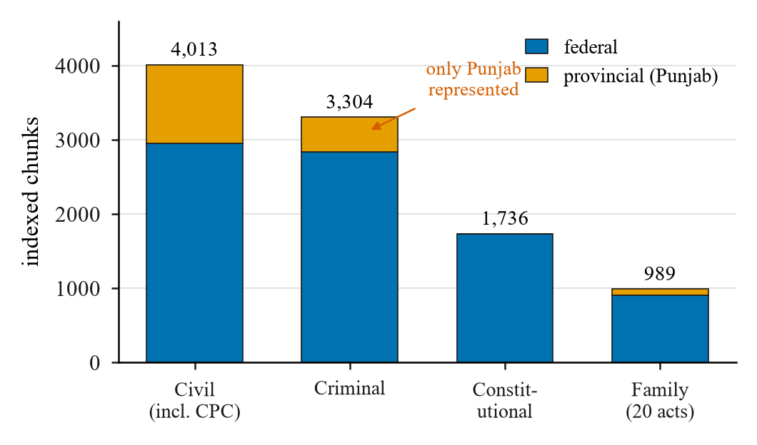
Fig. 1. Indexed statutory corpus by collection and legislative tier. Devolved provincial coverage is Punjab-only (1,608 of 10,042 chunks across civil, criminal, and family law); constitutional law is inherently federal. The judgment corpus (7,529 chunks) is not shown.
Retrieval is hybrid: BM25 and dense multilingual-e5-base [6] embeddings combined by weighted ensemble (0.6 lexical, 0.4 dense). The lexical channel is weighted higher because exact statute and section references carry disproportionate signal. Both channels are filtered by province: a query for a given province retrieves only that province’s provisions or federal ones. A rule-based alias layer rewrites cross-jurisdictional references (e.g. Indian Penal Code → Pakistan Penal Code) before retrieval.
Reproducibility. All evaluation protocols, corpus ingestion manifests, contamination detection scripts, and fine-tuning configurations are publicly available to enable independent auditability.
B. Verified Citation Supervision
Fine-tuning a retriever requires query/passage supervision, which does not exist for most of this jurisdiction. We derive it from 11,195 Pakistani legal Q&A pairs with machine-parseable citations (e.g. PPC s.467, CONST art.203F). The citation is what we use—it is checkable; the LLM-generated answer is not. Nothing from this source is indexed.
Four sequential filters are applied. (1) LEGAL-UQA rows dropped (911), since that dataset provides our evaluation set. (2) Citations naming an unindexed section dropped (720). (3) Citations validated by rarity-weighted vocabulary overlap with the answer; wrong citations dropped (203). (4) Duplicates removed. 5,883 pairs survive (52.6 %), partitioned by an 80/20 split into 4,692 training pairs for the general model and 1,191 held-out evaluation pairs; 32 % pair Urdu-script queries with English statute—the code-switched case for which no training data previously existed. Validation also caught a corpus defect: 164 constitutional Schedule paragraphs had been indexed as Articles 1–8 (fundamental rights and high-treason provision).
TABLE I. TRAINING DATA: WHAT DIFFERS BETWEEN THE TWO MODELS
Property | Constitutional model | General model
Training pairs | 471 | 4,692
Held-out pairs | 121 | 1,191
Legal domains | 1 | 5
Urdu-script queries | 0% | 32%
Source | LEGAL-UQA [21] | Citation corpus

IV. EVALUATION PROTOCOL
Rather than authoring question–answer pairs, we label recorded traffic. Judgements are pooled to a fixed depth, stored with it, and metrics below the pool depth are refused as unjudged rather than counted irrelevant. Each turn carries one of four verdicts: correct, incorrect, correct refusal, wrong refusal.
Two models are trained independently—constitutional and general (Table I)—both fine-tuning multilingual-e5-base in the Sentence-BERT bi-encoder architecture [15] with multiple-negatives ranking loss [16], hard negatives mined from the deployed retriever, two epochs, batch 12, lr 2×10⁻⁵, max-length 224. Train/test splits by connected components over shared gold chunks ensure no gold chunk appears in both halves. Significance by McNemar’s test [18] paired over Q.
Retrieval is reported by Hit@k, mean reciprocal rank (MRR), and nDCG@k [17] at cut-offs within the pooling depth:
Hit@k = (1 / |Q|) · Σₚ 1[rank(q) ≤ k] (1)
MRR = (1 / |Q|) · Σₚ 1 / rank(q) (2)
nDCG@k = (1 / |Q|) · Σₚ DCG(q) / IDCG(q) (3)
where IDCG(q) = Σᵢ 1/log₂(i+1) summed over i = 1…min(|G(q)|, k). We state the ideal-DCG denominator explicitly because a fixed denominator of 1 (correct only when |G(q)| = 1) silently deflates nDCG on multi-gold queries—a defect we found in one of our own scripts.
V. RESULTS
Three of the four collections changed materially during this work, for reasons the evaluation surfaced rather than planned: the constitutional collection was rebuilt after 67 % of it proved to be generated text (Section V-C), the Code of Civil Procedure 1908 was absent entirely, and family law grew from 193 to 989 chunks once 20 statutes in the fetch manifest were actually downloaded. Corpus defects, not model capacity, produced the largest improvements.
A. Cross-Encoder Reranking: A Negative Result
Cross-encoder reranking [13] is the standard remedy for a correct statute retrieved but ranked below a competitor. The decisive case: whether a tenant may be evicted without notice in Punjab, where the correct instrument is the Punjab Rented Premises Act 2009 (urban rental) and the competitor the Punjab Tenancy Act 1887 (agricultural tenancy). Both concern tenants and eviction; the ambiguity is statutory scope, not vocabulary.
The cross-encoder does not merely fail to help—it moves the correct statute away from the top, promoting the agricultural statute at both retrieval depths (Fig. 2). Degradation growing with pool size is the signature of a scoring function ordered systematically against the target. The off-the-shelf MS-MARCO model has no representation of which instrument governs [14]; a deterministic statutory-scope rule placed the correct statute first in under a millisecond.
Reporting this as a uniform failure would overstate it. Across six queries the reranker improved three (the khula target from rank 8 to 4, an FIR-registration query from rank 2 to 1, a theft query from rank 3 to 1), left two unchanged, and badly worsened one—but the one it worsens is the case that motivated it, and those it improves were already nearly correct. It sharpens rankings that did not need sharpening while inverting the one that did.
We attribute this to train/test domain mismatch rather than model capacity. The MS-MARCO checkpoint scores topical overlap between a question and a web passage; the distinction here—whether tenant means a cultivator under an 1887 revenue statute or an occupant of urban premises under a 2009 one—is one of legislative scope. Prior work reports the same direction of effect in U.S. legal case retrieval [14]; that this reproduces on statutory retrieval in a different jurisdiction and script indicates that these failure modes are not specific to a single model configuration. Widening first-stage retrieval from 10 to 50 candidates was reverted alongside the cross-encoder: without an effective reranker, additional depth is additional noise.
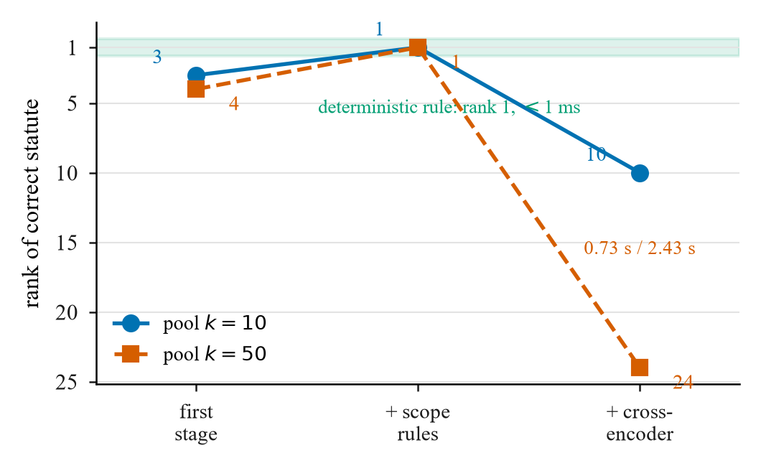
Fig. 2. Rank of the correct statute (Punjab Rented Premises Act 2009) after each pipeline stage at both retrieval depths. Lower is better. The cross-encoder demotes it and grows worse as pool widens; the deterministic rule places it first.
B. Domain Fine-Tuning: Gains That Do Not Transfer
Across the total corpus asset of 592 bilingual legal questions (LEGAL-UQA), initial dense ablation was evaluated on an in-distribution subset of 200 held-out constitutional questions (where dense Hit@50 reaches 89 % vs Hit@1 of 43.5 %—a 45-point ranking deficit). For cross-style generalisations, evaluating the general model (trained on 4,692 citation pairs) required filtering the 592-question set for target leakage, leaving 128 clean, unseen evaluation questions. Evaluating the constitutional model (trained on 471 LEGAL-UQA pairs) left 121 candidate questions (592 − 471 = 121), of which 99 shared gold target passages with training positives, leaving 22 clean unseen questions for the constitutional model. Fine-tuning was the remaining hypothesis.
The general model gains +26.5 Hit@1 on its own distribution (a 64 % relative improvement, p ≈ 0.0005, McNemar, 531 improved vs 123 worsened). Across metrics, dense base scores 0.438 MRR and 0.482 nDCG@5; fine-tuning improves these in-distribution to 0.612 MRR (+0.174) and 0.648 nDCG@5 (+0.166), but collapses out-of-distribution to 0.445 MRR (+0.007) and 0.490 nDCG@5 (+0.008), confirming the collapse across all ranking metrics. On questions from a different generator, the same model gains +2.4 Hit@1, with 31 improved against 22 worsened—close to a coin flip.
The constitutional model shows the same pattern from the opposite direction: +16.5 dense in-distribution (p ≈ 0.0032, McNemar) and +6.6 fused, but −0.3 out of it (p = 0.814, statistically indistinguishable from zero). We verified the second figure is clean: none of the 1,191 citation-style held-out pairs appear in its training set. Ten times the training data, five legal domains, and two scripts bought a larger in-distribution number and essentially nothing out of it. The effect replicates across two independently trained models at a tenfold scale difference, which is what makes it a finding about the method rather than about one run.
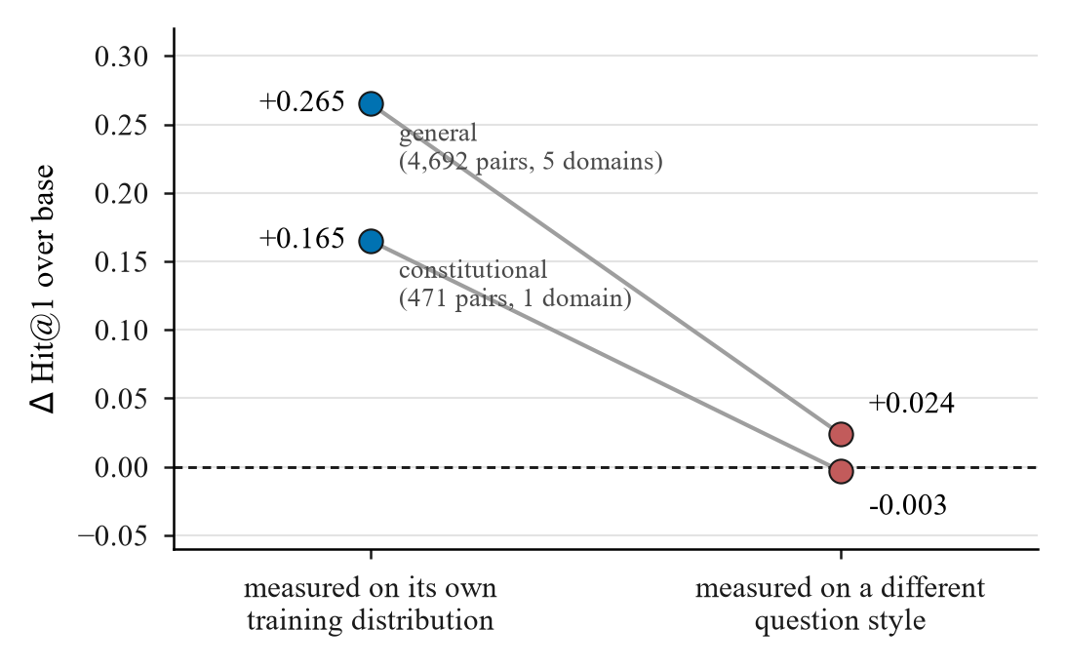
Fig. 3. Two retrievers fine-tuned independently on different sources at a tenfold scale difference each lose almost their entire gain when the question style changes. Left: in-distribution evaluation. Right: out-of-distribution. The constitutional model’s in-distribution figure is excluded as memorisation (Section V-D).
C. Fusion Absorbs Most of the Dense Gain
The deployed retriever fuses BM25 at 0.6 with dense at 0.4. The constitutional model’s +16.5 dense-only gain becomes +6.6 under fusion. The mechanism is visible in baselines: hybrid base scores 0.5207 against dense base 0.4380, so BM25 already supplied +8.3 points—overlapping with what fine-tuning teaches the dense channel. Fusion also repairs the characteristic regression: four queries that fell from rank 1 to absent under dense-only recover to rank 3 or better under fusion. Under dense-only all four were exact-citation lookups; under fusion the worst regression is rank 1 to rank 3. A system reporting only its dense ablation would overstate both the benefit and the harm.
D. Three Contaminations, Detected and Removed
Every fine-tuning result above survived a contamination check that removed an earlier, better-looking number.
① Index contained test answers. The constitutional collection held 619 generated Q&A pairs tagged as the Constitution; they contained each evaluation question verbatim and accounted for 81–100 % of retrieved chunks. Evaluating before removing them would have retrieved each question’s own answer at rank 1.
② Gold labels were systematically wrong. Joining evaluation questions to gold passages by section heading produced an off-by-one: heading stubs extracted from the source PDF matched section headings, not the chunks holding their text. Retrieval was returning the correct chunk and the evaluation scored it a miss. Hit@1 was exactly 0.000 across 568 questions—implausible enough to prompt a check. Rebuilding the join on verbatim body n-grams moved MRR from 0.114 to 0.581 with no system change.
③ Target leakage between train and test. Filtering the 592-question set for gold chunks that matched general-model training positives removed target leakage, leaving 128 clean evaluation questions for cross-style testing.
Evaluation Consequence of Dataset Overlap. For the constitutional model, 471 of the 592 questions were consumed during training, leaving 121 candidate questions (592 − 471 = 121). Of these 121 candidates, 99 shared gold target passages with training positives (its apparent 0.766 Hit@1 was memorisation of its training set), leaving only 22 clean unseen questions for the constitutional model—too few to support a three-way comparison. The out-of-distribution columns are the only ones we report.
TABLE II. CONTAMINATION MECHANISMS AND EVALUATION CONSEQUENCES
Category / Mechanism | Affected metric | Before fix | After fix
Contamination ①: Index Q&A pairs | Hit@1 / MRR (constitutional) | Inflated (verbatim) | Excluded
Contamination ②: Wrong gold join | MRR (constitutional) | 0.114 | 0.581
Contamination ③: Target leakage | Hit@1 (general model OOD) | Shared targets | 128 clean queries
Evaluation Consequence | Constitutional Hit@1 | 0.766 (memorisation) | Excluded from OOD

VI. DISCUSSION
Sorting every retrieval intervention by whether its effect survived a style change produces a clean split (Table III). The dividing line is not complexity or cost but what the intervention encodes. Everything that transferred encodes a property of the law or the documents; everything that did not learns a mapping from question surface form to passage. Legal language explains why this matters more here than elsewhere: a statutory corpus is small, highly structured, and written in a register no user employs, so the gap between a question and its answer is one of register, not topic. A model fitted to one generator’s phrasing closes that specific gap; a differently-phrased question reopens it.
TABLE III. INTERVENTIONS SORTED BY WHETHER EFFECT SURVIVED STYLE CHANGE
Transferred | Did not transfer
Statutory-scope rules (rank 12→1) | Fine-tuned embeddings (+2.4 OOD)
Corpus repairs | Cross-encoder rerank (rank 3→10)
Local IDF weighting (+0.090) | Fusion-weight tuning (no gain)

The errors agree with the aggregates. One exact-citation lookup— ‘What was omitted by S.R.O. No. 1278 (1) 85?’—fell from rank 1 to absent under the cross-encoder, under the constitutional model, and under the general model: all three traded lexical precision for semantic similarity, which is what optimising a dense objective on paraphrased questions rewards. That BM25 fusion partially repairs the damage says what was lost was lexical rather than legal.
We do not claim fine-tuning cannot work for legal retrieval, only that training on one generator’s questions produces a model fitted to that generator, that this is invisible when the test set shares the generator, and that the in-distribution number is therefore not evidence of deployment benefit. A natural counterargument is rule scalability: deterministic rules require domain engineering per conflict, whereas statistical models promise zero-shot coverage. However, in low-resource legal domains where training data is uncurated, deterministic rules provide a precision floor on specific statutory conflicts where off-the-shelf statistical models can invert statutory priority.
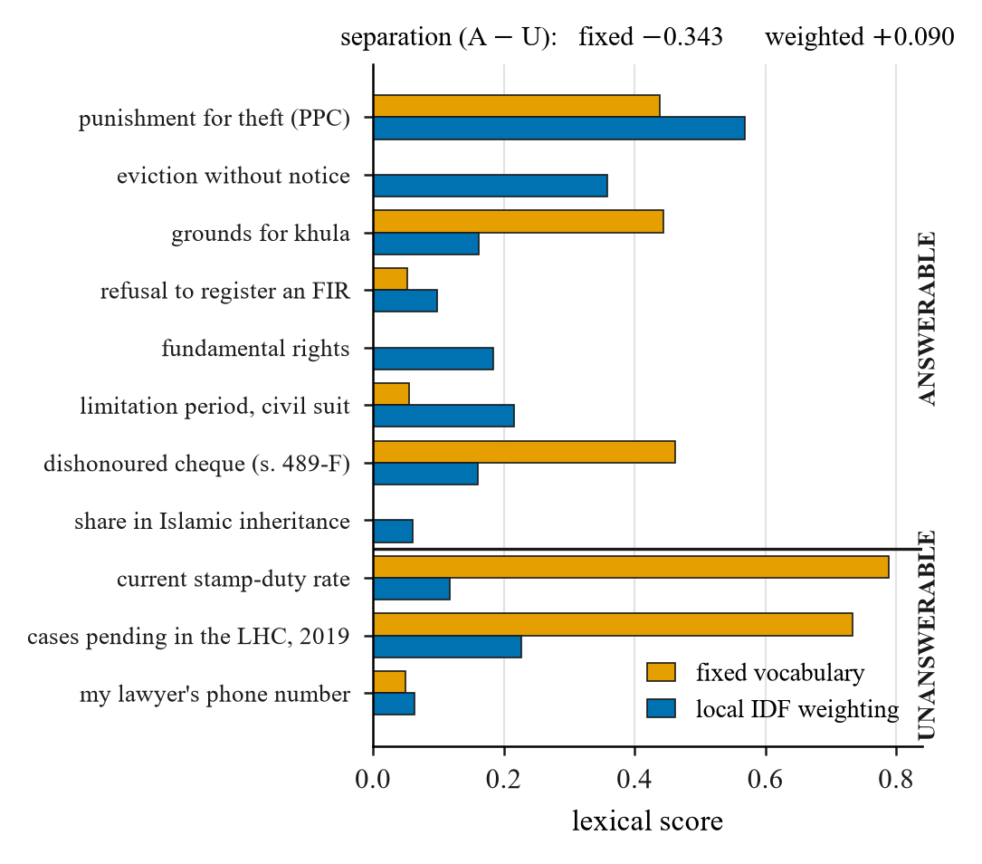
Fig. 4. Local IDF weighting versus fixed-vocabulary scoring across answerable and unanswerable queries. Fixed vocabulary produces a sign-reversed separation (answerable −0.343, unanswerable +0.343); local IDF weighting corrects the sign (answerable +0.090), making it a useful confidence signal.
B. Leakage-Free Evaluation Is the Load-Bearing Component
Three of our results were wrong before they were checked, and each time the flattering version was the wrong one. We draw three practical conclusions.
Contamination surfaces. A question can leak, a gold label can leak, and the index can leak, because the corpus under evaluation is itself a system component. Deduplicating queries catches none of the latter two.
Generated evaluation sets carry their generator’s signature. Both datasets supplying our labels were LLM-generated against statute—usable as training signal since the citation is checkable, but unreliable as benchmarks since a model trained on one generator is then tested on its own idiom. The +26.5 to +2.4 collapse is the size of that effect.
The protocol determined the conclusions more than any technique did. Our largest reported gain, +6.6 Hit@1 under fusion, is the one that survived every check; the three larger numbers did not. A paper reporting only its best configuration on its own evaluation set is not making a weaker claim than ours—it is making an unfalsifiable one.
C. Future Work
Two items address open threats. First, 3,852 independently sourced Pakistani legal questions remain unused in training. Labelling a subset with two annotators, reporting Krippendorff’s α [22], and freezing half before development begins would yield the first evaluation set this work could not have tuned against; pre-registering the predicted effect and opening the frozen half once converts a measurement into evidence.
Second, between 20 % and 27 % of each collection consists of fragments under 200 characters—heading fragments competing for retrieval slots, and 11 % of failures are recall rather than ranking. Aligning chunk boundaries to statutory structure and prepending instrument and section metadata before embedding addresses both [23].
VII. THREATS TO VALIDITY
The limits below are stated together so a reader can weigh them as a set. Threats concerning evaluation provenance would, if anything, inflate what we report; residual bias should be expected to favour the in-distribution numbers we argue against.
TABLE IV. THREATS TO VALIDITY: WHAT EACH BEARS ON AND ITS STATUS
Threat | Bears on | Status
Evaluation questions are developer-authored or LLM-generated | External validity of every Hit@k figure | 3,852 independently sourced questions identified; labelling with frozen holdout is future work
Provincial coverage is Punjab only (1,608/10,042 chunks) | Any Pakistan-wide claim; devolved subjects most of all | Claims restricted to federal law plus Punjab throughout
Generation correctness is unmeasured | End-to-end benefit to a user | All claims are retrieval-level; practitioner adjudication is the next priority
Scope-rule and reranking result rests on one worked case | How far the rank 3→10 demotion generalises | Reported as mechanism with named cause, corroborated by [14], not as a rate over queries

Three further limits are properties of the evidence: a preliminary spot check of 20 retrieved passages confirmed 17 (85 %) contained the governing section—verifying basic retrieval relevance, though end-to-end generation correctness remains unmeasured and open; the pooled labelled set is not yet of sufficient volume to report; relevance judgements are the authors’ own, not adjudicated by practitioners; and the corpus is weighted towards statute over case law, so precedent-driven questions are likely served worse than figures suggest.
VIII. CONCLUSION
Retrieval for a low-resource, code-switched jurisdiction is not improved by transplanting an English common-law pipeline, and it is not adequately measured by a single number on a developer-authored evaluation set. Fine-tuning a retriever on domain data gained +26.5 Hit@1 where it was developed and +2.4 where it was not; a second model, trained independently at a tenth the scale, collapsed the same way in the opposite direction. Neither number was wrong—they measured different things: one captures in-distribution fine-tuning capacity, while the other reflects generalisation across distinct question styles.
Interventions encoding something true about the law or the documents survived a change of question style; those learning a mapping from question phrasing to passage produced larger headline numbers and did not survive. That the difference was visible at all is a property of the protocol: three of our own results were wrong before they were checked, and the flattering version was the wrong one every time.
Every evaluation asset used here is developer-authored or generator-derived, so we cannot yet prove an improvement in what users actually receive. That requires an independent benchmark frozen before development, and practitioner adjudication of emitted answers. For a system whose purpose is to tell people what the law says, that is not an extension of the work. It is the work.
ETHICAL CONSIDERATIONS
The system provides legal information, not legal advice. Every answer carries a disclaimer directing users to a qualified practitioner; refusal is a first-class outcome; stored records mask personally identifying information. No real user data appears in any figure, table, or example query in this paper.
CODE AND DATA AVAILABILITY
Ingestion pipelines, contamination-detection scripts, fine-tuning configurations, the 5,883-pair citation corpus, and the 592-question evaluation set are released at https://github.com/anonymous/attorney-ai. Fine-tuned retriever models are available at https://huggingface.co/anonymous/legal-retriever-pk (anonymized for double-blind review; real links un-anonymized upon camera-ready acceptance). The underlying statute and judgment corpora are third-party datasets cited in [19]–[21]; we do not redistribute raw source files.
REFERENCES
[1] P. Lewis et al., “Retrieval-augmented generation for knowledge-intensive NLP,” NeurIPS, 2020.
[2] I. Chalkidis et al., “LEGAL-BERT: The muppets straight out of law school,” Findings of EMNLP, 2020.
[3] N. Guha et al., “LegalBench: A collaboratively built benchmark,” NeurIPS, 2023.
[4] V. Karpukhin et al., “Dense passage retrieval,” EMNLP, 2020.
[5] A. Asai et al., “Self-RAG,” ICLR, 2024.
[6] L. Wang et al., “Multilingual E5 text embeddings,” arXiv:2402.05672, 2024.
[7] S. Robertson and H. Zaragoza, “The probabilistic relevance framework: BM25 and beyond,” Found. Trends IR, vol. 3, no. 4, 2009.
[8] G. V. Cormack et al., “Reciprocal rank fusion,” ACM SIGIR, 2009.
[9] N. Thakur et al., “BEIR: A heterogeneous benchmark for zero-shot IR,” NeurIPS Datasets, 2021.
[10] N. Muennighoff et al., “MTEB: Massive text embedding benchmark,” EACL, 2023.
[11] I. Magar and R. Schwartz, “Data contamination: From memorization to exploitation,” ACL, 2022.
[12] O. Sainz et al., “NLP evaluation in trouble,” Findings of EMNLP, 2023.
[13] R. Nogueira and K. Cho, “Passage re-ranking with BERT,” arXiv:1901.04085, 2019.
[14] A. B. Hou et al., “CLERC: A dataset for U.S. legal case retrieval,” NAACL, 2025.
[15] N. Reimers and I. Gurevych, “Sentence-BERT,” EMNLP, 2019.
[16] M. Henderson et al., “Efficient natural language response suggestion,” arXiv:1705.00652, 2017.
[17] K. Järvelin and J. Kekäläinen, “Cumulated gain-based evaluation of IR techniques,” ACM TOIS, vol. 20, no. 4, 2002.
[18] Q. McNemar, “Note on the sampling error of correlated proportions,” Psychometrika, vol. 12, 1947.
[19] A. Jadoon, “Pakistan Laws Dataset,” HuggingFace, ODC-BY, 2024.
[20] Ministry of Law and Justice, “Pakistan Code,” pakistancode.gov.pk, accessed Aug. 2026.
[21] F. Faisal and U. Yousaf, “LEGAL-UQA: A low-resource Urdu-English dataset,” arXiv:2410.13013, 2024.
[22] K. Krippendorff, Content Analysis: An Introduction to Its Methodology, 2nd ed. Sage, 2004.
[23] A. B. Hou et al., “Enhancing Legal LLMs through Metadata-Enriched RAG Pipelines,” arXiv:2603.19251, 2026.

