DATA ANALYTICS PROJECT REPORT

Country-Wise Worker Remittance Dashboard
A Power BI dashboard analyzing Pakistan's worker remittances by country, FY 1972 – FY 2026 (55 years)

1. Project Overview
This project presents an interactive Power BI dashboard that tracks worker remittances sent to Pakistan from 34 countries across a 55-year period, from FY July-72 to FY Jun-26. The dashboard consolidates decades of remittance data into a single, decision-ready view, allowing users to filter by country, month, and year, and to instantly see how inflows compare across geographies and time.
The dashboard was built as part of a Data Analytics portfolio to demonstrate skills in data modelling, DAX-based KPI design, and dashboard storytelling using real-world government financial data.

2. Objective
- Consolidate 55 years of country-wise remittance data into one interactive dashboard.
- Identify the highest and lowest performing countries by average remittance.
- Reveal seasonal (monthly) remittance patterns to support forecasting.
- Provide slicers (Country, Month, Year) so stakeholders can self-serve their own analysis.

3. Data Source
The dashboard is built on data from the State Bank of Pakistan (SBP) — the Country-wise Workers' Remittances dataset (Zone Smart dataset). The report footer notes that the dashboard is "built on data, not opinion," underscoring that every KPI and chart is traceable to this official source.
Year slicer input convention used in the dashboard:
- Enter 99 for 1999
- Enter 00 for 2000
- Enter 01 for 2001 — and so on, using the last two digits of the year

4. Key Metrics (KPI Cards)
The top of the dashboard surfaces four headline KPIs:
34  Total Countries | 1,136,884.20  Total Remittance (Million) | 51.60  Average Remittance | 55  Total Years

5. Dashboard Design & Features
The dashboard layout follows a top-down analytical flow: filters on the left, headline KPIs across the top, and detail visuals below.

5.1 Filters / Slicers
- Countries — a scrollable list including Abu Dhabi, Australia, Bahrain, Belgium, and more.
- Month — Jan through Dec, for seasonal drill-down.
- Year — a text-entry slicer using the two-digit year convention described above.

5.2 Visuals
- Countries vs. Average Remittance table — a ranked breakdown by country/category.
- Top 5 Countries with Highest Average Remittance — bar chart.
- Top 5 Countries with Lowest Average Remittance — bar chart.
- Months with Remittance Above Average — a highlighted card grid (Mar, Jun, May, Apr).
- Sum of Remittance in USD by Month — trend line across the calendar.
- Average Remittance by Month — trend line showing seasonal average.
Dashboard Screenshot
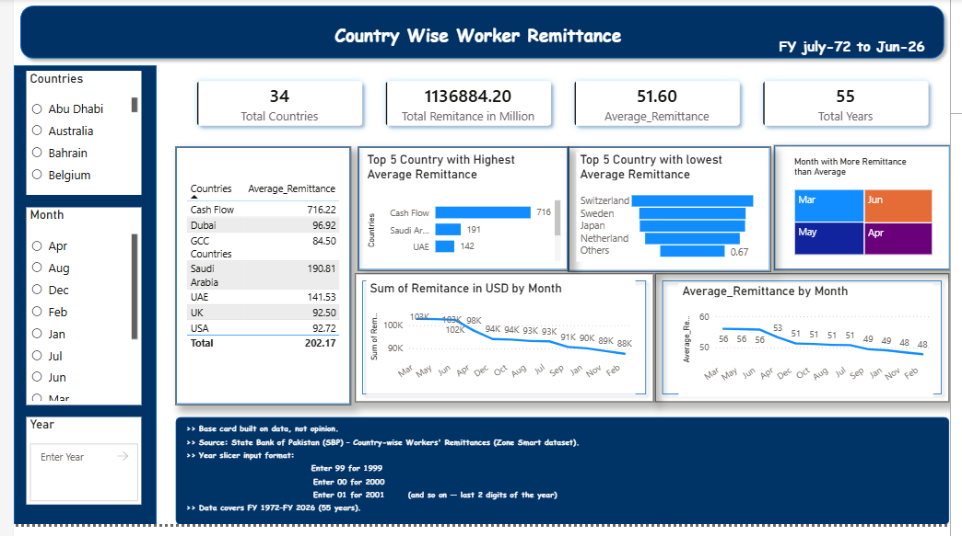

6. Key Insights

6.1 Highest vs. Lowest Average Remittance
The categories/countries with the highest average remittance — led by the Cash Flow category (716.22), Saudi Arabia (190.81), and UAE (141.53) — dominate total inflows, while categories such as Switzerland, Sweden, Japan, and Netherlands post the lowest average remittances, closer to the "Others" tail (0.67).
Country / Category | Average Remittance
Cash Flow | 716.22
Dubai | 96.92
GCC Countries | 84.50
Saudi Arabia | 190.81
UAE | 141.53
UK | 92.50
USA | 92.72
Total | 202.17

6.2 Seasonal Pattern
Remittance inflows are not evenly spread across the year. March, June, May, and April consistently receive above-average remittance — a pattern likely tied to religious and cultural events (e.g., Ramadan/Eid timing) when overseas workers send extra money home.
Both the monthly USD-sum trend and the monthly average-remittance trend peak around March and taper off toward the end of the fiscal year (Jan–Feb), sliding from roughly 103K down to about 88K in the sum-of-remittance view, and from 56 down to about 48 in the average-remittance view.

7. Tools & Skills Applied
- Power BI — data modelling, DAX measures, interactive slicers, and dashboard layout.
- Data source integration — official SBP government dataset (55 years of records).
- KPI design — card visuals, ranked tables, bar charts, and trend lines.
- Data storytelling — organizing visuals to answer "who," "when," and "how much" at a glance.

8. Conclusion
This dashboard demonstrates the ability to turn a large, multi-decade government dataset into a clear, interactive analytical tool. It highlights strong Power BI fundamentals — slicers, KPI cards, ranked visuals, and trend analysis — and surfaces genuine business insight: remittance is heavily concentrated in a few corridors (Cash Flow, Saudi Arabia, UAE) and shows a clear seasonal peak around March–June.
As a next step, this project could be extended with year-over-year growth measures, currency-adjusted (real) remittance trends, and forecasting for future fiscal years.

