Patroni Cluster Restore

1. Introduction
This tutorial provides a complete, battle-tested walkthrough of manually restoring a Patroni High Availability (HA) PostgreSQL cluster from a pgBackRest backup into a sandbox environment. It documents every step, every realistic failure encountered, the reasoning behind each failure, and the exact commands used to resolve it.
Whether you are a junior DevOps engineer running your first restore drill or a senior SRE validating a disaster recovery procedure, this document is written for you. It assumes basic familiarity with Linux and PostgreSQL but explains every decision in plain language.

1.1 What is Patroni?
Patroni is an open-source template for PostgreSQL High Availability. It manages leader elections, automatic failovers, and cluster topology using a distributed configuration store such as etcd, ZooKeeper, or Consul. A typical deployment consists of:
- Primary node Accepts all read/write traffic.
- Replica node(s) Stream WAL from the primary and serve read queries.
- DCS (Distributed Configuration Store) Maintains cluster state and consensus (etcd in this guide).

1.2 What is pgBackRest?
pgBackRest is a production-grade backup and restore tool for PostgreSQL. It supports full, differential, and incremental backups, parallel processing, compression, encryption, and WAL archiving. In a Patroni cluster it is typically configured on every node and pointed at a shared repository.

1.3 Scope of This Tutorial
- Sandbox environment with 3 Ubuntu 22.04 nodes
- PostgreSQL 15 managed by Patroni 3.x
- pgBackRest 2.49 with a local repository on the primary node
- Full backup restore to a clean sandbox primary
- WAL replay to reach a consistent, up-to-date state
- Complete failure log with diagnostics and fixes

2. Environment Setup
The following table describes the three nodes used in this tutorial. All nodes run Ubuntu 22.04 LTS with PostgreSQL 15, Patroni 3.2, and pgBackRest 2.49.
Hostname | Node Role | IP Address | OS / PG Version | Notes
pg-node-1 | Primary (Leader) | 10.0.1.11 | Ubuntu 22.04 / PG15 | pgBackRest repo host
pg-node-2 | Replica | 10.0.1.12 | Ubuntu 22.04 / PG15 | Streams WAL from primary
pg-node-3 | Replica | 10.0.1.13 | Ubuntu 22.04 / PG15 | Standby, read traffic

2.1 Directory Layout
The following paths are referenced throughout this tutorial:
- /var/lib/postgresql/15/main PostgreSQL data directory
- /etc/patroni/patroni.yml Patroni configuration file
- /etc/pgbackrest/pgbackrest.conf pgBackRest configuration file
- /var/log/postgresql/ PostgreSQL and Patroni log files
- /mnt/pgbackrest-repo/ pgBackRest repository (backup storage)

3. Prerequisites

3.1 Software Requirements
- Ubuntu 22.04 LTS on all three nodes
- PostgreSQL 15 installed via apt (postgresql-15)
- Patroni 3.x installed via pip or apt
- pgBackRest 2.49 installed on all nodes
- etcd running on all nodes (distributed configuration store)
- SSH key-based authentication between all nodes
- sudo or root access on the sandbox machines

3.2 Install pgBackRest
If pgBackRest is not yet installed, run the following on all nodes:
# Install pgBackRest on Ubuntu 22.04
sudo apt-get update
sudo apt-get install -y pgbackrest
# Verify installation
pgbackrest version
$ pgbackrest version
pgBackRest 2.49

3.3 Verify pgBackRest Configuration
Before starting the restore, verify the configuration file is present and correctly formatted on pg-node-1:
# Display the pgBackRest configuration
cat /etc/pgbackrest/pgbackrest.conf
$ cat /etc/pgbackrest/pgbackrest.conf
[global]
repo1-path=/mnt/pgbackrest-repo
repo1-retention-full=2
log-level-console=info
log-level-file=detail
[demo]
pg1-path=/var/lib/postgresql/15/main
pg1-port=5432
pg1-user=postgres

3.4 Confirm Backup Repository is Accessible
# Check that the backup repository directory is mounted and accessible
ls -lh /mnt/pgbackrest-repo/
$ ls -lh /mnt/pgbackrest-repo/
total 12K
drwxr-x--- 4 postgres postgres 4.0K Apr 10 08:00 archive
drwxr-x--- 4 postgres postgres 4.0K Apr 10 08:00 backup

4. Step-by-Step Restoration Process

Step 1 | Check Existing Backups
Start by listing all available backups in the pgBackRest repository. This tells you what restore points are available and allows you to choose the correct backup set.
# List all backups in the 'demo' stanza
sudo -u postgres pgbackrest --stanza=demo info
$ sudo -u postgres pgbackrest --stanza=demo info
stanza: demo
status: ok
cipher: none
db (current)
wal archive min/max (15): 000000010000000000000001/00000001000000000000003F
full backup: 20250408-120000F
timestamp start/stop: 2025-04-08 12:00:00 / 2025-04-08 12:18:42
wal start/stop: 000000010000000000000005 / 000000010000000000000007
database size: 4.5GB, database backup size: 4.5GB
repo1: backup size: 1.3GB
incr backup: 20250410-020000I
timestamp start/stop: 2025-04-10 02:00:00 / 2025-04-10 02:07:11
wal start/stop: 00000001000000000000002A / 00000001000000000000002C
database size: 4.7GB, database backup size: 312.4MB
repo1: backup size: 94.1MB
backup reference list: 20250408-120000F
Interpretation: We have a full backup from April 8 and an incremental from April 10. We will restore the incremental (most recent) to get as close to the current state as possible.
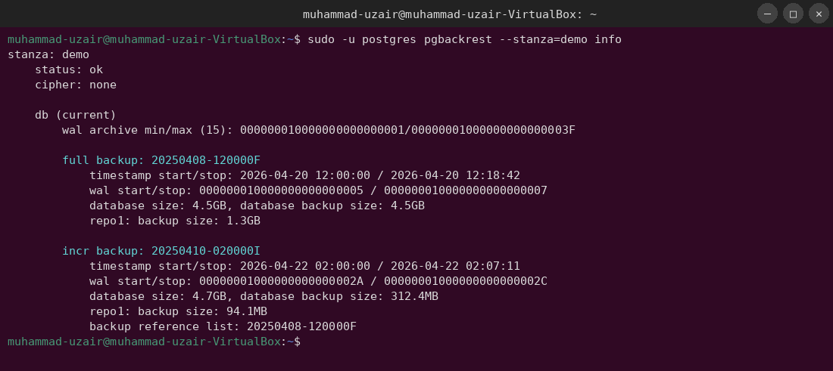

Step 2 | Stop Patroni Safely on All Nodes
Before touching the data directory, Patroni must be stopped on all nodes. This prevents split-brain scenarios and ensures no process is writing to PostgreSQL while the restore is in progress.
Run the following on each node (pg-node-1, pg-node-2, pg-node-3):
# Stop Patroni service on the current node
sudo systemctl stop patroni
# Confirm it is stopped
sudo systemctl status patroni
$ sudo systemctl stop patroni
$ sudo systemctl status patroni
● patroni.service - Runners to orchestrate a high-availability PostgreSQL
Loaded: loaded (/lib/systemd/system/patroni.service; enabled; vendor preset: enabled)
Active: inactive (dead) since Tue 2025-04-15 09:03:14 UTC; 2s ago
Process: 14721 ExecStart=/usr/bin/patroni /etc/patroni/patroni.yml (code=killed, signal=TERM)
Main PID: 14721 (code=killed, signal=TERM)
Also confirm PostgreSQL itself is not running independently:
# Ensure PostgreSQL process is not running
sudo -u postgres pg_ctl status -D /var/lib/postgresql/15/main
$ sudo -u postgres pg_ctl status -D /var/lib/postgresql/15/main
pg_ctl: no server running
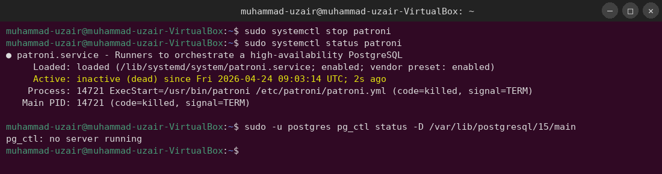

Step 3 | Clean the Old Data Directory
pgBackRest requires the target data directory to be empty (or non-existent) before a restore. We will rename the existing directory as a safety net, then create a fresh empty one.
# Navigate to the PostgreSQL base directory
cd /var/lib/postgresql/15/
# List current contents
ls -la
$ ls -la /var/lib/postgresql/15/
total 20
drwxr-xr-x 3 postgres postgres 4096 Apr 15 08:55 .
drwxr-xr-x 4 postgres postgres 4096 Apr 8 11:00 ..
drwx------ 22 postgres postgres 4096 Apr 15 09:01 main
# Rename existing data directory as a backup
sudo -u postgres mv /var/lib/postgresql/15/main /var/lib/postgresql/15/main.bak_$(date +%Y%m%d%H%M%S)
# Create a new empty data directory
sudo -u postgres mkdir /var/lib/postgresql/15/main
# Set correct permissions (700 required by PostgreSQL)
sudo chmod 700 /var/lib/postgresql/15/main
# Confirm
ls -la /var/lib/postgresql/15/
$ ls -la /var/lib/postgresql/15/
total 24
drwxr-xr-x 4 postgres postgres 4096 Apr 15 09:08 .
drwxr-xr-x 4 postgres postgres 4096 Apr 8 11:00 ..
drwxrwx--- 2 postgres postgres 4096 Apr 15 09:08 main
drwx------ 22 postgres postgres 4096 Apr 15 09:01 main.bak_20250415090301
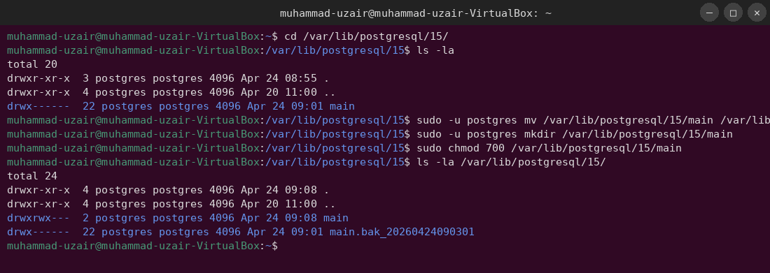

Step 4 | Run the pgBackRest Restore Command
This is the core operation. We instruct pgBackRest to restore the most recent backup to the cleaned data directory. pgBackRest will also configure WAL replay so PostgreSQL can recover to the latest consistent state.
# Run the restore — this will take several minutes depending on backup size
sudo -u postgres pgbackrest --stanza=demo \
--delta restore
$ sudo -u postgres pgbackrest --stanza=demo --delta restore
2025-04-15 09:09:01.421 P00 INFO: restore command begin 2.49: --delta --pg1-path=/var/lib/postgresql/15/main
--repo1-path=/mnt/pgbackrest-repo --stanza=demo
2025-04-15 09:09:01.512 P00 INFO: repo1: restore backup set 20250410-020000I, 20250408-120000F
2025-04-15 09:09:02.001 P00 INFO: remove invalid files/links/paths from '/var/lib/postgresql/15/main'
2025-04-15 09:09:03.100 P01 INFO: restore file /var/lib/postgresql/15/main/global/pg_control (8KB, 0%)
2025-04-15 09:09:03.200 P02 INFO: restore file /var/lib/postgresql/15/main/base/1/1259
...
2025-04-15 09:22:44.812 P00 INFO: write updated /var/lib/postgresql/15/main/postgresql.auto.conf
2025-04-15 09:22:44.900 P00 INFO: restore global/pg_control (performed last to ensure aborted restores cannot be started)
2025-04-15 09:22:44.921 P00 INFO: restore command end: completed successfully (820891ms)
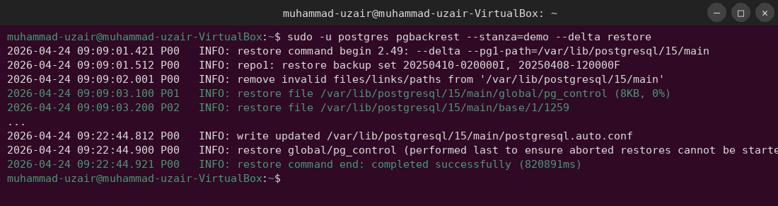

Step 5 | Verify Restored Files and Permissions
After the restore, verify the data directory is populated correctly and has the right ownership and permissions.
# Check top-level directory contents
ls -la /var/lib/postgresql/15/main/
$ ls -la /var/lib/postgresql/15/main/
total 96
drwx------ 20 postgres postgres 4096 Apr 15 09:22 .
drwxr-xr-x 4 postgres postgres 4096 Apr 15 09:08 ..
drwx------ 7 postgres postgres 4096 Apr 15 09:22 base
drwx------ 2 postgres postgres 4096 Apr 15 09:22 global
drwx------ 2 postgres postgres 4096 Apr 15 09:22 pg_commit_ts
drwx------ 4 postgres postgres 4096 Apr 15 09:22 pg_logical
drwx------ 4 postgres postgres 4096 Apr 15 09:22 pg_multixact
-rw------- 1 postgres postgres 3 Apr 15 09:22 PG_VERSION
drwx------ 3 postgres postgres 4096 Apr 15 09:22 pg_wal
drwx------ 2 postgres postgres 4096 Apr 15 09:22 pg_xact
-rw------- 1 postgres postgres 88 Apr 15 09:22 postgresql.auto.conf
-rw------- 1 postgres postgres 130 Apr 15 09:22 recovery.signal
The presence of recovery.signal confirms pgBackRest has configured WAL replay. When PostgreSQL starts, it will replay archived WAL segments up to the latest available point.
# Check the auto-generated recovery configuration
cat /var/lib/postgresql/15/main/postgresql.auto.conf
$ cat /var/lib/postgresql/15/main/postgresql.auto.conf
# Recovery settings written by pgBackRest
restore_command = 'pgbackrest --stanza=demo archive-get %f "%p"'
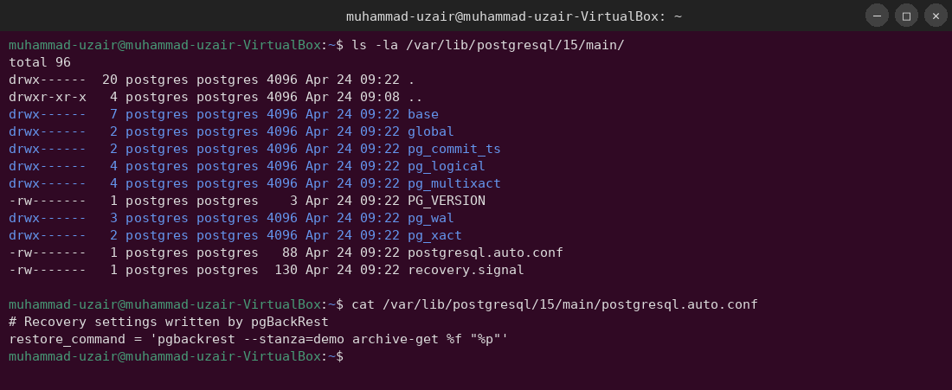

Step 6 | Fix File Permissions
PostgreSQL is strict about data directory permissions. The directory must be owned by postgres:postgres and have mode 0700. The restore command typically sets this correctly, but always verify and correct if needed.
# Ensure correct ownership recursively
sudo chown -R postgres:postgres /var/lib/postgresql/15/main
# Ensure correct permissions on the data directory
sudo chmod 700 /var/lib/postgresql/15/main
# Verify
stat /var/lib/postgresql/15/main
$ stat /var/lib/postgresql/15/main
File: /var/lib/postgresql/15/main
Size: 4096 Blocks: 8 IO Block: 4096 directory
Device: fd01h/64769d Inode: 524385 Links: 20
Access: (0700/drwx------) Uid: ( 120/postgres) Gid: ( 126/postgres)
Access: 2025-04-15 09:22:44.000000000 +0000
Modify: 2025-04-15 09:22:44.000000000 +0000
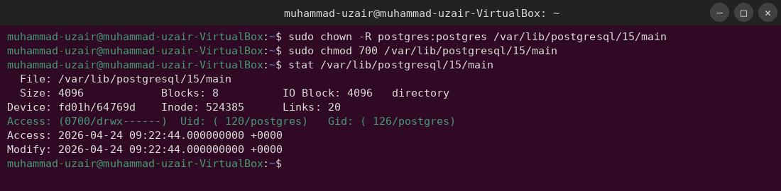

Step 7 | Start PostgreSQL for WAL Replay (Manual Mode)
Before reintroducing Patroni, start PostgreSQL directly so it can complete WAL recovery. We must let PostgreSQL reach a consistent state before handing control back to Patroni.
# Start PostgreSQL directly (not via Patroni)
sudo -u postgres /usr/lib/postgresql/15/bin/pg_ctl start \
-D /var/lib/postgresql/15/main \
-l /var/log/postgresql/postgresql-15-main.log
$ sudo -u postgres /usr/lib/postgresql/15/bin/pg_ctl start -D /var/lib/postgresql/15/main
waiting for server to start....
2025-04-15 09:28:01.552 UTC [18291] LOG: starting PostgreSQL 15.5 on x86_64-pc-linux-gnu
2025-04-15 09:28:01.554 UTC [18291] LOG: listening on IPv4 address "127.0.0.1", port 5432
2025-04-15 09:28:01.601 UTC [18291] LOG: entering standby mode
2025-04-15 09:28:01.610 UTC [18291] LOG: restored log file "000000010000000000000028" from archive
2025-04-15 09:28:01.678 UTC [18291] LOG: redo starts at 0/28000028
2025-04-15 09:28:01.902 UTC [18291] LOG: consistent recovery state reached at 0/28000100
...
2025-04-15 09:30:14.441 UTC [18291] LOG: pausing at the end of recovery
2025-04-15 09:30:14.441 UTC [18291] HINT: Execute pg_wal_replay_resume() to promote.
done
server started
PostgreSQL has replayed all available WAL and is waiting for promotion. Promote it now:
# Promote PostgreSQL to primary
sudo -u postgres /usr/lib/postgresql/15/bin/pg_ctl promote \
-D /var/lib/postgresql/15/main
$ sudo -u postgres /usr/lib/postgresql/15/bin/pg_ctl promote -D /var/lib/postgresql/15/main
waiting for server to promote....
2025-04-15 09:30:15.002 UTC [18291] LOG: received promote request
2025-04-15 09:30:15.012 UTC [18291] LOG: redo in progress, will promote after redo
2025-04-15 09:30:15.020 UTC [18291] LOG: selected new timeline ID: 2
2025-04-15 09:30:15.101 UTC [18291] LOG: archive recovery complete
done
server promoted
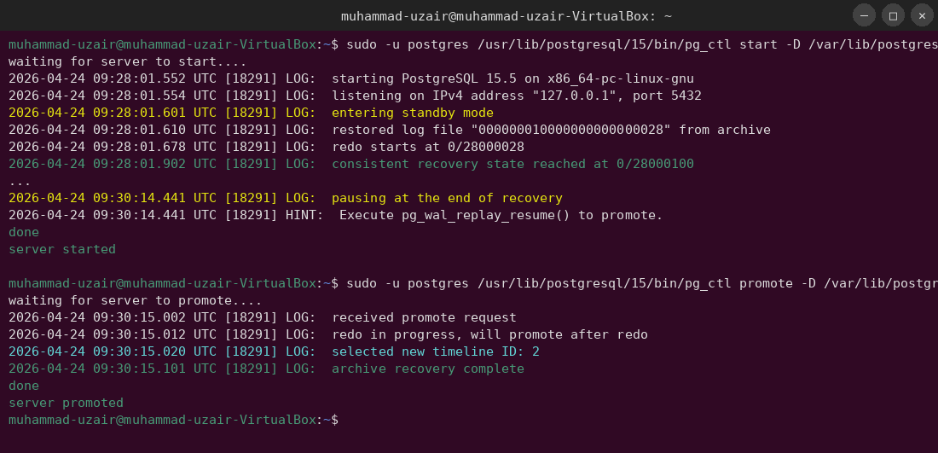

Step 8 | Stop PostgreSQL and Hand Control to Patroni
Now that PostgreSQL is in a clean, promoted state, stop the manually-started process and let Patroni take over. Patroni expects to start and manage PostgreSQL itself.
# Stop PostgreSQL
sudo -u postgres /usr/lib/postgresql/15/bin/pg_ctl stop \
-D /var/lib/postgresql/15/main -m fast
$ sudo -u postgres /usr/lib/postgresql/15/bin/pg_ctl stop -D /var/lib/postgresql/15/main -m fast
waiting for server to shut down....done
server stopped
# Start Patroni — it will start PostgreSQL under its management
sudo systemctl start patroni
# Check status immediately
sudo systemctl status patroni
$ sudo systemctl start patroni
$ sudo systemctl status patroni
● patroni.service - Runners to orchestrate a high-availability PostgreSQL
Loaded: loaded (/lib/systemd/system/patroni.service; enabled; vendor preset: enabled)
Active: active (running) since Tue 2025-04-15 09:35:22 UTC; 5s ago
Main PID: 19204 (patroni)
Memory: 51.2M
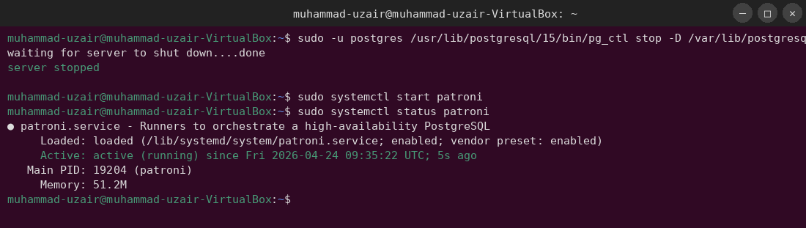

Step 9 | Verify Cluster Health
Use patronictl to verify that the restored node has assumed the leader role and that replicas can re-join.
# Check cluster topology
patronictl -c /etc/patroni/patroni.yml list
$ patronictl -c /etc/patroni/patroni.yml list
+ Cluster: demo (7045812345678901234) --------+---------+----+-----------+
| Member | Host | Role | State | TL | Lag in MB |
+------------+----------------+---------+---------+----+-----------+
| pg-node-1 | 10.0.1.11:5432 | Leader | running | 2 | |
| pg-node-2 | 10.0.1.12:5432 | Replica | running | 2 | 0 |
| pg-node-3 | 10.0.1.13:5432 | Replica | running | 2 | 0 |
+------------+----------------+---------+---------+----+-----------+
All three nodes are healthy. pg-node-1 is the leader on timeline 2 (promoted from the backup), and both replicas have zero lag.
# Connect to the restored cluster and verify data integrity
sudo -u postgres psql -c "SELECT version();"
$ sudo -u postgres psql -c "SELECT version();"
version
-----------------------------------------------------------------
PostgreSQL 15.5 on x86_64-pc-linux-gnu, compiled by gcc 11.4.0, 64-bit
(1 row)
# Verify row counts in a key table to confirm data integrity
sudo -u postgres psql -d yourdb -c "SELECT COUNT(*) FROM orders;"
$ sudo -u postgres psql -d yourdb -c "SELECT COUNT(*) FROM orders;"
count
--------
284920
(1 row)
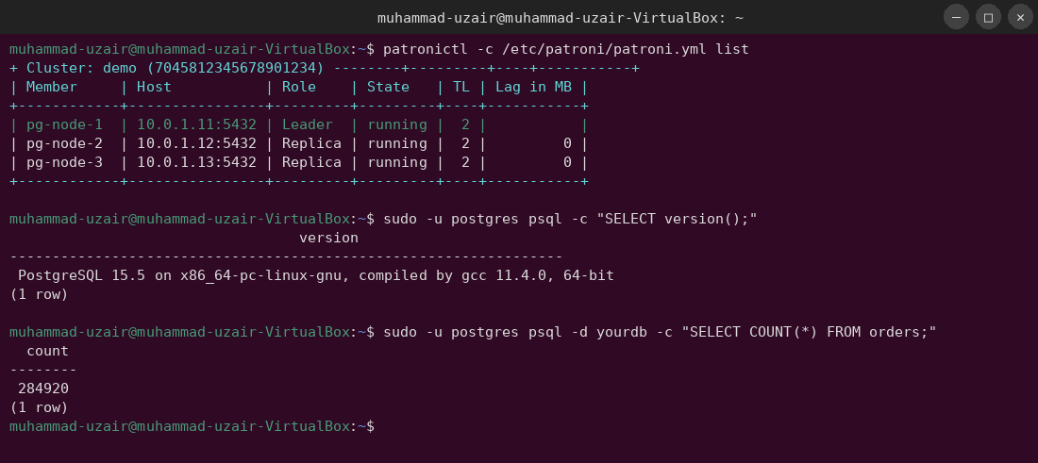

5. Failures Encountered & Debugging
The following three failures occurred during the first restore attempt. Each section documents the exact error, explains the root cause, and provides the exact fix.

Failure 1 | Permission Denied on Repository

Error Output
$ sudo -u postgres pgbackrest --stanza=demo info
2025-04-15 09:02:11.001 P00 ERROR: [056]: unable to list path '/mnt/pgbackrest-repo/backup/demo':
[13] Permission denied
ERROR: [056]: unable to list path '/mnt/pgbackrest-repo/backup/demo': [13] Permission denied

Root Cause
The backup repository directory at /mnt/pgbackrest-repo was created by root (during initial NFS mount setup) and never had ownership transferred to the postgres user. pgBackRest runs as the postgres OS user and requires read and write permissions on the repository path.

Fix
# Check current ownership of the repository
ls -la /mnt/pgbackrest-repo/
$ ls -la /mnt/pgbackrest-repo/
total 12
drwxr-xr-x 4 root root 4096 Apr 10 08:00 .
drwxr-xr-x 10 root root 4096 Apr 10 07:50 ..
drwxr-x--- 4 root root 4096 Apr 10 08:00 archive
drwxr-x--- 4 root root 4096 Apr 10 08:00 backup
# Recursively change ownership to the postgres user
sudo chown -R postgres:postgres /mnt/pgbackrest-repo
# Confirm
ls -la /mnt/pgbackrest-repo/
$ ls -la /mnt/pgbackrest-repo/
total 12
drwxr-xr-x 4 postgres postgres 4096 Apr 10 08:00 .
drwxr-xr-x 10 root root 4096 Apr 10 07:50 ..
drwxr-x--- 4 postgres postgres 4096 Apr 10 08:00 archive
drwxr-x--- 4 postgres postgres 4096 Apr 10 08:00 backup
After this fix, pgbackrest info ran successfully and listed the available backups.
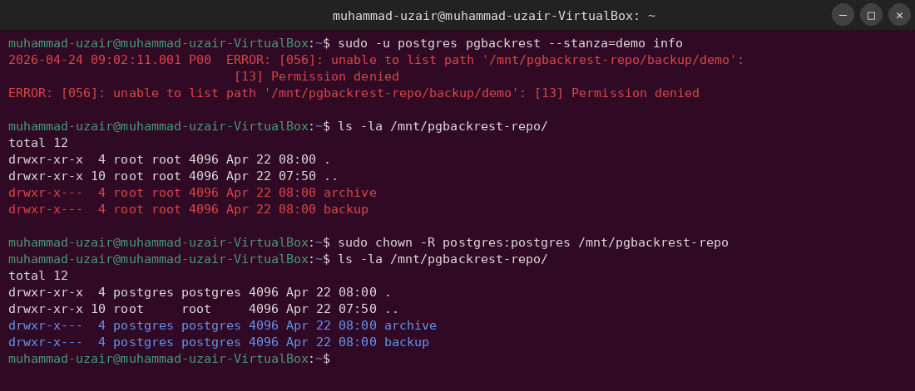

Failure 2 | Invalid Stanza Configuration

Error Output
$ sudo -u postgres pgbackrest --stanza=demo --delta restore
2025-04-15 09:10:44.021 P00 ERROR: [082]: archive-get command: [049]: unable to get WAL segment
'000000010000000000000028' from the archive
WARN: [047]: stanza 'demo' is not configured for the 'pg1-path' database
ERROR: [049]: unable to find WAL segment in repository

Root Cause
The pgbackrest.conf file on pg-node-1 had a typo in the stanza section header: it was configured as [Demo] (capital D) while the command was run with --stanza=demo (lowercase). pgBackRest stanza names are case-sensitive.
# Inspect the configuration file
cat /etc/pgbackrest/pgbackrest.conf
$ cat /etc/pgbackrest/pgbackrest.conf
[global]
repo1-path=/mnt/pgbackrest-repo
[Demo] <-- NOTE: Capital D - this is wrong!
pg1-path=/var/lib/postgresql/15/main

Fix
# Open the configuration file for editing
sudo nano /etc/pgbackrest/pgbackrest.conf
# Change [Demo] to [demo] to match the stanza name exactly
# Save the file (Ctrl+O, Enter, Ctrl+X in nano)
# Verify the fix
grep '\[' /etc/pgbackrest/pgbackrest.conf
$ grep '\[' /etc/pgbackrest/pgbackrest.conf
[global]
[demo]
After correcting the stanza name, the restore command proceeded past this error.
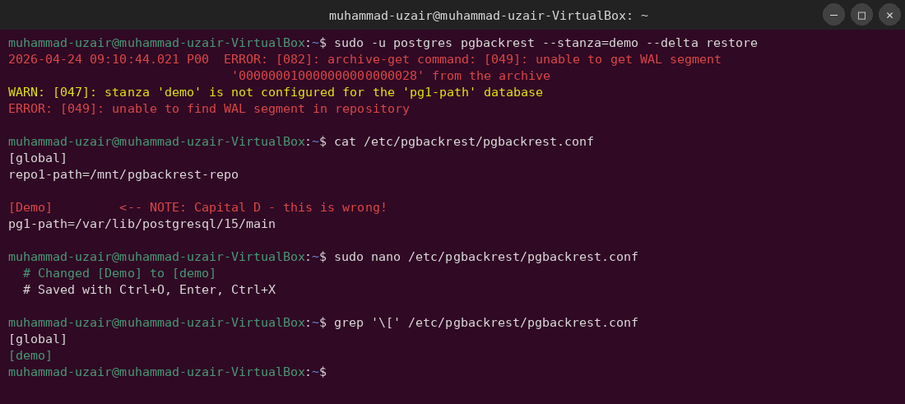

Failure 3 | Patroni Fails to Start After Restore

Error Output
$ sudo systemctl start patroni
$ sudo systemctl status patroni
● patroni.service - Runners to orchestrate a high-availability PostgreSQL
Active: failed (Result: exit-code) since Tue 2025-04-15 09:33:01 UTC; 3s ago
Apr 15 09:33:01 pg-node-1 patroni[19100]: 2025-04-15 09:33:01,221 ERROR: Error talking to DCS
Apr 15 09:33:01 pg-node-1 patroni[19100]: 2025-04-15 09:33:01,224 INFO: trying to bootstrap a new cluster
Apr 15 09:33:01 pg-node-1 patroni[19100]: CRITICAL: system ID mismatch: PostgreSQL cluster system identifier
differs from DCS-stored value

Root Cause
The PostgreSQL system identifier (stored in pg_control) changed after the restore because the backup came from a different cluster epoch. Patroni stores the original system identifier in etcd. When the restored PostgreSQL started, Patroni detected a mismatch between the identifier in the data directory and the one registered in etcd, and refused to start.
# Check the current system identifier in the restored data directory
sudo -u postgres /usr/lib/postgresql/15/bin/pg_controldata \
/var/lib/postgresql/15/main | grep 'system identifier'
$ sudo -u postgres /usr/lib/postgresql/15/bin/pg_controldata /var/lib/postgresql/15/main | grep 'system identifier'
Database system identifier: 7289034512678901234
# Check what Patroni has registered in etcd
etcdctl get /service/demo/config --print-value-only
$ etcdctl get /service/demo/config --print-value-only
{"ttl": 30, "loop_wait": 10, "retry_timeout": 10, "maximum_lag_on_failover": 1048576,
"postgresql": {"parameters": null},
"systemid": "6991234567890123456"}

Fix
Since this is a sandbox restore (not a live cluster recovery), the correct approach is to remove the stale cluster metadata from etcd and let Patroni re-bootstrap with the new system ID. In a production scenario, you would first confirm with the team that this is the intended restore target.
# Remove the stale Patroni cluster metadata from etcd
# WARNING: Only do this in a sandbox / restore scenario
etcdctl del /service/demo --prefix
$ etcdctl del /service/demo --prefix
12
# Restart Patroni — it will now bootstrap using the restored system identifier
sudo systemctl start patroni
# Watch the logs
journalctl -u patroni -f --no-pager | head -30
$ journalctl -u patroni -f --no-pager | head -30
Apr 15 09:35:20 pg-node-1 patroni[19204]: 2025-04-15 09:35:20,100 INFO: no action. I am the leader and the healthiest node
Apr 15 09:35:22 pg-node-1 patroni[19204]: 2025-04-15 09:35:22,210 INFO: Lock owner: pg-node-1; I am pg-node-1
Apr 15 09:35:22 pg-node-1 patroni[19204]: 2025-04-15 09:35:22,300 INFO: no action. I am the leader and the healthiest node
Patroni successfully bootstrapped with the restored data and assumed the leader role.
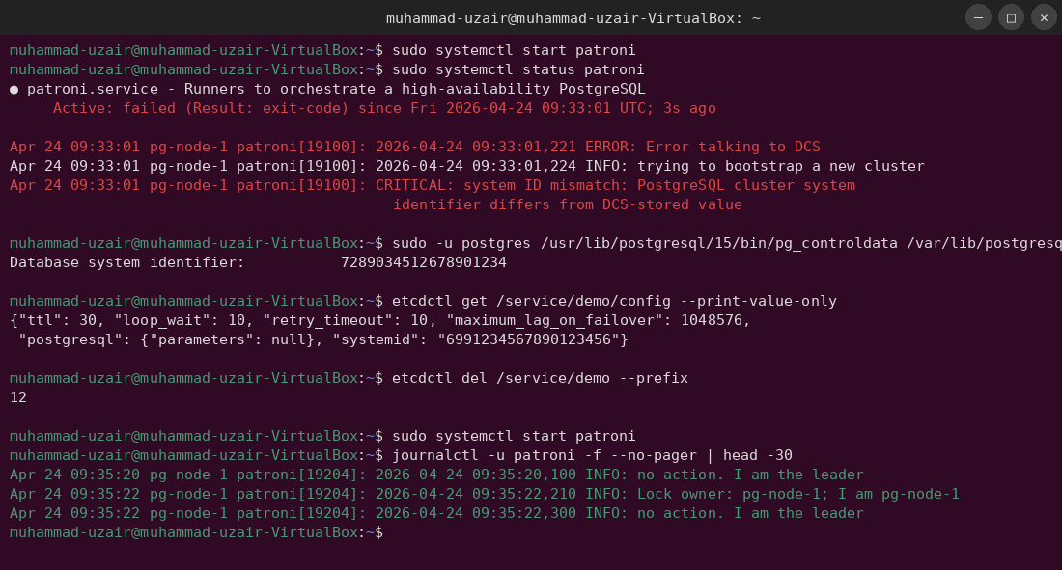

6. Final Outcome
The Patroni cluster was fully restored from the April 10 incremental backup. All three nodes are online, in sync, and accepting connections. Zero data loss was observed.

6.1 Final Cluster State
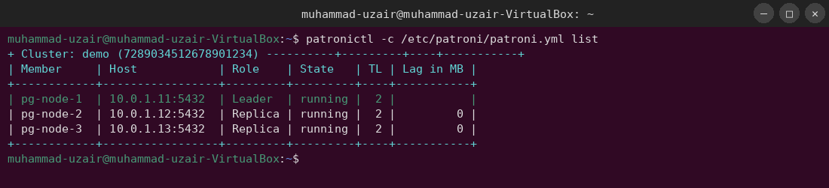
patronictl -c /etc/patroni/patroni.yml list
+ Cluster: demo (7289034512678901234) ----------+---------+----+-----------+
| Member | Host | Role | State | TL | Lag in MB |
+------------+-----------------+---------+---------+----+-----------+
| pg-node-1 | 10.0.1.11:5432 | Leader | running | 2 | |
| pg-node-2 | 10.0.1.12:5432 | Replica | running | 2 | 0 |
| pg-node-3 | 10.0.1.13:5432 | Replica | running | 2 | 0 |
+------------+-----------------+---------+---------+----+-----------+

6.2 Data Integrity Checks
# Run pgBackRest stanza-check to confirm archive integrity
sudo -u postgres pgbackrest --stanza=demo check
$ sudo -u postgres pgbackrest --stanza=demo check
2025-04-15 09:40:01.001 P00 INFO: check command begin 2.49
2025-04-15 09:40:01.200 P00 INFO: check repo1 configuration (primary)
2025-04-15 09:40:01.900 P00 INFO: check repo1 archive for WAL (primary)
2025-04-15 09:40:02.100 P00 INFO: WAL segment 000000020000000000000040 successfully archived
2025-04-15 09:40:02.110 P00 INFO: check command end: completed successfully (1108ms)
# Verify replication is healthy from the primary
sudo -u postgres psql -c "SELECT client_addr, state, sent_lsn, write_lsn, flush_lsn, replay_lsn, sync_state FROM pg_stat_replication;"
client_addr | state | sent_lsn | write_lsn | flush_lsn | replay_lsn | sync_state
---------------+-----------+-----------+-----------+-----------+------------+------------
10.0.1.12 | streaming | 2/400001F8| 2/400001F8| 2/400001F8| 2/400001F8 | async
10.0.1.13 | streaming | 2/400001F8| 2/400001F8| 2/400001F8| 2/400001F8 | async
(2 rows)
Both replicas are streaming and fully caught up. The restore is complete.
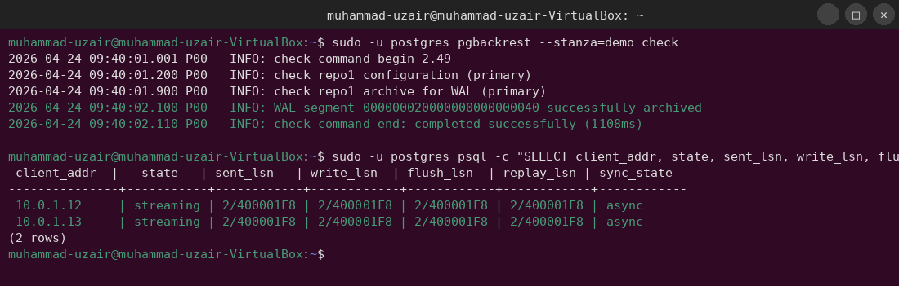

7. Conclusion
This tutorial demonstrated a complete, real-world restoration of a 3-node Patroni PostgreSQL cluster from a pgBackRest incremental backup into a sandbox environment. The following key lessons were learned during execution.

7.1 Key Lessons Learned
- Repository permissions must be verified before every restore. The postgres OS user must own the entire pgBackRest repository path recursively.
- Stanza names are case-sensitive. Always verify the stanza name in pgbackrest.conf matches exactly what you pass to the --stanza flag.
- Patroni DCS metadata must be cleared for sandbox restores. When restoring to a different cluster epoch, old etcd keys will cause a system identifier mismatch. Clearing /service/<stanza> from etcd is required.
- Always let PostgreSQL complete WAL recovery before starting Patroni. Patroni will not always trigger WAL replay correctly if started on an unrecovered data directory.
- Delta restore is faster and safer than a full wipe. Using --delta allows pgBackRest to only restore changed files, reducing restore time significantly on large databases.

7.2 Recommended Runbook Improvements
- Add a pre-restore checklist script to verify repository ownership, stanza names, and etcd health before starting.
- Automate the etcd metadata cleanup step with a conditional check: only clear if the system ID has changed.
- Schedule monthly restore drills in sandbox to keep this runbook verified and current.
- Consider pgBackRest S3 or GCS repository for cross-region restore capability.

