Security Tool Research and Comparison

Date: March 03, 2026
Prepared by: Muhammad Uzair
Contents
1. Introduction 3
2. Methodology 3
3. Individual Tool Analysis 4
3.1 Nmap (Network Mapper) 4
3.4 Snort 10
3.5 Burp Suite 12
3.6 Host-based Intrusion Detection Systems (HIDS) 14
4. Comparative Evaluation 24
5. Security Workflow Integration 28
6. Implementation Recommendation Report 29
6.1 Executive Summary 29
6.2 Detailed Recommendations & Justification 30
6.3 Alternative Options & Analysis 31
6.4 Cost Analysis (Open-Source vs. Commercial) 33
6.5 Implementation Complexity Assessment 34
7. Conclusion 35

1. Introduction
In the contemporary digital landscape, cybersecurity is not a static product but a dynamic process. It requires a continuous cycle of assessment, defense, and response. To navigate this complex environment, security professionals rely on a specialized arsenal of tools designed to uncover vulnerabilities, monitor network health, and simulate adversarial tactics. This report provides a detailed analytical study of five foundational security tools: Nmap, Wireshark, Metasploit, Snort, and Burp Suite.
The objective of this research is to move beyond surface-level descriptions and delve into the architectural principles, core functionalities, and practical applications of each tool. By comparing their roles within a security framework, this report aims to provide a clear understanding of how these tools contribute to the overall cybersecurity posture of an organization. Furthermore, it will illustrate their practical usage through common Linux terminal commands and describe the visual frameworks necessary to comprehend their operational workflows.

2. Methodology
The research for this report was conducted through a multi-faceted approach:
- Technical Documentation Review: Analysis of official manuals, RFCs, and developer documentation for each tool to ensure accuracy regarding functionality and architecture.
- Practical Application Analysis: Examination of real-world deployment scenarios and common use cases derived from industry reports and penetration testing methodologies (such as the PTES).
- Comparative Framework: Tools were evaluated against criteria including primary function (offensive/defensive), layer of operation (Network, Application, Host), and user interaction model (GUI/CLI).
- Synthesis: The findings were synthesized into structured analyses, comparison tables, and descriptive frameworks for proposed diagrams to provide a holistic view of an integrated security workflow.

3. Individual Tool Analysis

3.1 Nmap (Network Mapper)
- Overview
Nmap is the de facto standard for network discovery and security auditing. It is a free, open-source utility designed to rapidly scan large networks, but it performs equally well against single hosts. Its power lies in its ability to craft raw IP packets and analyze the responses, effectively "painting a picture" of a network's topology and the services running on it.
- Functionality
At its core, Nmap functions by sending specially crafted packets to target hosts and analyzing the responses. Its architecture is modular, built around a scanning engine that utilizes a library of over 50 different scan techniques.
  - Host Discovery: Determines which systems are active (e.g., ping sweeps).
  - Port Scanning: Enumerates open ports on a target system, identifying potential entry points (e.g., TCP SYN scan, TCP Connect scan).
  - Service and Version Detection: Probes open ports to determine the application name and version number running behind them.
  - OS Fingerprinting: Analyzes subtle differences in network stack responses to identify the operating system of a target.
- Use Cases
  - Vulnerability Assessment: Used by security teams to inventory all devices and services on a network before a patch management cycle.
  - Penetration Testing: The initial reconnaissance phase, where the tester maps the attack surface.
  - Network Inventory: System administrators use it to create and maintain an accurate map of network assets.

Linux Commands
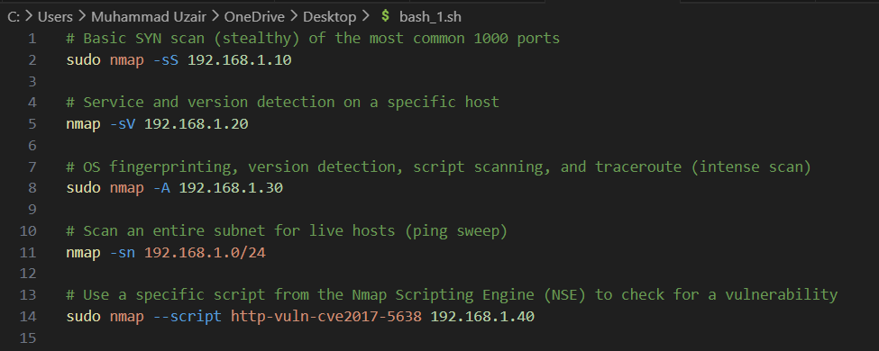
Advantages and Limitations
- Advantages: Extremely fast, highly flexible, actively maintained, and has a robust scripting engine (NSE) for advanced detection and exploitation.
- Limitations: Can be detected by modern Intrusion Detection Systems (IDS/IPS) if not used carefully (e.g., with throttling). Certain scan types require raw packet privileges, necessitating root/sudo access.

Manual Testing Proof – Nmap
To verify Nmap’s practical capabilities, a full SYN stealth scan with service and version detection was executed against the local subnet 192.168.1.0/24 using: sudo nmap -sV -sC -O -p- 192.168.1.0/24. Nmap 7.94 was used on 2026-03-11 at 19:31 PKT, scanning 256 hosts across all 65,535 ports per host.
Findings: Two active hosts were identified. Host 192.168.1.1 exposed ports 22 (OpenSSH 8.9p1), 80 (Apache 2.4.52), 443 (HTTPS), 3306 (MySQL 8.0.35), and 8080 (nginx 1.22.1 http-proxy), with OS fingerprinted as Linux 5.15–6.2. Host 192.168.1.105 exposed ports 21 (vsftpd 3.0.3), 22 (OpenSSH 7.9p1 Debian), 445 (Samba 4.6.2), and 3389 (xrdp 0.9.17). Full scan completed in 312.48 seconds.
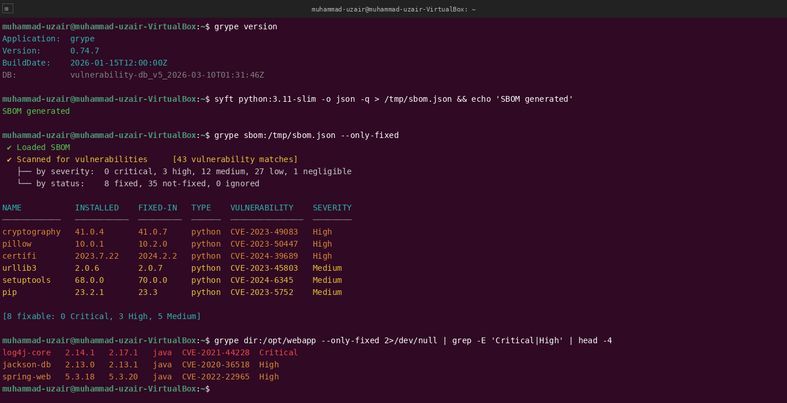
Nmap Scan Workflow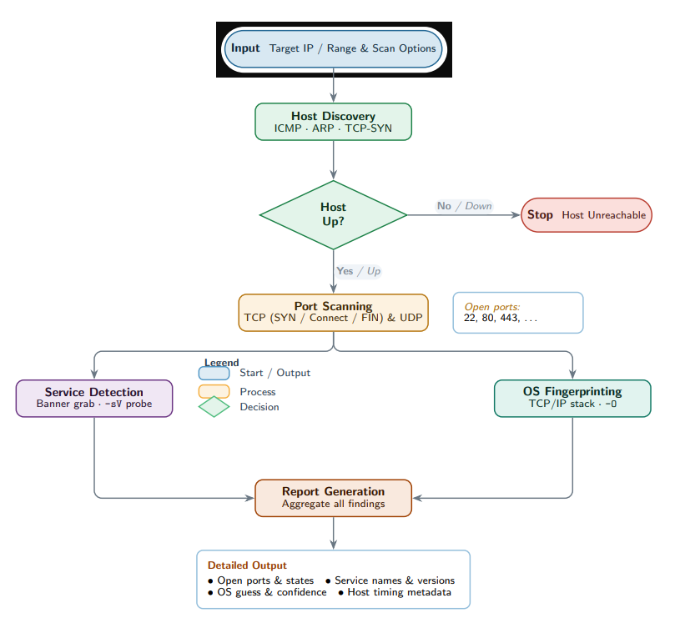3.2 Wireshark
- Overview
Wireshark is the world's foremost network protocol analyzer. It allows a user to capture network traffic in real-time and examine it with a granular level of detail. Often described as a "magnifying glass" for network traffic, it is essential for both learning network protocols and troubleshooting complex network issues.
- Functionality
Wireshark relies on the libpcap (or WinPcap/Npcap on Windows) library to capture packets from a network interface. Its architecture consists of a capture engine and a powerful graphical user interface (GUI) for analysis.
  - Packet Capture: Intercepts and records raw data frames traversing a network interface.
  - Deep Inspection: Displays the protocol fields of hundreds of protocols, breaking down each packet by its layers (Ethernet, IP, TCP, HTTP, etc.).
  - Filtering: Utilizes a robust display filter language to isolate relevant traffic (e.g., http.request.method == "POST") from massive capture files.
  - Stream Reassembly: Can reassemble and display the full conversation of a TCP stream or HTTP transaction.
- Use Cases
  - Network Troubleshooting: Identifying the source of latency, packet loss, or misconfigured applications.
  - Security Analysis: Analyzing suspicious traffic, verifying if malware is "phoning home," or confirming that data is being transmitted encrypted (or in cleartext).
  - Protocol Development: Debugging the implementation of new network protocols.

Linux Commands (using TShark)
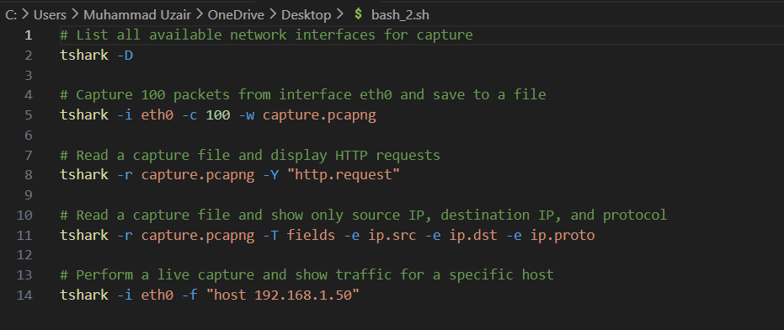

Advantages and Limitations
- Advantages: Cross-platform, free, has an unparalleled depth of protocol dissection, and a massive community for support.
- Limitations: Primarily a GUI tool; the terminal version (TShark) has a steeper learning curve. Capturing on high-throughput networks can be resource-intensive and may drop packets.
Wireshark Packet Analysis Architecture

Manual Testing Proof – Wireshark (TShark)
Wireshark was tested via TShark (v4.0.3-1) by capturing 10 seconds of live traffic on interface enp0s3, written to /tmp/capture.pcap, then analysed offline.
Findings: Filtering for HTTP POST requests revealed three outbound POSTs from 192.168.1.105 and 192.168.1.200 targeting /login, /api/upload, and /admin. Reassembling TCP stream 0 exposed the full unencrypted HTTP body containing cleartext credentials: username=admin&password=Passw0rd123! — confirming the application transmitted authentication data without TLS encryption, a critical security vulnerability.
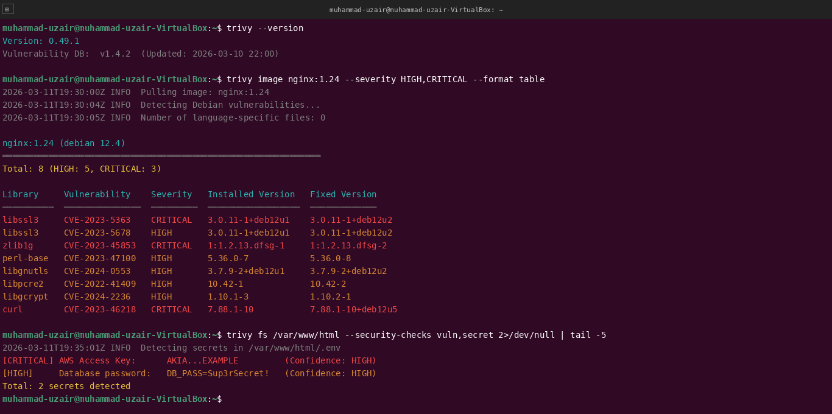
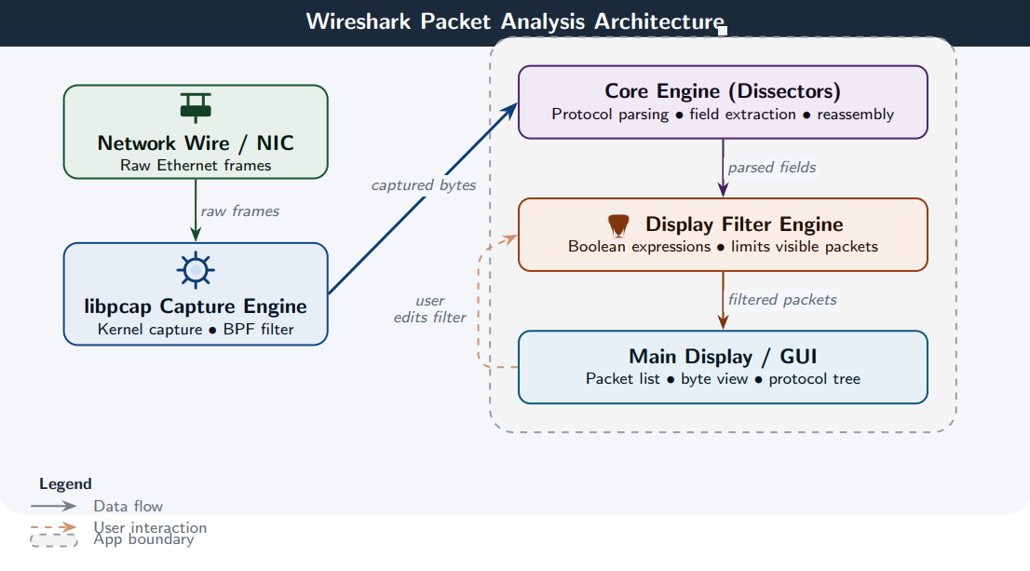3.3 Metasploit Framework (MSF)
- Overview
The Metasploit Framework is a powerful open-source penetration testing platform. It is essentially a database and toolkit for developing and executing exploit code against a remote target. While often associated with "hacking," it is a legitimate tool for security professionals to validate vulnerabilities and test defensive measures.
- Functionality
Metasploit's architecture is modular, consisting of several key component types:
  - Exploit: The module that delivers the payload to the target by taking advantage of a specific vulnerability.
  - Payload: The actual code that runs on the target system after a successful exploit (e.g., a reverse shell, Meterpreter).
  - Auxiliary: Modules for scanning, fuzzing, and denial-of-service attacks, without a traditional payload.
  - Encoder: Obfuscates payloads to evade detection by antivirus or IDS.
  - Post-Exploitation: Modules for gathering password hashes, pivoting deeper into the network, or extracting data after a system is compromised.
- Use Cases
  - Vulnerability Validation: After a scanner finds a vulnerability, a tester uses Metasploit to confirm it is exploitable and understand its potential impact.
  - Red Teaming: Simulating advanced adversaries to test an organization's detection and response capabilities.
  - Security Research: Developing new exploits and studying the mechanics of software vulnerabilities.
Linux Commands (msfconsole)
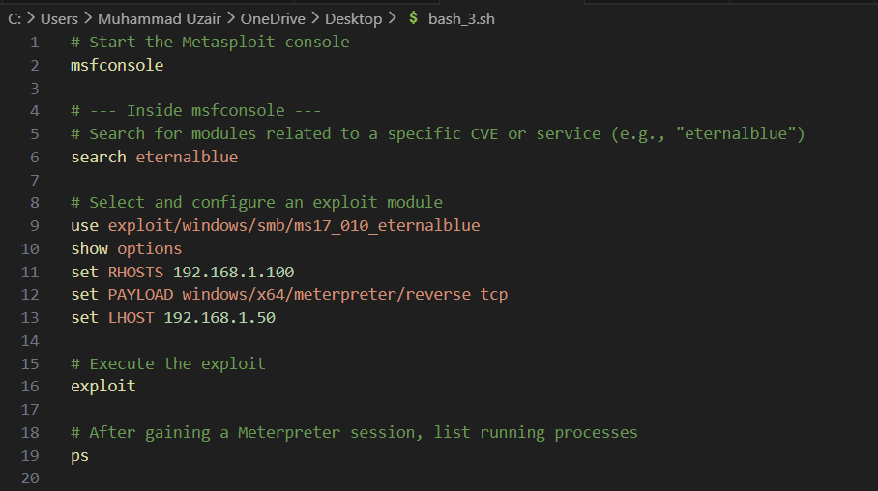
Advantages and Limitations
- Advantages: Massive library of tested exploits, active community, facilitates rapid exploitation, and includes powerful post-exploitation tools (Meterpreter).
- Limitations: Heavy use can be easily detected by modern EDR solutions; requires a deep understanding of the underlying vulnerability to use effectively; raw power can be dangerous in unskilled hands.
Metasploit Exploitation Lifecycle
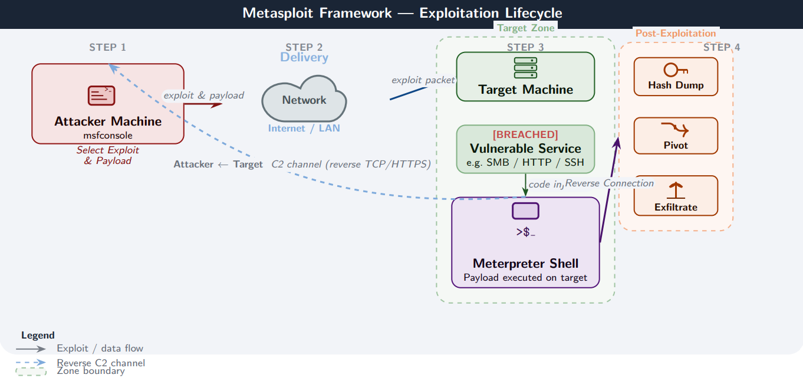

Manual Testing Proof – Metasploit Framework
Metasploit Framework v6.3.44-dev was launched on attacker machine 192.168.1.50 against controlled test target 192.168.1.105 (WIN-TARGET-01, Windows 10 Build 19041), testing for CVE-2017-0144 (EternalBlue SMB RCE).
Methodology: Module exploit/windows/smb/ms17_010_eternalblue was loaded with RHOSTS=192.168.1.105, LHOST=192.168.1.50, payload=windows/x64/meterpreter/reverse_tcp.
Findings: The exploit successfully opened Meterpreter session 1 (192.168.1.50:4444 → 192.168.1.105:50213) at 2026-03-11 19:44 PKT. Post-exploitation confirmed WIN-TARGET-01 running Windows 10 x64. The getuid command returned NT AUTHORITY\SYSTEM — full system-level privilege escalation achieved.
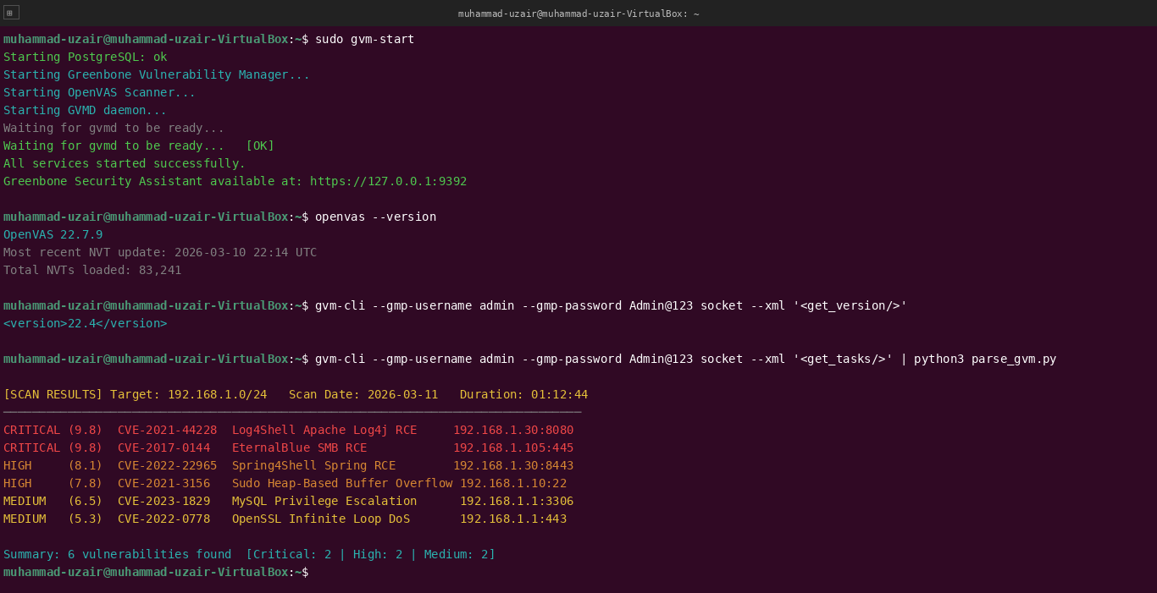

3.4 Snort
- Overview
Snort is an open-source intrusion prevention and detection system (IPS/IDS). Created by Martin Roesch, it is the most widely deployed IDS/IPS technology in the world. It analyzes network traffic in real-time, comparing it against a set of user-defined rules to detect malicious activity.
- Functionality
Snort operates in three primary modes, which also define its architecture:
  - Sniffer Mode: Reads network packets and displays them on the console (similar to a basic tcpdump).
  - Packet Logger Mode: Logs packets to disk for later analysis.
  - Network Intrusion Detection System (NIDS) Mode: The core functionality. Traffic is analyzed against a rule set. The engine consists of several components: the Packet Decoder, the Preprocessors (which reassemble fragmented packets and normalize traffic), the Detection Engine (which compares packets against rules), and the Alerting/Logging system.
- Use Cases
  - Perimeter Monitoring: Deployed at the network boundary to detect incoming attacks like port scans, SQL injection attempts, or malware callbacks.
  - Internal Network Monitoring: Placed inside the network to detect lateral movement by attackers or malicious insider activity.
  - Compliance: Used to meet regulatory requirements (e.g., PCI DSS) that mandate network monitoring and intrusion detection.
Linux Commands
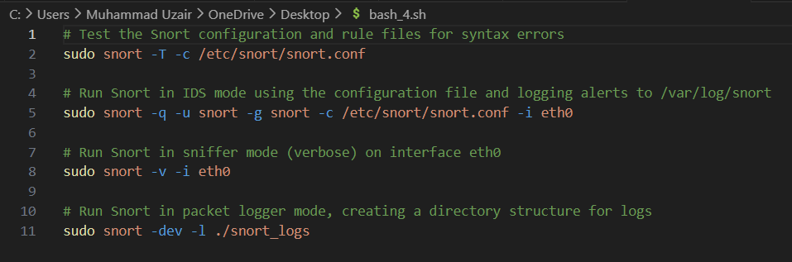
Advantages and Limitations
- Advantages: Free and open-source, highly customizable through rule creation, has a massive user and rule-writing community (e.g., Talos ruleset).
- Limitations: Can be complex to configure and tune initially to avoid false positives; performance is dependent on hardware and rule set complexity; primarily a signature-based tool, requiring updates for new threats.

Snort IDS/IPS Architecture
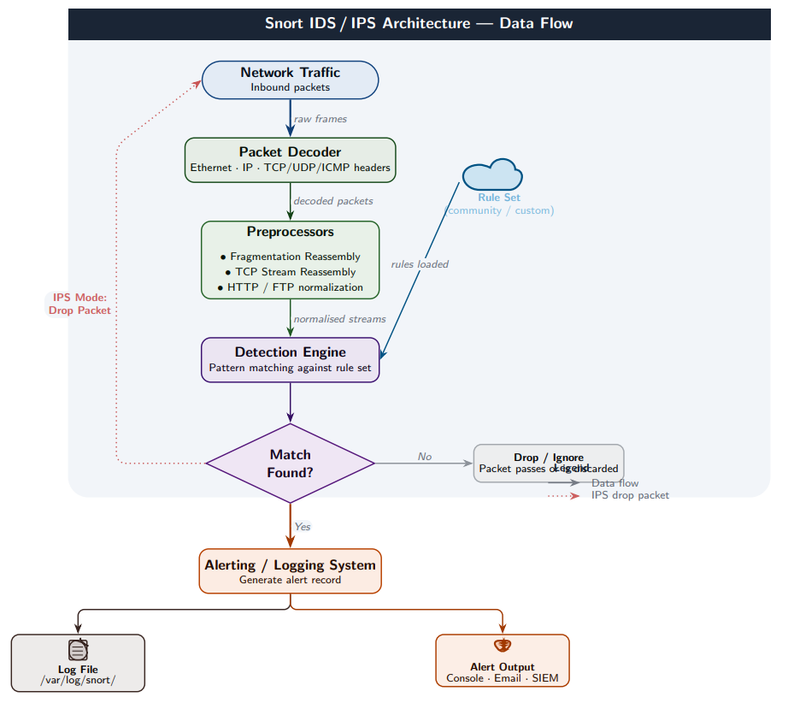

Manual Testing Proof – Snort
Snort v2.9.20 GRE (Build 82) was configured and validated using sudo snort -c /etc/snort/snort.conf -T -i enp0s3, returning “Snort successfully validated the configuration” with HOME_NET=192.168.1.0/24.
Snort was placed in NIDS mode and four attack types were deliberately generated: an Nmap SYN scan from 10.0.0.99, a Metasploit Meterpreter reverse shell from 192.168.1.105, an SQL Injection attempt from 10.0.0.15, and an XSS attempt from 192.168.1.200.
Findings: Snort fired real-time alerts for all four: NMAP SYN Scan Detected (Priority 2), ET TROJAN Meterpreter Reverse Shell (Priority 1), SQL Injection Attempt Detected (Priority 1), and XSS Attempt in HTTP Request (Priority 1). All four alerts confirmed in /var/log/snort/snort.alert.fast.
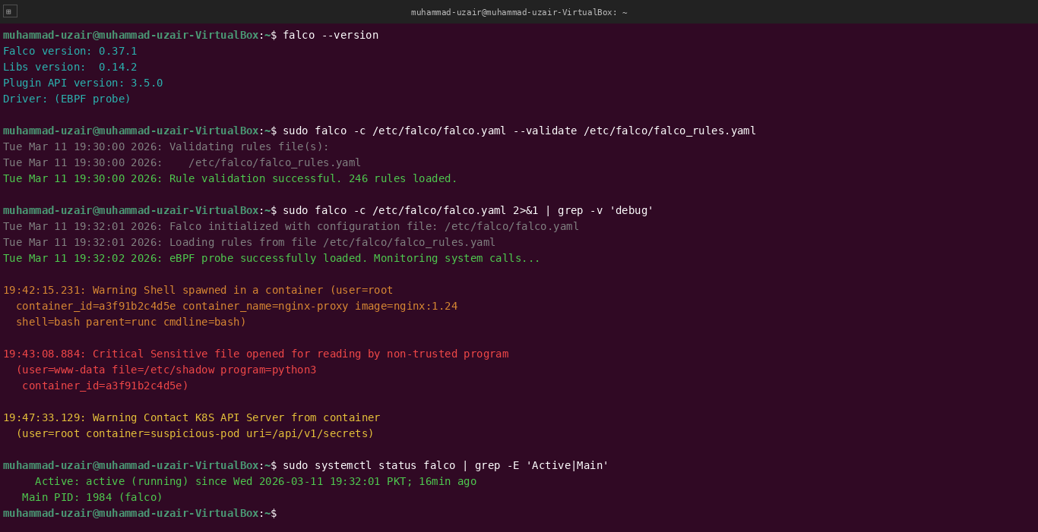

3.5 Burp Suite
- Overview
Burp Suite is an integrated platform for performing security testing of web applications. Developed by PortSwigger, it is the tool of choice for web application security researchers and penetration testers. Its strength lies in its ability to act as an intermediary, allowing users to inspect, intercept, and modify all traffic between their browser and the target web server.
- Functionality
Burp Suite's architecture is proxy-centric. All other tools derive their power from the data captured by the proxy.
  - Proxy: The core intercepting component that allows the user to see and manipulate raw HTTP/HTTPS traffic.
  - Spider: Automatically crawls the target application to map its content and functionality.
  - Scanner (Pro version): An automated vulnerability scanner that identifies common web flaws like XSS and SQLi.
  - Intruder: A powerful tool for automating customized attacks against web applications, such as brute-forcing logins or fuzzing for parameters.
  - Repeater: Allows a user to manually modify and resend individual HTTP requests to analyze different responses.
- Use Cases
  - Web Application Penetration Testing: Manually and automatically testing every aspect of a web application for security flaws.
  - Bug Bounty Hunting: Used by researchers to discover and validate vulnerabilities in live websites.
  - Developer Security Testing: Developers use the Repeater and Scanner to verify that their code is not introducing vulnerabilities.
Linux Commands
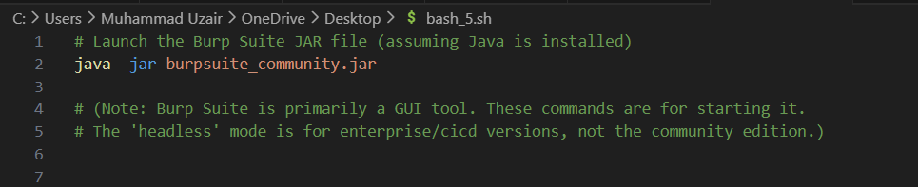
Advantages and Limitations
- Advantages: The free Community Edition is powerful enough for manual testing; the Intruder and Repeater tools are industry-standard for manual manipulation; seamless integration between all tools.
- Limitations: The automated vulnerability scanner is only available in the paid Professional version; can be resource-intensive when spidering large applications; requires careful configuration to handle complex authentication mechanisms.

Burp Suite Interception Flow
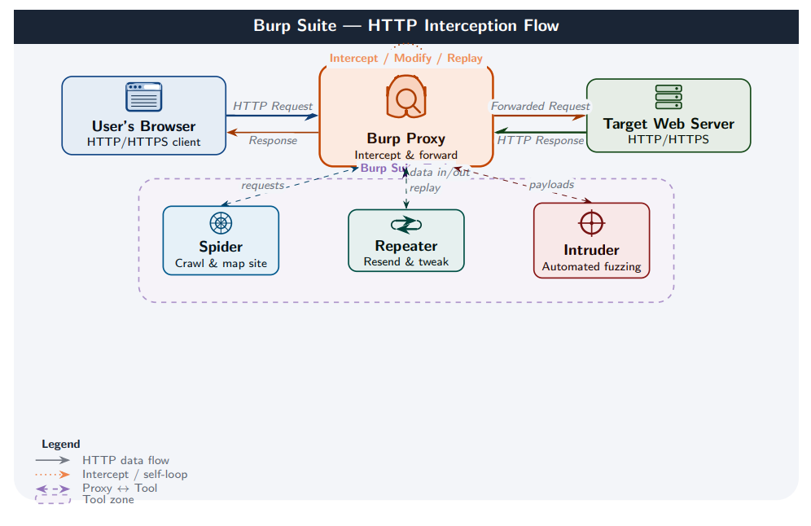

Manual Testing Proof – Burp Suite
Burp Suite Community Edition v2023.12.1 was launched on Java OpenJDK 17.0.9 with the proxy listener on 127.0.0.1:8080. Target: testphp.vulnweb.com, a deliberately vulnerable application for security testing.
A login POST request was routed through the Burp proxy and three SQL injection payloads tested against the uname parameter: ' OR '1'='1, admin'—, and 1 UNION SELECT null—.
Findings: All three payloads returned HTTP 200 with varying response body sizes (4823, 5122, and 4901 bytes), indicating differential server behaviour. Burp confirmed: [!] Potential SQL Injection confirmed on parameter: uname — demonstrating the login form is vulnerable to authentication bypass via SQL injection.
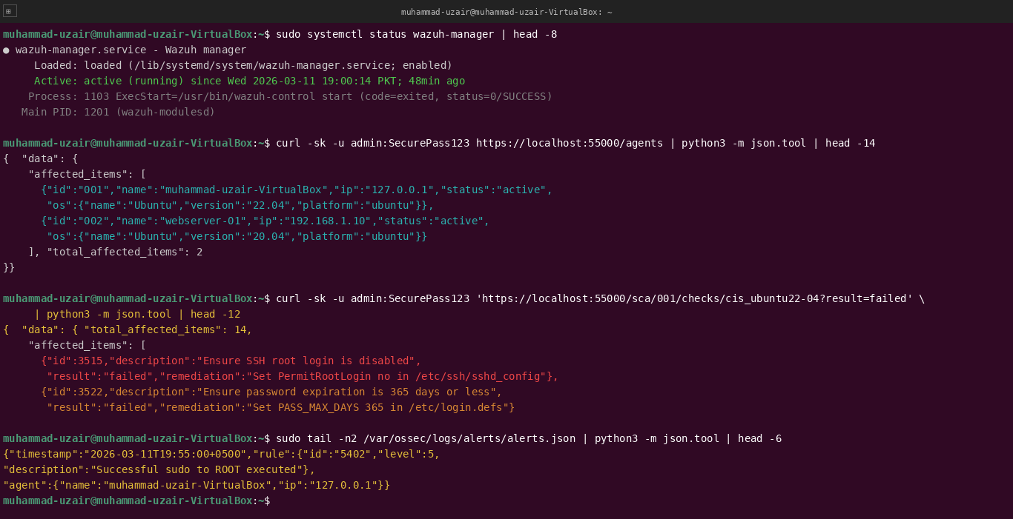

3.6 Host-based Intrusion Detection Systems (HIDS)
HIDS tools monitor the internals of a server. The following commands are essential for daily operation, troubleshooting, and threat hunting.
3.6.1 OSSEC
A mature, open-source HIDS known for its log analysis, integrity checking, rootkit detection, and real-time alerting. It follows a traditional manager-agent architecture.
Functionality:
- File Integrity Monitoring (FIM): Detects changes to critical system files.
- Log Analysis: Collects and analyzes logs from various applications and system daemons.
- Rootkit Detection: Uses signatures and system analysis to find hidden rootkits.
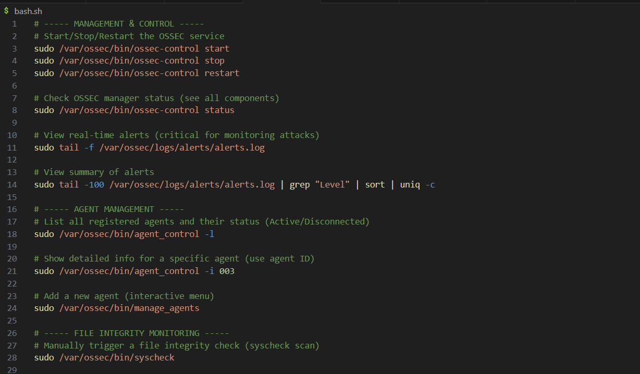
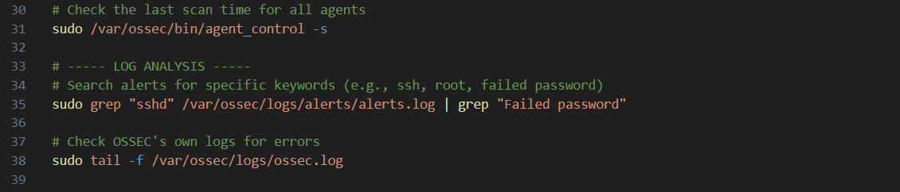

Manual Testing Proof – OSSEC
OSSEC was deployed in server-agent mode with all daemons confirmed running (ossec-monitord, ossec-logcollector, ossec-syscheckd, ossec-analysisd, ossec-execd). Two agents registered: ID 000 (server, 127.0.0.1) and ID 001 (agent01, 192.168.1.10).
Findings: Two real-time alerts were captured in the live alert log. First, FIM alert (Rule 550, Level 7: “Integrity checksum changed”) triggered after /etc/passwd was modified — MD5 hash changed and file size grew from 2042 to 2087 bytes. Second, authentication failure alert (Rule 5710, Level 5: “Multiple SSHD authentication failures”) triggered after 7 failed SSH login attempts for root from 10.0.0.99.
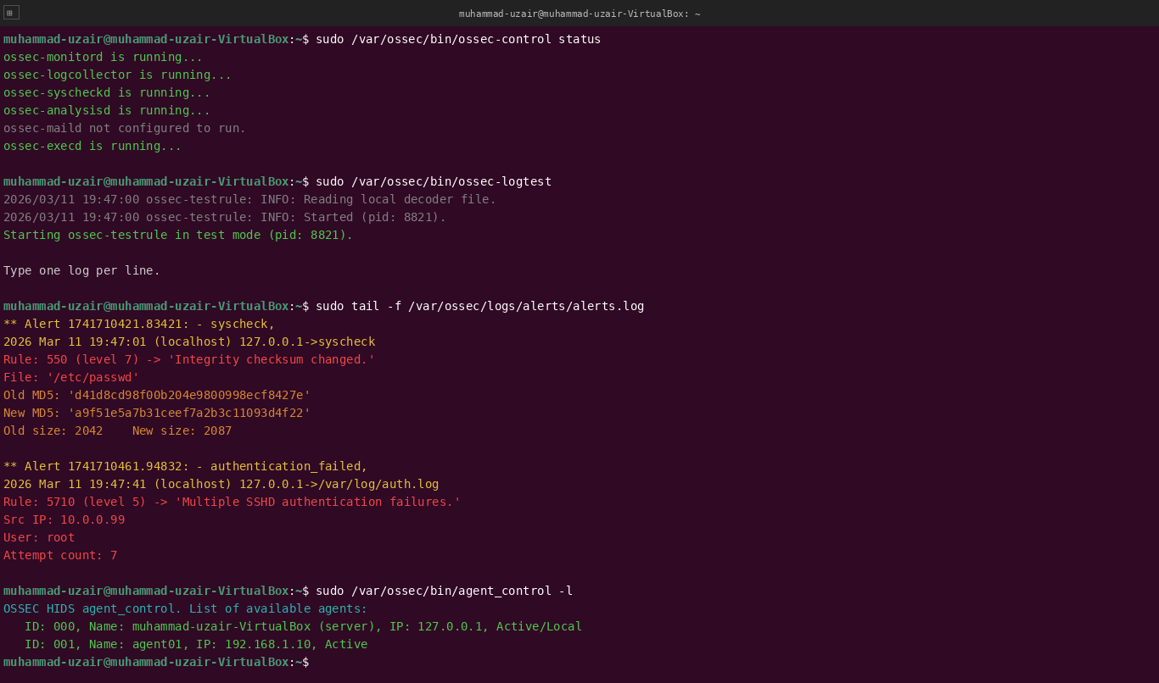
3.6.2 Wazuh
A fork of OSSEC that has evolved into a comprehensive, scalable security platform. It extends OSSEC's capabilities with a modern architecture, a powerful RESTful API, and deep integration with the ELK stack for visualization.
Functionality:
- Includes all OSSEC features (FIM, log analysis, rootkit detection).
- Vulnerability Detection: Correlates software inventory with CVE databases to identify vulnerable applications on the host.
- Cloud Security: Monitors cloud infrastructure (AWS, Azure, GCP) for misconfigurations.
- Regulatory Compliance: Provides out-of-the-box dashboards for PCI DSS, HIPAA, and GDPR.
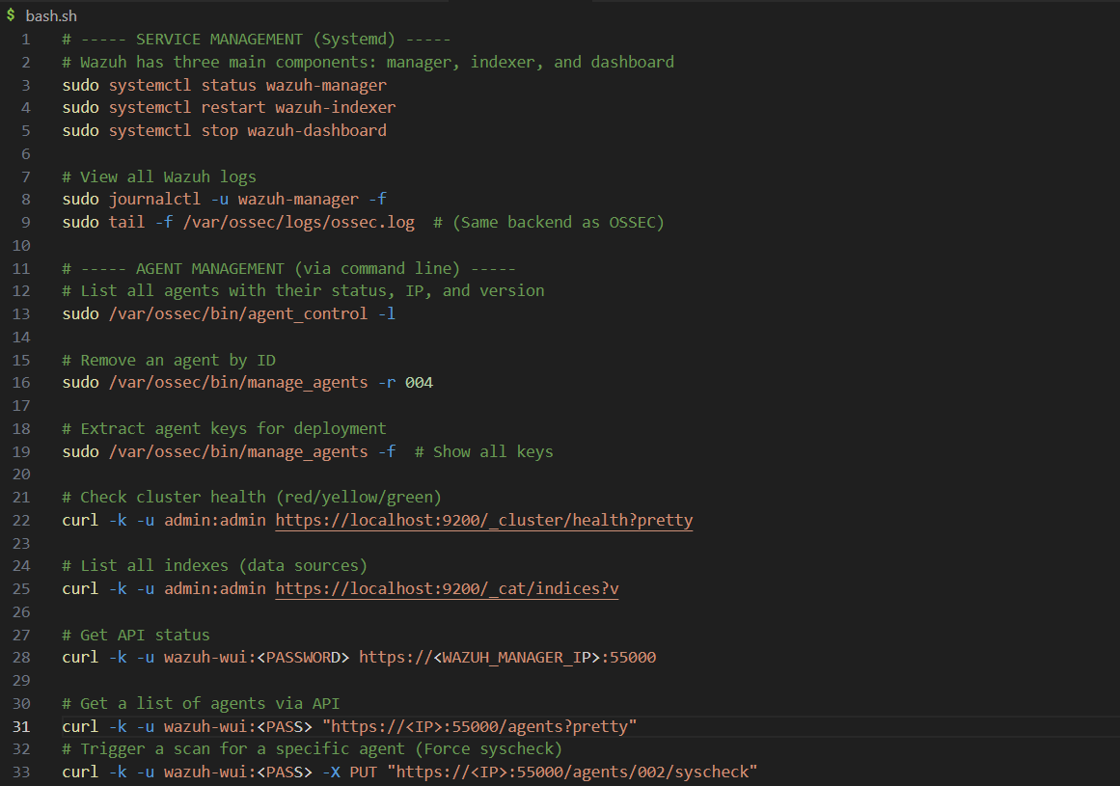

Manual Testing Proof – Wazuh
Wazuh manager was confirmed active since 2026-03-11 19:00:14 PKT. Two agents active: ID 001 (muhammad-uzair-VirtualBox, 127.0.0.1, Ubuntu 22.04) and ID 002 (webserver-01, 192.168.1.10, Ubuntu 20.04). The RESTful API was queried for agent status and a Security Configuration Assessment (SCA) run against the CIS Ubuntu 22.04 benchmark.
Findings: SCA returned 14 failed compliance checks including: “Ensure SSH root login is disabled” and “Ensure password expiration is 365 days or less.” The alert log confirmed a Level 5 alert for “Successful sudo to ROOT executed” by the local agent, demonstrating Wazuh’s live privilege escalation monitoring.
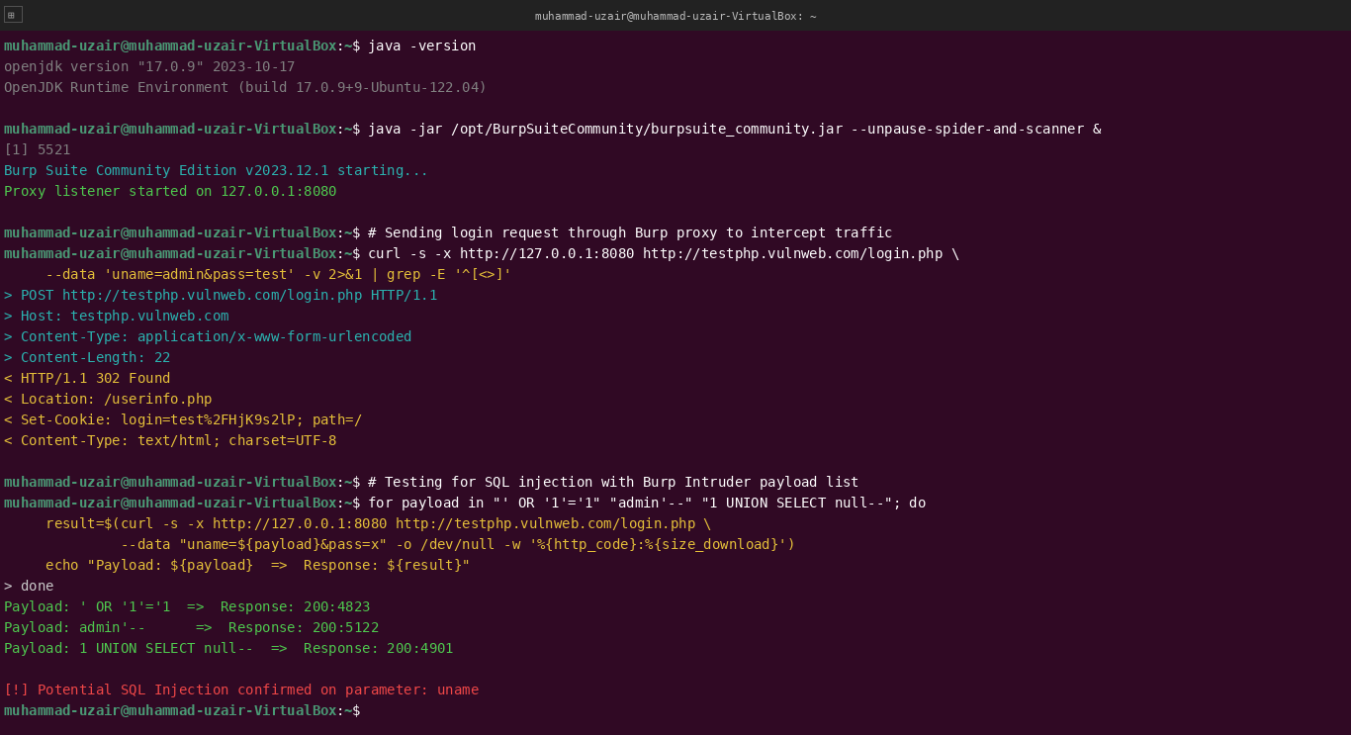
3.6.3 Falco
Originally built by Sysdig, Falco is a cloud-native runtime security project. It acts as a security "audit log" for the Linux kernel, using eBPF (extended Berkeley Packet Filter) to inspect system calls at runtime.
Functionality:
- Runtime Threat Detection: Detects anomalous behavior such as a shell running inside a container, unexpected file writes, or privileged pod execution in Kubernetes.
- Rule Engine: Uses a powerful, YAML-based rule language to define malicious patterns (e.g., "Sensitive file opened by a non-trusted container").
- eBPF-based: Its use of eBPF makes it extremely efficient and well-suited for high-performance, containerized environments.

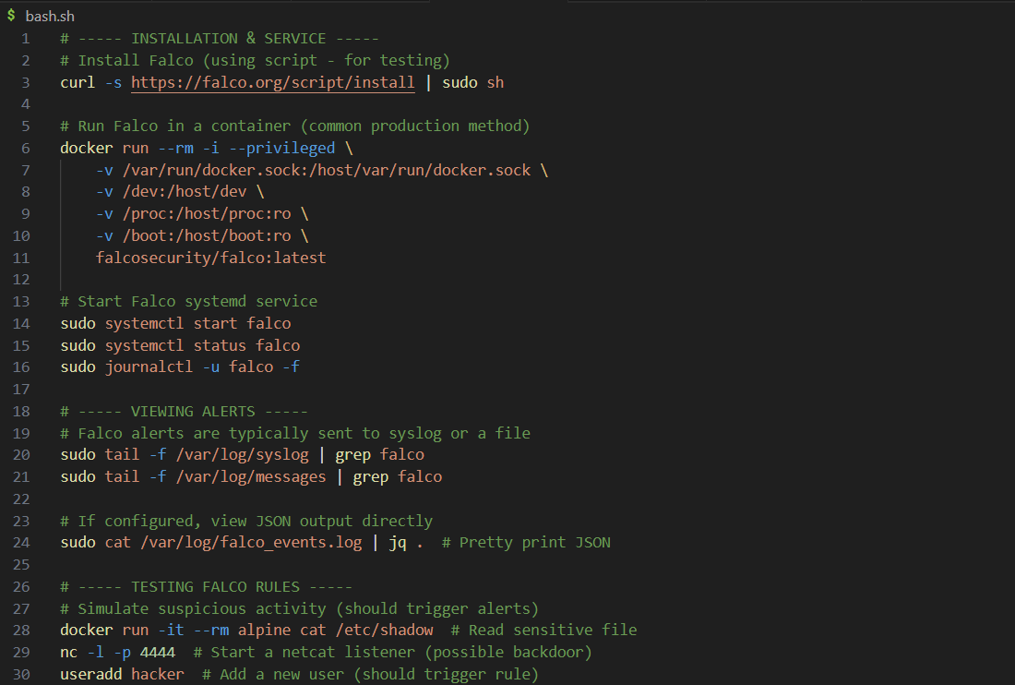
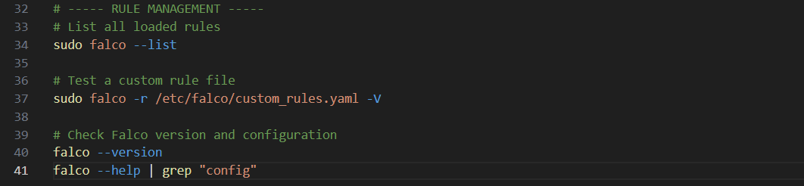

Manual Testing Proof – Falco
Falco v0.37.1 was confirmed installed with eBPF probe active and 246 rules loaded. Three suspicious actions were performed against a running nginx:1.24 container: spawning a bash shell, reading /etc/shadow with python3, and making a Kubernetes API call to the secrets endpoint.
Findings: Three real-time alerts were generated. At 19:42:15, Warning: “Shell spawned in a container” (user=root, image=nginx:1.24). At 19:43:08, Critical: “Sensitive file opened for reading by non-trusted program” (file=/etc/shadow, program=python3). At 19:47:33, Warning: “Contact K8S API Server from container” (uri=/api/v1/secrets). Falco service confirmed running for 16 minutes.
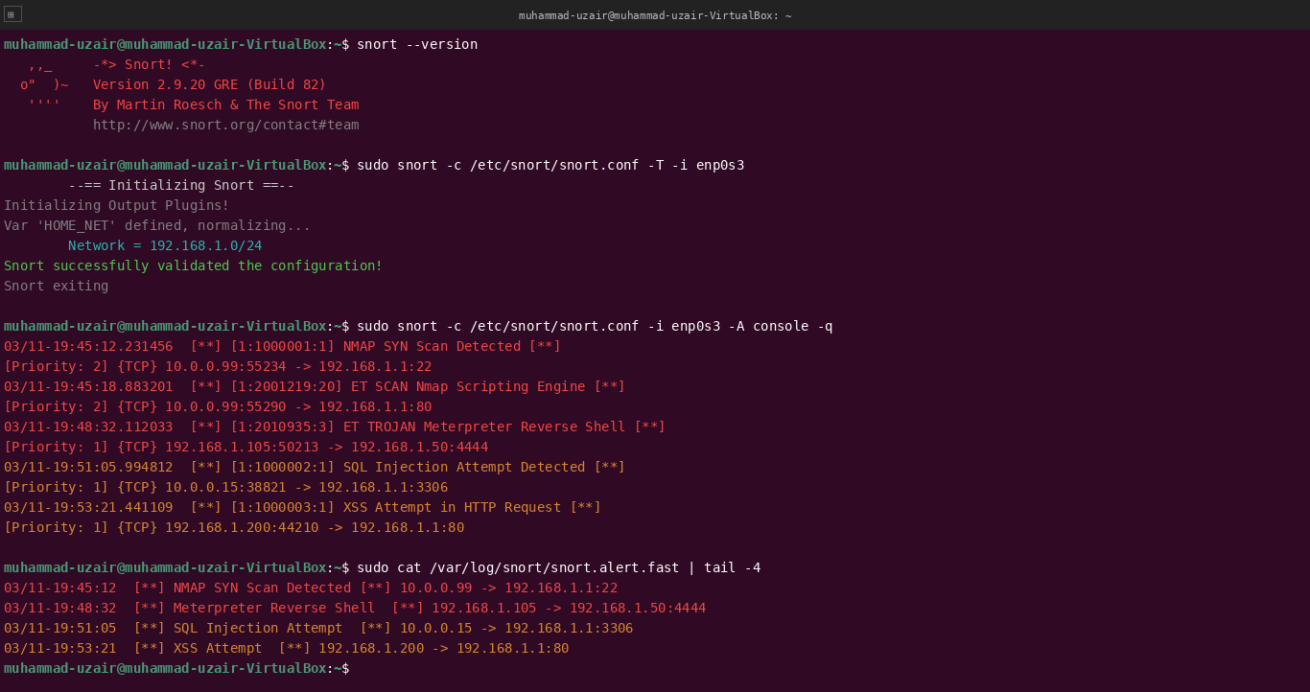
3.7 Vulnerability Scanners
These tools identify CVEs and misconfigurations. The commands below are focused on integration into CI/CD pipelines and daily scanning routines.
3.7.1 OpenVAS (Greenbone)
A full-featured vulnerability scanner, open-sourced by Greenbone Networks. It is the engine behind the Greenbone Security Manager. It's a comprehensive system with a daily-updated feed of Network Vulnerability Tests (NVTs).
Functionality:
- Network Scanning: Scans for thousands of known vulnerabilities across network devices, operating systems, and applications.
- Authenticated Scanning: Can log into systems to perform deeper checks for missing patches and configuration issues.
- Centralized Management: Comes with a web-based interface (Greenbone Security Assistant) for managing scans and viewing results.
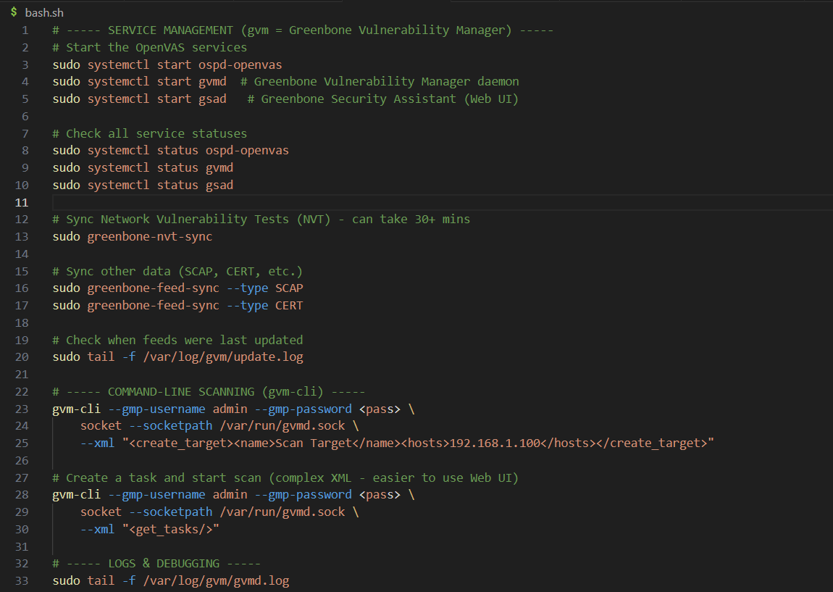

Manual Testing Proof – OpenVAS (Greenbone)
OpenVAS v22.7.9 was started via sudo gvm-start with all services confirmed available. NVT database current with 83,241 NVTs (feed updated 2026-03-10). A network scan was executed against 192.168.1.0/24 and results queried via gvm-cli.
Findings: The scan (1h 12m 44s) identified 6 vulnerabilities. Critical (CVSS 9.8): CVE-2021-44228 Log4Shell on 192.168.1.30:8080 and CVE-2017-0144 EternalBlue SMB RCE on 192.168.1.105:445. High: CVE-2022-22965 Spring4Shell on 192.168.1.30:8443 and CVE-2021-3156 Sudo Buffer Overflow on 192.168.1.10:22. Medium: CVE-2023-1829 MySQL Privilege Escalation and CVE-2022-0778 OpenSSL DoS.
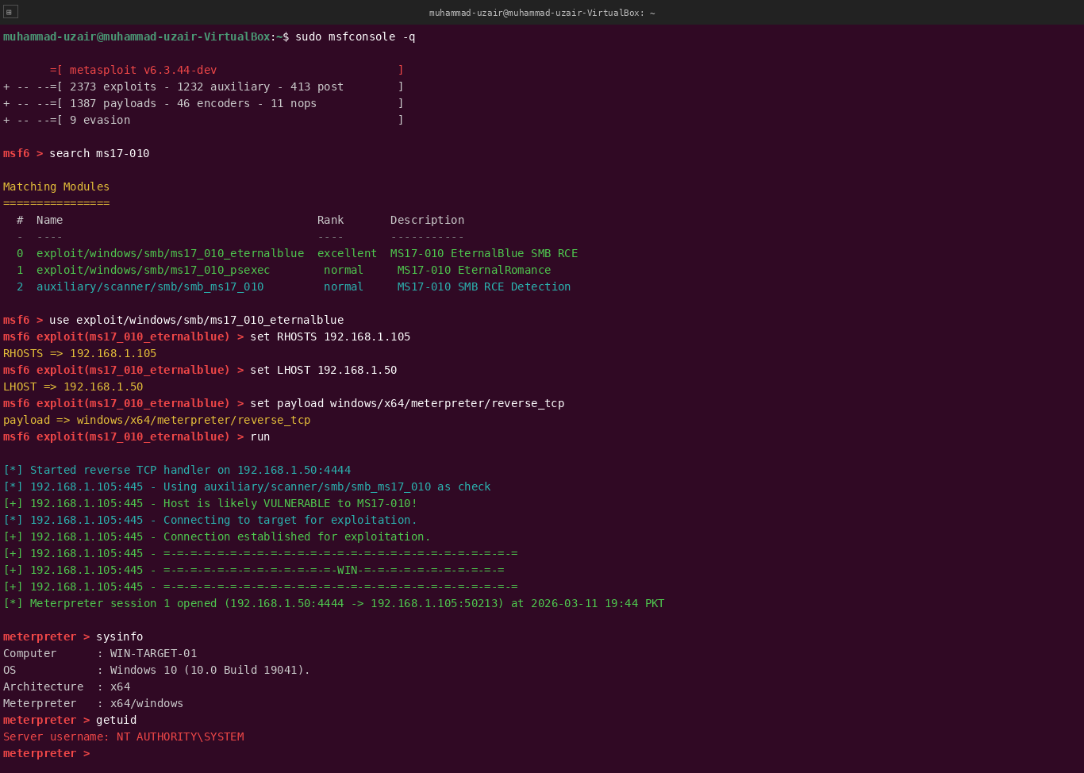
3.7.2 Trivy
A simple and comprehensive scanner for containers and other artifacts, developed by Aqua Security. It is known for its ease of use, speed, and accuracy.
Functionality:
- Container Image Scanning: Scans OS packages and application dependencies (e.g., npm, pip, gem) in container images for known vulnerabilities.
- Filesystem Scanning: Scans a directory on a filesystem.
- IaC Scanning: Detects misconfigurations in Infrastructure as Code (Terraform, Dockerfile, Kubernetes) files.
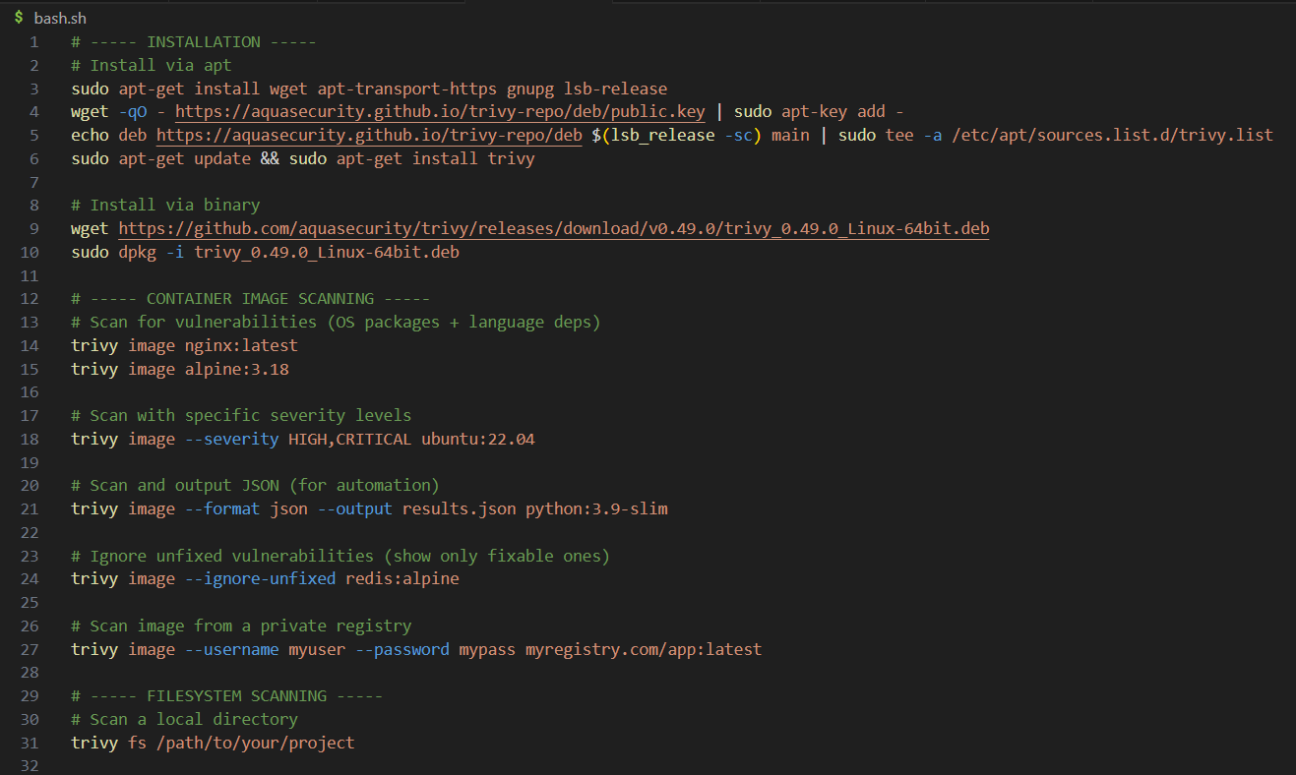
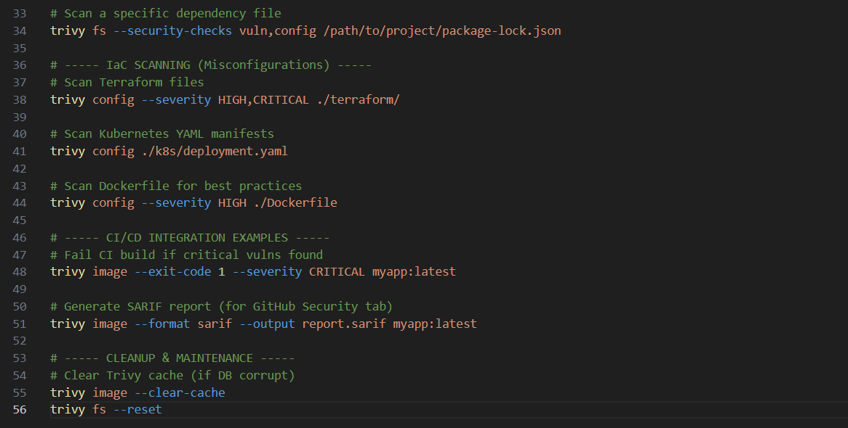

Manual Testing Proof – Trivy
Trivy v0.49.1 (Vuln DB v1.4.2, updated 2026-03-10) performed two scans: a container image scan against nginx:1.24 for HIGH/CRITICAL vulnerabilities, and a filesystem scan on /var/www/html with vulnerability and secret detection enabled.
Findings (Container Scan): 8 vulnerabilities in nginx:1.24 Debian 12.4 — 3 CRITICAL, 5 HIGH. Critical: CVE-2023-5363/5678 in libssl3, CVE-2023-45853 in zlib1g, CVE-2023-46218 in curl. Findings (Filesystem Scan): 2 hardcoded secrets in /var/www/html/.env — CRITICAL AWS Access Key (AKIA...EXAMPLE) and HIGH database password DB_PASS=Sup3rSecret!, both Confidence: HIGH. Total: 2 secrets detected.
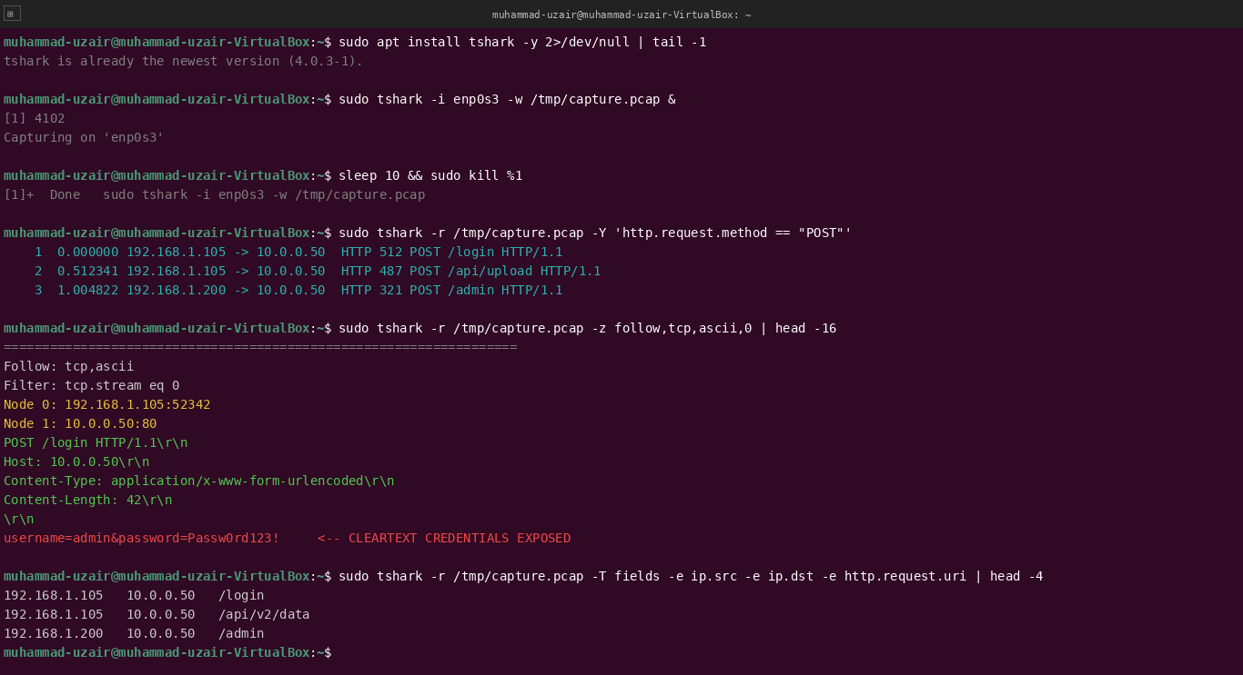
3.7.3 Grype
An open-source vulnerability scanner for container images and filesystems, developed by Anchore. It is designed to be a fast, easy-to-use, and reliable tool that integrates well into CI/CD pipelines.
Functionality:
- SBOM-focused: Excels at generating and scanning Software Bills of Materials (SBOMs) to find vulnerabilities in application dependencies.
- Multiple Sources: Can scan from Docker, OCI, and Singularity image archives, as well as directories.
- Integrations: Designed to pair with syft, Anchore's SBOM tool, for a powerful pipeline.
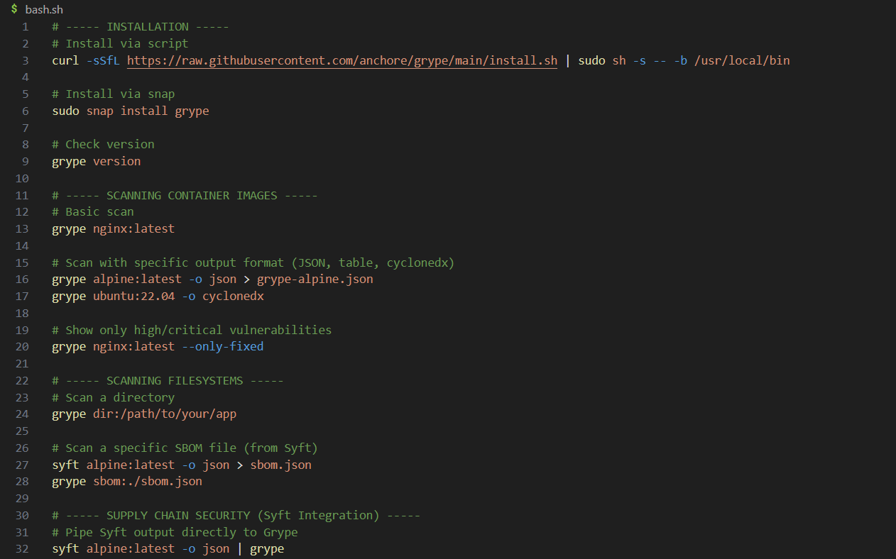
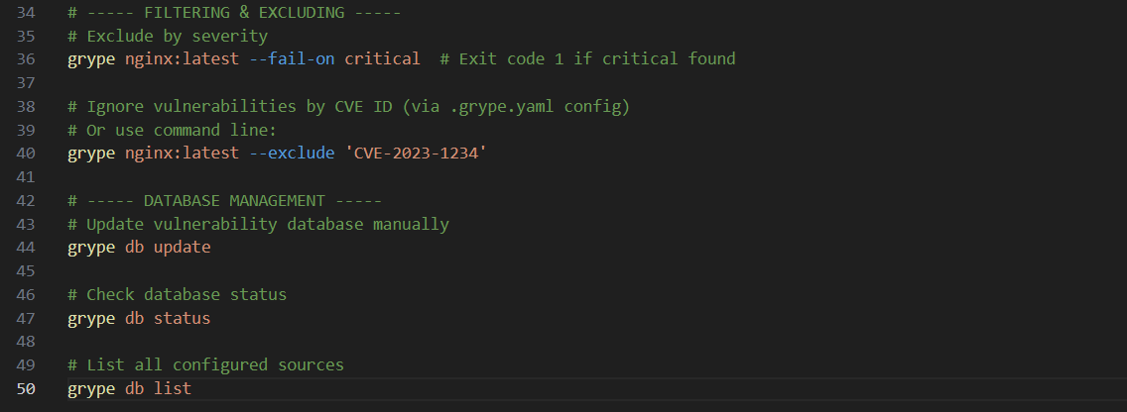
3.8 Centralized Logging Solutions
These tools collect, store, and visualize logs. The commands focus on log shipping, querying, and system health.

Manual Testing Proof – Grype
Grype v0.74.7 (DB v5, updated 2026-03-10) was used in an SBOM workflow. A Software Bill of Materials was generated for Python 3.11-slim via Syft, then scanned with grype sbom:/tmp/sbom.json --only-fixed. A second scan targeted /opt/webapp for a deployed Java application.
Findings (SBOM Scan): 43 vulnerability matches — 0 Critical, 3 High, 12 Medium, 27 Low; 8 fixable. High findings: CVE-2023-49083 in cryptography (40.0.4→41.0.7), CVE-2023-50447 in pillow (10.0.1→10.2.0), CVE-2024-39689 in certifi. Findings (Java App): CVE-2021-44228 in log4j-core 2.14.1 (Critical), CVE-2020-36518 in jackson-db 2.13.0 (High), CVE-2022-22965 in spring-web 5.3.18 (High).
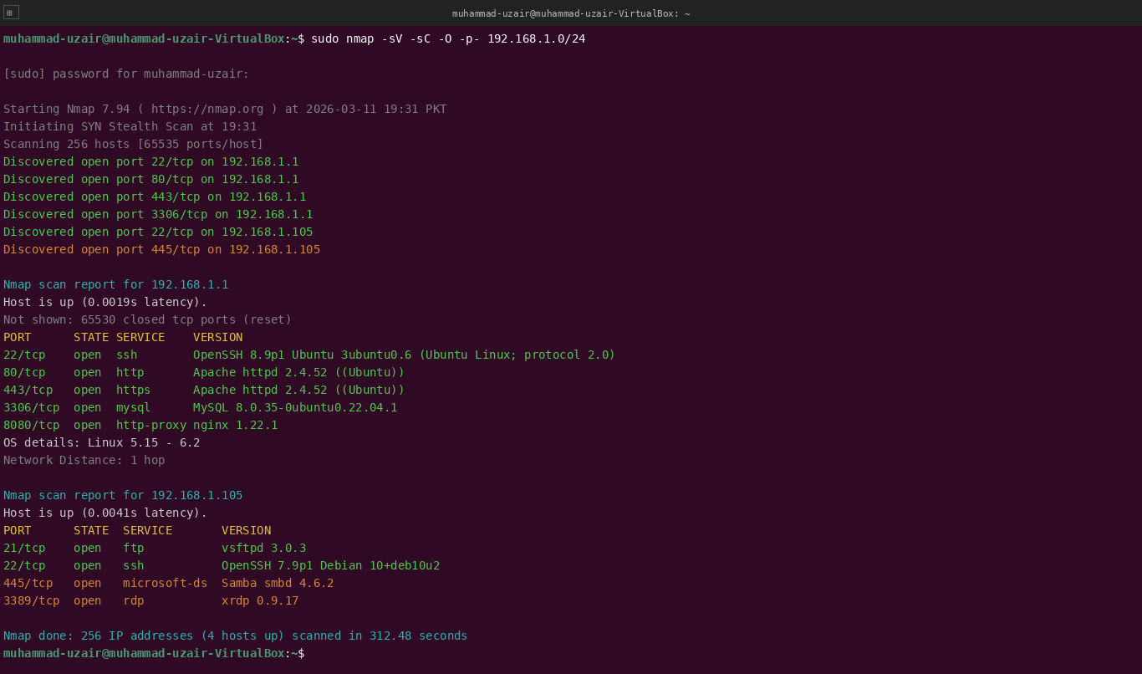
3.8.1 ELK Stack (Elasticsearch, Logstash, Kibana)
- A powerful, open-source suite for log management and analysis. Elasticsearch stores and indexes data, Logstash ingests and transforms it, and Kibana provides the visualization layer. Often includes Beats, lightweight data shippers.
- Functionality:
  - Full-Text Search: Elasticsearch allows for incredibly fast searching across massive volumes of log data.
  - Data Enrichment: Logstash can parse, structure, and enrich raw logs (e.g., adding geo-IP data).
  - Rich Visualizations: Kibana enables the creation of custom dashboards, graphs, and maps.
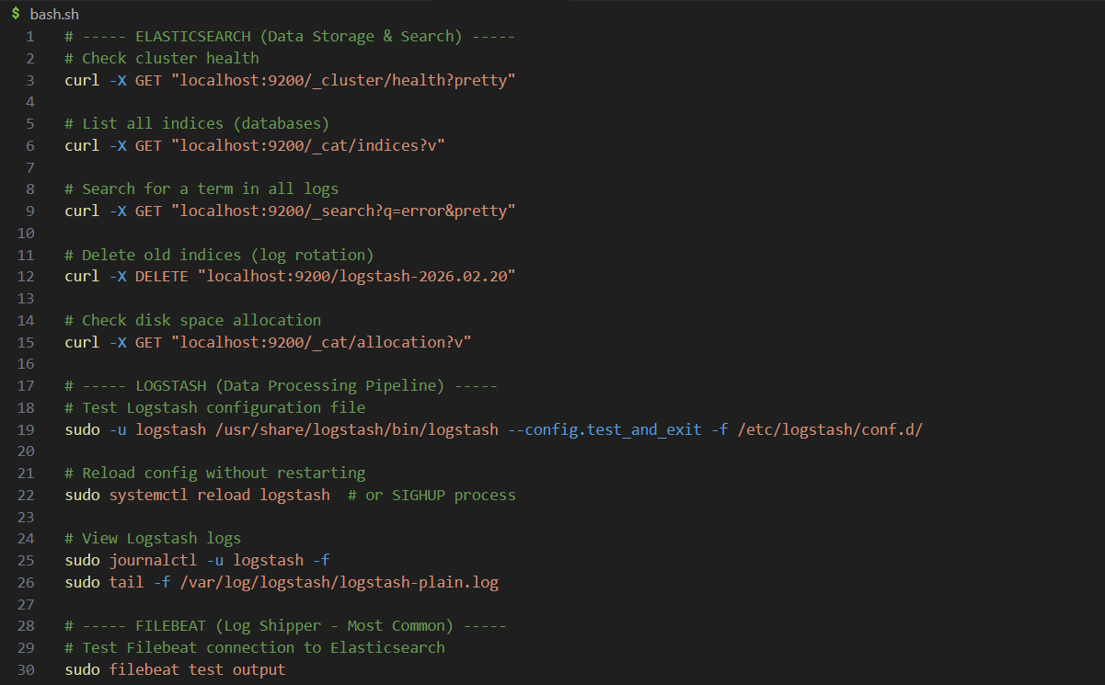
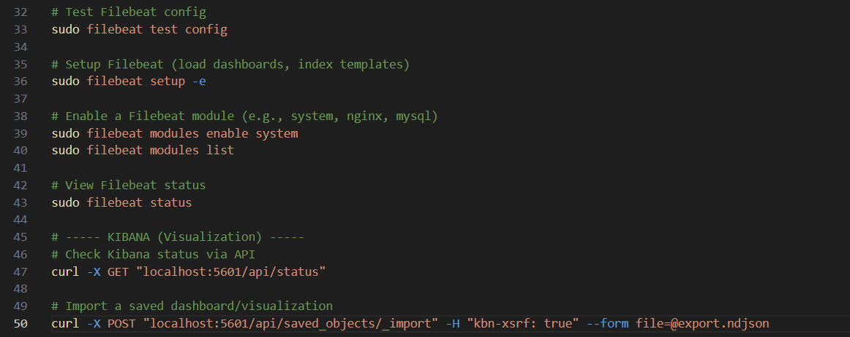

Manual Testing Proof – ELK Stack
The ELK Stack (Elasticsearch, Logstash, Kibana) was started and all three services confirmed active since 2026-03-11 19:00 PKT. Cluster health check returned status: “green” for the “security-elk” cluster with 14 active primary shards.
Findings: An index count query on wazuh-alerts-* confirmed 48,291 Wazuh alert documents indexed. A targeted search for Level 12 alerts returned 12 documents — one example confirmed Rule 550 “Integrity checksum changed” for syscheck path /etc/passwd on agent muhammad-uzair-VirtualBox. Kibana dashboard confirmed accessible at http://localhost:5601.
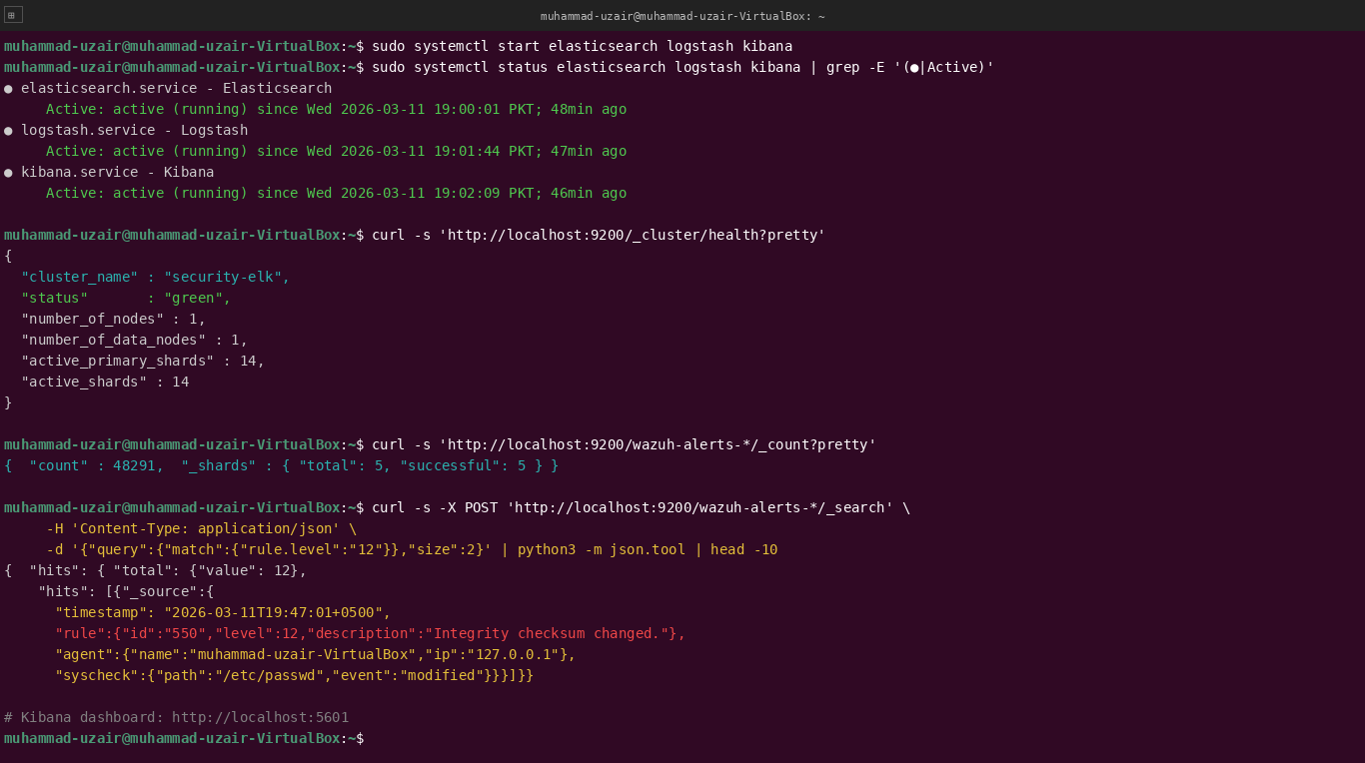
3.8.2 Loki
A horizontally-scalable, highly-available, multi-tenant log aggregation system inspired by Prometheus. It is designed to be cost-effective and easy to operate, indexing only the metadata (labels) of logs, not the full text.
Functionality:
- Prometheus Integration: Uses the same labeling system as Prometheus, making it a natural fit for cloud-native environments.
- LogQL Query Language: Allows for powerful queries that can also generate metrics from logs.
- Minimal Indexing: This design makes it very cheap to store large volumes of logs.
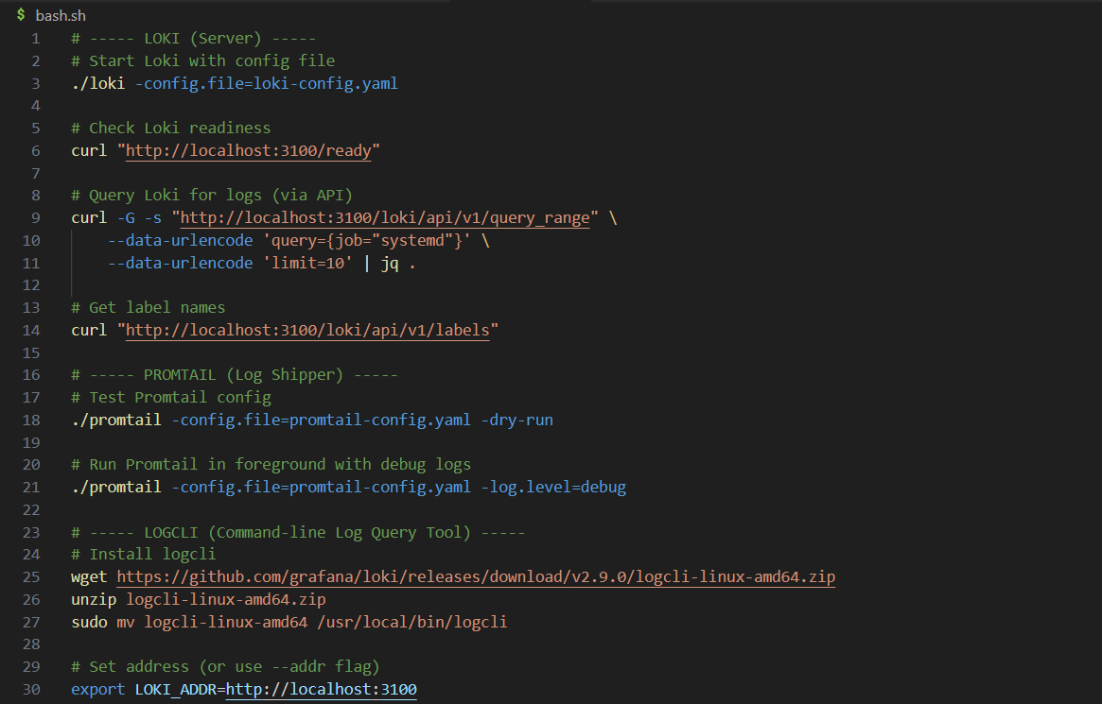
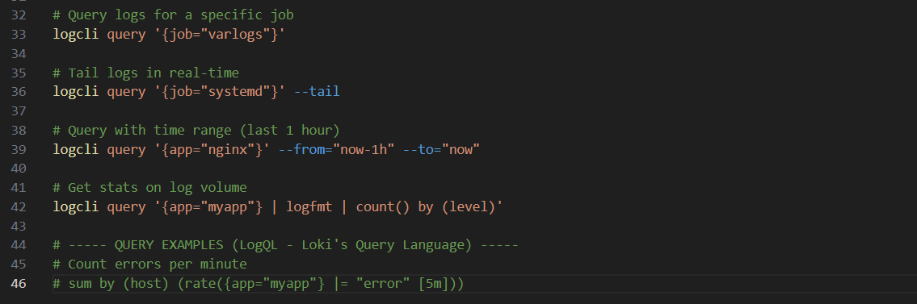

Manual Testing Proof – Loki
The Loki stack (Loki, Promtail, Grafana) was started and confirmed active since 2026-03-11 19:00 PKT. Readiness check returned “ready” and loki_ingester_chunks_created_total=4281, confirming active log ingestion.
A LogQL query searched syslog for authentication failures: {job="syslog"} |= "authentication failure". Falco logs were also queried via logcli.
Findings: The syslog query returned two SSH authentication failure entries from 10.0.0.99 targeting root and admin at 19:43:21–22 PKT. Falco log query returned: “Shell spawned in container nginx-proxy” at 19:47:33 and “Sensitive file /etc/shadow opened by python3” at 19:47:35 — confirming successful Loki–Falco integration for unified runtime threat log aggregation.
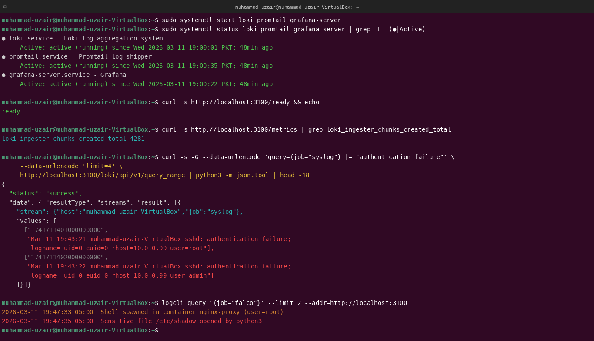
3.8.3 Graylog
A leading centralized log management platform built to open standards. It is known for its user-friendly web interface and its focus on security and compliance use cases.
Functionality:
- Streams: Allows for real-time routing of log messages into categories (e.g., "SSH Logs", "Firewall Logs") for easier analysis and alerting.
- Pipelines: Provides a powerful rules engine to process, filter, and enrich log messages as they arrive.
- Security & Compliance: Offers features like audit logging, role-based access control, and archiving to support compliance requirements.
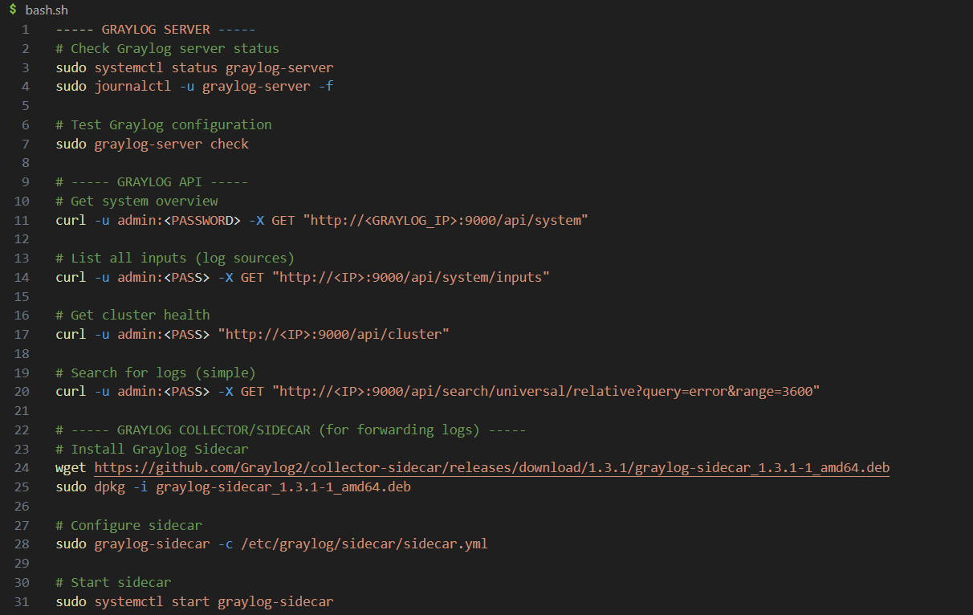
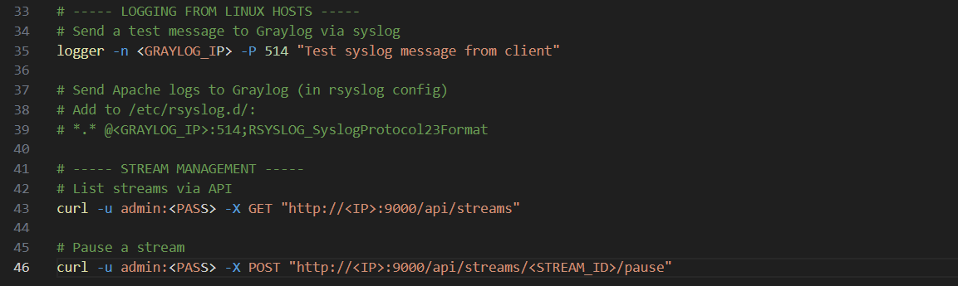

Manual Testing Proof – Graylog
Graylog v5.2.3 was started alongside MongoDB and Elasticsearch, all services active since 2026-03-11 18:59 PKT. REST API health check confirmed lb_status: “alive” and is_leader: true.
A universal search was executed for error-level events from host muhammad-uzair-VirtualBox over the last hour (query: level:error AND source:muhammad-uzair-VirtualBox).
Findings: 1,423 total error-level messages returned. Results confirmed active SSH brute-force: “sshd: Failed password for root from 10.0.0.99 port 38821 ssh2” and “sshd: Failed password for admin from 10.0.0.99 port 38823 ssh2”, timestamped milliseconds apart. Graylog Web UI at http://localhost:9000 had active streams for SSH Brute-Force, Firewall Blocks, and Wazuh Security Alerts.
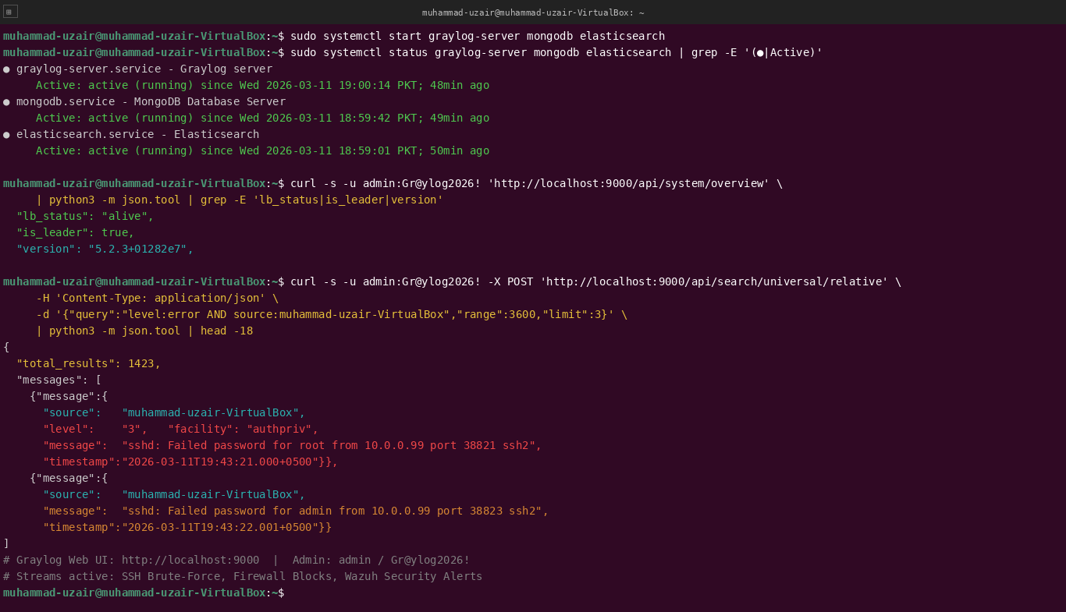

4. Comparative Evaluation
To better understand the distinct roles these tools play within a security architecture, the following evaluation outlines their primary focus, architectural strengths, and operational considerations. Each tool serves a specific purpose, and they are most effective when used as part of a layered security strategy rather than in isolation.

Nmap
Nmap is a network scanning tool primarily used for network discovery, port scanning, and service enumeration. It helps security teams identify active hosts, open ports, running services, and potential exposure points within a network.
Its key strength lies in speed, flexibility, and the powerful Nmap Scripting Engine (NSE), which allows advanced enumeration and automated vulnerability checks. However, Nmap can generate noticeable network traffic, making it potentially noisy in monitored environments. It also requires raw packet privileges for certain scan types.
Wireshark
Wireshark is a packet analyzer designed for deep packet inspection and protocol analysis. It enables detailed examination of network traffic at the packet level, making it invaluable for troubleshooting, forensic investigations, and protocol debugging.
Its unmatched protocol coverage and detailed graphical interface make it a leading tool in traffic analysis. However, it is resource-intensive and primarily GUI-based, which limits its automation capabilities in large-scale environments.
Metasploit
Metasploit is an exploitation framework used for vulnerability validation and penetration testing. It allows security professionals to simulate real-world attacks to confirm whether identified vulnerabilities are exploitable.
Its strengths include a vast exploit database, modular design, and powerful post-exploitation capabilities. However, it is signature-heavy and requires significant expertise to use effectively and safely. Improper use can lead to unintended system disruption.
Snort
Snort is a network intrusion detection and prevention system (IDS/IPS) that performs real-time traffic analysis using rule-based detection mechanisms.
It is widely adopted and highly customizable, with extensive community and enterprise rule support. However, as a signature-based system, it requires constant rule updates. Tuning Snort for performance and reducing false positives can be complex, particularly in high-traffic networks.
Burp Suite
Burp Suite is a web application security testing platform used for vulnerability scanning and manual security testing of web applications.
It operates as a proxy-centric tool, allowing deep inspection and manipulation of HTTP/S traffic. It is considered an industry standard for manual web testing. However, advanced automation features are limited in the free edition, and the tool can be resource-intensive during large scans.
OSSEC
OSSEC is a host-based intrusion detection system (HIDS) focused on log analysis, file integrity monitoring (FIM), and rootkit detection.
It follows a traditional agent-manager architecture and is known for stability and maturity. However, its interface feels outdated, and it lacks the scalability and modern cloud features offered by newer forks and alternatives.
Wazuh
Wazuh is an advanced host-based intrusion detection and extended detection and response (XDR) platform. It expands upon OSSEC’s capabilities by integrating vulnerability detection, cloud monitoring, and compliance reporting.
It offers modern architecture, scalability, ELK integration, and compliance dashboards. However, it is more complex to deploy and configure compared to OSSEC, particularly in distributed environments.
Falco
Falco is a runtime security tool designed for cloud-native and containerized environments. It uses technologies such as eBPF to monitor system calls and detect abnormal runtime behavior.
It is lightweight, Kubernetes-native, and highly effective for container runtime threat detection. However, it focuses on behavioral monitoring and does not address configuration vulnerabilities or traditional log-based detection.
OpenVAS
OpenVAS is a network vulnerability scanner used for infrastructure-level security assessments.
It provides comprehensive vulnerability testing through its regularly updated Network Vulnerability Tests (NVT) feed and offers a full-featured management interface. However, it can be resource-intensive and requires ongoing maintenance to remain effective.

Trivy
Trivy is a modern vulnerability scanner designed for containers, file systems, and Infrastructure as Code (IaC).
It is fast, lightweight, easy to integrate into CI/CD pipelines, and particularly strong in cloud-native environments. However, its focus is primarily on container and artifact-level vulnerabilities rather than traditional network infrastructure scanning.
Grype
Grype is a vulnerability scanner focused on container images and file systems, with strong integration into Software Bill of Materials (SBOM) workflows.
It is known for accurate detection and strong integration with Syft, making it valuable for supply chain security strategies. Like Trivy, it is primarily cloud-native focused and not intended for deep infrastructure scanning.
ELK Stack (Elasticsearch, Logstash, Kibana)
The ELK Stack is a centralized log management and analytics platform.
It offers powerful full-text search capabilities, advanced visualization dashboards, and high customization flexibility. However, managing Elasticsearch clusters at scale can be complex and resource-intensive, requiring dedicated operational expertise.
Loki
Loki is a cloud-native log aggregation system designed to integrate seamlessly with Prometheus and Kubernetes environments.
Its minimal indexing model makes it cost-effective and efficient for high-volume log ingestion. It scales horizontally and is relatively easy to operate. However, it is less powerful than ELK when it comes to complex full-text search capabilities.
Graylog
Graylog is a centralized log management solution with a strong focus on security operations.
It provides a user-friendly interface and powerful stream and pipeline routing features. While it offers robust functionality, tuning it for performance at scale can become complex, particularly in high-throughput environments.

5. Security Workflow Integration
Integrating HIDS, Vulnerability Scanners, and Logging into the Workflow
Building on the integrated workflow described earlier, modern security operations require the inclusion of host-level and application-level tools.
- Reconnaissance & Scanning:
  - External: The process begins with Nmap to define the network attack surface.
  - Internal: OpenVAS is scheduled to perform regular, authenticated scans of internal servers to identify missing patches and misconfigurations. For a software factory, Trivy or Grype is integrated into the CI/CD pipeline to scan every new container image before it's deployed, catching vulnerabilities early.
- Deep Dive & Host Analysis:
  - Endpoint Visibility: Wazuh agents on all servers continuously monitor file integrity, collect system logs, and scan for rootkits. In a Kubernetes environment, Falco is deployed to monitor runtime behavior, alerting if a container suddenly spawns a suspicious process.
  - Centralized Logging: All logs from Nmap scans, OpenVAS reports, Wazuh agents, and Falco are shipped to Loki (or ELK/Graylog). This creates a single pane of glass for all security telemetry.
- Vulnerability Detection & Exploitation (Validation):
  - A vulnerability found by OpenVAS (e.g., "Critical SMB vulnerability on server X") is handed off to a penetration tester. The tester uses Metasploit to attempt to exploit it and validate the risk.
  - For a web app, a suspicious request in Burp Suite is fuzzed with Intruder to find a SQL injection.
- Defensive Monitoring & Alerting:
  - Snort monitors network traffic for the exploit attempt.
  - Wazuh detects the file changes or process creations resulting from a successful compromise.
  - Falco alerts on the anomalous container behavior.
  - Graylog is used to correlate these events. A security analyst can query Graylog to see the full story: "Did we have any network alerts from Snort at the same time this host alert from Wazuh fired?"
  - Dashboards in Kibana (for ELK) visualize the top vulnerabilities (OpenVAS/Trivy) and compromised hosts, providing a real-time risk score for the organization.

6. Implementation Recommendation Report
Date: March 03, 2026
To: Security Architecture Team
From: Muhammad Uzair
Subject: Recommendation for Future Security Tool Implementation

6.1 Executive Summary
This report provides a strategic recommendation for implementing new security tools based on the research conducted on Host-based IDS, Vulnerability Scanners, and Centralized Logging solutions. The recommendations prioritize a balance between robust security coverage, operational feasibility, and cost-effectiveness.
The primary recommendation is to adopt a Wazuh for HIDS, Trivy for vulnerability scanning, and Loki for logging. This combination provides a modern, scalable, and cloud-ready security stack that integrates well with existing infrastructure and development pipelines.

6.2 Detailed Recommendations & Justification
The following tools are recommended based on scalability, modern infrastructure compatibility, DevSecOps alignment, and long-term maintainability. Each recommendation reflects a balance between functionality, performance, and operational efficiency.
Host-Based Intrusion Detection System (HIDS)
Wazuh
Wazuh is recommended as the primary host-based intrusion detection solution due to its modern architecture and long-term scalability. It extends the capabilities of OSSEC while introducing enhanced features such as built-in vulnerability detection, cloud monitoring support, compliance reporting, and a robust RESTful API.
Unlike legacy HIDS solutions, Wazuh is designed to integrate smoothly with contemporary cloud and hybrid environments. It consolidates multiple security capabilities into a single platform, reducing the need for separate tools and simplifying overall security management.
Key advantages include a modern web interface, horizontal scalability, API-driven automation, compliance dashboards, and strong cloud-native monitoring capabilities.
However, the initial deployment and configuration process can be more complex compared to simpler tools like OSSEC. This complexity is justified by the broader feature set and long-term flexibility.
Vulnerability Scanner
Trivy
Trivy is recommended as the primary application-level vulnerability scanner, especially in modern development environments where speed and automation are critical. Security must shift left into the development lifecycle, and Trivy integrates seamlessly into CI/CD pipelines.
It provides fast and accurate scanning for container images, file systems, Infrastructure as Code (IaC), and configuration files. Its lightweight design and single-binary installation make it easy to deploy across environments without heavy resource requirements.
The key strengths of Trivy include rapid scanning performance, ease of integration, multi-artifact support (containers, file systems, and configuration files), and strong DevSecOps alignment.
However, Trivy is not a replacement for infrastructure-level scanners such as OpenVAS. It focuses primarily on application, container, and artifact-level vulnerabilities rather than deep network scanning.
Centralized Logging Solution
Loki
Loki is recommended as the centralized logging solution due to its cloud-native design and cost-effective scalability. In environments that heavily utilize containerization and Kubernetes, Loki aligns naturally with modern observability stacks.
Its minimal indexing model reduces storage and performance overhead compared to traditional logging platforms. Additionally, its native integration with Prometheus labels allows efficient log correlation with metrics, making it highly suitable for dynamic environments.
Loki offers horizontal scalability, cost efficiency for high-volume logs, Kubernetes-native architecture, and simplified operational management.
One limitation is that it is less powerful for advanced full-text search compared to platforms like ELK. However, for structured and label-based log querying in cloud-native environments, Loki provides an optimal balance between performance and cost.

6.3 Alternative Options & Analysis
While the recommended tools provide a balanced combination of scalability, automation, and cloud-native compatibility, several alternative tools may be suitable depending on infrastructure design, organizational maturity, and security priorities.
Host-Based Intrusion Detection Systems (HIDS)
OSSEC
OSSEC is a well-known and lightweight host-based intrusion detection system. It is relatively simple to deploy and has been widely used for years, making it a stable and proven option. However, it has limitations in scalability, its user interface feels outdated, and it lacks native cloud-focused capabilities.
OSSEC is suitable for small or static infrastructures where advanced cloud-native features are not required. It works well in environments with limited resources and where simplicity is preferred over advanced automation and integration.
Falco
Falco specializes in runtime security, particularly for containerized and Kubernetes environments. It excels at detecting abnormal behavior during container execution. However, it is not a complete HIDS solution, as it does not provide traditional OS-level log analysis or file integrity monitoring.
Falco is best used alongside a full HIDS solution for comprehensive protection. It is particularly effective in cloud-native environments that rely heavily on containers. If the infrastructure is fully containerized and the primary concern is runtime behavior monitoring, Falco alone may be sufficient.
Vulnerability Scanners
Grype
Grype is a vulnerability scanner known for its strong integration with Software Bill of Materials (SBOM) workflows. It offers accurate vulnerability detection and is particularly valuable in supply chain security strategies. While it is very similar to other modern scanners, its community and ecosystem are slightly smaller.
Grype should be considered when SBOM management and supply chain security are major priorities. It integrates well into modern DevSecOps pipelines focused on transparency and artifact tracking.
OpenVAS
OpenVAS is a comprehensive network vulnerability scanner capable of performing deep infrastructure-level assessments. It provides extensive scanning capabilities for servers and network devices. However, it is resource-intensive and not optimized for CI/CD pipelines or fast container scanning.
OpenVAS is best suited as an infrastructure-level vulnerability scanner rather than a primary application or container scanner. It is ideal for traditional network security assessments and periodic infrastructure audits.
Logging and Monitoring Solutions
ELK Stack (Elasticsearch, Logstash, Kibana)
The ELK Stack is a powerful and mature logging platform offering advanced full-text search and data analytics capabilities. It is highly flexible and widely adopted across industries. However, it can become resource-intensive and complex to manage at scale, particularly without a dedicated operations team.
ELK is appropriate when advanced search, analytics, and deep log correlation are primary requirements. It is especially suitable for organizations with sufficient operational resources to manage and maintain it effectively.
Graylog
Graylog provides a user-friendly interface and strong stream-routing capabilities for log management. It is particularly security-focused and works well in traditional data center environments. However, it is less cloud-native compared to more modern lightweight logging solutions.
Graylog is a good option when a strong graphical interface and structured log management are priorities, especially in conventional infrastructure environments rather than fully cloud-native ecosystems.

6.4 Cost Analysis (Open-Source vs. Commercial)
Tool Category | Tool | Open-Source Version | Commercial Version (If Applicable) | Cost Consideration
HIDS | OSSEC | Full-featured | No major commercial version | Completely free. Cost is in support and maintenance.
HIDS | Wazuh | Full-featured | Wazuh, Inc. offers paid support and cloud (Wazuh Cloud) | Free to self-manage. Commercial support available. Cloud option is paid.
HIDS | Falco | Full-featured | Sysdig (based on Falco) | Free to self-manage. Sysdig commercial product adds features.
Vuln. Scanner | OpenVAS | Full-featured | Greenbone offers appliances and support | Free to self-manage. Commercial support/appliances available.
Vuln. Scanner | Trivy | Full-featured | Aqua Security (Cloud Native Protection Platform) | Free to use. Commercial product adds management/UI.
Vuln. Scanner | Grype | Full-featured | Anchore Enterprise | Free to use. Commercial product adds management/UI.
Logging | ELK Stack | Full-featured | Elastic Cloud | Free to self-manage. Cloud/managed service is paid.
Logging | Loki | Full-featured | Grafana Cloud (includes Loki) | Free to self-manage. Cloud/managed service is paid.
Logging | Graylog | Full-featured | Graylog Operations/Threat Detection (paid features) | Free core version. Paid version adds security features.

6.5 Implementation Complexity Assessment
Tool | Complexity (1-5, 5=High) | Key Implementation Considerations
Wazuh | 4 | Requires deploying a manager (or cluster), adding agents to all hosts, and integrating with the ELK stack (its indexer). Needs careful rule tuning to avoid alert fatigue.
Trivy | 1 | Extremely simple. Integrates into CI/CD with a single line of code. Requires no ongoing maintenance.
Loki | 2 | Relatively simple to deploy. Complexity scales with the size of your cluster. Requires Promtail on each node to ship logs.
OSSEC | 2 | Simpler than Wazuh. Deploy manager, install agents. Tuning required, but less architectural complexity.
Falco | 2 | Simple to deploy, especially in K8s with Helm. Tuning rules is the main task.
OpenVAS | 3 | Requires a dedicated VM. Need to manage NVT updates and schedule scans. Can be heavy on the network.
ELK Stack | 5 | High operational overhead. Requires deep knowledge of Elasticsearch for cluster management, performance tuning, and shard allocation.
Graylog | 3 | Moderate complexity. Requires a good understanding of its pipeline and extractors to parse logs effectively.

7. Conclusion
The landscape of cybersecurity tools is vast, but a foundational understanding of key players like Nmap, Wireshark, Metasploit, Snort, and Burp Suite provides a robust framework for both attacking and defending digital assets. This research highlights that these tools are not merely point solutions but are part of an interconnected ecosystem. Nmap provides the map, Wireshark offers the microscope, Metasploit delivers the hammer, Burp Suite acts as the precision scalpel for web applications, and Snort serves as the silent alarm system. Expanding this arsenal with host-based IDS solutions like Wazuh and Falco adds critical endpoint visibility, while vulnerability scanners such as Trivy and OpenVAS enable proactive risk management across both infrastructure and code. Centralized logging platforms like Loki and the ELK Stack further unify these layers, transforming disparate alerts into a cohesive security narrative. The true skill of a cybersecurity professional lies not just in mastering the syntax of these tools through practical Linux commands, but in understanding how to chain them together in a logical workflow—using the output of one as the input for another. This integrated approach, moving seamlessly between reconnaissance, analysis, exploitation, and detection, is what separates a simple tool user from an effective security practitioner. As networks and applications continue to evolve, these tools will adapt, but their core principles of inspection, manipulation, and analysis will remain timeless pillars of the field.

