AI-Assisted Medication Prior Authorization Process

Contents
- Introduction 2
- The Healthcare Problem 2
  - Impact on Stakeholders . . . . . . . . . . . . . . . . . . . . . . . . . . . . 2
- The Solution 2
  - Key Features . . . . . . . . . . . . . . . . . . . . . . . . . . . . . . . . . 2
- Workflow Diagram 2
- Conclusion 3
- Contributors 3

Introduction
The medication prior authorization (PA) process is currently a manual, time-consuming, and error-prone task. This project aims to streamline this process using artificial intelli- gence (AI) to automate key components, reducing delays and improving patient care.

The Healthcare Problem
The current medication prior authorization process involves healthcare providers and staff manually inputting patient data into insurance portals. This process frequently leads to delays due to errors and rejections.

Impact on Stakeholders
The manual process impacts multiple stakeholders, including:
    - Healthcare Providers: Increased workload due to manual data entry.
    - Patients: Delayed access to necessary medications.
    - Insurance Companies: Higher risk of receiving incorrect or incomplete data, leading to rejections.

The Solution
Our AI system automates the extraction of clinical data from Electronic Health Records (EHRs). It summarizes the data for healthcare providers, recommends medications, and predicts the likelihood of approval. This reduces the manual input required and accelerates the PA process.

Key Features
The key features of the system include:
    - Automated extraction of clinical data from EHRs.
    - Generation of clinical data summaries for review.
    - Medication recommendations.
    - Prediction of the likelihood of PA approval.
    - Integration with the existing PA submission process.

Workflow Diagram
Below is a flowchart that represents the workflow of the AI-assisted medication prior authorization process.

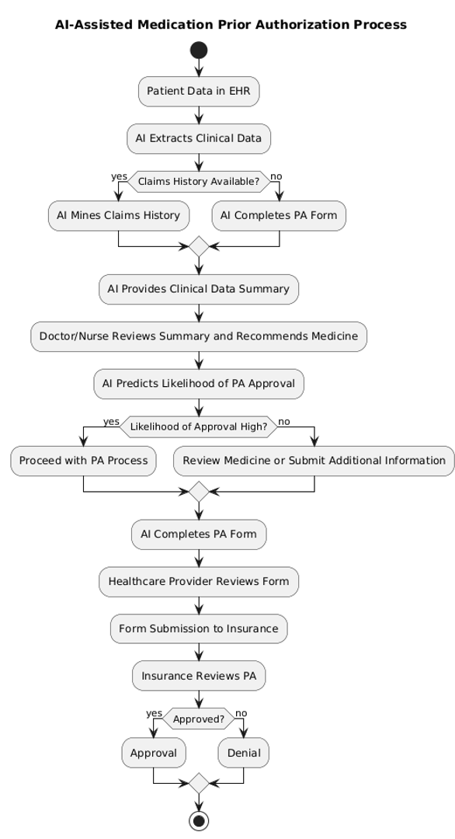

Figure 1: AI-Assisted Medication Prior Authorization Workflow

Conclusion
The AI-Assisted Medication Prior Authorization system offers a promising solution to the inefficiencies of the traditional manual process. By reducing the time required for data entry and improving the accuracy of PA submissions, this system can enhance patient care and streamline healthcare operations.

Contributors
This project was carried out by the following team members:
- M. Rafay Shafqat
- Khurram Iqbal
- Kristty Huffman
- Lim Jen

