**Introduction to Computing and Data Science**

**Department of Computer Science**

**University of Engineering and Technology Lahore**

**Learning Outcomes:**

* Students should be able to think logically and develop problem-solving skills
* Students should be able to learn about user defined and built-in functions

**Introduction**

In this lab, you will learn about functions and its different operations in data science using statistics.

# Functions

**Introducing Function:**

A function is a block of organized, reusable code that is used to perform a single related action. Functions can be used to define reusable code and organize and simplify code. Python gives you many built-in functions like print, etc. but you can also create your own functions. These functions are called user-defined functions.

## Defining a function

A function definition consists of the function’s name, parameters, body and return some output. The **syntax** for defining a function is as follows:

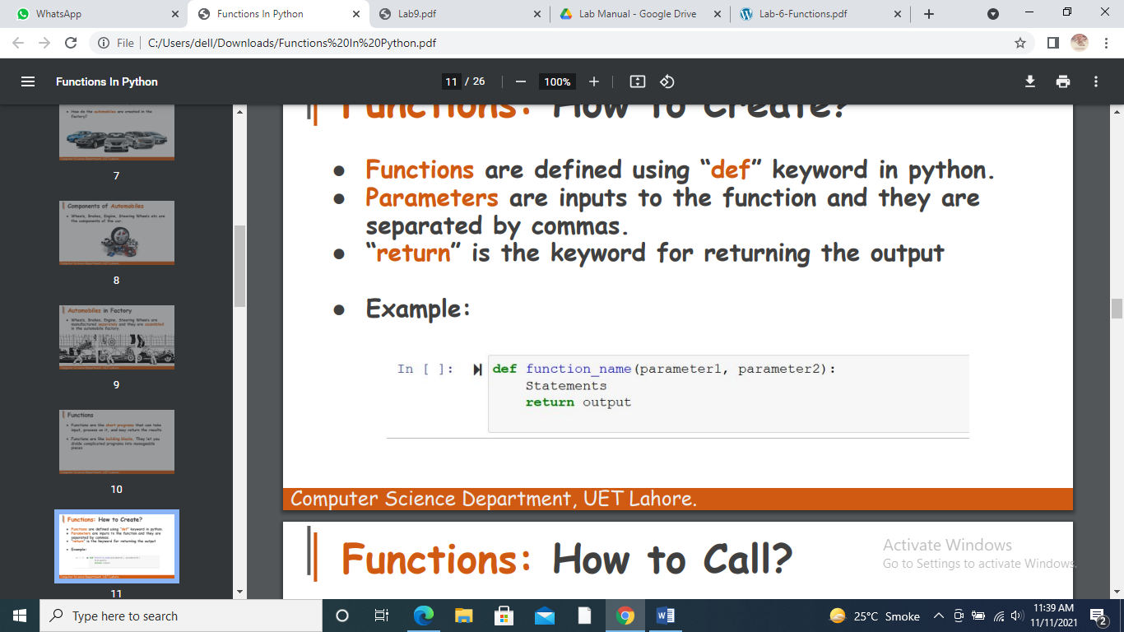

## Example:

## 

### Output:

## It will not print anything because we did not call this function.

## A function can be divided into many categories according to the number of passing parameters. i.e., a function with no parameter, a function with one parameter, a function with two parameters etc.

## Function with no parameter

## 

## Function with one parameter

## 

## In this function, only one parameter is being passed. This function will return the value of x multiply by 5.

## x can be 1,2,3,4…...

## Function with two parameters

## 

## This function contains two parameters. It prints the maximum value from x and y. if x is greater than y, it will print the value of x. otherwise, it will print the value of y.

## Calling function

A function executes the code in the function by writing the names and passing parameter to functions. In a function’s definition, you define what it is to do. To use a function, you have to call or invoke it. The program that calls the function is called a caller.

## Example:

## 

## After calling this function, output will be:

## 

## Function with return value

## To let a function, return a value, use “return” statement.

## Example:

### 

### Output:

## 

**Function with no return value**

We don’t use “return” statement in such type of functions.

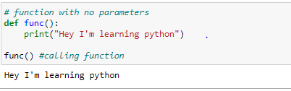

**Types of functions**: There are two types of functions: (i) User defined functions (ii) built-in functions.

**User defined functions**

These functions are used for organizing the code in function body. In Python, a user-defined function's declaration begins with the keyword ‘def’ and followed by the function name. The function may take arguments as input within the opening and closing parentheses, just after the function name followed by a colon. After defining the function name and arguments a block of program statement(s) start at the next line and these statement(s) must be indent. Following are the user defined function examples of “Grade Calculation”, “Variance” and “Standard deviation” of sample data**.**

## Average Grade Calculation

## 

## Output

## 

## It will calculate the average of grades. This program will accept input until user enter -1. if user enters -1, it will not accept any output and calculate the average of the grades.

## Variance

### Variance is the average of the squares of each value from the mean. Following are steps to calculate the variance:

### Find the mean of the data

### Subtract mean from each value of the data

### Square each result

### Find the sum of the squares

### Divide the sum by N to get variance

### Example of Variance

## Following code calculates the variance of 10 six-sided die rolls 1,3,4,2,6,5,3,4,5,2

### 

### we calculated variance here after calculating the mean of the data. Here we used statistics library of python to calculate the sum of temp_list to find the variance. It is built-in module that is used to calculate the mathematics statistics of numerical data.

### Standard Deviation

### Square root of the variance is known as Standard deviation.

### Example of Standard deviation:

### Here we used two libraries to calculate standard deviation. Statistics library is used for calculation of variation and math library that contains all basic built-in functions of mathematics, is used for taking the square root of variance.

## 

### Output:

## 

## Built-in functions:

The functions which are already defined in a program or programming framework with a set of statements, which together performs a task are called built-in functions. So, user need not to create such functions and can use directly into their program. Following example shows the Average grade calculation through built-in functions.

**Example of Average Grade Calculation**

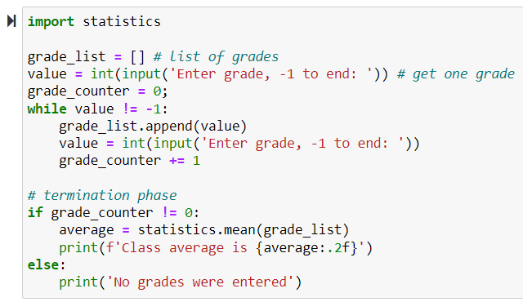

**Output**

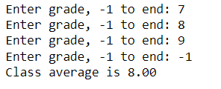

Let’s takeanother example which calculates the “variance” through built-in functions**.**

**Example of Variance:**

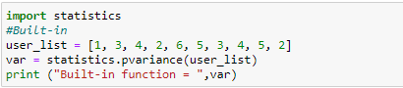

### Output:



Let’s takeanother example which calculates the “Standard deviation” through built-in functions**.**

### Example of standard deviation:

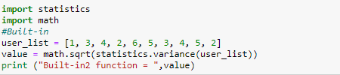

### Output:



### Exercise!

**Tasks to be completed in lab:**

1. Write a program that will display your name on screen using function.
2. Write a program that inputs two numbers in main() function, passes these numbers to a function. The function will display the maximum number.
3. Write a program that inputs a number in main() function, passes the number to a function. The function will display the factorial of that number.
4. Write a program to check whether a number is prime number, even number or odd number using function.
5. Write a program that inputs two integers in main() function, passes these integers to a function by reference. The function swaps the values. The main() function should display the values before and after swapping.
6. Write a program that inputs base and height of a triangle in main function and passes them to a function. The function finds the area of triangle and returns it to main function where it is displayed on the screen. **Area = 1/2(Base*Height)**
7. Write a program that inputs two integers in main() and passes these integers to function. The function finds and returns the greatest common divisor. The main() function then displays the returned value.
8. Write a function to multiply two numbers. The function will define two parameters as default parameter. Main() function can pass any number of parameters 0 or 1 or 2 parameters to function and the function will multiply these number. Finally, function will return calculated value.

**Tasks to be submitted:**

1. Write a program that prompts the user to enter a number and reverse it. Write a function reverse() to reverse the number. For example, if the user enter 2764 term function should reverse it so that it becomes 5672. The function should accept the number as an input parameter and return the reverse number.
2. Write a program inputs an integer and passes it to a function. The function should return the number of digits in integer. For example, if the integer is 35 the function should return 2, if it is 3572 the function should return 4.