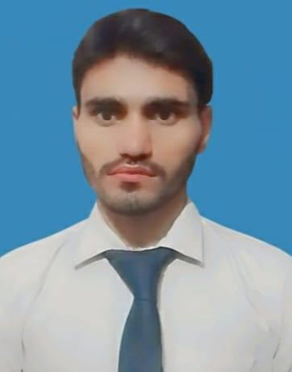

Muhammad Waseem

Contact

📍 Current Location: Qazi Town, Chaha KoryWala, Gulgasht, Multan

📞 Phone: 0348-4953916

💬 WhatsApp: 0319-6481233

📧 Email: (muhammadwaseem997550@gmail.com)

Personal information

Identity Number

Name Father Name Date of Birth
Date of Expiry
PermanentAddress (Urdu)

32304-5448368-3

Muhammad Waseem Manzoor Hussain 27.12.2002 21.12.2032
Mohallah PeereWala, DakhanaLiaqatabad,GaireyWaheen, Tehsil-o-Zila Muzaffargarh.

🎯 Objective

Highly motivated Computer Science student with practical experience in Full-Stack Web Development. Focused on building responsive front-end interfaces and robust back-end systems using HTML, CSS, JavaScript, PHP, and Laravel. Seeking an entry-level position to leverage core programming concepts and modern web frameworks to contribute to a challenging technical environment.

🎓 Education

Institution/Board

NationalUniversityOf Modern languages
Degree/Certification

Bachelor of Science in ComputerScience(BSCS)
Status/Result

6thSemester(In Progress)
Dates

(Start Date-13-Feb-23

Present

Board of Intermediate and SecondaryEducation,Multan (BISE Multan)

IntermediateCertificate (Engineering Group)

687/1100 Marks (ExternalGradeA)
Issued: January22, 2022

📋 Key Soft Skills

• Problem-Solving & Debugging: Proven ability to resolve complex coding issues, specifically in debugging web-based scripts and backend logic.

• Continuous Learning: Dedicated to staying updated on the latest web libraries, security best practices, and the evolving Laravel ecosystem.

• Analytical Thinking: Skilled in applying object-oriented principles to structure clean and maintainable software solutions.

🛠 Technical Skills

Web Development (Full-Stack): HTML5, CSS3, JavaScript, PHP, and Laravel Framework. Programming Languages: PHP, JavaScript, Python, and C++.
Core Concepts: MVC Architecture, Data Structures, Computer Networks, and Object-Oriented Programming.

Tools & Version Control: Git, GitHub, MS Word, and MS Excel.

🚀 Experience & Projects

Full-Stack Web Application (Laravel): Developed a dynamic web platform utilizing the Laravel framework to manage backend logic, database interactions (Eloquent ORM), and secure user authentication.

Online Smart Directory: Built a responsive web-based directory using HTML, CSS, and JavaScript to provide a searchable interface for local services.

Server Farm Implementation (Web, Email, FTP): Configured virtual networks and demonstrated underlying protocols (HTTP, FTP) for resource sharing and communication in a simulated server farm environment.

Technical Documentation: Proficient in using MS Word and Excel for managing project documentation and data analysis.

🌟 Interest
• Development & Programming: Passionate about learning new frameworks and solving problems through code.
• Reading Books: Committed to continuous learning and professional development.
• Marketing & Social Media: Active interest in digital trends and online engagement strategies.

💬 Languages

• Urdu :
• English : • Punjabi :

📜 Reference

Will Be Furnished On Demand

