How to approach a task: understand it, then harden it
The workflow from the first read to a packed task, and the dead ends that waste batteries. The trick that finally makes your task hard is yours to find. Every task hides it somewhere else. What repeats is the order of the work, and the ways it goes wrong.
UNDERSTAND THE TASK
1. Start with the instruction and the policy
Read the prompt and the policy end to end before you open a data file. You are reading for three things: what kind of data feeds the work, what the answer counts, and which fields the grade will depend on.
This is not wasted time. Almost everything you do later, you do to the data, and you cannot safely change data you do not understand yet. Read the notes too, and mark anything that is handed over for free: a pointer to a column, a named file, a sentence that tells the model what to do with one row. Those are your first deletions.
2. Then read the data, and how the sets relate to each other
For every input file write one line: what one row is, what identifies it, and which rules read it.
A mined task is usually solved 5/5 because it arrives already prepared. Whoever built it settled the difficult parts before the model ever saw them, so the model has nothing to work out and only has to apply the rules. Knowing what was settled for it, and by whom, is the point of reading the data carefully.
3. Run a baseline battery before you change anything
Run a battery, or at least one trial, on the untouched task, and read the trajectories instead of the score. On a task that already scores 5/5 this feels like a wasted run. It is the most useful run of the whole build:
- It gives you the model's own solving script: every assumption it made about your data, written out in code you can read.
- It shows where the model checks carefully and where it moves fast. The careful steps are ground you will not win. The steps it skims are where something can sit unnoticed.
- It is the control for every later measurement. When a run fails you need to know whether it failed on reasoning or on something you made unclear, and only a baseline you have read tells you which.
Keep the trajectories and the scripts. You will come back to them at every version.
HARDEN THE TASK
4. Two things that look like hardening and are not
Adding rules or instructions. A rule clear enough to be fair is a rule the model turns into a few lines of code. It reads it, copies it out, runs it. What you really buy is boundary risk: runs failing on greater-than versus greater-or-equal, on which side of an as-of date a record falls, on a phrase that can be read two honest ways. That is vagueness dressed up as difficulty, it points straight back to the sentence you added, and review will fail it.
Adding data. Volume is not difficulty. A script crunches two hundred thousand rows as fast as two hundred.
5. Put the difficulty in the data
Go back to the script the model wrote and read what it assumed your data would be. Every script makes assumptions about the shape of the records it reads, and it makes them quietly. List them, then make the data honestly not like that, in a way the policy still describes correctly and a careful reader could work out.
What is on offer depends completely on the task, and that is the point. The difficulty is a property of your data, not of your prose. A trap copied from someone else's task usually measures nothing on yours, because what made it work there was a property of their data.
6. Test the idea before you build it
- Name the exact wrong answer. The wrong count, the wrong cell, the wrong total. If you cannot write it down, you have a hope, not a trap.
- Ask whether the model's own checks would catch it. The model checks most of what it does. Go back to the baseline trajectory and find the check it already runs at that step. If that check catches this, the model fixes itself before it writes a file. No go. The idea is dead before you build it.
- Simulate the wrong method against the graded output. If no graded cell moves, the trap changes nothing.
7. Build it, measure, keep or drop
Freeze the task, run a battery, read the trajectories again. If the trap did not fire, take it out and try another one. Do not leave a dead trap in the data in case it helps later, because every extra thing in the input is one more way a correct run can go wrong. If it did fire, check that it fired for the reason you designed: name the wrong value in the delivered file, and match it to the step where the run chose it.
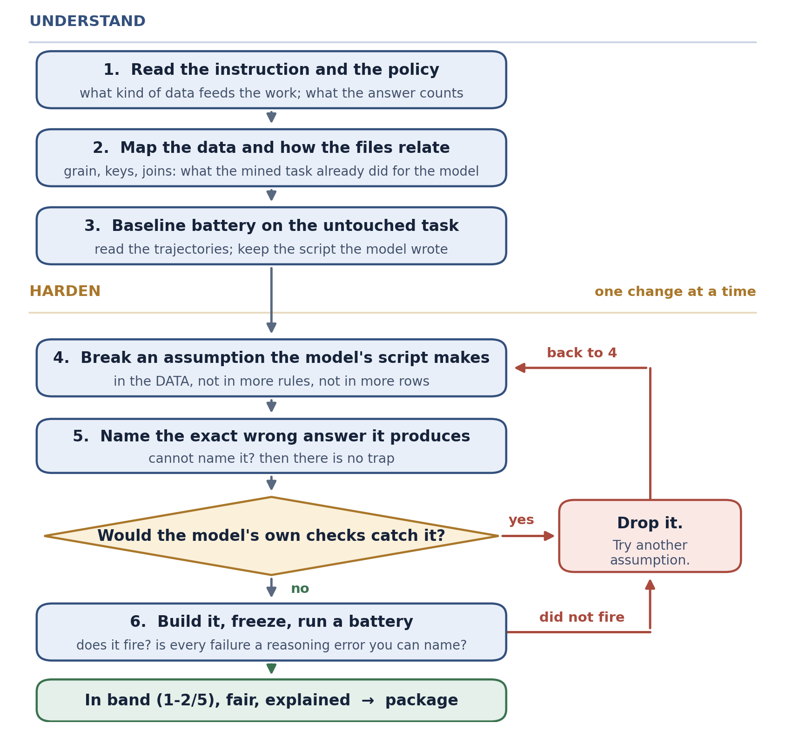
THE GOTCHAS THAT COST BATTERIES
The task is in band, but unfair
- Two honest methods give different answers. Fix the data so both methods agree, and keep values off thresholds rather than arguing about which side of one they fall.
- Every field the grade depends on must agree with itself across the whole input set, and you assert that after the last edit rather than before it.
- Dates break the story: a record after the as-of date, an override dated after the thing it overrides, an order column that disagrees with its timestamp. Assert all three every time.
- Make sure no two rules can apply to the same input at once, or a run can be right about one of them and still wrong about the grade.
- The last edit created a new ambiguity in a rule you did not touch. Re-check every rule after the final edit, including the ones you believe you left alone.
- The test for all of this is the trajectory, not the score. A run that reasons correctly and then writes “the spec would need to say” is telling you the task is unfair, whatever it scored.
The artifacts describe different tasks
- Prompt, solution, tests, manifest and environment drift on filenames, paths, columns or counts. Reconcile them on purpose, not by trusting a green oracle. Confirm the solution follows the required method, not just the reward.
- The reference answer's own write-up is not graded by anything, so nothing catches it repeating the mistake the task is built around. Read it against the standard line by line and recompute every figure it states from the inputs.
The measurement is wrong
- One battery is not a result. Run several. Report a rate only when every failure is traced to a named model error.
- Timeouts, empty runs, provider errors and memo-only failures are not kills. Triage every failed run to a step and a wrong value.
- Judge a failure by the delivered file, not by what the model said while working.
- Several edits at once make the result impossible to explain. Change one thing per version, and batch every content edit before you freeze, because each one voids the evidence before it.
- Pass rates multiply. A second trap on a working task often gives 0/5. Count traps that fire, not traps you planted.
- A four-trial sample carries about one trial of noise. One high battery beside two in-band ones is a sampling question, not a difficulty one, and it costs one more battery to answer.
Nothing moves
- After two builds with no change, stop turning the same dial. The tell is that every build so far moved the same thing.
- Volume is not a rung. More of the same pattern moves nothing.

FINALIZATION QC LEARNINGS FROM REPAIRS
- Start with the exact version that QC reviewed, not the newest working folder. Reproduce the reported example there and group findings that come from the same root cause before making a change. This prevents several patches for what is really one problem.
- Treat the instruction and supplied policy as the public contract. A verifier name, internal comment, or Golden phrase cannot impose a condition that the participant was never told about. Either disclose an exact requirement or grade equivalent correct work fairly.
- Be strict only where the format is genuinely pinned. Filenames, schemas, codes, and JSON keys can be exact when the instruction says so, while memo wording and harmless number presentation need room for natural alternatives. Do not demand a precise narrative value that belongs in a structured report.
- Read the meaning of a sentence, not just the presence of a keyword. Negation and contradiction checks should understand phrases such as not reconciled and no longer current. They must also stay within the correct record and topic so one paragraph cannot accidentally pass or fail another record.
- Give every verifier repair a positive and negative regression. The exact valid phrase from QC should pass, and a nearby version with the wrong meaning should fail. Also cover ordinary layouts such as numbered lists, table rows, punctuation, and line breaks when the instruction allows them.
- Make each reward check measure the requirement named in its description. Two different checks should not both fail because one shared setup phrase broke, and a small memo issue should not carry the same loss as a missing core report. Keep local author tests out of the hidden reward path unless they are declared.
- Test a reusable CLI beyond the supplied dataset. Its normal, dry-run, and verify-only modes should follow the exact public promise, reject clearly defined malformed inputs, and avoid partial writes. An independent fixture should test general logic without exposing or encouraging hardcoded answers.
- Keep Golden files, grader code, hidden fixtures, and answer keys outside the agent-readable workspace. Save complete run evidence as well, including valid trajectory JSON, artifact manifests, detailed verifier output, rewards, and supported model settings read from the environment. A good run is difficult to defend when its saved record is missing or broken.
- Finish the package as carefully as the repair. review.csv needs all 14 areas resolved with task-specific notes, and the ZIP should contain exactly one task root with no caches, temporary reports, or duplicate archives. Extract the ZIP and test that extracted copy before handoff.
- Do not change a sound task because QC returned INDETERMINATE or an obvious capture failure. Rerun first, then record a short evidence-based platform explanation if the same engine problem repeats. Task changes should be reserved for defects that can actually be reproduced.

