ONLINE REAL ESTATE MANAGEMENT SYSTEM

MUHAMMAD ZIA UL HASSAN

FA17-BSE-061


NOvember 2019
Department of Computer Science
COMSATS INSTITUTE OF INFORMATION TECHNOLOGY
ATTOCK – PAKISTAN

PROJECT ID |  |  |  |  | NUMBER OF MEMBERS
TITLE
SUPERVISOR NAME |  |  | TERNAL / EXTERNAL

MEMBER NAME | REG. NO. | EMAIL ADDRESS

CHECKLIST:
Number of pages in this report
I/We have enclosed the soft-copy of this document along-with the codes and scripts created by myself/ourselves | YES / NO
My/Our supervisor has attested the attached document | YES / NO
I/We confirm to state that this project is free from any type of plagiarism and misuse of copyrighted material | YES / NO

MEMBERS’ SIGNATURES
Supervisor’s Signature

Note 1: This paper must be signed by your supervisor
Note 2: The soft-copies of your project report, source codes, schematics, and executables should be delivered in a CD

This work, entitled “Insert Project Title Here” has been approved for the award of

Bachelors of Science in Computer Science

Date

External Examiner:

Head of Department:

Department of Computer Science
COMSATS INSTITUTE OF INFORMATION TECHNOLOGY
ATTOCK – PAKISTAN

Declaration

“No portion of the work referred to in the dissertation has been submitted in support of an application for another degree or qualification of this or any other university/institute or other institution of learning”.

MEMBERS’ SIGNATURES

Acknowledgements

The satisfaction and euphoria that accompanies the successful completion of any task would be incomplete without the mention of the people who made it possible. If there is a driving force that kept use going on in doing this project, it is the constant support of our guide Mr. ADNAN We present our sincere and heartiest thanks to him, for giving us a patient hearing and clearing our doubts.
We would like to express our profound thanks to DR. Muazzam Maqsood for their support and encouragement towards us at every stage in successful completion of our project.
We place our gratitude to our parents who always encouraged us to pursue our interest, who have led us onto the right path. We are undoubted for all the love and affection they bestowed upon us. Many are responsible for the knowledge and experience we have gained during our project and throughout the course. With profound sense of gratitude and regards we acknowledge for support extended by our friends for their support in completion of this project.
Finally, we would also like to thank all those who knowingly or unknowingly helped to us all throughout our project.

Abstract

- Our project “ONLINE REAL ESTATE BUSINESS” is related to online application of estate.
- Real estate management system is advanced solution for his/her estate problem.
- User shows all the properties of Buyer that are secure & verify & send them to the Builder.
- Real System Buy the property &verify them and the online service is provided by us free of charge.
- Here registration is also free of cost. So user can registration by using Real System then Buy the property & verify them. After few hours or days our guys put the estate solution. The software is so reliable to user .Our main concept is give best & quick result to user.

Table of contents
1 Introduction 1
2 REQUIRMENT SPECIFICATION……………………………………………………2
2.1 Non functional requirement……………………………………………………2
2.1.1 product requirement……………………………………………………2
2.1.2 External requirement……………………………………………………2
2.2 functional requirement………..……………………………………………………3
2.2.1 Member(customer)……………………………………………………3
2.2.2 Admin Acess……………………………………………………3

3 PRoject design 4
3.2 USe case diagram 5
3.2 CLASS DIAGRAM 6
3.3 activity diagram 7
3.3 Data flow diagram 8
3.5 Sequence diagram 10
3.6 component diagram 11

Introduction
This website is a Online real estate business website through which a user can access its information and manage all the adding, updating, deleting the assets and some of its tasks.
The Admin user can change the update the information regarding property selling and buying and cancellation. The system is very useful for the companies who develope apartments, hotels, villa, residential properties and commercial properties. Companies or individual agents can also advertise their property .

Requirements Specification

Non functional requirement

Product requirement
- Our system must save time and money: Accurate upfront software requirements definition helps ensure your team works on the business problems that matter most.
- Reduce rework: Early validation and agreement by stakeholder’s means development and quality teams spend less time on rework.
- Improve requirement accuracy: Industry-unique collaborative storyboarding improves accuracy by promoting effective communication.

External requirement
- Usability: The interface should use terms and concepts, which are drawn from the experience of the people who will make most of the system.
- Efficiency: The system must provide easy and fast access without consuming more cost.
- Reliability: User should never be surprised by the behavior of the system and it‘s easy to use to stored data and easy to used transfer voice data

Functional Requirements
Since this project uses database and control, it needs the retrieval of information from the database. It needs access of Database from a front end, as ASP.net is a Microsoft Family product, it provides easy linking to the database, along with the flexibility required to develop a user-friendly front end.

Member

2.2.1.1: Login
FR1. The System shall verify valid ID and Password.
FR2.The System shall not allow to enter the system with invalid ID or Password.
FR3.The System shall allow member to enter with valid ID or Password.

2.2.1.2 : Search
FR4. The System shall allow members to be able to search for available property by Price, city
FR5. The system shall display the search results with the details of preferred Resource.

2.2.1.3 Manage / View Account
FR6. The System shall allow members to view history containing information such as list of available property .
FR7. The System shall allow update their personal information such as phone number, address, email address, password.

2.2.1.4 : Payment Management

FR8. The System shall display the payment method to the customer

Admin acess

2.2.2.1 Admin Access

FR9. The System shall verify admin info to provide all access privilege.

2.2.2.2 : Register Member

FR10. The System shall store the registered ID in the membership database.

2.2.2. 3 : Update resources

FR1. The System shall allow add, delete or edit resource with their details

Project Design

Use case digram
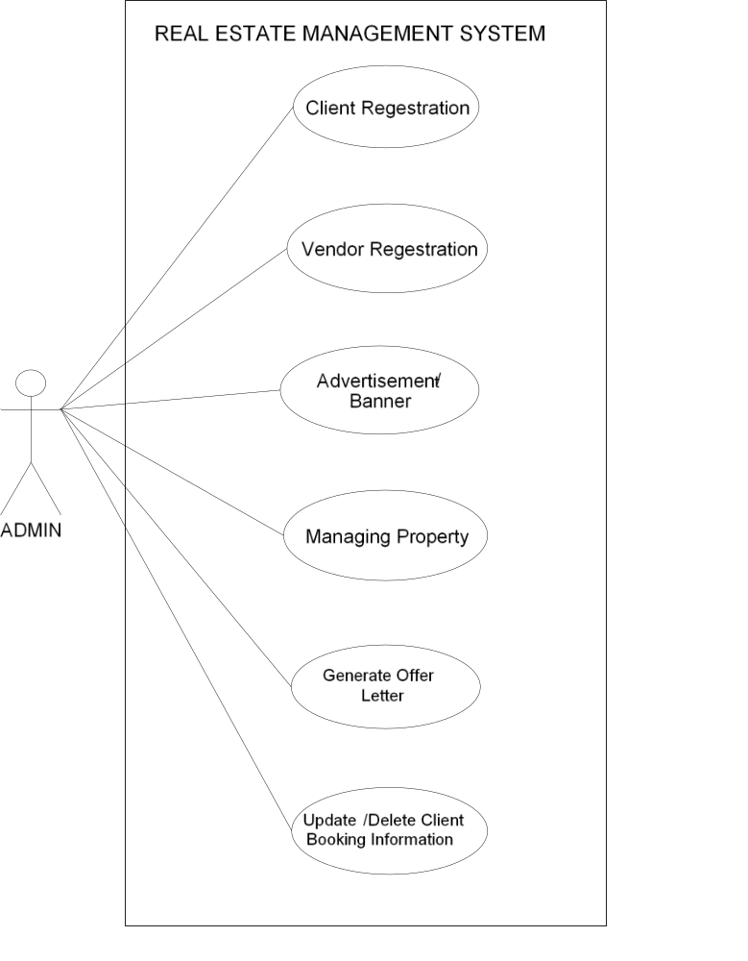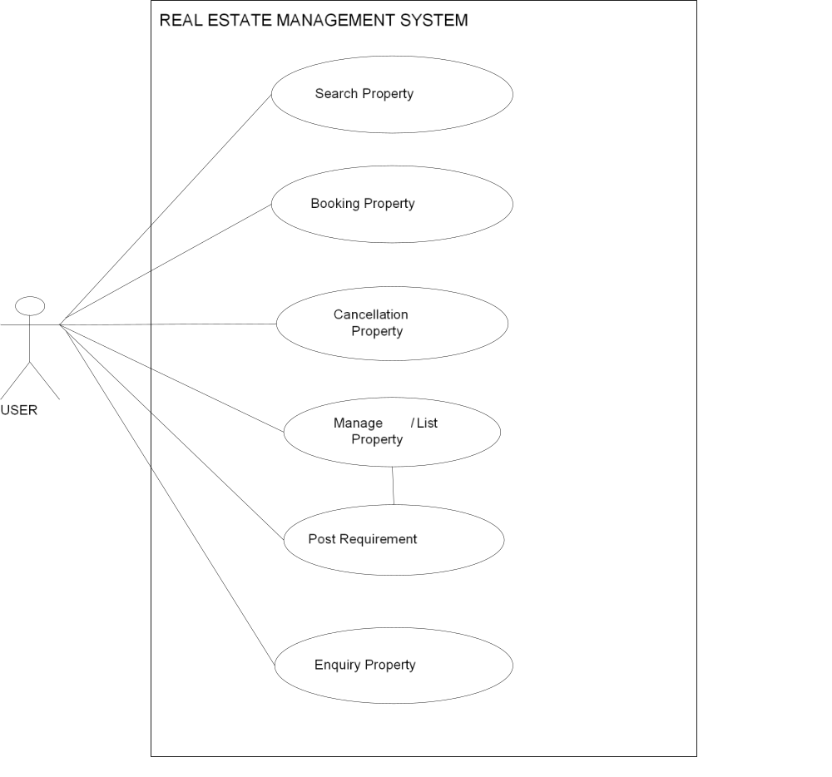

Class diagram
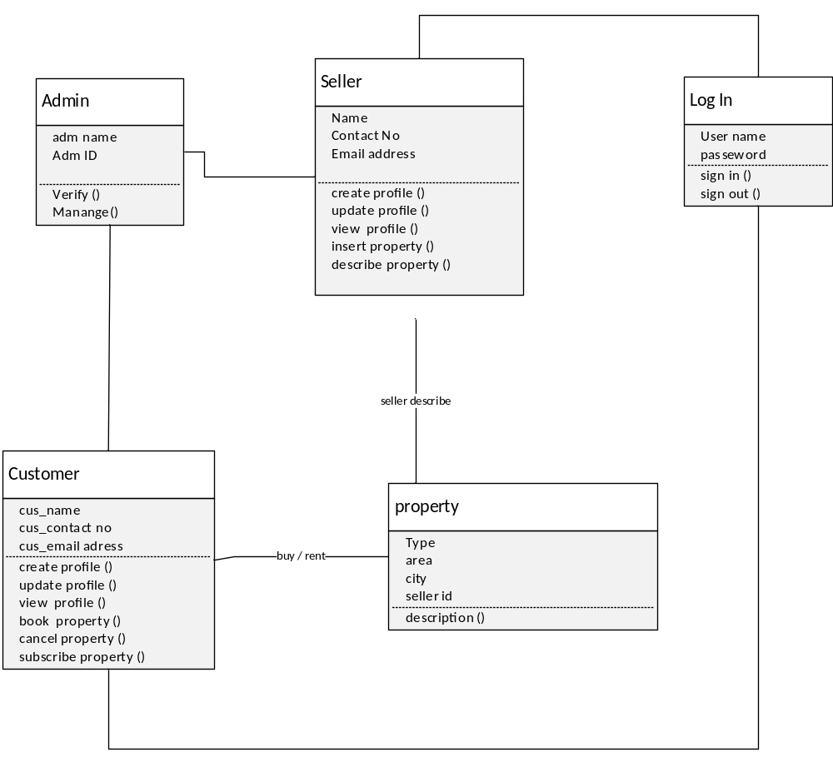

Activity diagram
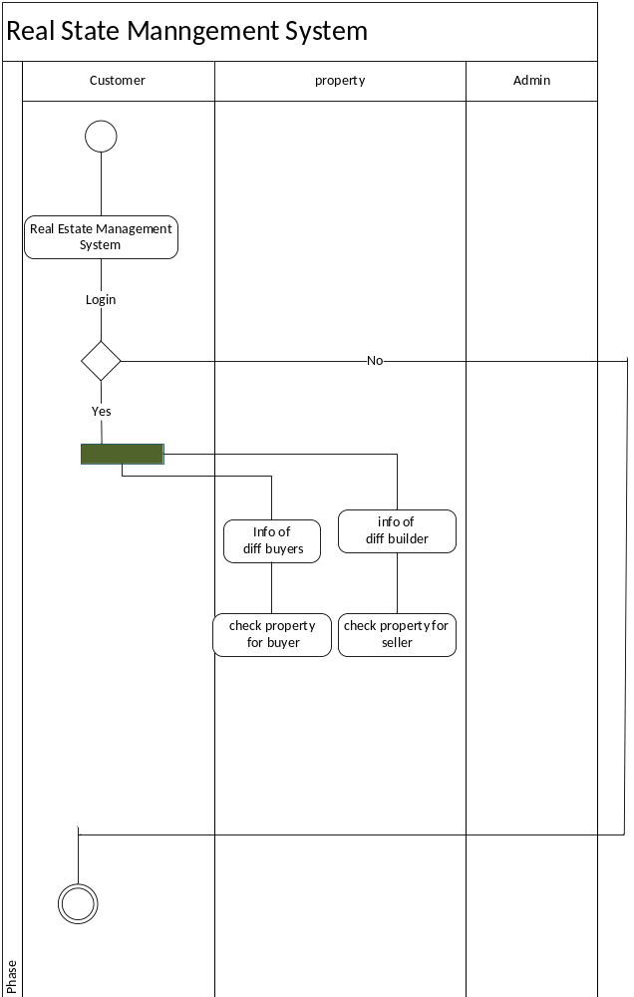

Data flow diagram

Context level diagram

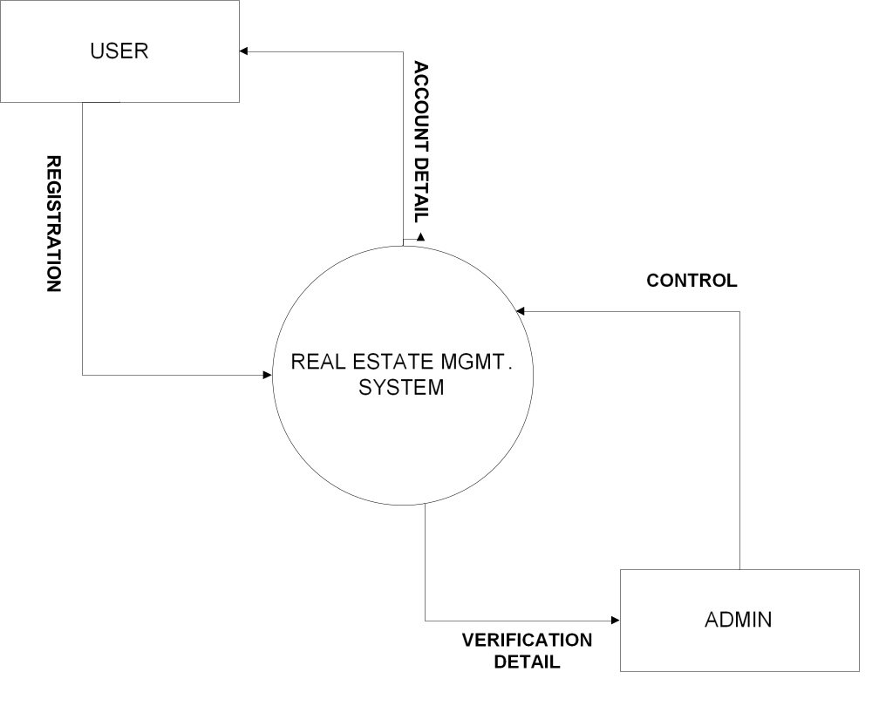

Level 1
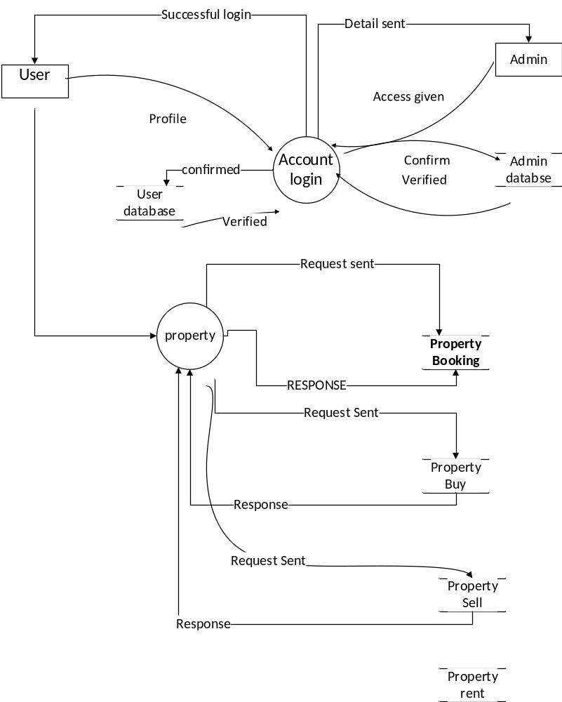

Sequence diagram
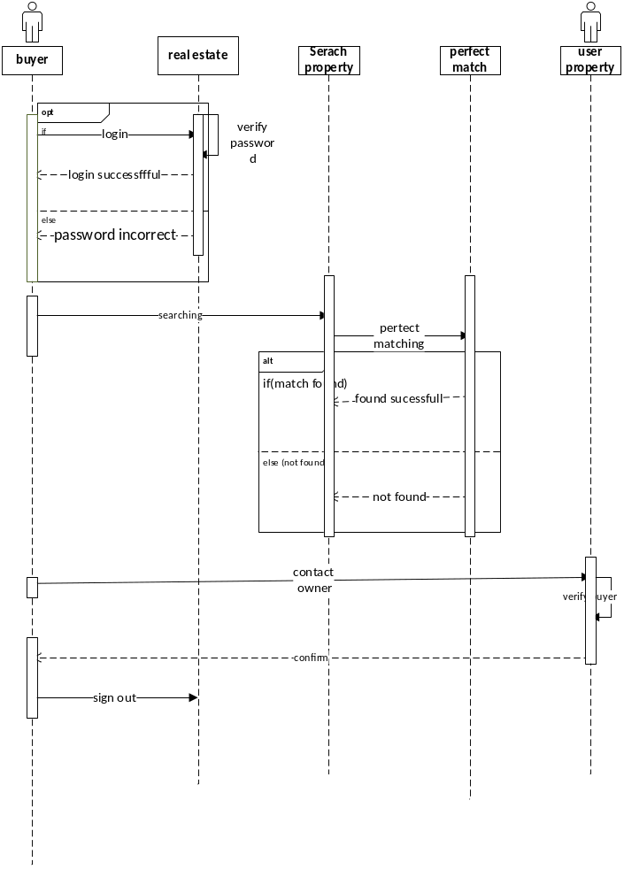

Component diagram

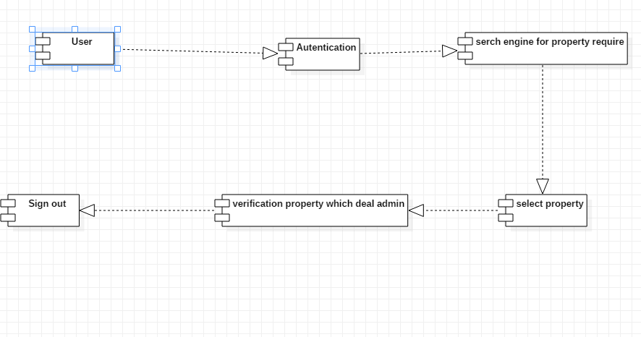

Appendix D: Project Timeline

DATE

PROJECT ID |  |  |  |  |  | TOTAL NUMBER OF WEEKS IN PLAN
TITLE
No. | STARTING WEEK |  |  | DESCRIPTION OF MILESTONE |  |  | DURATION
1
2
3
4
5
6
7
8
9
10

* You can provide Gantt chart instead of filling this form, if you like

