Team Members

|  |  |  |  |
| --- | --- | --- | --- |
| **Name** | **ID** | **Department** | **Level** |
| محمد مصطفي محمود عبدالمجيد | 20210837 | CS | 3 |
| يوسف محمد نادي حسن | 20211104 | CS | 3 |
| محمد أيمن محمد قنديل | 20210751 | CS | 3 |
| احمد رضا شعبان عبد الوهاب | 20210050 | CS | 3 |
| محمد ناصر رفعت على | 20210841 | CS | 3 |
| محمد عوض الله سري احمد | 20210822 | CS | 3 |

* 1. ***General Information on dataset:***

***Dataset Name:*** *Fraud Detection(Numerical), Oxford pets(Image).*

***Number of classes:*** *2.*

***Numerical labels:*** *1 or 0.*

***Image labels:*** *Cats, Dogs.*

***Total number of samples:*** *6799(Images), 1000000(Numerical).*

***Size of each image:*** *avg(100Kb).*

***Number of training samples:*** *5439(Images),* 503080 || 6294(*Numerical*)

***Number of validation samples****: 200000.*

***Number of testing samples:*** *1360(Images),*215606 ||2698(*Numerical*)***.***

* 1. ***Implementation details:***
  + *5 -> Features extracted*

1.Resizing and Scaling.

2.Sharpen Image.

3.Convert to grey scale.

4.Image Array.

5.Distribution of Pixel Value.

* + *Name: HOG.*
  + *Dimension: 2D.*
  + *Is cross-validation is used in any of implemented models?* ***yes, number of k-fold = 5****.*
  + *ratio of training/validation.* ***4:1****.*
  + *Hyperparameters used in your model, as initial learning rate, optimizer, regularization, batch size, no. of epochs, etc…*
  1. ***Results details:***

*For each model you should show all these results for your model on testing data (loss curve, accuracy, confusion matrix, ROC curve)*

**accuracy:**

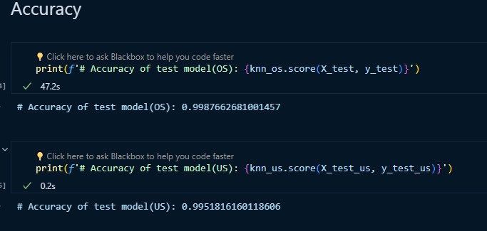

**confusion matrix:**

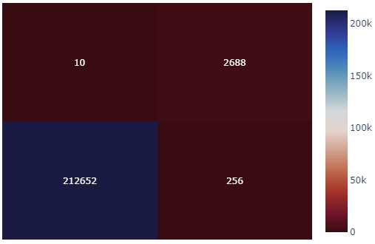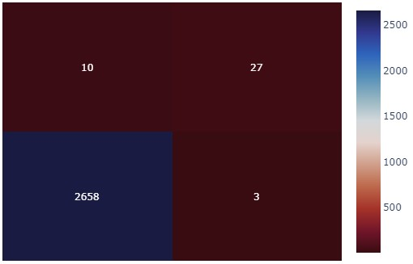

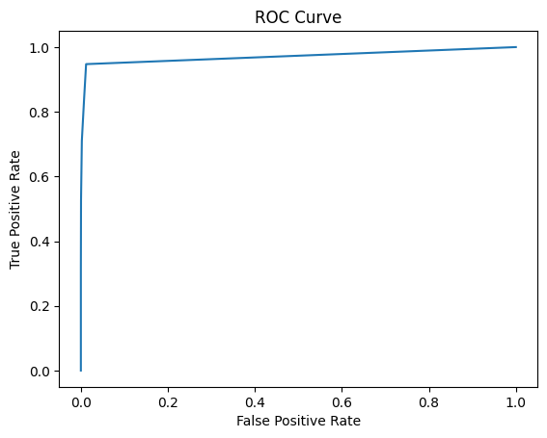**ROC curve:**

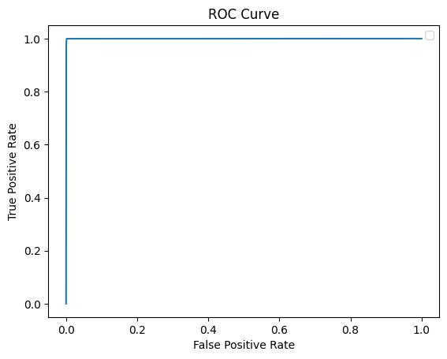

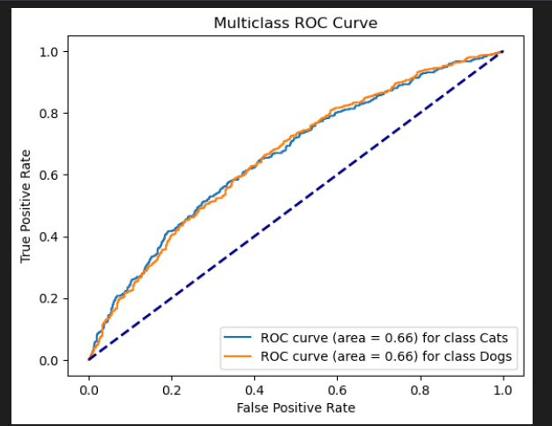

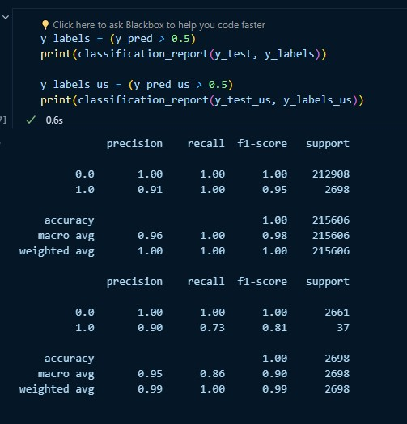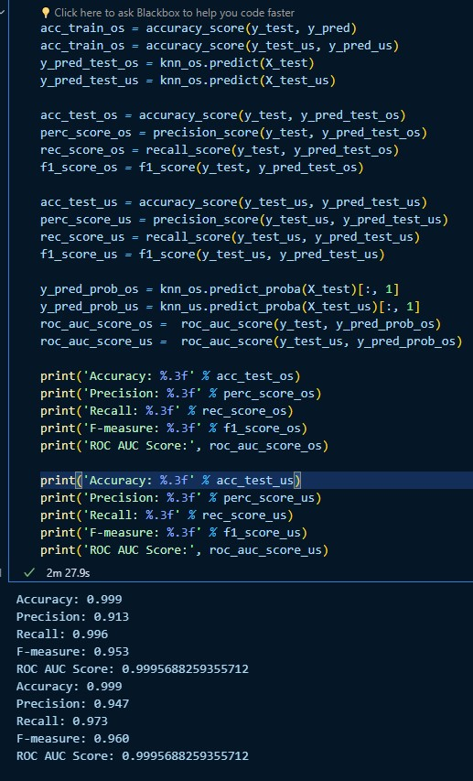**classification report:**

FINAL:

