DATA MINING ALGORITHMS
Wine Cultivar Classification Using Classical Data Mining Techniques
Course Project

Project objective: determine whether a wine cultivar can be predicted from 13 chemical measurements, then compare multiple classical data-mining classifiers under the same evaluation protocol.

1. Problem Definition
The proposed problem is a three-class classification task. Each record represents a wine sample characterized by 13 chemical measurements. The target is the cultivar class. The project investigates whether these measurements contain enough structure to distinguish the three classes reliably, and compares Decision Tree, K-Nearest Neighbors (KNN), and Random Forest approaches.

2. Dataset Description
The dataset is the UCI Machine Learning Repository Wine dataset (DOI 10.24432/C5PC7J). UCI describes it as chemical analyses of wines grown in the same Italian region but derived from three different cultivars. The dataset has 178 instances, 13 features, and three target classes. The 13 measurements are Alcohol, Malic acid, Ash, Alcalinity of ash, Magnesium, Total phenols, Flavanoids, Nonflavanoid phenols, Proanthocyanins, Color intensity, Hue, OD280/OD315 of diluted wines, and Proline. The dataset contains no missing values.

3. Preprocessing
The preprocessing workflow was intentionally conservative because the dataset is already clean. First, the shape, missing-value count, duplicate count, and class distribution were checked. There were no missing values. A stratified 80/20 train/test split was used with random_state=42, resulting in 142 training observations and 36 test observations. Feature relevance was estimated with mutual information, and the top eight features were selected inside each modeling pipeline. This avoids data leakage because the selection step is fit only within the training folds. KNN inputs were standardized with StandardScaler; tree-based methods were not scaled because their splits are not distance-based.
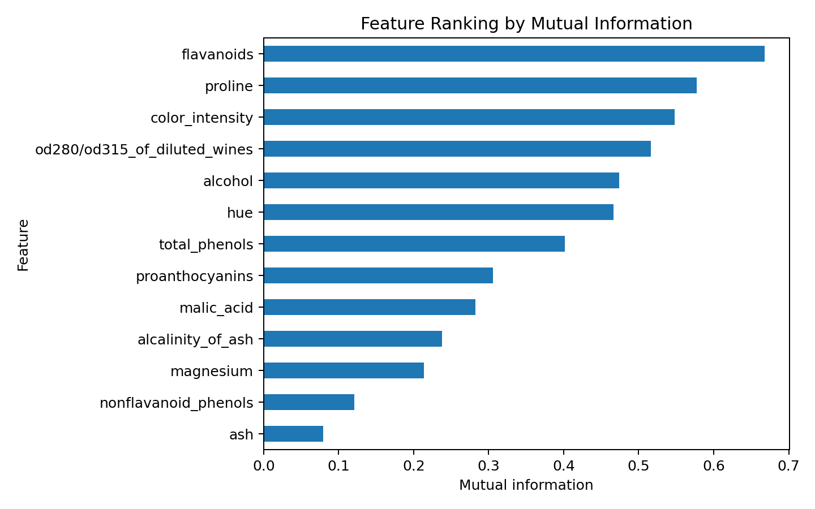
Figure 1. Feature ranking using mutual information.

4. Algorithm Selection and Rationale
Decision Tree was selected because it provides an interpretable set of hierarchical rules and directly handles numeric features. KNN was selected as a distance-based baseline, which makes preprocessing and scaling meaningful. Random Forest was selected as an ensemble of decision trees that can capture nonlinear relationships while reducing the variance of a single tree. The comparison therefore represents three distinct modeling strategies rather than minor variations of the same algorithm.

5. Experimental Setup
All models use the same feature-selection step and the same train/test split. Performance is assessed using five-fold stratified cross-validation on the training data, followed by evaluation on the held-out test set. Primary metrics are accuracy and weighted F1; weighted precision and recall are also reported. The implementation uses Python, pandas, NumPy, Matplotlib, Seaborn, and scikit-learn, and the notebook can be run directly in Google Colab.

6. Results and Discussion

Model | 5-fold CV Accuracy | Held-out Test Accuracy | Weighted Precision | Weighted F1
Decision Tree | 0.874 ± 0.046 | 1.000 | 1.000 | 1.000
KNN | 0.965 ± 0.022 | 0.944 | 0.947 | 0.944
Random Forest | 0.972 ± 0.026 | 1.000 | 1.000 | 1.000
The results show strong separation among the three classes. The Random Forest achieved the highest mean cross-validation accuracy in this experiment, while the Decision Tree and Random Forest both classified all 36 held-out observations correctly for the fixed split. KNN was also highly accurate, but made two test-set errors.
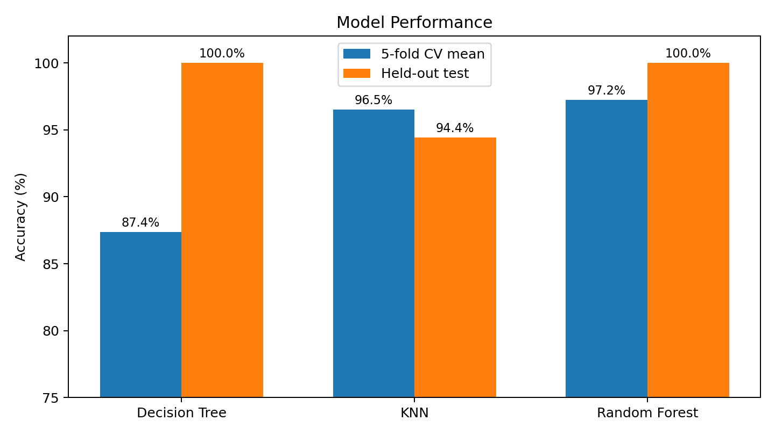
Figure 2. Comparison of cross-validation and held-out test accuracy.
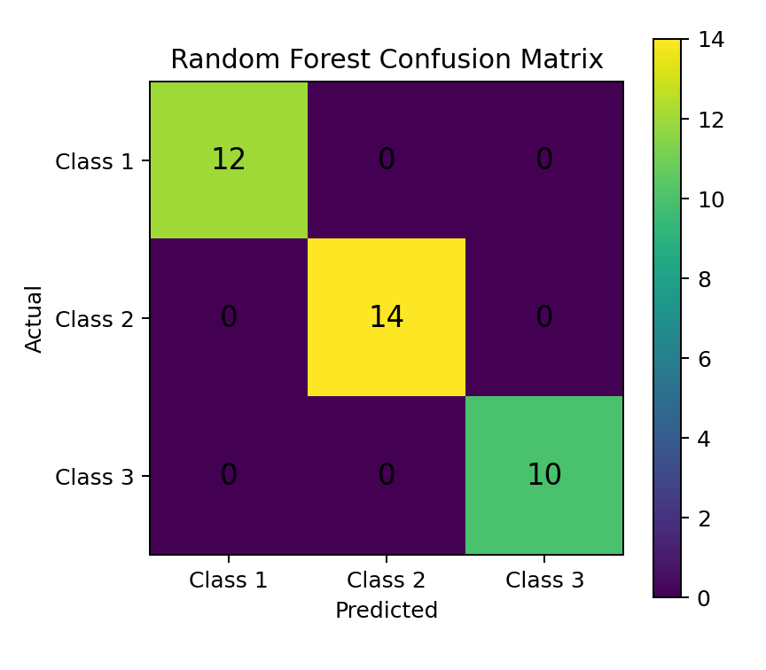
Figure 3. Random Forest confusion matrix on the held-out test split.
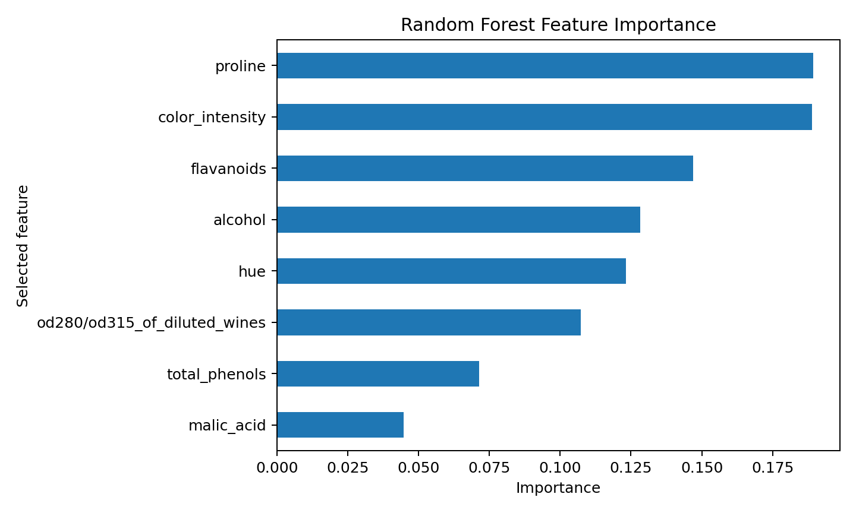
Figure 4. Random Forest importance among the selected features.

7. Conclusions
The experiment demonstrates a complete data-mining workflow: define a classification problem, inspect and preprocess the data, select relevant features without leakage, compare multiple algorithms, and evaluate with both cross-validation and a held-out test set. The strong performance indicates that the chemical measurements contain substantial information about cultivar membership. The project also illustrates why evaluation should not rely on one accuracy value alone.

8. Future Work
- Repeat the evaluation over multiple stratified random splits to estimate performance variability more robustly.
- Tune hyperparameters with nested cross-validation rather than fixed, reasonable settings.
- Compare additional methods such as SVM, Gaussian Naive Bayes, Gradient Boosting, or linear discriminant analysis.
- Investigate PCA or other dimensionality-reduction methods and visualize class separation in two dimensions.
- Use domain knowledge from chemistry to interpret why the most informative measurements distinguish the cultivars.

9. References
- UCI Machine Learning Repository. Wine dataset. https://doi.org/10.24432/C5PC7J
- scikit-learn. Wine recognition dataset documentation. https://scikit-learn.org/stable/modules/generated/sklearn.datasets.load_wine.html
- scikit-learn. DecisionTreeClassifier documentation. https://scikit-learn.org/stable/modules/generated/sklearn.tree.DecisionTreeClassifier.html
- scikit-learn. RandomForestClassifier documentation. https://scikit-learn.org/stable/modules/generated/sklearn.ensemble.RandomForestClassifier.html
- scikit-learn. KNeighborsClassifier documentation. https://scikit-learn.org/stable/modules/generated/sklearn.neighbors.KNeighborsClassifier.html

