**Name : Mohammed desoukey Mohammed ail محمد دسوقي محمد علي**

**B.N:**

**Date :**

**Topic:** **programming languages**

**Github link :**

**Github page :**

**Content overview**

**Computer programming language**, any of various languages for expressing a set of detailed instructions for a digital [computer](https://www.britannica.com/technology/computer). Such instructions can be executed directly when they are in the computer manufacturer-specific numerical form known as [machine language](https://www.britannica.com/technology/machine-language), after a simple substitution process when expressed in a corresponding [assembly language](https://www.britannica.com/technology/assembly-language), or after translation from some “higher-level” language. Although there are many computer languages, relatively few are widely used.

Machine and assembly languages are “low-level,” requiring a programmer to manage explicitly all of a computer’s [idiosyncratic](https://www.merriam-webster.com/dictionary/idiosyncratic) features of data storage and operation. In

contrast, high-level languages shield a programmer from worrying about such considerations and provide a notation that is more easily written and read by programmers.

**We talked at the beginning of the topic on programming languages ​​in general, starting from how the computer deals with the data and knows the programming language and the definition of the programmer, then they talked about a comparison about programming languages ​​so we can compare the programming language in terms of level and in terms of the method of implementation and in terms of use and then we developed a picture showing the types of programming language then We talked about the advantages and disadvantages of programming language**

**Screenshots :**

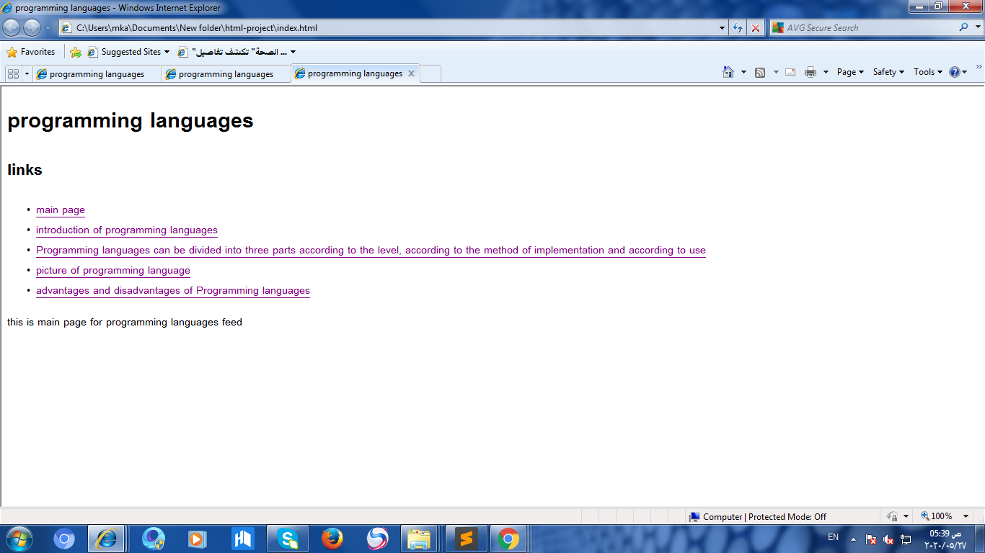

**Fig main page**

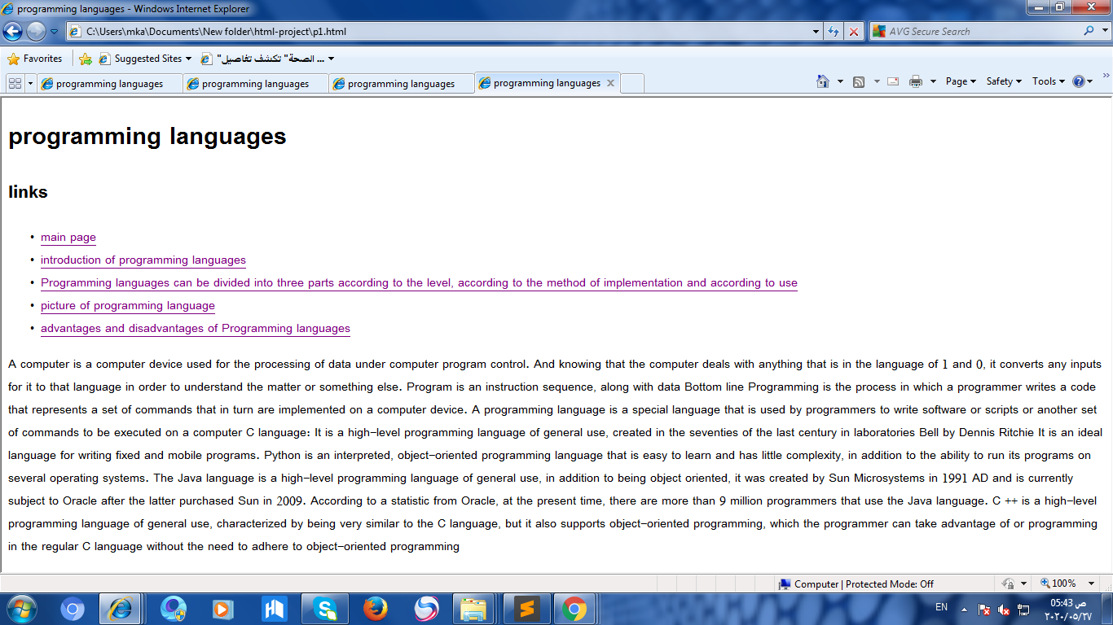

**Fig of introduction**

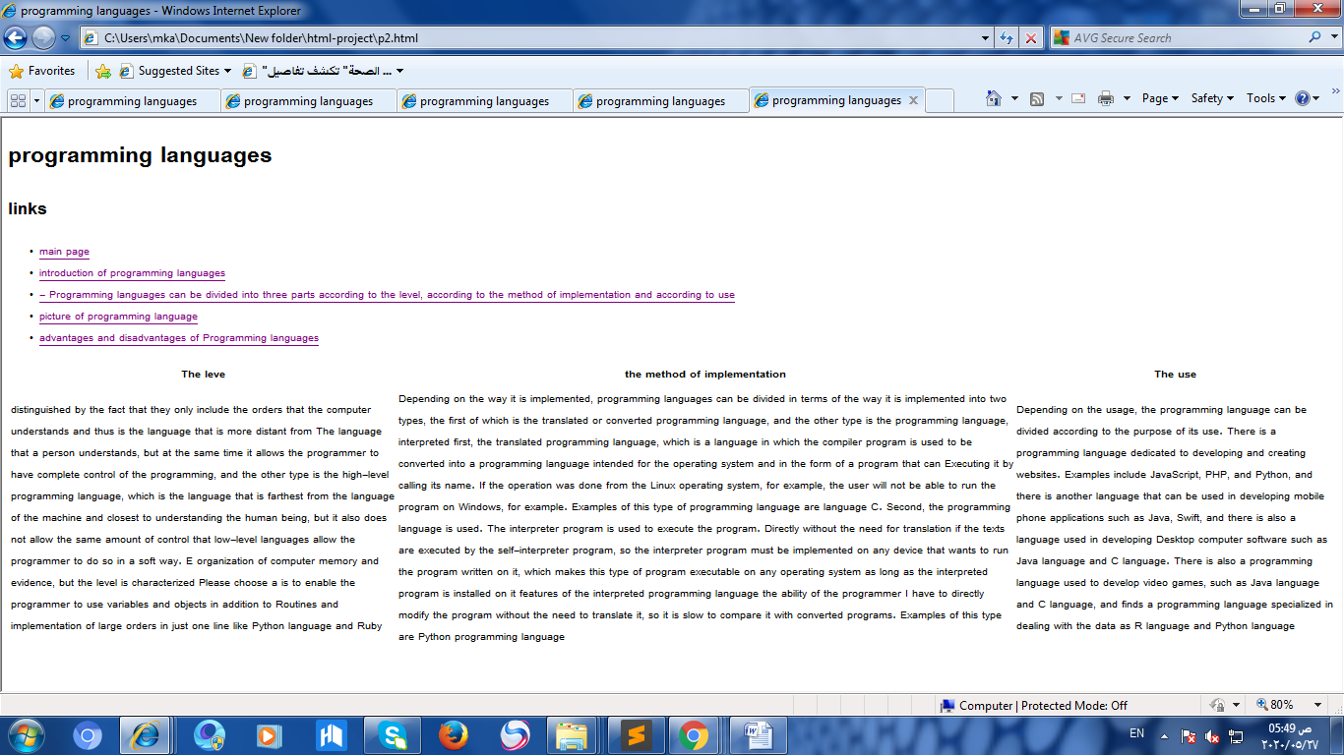

**Fig table**

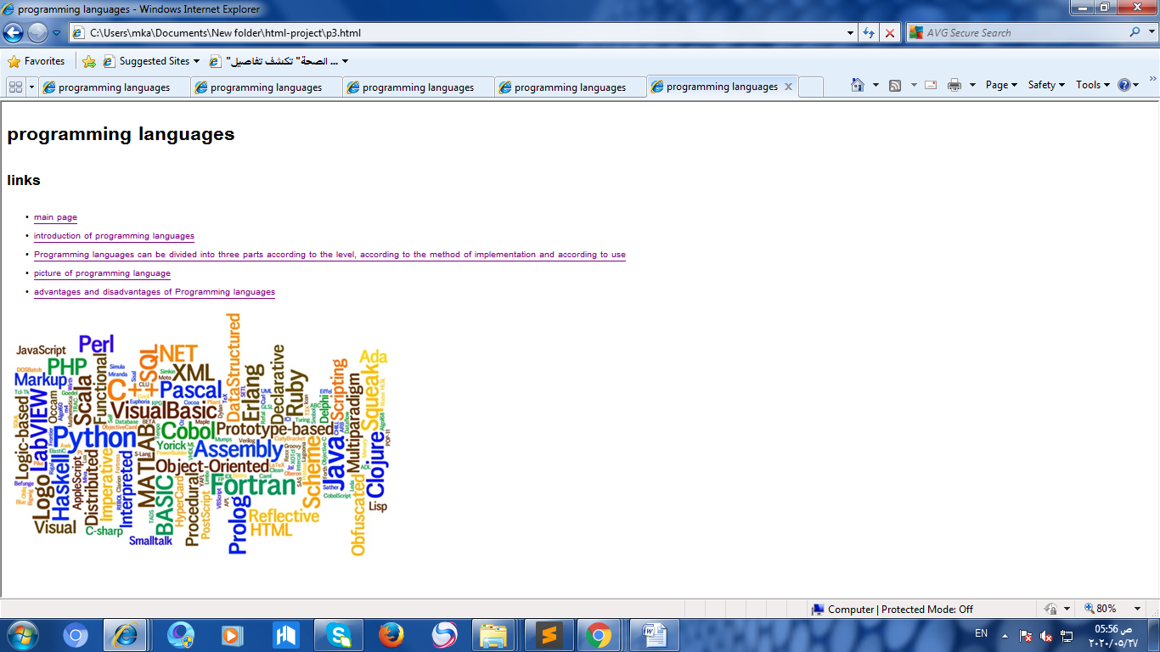

**Fig of image**

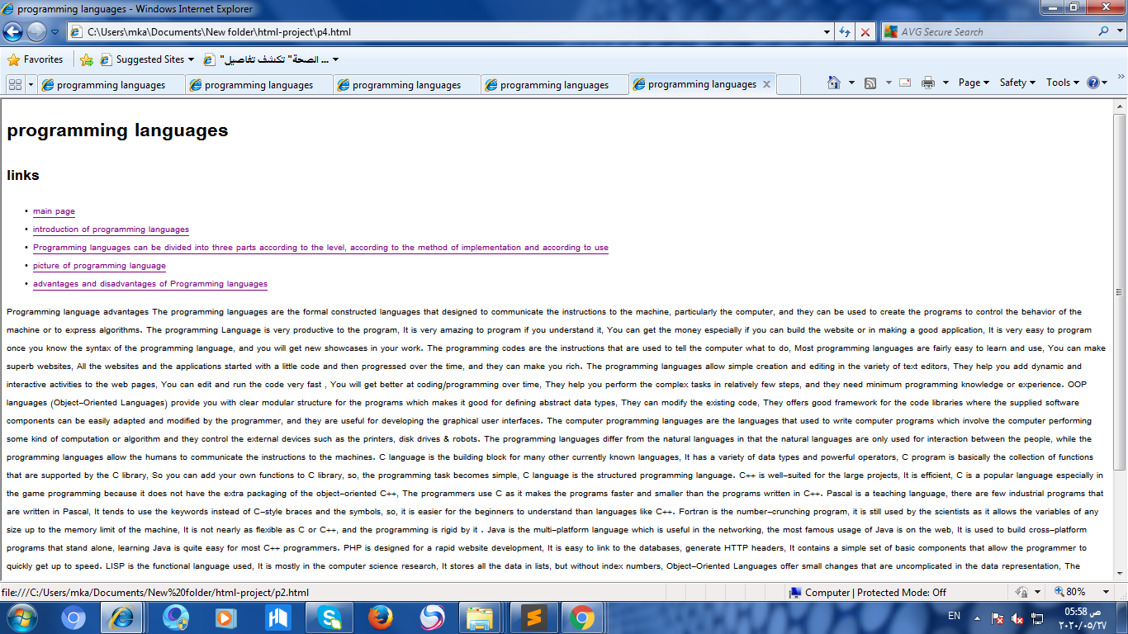

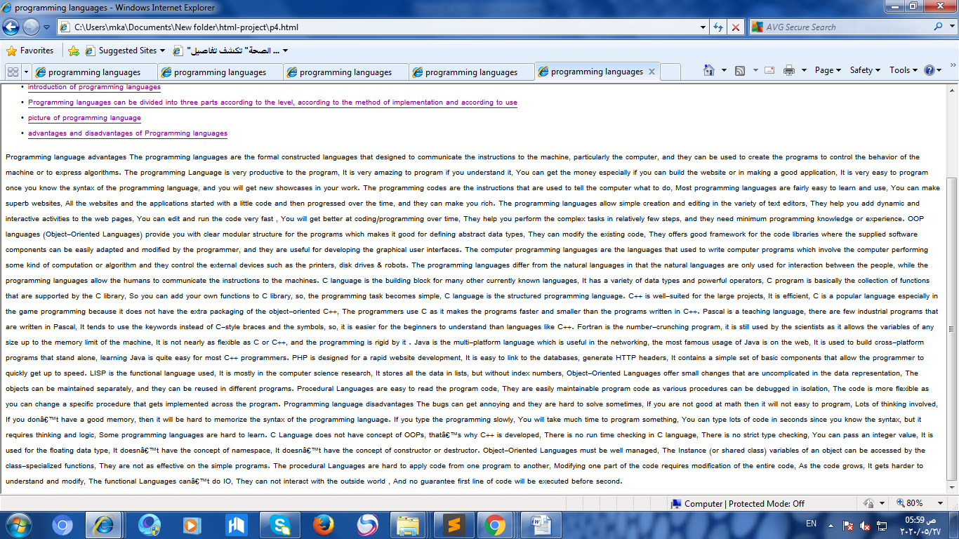

**Fig of advantages and disadvantages of some program language**

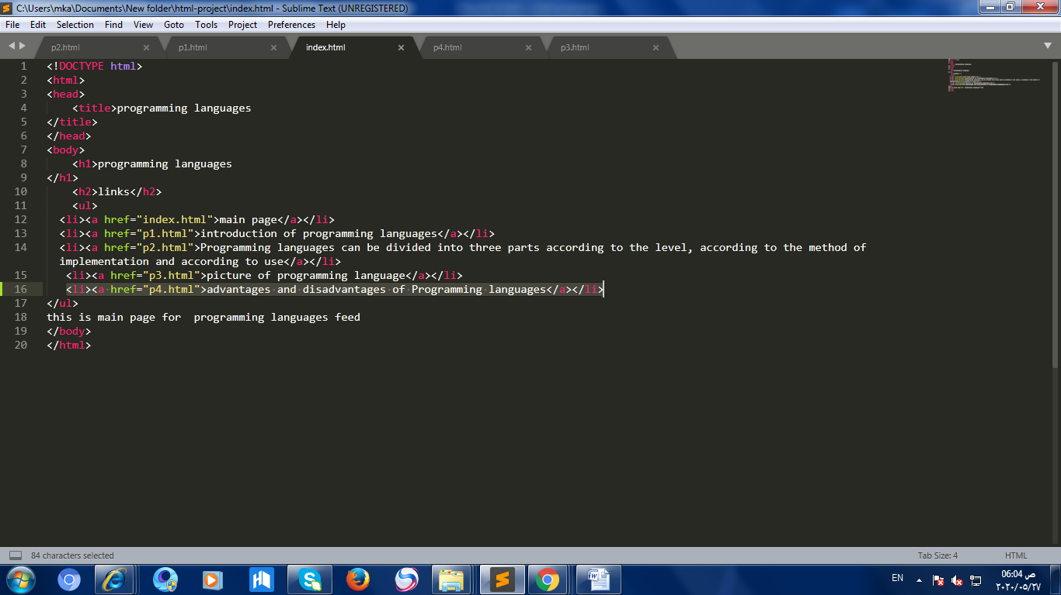

**Fig main page html**

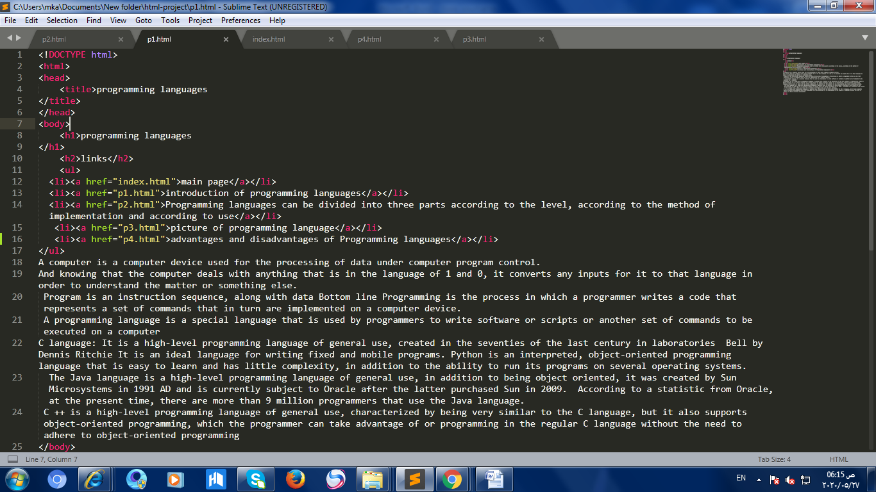

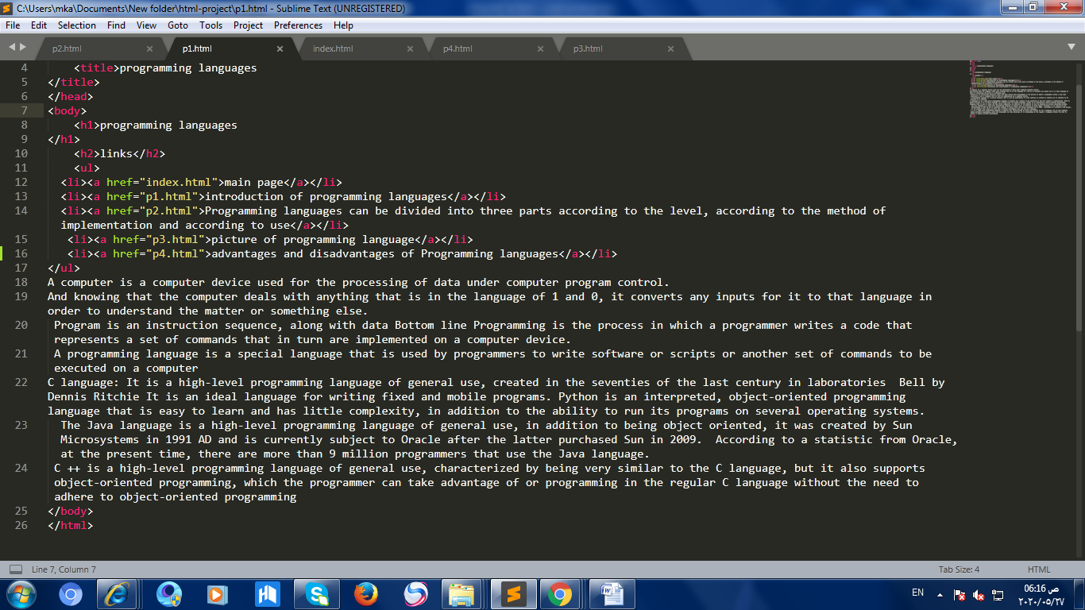

**Fig of introduction html**

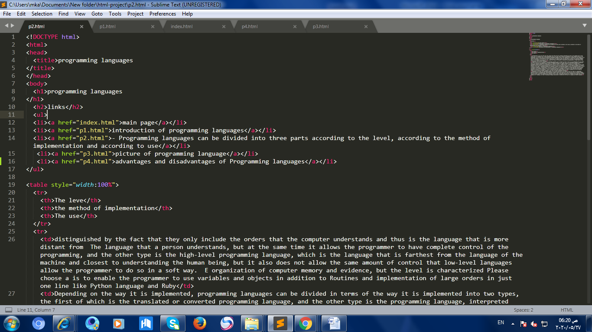 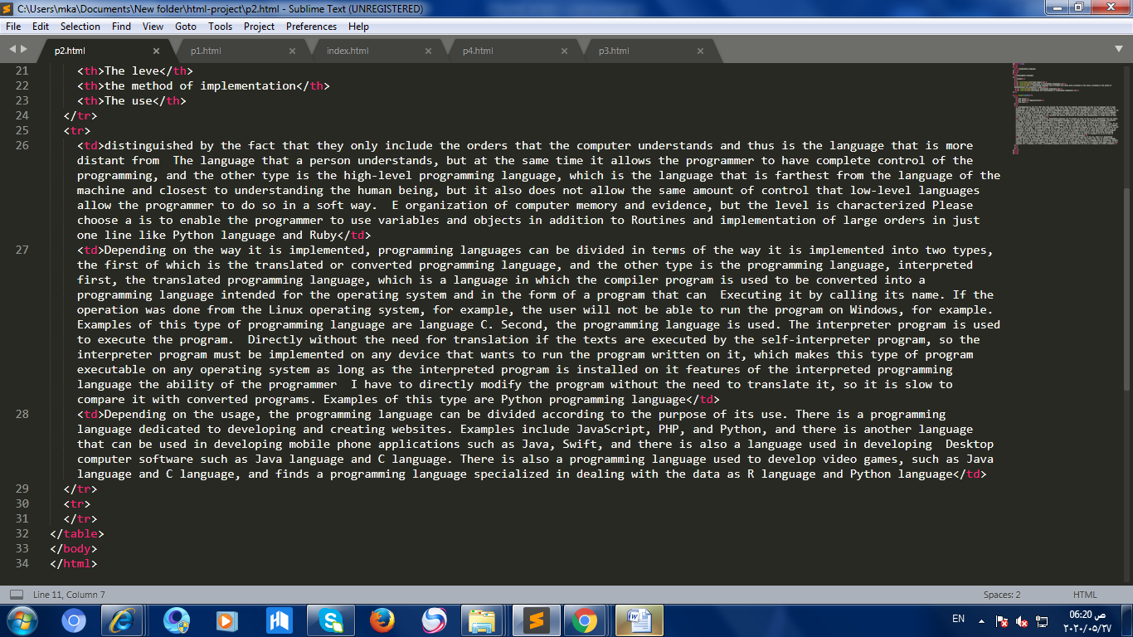 **Fig table html**

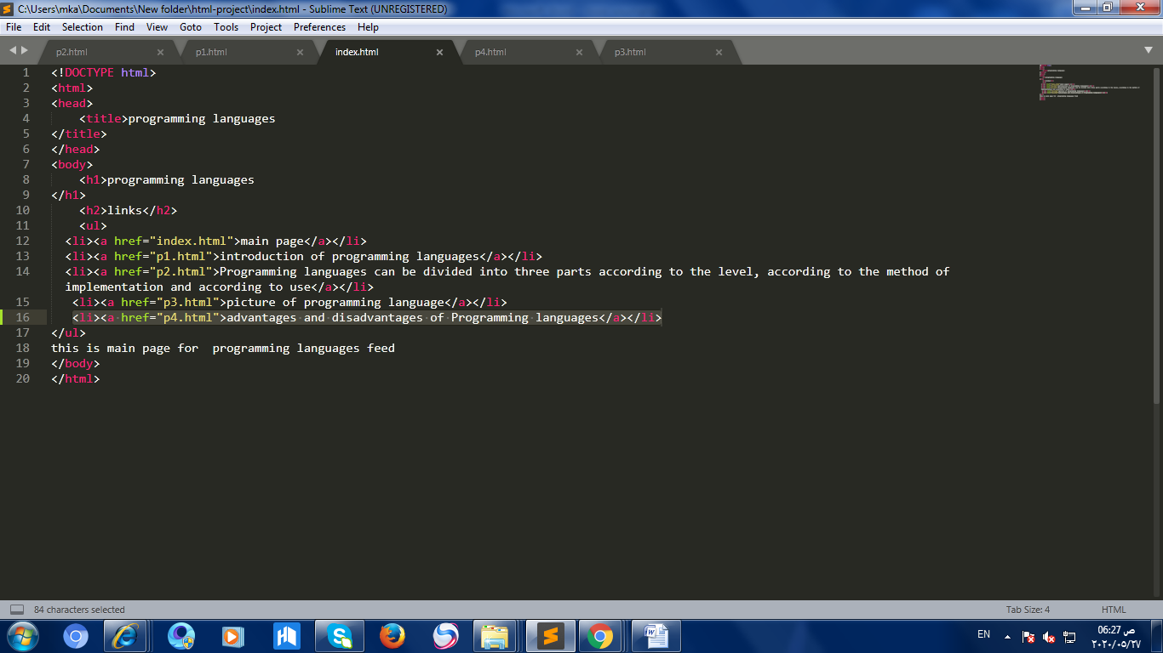

**Fig of image html**

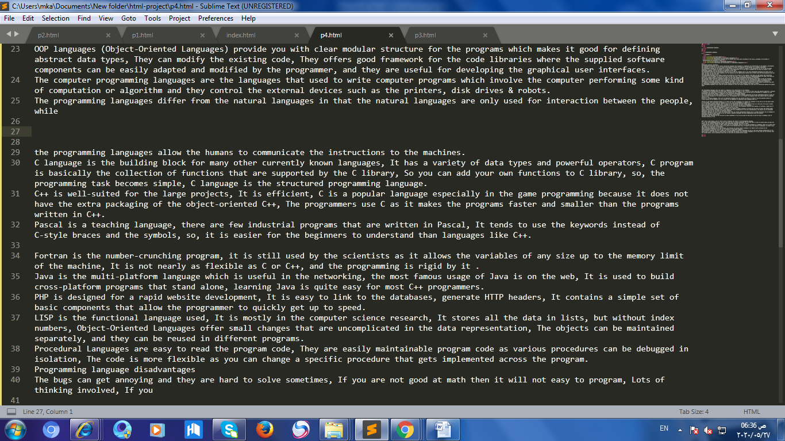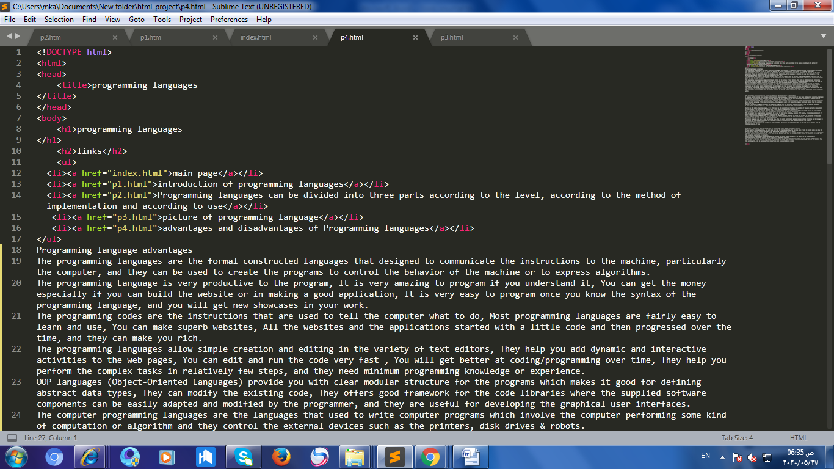

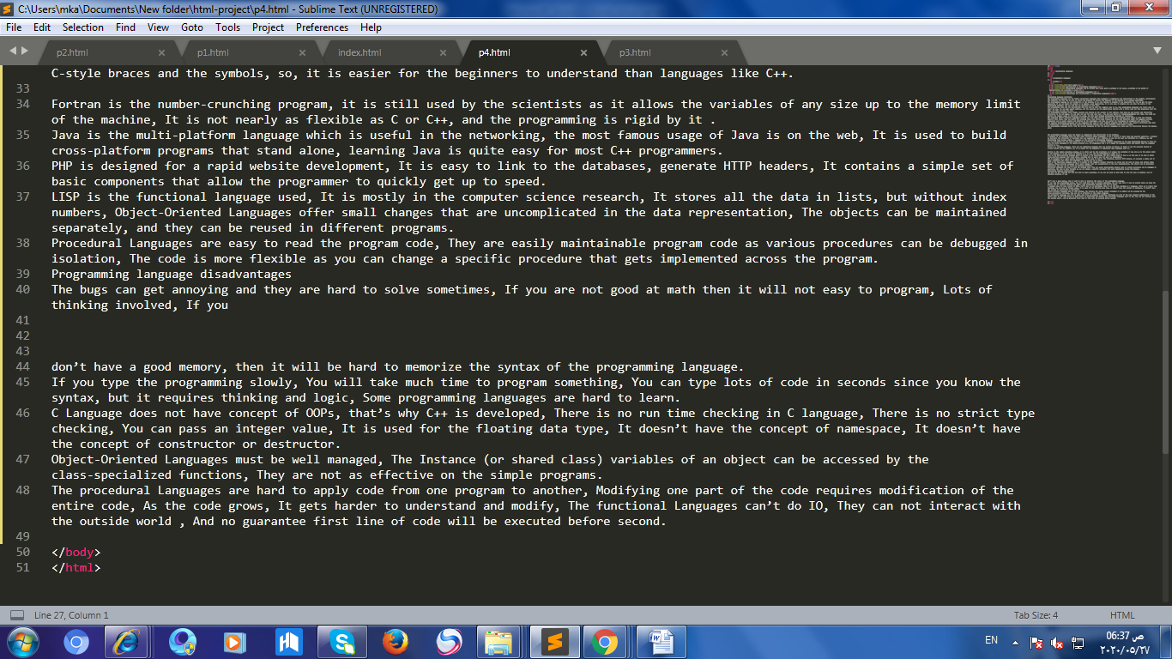

**Fig of advantages and disadvantages of some program language html**