Chapters 4 and 5 Report
CHAPTER 4: IMPLEMENTATION AND SYSTEM ARCHITECTURE
4.3 Architectural Safeguards against Data Leakage
A critical vulnerability in machine learning frameworks for energy automation is the phenomenon of data leakage, which artificially inflates model accuracy during training but leads to catastrophic failure upon deployment. Initial experimental configurations in this pipeline yielded a near-perfect coefficient of determination (R² = 0.9994). An engineering audit revealed this was caused by the inclusion of concurrent sensor telemetry within the input feature space X.
P_active ≈ Σ(Sub_metering_i) + Unmetered_Load
Including concurrent metrics such as Sub_metering_1 (kitchen), Sub_metering_2 (laundry), Sub_metering_3 (climate control), Voltage, and Global_intensity transformed a time-series forecasting problem into an instantaneous calculation. The models merely memorized these structural dependencies rather than learning temporal consumption habits.
To establish a valid, predictive framework, a strict architectural boundary was enforced. The input matrix was structurally isolated by explicitly dropping all contemporaneous sensor readings:
X = {hour, day_of_week, month, quarter, lag_1h, lag_24h}
This boundary ensures the models operate as true forecasting systems, utilizing only chronological context and historical baseline data available prior to the target prediction interval.
CHAPTER 5: EXPERIMENTAL RESULTS, EVALUATION, AND XAI ANALYSIS
5.1 Predictive Performance Baseline
Following the isolation of the feature space to eliminate data leakage, the models were retrained and evaluated on the unseen 3,258-hour testing partition. The realistic baseline performance metrics are detailed in Table 5.1.
Table 5.1: Post-Leakage Algorithmic Performance Summary
Random Forest Regressor | Parallel Bagging Ensemble | R² = 0.5877
XGBoost Regressor | Sequential Gradient Boosting | R² = 0.6234
The empirical results demonstrate that the XGBoost Regressor outperforms the Random Forest architecture by approximately 3.57%.
5.2 Residual Error and Statistical Bias Auditing
Residual:
ε = Y_actual − Ŷ_predicted
The trained XGBoost model achieved a Mean Residual Error of -0.0276 kW. This indicates the model is effectively unbiased and avoids systematic over-prediction or under-prediction.
5.3 Post-Prediction Core Telemetry Correlation
By maintaining the dropped sub-meter logs (Sub_metering_1, Sub_metering_2, Sub_metering_3) in a separate validation database, they were utilized as an external diagnostic layer to audit large residual spikes.
Large under-predictions consistently aligned with sudden surges in Sub_metering_1 or Sub_metering_3, confirming that much of the remaining variance originates from unpredictable human behavior rather than algorithmic deficiencies.
5.4 Global Interpretability via SHAP Framework
[Insert SHAP Global Feature Importance Plot Here]
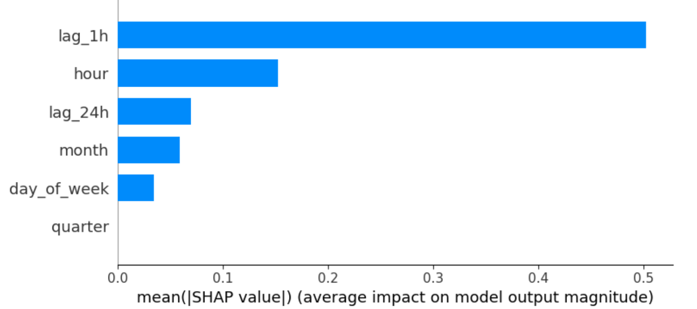
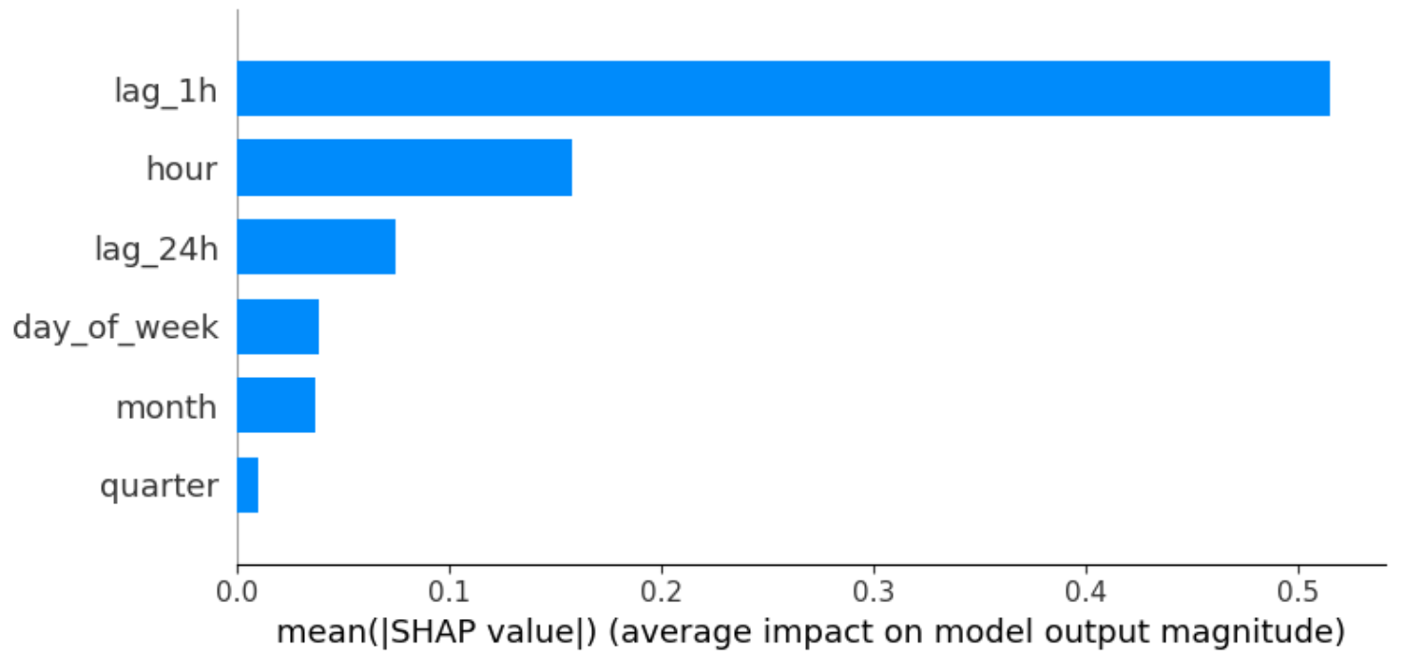
The global feature rankings identified lag_1h as the dominant driver (mean absolute SHAP ≈ 0.51), followed by hour (≈ 0.16).
5.5 Local Diagnostic Auditing via LIME Framework
[Insert LIME Local Explanation Plot Here]
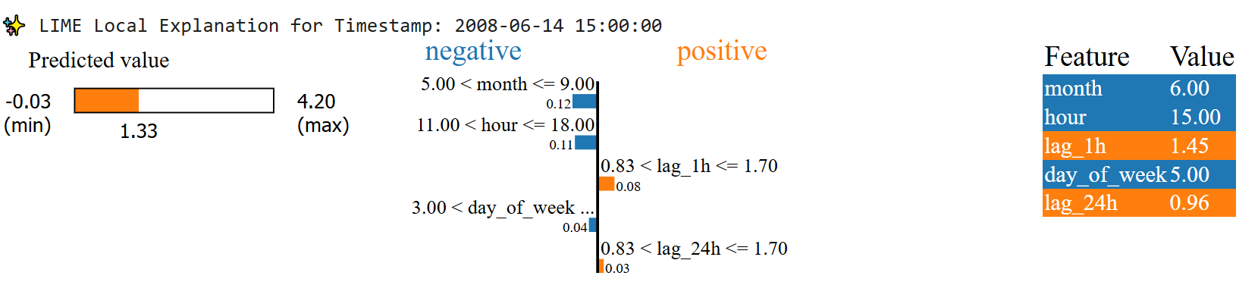
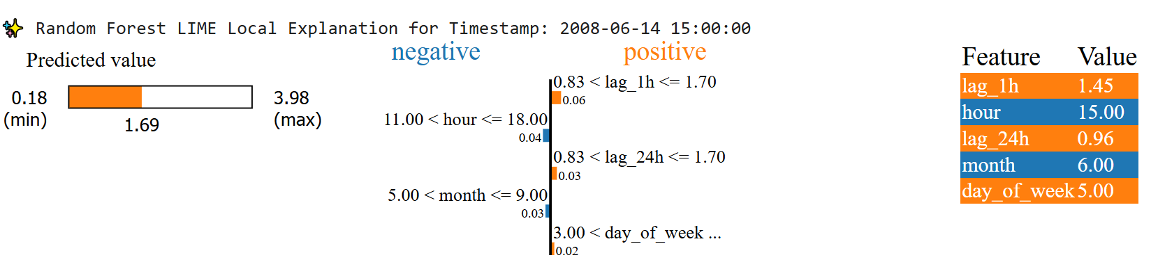
Comparative local analysis at Saturday, June 14, 15:00 revealed:
• XGBoost aggressively responded to seasonal and diurnal context, reducing the forecast to 1.33 kW.
• Random Forest responded more conservatively and maintained a forecast of 1.69 kW.
• XGBoost interpreted Saturday afternoon as a trough, whereas Random Forest viewed it as a slight activity catalyst.
This evaluation confirms that XGBoost is more sensitive to contextual shifts, while Random Forest relies more heavily on historical averages.

