

Functional Safety Concept Lane Assistance

**Document Version: 1.0**

**Template Version 1.0, Released on 2017-06-21**



# Document history

|  |  |  |  |
| --- | --- | --- | --- |
| Date | Version | Editor | Description |
| 24-Aug-2018 | 1.0 | Mohamed ZIEDAN | Initial Release |
|  |  |  |  |
|  |  |  |  |
|  |  |  |  |
|  |  |  |  |

# 

# Table of Contents

Document history

Table of Contents

Purpose of the Functional Safety Concept

Inputs to the Functional Safety Analysis

Safety goals from the Hazard Analysis and Risk Assessment

Preliminary Architecture

Description of architecture elements

Functional Safety Concept

Functional Safety Analysis

Functional Safety Requirements

Refinement of the System Architecture

Allocation of Functional Safety Requirements to Architecture Elements

Warning and Degradation Concept

# Purpose of the Functional Safety Concept

The goal of the Functional Safety Concept is to document the safety goals at a high level. New requirements may be identified to meet these safety goals and allocated to the appropriate part of the system. The document is restricted to the general functionality of the safety goals and does not extend to the technical details. The information from the Functional Safety Concept is used to create the Technical Safety Concept.

# Inputs to the Functional Safety Concept

## Safety goals from the Hazard Analysis and Risk Assessment

|  |  |
| --- | --- |
| **ID** | **Safety Goal** |
| Safety_Goal_01 | The oscillating torque from the Lane Departure Warning (LDW) function shall be limited. |
| Safety_Goal_02 | The lane keeping assistance function shall be time limited and the additional steering torque shall end after a given time interval so that the driver cannot misuse the system for autonomous driving. |

## Preliminary Architecture

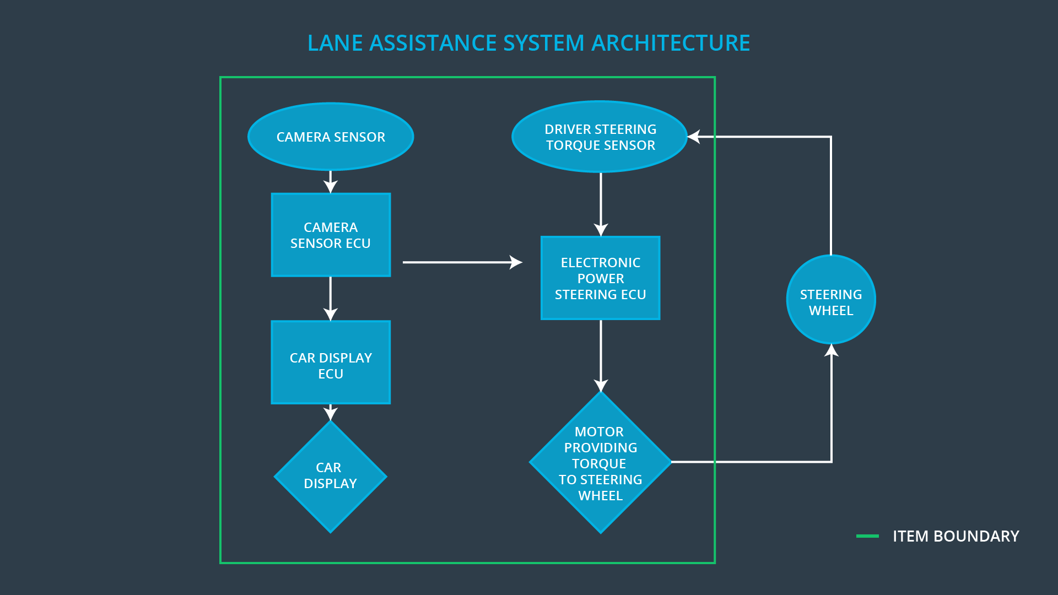

### Description of architecture elements

|  |  |
| --- | --- |
| **Element** | **Description** |
| Camera Sensor | Take images of the road |
| Camera Sensor ECU | detects lane departures, and tells the Electronic Power Steering ECU how hard to turn , and Car Display ECU to display a warning |
| Car Display | show a warning for the driver |
| Car Display ECU | receives a warning from Camera ECU, show Warning on Car Display |
| Driver Steering Torque Sensor | Detect how hard the driver is turning the steering wheel |
| Electronic Power Steering ECU | Analyze how hard the driver is turning the steering wheel, when it receives a warning from Camera Sensor ECU, it then decides the vibration required to alert the driver, and output a torque value to the motor . |
| Motor | The motor will provide the torque to steering wheel. |

# Functional Safety Concept

The functional safety concept consists of:

* Functional safety analysis
* Functional safety requirements
* Functional safety architecture
* Warning and degradation concept

## Functional Safety Analysis

|  |  |  |  |
| --- | --- | --- | --- |
| **Malfunction ID** | **Main Function of the Item Related to Safety Goal Violations** | **Guidewords (NO, WRONG, EARLY, LATE, MORE, LESS)** | **Resulting Malfunction** |
| Malfunction_01 | Lane Departure Warning (LDW) function shall apply an oscillating steering torque to provide the driver a haptic feedback | MORE | The lane departure warning function applies an oscillating torque with very high torque amplitude (above limit) |
| Malfunction_02 | Lane Departure Warning (LDW) function shall apply an oscillating steering torque to provide the driver a haptic feedback | MORE | The lane departure warning function applies an oscillating torque with very high torque amplitude (above limit) |
| Malfunction_03 | Lane Keeping Assistance (LKA) function shall apply the steering torque when active in order to stay in ego lane | NO | The lane keeping assistance function is not limited in time duration which leads to misuse as an autonomous driving function. |

## Functional Safety Requirements

Lane Departure Warning (LDW) Requirements:

|  |  |  |  |  |
| --- | --- | --- | --- | --- |
| **ID** | **Functional Safety Requirement** | **ASIL** | **Fault Tolerant Time Interval** | **Safe State** |
| Functional  Safety  Requirement  01-01 | The lane keeping item shall ensure that the lane departure oscillating torque amplitude is below *Max_Torque_Amplitude* | C | 50ms (Diagnostic Test Interval + Fault Reaction Time + Time in Safe State) | Switch Off Lane Assistance System |
| Functional  Safety  Requirement  01-02 | The lane keeping item shall ensure that the lane departure oscillating torque frequency is below *Max_Torque_Frequency* | C | 50ms (Diagnostic Test Interval + Fault Reaction Time + Time in Safe State) | Switch Off Lane Assistance System |

Lane Departure Warning (LDW) Verification and Validation Acceptance Criteria:

|  |  |  |
| --- | --- | --- |
| **ID** | **Validation Acceptance**  **Criteria and Method** | **Verification Acceptance**  **Criteria and Method** |
| Functional  Safety  Requirement  01-01 | test how drivers react to different torque amplitudes to prove that we chose an appropriate *Max_Torque_Amplitude* value. | when the torque amplitude crosses the limit, the lane assistance output is set to zero within the 50 ms fault tolerant time interval. |
| Functional  Safety  Requirement  01-02 | test how drivers react to different torque frequencies to prove that we chose an appropriate *Max_Torque_Amplitude* value. | when the torque frequency crosses the limit, the lane assistance output is set to zero within the 50 ms fault tolerant time interval. |

Lane Keeping Assistance (LKA) Requirements:

|  |  |  |  |  |
| --- | --- | --- | --- | --- |
| **ID** | **Functional Safety Requirement** | **ASIL** | **Fault Tolerant Time Interval** | **Safe State** |
| Functional  Safety  Requirement  02-01 | The lane keeping item shall ensure that the lane keeping assistance torque is applied for only *Max_Duration* | B | 500 ms | Switch Off Lane Assistance System |

Lane Keeping Assistance (LKA) Verification and Validation Acceptance Criteria:

|  |  |  |
| --- | --- | --- |
| **ID** | **Validation Acceptance**  **Criteria and Method** | **Verification Acceptance**  **Criteria and Method** |
| Functional  Safety  Requirement  02-01 | test and validate that the *Max_Duration* chosen really did dissuade drivers from taking their hands off the wheel. | verify that the system really does turn off if the lane keeping assistance every exceeded *Max_Duration*. |

## Refinement of the System Architecture

## Allocation of Functional Safety Requirements to Architecture Elements

|  |  |  |  |  |
| --- | --- | --- | --- | --- |
| **ID** | **Functional Safety Requirement** | **Electronic Power Steering ECU** | **Camera ECU** | **Car Display ECU** |
| Functional  Safety  Requirement  01-01 | The lane keeping item shall ensure that the lane departure oscillating torque amplitude is below *Max_Torque_Amplitude* |  |  |  |
| Functional  Safety  Requirement  01-02 | The lane keeping item shall ensure that the lane departure oscillating torque frequency is below *Max_Torque_Frequency* |  |  |  |
| Functional  Safety  Requirement  02-01 | The lane keeping item shall ensure that the lane keeping assistance torque is applied for only *Max_Duration* |  |  |  |

## Warning and Degradation Concept

|  |  |  |  |  |
| --- | --- | --- | --- | --- |
| **ID** | **Degradation Mode** | **Trigger for Degradation Mode** | **Safe State invoked?** | **Driver Warning** |
| WDC-01 | turn off the functionality | Functional  Safety  Requirement  01-01 is violated | YES | Display Warning on display system, and different Haptic feedback on the steering wheel |
| WDC-02 | turn off the functionality | Functional  Safety  Requirement  02-01 is violated | YES | Display Warning on display system, and beep sound. |