

Technical Safety Concept Lane Assistance

**Document Version: 1.0**

**Template Version 1.0, Released on 2017-06-21**



# Document history

|  |  |  |  |
| --- | --- | --- | --- |
| Date | Version | Editor | Description |
| 24-Aug-2018 | 1.0 | Mohamed ZIEDAN | Initial Release |
|  |  |  |  |
|  |  |  |  |
|  |  |  |  |
|  |  |  |  |

# 

# Table of Contents

Document history

Table of Contents

Purpose of the Technical Safety Concept

Inputs to the Technical Safety Concept

Functional Safety Requirements

Refined System Architecture from Functional Safety Concept

Functional overview of architecture elements

Technical Safety Concept

Technical Safety Requirements

Refinement of the System Architecture

Allocation of Technical Safety Requirements to Architecture Elements

Warning and Degradation Concept

# Purpose of the Technical Safety Concept

The technical safety concept defines how the subsystems interact at the message level and describes how the ECUs communicate with each other.

# Inputs to the Technical Safety Concept

## Functional Safety Requirements

|  |  |  |  |  |
| --- | --- | --- | --- | --- |
| **ID** | **Functional Safety Requirement** | **ASIL** | **Fault Tolerant Time Interval** | **Safe State** |
| Functional  Safety  Requirement  01-01 | Electronic Power Steering ECU shall ensure that the lane departure oscillating torque amplitude is below *Max_Torque_Amplitude* | C | 50ms | LDW will set the oscillating torque amplitude to 0 |
| Functional  Safety  Requirement  01-02 | Electronic Power Steering ECU shall ensure that the lane departure oscillating torque frequency is below *Max_Torque_Frequency* | C | 50ms | LDW will set the oscillating torque frequency to 0 |
| Functional  Safety  Requirement  02-01 | Electronic Power Steering ECU shall ensure that the lane keeping assistance torque is applied for only *Max_Duration* | B | 500ms | LKA will set the oscillating torque Duration to 0 |

## Refined System Architecture from Functional Safety Concept

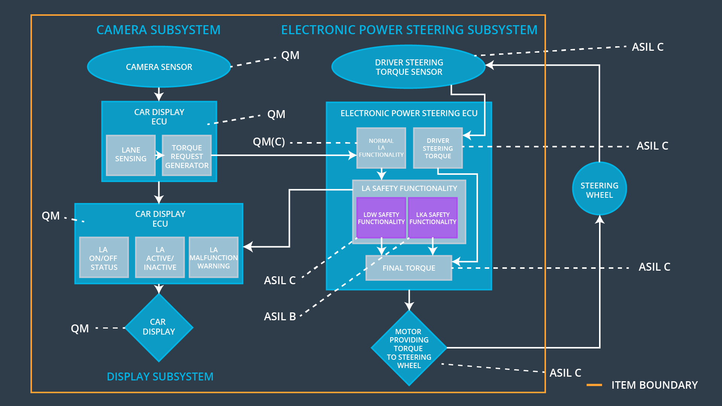

### Functional overview of architecture elements

|  |  |
| --- | --- |
| **Element** | **Description** |
| Camera Sensor | Take images of the road |
| Camera Sensor ECU - Lane Sensing | Detects lanes on road, and lane departures |
| Camera Sensor ECU - Torque request generator | tells the Electronic Power Steering ECU how hard to turn , and Car Display ECU to display a warning` |
| Car Display | show a warning for the driver |
| Car Display ECU - Lane Assistance On/Off Status | receives a warning from Electronic Power Steering (EPS) ECU, show Lane Assistance status |
| Car Display ECU - Lane Assistant Active/Inactive | receives a warning from Electronic Power Steering (EPS) ECU, show Lane Assistant Activity state |
| Car Display ECU - Lane Assistance malfunction warning | receives a warning from Electronic Power Steering (EPS) ECU, show Warning on Lane Assistance malfunction |
| Driver Steering Torque Sensor | Detect how hard the driver is turning the steering  Wheel |
| Electronic Power Steering (EPS) ECU - Driver Steering Torque | Analyze how hard the driver is turning the steering  wheel, and contribute at the 'FINAL TORQUE' |
| EPS ECU - Normal Lane Assistance Functionality | receives a warning from Camera  Sensor ECU, it then decides the vibration required to warn driver and how much steering torque is required |
| EPS ECU - Lane Departure Warning Safety Functionality | Analyze and decides the vibration required to warn driver and how much steering torque is required, then send contribute at the 'FINAL TORQUE', and alert Car Display ECU |
| EPS ECU - Lane Keeping Assistant Safety Functionality | Analyze and decides the duration required to run the LKA item, then send contribute at the 'FINAL TORQUE' and Alert Car Display ECU |
| EPS ECU - Final Torque | Receives inputs from LKA Safety, LDW Safety , and Driver Steering Torque to product the FINAL TORQUE amount that will be passed to steering Motor |
| Motor | motor will provide the torque to steering wheel |

# Technical Safety Concept

## Technical Safety Requirements

**Lane Departure Warning (LDW) Requirements:**

Functional Safety Requirement 01-01 with its associated system elements

(derived in the functional safety concept)

|  |  |  |  |  |
| --- | --- | --- | --- | --- |
| **ID** | **Functional Safety Requirement** | **Electronic Power Steering ECU** | **Camera ECU** | **Car Display ECU** |
| Functional  Safety  Requirement  01-01 | The lane keeping item shall ensure that the lane departure oscillating torque amplitude is below *Max_Torque_Amplitude* | X |  |  |

Technical Safety Requirements related to Functional Safety Requirement 01-01 are:

|  |  |  |  |  |  |
| --- | --- | --- | --- | --- | --- |
| **ID** | **Technical Safety Requirement** | **ASIL** | **Fault Tolerant Time Interval** | **Architecture Allocation** | **Safe State** |
| Technical  Safety  Requirement  01 | The LDW safety component shall ensure that the amplitude of the *'LDW_Torque_Request*' sent to the 'Final electronic power steering Torque' component is below *'Max_Torque_Amplitude* | C | 50ms | Lane Assistance Safety Functionality | Deactivate functionality (reset Amplitude to 0) |
| Technical  Safety  Requirement  02 | As soon as the LDW function deactivates the LDW feature, the 'LDW Safety' software block shall send a signal to the car display ECU to turn on a warning light | C | 50ms | LDW Safety Functionality | Deactivate functionality (reset Amplitude to 0) |
| Technical  Safety  Requirement  03 | As soon as a failure is detected by the LDW function, it shall deactivate the LDW feature and the '*LDW_Torque_Request*' shall be set to zero | C | 50ms | LDW Safety Functionality | Deactivate functionality (reset Amplitude to 0) |
| Technical  Safety  Requirement  04 | The validity and integrity of the data transmission for '*LDW_Torque_Request*' signal shall be ensured | C | 50ms | Data Transmission Integrity Check | Deactivate functionality (reset Amplitude to 0) |
| Technical  Safety  Requirement  05 | Memory test shall be conducted at startup of the EPS ECU to check for any faults in memory | A | ignition cycle | SAFETY STARTUP | *Max_Torque_Amplitude* is correct and Deactivate Functionality will reset Amplitude to 0 |

Functional Safety Requirement 01-2 with its associated system elements

(derived in the functional safety concept)

|  |  |  |  |  |
| --- | --- | --- | --- | --- |
| **ID** | **Functional Safety Requirement** | **Electronic Power Steering ECU** | **Camera ECU** | **Car Display ECU** |
| Functional  Safety  Requirement  01-02 | The lane keeping item shall ensure that the lane departure oscillating torque frequency is below *Max_Torque_Frequency* | X |  |  |

Technical Safety Requirements related to Functional Safety Requirement 01-02 are:

|  |  |  |  |  |  |
| --- | --- | --- | --- | --- | --- |
| **ID** | **Technical Safety Requirement** | **ASIL** | **Fault Tolerant Time Interval** | **Architecture Allocation** | **Safe State** |
| Technical  Safety  Requirement  01 | The LDW safety component shall ensure that the Frequency of the '*LDW_Frequency_Request*' sent to the 'Final electronic power steering Torque' component is below *Max_Torque_Frequency* | C | 50ms | Lane Assistance Safety Functionality | Deactivate functionality (reset Frequency to 0) |
| Technical  Safety  Requirement  02 | As soon as the LDW function deactivates the LDW feature, the 'LDW Safety' software block shall send a signal to the car display ECU to turn on a warning light | C | 50ms | LDW Safety Functionality | Deactivate functionality (reset Frequency to 0) |
| Technical  Safety  Requirement  03 | As soon as a failure is detected by the LDW function, it shall deactivate the LDW feature and the '*LDW_Frequency_Request*' shall be set to zero | C | 50ms | LDW Safety Functionality | Deactivate functionality (reset Frequency to 0) |
| Technical  Safety  Requirement  04 | The validity and integrity of the data transmission for '*LDW_Frequency_Request*' signal shall be ensured | C | 50ms | Data Transmission Integrity Check | Deactivate functionality (reset Frequency to 0) |
| Technical  Safety  Requirement  05 | Memory test shall be conducted at startup of the EPS ECU to check for any faults in memory | A | ignition cycle | SAFETY STARTUP | *Max_Torque_Frequency* is correct & Deactivate Functionality will reset Frequency to 0 |

**Lane Departure Warning (LDW) Verification and Validation Acceptance Criteria:**

**Lane Keeping Assistance (LKA) Requirements:**

Functional Safety Requirement 02-1 with its associated system elements

(derived in the functional safety concept)

|  |  |  |  |  |
| --- | --- | --- | --- | --- |
| **ID** | **Functional Safety Requirement** | **Electronic Power Steering ECU** | **Camera ECU** | **Car Display ECU** |
| Functional  Safety  Requirement  02-01 | The lane keeping item shall ensure that the lane keeping assistance torque is applied for only *Max_Duration* | X |  |  |

Technical Safety Requirements related to Functional Safety Requirement 02-01 are:

|  |  |  |  |  |  |
| --- | --- | --- | --- | --- | --- |
| **ID** | **Technical Safety Requirement** | **ASIL** | **Fault Tolerant Time Interval** | **Allocation to Architecture** | **Safe State** |
| Technical  Safety  Requirement  01 | The LKA safety component shall ensure that the Duration of the '*LKA_Duration_Request*' sent to the 'Final electronic power steering Torque' component is below *Max_Duration* | C | 50ms | Lane Assistance Safety Functionality | Deactivate functionality (reset Duration to 0) |
| Technical  Safety  Requirement  02 | As soon as the LKA function deactivates the LKA feature, the 'LKA Safety' software block shall send a signal to the car display ECU to turn on a warning light | C | 50ms | LKA Safety Functionality | Deactivate functionality (reset Duration to 0) |
| Technical  Safety  Requirement  03 | As soon as a failure is detected by the LKA function, it shall deactivate the LKA feature and the '*LKA_Duration_Request*' shall be set to zero | C | 50ms | LKA Safety Functionality | Deactivate functionality (reset Duration to 0) |
| Technical  Safety  Requirement  04 | The validity and integrity of the data transmission for '*LKA_Duration_Request*' signal shall be ensured | C | 50ms | Data Transmission Integrity Check | Deactivate functionality (reset Duration to 0) |
| Technical  Safety  Requirement  05 | Memory test shall be conducted at startup of the EPS ECU to check for any faults in memory | A | ignition cycle | SAFETY STARTUP | Max_ Duration is correct, and Deactivate Functionality will reset Duration to 0 |

**Lane Keeping Assistance (LKA) Verification and Validation Acceptance Criteria:**

## Refinement of the System Architecture

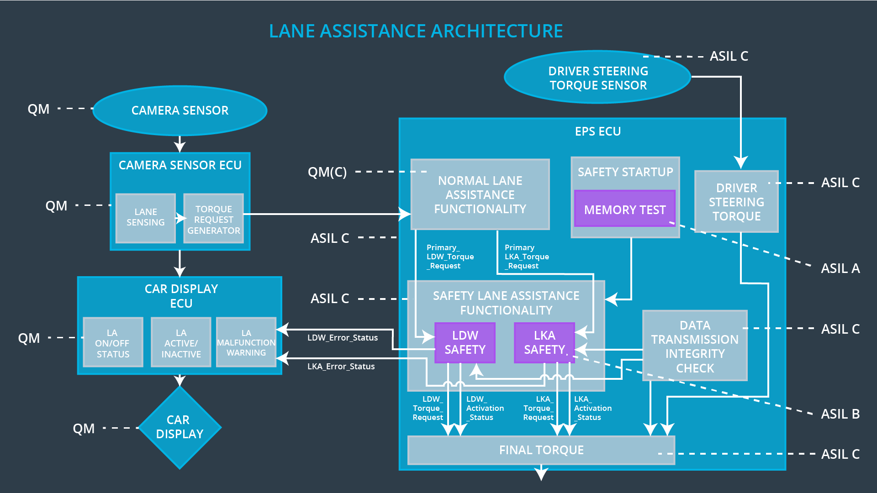

## Allocation of Technical Safety Requirements to Architecture Elements

All technical safety requirements are allocated to the Electronic Power Steering ECU

## Warning and Degradation Concept

|  |  |  |  |  |
| --- | --- | --- | --- | --- |
| **ID** | **Degradation Mode** | **Trigger for Degradation Mode** | **Safe State invoked?** | **Driver Warning** |
| WDC-01 | turn off the functionality | Functional  Safety  Requirement  01-01 is violated | YES | Display Warning on display system, and different Haptic feedback on the steering wheel |
| WDC-02 | turn off the functionality | Functional  Safety  Requirement  02-01 is violated | YES | Display Warning on display system, and beep sound. |