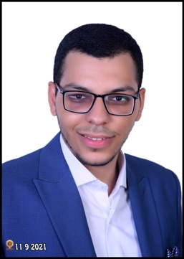

Youssef essam halawa

PROFILE

Contact

A Fresh graduate Pharmacist, I am a self-motivated person who is willing to get into and gain experience in the field of medical Rep and marketing, Also I’m willing to develop myself more and more so one of my interests is Digital Marketing.

0 114 0356 058

Youssefhalawa4@gmail.com

Toukh, Qalyubia, Egypt

Objective

To obtain a position as Medical Representative with growing company in which to enhance my skills, gain experience, and help company growing.

Military status

**Exempted**

skills

2016 – 2021

education

**Faculty of Pharmacy Zagazig University**

Bachelor’s degree of Pharmacy.

Degree: Very Good.

* Team Work
* Fast Learner
* Attention to Detail
* Patience

experience

**Community Pharmacy Training**

Training

**Double Bond Company**

Medical Rep Internship

6 Mo (2020)

Computer skills

* Microsoft Word
* Microsoft Excel
* Adobe Premier

2020

Courses

* Industrial pharmacy

Football

Video Editing

INTERESTS

Arabic

English

Language