Code & Name of the Course | 1413002043 Blockchain Systems
Lecturer | Prof. Dr. Vedat COSKUN
Name & Lastname | Muhammed Emin DENİZ
Student ID | 220504018
URL of Your Project | https://muhammeddeniz33.github.io/FreshChain/
Admin Account | 0x1C967E7EE80058B38f4b3bC2Aac58009bDa01E84
Producer Account | 0x43E2263775f8687BAD763362f7ee25eb8D995aE2
Transporter Account | 0x316131122B0D704BbcbADF35627bb57cD52597e3
Distributer Account | 0xc36649b492B21F54c89d113496920c694762a8BD
Retailer Account | 0x91E93fe881535D105611169E1f6F9Ef7868de361

1 Introduction
Modern food supply chains involve multiple stakeholders from production to consumption, and therefore face significant challenges in terms of transparency, data integrity, and reliability. Traditional logistics infrastructures based on centralized systems make it difficult to verify product history accurately due to fragmented data storage, manual recording processes, and vulnerability to unauthorized modifications. These issues become especially critical for perishable food products (such as fruits, vegetables, and dairy), where the inability to properly monitor transportation and storage conditions poses serious risks to both food safety and consumer trust.

FreshChain is a blockchain-based, decentralized food traceability system designed to address these challenges. The primary objective of FreshChain is to track the entire lifecycle of a food product—from the producer to the final consumer—on an immutable, transparent, and verifiable digital ledger, ensuring that all relevant data remains trustworthy for every stakeholder.

The system records all critical supply chain events through smart contracts deployed on the Ethereum Sepolia Testnet. FreshChain’s architecture consists of multiple integrated components: a frontend web application, Solidity smart contracts, the Ethereum blockchain network, a public product history page, and a QR-based verification mechanism. In Web3-based interactions (Admin, Producer, Transporter, Distributor, and Retailer), users write data to the blockchain by sending authenticated transactions through MetaMask. In contrast, the Web2-based public access model allows customers to view product history in read-only mode without any wallet connection or authentication. This distinction is an intentional design choice that enhances security while keeping the user experience simple for consumers. The system operates on a role-based access control model.

In this model, each actor’s permitted blockchain operations directly reflect their real-world responsibilities within the supply chain. The Admin acts as the system manager, responsible for registering and authorizing all actors; this central authority prevents unauthorized addresses from interacting with privileged smart contract functions. The Producer (Farmer), as the origin of the supply chain, is authorized to create product batches. The Transporter is the only role permitted to record environmental data—such as temperature, humidity, and location—because they oversee the physical transportation process. The Distributor manages storage and intermediate distribution and is therefore able to transfer product ownership. The Retailer, positioned at the final checkpoint, is authorized to perform the final acceptance and quality inspection. Conversely, the Customer role is intentionally designed as read-only; although customers need to verify product history, allowing them to modify data would compromise system security. For this reason, customer access is strictly limited to non-destructive (read-only) operations.

Restricting write permissions to authorized actors prevents unauthorized changes, preserves the immutability of blockchain records, and ensures overall data integrity throughout the system.

FreshChain’s data model is structured around batch-based traceability. Each product batch is represented as a Batch entity identified by a unique Batch ID. This Batch structure stores product information, ownership status, environmental conditions recorded during transportation, and final inspection results as a unified dataset. Temperature, humidity, and location values recorded during transport are stored as multiple SensorRecord entries linked to the corresponding batch, enabling immutable tracking of environmental conditions over time. Ownership data and quality control results are also maintained as part of the batch state, clearly indicating the product’s stage within the supply chain. This data model ensures that product history is represented not as fragmented elements but as a coherent, verifiable whole.

In conclusion, FreshChain integrates blockchain technology’s immutability, transparency, and trust features into modern food logistics, offering a comprehensive traceability solution. By eliminating reliance on centralized systems, this project demonstrates that a secure and verifiable food tracking infrastructure is achievable for both supply chain stakeholders and end consumers.

2 System Analysis and Design
2.1 System Architecture
The FreshChain system is designed as a hybrid Web3–Web2 architecture that combines blockchain-based data integrity with public accessibility. Supply chain actors (Admin, Producer, Transporter, Distributor, and Retailer) interact with the system through a role-based user interface and a Web3 integration layer. These interactions are authenticated via the MetaMask wallet and executed on the Ethereum network through the FreshChain smart contract, ensuring secure and authorized data writing operations. All state changes and records are permanently stored on the blockchain ledger.

In contrast, customers access the system through a public product history page using a QR code or history URL generated by the frontend. This Web2-based access is strictly read-only and retrieves data directly from the smart contract without requiring wallet connection. This architectural separation ensures both data integrity and usability by restricting write operations to authorized actors while allowing transparent product verification for end users.(Figure-1)

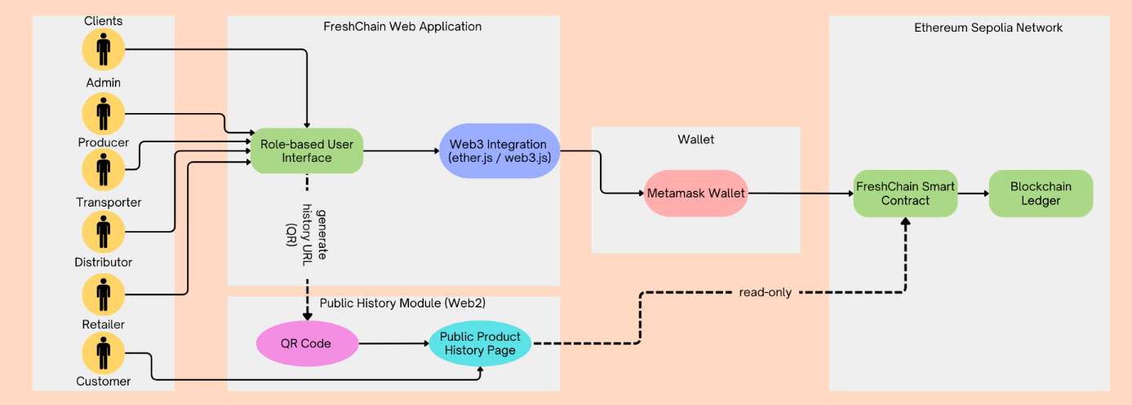
Figure 1
2.2.1) Role-Based Supply Chain Model:
The FreshChain system adopts a role-based supply chain model to accurately reflect real-world responsibilities within the food logistics process and to ensure secure interaction with the blockchain. In decentralized systems, unrestricted access to data creation and modification may lead to inconsistencies and security risks. Therefore, FreshChain assigns clearly defined roles and permissions to each participant, ensuring that blockchain transactions are performed only by authorized actors whose responsibilities correspond to specific stages of the supply chain. This approach enhances system security, preserves data integrity, and guarantees accountability throughout the product lifecycle.
2.2.2) Actor Roles and Responsibilities
Admin
The Admin serves as the governing authority of the FreshChain system. This role is responsible for registering supply chain participants and assigning their respective roles within the smart contract. By controlling access at the system level, the Admin prevents unauthorized blockchain addresses from interacting with critical smart contract functions, ensuring a controlled and secure operational environment.
Producer
The Producer represents the origin of the supply chain and is responsible for initiating the product lifecycle. This role creates product batches on the blockchain by assigning a unique Batch ID, product name, and quantity. The creation of a batch establishes the initial immutable record for the product and serves as the foundation for all subsequent traceability and verification processes.
Transporter
The Transporter is responsible for physically delivering the product between supply chain stages. During transportation, this role records critical environmental conditions—such as temperature and humidity—directly onto the blockchain. These sensor measurements are stored as immutable records, ensuring that handling conditions can be transparently audited and verified at any point in the product’s lifecycle.
Distributor
Following transportation, the Distributor manages intermediate storage and further distribution of the product. This role is authorized to receive ownership transfers and pass the batch to the next participant in the supply chain. The Distributor’s actions ensure continuity and accountability during midstream logistics operations.
Retailer
The Retailer represents the final operational checkpoint before the product reaches consumers. Upon receiving the batch, the Retailer performs a final quality inspection and confirms product acceptance. This approval marks the product as ready for sale, completing the operational phase of the supply chain.
Customer
The Customer interacts with the FreshChain system in a read-only capacity. By scanning a QR code associated with the product, the Customer can access the complete, tamper-proof history of the batch—covering production, transportation conditions, ownership transfers, and inspection results. This role is intentionally restricted from writing or modifying blockchain data to preserve system security and data integrity while ensuring full transparency.
2.3 USE CASES
FreshChain sistemi, tedarik zinciri boyunca gerçekleşen tüm kritik işlemleri kapsayan bir dizi use case üzerinden modellenmiştir. Bu use case’ler; sistem erişiminin kontrol edilmesini, ürün batch’lerinin oluşturulmasını, batch’lerin tedarik zinciri boyunca transfer edilmesini, taşıma koşullarının izlenmesini, nihai kalite kontrolün yapılmasını ve son kullanıcıların ürün geçmişini doğrulamasını sağlamaktadır. Her use case, belirli bir aktörün sorumluluklarını temsil etmekte ve rol tabanlı erişim modeliyle uyumlu şekilde tasarlanmıştır. (Figure-2)
2.3.1 Register and Authorize Actors
This use case covers the registration and authorization of supply chain participants by the Admin. Its primary purpose is to ensure that only authorized actors are allowed to interact with the smart contract functions and perform blockchain-verified operations within the system.
2.3.2 Create Batch
This use case describes the Producer’s action of creating a new product batch using a unique Batch ID. Once the batch information is submitted, it is permanently recorded on the blockchain, initiating the traceability lifecycle for that product.
2.3.3 Transfer Ownership
This use case enables the transfer of a product batch across the supply chain — from Producer to Transporter, then to Distributor, and finally to Retailer. Each transfer operation is recorded immutably on the blockchain, ensuring a transparent and verifiable chain of custody.

2.3.4 Record Sensor Data
This use case covers the recording of environmental data—such as temperature and humidity—by the Transporter during the transportation process. These measurements are associated with the corresponding batch and stored immutably on the blockchain.
2.3.5 Final Inspection and Approval
This use case represents the final quality inspection and product acceptance performed by the Retailer. At this stage, the batch is marked as ready for sale.
2.3.6 View Product History
This use case covers the Customer’s ability to view the complete history of a product using either the QR code on the item or its Batch ID. This access is strictly read-only and does not permit any modification of blockchain data.
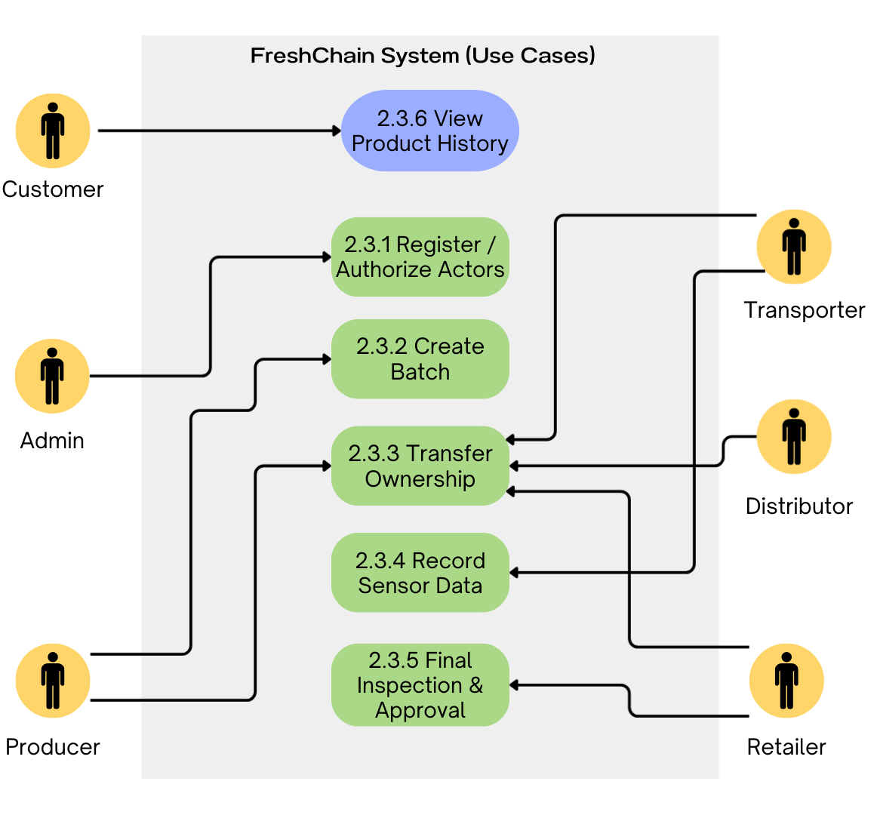
Figure 2
2.4) System Workflow
The workflow in the FreshChain system progresses through a structured and controlled sequence based on the roles of supply chain actors. The process begins with the Admin registering the blockchain addresses of system participants and assigning their respective roles. This step ensures access control by allowing only authorized actors to interact with the system.
Once authorization is completed, the Producer (Farmer) initiates the traceability process by creating a product batch with a unique Batch ID. After the batch is created, the product is transferred to the Transporter, who records environmental data such as temperature, humidity, and location during transportation. These measurements are permanently linked to the batch on the blockchain, making the product’s transport conditions immutably traceable.
Following the transportation stage, the batch is transferred sequentially to the Distributor and then to the Retailer. Each ownership change is recorded on the blockchain, ensuring that the product’s position within the supply chain is continuously verifiable. When the batch reaches the Retailer, a final quality inspection is performed, and the batch is marked as ready for sale.
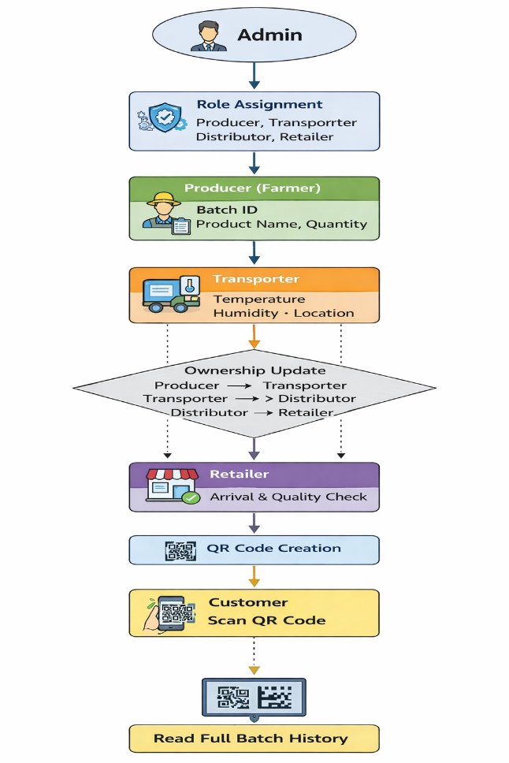
In the final phase, a QR code containing access to the batch’s full history is generated. By scanning this QR code, the Customer can view the complete lifecycle of the product—including production, transportation, and quality inspection—in a strictly read-only format. This structure preserves data integrity while providing end users with a transparent and reliable verification mechanism.
Figure-3
2.5) System Data Flow
The data flow in the FreshChain system defines how information is transferred between the frontend application, the smart contract, and the blockchain network. User interactions begin through the role-based interface, where inputs are processed and forwarded to the blockchain via the Web3 integration layer. All write operations are signed through MetaMask and then transmitted to the smart contract.
During batch creation, the product information entered by the Producer is stored by the smart contract as a new batch record, becoming part of the immutable blockchain state. Ownership transfers are processed as transactions that update the batch’s current owner and append the new owner to the historical ownership log. Environmental measurements entered during transportation—such as temperature and humidity—are stored as sensor log entries associated with the batch and timestamped automatically by the blockchain.
All batch records, ownership changes, and sensor logs stored on the blockchain serve as a single source of truth. The public product-history page retrieves this information using read-only contract calls, ensuring that customers access authentic and unaltered data. The QR code embeds a direct query URL for a specific batch, allowing customers to instantly open the corresponding history page. In this data flow, no write or state-changing operation occurs on the customer side, preserving the integrity and immutability of blockchain-stored information.
2.6 System Data Model
The FreshChain data model is designed as a batch-centric structure to meet the requirements of food traceability. Every product unit tracked throughout the supply chain is represented under a Batch entity uniquely identified by a BatchID. The Batch functions as the digital identity of the product, consolidating all relevant information into a single cohesive structure. Core attributes—such as product name, quantity, creator (Producer), and creation timestamp—are stored within the Batch, along with the batch’s current status and ownership information.
The ability of a batch to move between different actors in the supply chain is modeled by treating ownership as a dynamic state variable within the Batch. Each ownership transfer triggers a state update replacing the current owner, while also generating a TransferRecord entry to preserve historical traceability. TransferRecord objects capture which actor transferred the batch to whom and at what time, and these records are stored immutably on the blockchain. This approach enables a complete and verifiable reconstruction of the batch’s journey across the supply chain.
To document environmental conditions during transportation, FreshChain uses SensorRecord structures. Each SensorRecord contains temperature, humidity, location, and timestamp information and is linked to a specific batch through a one-to-many (1–N) relationship. This design allows multiple sensor measurements to be recorded for a single batch, offering a detailed chronological overview of the environmental conditions the product was exposed to during transit. Associating these records directly with the batch is particularly important for perishable goods, as it enables verification of handling and storage conditions after delivery.
The final stage of the supply chain—product inspection—is also integrated into the data model. The Retailer verifies the product’s condition and records the result through an InspectionRecord associated with the batch via a zero-to-one (0–1) or one-to-one (1–1) relationship. The InspectionRecord includes the inspection time, the actor performing the inspection, and the approval status, ensuring that the product’s suitability for sale is documented immutably on the blockchain. This record serves as a critical checkpoint in the batch history, marking the completion of the operational lifecycle.
In summary, the FreshChain data model unifies product information, ownership history, environmental logs, and inspection status under a batch-centric architecture, providing a holistic and verifiable traceability framework. Combined with the immutability of blockchain, this model prevents data manipulation at any stage of the supply chain and establishes a secure, transparent mechanism for tracking food products from origin to consumer.

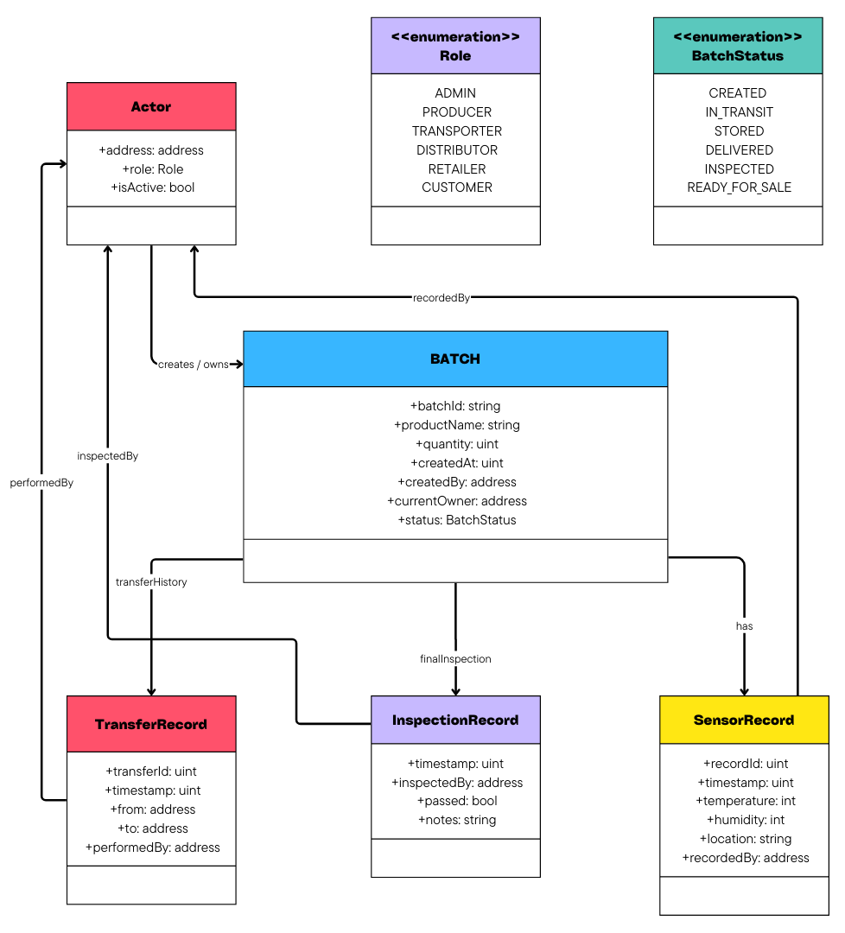
Figure-4
3 Sequence Diagrams
This section presents the sequence diagrams that illustrate the dynamic behavior of the FreshChain system. Unlike the static architectural or data-model views, sequence diagrams capture how system components, smart contract functions, and user roles interact over time during critical operational workflows. Each diagram clarifies the order of messages, the responsibilities of participating actors, and the logic behind major processes such as batch lifecycle management and customer-side traceability verification.
These diagrams play a crucial role in demonstrating how the conceptual design is executed in practice, showing not only what the system does but how and when it does it. By visualizing time-ordered interactions, sequence diagrams help validate that the system’s procedures align with real-world supply chain requirements and that the blockchain-based design ensures integrity, immutability, and transparency throughout the product journey.
3.1 Batch Lifecycle Sequence Diagram
The first sequence diagram illustrates the complete lifecycle of a product batch as it moves through all supply chain roles—from its creation by the Producer to its final inspection by the Retailer. This diagram emphasizes how ownership transfers are executed using the smart contract, how environmental sensor data is recorded during transportation, and how each role interacts with the system at different stages.
The process begins with the Producer creating a new batch on the blockchain and transferring it to the Transporter. The Transporter records temperature, humidity, and location metadata before passing the batch to the Distributor. The Distributor then transfers ownership to the Retailer, who performs the final quality inspection and updates the batch status on-chain.
This diagram captures the chronological order of messages exchanged between the UI, the blockchain network, and the actors involved, demonstrating how transparency and traceability are maintained throughout the supply chain.
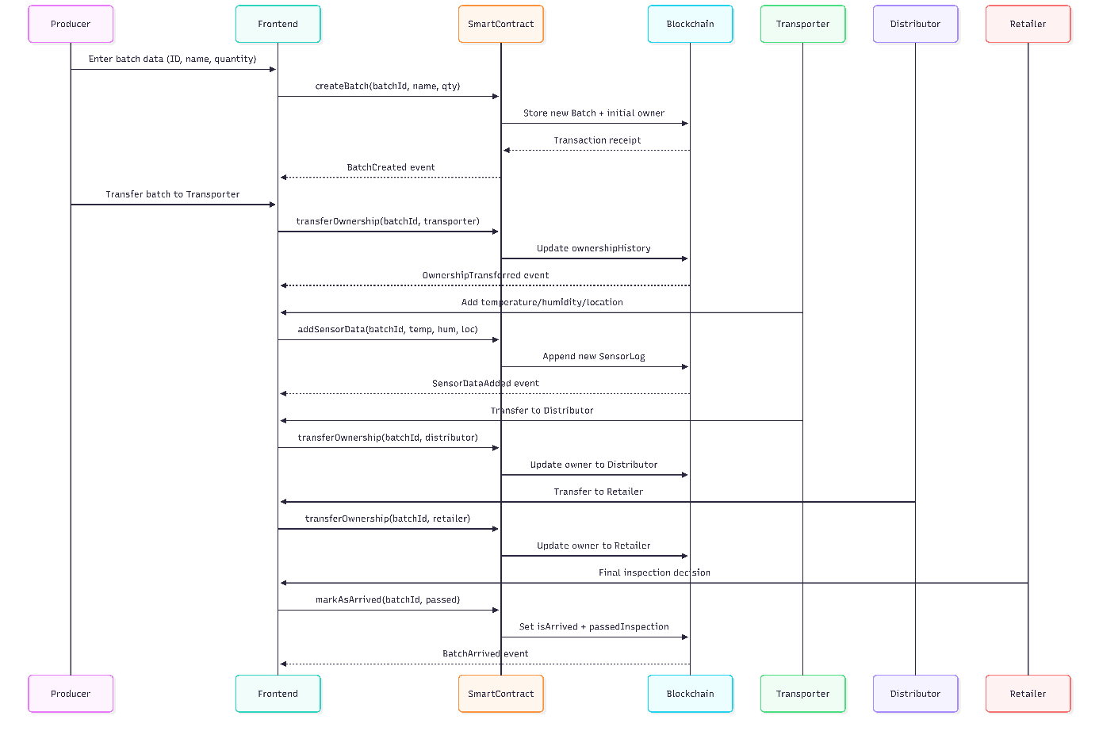

3.2 Customer Verification & QR-Based History Retrieval Sequence Diagram
The second sequence diagram presents the customer-side verification process, focusing on how users retrieve product history using a TrackID or by scanning a QR code. Unlike other roles, customers do not interact with MetaMask or write any data to the blockchain; instead, they initiate a read-only query that fetches batch information from the smart contract.
The diagram shows how the customer enters a Batch ID or scans a QR code containing a URL parameter, after which the frontend automatically calls the getBatchHistory function. The system then retrieves product details—including sensor logs, ownership history, and inspection status—and displays them to the user. If accessed via QR, the browser loads the page directly in Guest Mode using a public RPC endpoint, enabling seamless mobile verification without requiring a wallet connection.
This sequence diagram highlights the Web2/Web3 hybrid design of FreshChain, demonstrating how the blockchain ensures data integrity while the frontend provides an accessible user experience for non-technical consumers.
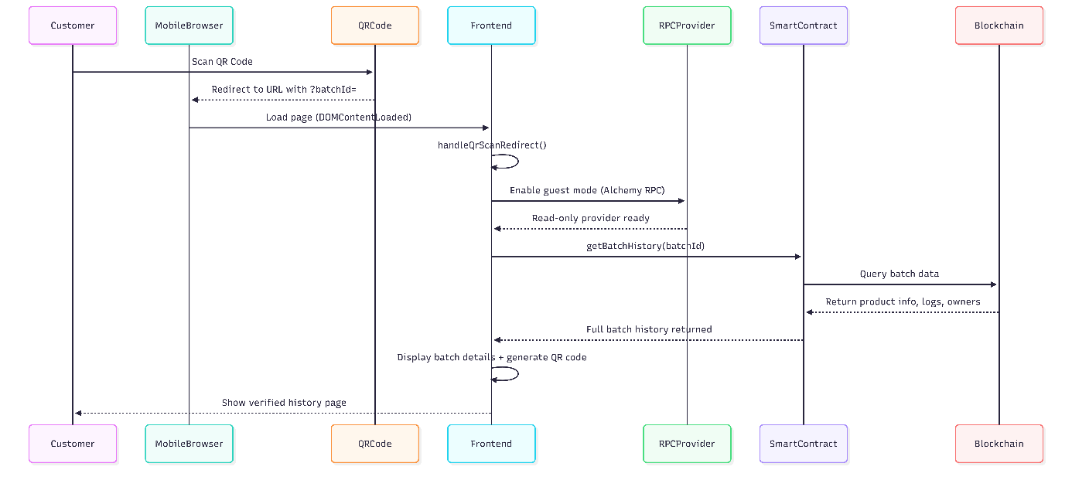

4 System Usage and Role-Based Interaction Guide
4.1 Wallet Connection & Role Detection
When the user first opens the FreshChain interface, the system requires either a MetaMask connection or the activation of Guest Mode. Connecting MetaMask enables full read–write interaction with the blockchain, while Guest Mode provides a read-only experience for customers who only need to verify product history.
When MetaMask is connected, the application retrieves the wallet address and displays it at the top of the interface. Based on this address, the system detects whether the user has been registered as a Producer, Transporter, Distributor, Retailer, or Admin. The interface dynamically reveals the correct panel according to this role. This ensures that each actor only sees the functions they are authorized to perform, maintaining both usability and security.

4.2 Actor Registration (Admin Workflow)
The Admin interface is protected by a predefined password that is automatically filled into the input field. This UI-level authentication mechanism simplifies the demonstration process for the instructor. Even after entering the correct password, administrative operations still require MetaMask confirmation, preserving blockchain-level security.
Once unlocked, the Admin panel allows the instructor to register wallet addresses as Producers, Transporters, Distributors, or Retailers. Registration determines the permissions available to each address in subsequent interactions. For instance, only registered Producers can create batches, and only Transporters can record sensor data. This role assignment is essential for enforcing the supply chain workflow.

4.3 Batch Creation (Producer Workflow)
After registration, the Producer creates a new batch by entering a Batch ID, product name, and quantity. Submitting this information triggers a smart contract call to createBatch, which records the batch permanently on the blockchain.
Upon successful confirmation, the system notifies the user and the batch becomes available for transfer to the next actor in the workflow. Each newly created batch includes a unique ID, initial ownership data, and production metadata, forming the starting point of the traceability lifecycle.

4.4 LIST BATCHES Functionality
The platform includes a batch-listing interface designed to help evaluators verify existing products in the system. This section displays both newly created batches and mandatory predefined batches required for the demo. The LIST BATCHES feature retrieves batch metadata from the smart contract and presents it in a structured format.
Its primary purpose is to allow the instructor to confirm that batches exist, that creation has been performed correctly, and that the supply chain contains the expected items before proceeding to transfers, sensor logging, or inspection. This creates a clear and auditable overview of the current blockchain state.
Predefined batches are required to ensure the evaluator always sees an initialized blockchain state. They allow the demonstration of listing, ownership transfer, sensor logging, and QR generation even if no new batches have been created during the current session.

4.5 Ownership Transfer
Ownership transfer is a key element of the FreshChain workflow. Each actor can transfer a batch only when they are its current blockchain-verified owner.
The Producer initiates the process by transferring the batch to a registered Transporter. After environmental data is collected, the Transporter transfers the batch to the Distributor. The Distributor then forwards it to the Retailer, completing the chain of custody. Each transfer generates a blockchain transaction that updates the batch’s currentOwner and records the ownership in the historical log.
This ensures immutability and transparency throughout the supply chain.

4.6 Sensor Data Recording (Transporter Workflow)
When the Transporter receives ownership of a batch, the interface automatically reveals the sensor data entry fields. The Transporter is responsible for entering environmental measurements such as temperature, humidity, and location.
Submitting these values triggers the smart contract’s addSensorData function, which stores each entry as a timestamped record. These logs form the environmental history of the product, enabling customers and retailers to see whether the product was handled under proper conditions during transport.
Sensor logs cannot be altered or removed once written, ensuring complete traceability.
4.7 Retailer Inspection
Once the Distributor transfers the batch to the Retailer, the Retailer performs the final inspection. The interface provides a simple selection: the batch either passes or fails quality control.
Calling the markAsArrived function permanently records this inspection result on the blockchain and sets the batch status to “Arrived.” If the product fails inspection, this information becomes visible to future viewers, ensuring consumer safety and transparency.
The Retailer’s decision closes the supply chain lifecycle and finalizes the batch’s traceability record.

4.8 QR-Based Product History View (Customer Workflow)
Customers interact with the system through a Web2 interface without requiring any wallet connection. A customer enters a Batch ID into the inquiry field and presses the history button. The system then retrieves the product’s complete blockchain record, including ownership timeline, sensor logs, and inspection results.
The interface simultaneously generates a QR code containing a URL structured as:
<website-url>?batchId=<ID>
Scanning this QR code on a smartphone opens the same history page instantly, without needing to log in or install MetaMask. This provides universal accessibility, making product verification effortless for end users. Every detail displayed originates directly from immutable blockchain data, ensuring full trust and transparency.
5 Technical Architrcture and Implementation
5.1) Smart Contract Design(Remix IDE)
The smart contract of the FreshChain system was developed using the Remix IDE environment. Remix was preferred due to its browser-based structure, built-in Solidity compiler, and ease of managing smart contract files. The development process started by creating a new Solidity file and defining the contract structure required for role management, batch tracking, and data recording.(Figure-5)
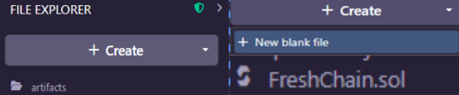
Figure-5
The contract was written in Solidity using version ^0.8.30 and compiled directly within the Remix IDE. Compilation ensured that the contract logic was syntactically correct and compatible with the Ethereum Sepolia test network before deployment.(Figure-6)
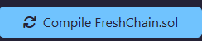
Figure-6

5.2) Remix IDE Deployment
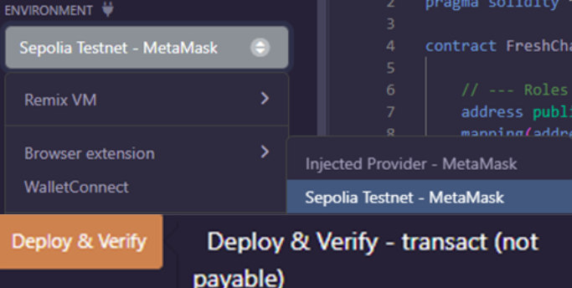
The deployment of the FreshChain smart contract was performed using the Remix IDE by connecting to the Ethereum Sepolia test network through the MetaMask injected provider. This configuration enabled the contract to be deployed on a public test blockchain, ensuring realistic execution and transaction handling. (Figure-7)
Figure-7
After initiating the deployment, the transaction was approved and signed via MetaMask. A confirmation indicator appeared in the Remix console, verifying that the deployment was successfully completed on the Sepolia network. Once confirmed, the smart contract address was generated and listed under the Deployed Contracts section. At this stage, all smart contract functions became accessible, enabling authorized users to perform role registration, batch creation, sensor data logging, and final inspection operations (Figure 8).

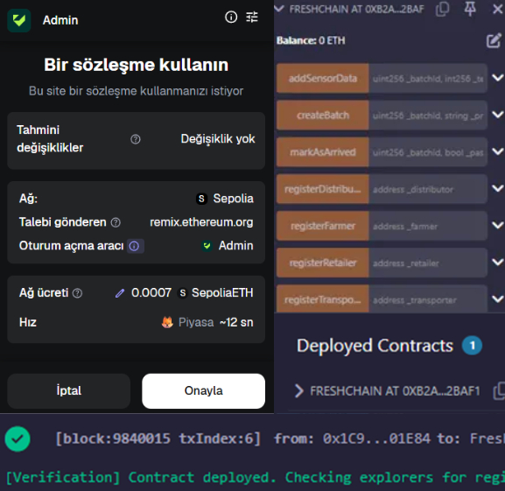
Figure-8

5.3) Frontend Implementation
The frontend of the FreshChain system was implemented as a web-based interface using HTML, CSS, and JavaScript. The application provides a simple and role-oriented structure that allows users to interact with the deployed smart contract through a local development server. The interface was designed to support core operations such as role selection, batch creation, sensor data entry, and product status updates.
The frontend communicates with the blockchain via a wallet-enabled environment, enabling authorized users to execute smart contract functions. A dedicated customer view allows end-users to retrieve and display the full batch history in a read-only manner by entering or scanning a Batch ID. (Figure-9)
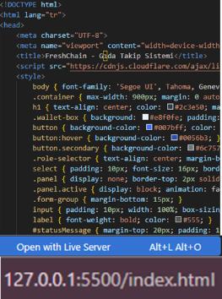Figure-9
6) User Interface
6.1 MetaMask Wallet Connection
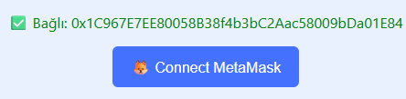
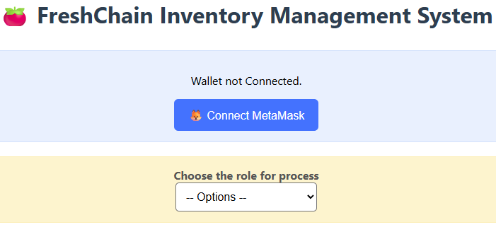
The user interface initially prompts users to connect their MetaMask wallet before any interaction with the system. This step is mandatory, as all operations require blockchain authentication. Once the wallet is successfully connected, the system verifies the user’s address and enables access to role selection and authorized functions.(Figure-10)
Figure-10

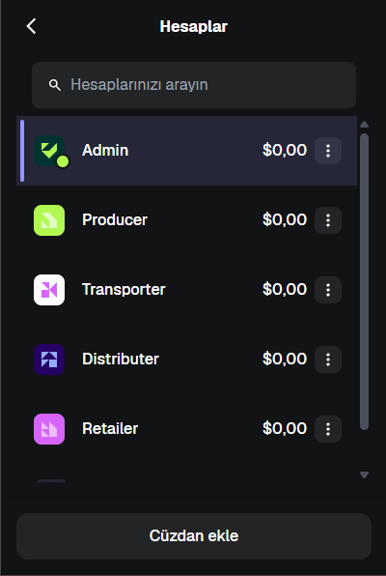
6.2 Role-Based Wallet Management
For security and role separation, a different MetaMask account is used for each supply chain role in the system. This approach ensures that every role (Admin, Producer, Transporter, Distributor, and Retailer) interacts with the smart contract using a unique blockchain address. By switching between accounts in MetaMask, the interface enforces role-based access control and prevents unauthorized function calls.(Figure-11)

Figure-11

6.3 Admin Authentication Mechanism

The administrative interface in FreshChain is protected by a predefined password mechanism that serves as an additional UI-level authentication layer. When the Admin panel is selected, the password field is automatically filled with the fixed credential so that the instructor does not need to type anything manually. The user only needs to click the “Login as Admin” button, after which the system verifies the predefined password and unlocks the administrative controls.

This design ensures that the evaluator can quickly access administrative functions—such as actor registration and role assignment—without dealing with complex wallet-based role verification during demonstrations. At the same time, administrative actions still require MetaMask authorization, meaning that the underlying blockchain security model remains intact. The simplified UI layer prevents accidental misuse of admin privileges and ensures that role assignment occurs intentionally. (Figure-12)

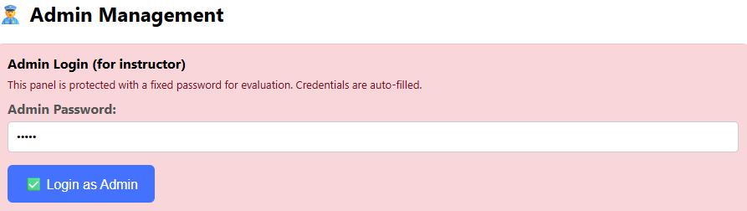

Figure-12

6.4 Role Selection and Admin Authorization
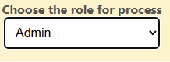
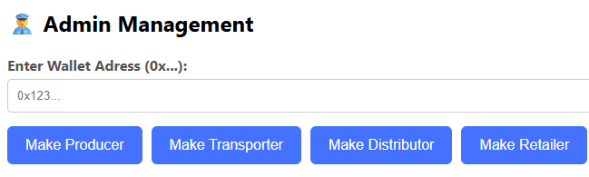
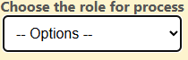
After connecting the MetaMask wallet, users select their role from the role selection menu. When the Admin role is chosen, the interface displays the admin management panel. In this panel, the Admin enters wallet addresses and assigns roles such as Producer, Transporter, Distributor, and Retailer. These actions call the corresponding smart contract functions, ensuring that only authorized blockchain addresses can perform role-specific operations. (Figure-13)
Figure-13

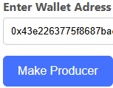
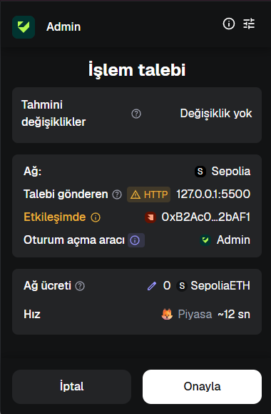
When assigning a role, the Admin enters the blockchain address of the corresponding account (for example, the Producer’s MetaMask address) into the input field and submits the request. The transaction is then sent to MetaMask for approval. After the Admin confirms the transaction, the role assignment is recorded on the Sepolia network and the operation is completed successfully. This process must be repeated separately for each role (Producer, Transporter, Distributor, and Retailer), ensuring that every role is explicitly authorized with its own blockchain address.(Figure-14)

Figure-14

6.5 Producer Interface – Batch Creation
After the Producer role is selected from the role menu, the batch creation interface becomes available. In this section, the Producer enters the Batch ID, product name, and quantity, then submits the request to create a new batch. The transaction is sent to MetaMask for approval, and once confirmed, the batch information is recorded on the blockchain. Upon successful completion, the system displays a confirmation message indicating that the batch has been created successfully.(Figure-15)
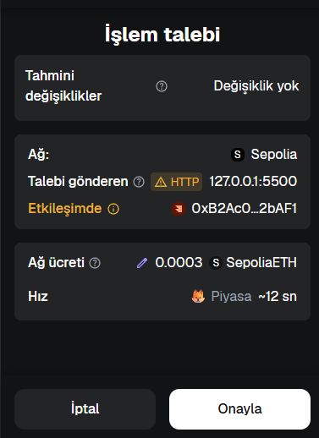
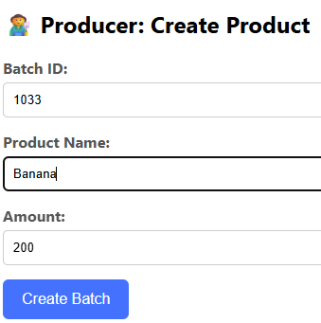

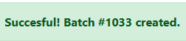
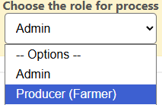

Figure-15

After the batch is successfully created, the Producer initiates the transfer process by entering the Batch ID and the blockchain address of the Transporter. The transfer request is submitted through the interface and sent to MetaMask for approval. Once the transaction is confirmed, ownership of the batch is transferred to the Transporter and recorded on the blockchain. The system displays a success message to confirm that the transfer operation has been completed successfully.(Figure-16)

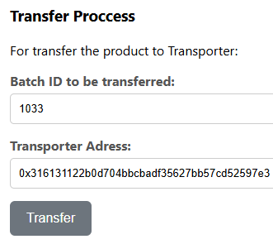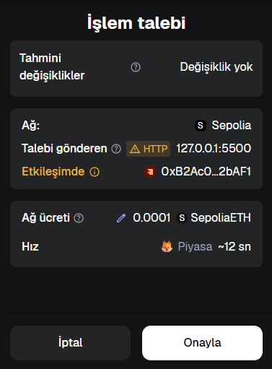

Figure-16

6.6 Transporter Interface – Sensor Data Entry
After ownership is transferred to the Transporter, the transporter role gains access to the sensor data entry interface. In this section, the Transporter enters the Batch ID along with environmental measurements, including temperature, humidity, and location information. The submitted data is sent to the blockchain through MetaMask approval, ensuring that all sensor records are immutably stored. Upon successful submission, the system confirms that the sensor data has been added successfully.(Figure-17)
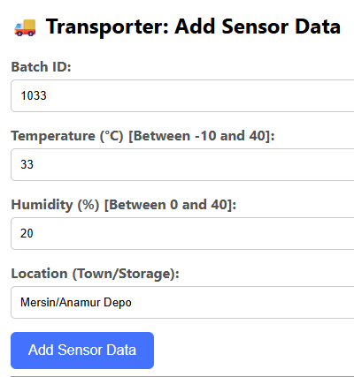
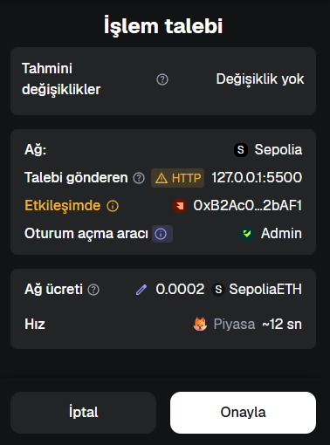


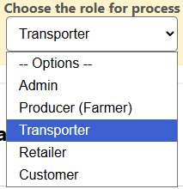

Figure-17

6.7 Distributor Interface – Product Acceptance

The Distributor Interface is used to transfer a batch that has been received from the transporter to the retailer. The user provides two inputs: Batch ID and Retailer Address. When the “Transfer to Retailer” button is clicked, the interface calls the smart contract’s transferOwnership function, completing the ownership transfer on the blockchain.


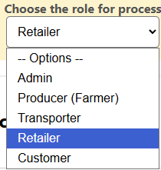
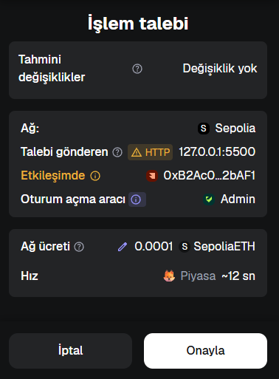
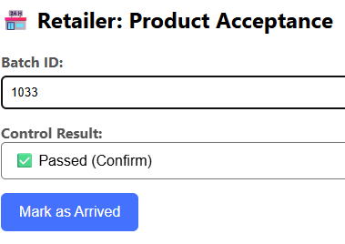
This action is permanently recorded on-chain and added to the ownershipHistory list. The distributor panel represents the middle stage of the supply chain, enabling the final transfer before the product reaches the retail phase.(Figure-18)

Figure-18

6.8 Retailer Interface – Product Acceptance
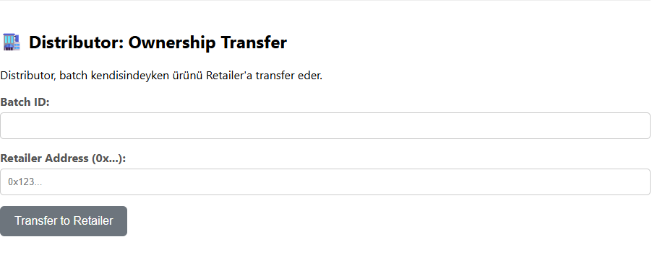
After the transportation process is completed, the Retailer accesses the product acceptance interface. In this step, the Retailer enters the Batch ID and performs the final quality inspection. Based on the inspection result, the product is marked as arrived and approved. The confirmation is sent to the blockchain via MetaMask, and the product status is permanently updated. A success message indicates that the product has been successfully accepted. (Figure-19)

Figure-19

6.9 Customer Interface – Product Inquiry and QR Code Verification
The Customer interacts with the system in a read-only mode through the product inquiry interface. By selecting the Customer role and entering a Batch ID, the system retrieves the complete product history from the blockchain. Upon inquiry, a QR code is generated, allowing the product information to be accessed on mobile devices.
The displayed data includes product details, sensor measurements recorded during transportation, quality control results, and ownership transfer history. This interface enables customers to verify the authenticity and safety of the product without the ability to modify any blockchain data.(Figure-20)
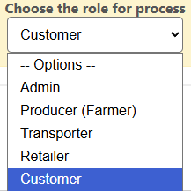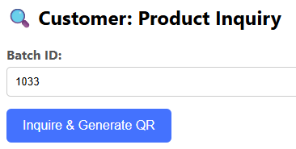
Figure-20

6.10 Product History Visualization and QR Code Output
After generating the QR code, the system displays the complete product history retrieved from the blockchain. This view presents detailed information including product attributes, current ownership status, market arrival confirmation, quality control results, recorded sensor data with timestamps and locations, and the full ownership transfer history. The QR code enables easy access to this information on mobile devices, ensuring transparency and verifiability for end users.(Figure-21)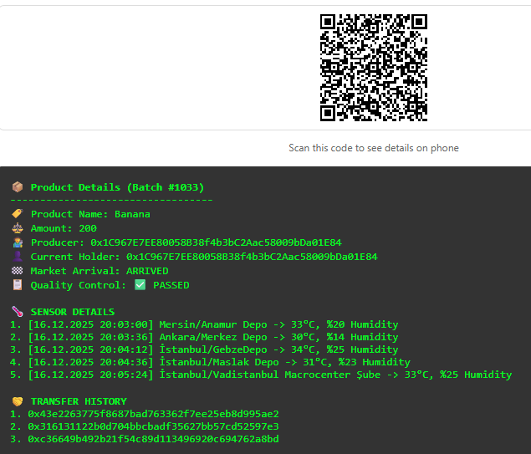
Figure-21
6.10.1 QR Code Generation & Output
The QR system in FreshChain is designed to make product traceability instantly accessible to any user, even if they do not have a crypto wallet. When a customer queries a batch, the interface first constructs a unique link by detecting the application’s active URL and appending the corresponding batch ID as a query parameter. This link becomes the content encoded into a dynamically generated QR image. The QR code itself does not store product information; instead, it acts as a pointer that directs the user back to the FreshChain interface.
Once the QR code is scanned, the browser loads the application with the batch ID already embedded in the URL. A redirection handler immediately checks for this parameter. If present, the system automatically switches into Guest Mode, a dedicated read-only environment that does not require MetaMask. In Guest Mode, the application does not rely on the user’s wallet provider but instead connects directly to the blockchain through a public RPC endpoint defined as:
constsepoliaRpcUrl = "https://eth-sepolia.g.alchemy.com/v2/7wZVQuGXZ_Uo833XR3fmR";
This RPC URL is a dedicated endpoint provided by Alchemy, a third-party blockchain infrastructure service widely used for reliable Ethereum network access. By routing all read-only operations through Alchemy’s Sepolia endpoint, the system ensures stable, high-availability access to on-chain data, regardless of the visitor’s device, installed extensions, or browser environment. The application instantiates the FreshChain smart contract using this RPC provider, enabling it to retrieve batch details, sensor logs, ownership history, and inspection results directly from the blockchain without requiring any authenticated account.
Through this mechanism, the QR code becomes a universal access point. A customer scanning the label on a product in a store receives the complete blockchain-verified lifecycle of that item—creation, transportation conditions, distributor transfers, and retailer inspection—without needing to log in or manage cryptographic keys. The combination of QR redirection and Alchemy’s RPC infrastructure delivers a seamless, trust-driven traceability experience while preserving decentralization, data integrity, and platform accessibility.(Figure-22)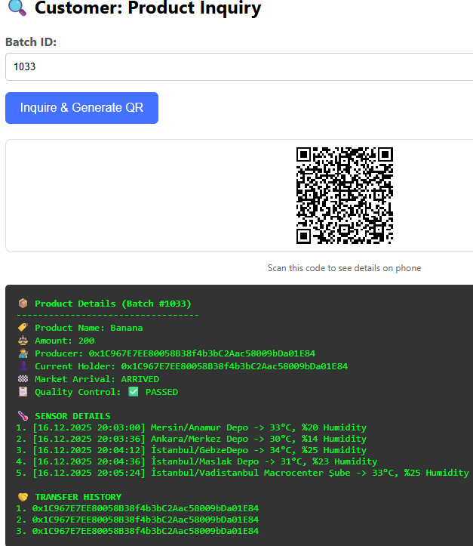
Figure-22
https://muhammeddeniz33.github.io/FreshChain/?batchId=1033
6.11 Guest Mode
Guest Mode allows users to access the system in read-only mode without connecting a crypto wallet. When enabled, the application switches from a Web3 provider (MetaMask) to an Alchemy RPC provider, giving public access to blockchain data while blocking all write operations.
In Guest Mode, only the Customer panel becomes active. Users can view batch history simply by entering a Batch ID or by scanning a QR code generated by the system. If the URL contains a batchId parameter (e.g., ...?batchId=12), the interface automatically loads the product history and displays all supply chain details.
Guest Mode ensures easy and universal access for consumers while maintaining full security by preventing unauthorized transactions. (Figure-23)

Figure-23
7) GitHub Repository and Project Structure
The FreshChain project was developed and maintained using a GitHub repository, which provided a structured environment for version control, accessibility, and transparent development practices. The repository hosts all essential components of the system, ensuring that both the frontend interface and the smart contract implementation are preserved, traceable, and easily accessible for review. The initial setup involved creating a new repository and uploading the main frontend entry file (index.html) to the primary branch, where each change was committed using GitHub’s version management features. This process allowed every update to be tracked with clear commit histories, enabling systematic development and simplifying debugging and evaluation.
To ensure public accessibility without requiring a local development environment, the repository was configured to deploy the frontend application through GitHub Pages. By enabling deployment from the main branch, the system was automatically hosted on a static URL. This allowed users, instructors, and evaluators to interact with the FreshChain interface directly from a web browser, eliminating the need for additional server infrastructure or command-line execution. As a result, the blockchain interactions, smart contract calls, and customer-facing features could be demonstrated in a clean and consistent environment.
The structure of the repository reflects the modular design of the project. The frontend section contains the index.html file along with accompanying JavaScript and CSS code blocks embedded within it. This file represents the core user interface, handling role selection, wallet connection, batch operations, sensor data submission, and the QR-based customer history viewer.
The smart contract section includes the Solidity (.sol) file for the FreshChain contract, defining the data structures, access control rules, and all blockchain operations (batch creation, ownership transfer, sensor logging, inspection confirmation, and public history retrieval). Although the deployed contract resides on the Sepolia network, the contract source code remains in the repository to maintain transparency and to allow future auditing or redeployment.
The repository also contains a documentation section, which includes the project’s written materials. The Word document used for the final project report is stored in this section, ensuring that the documentation is preserved alongside the source code. This integration provides a unified reference point where both the technical implementation and its accompanying explanation remain synchronized. Having the report within the repository also makes it easier to revise, update, and version-control the written components of the project in parallel with the software itself.
In addition to these components, the repository hosts a public history page, which is accessed by customers scanning the QR code generated by the system. This page operates independently of MetaMask and interacts with the blockchain through a read-only RPC provider. Its presence in the repository ensures that both the main interface and the QR-accessible history viewer share the same deployment pipeline and remain consistent across updates.
Overall, the GitHub repository functions as a comprehensive storage and deployment environment for FreshChain, maintaining the complete codebase, documentation, smart contract definitions, and public-facing pages in a cohesive and traceable structure.(Figure-24)
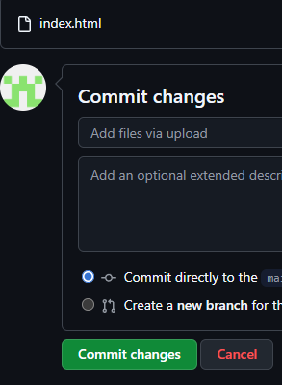

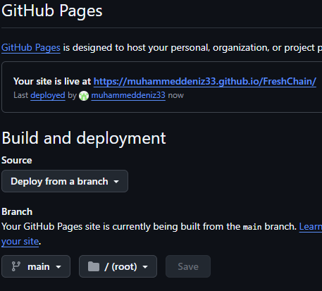

Figure-24

