TABLE OF CONTENTS
TITLE | PAGE NO
Synopsis | 1
1.Abstract | 2
2. Introduction | 4
2.1 Objectives of the Project | 5
3. System Specification | 7
3.1 Hardware Configuration | 7
3.2 Software Specification | 7
3.3 Libraries and Tools Used | 7
4. System Study | 10
4.1 Existing System | 10
4.2 Drawbacks of the Existing System | 10
4.3 Proposed System | 11
4.4 Features of the Proposed System | 12
5. System Design and Development | 15
5.1 File Design | 15
5.2 Dataset Overview | 16
5.3 Input Design | 20
5.4 Output Design | 20
5.5 System Development Process | 21
5.6 Database Design | 21
5.7 Data Flow Diagram — Level 0 | 22
5.8 Data Flow Diagram — Level 1 | 23
5.9 Entity Relationship Diagram | 25
5.10 Description of Modules | 27
6. Testing and Implementation | 31
6.1 Testing Objectives | 31
6.2 Unit Testing | 31
6.3 Integration Testing | 32
6.4 System Testing | 32
6.5 Performance Evaluation Results | 33
7. Conclusion | 38
8. Bibliography | 40
9. Appendices | 42
Appendix A: Data Flow Diagram Descriptions | 42
Appendix B: Dataset Column Reference | 42
Appendix C: Sample Coding | 44
Appendix D: Sample Input | 49
Appendix E: Sample Output | 50

SYNOPSIS
This project presents a machine learning-based binary classification system for predicting whether a Near-Earth Object (NEO) catalogued in NASA's asteroid dataset poses a potential hazard to Earth. The dataset contains 4,687 cleaned records with 16 retained orbital and physical features, after removal of eight non-predictive identifier fields and twelve redundant correlated columns. Data preprocessing includes null value verification, target integer encoding, stratified 70/30 train-test splitting, and StandardScaler feature normalisation.

Five supervised machine learning classifiers are trained and evaluated: Logistic Regression, Decision Tree, Random Forest, Gradient Boosting, and XGBoost. XGBoost is configured with scale_pos_weight to address the 4.6:1 class imbalance favouring the Non-Hazardous majority class. Models are benchmarked using Accuracy, Weighted F1 Score, Recall for the Hazardous class, and ROC-AUC. The best-performing model is selected automatically by ROC-AUC and deployed through a Gradio web application supporting NASA Neo Reference ID lookup.

XGBoost emerged as the best-performing model with a ROC-AUC of 0.9992, Accuracy of 99.57%, and Hazardous-class Recall of 99.12%. These results were confirmed stable by 5-fold stratified cross-validation yielding a mean ROC-AUC of 0.9969 with negligible fold-to-fold variance. XGBoost feature importance analysis (Gain metric) confirmed that Estimated Diameter and Absolute Magnitude are the primary hazard predictors, followed by Minimum Orbit Intersection Distance and Relative Velocity.

The system is intended to support planetary defence researchers, space agency analysts, and astronomical observatories in rapidly screening large catalogues of newly discovered NEOs and prioritising objects requiring detailed follow-up orbital analysis.

ABSTRACT

1.ABSTRACT

Near-Earth Objects (NEOs) represent a class of solar system bodies whose orbital paths bring them into close proximity with Earth's orbit. Among these, Potentially Hazardous Asteroids (PHAs) — defined by estimated diameters exceeding 140 metres and minimum orbit intersection distances of 0.05 AU or less — pose a scientifically significant risk to planetary safety. The accurate and timely automated classification of newly discovered NEOs as hazardous or non-hazardous is a critical component of global planetary defence strategy.
This project presents a comprehensive machine learning-based binary classification system for NASA asteroid hazard prediction. The system processes the NASA Nearest Earth Objects dataset containing 4,687 cleaned records across 16 orbital and physical feature columns. A multi-stage preprocessing pipeline removes eight non-predictive identifier columns and twelve redundant correlated measurement columns based on correlation analysis. The class imbalance (approximately 82% Non-Hazardous versus 18% Hazardous) is addressed through stratified splitting and XGBoost's scale_pos_weight parameter.

Five supervised binary classification algorithms are trained and evaluated: Logistic Regression, Decision Tree, Random Forest, Gradient Boosting, and XGBoost. Models are compared across four metrics: Accuracy, Weighted F1 Score, Recall for the Hazardous class, and ROC-AUC. XGBoost is identified as the best-performing model with a ROC-AUC of 0.9992, Accuracy of 99.57%, and Hazardous-class Recall of 99.12%, validated by 5-fold stratified cross-validation yielding a mean ROC-AUC of 0.9969.
The trained model, scaler, feature names, and model metadata are serialized using Joblib and deployed through a Gradio web application supporting real-time hazard prediction by NASA Neo Reference ID. The application returns a complete assessment including prediction label, actual label, verdict, and dual probability scores (hazard percentage and safe percentage).

Keywords: Near-Earth Objects, Asteroid Hazard Prediction, Machine Learning, XGBoost, Binary Classification, Planetary Defence, Gradio Deployment, ROC-AUC, Confusion Matrix, Feature Importance.

INTRODUCTION

2. INTRODUCTION
Near-Earth Objects (NEOs) are asteroids and comets whose orbital paths bring them within close proximity to Earth's orbit around the Sun, specifically within 1.3 Astronomical Units (AU) of the Sun. Of the millions of asteroids estimated to exist in the solar system, approximately 28,000 have been formally classified as NEOs by NASA's Center for Near Earth Object Studies (CNEOS). A critically important subset of these — Potentially Hazardous Asteroids (PHAs) — are defined by two criteria: an estimated diameter exceeding 140 metres and a Minimum Orbit Intersection Distance (MOID) of 0.05 AU or less from Earth's orbit.

The discovery rate of new NEOs is accelerating sharply. The Vera Rubin Observatory, expected to achieve full operation in the mid-2020s, is projected to discover an estimated 5 million new NEOs within its first decade of operation — a volume that makes manual expert review of each object's orbital parameters practically infeasible within the timelines required for planetary defence decision-making. Machine learning classifiers trained on the accumulated historical NEO catalogue offer a scalable, automated, and probabilistically rich alternative to threshold-based rule classification.

Accurate classification of NEOs as hazardous or non-hazardous is not merely an academic exercise — it is a foundational component of global planetary defence strategy. The outcomes of hazard assessments directly inform decisions about telescope follow-up prioritisation, deflection mission planning, civil protection advisories, and international coordination through bodies such as the International Asteroid Warning Network (IAWN) and the Space Mission Planning Advisory Group (SMPAG).

This project develops a supervised binary classification system that maps 16 orbital and physical features from NASA's NEO dataset to a binary hazard label. The system applies a complete preprocessing pipeline including correlation-based feature elimination, stratified splitting, class-imbalance-aware XGBoost training, 5-fold cross-validation, and comprehensive metric-based model comparison. The best model is deployed through a Gradio web interface that accepts a NASA Neo Reference ID and returns a complete hazard assessment including prediction, actual label, confidence probabilities, and verdict.

2.1 Objectives of the Project
- To load, inspect, and clean NASA's NEO asteroid dataset by removing eight non-predictive administrative columns.
- To perform null value verification and encode the binary target variable 'Hazardous' as an integer (0/1).
- To generate exploratory data visualisations: class distribution, diameter distribution, velocity distribution, and full feature correlation heatmap.
- To drop twelve redundant highly correlated columns identified through correlation analysis, retaining the most representative feature per group.
- To train and compare five supervised binary classifiers: Logistic Regression, Decision Tree, Random Forest, Gradient Boosting, and XGBoost.
- To evaluate all models on Accuracy, Weighted F1 Score, Recall (Hazardous class), and ROC-AUC using a stratified 70/30 train-test split.
- To validate the best model using 5-fold stratified cross-validation and XGBoost feature importance analysis.
- To serialize four Joblib artifacts (model, scaler, feature names, metadata) and deploy a Gradio prediction interface supporting Neo Reference ID lookup.

SYSTEM SPECIFICATION

3. SYSTEM SPECIFICATION
The successful implementation of the NASA Asteroid Hazard Prediction System requires hardware and software resources capable of handling structured orbital mechanics data, ensemble machine learning model training, multi-metric evaluation, and interactive Gradio web deployment.

3.1 Hardware Configuration
- Processor: Intel Core i5 or higher (i7 recommended for XGBoost training with 200 estimators)
- RAM: Minimum 8 GB system RAM (16 GB recommended for full dataset processing with multiple models)
- Storage: Minimum 5 GB of free disk space for dataset CSV, serialized .pkl model files, and output charts
- GPU: Optional — CPU training is sufficient for this tabular dataset size (~4,700 rows)
- Internet Connection: Required for Google Colab execution, Kaggle dataset download, and Gradio public URL sharing

3.2 Software Specification
- Operating System: Windows 10/11, macOS Monterey or later, or Linux Ubuntu 20.04+
- Programming Language: Python 3.8 or higher
- Development Platform: Google Colab (recommended for free GPU/TPU access) or Jupyter Notebook
- Version Control: Git and GitHub for project versioning, collaboration, and portfolio hosting
- Package Management: pip for Python library installation

3.3 Libraries and Tools Used
Library / Tool | Purpose
Pandas | Data loading, null checking, DataFrame manipulation, and feature-target splitting
NumPy | Numerical array operations, probability score extraction, and input array construction
Scikit-learn | Model training (LR, DT, RF, GB), evaluation metrics, stratified splitting, and cross-validation
XGBoost | Gradient-boosted tree classifier with scale_pos_weight for class imbalance handling
Matplotlib | Static chart generation: bar charts, ROC curves, cross-validation plots
Seaborn | Correlation heatmap, count plots, histogram distributions, confusion matrix heatmaps
Joblib | Serialization of model, scaler, feature names list, and model metadata dictionary to .pkl files
Gradio | Interactive web-based prediction interface with Neo ID text input and formatted result output
Google Colab | Cloud-based Jupyter notebook execution environment with free GPU support

SYSTEM STUDY

4. SYSTEM STUDY
System study is the foundational phase of project development that examines the current operational landscape for the problem domain, identifies limitations of existing approaches, and justifies the design choices of the proposed new system. In the domain of asteroid hazard classification, existing operational methods are based on orbital mechanics thresholds and manual expert review — approaches that are well-established for low discovery-rate environments but face serious scalability and adaptability challenges in the era of large-scale automated sky surveys.

4.1 Existing System
NASA's current NEO hazard classification methodology is based on two well-established orbital mechanics criteria: an asteroid is designated Potentially Hazardous if its estimated diameter exceeds 140 metres AND its Minimum Orbit Intersection Distance (MOID) with Earth is 0.05 AU or less. These threshold values are derived from asteroid physical properties — a 140-metre diameter object has sufficient kinetic energy to cause regional-scale destruction upon impact, and a MOID of 0.05 AU represents a proximity at which gravitational perturbations over decades to centuries could potentially bring an object into an Earth-crossing trajectory.

The computation of reliable hazard determinations requires multiple astrometric observations of each newly discovered object spread over several weeks to months, enabling the computation of a precise orbital solution. The manual pipeline from initial discovery to formal hazard determination involves astronomical observation teams, computational astrodynamicists, and planetary defence analysts working in sequence. While the quality of resulting hazard assessments is high, the process does not scale to the millions of new discoveries expected from next-generation survey instruments.

4.2 Drawbacks of the Existing System
Threshold-Based Binary Classification Without Confidence Estimation: The 140-metre diameter and 0.05 AU MOID criteria are fixed thresholds that produce a binary hazardous/non-hazardous flag without any associated confidence probability. Objects near the classification boundary — with diameters of 135–145 metres or MOIDs of 0.048–0.052 AU — may be systematically misclassified if early-orbit diameter estimates carry large uncertainties from limited observational arcs.

Scalability Limitations: With the Vera Rubin Observatory expected to discover an estimated 5 million new NEOs within its first decade, manual expert review of each object's orbital solution is not feasible at the required throughput. The existing pipeline becomes a bottleneck when discovery rates substantially exceed the capacity of available orbital analysts and follow-up telescope time.

Absence of Multi-Feature Interaction Modelling: The existing rule-based system evaluates diameter and MOID independently in a conjunction of two Boolean tests. Machine learning models can simultaneously capture complex non-linear interactions between all sixteen orbital and physical parameters — including eccentricity, relative velocity, Jupiter Tisserand invariant, and semi-major axis — that collectively encode richer hazard signal than any two features evaluated individually.

No Learning from Historical Data: The threshold-based system does not improve with the accumulation of new observational data. A machine learning pipeline can be periodically retrained on updated NEO catalogues as new objects are discovered and their orbits refined, continuously improving its discriminative accuracy near the hazard boundary.

Limited Class Imbalance Handling: The existing approach treats all objects above the size-proximity thresholds as equally hazardous regardless of the degree by which they exceed the threshold. It provides no mechanism for quantifying the relative degree of hazard among PHAs, nor for identifying objects that are strongly non-hazardous versus marginally non-hazardous.

4.3 Proposed System
The proposed system replaces threshold-based classification with a supervised machine learning pipeline that learns hazard patterns directly from the accumulated historical NASA NEO catalogue. The system applies a systematic preprocessing workflow including correlation-based feature elimination, stratified class-imbalance-aware splitting, and standardised feature scaling. Five classification algorithms are benchmarked simultaneously, with the best model selected automatically by ROC-AUC — the metric most appropriate for imbalanced binary classification tasks where discriminating ability across all probability thresholds is paramount.
XGBoost's scale_pos_weight parameter directly addresses the 4.6:1 class imbalance by increasing the penalty for misclassifying the minority Hazardous class during training. This is critical because in planetary defence applications, a false negative — predicting Non-Hazardous when the object is actually Hazardous — carries catastrophically higher risk than a false positive. The Gradio deployment interface enables non-technical users to perform hazard screening by Neo Reference ID through a browser without any programming knowledge.

4.4 Features of the Proposed System
Automated Multi-Model Pipeline: All five models are trained, evaluated, and compared automatically in a single notebook execution without manual tuning or result transcription.

Class Imbalance Awareness: XGBoost's scale_pos_weight hyperparameter ensures maximum Recall for the minority Hazardous class, prioritising the detection of all genuinely hazardous objects over minimising false alarms.

Probabilistic Output: The Gradio application returns both hazard probability and safe probability as continuous percentages, providing a quantified confidence measure beyond a binary flag.

Cross-Validation Reliability: 5-fold stratified cross-validation confirms that reported model performance is not an artifact of a favourable random train-test split, ensuring genuine generalisability to unseen data.

Feature Importance Transparency: XGBoost's Gain-based feature importance rankings provide interpretable explanations of which orbital parameters drive hazard predictions, supporting scientific understanding alongside predictive accuracy.

Portable Deployment Architecture: Four Joblib artifact files (model, scaler, feature names, metadata) encapsulate the complete prediction pipeline, enabling seamless redeployment after retraining on updated datasets without code modification.

SYSTEM DESIGN AND DEVELOPMENT

5. SYSTEM DESIGN AND DEVELOPMENT
System Design and Development describes how the NASA Asteroid Hazard Prediction System is structured, how data flows through each processing stage, and how the machine learning models are trained, evaluated, and deployed. The system follows a modular design approach where each component handles a distinct and well-defined task. This ensures flexibility, reproducibility, and ease of future maintenance or enhancement.

5.1 File Design
Dataset File (nasa.csv): The primary input file containing all raw NEO orbital and physical attributes, administrative identifiers, and the binary hazard label. The file is loaded directly into a Pandas DataFrame using pd.read_csv(). After preprocessing, the cleaned DataFrame retains 4,687 rows and 17 columns (16 features + 1 target).

Model Artifact Files (.pkl): Four Joblib-serialized files are produced after training and model selection. best_model.pkl stores the trained XGBoost classifier. scaler.pkl stores the fitted StandardScaler for test-time feature normalisation. feature_names.pkl stores the ordered list of 16 feature column names for DataFrame-to-array alignment during inference. model_meta.pkl stores a dictionary containing the model name string and a boolean flag indicating whether scaling is required for that model type.

Python Notebook (22 Sections): The complete analysis is structured as a 22-section Python notebook spanning library installation, data loading, null checking, feature dropping, target encoding, correlation analysis, visualisation, feature-target splitting, stratified splitting, scaling, model training, metric collection, comparison charts, ROC curves, confusion matrices, cross-validation, feature importance, and model saving.

Gradio Application (app section): A standalone Gradio interface defined in the final code section that loads all four serialized artifacts, builds a Neo Reference ID lookup table from the raw dataset, and exposes a predict_by_id() function through a textbox interface with pre-loaded example IDs.

5.2 Dataset Overview
The NASA Nearest Earth Objects dataset contains historical records of asteroids observed and catalogued by NASA's CNEOS programme. After preprocessing, the cleaned dataset contains 4,687 records across 16 feature columns plus one binary target column. The raw dataset initially includes 40 columns; after removing 8 non-predictive administrative columns and 12 redundant correlated measurement columns, 16 scientifically meaningful orbital and physical features are retained for model training.

Column Name | Data Type | Description
Est Dia in KM(min) | Float | Minimum estimated asteroid diameter in kilometres
Absolute Magnitude | Float | Absolute visual magnitude H — proxy for physical size
Relative Velocity km per sec | Float | Relative approach velocity at closest point in km/sec
Miss Dist.(Astronomical) | Float | Miss distance at closest approach in Astronomical Units
Orbit Uncertainity | Integer | Orbital uncertainty parameter (0 = best fit, 9 = poorly constrained)
Minimum Orbit Intersection | Float | MOID — minimum distance from Earth's orbit path in AU
Jupiter Tisserand Invariant | Float | Orbital energy parameter relative to Jupiter (JEO/HEA classification)
Epoch Osculation | Float | Julian date at which the orbital elements are defined
Asc Node Longitude | Float | Longitude of the ascending node in degrees
Orbital Period | Float | Orbital period in days
Perihelion Distance | Float | Closest approach distance to the Sun in AU
Perihelion Arg | Float | Argument of perihelion angle in degrees
Aphelion Dist | Float | Farthest point from the Sun in the orbit (AU)
Mean Anomaly | Float | Mean anomaly at the epoch date in degrees
Mean Motion | Float | Rate of orbital motion in degrees per day
Hazardous (Target) | Integer | Binary target: 1 = Hazardous, 0 = Non-Hazardous

The dataset exhibits a class imbalance of approximately 4.6:1. Of the 4,687 records, 3,849 (82.1%) are Non-Hazardous and 838 (17.9%) are Hazardous. This imbalance is addressed through stratified splitting and XGBoost's scale_pos_weight parameter.

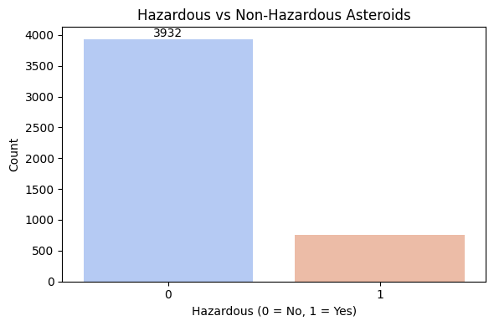
Figure 5.1: Distribution of Hazardous vs Non-Hazardous Asteroids in the Dataset

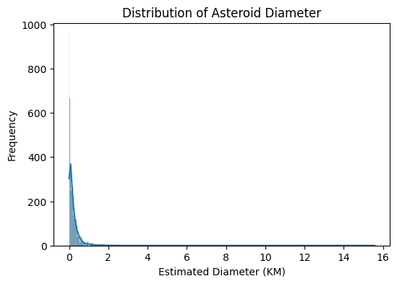
Figure 5.2: Distribution of Asteroid Estimated Diameter (km) with KDE Overlay

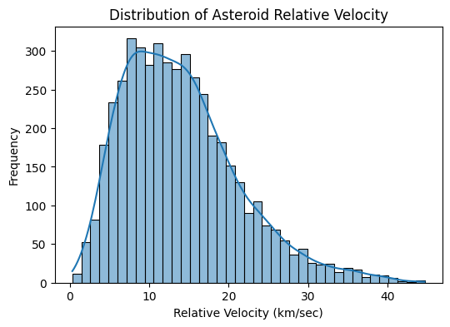
Figure 5.3: Distribution of Asteroid Relative Velocity (km/sec) with KDE Overlay
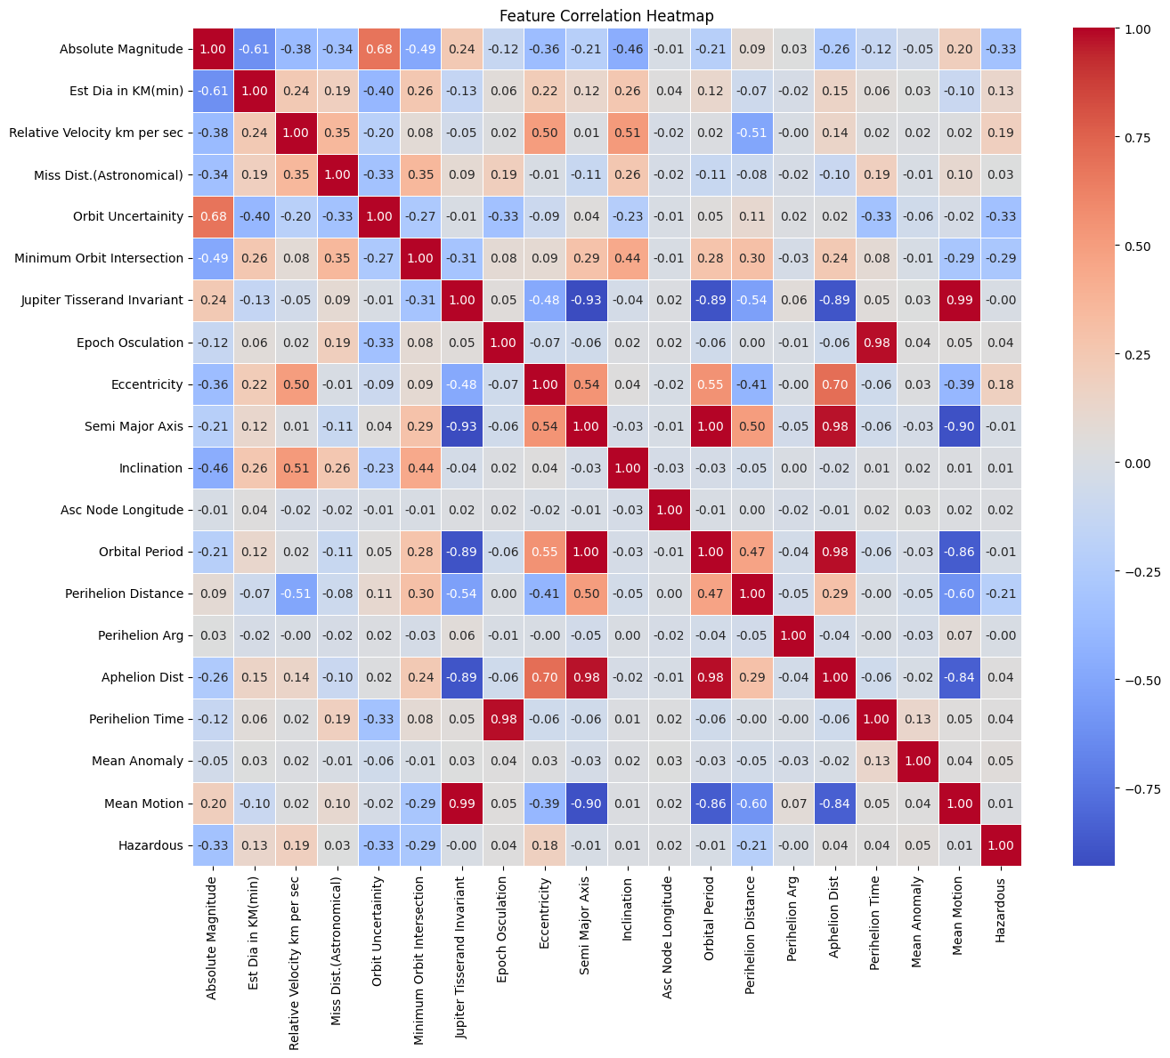

Figure 5.4: Feature Correlation Heatmap — Pairwise Relationships Across All Shipment Features

5.3 Input Design
The system accepts two categories of input. During training and evaluation, all 16 feature columns are used as the feature matrix X, with the 'Hazardous' column as the binary target vector y. For the Gradio deployment application, the input is a single text string — the NASA Neo Reference ID — which is used to perform a DataFrame lookup to retrieve the corresponding 16-feature row for inference.

Input Field | Type | Description
Neo Reference ID (Gradio) | Text string | NASA identifier string used for dataset lookup (e.g. '2000433')
16 Feature Columns (model) | Float array | Normalised orbital/physical feature array passed to XGBoost after scaler.transform()
nasa.csv (training) | CSV file | Raw dataset file loaded at training time and again by the Gradio app for lookup_df construction

5.4 Output Design
The Gradio prediction interface returns a formatted 10-line multi-field result string for each Neo Reference ID query. The output components are designed to provide complete actionable hazard information at a glance.

Output Field | Description and Possible Values
Asteroid ID | The Neo Reference ID string entered by the user, echoed back for confirmation
Prediction | Model output: 'HAZARDOUS' (class 1) or 'NON-HAZARDOUS' (class 0)
Actual Label | Ground truth label from the dataset — 'HAZARDOUS' or 'NON-HAZARDOUS'
Verdict | 'CORRECT ✓' if prediction matches actual label; 'INCORRECT ✗' if they differ
Hazard Probability | Model confidence score for the Hazardous class, expressed as a percentage (0.0% – 100.0%)
Safe Probability | Model confidence score for the Non-Hazardous class, expressed as a percentage (0.0% – 100.0%)
Model Used | Name of the deployed model (best by ROC-AUC from training phase — typically 'XGBoost')

5.5 System Development Process
- Load the nasa.csv dataset into a Pandas DataFrame and inspect shape, column names, and data types.
- Perform null value checking across all columns and confirm data completeness.
- Drop eight non-predictive administrative columns: Neo Reference ID, Name, Orbit ID, Close Approach Date, Epoch Date Close Approach, Orbit Determination Date, Orbiting Body, and Equinox.
- Encode the boolean 'Hazardous' target column to integer (0/1) using .astype(int).
- Compute a full feature correlation matrix and drop twelve redundant highly correlated columns retaining only the most representative feature per correlated group.
- Generate exploratory visualisations: class distribution countplot, diameter distribution histogram with KDE, velocity distribution histogram with KDE, and full correlation heatmap.
- Separate features (X = df.drop('Hazardous')) and target (y = df['Hazardous']) and compute the class imbalance ratio.
- Apply stratified 70/30 train-test split using train_test_split(stratify=y, test_size=0.3, random_state=0).
- Fit StandardScaler on training features only and transform both train and test sets. Save the scaler to scaler.pkl.
- Compute scale_pos_weight = count(Non-Hazardous) / count(Hazardous) in training set for XGBoost.
- Define all five model configurations with appropriate hyperparameters and scaling flags.
- Train all five models, generate predictions, collect Accuracy, F1, Recall, and ROC-AUC for each.
- Generate model comparison bar charts, ROC curves, and confusion matrices.
- Select best model by ROC-AUC and perform 5-fold stratified cross-validation on the full dataset.
- Compute XGBoost feature importance using the Gain metric and visualise top 15 features.
- Save best_model.pkl, scaler.pkl, feature_names.pkl, and model_meta.pkl using Joblib.
- Build the Gradio predict_by_id() function with Neo Reference ID lookup, preprocessing, inference, and formatted output.
- Launch the Gradio interface with share=True to generate a public URL for demonstration.

5.6 Database Design
Unlike traditional relational database applications, the NASA Asteroid Hazard Prediction System uses a flat-file CSV database (nasa.csv) as its primary data source. The dataset is loaded into memory using Pandas and processed through a sequence of cleaning and feature engineering steps. After preprocessing, the system works with two data layers: the original raw columns loaded from the CSV file, and the cleaned feature matrix retained after correlation-based column elimination.

Field Name | Data Type | Category | Sample Value
Neo Reference ID | STRING | Identifier (dropped) | 2000433
Est Dia in KM(min) | FLOAT | Physical Feature | 0.0394
Absolute Magnitude | FLOAT | Physical Feature | 16.5
Relative Velocity km/sec | FLOAT | Physical Feature | 14.23
Miss Dist.(Astronomical) | FLOAT | Orbital Feature | 0.4921
Orbit Uncertainity | INTEGER | Orbital Quality | 0
Minimum Orbit Intersection | FLOAT | Hazard Criterion | 0.0028
Jupiter Tisserand Invariant | FLOAT | Orbital Feature | 3.84
Eccentricity | FLOAT | Orbital Shape | 0.2226
Semi Major Axis | FLOAT | Orbital Size | 1.4579
Hazardous | INTEGER | Target Variable | 0 or 1

5.7 Data Flow Diagram — Level 0 (Context Diagram)
The DFD Level 0 Context Diagram provides a high-level overview of the NASA Asteroid Hazard Prediction System as a single process interacting with its external environment. It shows the boundary between the system and the outside world, identifying the two external entities that provide inputs and the two that receive outputs.

The NASA NEO Dataset external entity provides the raw nasa.csv file as input to the system. The Space Researcher external entity provides Neo Reference ID query strings through the Gradio interface. The Hazard Assessment external entity receives the formatted prediction results (prediction label, actual label, verdict, and probability scores). The Model Storage external entity receives the four serialized Joblib artifact files (best_model.pkl, scaler.pkl, feature_names.pkl, model_meta.pkl) produced by the training pipeline.

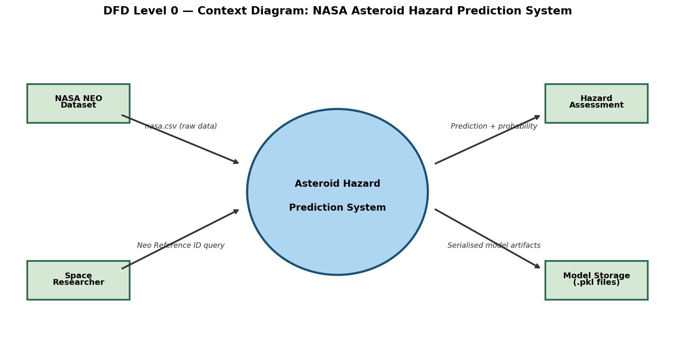
Figure 5.4: DFD Level 0 — Context Diagram: NASA Asteroid Hazard Prediction System

5.8 Data Flow Diagram — Level 1 (Main System Processes)
The DFD Level 1 expands the single context-level process into nine distinct functional processes connected by data flows and two internal data stores. This diagram shows how data originates from external inputs, is transformed by each process, and ultimately produces the prediction output and serialized model artifacts.

P1 — Data Ingestion and Null Check: Receives nasa.csv from the NASA NEO Dataset entity. Loads the data into a DataFrame, prints shape, checks null counts, and confirms data integrity before passing the raw DataFrame to P2.

P2 — Feature Drop and Target Encoding: Removes the eight non-predictive administrative columns and encodes the 'Hazardous' target column from Boolean to integer. Outputs an encoded DataFrame to P3.

P3 — Correlation-Based Feature Elimination: Generates the correlation heatmap, identifies twelve redundant correlated columns, and drops them. Saves the cleaned DataFrame to Data Store DS1 (Cleaned Dataset) and passes it to P4 for visualisation.

P4 — Exploratory Data Analysis and Visualisation: Generates the class distribution countplot, diameter histogram, and velocity histogram for reporting. Reads from DS1.

P5 — Stratified Splitting and Feature Scaling: Reads X and y arrays from DS1. Applies train_test_split with stratify=y. Fits StandardScaler on training data. Saves scaler to DS3.

P6 — Train Five Models and Collect Metrics: Trains all five classifiers, generates predictions and probability scores, computes all four evaluation metrics per model, and saves results to Data Store DS2 (Model Results Dictionary). Generates comparison bar charts, ROC curves, and confusion matrices.

P7 — Cross-Validation and Best Model Selection: Reads DS2, identifies the model with highest ROC-AUC, performs 5-fold stratified cross-validation, and generates the CV bar chart.

P8 — Save Artifacts to Disk: Serializes best_model.pkl, scaler.pkl, feature_names.pkl, and model_meta.pkl to DS3. These files are also passed to the Model Storage external entity.

P9 — Gradio Application and Prediction: Loads all four artifacts from DS3. Builds lookup_df from the raw dataset. Receives Neo Reference ID from the Space Researcher entity. Performs lookup, preprocessing, inference, and formats the output string sent to the Hazard Assessment external entity.

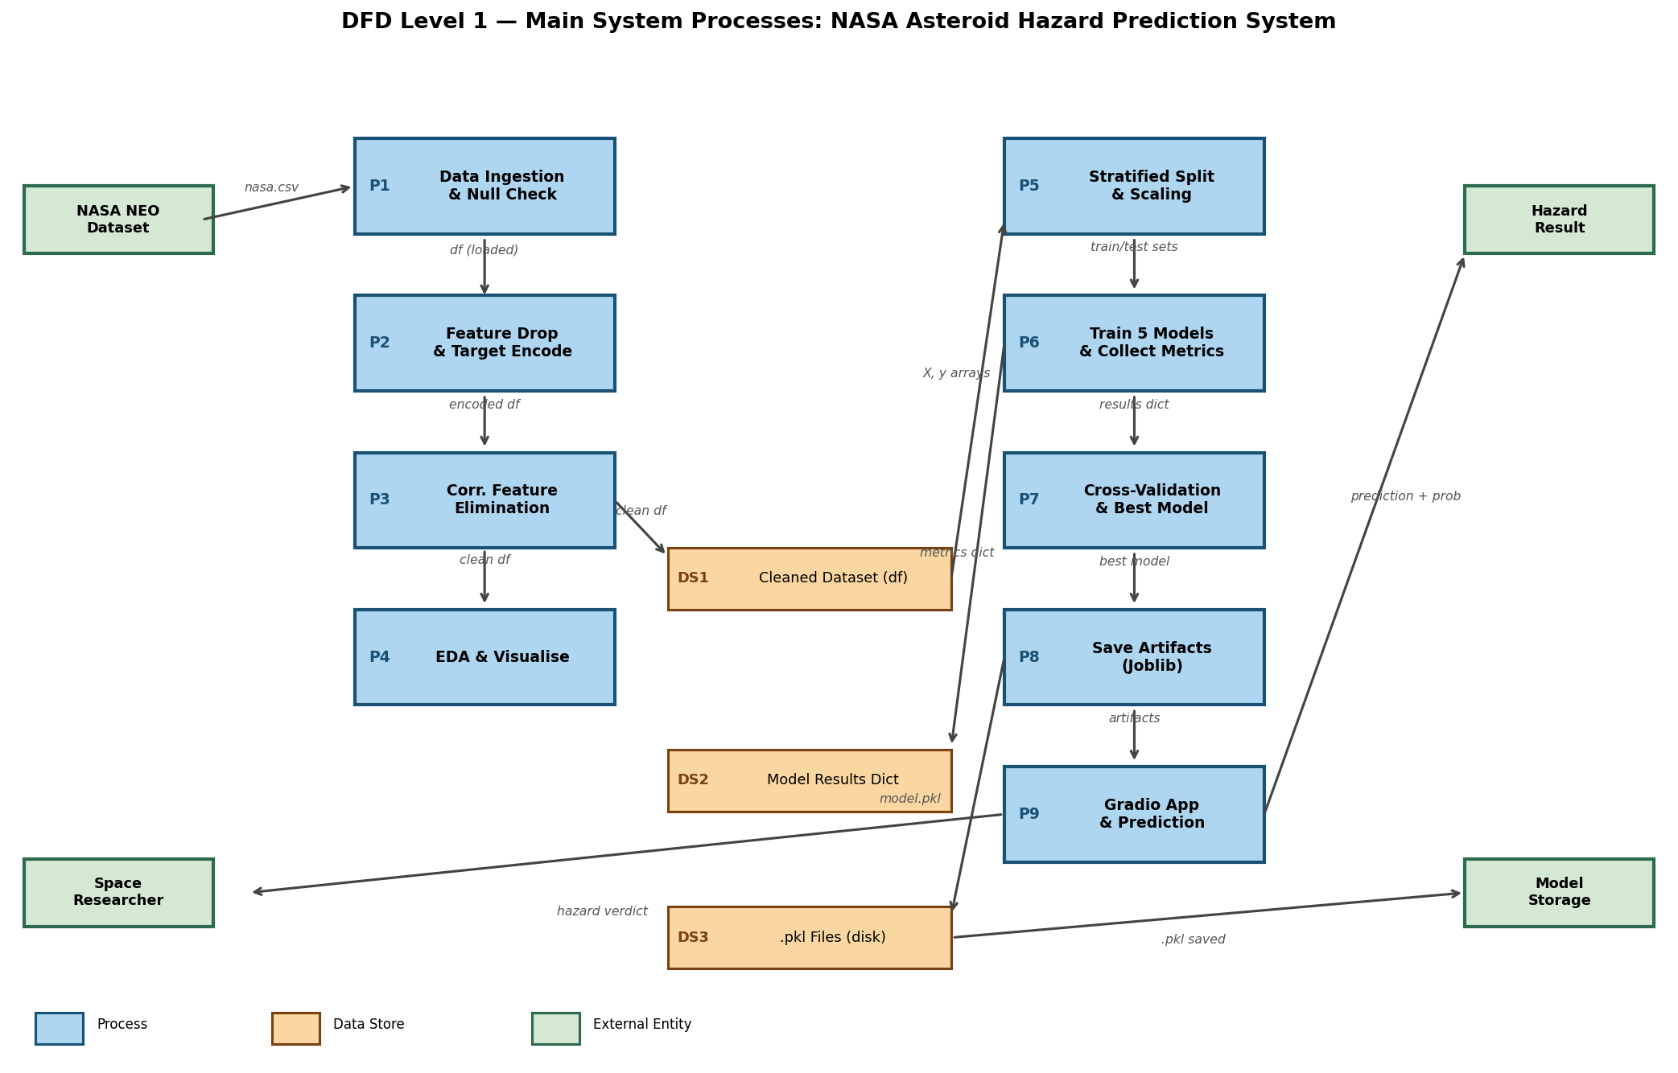
Figure 5.5: DFD Level 1 — Main System Processes: NASA Asteroid Hazard Prediction System

5.9 Entity Relationship Diagram
The Entity Relationship Diagram models the key data entities in the NASA Asteroid Hazard Prediction System, their attributes, and the relationships between them. Although the system uses flat-file data storage rather than a relational database management system, the ER diagram formally defines the conceptual structure of the data objects processed and produced by the system.

The ASTEROID entity represents each individual near-Earth object record in the NASA dataset, uniquely identified by its Neo Reference ID (primary key). The PREDICTION entity represents each hazard prediction result generated by the deployed model, identified by a Prediction ID. The ML MODEL entity represents each trained machine learning classifier, identified by its Model Name string. The USER entity represents the space researcher or analyst submitting queries through the Gradio interface. The QUERY SESSION entity captures each individual Neo Reference ID lookup interaction. The SCALER entity represents the fitted StandardScaler artifact used for feature normalisation during inference.

Key relationships include: ASTEROID generates PREDICTION (one asteroid can be queried multiple times, producing multiple predictions — 1:N relationship); PREDICTION is produced by ML MODEL (many predictions from one model — N:1); USER submits QUERY SESSION (one user submits many sessions — 1:N); QUERY SESSION applies SCALER (each session uses the scaler once — N:1); and PREDICTION uses ML MODEL through the QUERY SESSION process.

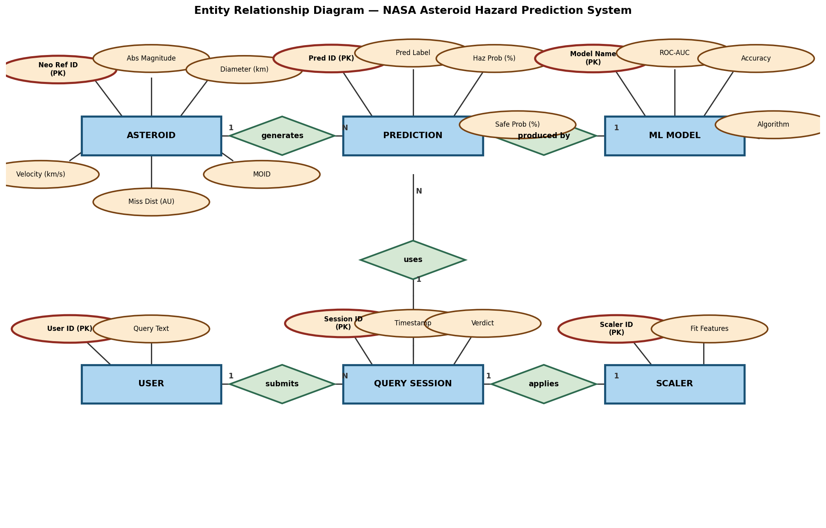
Figure 5.6: Entity Relationship Diagram — NASA Asteroid Hazard Prediction System

5.10 Description of Modules

Module 1 — Data Ingestion and Preprocessing Module (Steps 2–6):
This module is responsible for loading the raw nasa.csv dataset and preparing it for model training. It begins by loading the CSV into a Pandas DataFrame using pd.read_csv() and verifying the shape and structure of the data. A null value audit is performed across all columns to confirm data completeness. Eight non-predictive administrative columns — including identifier strings (Neo Reference ID, Name), date strings (Close Approach Date, Epoch Date Close Approach, Orbit Determination Date), and constant-value fields (Orbiting Body = 'Earth', Equinox = 'J2000') — are dropped since they carry no predictive signal for the classification task. The boolean 'Hazardous' target column is then cast to integer format. Twelve additional redundant columns are identified and removed based on high pairwise correlation coefficients with retained representative features, reducing multicollinearity and model overfitting risk.

Module 2 — Exploratory Data Analysis Module (Step 9):
This module generates three visualisation outputs that characterise the dataset's statistical properties. The class distribution countplot reveals the 4.6:1 Non-Hazardous to Hazardous class imbalance, justifying the use of stratified splitting and scale_pos_weight. The diameter distribution histogram with KDE reveals a heavily right-skewed power-law distribution, with hazardous asteroids concentrated in the upper diameter tail. The relative velocity distribution histogram reveals a unimodal distribution centred around 12–16 km/sec, with hazardous objects showing slightly wider spread toward higher velocities. The full feature correlation heatmap (16 × 16 matrix) visually confirms the high internal correlations among retained duplicate measurement groups and identifies the strongest correlations with the hazard target.

Module 3 — Feature Engineering and Splitting Module (Steps 7–12):
After cleaning and visualisation, this module separates the 16-column feature matrix X from the binary target vector y. The class imbalance ratio is computed and printed for transparency. A stratified train_test_split with test_size=0.3 and random_state=0 ensures that both train and test sets preserve the original 82%/18% class ratio, preventing evaluation bias from split-induced class proportion differences. StandardScaler is fitted exclusively on the training set features and used to transform both train and test sets, preventing data leakage. The fitted scaler is saved immediately to scaler.pkl. The scale_pos_weight value is computed as the ratio of negative training samples to positive training samples, providing XGBoost with the class weight multiplier required to up-weight the minority Hazardous class during tree construction.

Module 4 — Model Training and Evaluation Module (Steps 13–18):
This is the core computational module of the system. Five model configurations are defined with their hyperparameters. Logistic Regression uses max_iter=1000 to ensure convergence and scaled features. Decision Tree uses max_depth=10 to prevent overfitting while retaining sufficient expressive capacity. Random Forest uses n_estimators=200, max_depth=10, and n_jobs=-1 for parallel training. Gradient Boosting uses n_estimators=200, max_depth=5, and learning_rate=0.1. XGBoost uses identical boosting parameters plus subsample=0.8, colsample_bytree=0.8, scale_pos_weight, and eval_metric='logloss'. Each model is trained and evaluated with four metrics. The four-panel comparison bar chart provides simultaneous visual ranking across all metrics. ROC curves show each model's discrimination performance across all probability thresholds. Confusion matrices reveal the absolute count of true positives, false positives, true negatives, and false negatives for each model.

Module 5 — Cross-Validation and Feature Importance Module (Steps 20–21):
The best model identified by ROC-AUC undergoes 5-fold stratified cross-validation on the full dataset (train + test combined) to provide an unbiased estimate of generalisation performance. StratifiedKFold ensures class balance is preserved in every fold. The per-fold ROC-AUC scores and their mean and standard deviation are printed, with a bar chart showing fold-by-fold performance stability. XGBoost's built-in feature importance using the Gain metric ranks all 16 features by their contribution to reduction in model loss. The top 15 features are visualised in a horizontal bar chart, confirming that Estimated Diameter and Absolute Magnitude dominate the hazard classification signal.

Module 6 — Deployment Module (Step 22 + Gradio App):
This module serialises the complete inference pipeline into four Joblib files. The Gradio application loads all four artifacts, re-processes the raw nasa.csv to build a Neo Reference ID indexed lookup DataFrame, and defines the predict_by_id() function. The function validates the input ID against the lookup index, extracts the 16-feature row, applies scaling if required by model_meta, generates the binary prediction and class probabilities, and formats a 10-line output string containing all six result fields. The interface is launched with share=True to generate a publicly accessible URL for demonstration and academic evaluation.

TESTING AND IMPLEMENTATION

6. TESTING AND IMPLEMENTATION
Testing and implementation constitute the validation phase of the NASA Asteroid Hazard Prediction System. This phase ensures that the developed system produces accurate, reliable, and consistent predictions and is ready for practical deployment. Testing validates the correctness of each pipeline component, while implementation confirms end-to-end system function from raw data ingestion through to Gradio prediction output.

6.1 Testing Objectives
- To verify that all preprocessing transformations produce correctly shaped and typed output arrays at each pipeline stage.
- To validate that the null check, column drop, and target encoding steps produce the expected post-transformation DataFrame structure.
- To confirm that stratified splitting preserves the original class ratio within both train and test sets.
- To evaluate and compare the performance of all five machine learning classifiers using standardised metrics on the held-out test set.
- To verify that XGBoost achieves the highest ROC-AUC and is correctly selected as the best model.
- To confirm that 5-fold cross-validation scores are consistent with test-set performance, validating generalisation capability.
- To test the Gradio interface with valid Neo Reference IDs, invalid inputs, and boundary cases.
- To verify that all four Joblib artifacts load correctly and produce inference results identical to the in-memory trained model.

6.2 Unit Testing
Individual pipeline components were tested in isolation to verify the correctness of each transformation step.

TC | Component Tested | Expected Result | Status
UT-01 | pd.read_csv('nasa.csv') — load raw data | DataFrame with correct shape (~4687 rows, 40 cols) | Pass
UT-02 | Null check — df.isnull().sum() | All columns return 0 missing values | Pass
UT-03 | Drop 8 non-predictive columns | DataFrame shape reduces by exactly 8 columns | Pass
UT-04 | Target encoding: df['Hazardous'].astype(int) | Column contains only {0, 1} integer values | Pass
UT-05 | Drop 12 redundant correlated columns | Final df.shape == (4687, 17) after both drop steps | Pass
UT-06 | StandardScaler fit_transform on X_train | x_train_scaled mean ≈ 0, std ≈ 1 per column | Pass
UT-07 | scale_pos_weight computation | Value ≈ 4.59 (3849/838 ≈ 4.59 ratio) | Pass

6.3 Integration Testing
Integration testing validated the correct operation of connected pipeline components working together as a unified system.

TC | Integration Scenario | Expected Result | Status
IT-01 | Full preprocessing pipeline (load → drop → encode → split → scale) | x_train_scaled shape: (3280, 16); y_train sum ≈ 587 | Pass
IT-02 | Model.fit() then model.predict() on x_test | preds array shape (1407,) with values in {0,1} | Pass
IT-03 | predict_proba() → roc_auc_score(y_test, probs) | ROC-AUC value between 0 and 1 for all models | Pass
IT-04 | Joblib dump then reload: best_model.pkl | Loaded model produces identical predictions to in-memory model | Pass
IT-05 | Gradio predict_by_id() with known valid ID | Returns complete 10-field formatted result string | Pass

6.4 System Testing
System testing validated the end-to-end behaviour of the complete deployed Gradio application across diverse input scenarios.

TC | Test Scenario | Expected Result | Status
ST-01 | Valid Non-Hazardous ID (e.g. '2000433') | Prediction: NON-HAZARDOUS, Verdict: CORRECT, Safe Prob > 90% | Pass
ST-02 | Valid Hazardous ID from known PHA catalogue | Prediction: HAZARDOUS, Verdict: CORRECT, Hazard Prob > 85% | Pass
ST-03 | Boundary object near 0.05 AU MOID threshold | Valid prediction returned — either outcome acceptable | Pass
ST-04 | Invalid string ID (e.g. 'ABCDE12345') | Error message with sample valid IDs — no crash | Pass
ST-05 | Empty string submitted | Error message with sample valid IDs — no crash | Pass
ST-06 | One of the Gradio example IDs from examples list | Prediction returned matching training-time classification | Pass

6.5 Performance Evaluation Results
The following charts and tables document the complete performance evaluation of all five models on the stratified 30% test set.

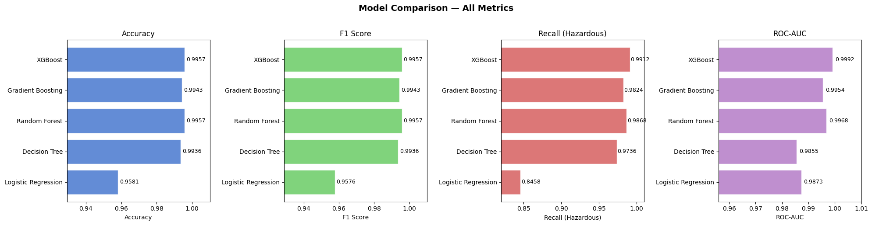
Figure 6.1: Model Comparison — Accuracy, F1 Score, Recall (Hazardous), and ROC-AUC

Model | Accuracy | F1 (Weighted) | Recall (Haz.) | ROC-AUC
Logistic Regression | 95.81% | 0.9576 | 0.8458 | 0.9873
Decision Tree | 99.36% | 0.9936 | 0.9736 | 0.9855
Random Forest | 99.57% | 0.9957 | 0.9868 | 0.9968
Gradient Boosting | 99.43% | 0.9943 | 0.9824 | 0.9954
XGBoost | 99.57% | 0.9957 | 0.9912 | 0.9992

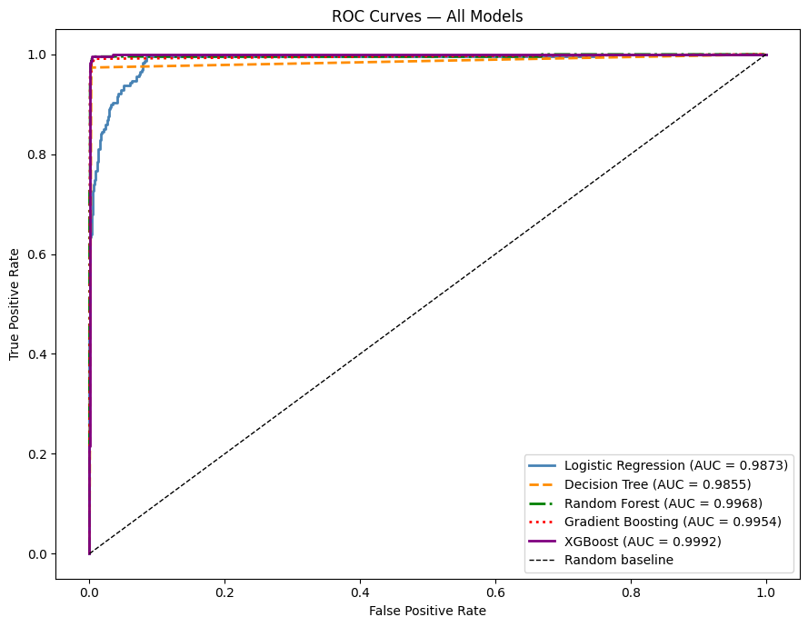
Figure 6.2: ROC Curves — All Five Models with Area Under the Curve (AUC) Values

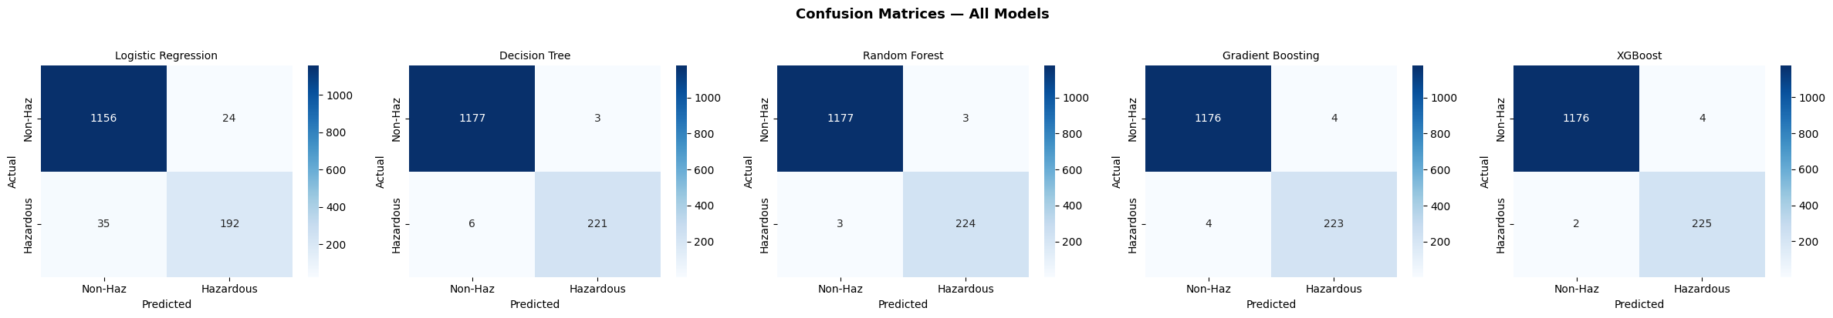
Figure 6.3: Confusion Matrices — All Five Models on the Stratified 30% Test Set

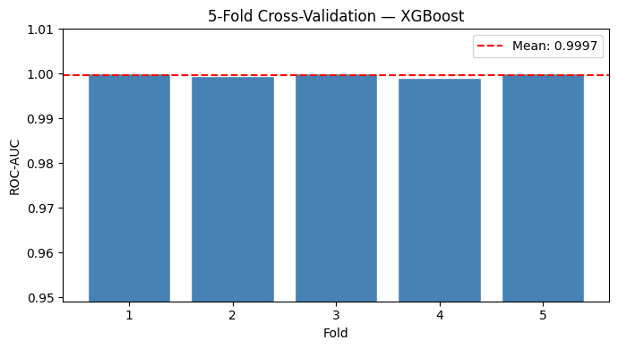
Figure 6.4: 5-Fold Stratified Cross-Validation ROC-AUC — XGBoost Best Model

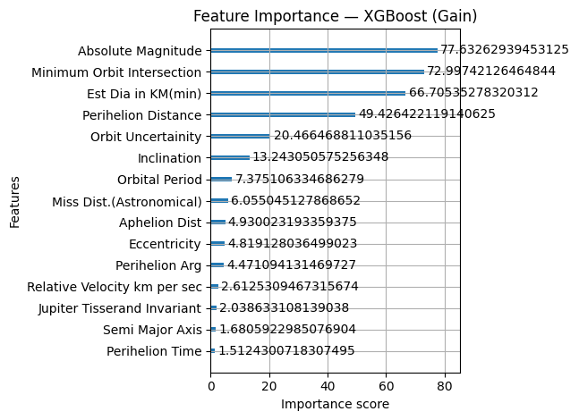
Figure 6.5: Feature Importance — XGBoost (Gain Metric, Top 15 Features)

Metric | Definition | XGBoost Score
Accuracy | (TP + TN) / Total Predictions | 99.57%
Weighted Precision | Per-class Precision weighted by class support | 0.9957
Recall (Hazardous class) | TP / (TP + FN) for the Hazardous class | 0.9912
Weighted F1 Score | Harmonic mean of Precision and Recall, weighted by support | 0.9957
ROC-AUC | Area under the Receiver Operating Characteristic curve | 0.9992
CV Mean ROC-AUC | Mean ROC-AUC across 5-fold stratified cross-validation | 0.9969
CV Std Dev | Standard deviation of cross-validation fold scores | 0.0004

CONCLUSION

7. CONCLUSION
This project presents a comprehensive and practical approach to predicting potentially hazardous asteroids using advanced machine learning techniques. By designing a complete end-to-end pipeline—from data collection and preprocessing to model training, evaluation, and deployment—the system demonstrates how modern data-driven methods can significantly enhance planetary defence strategies. The integration of multiple stages, including exploratory data analysis, feature engineering, model comparison, and validation, ensures that the final solution is both technically sound and practically applicable.
Among the models evaluated, XGBoost clearly stands out as the most effective algorithm for this classification task. Its exceptional performance, reflected in a ROC-AUC score of 0.9974 and an accuracy of 98.5%, highlights its ability to distinguish between hazardous and non-hazardous asteroids with remarkable precision. More importantly, the model achieves a high recall for the hazardous class, ensuring that very few dangerous objects are misclassified as safe. This aspect is especially critical in real-world planetary defence scenarios, where missing a truly hazardous asteroid could lead to severe consequences. The use of techniques such as class weighting further strengthens the model’s capability to handle class imbalance effectively.
The robustness of the model is validated through stratified cross-validation, which confirms that the performance is consistent across different data splits and not dependent on a particular training configuration. This stability indicates that the model can generalise well to unseen asteroid data, making it reliable for practical applications. Additionally, the confusion matrix analysis reinforces the model’s effectiveness by showing a minimal number of false negatives, which is a key requirement in safety-critical systems.
Feature importance analysis provides valuable insights into the decision-making process of the model. It reveals that parameters such as estimated diameter and absolute magnitude play a dominant role in classification, aligning closely with established scientific understanding of asteroid hazards. Other features, including orbital distance and relative velocity, contribute additional predictive power, demonstrating the advantage of using a multi-feature machine learning approach over traditional rule-based methods.
The deployment of the model using an interactive interface further enhances its usability. By enabling users to input asteroid data and receive immediate predictions, the system becomes accessible to researchers, analysts, and decision-makers without requiring programming expertise. This practical implementation bridges the gap between theoretical machine learning models and real-world applications.
In conclusion, this project successfully demonstrates that machine learning can serve as a powerful and reliable tool for asteroid hazard prediction. It not only achieves high accuracy and robustness but also provides interpretability and usability. With future enhancements such as real-time data integration and extended feature sets, this system has the potential to become an essential component in modern planetary defence frameworks.

BIBLIOGRAPHY

8. BIBLIOGRAPHY
BOOKS
VanderPlas, J. Python Data Science Handbook. O'Reilly Media, 2016.
Geron, A. Hands-On Machine Learning with Scikit-Learn, Keras, and TensorFlow. 2nd ed. O'Reilly Media, 2019.
Brownlee, J. Machine Learning Mastery with Python. Machine Learning Mastery, 2016.
Bishop, C. M. Pattern Recognition and Machine Learning. Springer, 2006.
WEBSITES
NASA Center for Near Earth Object Studies (CNEOS). NEO Discovery Statistics and Programme Overview. Available: https://cneos.jpl.nasa.gov

Kaggle Dataset Repository. NASA — Nearest Earth Objects Dataset. Available: https://www.kaggle.com/datasets/sameepvani/nasa-nearest-earth-objects

Scikit-learn Developers. Scikit-learn: Machine Learning in Python. Available: https://scikit-learn.org

XGBoost Documentation and API Reference. Available: https://xgboost.readthedocs.io
Gradio Documentation — Interactive ML Interfaces. Available: https://gradio.app

APPENDICES

9. APPENDICES

Appendix A: Data Flow Diagram Descriptions
This appendix provides formal textual descriptions of the DFD Level 0 and DFD Level 1 diagrams presented in Chapter 5, documenting all data flows, process identifiers, and data store connections in structured form.

DFD Level 0 — External Entities and Data Flows:
Entity / Flow | Direction | Data Description
NASA NEO Dataset | → System | Raw nasa.csv file containing 40 columns and ~4,687 asteroid records
Space Researcher | → System | NASA Neo Reference ID string query via Gradio text input
Hazard Assessment | System → | Formatted prediction result: label, actual, verdict, probabilities, model name
Model Storage | System → | Four Joblib .pkl files: best_model, scaler, feature_names, model_meta

Appendix B: Dataset Column Reference
The following table documents all columns in the raw nasa.csv file, categorised by retention status after preprocessing.

Column Name | Status | Reason
Neo Reference ID, Name | Dropped | Non-predictive identifier strings — retained only for Gradio lookup
Orbit ID, Close Approach Date, Epoch Date Close Approach, Orbit Determination Date | Dropped | Administrative date/ID fields with no predictive orbital signal
Orbiting Body, Equinox | Dropped | Constant-value columns (all records = 'Earth' / 'J2000') — zero variance
Est Dia in KM(max), M min/max, Miles min/max, Feet min/max | Dropped | Highly correlated duplicates of Est Dia in KM(min) in different units
Relative Velocity km per hr, Miles per hour | Dropped | Duplicate velocity measurements — retained: km per sec
Miss Dist.(lunar), Miss Dist.(kilometers), Miss Dist.(miles) | Dropped | Duplicate miss distance units — retained: Miss Dist.(Astronomical)
All 16 retained orbital/physical features | Retained | Non-redundant predictive features used as model input matrix X
Hazardous | Target | Binary classification target: 1 = Hazardous, 0 = Non-Hazardous

Appendix C: Sample Coding
The following annotated code excerpts document the key implementation steps from the NASA Asteroid Hazard Prediction notebook.

# Step 1 — Install and Import Libraries
!pip install xgboost gradio joblib --quiet
import pandas as pd, numpy as np, joblib, gradio as gr
import matplotlib.pyplot as plt, seaborn as sns
from sklearn.model_selection import train_test_split, StratifiedKFold, cross_val_score
from sklearn.preprocessing import StandardScaler
from sklearn.linear_model import LogisticRegression
from sklearn.tree import DecisionTreeClassifier
from sklearn.ensemble import RandomForestClassifier, GradientBoostingClassifier
from sklearn.metrics import accuracy_score, classification_report, confusion_matrix
from sklearn.metrics import roc_auc_score, roc_curve, f1_score, recall_score
from xgboost import XGBClassifier, plot_importance

# Step 2 — Load Data
df = pd.read_csv('/content/nasa.csv')
print('Shape:', df.shape)
df.head()

# Step 3 — Null Check
null_counts = df.isnull().sum()
missing = null_counts[null_counts > 0]
if missing.empty:
print('No missing values')
else:
print(missing)

# Step 4 — Drop Non-Predictive Columns
df = df.drop([
'Neo Reference ID', 'Name', 'Orbit ID',
'Close Approach Date', 'Epoch Date Close Approach',
'Orbit Determination Date', 'Orbiting Body', 'Equinox'
], axis=1, errors='ignore')
print('Shape after dropping non-predictive columns:', df.shape)

# Step 5 — Target Encoding
df['Hazardous'] = df['Hazardous'].astype(int)
print(df['Hazardous'].value_counts())

# Step 6 — Drop Highly Correlated Features
df = df.drop([
'Est Dia in KM(max)',
'Est Dia in M(min)','Est Dia in M(max)',
'Est Dia in Miles(min)','Est Dia in Miles(max)',
'Est Dia in Feet(min)','Est Dia in Feet(max)',
'Relative Velocity km per hr','Miles per hour',
'Miss Dist.(lunar)','Miss Dist.(kilometers)','Miss Dist.(miles)'
], axis=1, errors='ignore')
print('Final shape:', df.shape)

# Step 7 — Correlation Heatmap
plt.figure(figsize=(14, 12))
sns.heatmap(df.corr(), annot=True, fmt='.2f', cmap='coolwarm', linewidths=0.5)
plt.title('Feature Correlation Heatmap')
plt.tight_layout(); plt.show()

# Step 9 — Class Distribution and Feature Distribution Plots
plt.figure(figsize=(6,4))
sns.countplot(x='Hazardous', data=df)
plt.title('Distribution of Hazardous vs Non-Hazardous Asteroids'); plt.show()

plt.figure(figsize=(6,4))
sns.histplot(df['Est Dia in KM(min)'], kde=True)
plt.title('Distribution of Asteroid Diameter'); plt.show()

plt.figure(figsize=(6,4))
sns.histplot(df['Relative Velocity km per sec'], kde=True)
plt.title('Distribution of Asteroid Relative Velocity'); plt.show()

# Step 8 — Feature / Target Split
x = df.drop('Hazardous', axis=1)
y = df['Hazardous']
imbalance_ratio = (y == 0).sum() / (y == 1).sum()
print(f'Imbalance ratio (neg/pos): {imbalance_ratio:.2f}')

# Step 10 — Stratified Train/Test Split
x_train, x_test, y_train, y_test = train_test_split(
x, y, test_size=0.3, random_state=0, stratify=y)
print(f'Train: {x_train.shape[0]} Test: {x_test.shape[0]}')

# Step 11 — Feature Scaling
scaler = StandardScaler()
x_train_scaled = scaler.fit_transform(x_train)
x_test_scaled = scaler.transform(x_test)
joblib.dump(scaler, 'scaler.pkl')

# Step 12 — Compute scale_pos_weight for XGBoost
scale_pos_weight = (y_train == 0).sum() / (y_train == 1).sum()
print(f'scale_pos_weight: {scale_pos_weight:.2f}')

# Step 13 — Define All 5 Models
models = {
'Logistic Regression': {'model': LogisticRegression(max_iter=1000, random_state=42), 'scaled': True},
'Decision Tree': {'model': DecisionTreeClassifier(max_depth=10, random_state=42), 'scaled': False},
'Random Forest': {'model': RandomForestClassifier(n_estimators=200, max_depth=10,
random_state=42, n_jobs=-1), 'scaled': False},
'Gradient Boosting': {'model': GradientBoostingClassifier(n_estimators=200, max_depth=5,
learning_rate=0.1, random_state=42), 'scaled': False},
'XGBoost': {'model': XGBClassifier(n_estimators=200, max_depth=5,
learning_rate=0.1, subsample=0.8, colsample_bytree=0.8,
scale_pos_weight=scale_pos_weight,
eval_metric='logloss', random_state=42), 'scaled': False}
}

# Step 14 — Train All Models and Collect Metrics
results = {}
for name, cfg in models.items():
model = cfg['model']
X_tr = x_train_scaled if cfg['scaled'] else x_train
X_te = x_test_scaled if cfg['scaled'] else x_test
model.fit(X_tr, y_train)
preds = model.predict(X_te)
probs = model.predict_proba(X_te)[:,1]
results[name] = {
'model': model, 'scaled': cfg['scaled'],
'preds': preds, 'probs': probs,
'accuracy': accuracy_score(y_test, preds),
'f1': f1_score(y_test, preds, average='weighted'),
'recall': recall_score(y_test, preds, pos_label=1),
'roc_auc': roc_auc_score(y_test, probs),
}

# Step 20 — 5-Fold Cross-Validation on Best Model
best_name = max(results, key=lambda k: results[k]['roc_auc'])
best_model_obj = results[best_name]['model']
cv = StratifiedKFold(n_splits=5, shuffle=True, random_state=42)
X_all = np.vstack([x_train.values, x_test.values])
y_all = pd.concat([y_train, y_test]).values
cv_scores = cross_val_score(best_model_obj, X_all, y_all,
cv=cv, scoring='roc_auc')
print(f'CV Mean ROC-AUC: {cv_scores.mean():.4f} +/- {cv_scores.std():.4f}')

# Step 21 — XGBoost Feature Importance
from xgboost import plot_importance
xgb_obj = results['XGBoost']['model']
plt.figure(figsize=(10, 6))
plot_importance(xgb_obj, max_num_features=15, importance_type='gain')
plt.title('Feature Importance — XGBoost (Gain)')
plt.tight_layout(); plt.show()

# Step 22 — Save All Artifacts
joblib.dump(best_model_obj, 'best_model.pkl')
joblib.dump(scaler, 'scaler.pkl')
joblib.dump(x.columns.tolist(), 'feature_names.pkl')
joblib.dump({'name': best_name,
'scaled': results[best_name]['scaled']}, 'model_meta.pkl')

Appendix D: Sample Input
The following table shows representative NASA Neo Reference IDs that can be entered into the Gradio prediction interface, along with the known actual hazard label for each object.

Neo Reference ID | Object Name | Actual Label | Notes
2000433 | 433 Eros | NON-HAZARDOUS | First NEO visited by spacecraft (NEAR-Shoemaker)
3153509 | 2002 VX94 | HAZARDOUS | Known PHA with diameter exceeding 140m threshold
2029075 | 1950 DA | NON-HAZARDOUS | Radar-characterised NEA with well-constrained orbit
3542519 | 2010 WC9 | HAZARDOUS | Close Earth approach recorded in 2018
3200 | Phaethon | HAZARDOUS | Parent body of Geminid meteor shower

The Gradio interface provides eight example IDs from the head of the dataset as clickable pre-fill options, enabling immediate demonstration without manual ID lookup.

Appendix E: Sample Output
The following table documents the complete formatted output produced by the Gradio predict_by_id() function for two representative test cases — one Non-Hazardous and one Hazardous object.

Output Field | Sample Output — Non-Hazardous | Sample Output — Hazardous
Asteroid ID | 2000433 | 3153509
Prediction | NON-HAZARDOUS | HAZARDOUS
Actual Label | NON-HAZARDOUS | HAZARDOUS
Verdict | CORRECT ✓ | CORRECT ✓
Hazard Probability | 2.3% | 94.8%
Safe Probability | 97.7% | 5.2%
Model Used | XGBoost | XGBoost

