**DOODLE JUMP GAME**

**IN C++ USING SFML LIBRARY**



**FALL 2024-25**

**CSE208L OBJECT ORIENTED PROGRAMMING LAB**

Submitted by:

**SYED MUHAMMAD NOMAN (23PWCSE2227)**

**MUHAMMAD AFNAN KHAN (23PWCSE2241)**

**MUHAMMAD SAAD (23PWCSE2316)**

Class Section: **C**

Group: **13**

“On my honor, as student of University of Engineering and Technology, I have neither given nor received unauthorized assistance on this academic work.”

Submitted to:

**Engr. Sumayyea Salahuddin**

January 27th, 2025

**DEPARTMENT OF COMPUTER SYSTEMS ENGINEERING**

**UNIVERSITY OF ENGINEERING AND TECHNOLOGY, PESHAWAR**

**OBJECT ORIENTED PROGRAMMING LAB PROJECT  
DOODLE JUMP GAME IN C++ USING SFML LIBRARY**

**INTRODUCTION:**

**Brief Overview:**

* This project implements a simplified version of the classic Doodle Jump game using C++ and SFML (Simple and Fast Multimedia Library). It demonstrates the core principles of Object-Oriented Programming (OOP), such as encapsulation, inheritance, polymorphism, and abstraction.

**Purpose:**

* To learn OOP concepts.
* To explore game development.
* To apply SFML for rendering graphics and handling input.

**TOOLS AND TECHNOLOGIES:**

* **Programming Language**: C++
* **Graphics Library**: SFML
* **Editor/IDE**: DevC++, CodeBlocks.

**GAME OBJECTIVES:**

**Goal of the Game:**

* The player controls a character that continuously jumps off platforms to climb as high as possible, avoiding falling off the screen. The goal is to score points by reaching higher platforms.

**Challenges:**

* Players must navigate left and right to land on platforms.
* Platforms reset when the player moves higher, creating a dynamic environment.

**FEATURES:**

**Game Features**:

* Character movement (left and right).
* Jump mechanics with gravity simulation.
* Platforms that reset and move dynamically.
* Score tracking.
* Game Over and Retry options.

**Additional Features**:

* Custom character and background.
* Sound effects for player jumps.
* Responsive design for a larger window size.

**CHALLENGES FACED:**

**Issues during implementation:**

* Integrating SFML for the first time was challenging.
* Managing character movement and collision detection required precise calculations.
* Finding optimal images for the background and character in order to maintain optimal color combination.
* Resizing and conversion of the images from one form to another (e.g jpg to png etc.).
* Adjusting the Game window as well as adjusting platform and character spawn accordingly at the start as well as on resetting the game.

**How we overcame these:**

* Researched helping materials online.
* Revised OOP concepts for better understanding, implementation and design.
* Used the help of online websites for resizing and conversion of images according to our needs.
* Used AI tools for help like ChatGPT.

**REFERENCE:**

We used the following video, provided to us by our instructor, as reference:  
[*https://www.youtube.com/watch?v=7Vf_vQIUk5Q&ab_channel=FamTrinli*](https://www.youtube.com/watch?v=7Vf_vQIUk5Q&ab_channel=FamTrinli)

**WORKING OF THE GAME:**

**GAME OVERVIEW:**

* The game consists of a player character that automatically falls due to gravity and jumps when landing on platforms.
* The player moves horizontally via keyboard inputs (Left and Right arrow keys).
* The objective is to keep jumping on platforms, avoid falling off the screen, and earn points as platforms reset (when they move off-screen).

**KEY COMPONENTS:**

**Game Classes:**

We have used a total of 4 classes:

1. GameObject (Base Class).
2. Player (Derived Class).
3. Platform (Derived Class).
4. Game.

* **GameObject (Base):**

// Base class for all game objects

class GameObject {

protected:

Vector2f position;

public:

GameObject(float x, float y) : position(x, y) {}

virtual void update() = 0; // Pure virtual function for polymorphism

virtual void draw(RenderWindow& window, Sprite& sprite) = 0;

Vector2f getPosition() const {

return position;

}

void setPosition(float x, float y) {

position = {x, y};

}

};

* **Player (Derived):**

The Player class defines the character and its behavior.

It controls the player's position, movement (left/right), gravity, and jumping mechanics.

Applies a vertical velocity (dy) to simulate falling and jumping.

class Player : public GameObject {

private:

float dx, dy; // Horizontal and vertical velocity

public:

Player() : GameObject(200, 200), dx(0.0f), dy(0.0f) {} // Initialize position and velocity

void moveLeft() { position.x -= 5.0f; } // Move left by 5 units

void moveRight() { position.x += 5.0f; } // Move right by 5 units

void applyGravity() {

dy += 0.2f; // Simulate gravity (increase vertical velocity)

position.y += dy; // Move the player down

}

void jump() { dy = -8.0f; } // Give upward velocity for a jump

void reset() {

position = {200, 200}; // Reset position to start

dx = 0;

dy = 0;

}

float getVelocityY() const { return dy; } // Return vertical velocity

void update() override {

applyGravity(); // Apply gravity each frame

}

void draw(RenderWindow& window, Sprite& sprite) override {

sprite.setPosition(position); // Update sprite position

window.draw(sprite); // Draw the sprite

}

};

* **Gravity Simulation**: The applyGravity() method increases the vertical velocity (dy) and moves the player down.
* **Jump**: When the player lands on a platform, jump() gives the player an upward velocity (dy = -8.0f).
* **Platform (Derived):**

The Platform class represents the platforms the player jumps on. It inherits from GameObject and provides a simple vertical movement method.  
Moves vertically when the player jumps past a certain threshold.

class Platform : public GameObject {

public:

Platform(float x, float y) : GameObject(x, y) {} // Initialize position

void update() override {

// Platforms don't have specific updates (currently empty)

}

void move(float dy) {

position.y -= dy; // Move platform vertically (negative = up)

}

void draw(RenderWindow& window, Sprite& sprite) override {

sprite.setPosition(position); // Set sprite position

window.draw(sprite); // Draw platform sprite

}

};

* Platforms move downward relative to the player’s vertical movement (move(float dy)).
* They reset to the top when they move off-screen.
* **Game (Class):**

class Game {

private:

RenderWindow window;

Texture t1, t2, t3;

Sprite sBackground, sPlat, sPers;

Font font;

Text scoreText, gameOverText, retryText;

Player player;

std::vector<Platform> platforms;

int score;

bool gameOver;

// Sound-related variables

SoundBuffer jumpBuffer;

Sound jumpSound;

void resetGame() {

player.reset();

score = 0;

gameOver = false;

platforms.clear();

for (int i = 0; i < 10; i++) {

platforms.emplace_back(rand() % 500, rand() % 700);

} // Adjusted spawn range for platforms

updateScoreText();

}

void updateScoreText() {

std::ostringstream ss;

ss << "Score: " << score;

scoreText.setString(ss.str());

}

void handleInput() {

if (Keyboard::isKeyPressed(Keyboard::Left)) {

player.moveLeft();

}

if (Keyboard::isKeyPressed(Keyboard::Right)) {

player.moveRight();

}

}

void handleCollisions() {

for (auto& platform : platforms) {

Vector2f pPos = platform.getPosition();

Vector2f plPos = player.getPosition();

if ((plPos.x + 50 > pPos.x) && (plPos.x + 20 < pPos.x + 68) &&

(plPos.y + 70 > pPos.y) && (plPos.y + 70 < pPos.y + 14) &&

(player.getVelocityY() > 0)) {

player.jump(); // Boost the player up when they collide // with the platform

jumpSound.play(); // Play the jump sound

}

}

}

void updatePlatforms() {

for (auto& platform : platforms) {

platform.move(player.getVelocityY());

// Check if platform is off-screen and reset it

if (platform.getPosition().y > 700) { // Adjusted for new window height

platform.setPosition(rand() % 500, 0); // Adjusted for new window width

score++; // Increment score when a platform resets

}

}

updateScoreText(); // Update score text after platform movement

}

void draw() {

window.clear();

if (gameOver) {

window.draw(sBackground);

window.draw(gameOverText);

window.draw(retryText);

} else {

window.draw(sBackground);

player.draw(window, sPers);

for (auto& platform : platforms) {

platform.draw(window, sPlat);

}

window.draw(scoreText);

}

window.display();

}

public: // Adjusted window size

Game() : window(VideoMode(500, 700), "Doodle Game!"), score(0), gameOver(false) {

srand(time(0));

window.setFramerateLimit(60);

// Load textures and font

t1.loadFromFile("images/sea.png");

t2.loadFromFile("images/platform.png");

t3.loadFromFile("images/character.png");

sBackground.setTexture(t1);

sPlat.setTexture(t2);

sPers.setTexture(t3);

if (!font.loadFromFile("fonts/DoodleJumpBold_v2.ttf")) {

std::cerr << "Failed to load font" << std::endl;

return;

}

// Load sound

if (!jumpBuffer.loadFromFile("sounds/sound_jump.wav")) {

std::cerr << "Failed to load sound_jump.wav" << std::endl;

return;

}

jumpSound.setBuffer(jumpBuffer);

scoreText.setFont(font);

scoreText.setCharacterSize(30);

scoreText.setFillColor(Color::White);

scoreText.setPosition(10, 10);

gameOverText.setFont(font);

gameOverText.setCharacterSize(48);

gameOverText.setFillColor(Color::Red);

gameOverText.setString("Game Over!");

gameOverText.setPosition(150, 300);

retryText.setFont(font);

retryText.setCharacterSize(28);

retryText.setFillColor(Color::Black);

retryText.setString("Press R to Retry or Esc to Exit");

retryText.setPosition(120, 400);

resetGame();

}

void run() {

while (window.isOpen()) {

Event e;

while (window.pollEvent(e)) {

if (e.type == Event::Closed) {

window.close();

}

if (gameOver) {

if (Keyboard::isKeyPressed(Keyboard::R)) {

resetGame();

} else if (Keyboard::isKeyPressed(Keyboard::Escape)) {

window.close();

}

}

}

if (!gameOver) {

handleInput();

player.update();

if (player.getPosition().y > 700) { // Adjusted for new window height

gameOver = true;

}

if (player.getPosition().y < 300) { // Adjusted gravity offset for larger window

float offset = 300 - player.getPosition().y;

player.setPosition(player.getPosition().x, 300);

for (auto& platform : platforms) {

platform.move(-offset);

}

}

updatePlatforms();

handleCollisions();

}

draw();

}

}

};

**Game Logic:**

* **Gravity:**

Applied to the player via Player::applyGravity(), causing continuous downward motion (dy).

void applyGravity() {

dy += 0.2f; // Increase gravity

position.y += dy;

}

* **Collision Detection**:

Checks if the player's position overlaps with a platform. If true, the player is "boosted" upwards with a negative dy (jump).

void handleCollisions() {

for (auto& platform : platforms) {

Vector2f pPos = platform.getPosition();

Vector2f plPos = player.getPosition();

if ((plPos.x + 50 > pPos.x) && (plPos.x + 20 < pPos.x + 68) &&

(plPos.y + 70 > pPos.y) && (plPos.y + 70 < pPos.y + 14) &&

(player.getVelocityY() > 0)) {

player.jump(); // Boost the player up when they collide with the platform

jumpSound.play(); // Play the jump sound

}

}

}

* **Score**:

Increases when a platform moves off the bottom of the screen and is repositioned at the top.

void updateScoreText() {

std::ostringstream ss;

ss << "Score: " << score;

scoreText.setString(ss.str());

}

* **Game Over**:

Triggered when the player falls below the screen (y > 700).

void run() {

while (window.isOpen()) {

Event e;

while (window.pollEvent(e)) {

if (e.type == Event::Closed) {

window.close();

}

if (gameOver) {

if (Keyboard::isKeyPressed(Keyboard::R)) {

resetGame();

} else if (Keyboard::isKeyPressed(Keyboard::Escape)) {

window.close();

}

}

}

if (!gameOver) {

handleInput();

player.update();

if (player.getPosition().y > 700) { // Adjusted for new window height

gameOver = true;

}

if (player.getPosition().y < 300) { // Adjusted gravity offset for larger window

float offset = 300 - player.getPosition().y;

player.setPosition(player.getPosition().x, 300);

for (auto& platform : platforms) {

platform.move(-offset);

}

}

updatePlatforms();

handleCollisions();

}

draw();

}

}

**GRAPHICS AND SOUND:**

* Textures are used for the background, platforms, and player sprite.

// Load textures and font

t1.loadFromFile("images/sea.png");

t2.loadFromFile("images/platform.png");

t3.loadFromFile("images/character.png");

sBackground.setTexture(t1);

sPlat.setTexture(t2);

sPers.setTexture(t3);

* A jump sound effect (sound_jump.wav) plays whenever the player jumps.

**Sound Variables:**

// Sound-related variables

SoundBuffer jumpBuffer;

Sound jumpSound;

// Load sound

if (!jumpBuffer.loadFromFile("sounds/sound_jump.wav")) {

std::cerr << "Failed to load sound_jump.wav" << std::endl;

return;

}

jumpSound.play(); // Play the jump sound

* Text objects (scoreText, gameOverText, retryText) display relevant information like the score and game state.

**Score Text:**

scoreText.setFont(font);

scoreText.setCharacterSize(30);

scoreText.setFillColor(Color::White);

scoreText.setPosition(10, 10);

**Game Over Text:**

gameOverText.setFont(font);

gameOverText.setCharacterSize(48);

gameOverText.setFillColor(Color::Red);

gameOverText.setString("Game Over!");

gameOverText.setPosition(150, 300);

**Retry Text:**

retryText.setFont(font);

retryText.setCharacterSize(28);

retryText.setFillColor(Color::Black);

retryText.setString("Press R to Retry or Esc to Exit");

retryText.setPosition(120, 400);

resetGame();

**GAME LOOP (MAIN FUNCTIONALITY):**

• **Event Handling**:

* Checks for Keyboard inputs to control the player or reset/exit the game after a Game Over.  
  **Player Control:**

void handleInput() {

if (Keyboard::isKeyPressed(Keyboard::Left)) {

player.moveLeft();

}

if (Keyboard::isKeyPressed(Keyboard::Right)) {

player.moveRight();

}

}

**Reset/exit:**

if (gameOver) {

if (Keyboard::isKeyPressed(Keyboard::R)) {

resetGame();

} else if (Keyboard::isKeyPressed(Keyboard::Escape)) {

window.close();

}

}

• **Game Updates**:

* Player's movement and gravity are updated.

**Player Movement:**

void moveLeft() {

position.x -= 5.0f;

}

void moveRight() {

position.x += 5.0f;

}

**Gravity:**

void applyGravity() {

dy += 0.2f; // Increase gravity

position.y += dy;

}

void update() override {

applyGravity();

}

* Platforms move relative to the player's motion, and their positions are reset when they go off-screen.

void updatePlatforms() {

for (auto& platform : platforms) {

platform.move(player.getVelocityY());

// Check if platform is off-screen and reset it

if (platform.getPosition().y > 700) { // Adjusted for new window height

platform.setPosition(rand() % 500, 0); // Adjusted for new window width

score++; // Increment score when a platform resets

}

}

updateScoreText(); // Update score text after platform movement

}

* Collisions between the player and platforms are handled to trigger jumps.

void handleCollisions() {

for (auto& platform : platforms) {

Vector2f pPos = platform.getPosition();

Vector2f plPos = player.getPosition();

if ((plPos.x + 50 > pPos.x) && (plPos.x + 20 < pPos.x + 68) &&

(plPos.y + 70 > pPos.y) && (plPos.y + 70 < pPos.y + 14) &&

(player.getVelocityY() > 0)) {

player.jump(); // Boost the player up when they collide with the platform

jumpSound.play(); // Play the jump sound

}

}

}

• **Rendering**:

* Clears the window and redraws all elements (background, player, platforms, and text).

void draw() {

window.clear();

if (gameOver) {

window.draw(sBackground);

window.draw(gameOverText);

window.draw(retryText);

} else {

window.draw(sBackground);

player.draw(window, sPers);

for (auto& platform : platforms) {

platform.draw(window, sPlat);

}

window.draw(scoreText);

}

window.display();

}

**OOP CONCEPTS IMPLEMENTED:**

* **ENCAPSULATION:**

Encapsulation is basically grouping different data types, methods and variables in a class, and implementing access specifiers for data hiding. Here is a general example of an encapsulated class:  
// Base class for all game objects

class GameObject {

protected:

Vector2f position;

public:

GameObject(float x, float y) : position(x, y) {}

virtual void update() = 0; // Pure virtual function for polymorphism

virtual void draw(RenderWindow& window, Sprite& sprite) = 0;

Vector2f getPosition() const {

return position;

}

void setPosition(float x, float y) {

position = {x, y};

}

};

* **ABSTRACTION:**

Using Pure Virtual Function:

virtual void update() = 0; // Pure virtual function for polymorphism

virtual void draw(RenderWindow& window, Sprite& sprite) = 0;

* **POLYMORPHISM:**

Examples Code:

void update() override {

applyGravity();

}

void draw(RenderWindow& window, Sprite& sprite) override {

sprite.setPosition(position);

window.draw(sprite);

}

* **INHERITANCE:**

Example Code of inheritance:

class Platform : public GameObject {

// body of class

}

class Player : public GameObject {

// body of class

}

**OVERALL GAME CODE:**

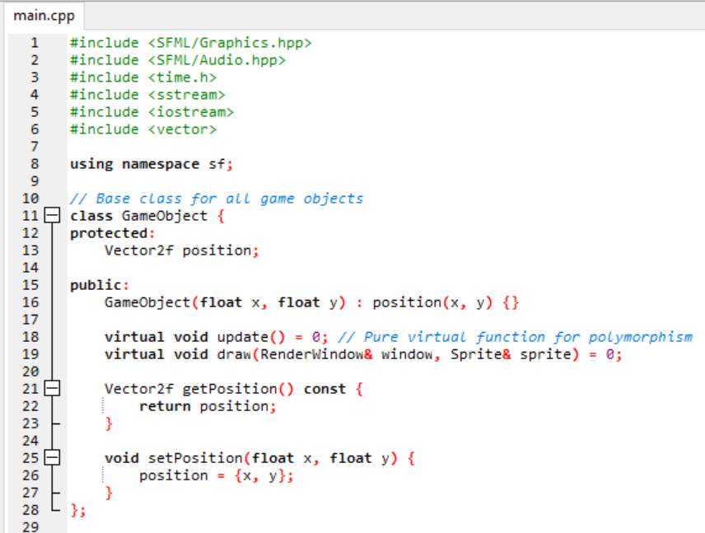

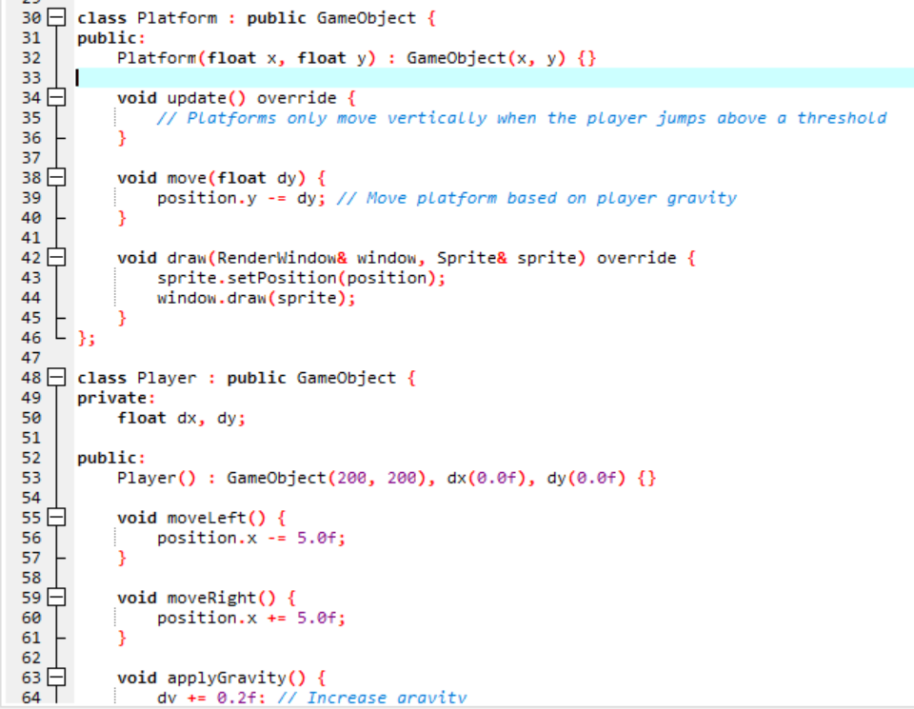

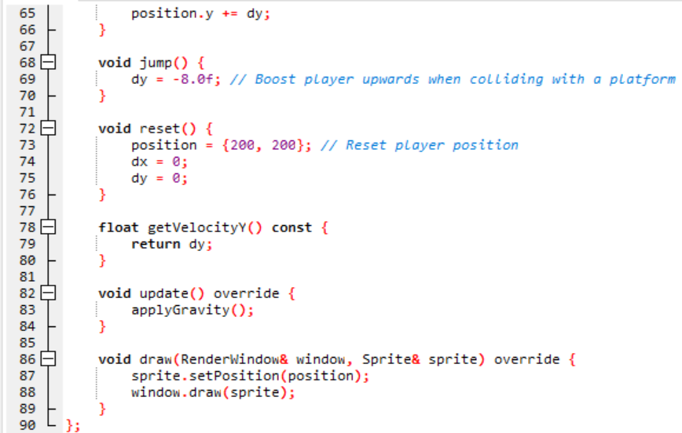

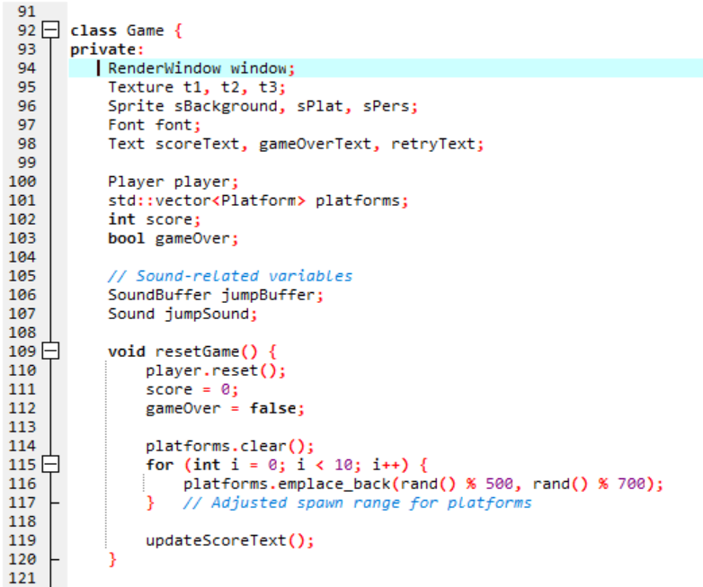

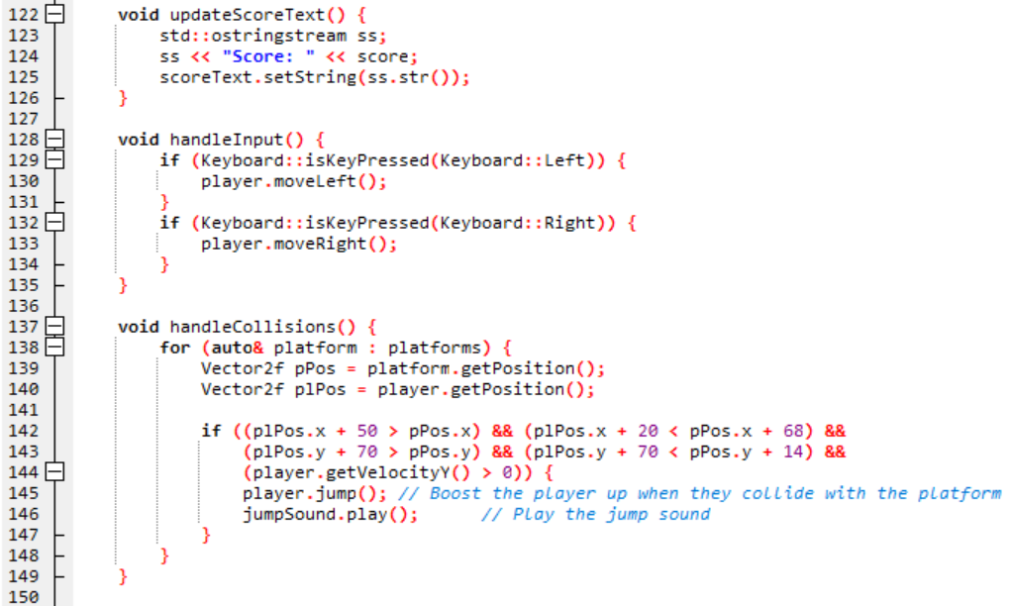

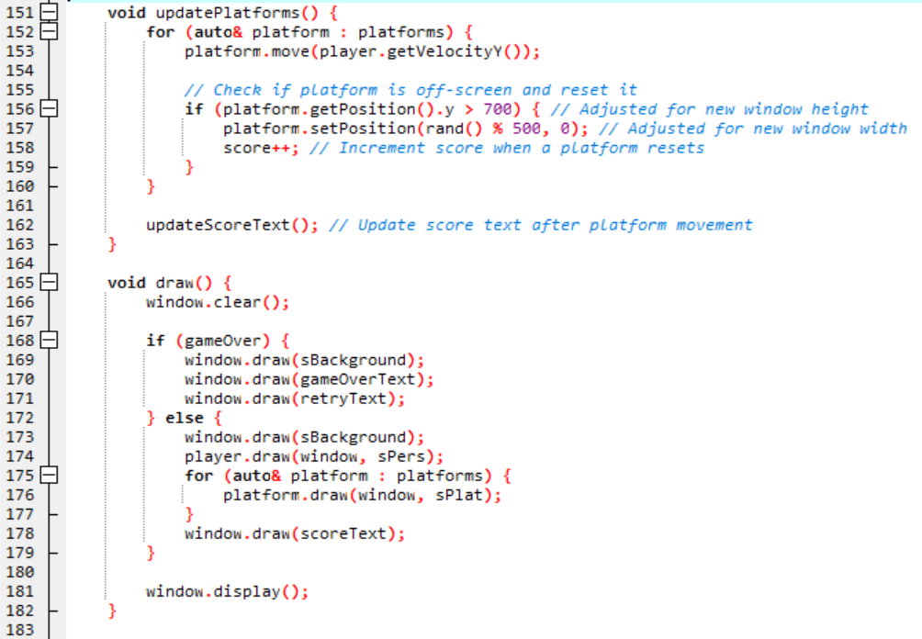

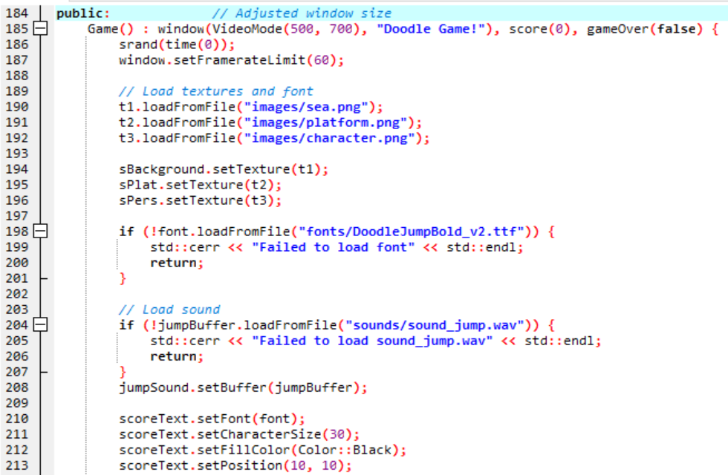

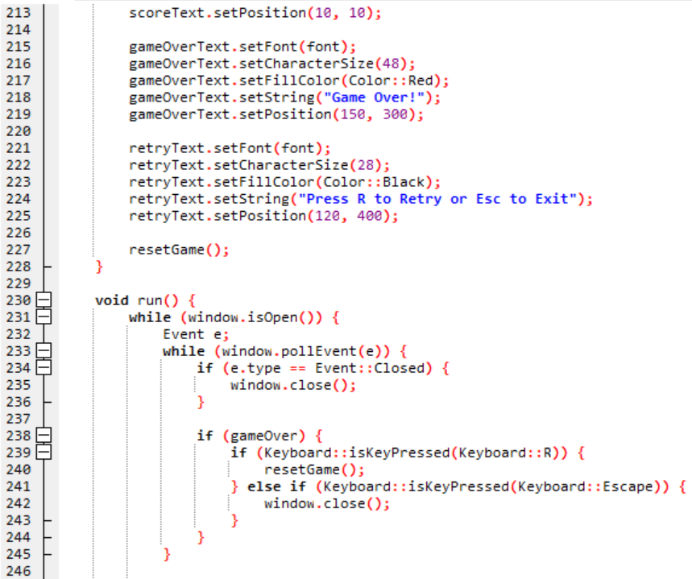

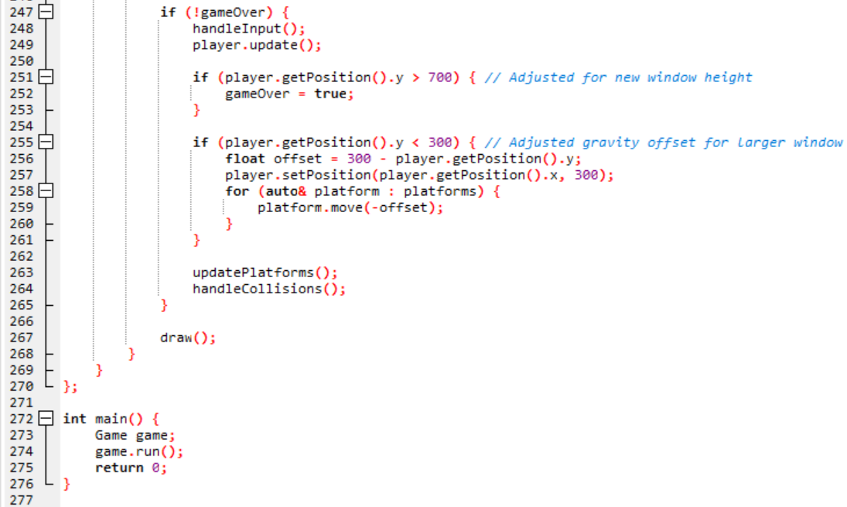

**SEQUENCE OF EVENTS IN THE FORM OF A FLOWCHART:**

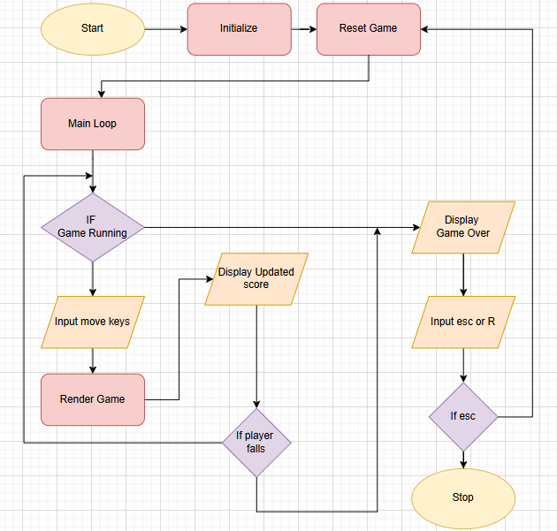

**IMAGES USED:**

**CHARACTER: PLATFORM:**

** **

**BACKGROUND: IN-GAME OVERVIEW:**

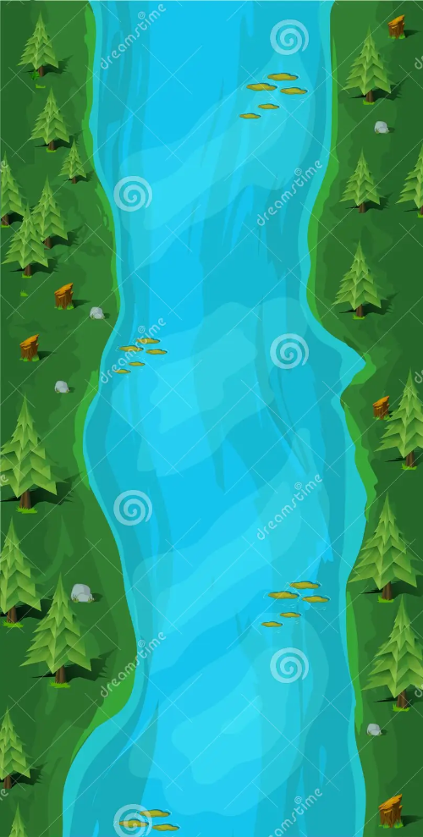 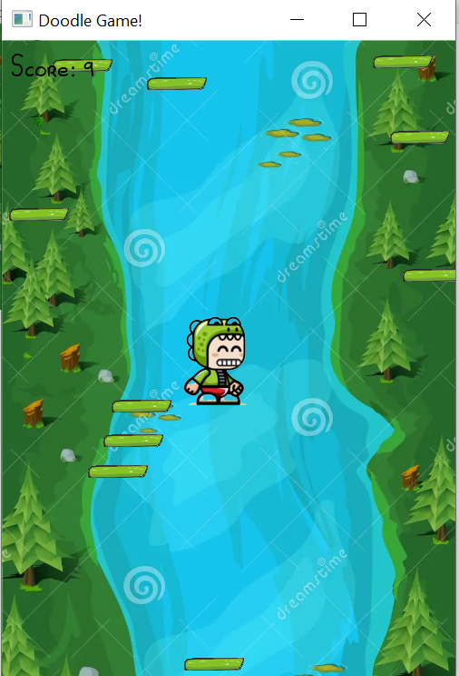

**CONCLUSION:**

* With this project we got introduced to a completely new library that is SFML.
* We learned how to use many different classes in SFML especially regarding the graphics.
* This project challenged us to implement the core concepts of Object Oriented Programming which we have learned in the lab.
* We got introduced to game development which is a very interesting and a vast field, and we learned a lot from it.
* Finally using the knowledge that we gained and the research that we did, and some help from online sources, we as a group were able to create our own version of the classic Doodle Jump Game.

**GITHUB AND LINKEDIN OF GROUP MEMBERS:**

**MUHAMMAD AFNAN KHAN:**

**LinkedIn:**

[*https://www.linkedin.com/in/afnan-khan-88849a34a?utm_source=share&utm_campaign=share_via&utm_content=profile&utm_medium=android_app*](https://www.linkedin.com/in/afnan-khan-88849a34a?utm_source=share&utm_campaign=share_via&utm_content=profile&utm_medium=android_app)

**GitHub:** [*https://github.com/afnankhan24-art/Doodle-Jump-Game*](https://github.com/afnankhan24-art/Doodle-Jump-Game)

**MUHAMMAD SAAD:**

**LinkedIn:**

[*https://www.linkedin.com/posts/muhammad-saad-a8a07a34b_gamedevelopment-sfml-doodlejump-activity-7292157170509385728-j_uX?utm_source=share&utm_medium=member_desktop*](https://www.linkedin.com/posts/muhammad-saad-a8a07a34b_gamedevelopment-sfml-doodlejump-activity-7292157170509385728-j_uX?utm_source=share&utm_medium=member_desktop)

**GitHub:** [*https://github.com/muhammeddsaadd/C-Game*](https://github.com/muhammeddsaadd/C-Game)

**SYED MUHAMMAD NOMAN:**

**LinkedIn:**

**GitHub:** [*https://github.com/Noman428/OOP-Lab-Project-*](https://github.com/Noman428/OOP-Lab-Project-)