Machine Learning – Midterm Assignment Report
Breast Cancer Wisconsin and Wine Classification
Muhammed Efe Öneş – 23040202015
İstanbul Topkapı University – Electrical and Electronics Engineering – 11 November 2026
GitHub repository: https://github.com/muhammedefeones/ml-midterm-23040202015
Video walkthrough: https://youtu.be/OlxBqkiMlMQ
Both datasets went through the same steps. Full code and run tables are in the notebooks and the six CSV files.

1. Loading the Datasets
Data were loaded with load_breast_cancer and load_wine. Features are in X, the target is in y, and the original labels were kept.
Table 1: Dataset overview and class-label mapping
Dataset | Samples × features | Label | Name | Samples | %
Breast Cancer | 569 × 30 | 0 | malignant (positive class) | 212 | 37.26
Breast Cancer |  | 1 | benign | 357 | 62.74
Wine | 178 × 13 | 0 | class_0 | 59 | 33.15
Wine |  | 1 | class_1 | 71 | 39.89
Wine |  | 2 | class_2 | 48 | 26.97

2. Dataset Quality Checks
Table 2: Quality-check summary
Check | Breast Cancer | Wine
Missing values | 0 – none present | 0 – none present
Duplicate rows | 0 – none present | 0 – none present
Numerical / categorical features | 30 / 0 | 13 / 0
Features with IQR outliers | 29 of 30 | 7 of 13
Most IQR outliers | area error: 65 (11.42 %) | max 4 per feature (2.25 %)
Other | 13 exact zeros in concavity features (real values) | none
Nothing was deleted or changed. Outliers mostly affect KNN and K-Means (distance), not Decision Trees.

3. Exploratory Data Analysis
Descriptive statistics of all features are in Appendix A. This section is descriptive only.
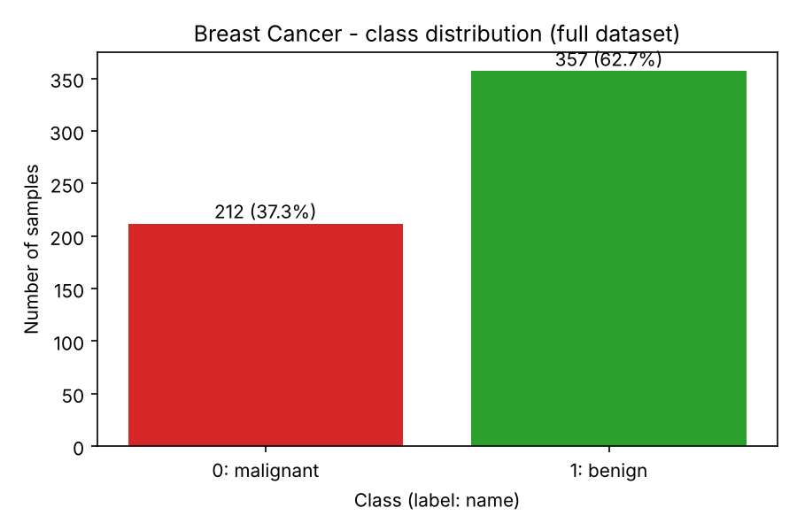  Figure 1: Breast Cancer – class distribution  Always saying benign gives 62.7 % accuracy. So macro-F1 is used for selection. | 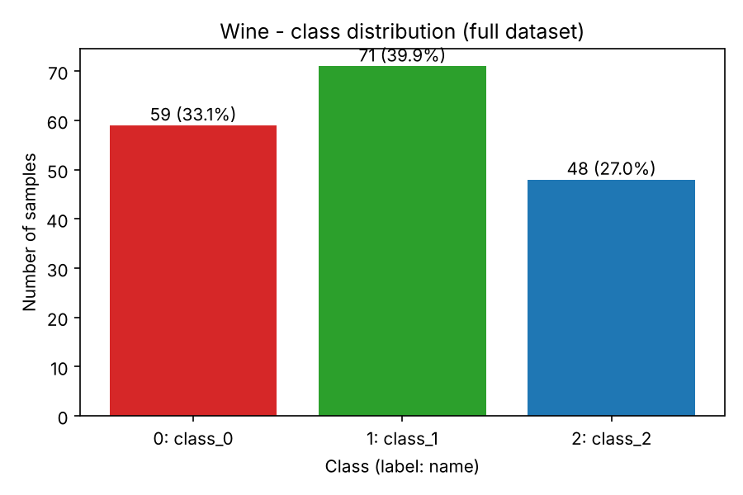  Figure 2: Wine – class distribution  Only a little imbalanced (59 / 71 / 48). Stratified splits keep these ratios.

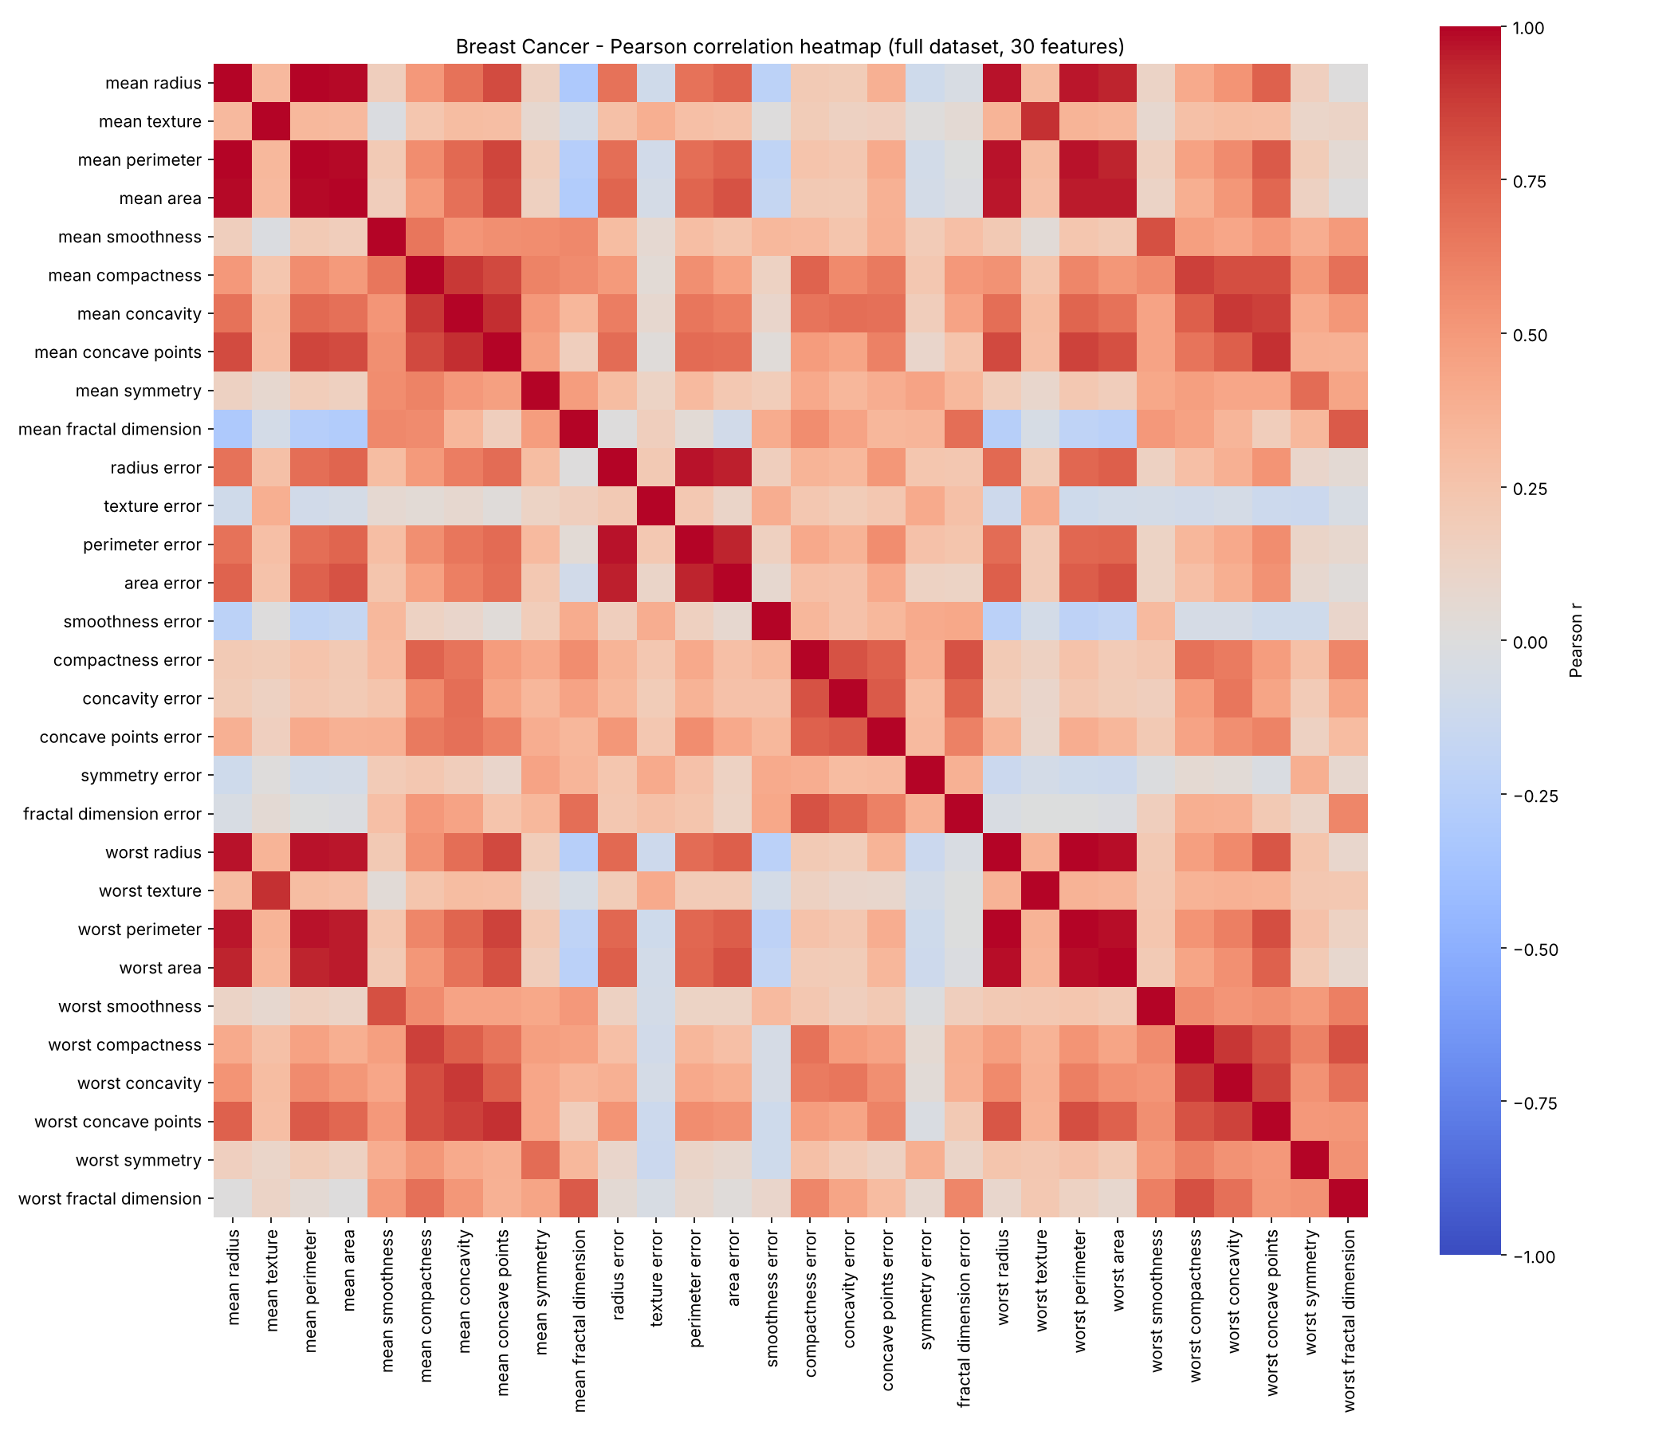
Figure 3: Breast Cancer – Pearson correlation heatmap
Many size features are almost perfectly correlated (dark red). Strongest: mean radius – mean perimeter, r = 0.998 (perimeter = 2πr).

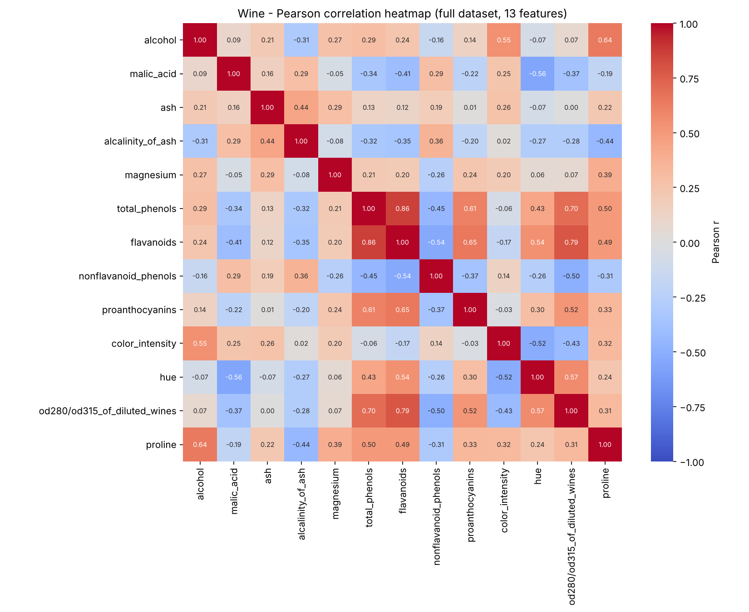
Figure 4: Wine – Pearson correlation heatmap
Correlations are weaker than in Breast Cancer. Strongest: total_phenols – flavanoids, r = 0.865.

Table 3: Three strongest unique feature pairs by |Pearson r|
Dataset | Feature 1 | Feature 2 | r
Breast Cancer | mean radius | mean perimeter | 0.998
Breast Cancer | worst radius | worst perimeter | 0.994
Breast Cancer | mean radius | mean area | 0.987
Wine | total_phenols | flavanoids | 0.865
Wine | flavanoids | od280/od315_of_diluted_wines | 0.787
Wine | total_phenols | od280/od315_of_diluted_wines | 0.700

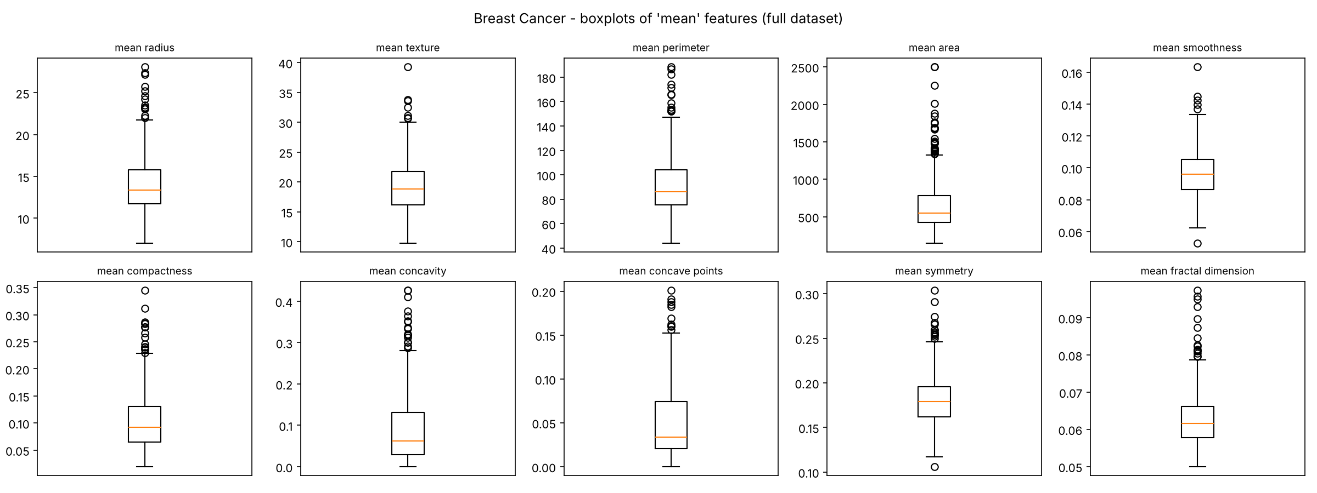
Figure 5: Breast Cancer – boxplots of the 'mean' features
Ranges are very different (area in hundreds, smoothness around 0.1). So KNN and K-Means need scaling.

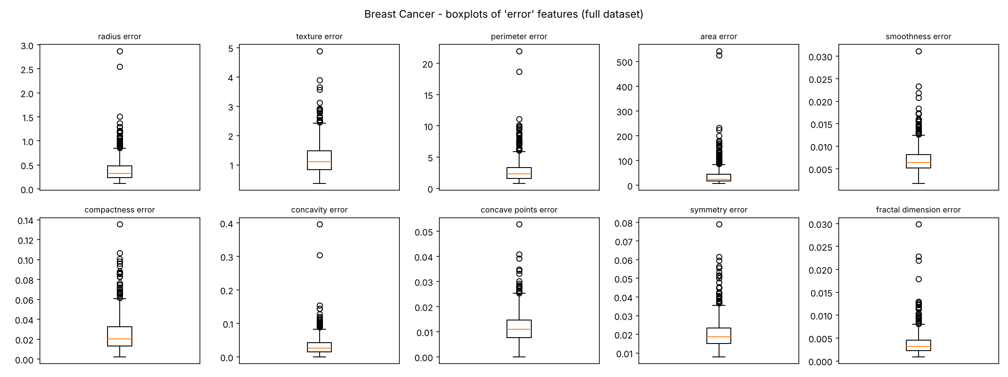
Figure 6: Breast Cancer – boxplots of the 'error' features
Strongly right-skewed with many high outliers. Area error: median about 24.5, max about 542.

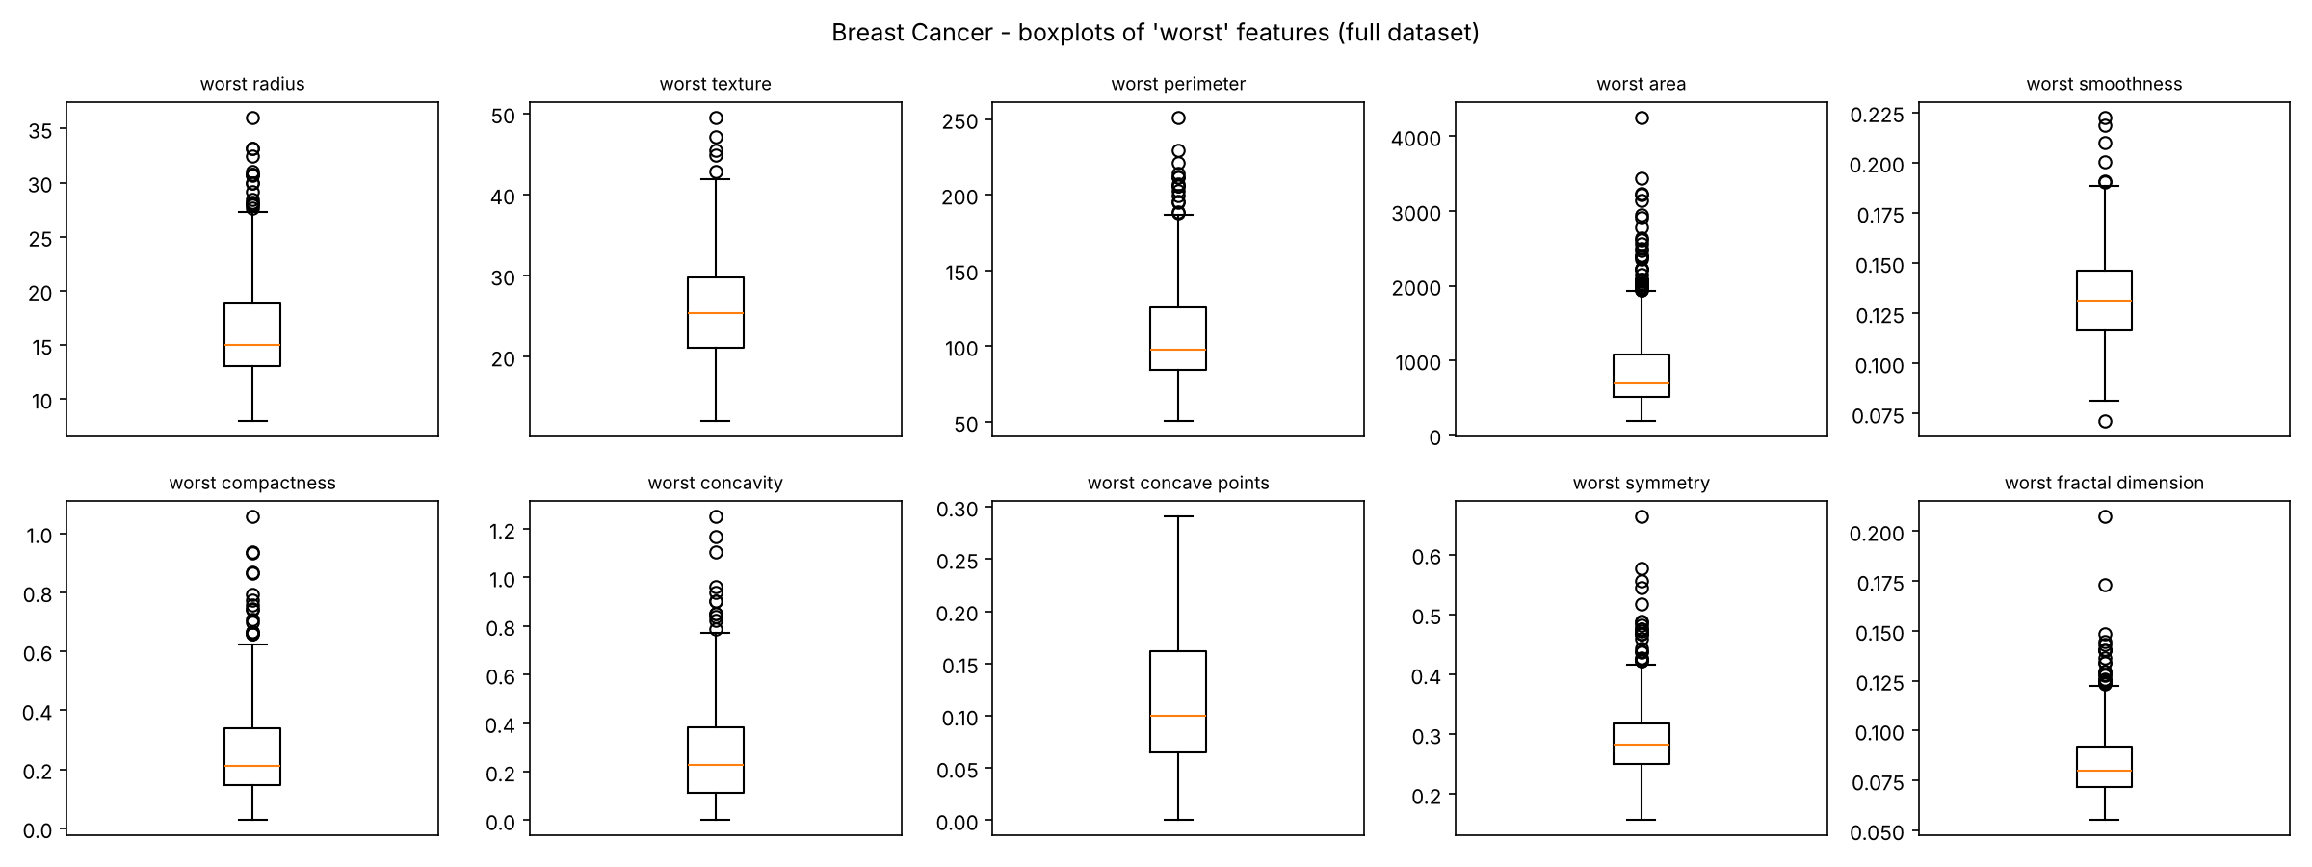
Figure 7: Breast Cancer – boxplots of the 'worst' features
Worst area goes up to about 4254. Outliers were kept: they are probably large malignant tumours.

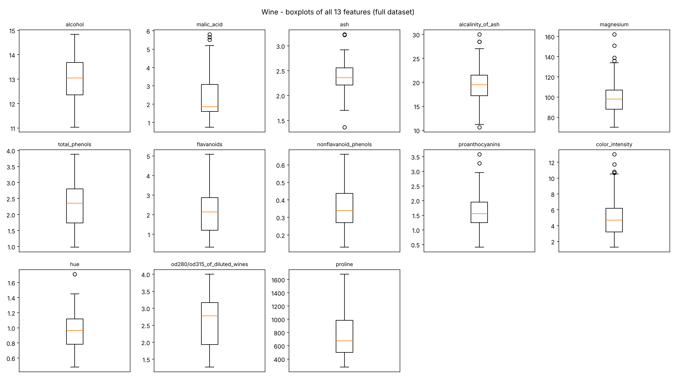
Figure 8: Wine – boxplots of all 13 features
Proline (278–1680) is much bigger than the other features. Only a few outliers; most features are symmetric.

4. Splitting the Datasets
The 20 % test set was created once (stratified, random_state = 42) and never changed. For seeds 42, 52 and 62, the other 80 % was split into training and validation (test_size = 0.125). No overlap; the test set is the same for all seeds; seed 42 was chosen in advance.
Table 4: Subset sizes (same counts for all three seeds)
Dataset | Subset | Samples | % of full data | Class counts
Breast Cancer | train | 398 | 69.95 | 149 malignant / 249 benign
Breast Cancer | validation | 57 | 10.02 | 21 / 36
Breast Cancer | test (fixed) | 114 | 20.04 | 42 / 72
Wine | train | 124 | 69.66 | 41 / 50 / 33
Wine | validation | 18 | 10.11 | 6 / 7 / 5
Wine | test (fixed) | 36 | 20.22 | 12 / 14 / 10

5. Data Preprocessing and Scaling
No imputer was needed. StandardScaler was fitted only on the training data of each dataset and seed (6 scalers); the test set used only the seed-42 scaler. Example: (471.3 − 653.7) / 351.6 = −0.52.

6. Preparing the Two Data Representations
Each seed has an unscaled and a scaled version with the same samples.

7. Training the Classification Models
11 settings (Decision Tree depth 2, 3, 5, 10, None; KNN k = 1, 3, 5, 7, 11; Gaussian NB) × 2 versions × 3 seeds = 66 runs per dataset, 132 in total. Models learned only from training data.

8. Measuring Validation Performance
Each run has five validation scores (accuracy, macro precision, recall, F1, ROC-AUC). Tables 5–6 show mean ± std over seeds; the setting with the highest mean validation macro-F1 was selected. The test set was not used. Std goes up to 0.057 because validation sets are small.

Table 5: Breast Cancer – 22-row validation summary (mean ± std over seeds); selected row highlighted
Configuration | Train acc | Train F1 | Val acc | Val precision | Val recall | Val F1 | Val ROC-AUC
DT unscaled d2 | 0.956 ± 0.004 | 0.953 ± 0.004 | 0.918 ± 0.020 | 0.913 ± 0.016 | 0.912 ± 0.031 | 0.912 ± 0.024 | 0.922 ± 0.040
DT unscaled d3 | 0.976 ± 0.004 | 0.974 ± 0.004 | 0.924 ± 0.027 | 0.920 ± 0.023 | 0.917 ± 0.036 | 0.918 ± 0.030 | 0.941 ± 0.021
DT unscaled d5 | 0.995 ± 0.004 | 0.995 ± 0.005 | 0.924 ± 0.020 | 0.917 ± 0.018 | 0.923 ± 0.031 | 0.919 ± 0.023 | 0.930 ± 0.025
DT unscaled d10 | 1.000 ± 0.000 | 1.000 ± 0.000 | 0.924 ± 0.010 | 0.916 ± 0.011 | 0.927 ± 0.017 | 0.919 ± 0.011 | 0.927 ± 0.017
DT unscaled dNone | 1.000 ± 0.000 | 1.000 ± 0.000 | 0.924 ± 0.010 | 0.916 ± 0.011 | 0.927 ± 0.017 | 0.919 ± 0.011 | 0.927 ± 0.017
KNN unscaled k1 | 1.000 ± 0.000 | 1.000 ± 0.000 | 0.889 ± 0.051 | 0.884 ± 0.049 | 0.876 ± 0.063 | 0.879 ± 0.057 | 0.876 ± 0.063
KNN unscaled k3 | 0.959 ± 0.004 | 0.956 ± 0.004 | 0.901 ± 0.041 | 0.900 ± 0.042 | 0.885 ± 0.047 | 0.891 ± 0.045 | 0.930 ± 0.023
KNN unscaled k5 | 0.951 ± 0.003 | 0.947 ± 0.003 | 0.918 ± 0.027 | 0.917 ± 0.027 | 0.905 ± 0.031 | 0.911 ± 0.030 | 0.948 ± 0.035
KNN unscaled k7 | 0.948 ± 0.003 | 0.944 ± 0.003 | 0.912 ± 0.000 | 0.913 ± 0.007 | 0.897 ± 0.006 | 0.904 ± 0.001 | 0.958 ± 0.029
KNN unscaled k11 | 0.945 ± 0.003 | 0.940 ± 0.003 | 0.924 ± 0.010 | 0.935 ± 0.015 | 0.903 ± 0.012 | 0.916 ± 0.011 | 0.961 ± 0.031
GNB unscaled default | 0.937 ± 0.004 | 0.932 ± 0.005 | 0.942 ± 0.020 | 0.938 ± 0.016 | 0.937 ± 0.031 | 0.937 ± 0.023 | 0.980 ± 0.013
DT scaled d2 | 0.956 ± 0.004 | 0.953 ± 0.004 | 0.918 ± 0.020 | 0.913 ± 0.016 | 0.912 ± 0.031 | 0.912 ± 0.024 | 0.922 ± 0.040
DT scaled d3 | 0.976 ± 0.004 | 0.974 ± 0.004 | 0.924 ± 0.027 | 0.920 ± 0.023 | 0.917 ± 0.036 | 0.918 ± 0.030 | 0.941 ± 0.021
DT scaled d5 | 0.995 ± 0.004 | 0.995 ± 0.005 | 0.924 ± 0.020 | 0.917 ± 0.018 | 0.923 ± 0.031 | 0.919 ± 0.023 | 0.930 ± 0.025
DT scaled d10 | 1.000 ± 0.000 | 1.000 ± 0.000 | 0.924 ± 0.010 | 0.916 ± 0.011 | 0.927 ± 0.017 | 0.919 ± 0.011 | 0.927 ± 0.017
DT scaled dNone | 1.000 ± 0.000 | 1.000 ± 0.000 | 0.924 ± 0.010 | 0.916 ± 0.011 | 0.927 ± 0.017 | 0.919 ± 0.011 | 0.927 ± 0.017
KNN scaled k1 | 1.000 ± 0.000 | 1.000 ± 0.000 | 0.942 ± 0.020 | 0.941 ± 0.028 | 0.934 ± 0.016 | 0.937 ± 0.021 | 0.934 ± 0.016
KNN scaled k3 | 0.981 ± 0.004 | 0.979 ± 0.004 | 0.959 ± 0.020 | 0.970 ± 0.014 | 0.944 ± 0.027 | 0.955 ± 0.023 | 0.979 ± 0.016
KNN scaled k5 | 0.974 ± 0.003 | 0.972 ± 0.003 | 0.959 ± 0.020 | 0.970 ± 0.014 | 0.944 ± 0.027 | 0.955 ± 0.023 | 0.979 ± 0.017
KNN scaled k7 | 0.972 ± 0.003 | 0.970 ± 0.003 | 0.971 ± 0.027 | 0.978 ± 0.020 | 0.960 ± 0.036 | 0.968 ± 0.030 | 0.978 ± 0.019
KNN scaled k11 | 0.972 ± 0.001 | 0.969 ± 0.002 | 0.965 ± 0.035 | 0.975 ± 0.025 | 0.952 ± 0.048 | 0.961 ± 0.039 | 0.994 ± 0.005
GNB scaled default | 0.936 ± 0.005 | 0.931 ± 0.006 | 0.930 ± 0.018 | 0.924 ± 0.014 | 0.928 ± 0.029 | 0.925 ± 0.020 | 0.976 ± 0.015

Table 6: Wine – 22-row validation summary (mean ± std over seeds); selected row highlighted
Configuration | Train acc | Train F1 | Val acc | Val precision | Val recall | Val F1 | Val ROC-AUC
DT unscaled d2 | 0.935 ± 0.008 | 0.936 ± 0.011 | 0.852 ± 0.032 | 0.872 ± 0.021 | 0.849 ± 0.049 | 0.848 ± 0.036 | 0.905 ± 0.022
DT unscaled d3 | 0.992 ± 0.000 | 0.993 ± 0.000 | 0.944 ± 0.056 | 0.961 ± 0.037 | 0.941 ± 0.061 | 0.946 ± 0.055 | 0.961 ± 0.043
DT unscaled d5 | 1.000 ± 0.000 | 1.000 ± 0.000 | 0.944 ± 0.056 | 0.961 ± 0.037 | 0.941 ± 0.061 | 0.946 ± 0.055 | 0.955 ± 0.046
DT unscaled d10 | 1.000 ± 0.000 | 1.000 ± 0.000 | 0.944 ± 0.056 | 0.961 ± 0.037 | 0.941 ± 0.061 | 0.946 ± 0.055 | 0.955 ± 0.046
DT unscaled dNone | 1.000 ± 0.000 | 1.000 ± 0.000 | 0.944 ± 0.056 | 0.961 ± 0.037 | 0.941 ± 0.061 | 0.946 ± 0.055 | 0.955 ± 0.046
KNN unscaled k1 | 1.000 ± 0.000 | 1.000 ± 0.000 | 0.704 ± 0.032 | 0.689 ± 0.024 | 0.684 ± 0.022 | 0.671 ± 0.023 | 0.765 ± 0.018
KNN unscaled k3 | 0.836 ± 0.012 | 0.829 ± 0.013 | 0.667 ± 0.056 | 0.661 ± 0.050 | 0.652 ± 0.048 | 0.646 ± 0.043 | 0.833 ± 0.031
KNN unscaled k5 | 0.788 ± 0.009 | 0.774 ± 0.009 | 0.704 ± 0.032 | 0.728 ± 0.072 | 0.686 ± 0.029 | 0.667 ± 0.040 | 0.864 ± 0.012
KNN unscaled k7 | 0.790 ± 0.021 | 0.780 ± 0.023 | 0.667 ± 0.000 | 0.647 ± 0.023 | 0.654 ± 0.015 | 0.636 ± 0.032 | 0.846 ± 0.008
KNN unscaled k11 | 0.739 ± 0.009 | 0.731 ± 0.008 | 0.630 ± 0.032 | 0.615 ± 0.013 | 0.614 ± 0.021 | 0.600 ± 0.001 | 0.822 ± 0.025
GNB unscaled default | 0.984 ± 0.000 | 0.984 ± 0.000 | 0.963 ± 0.032 | 0.968 ± 0.029 | 0.966 ± 0.030 | 0.964 ± 0.031 | 1.000 ± 0.000
DT scaled d2 | 0.935 ± 0.008 | 0.936 ± 0.011 | 0.852 ± 0.032 | 0.872 ± 0.021 | 0.849 ± 0.049 | 0.848 ± 0.036 | 0.905 ± 0.022
DT scaled d3 | 0.992 ± 0.000 | 0.993 ± 0.000 | 0.944 ± 0.056 | 0.961 ± 0.037 | 0.941 ± 0.061 | 0.946 ± 0.055 | 0.961 ± 0.043
DT scaled d5 | 1.000 ± 0.000 | 1.000 ± 0.000 | 0.944 ± 0.056 | 0.961 ± 0.037 | 0.941 ± 0.061 | 0.946 ± 0.055 | 0.955 ± 0.046
DT scaled d10 | 1.000 ± 0.000 | 1.000 ± 0.000 | 0.944 ± 0.056 | 0.961 ± 0.037 | 0.941 ± 0.061 | 0.946 ± 0.055 | 0.955 ± 0.046
DT scaled dNone | 1.000 ± 0.000 | 1.000 ± 0.000 | 0.944 ± 0.056 | 0.961 ± 0.037 | 0.941 ± 0.061 | 0.946 ± 0.055 | 0.955 ± 0.046
KNN scaled k1 | 1.000 ± 0.000 | 1.000 ± 0.000 | 0.963 ± 0.032 | 0.968 ± 0.027 | 0.968 ± 0.027 | 0.966 ± 0.030 | 0.975 ± 0.022
KNN scaled k3 | 0.968 ± 0.008 | 0.969 ± 0.008 | 0.944 ± 0.056 | 0.950 ± 0.052 | 0.952 ± 0.048 | 0.946 ± 0.056 | 1.000 ± 0.000
KNN scaled k5 | 0.976 ± 0.000 | 0.976 ± 0.001 | 0.981 ± 0.032 | 0.981 ± 0.032 | 0.984 ± 0.027 | 0.981 ± 0.032 | 1.000 ± 0.000
KNN scaled k7 | 0.960 ± 0.008 | 0.960 ± 0.008 | 0.981 ± 0.032 | 0.981 ± 0.032 | 0.984 ± 0.027 | 0.981 ± 0.032 | 1.000 ± 0.000
KNN scaled k11 | 0.965 ± 0.005 | 0.966 ± 0.005 | 0.981 ± 0.032 | 0.981 ± 0.032 | 0.984 ± 0.027 | 0.981 ± 0.032 | 1.000 ± 0.000
GNB scaled default | 0.984 ± 0.000 | 0.984 ± 0.000 | 0.963 ± 0.032 | 0.968 ± 0.029 | 0.966 ± 0.030 | 0.964 ± 0.031 | 1.000 ± 0.000

Selected: Breast Cancer – breast_cancer_knn_scaled_k7 (0.9677 ± 0.0297). Wine – wine_knn_scaled_k11 (0.9814 ± 0.0323); k = 5, 7 and 11 tied and k11 is first alphabetically.
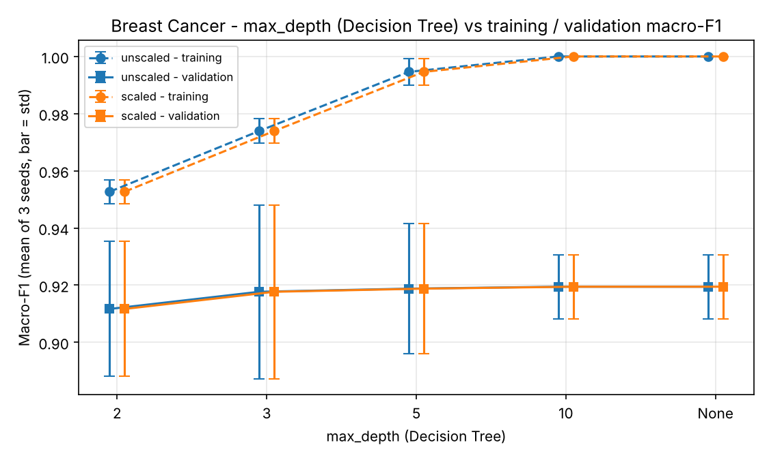  Figure 9: Breast Cancer – tree depth vs macro-F1  Training F1 goes to 1.0 but validation stays near 0.92: overfitting. Scaled and unscaled trees are the same. | 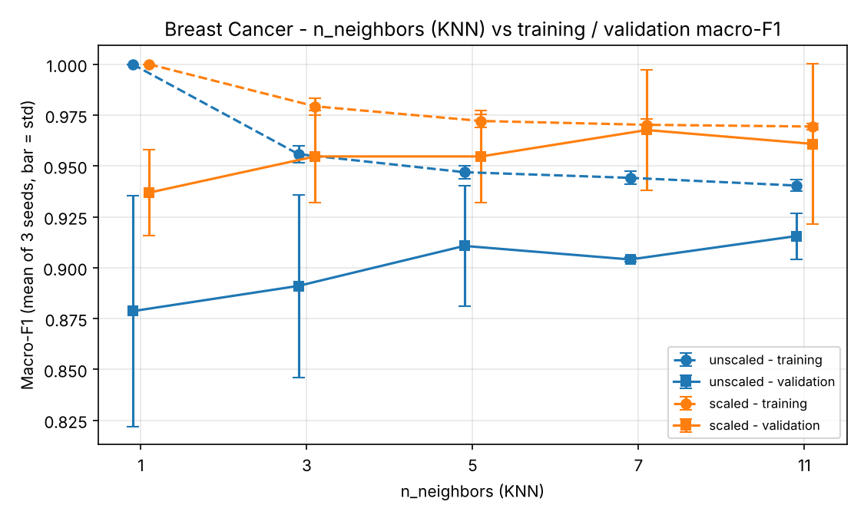  Figure 10: Breast Cancer – KNN k vs macro-F1  Scaling helps KNN a lot: 0.904 → 0.968 at k = 7. k = 7 has the best mean validation F1.

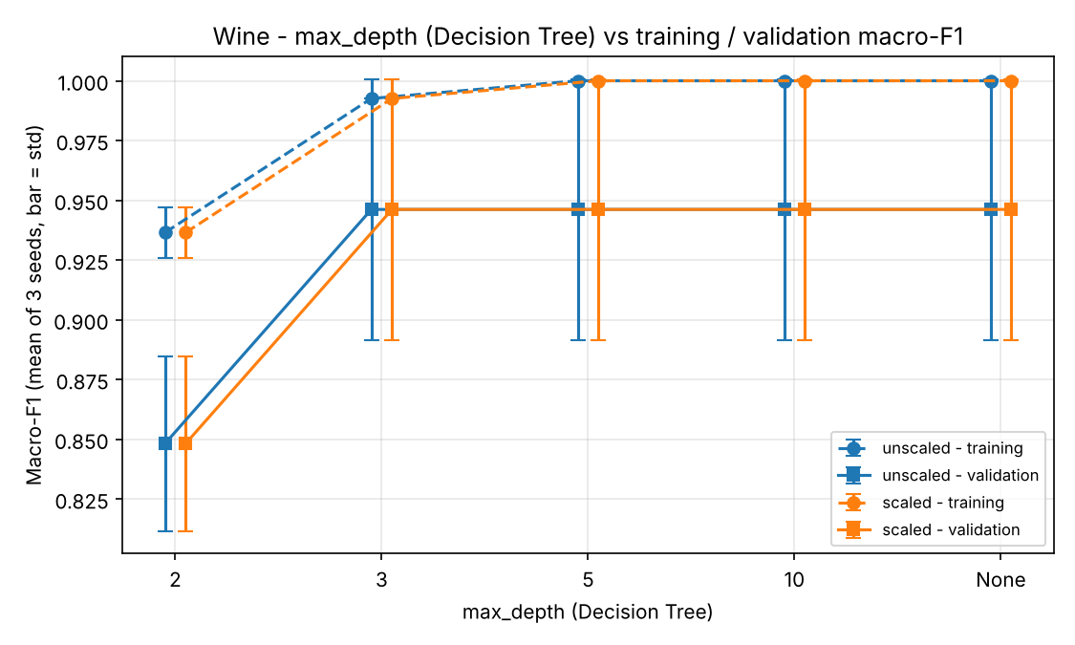  Figure 11: Wine – tree depth vs macro-F1  Depth 2 is too simple; from depth 3 validation stays at 0.946. Deeper trees only fit training data better. | 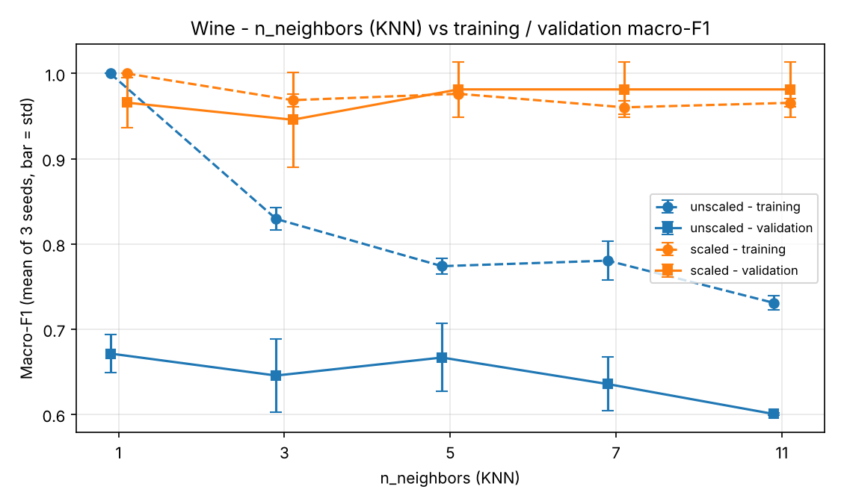  Figure 12: Wine – KNN k vs macro-F1  Unscaled KNN is poor (0.60–0.67): proline controls the distance. Scaled k = 5, 7, 11 tie at 0.981.

9. Evaluating the Selected Models on the Test Sets
Only the seed-42 model of each selected setting was tested, with the seed-42 scaler. Nothing was retrained.
Table 7: Final test evaluation (one column per dataset)
Item | Breast Cancer | Wine
Selected configuration | breast_cancer_knn_scaled_k7 | wine_knn_scaled_k11
Evaluation seed | 42 | 42
Mean val macro-F1 | 0.9677 | 0.9814
Val macro-F1 std | 0.0297 | 0.0323
Test accuracy | 0.9737 | 1.0000
Test macro precision | 0.9800 | 1.0000
Test macro recall | 0.9643 | 1.0000
Test macro F1 | 0.9713 | 1.0000
Test ROC-AUC | 0.9888 | 1.0000
Table 8: Per-class test classification reports
Dataset | Class | Precision | Recall | F1 | Support
Breast Cancer | malignant (0) | 1.0000 | 0.9286 | 0.9630 | 42
Breast Cancer | benign (1) | 0.9600 | 1.0000 | 0.9796 | 72
Wine | class_0 | 1.0000 | 1.0000 | 1.0000 | 12
Wine | class_1 | 1.0000 | 1.0000 | 1.0000 | 14
Wine | class_2 | 1.0000 | 1.0000 | 1.0000 | 10
Test results are close to validation (Breast Cancer 0.971 vs 0.968; Wine 1.000 vs 0.981). The models were not changed after the test.
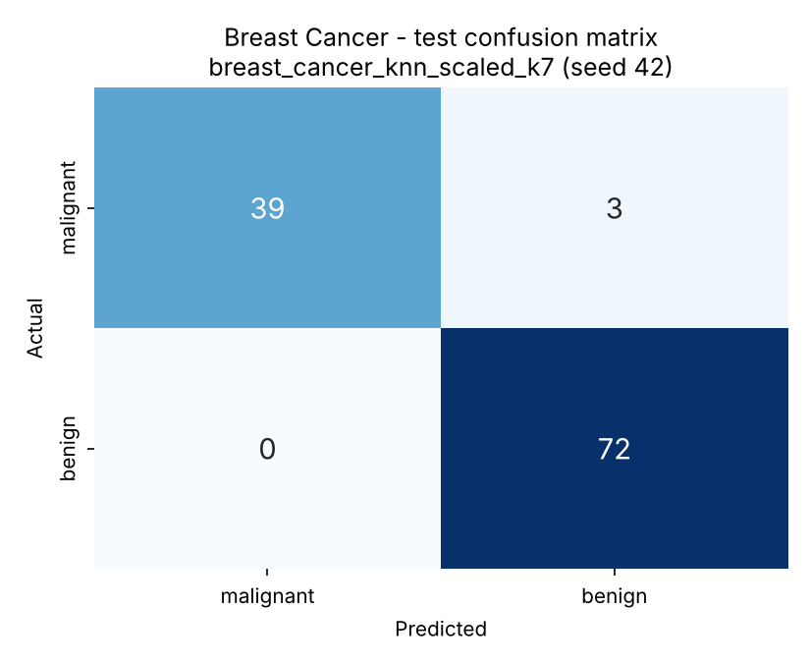  Figure 13: Breast Cancer – test confusion matrix  TP 39, FN 3 (missed cancers), FP 0, TN 72. Manual: precision 39/39 = 1.000, recall 39/42 = 0.929, F1 = 0.963 (same as Table 8). | 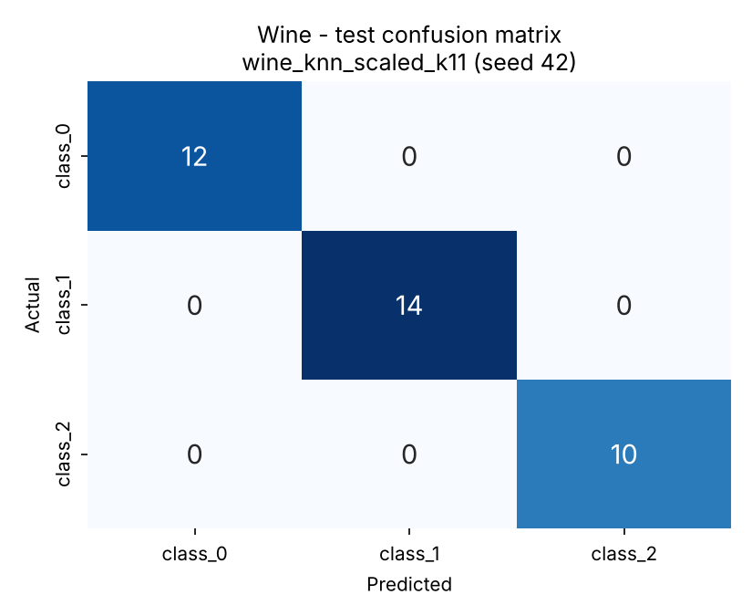  Figure 14: Wine – test confusion matrix  All 36 test wines are correct. Manual class_1 check: precision = recall = F1 = 1.000.

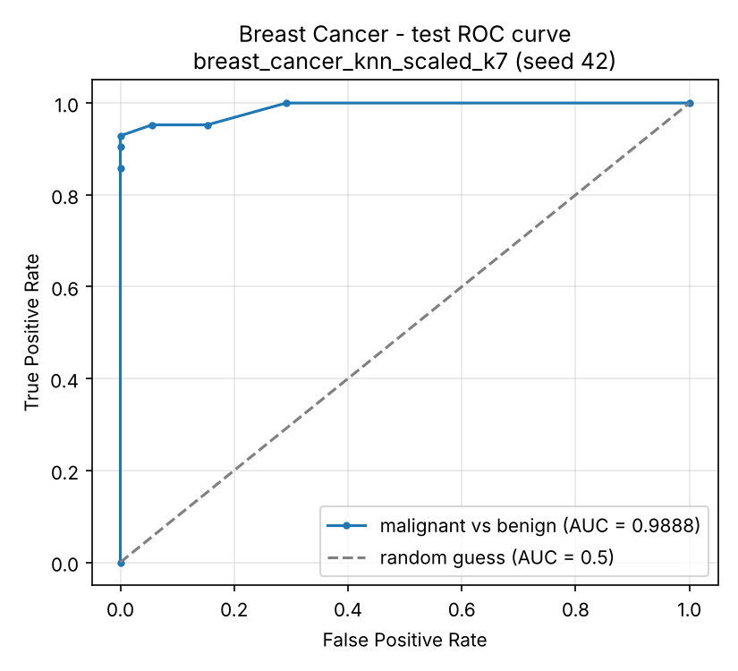  Figure 15: Breast Cancer – test ROC curve  AUC = 0.989: malignant patients almost always get a higher malignant probability. Descriptive only; no threshold was chosen with the test set. | 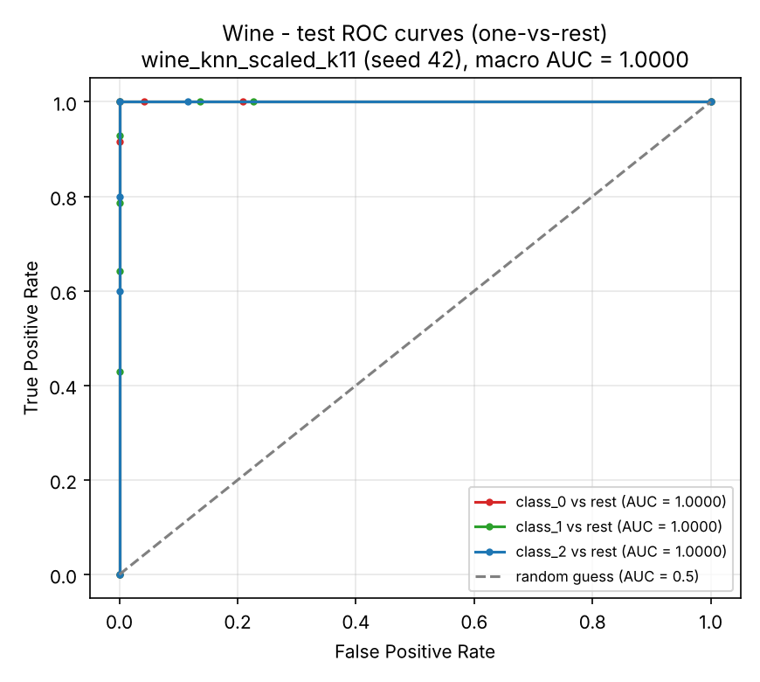  Figure 16: Wine – one-vs-rest test ROC curves  All three AUCs are 1.0 (macro AUC = 1.0). The ranking of the probabilities is perfect.

Threshold: The model gives each patient a probability of being malignant. Normally, if this probability is above 0.5, the patient is called malignant. If we lower the threshold, more patients are called malignant: fewer cancers are missed (FN goes down), but there are more false alarms (FP goes up).
Errors: all 3 Breast Cancer errors are missed cancers; patient 41 had P(malignant) = 0.429 (3 of 7 neighbours malignant). Wine had no errors, but 36 samples are too few to call it perfect. Limitations: small validation sets, overlapping splits, one tested seed.

10. K-Means Clustering
K-Means (k = 2 / 3, n_init = 10) was fitted on training features only (12 fits); labels were used only for ARI. Inertia and silhouette are not compared between unscaled and scaled data.
Table 9: K-Means across-seed summaries
Dataset | Version | Mean inertia | Val ARI | Val silhouette | Valid seeds (ARI / sil.)
Breast Cancer | unscaled | 5.127e+07 | 0.504 ± 0.106 | 0.677 ± 0.033 | 3 / 3
Breast Cancer | scaled | 7948 | 0.581 ± 0.142 | 0.312 ± 0.055 | 3 / 3
Wine | unscaled | 1.348e+06 | 0.361 ± 0.068 | 0.577 ± 0.101 | 3 / 3
Wine | scaled | 879.1 | 1.000 ± 0.000 | 0.275 ± 0.025 | 3 / 3
Table 10: Final K-Means test evaluation (seed-42 models)
Dataset | Representation | Seed | Test cluster counts | Test ARI | Test silhouette
Breast Cancer | unscaled | 42 | {0: 86, 1: 28} | 0.5585 | 0.7120
Breast Cancer | scaled | 42 | {0: 74, 1: 40} | 0.7354 | 0.3251
Wine | unscaled | 42 | {0: 14, 1: 10, 2: 12} | 0.3733 | 0.4929
Wine | scaled | 42 | {0: 13, 1: 13, 2: 10} | 0.9088 | 0.2711
Table 11: Class-versus-cluster contingency tables (test set)
Dataset / representation | True class | Cluster 0 | Cluster 1 | Cluster 2
Breast Cancer, unscaled | malignant | 14 | 28 | –
 | benign | 72 | 0 | –
Breast Cancer, scaled | malignant | 5 | 37 | –
 | benign | 69 | 3 | –
Wine, unscaled | class_0 | 2 | 10 | 0
 | class_1 | 5 | 0 | 9
 | class_2 | 7 | 0 | 3
Wine, scaled | class_0 | 12 | 0 | 0
 | class_1 | 1 | 13 | 0
 | class_2 | 0 | 0 | 10

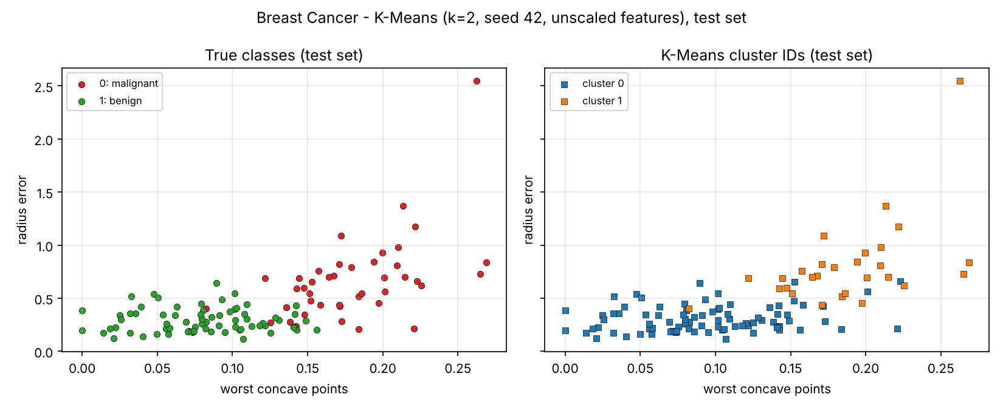
Figure 17: Breast Cancer – K-Means, unscaled (test set)
All benign and the smaller malignant tumours are in cluster 0. Area controls the distance (test ARI 0.559).

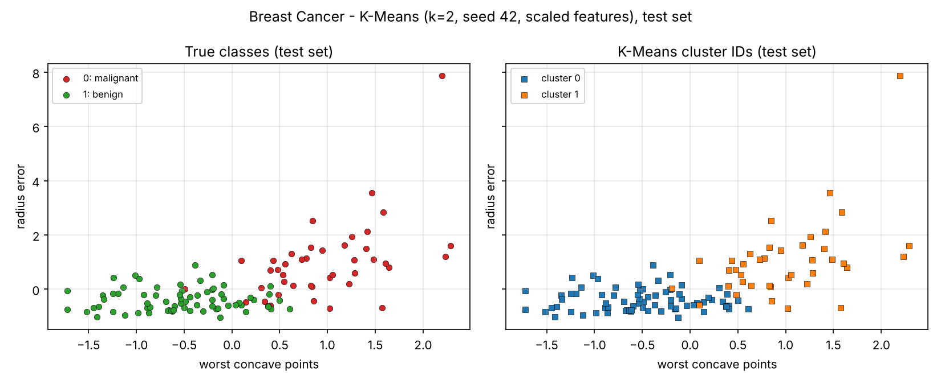
Figure 18: Breast Cancer – K-Means, scaled (test set)
Much closer to the classes (test ARI 0.735). Only 5 malignant and 3 benign are in the other cluster.

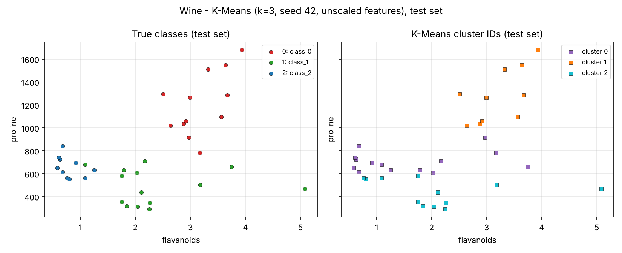
Figure 19: Wine – K-Means, unscaled (test set)
Clusters mostly follow proline, so classes are mixed (ARI 0.373). Silhouette is high (0.493) only because one feature dominates.

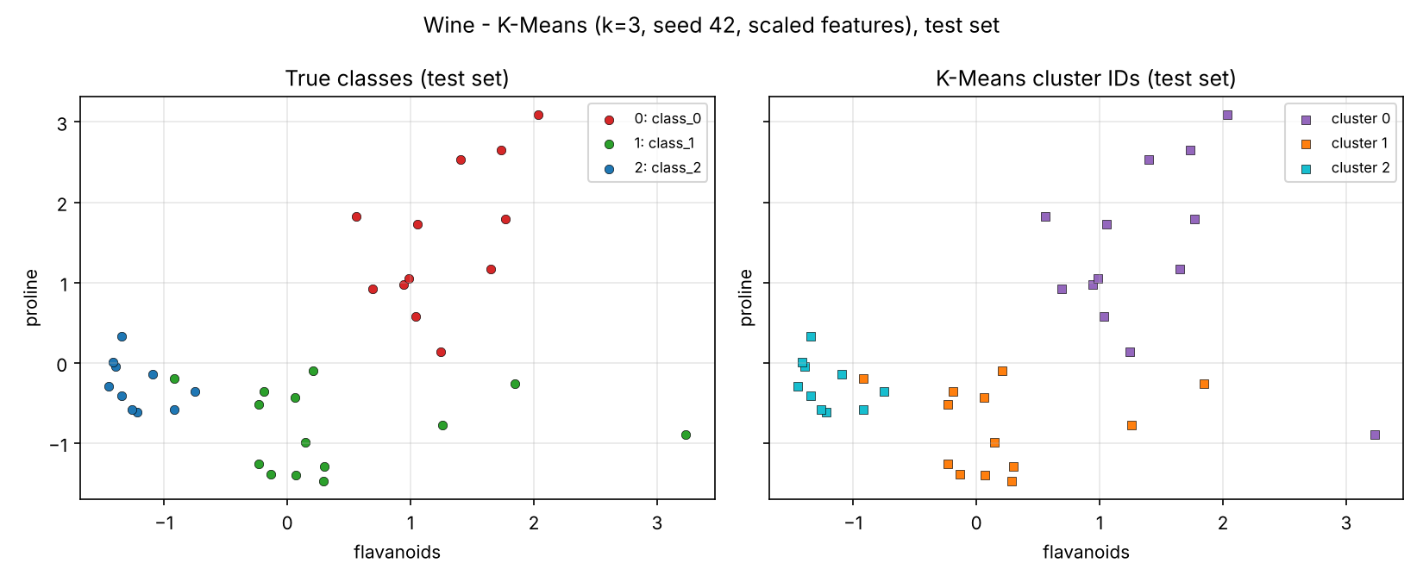
Figure 20: Wine – K-Means, scaled (test set)
Almost one-to-one with the classes (ARI 0.909). K-Means never saw labels; cluster IDs are only names.

11. Comparing the Two Datasets
Did the same classifier and representation perform best on both datasets? Yes. Scaled KNN was selected for both datasets, but with different k: k = 7 for Breast Cancer and k = 11 for Wine. In Wine, k = 5, 7 and 11 tied, and the alphabetical rule chose 11. On the test set, Breast Cancer got F1 = 0.97 and Wine got 1.0. Because only the selected models were tested, we cannot know if another model would have done better on the test set.
Which algorithm was most affected by scaling? KNN. For k = 7 in Breast Cancer it went from 0.90 to 0.97, and for k = 11 in Wine from 0.60 to 0.98. Decision Tree did not change at all, and GaussianNB almost did not change.
Did deeper trees or larger neighbour counts always improve mean validation performance? No. Deep trees get 1.0 on training data but validation does not change; this is overfitting. For KNN, the best k for Breast Cancer is 7; in Wine, k = 3 is even worse than k = 1. The difference between seeds goes up to 0.057, so small differences may be due to chance.
How did the main classification errors differ? In Breast Cancer, all 3 errors are missed cancers (FN) and there are no false alarms; this is the dangerous type of error. Wine has no test errors.
How did K-Means agreement with the true classes differ? Wine. With scaling, ARI was 0.91 and the clusters matched the classes almost one-to-one. In Breast Cancer, ARI stayed at 0.74; some malignant and benign tumours were mixed.
What would I investigate next? To reduce missed cancers in Breast Cancer, I would tune the threshold on the validation data, not on the test data, because missing a cancer is much worse than a false alarm.

12. Run and Output Inventory
Item | Count
Classifier fits (66 per dataset) | 132
K-Means fits (6 per dataset) | 12
Total model fits | 144
Final test evaluations (classifier / K-Means, reuse seed-42 models) | 2 / 4
classifier_runs / summary / test CSV rows | 132 / 44 / 2
kmeans_runs / summary / test CSV rows | 12 / 4 / 4
Figure files (EDA 8, classification 8, clustering 4) | 20

References
- scikit-learn documentation and user guide (data loaders, preprocessing, models, metrics, common pitfalls). https://scikit-learn.org/stable/
- Breast Cancer Wisconsin (Diagnostic) and Wine datasets, UCI Machine Learning Repository.

Appendix A – Descriptive Statistics (full datasets)
Table 12: Breast Cancer – descriptive statistics of all 30 features
Feature | Mean | Median | Min | Max | Std | Q1 | Q3
mean radius | 14.13 | 13.37 | 6.981 | 28.11 | 3.524 | 11.7 | 15.78
mean texture | 19.29 | 18.84 | 9.71 | 39.28 | 4.301 | 16.17 | 21.8
mean perimeter | 91.97 | 86.24 | 43.79 | 188.5 | 24.3 | 75.17 | 104.1
mean area | 654.9 | 551.1 | 143.5 | 2501 | 351.9 | 420.3 | 782.7
mean smoothness | 0.09636 | 0.09587 | 0.05263 | 0.1634 | 0.01406 | 0.08637 | 0.1053
mean compactness | 0.1043 | 0.09263 | 0.01938 | 0.3454 | 0.05281 | 0.06492 | 0.1304
mean concavity | 0.0888 | 0.06154 | 0 | 0.4268 | 0.07972 | 0.02956 | 0.1307
mean concave points | 0.04892 | 0.0335 | 0 | 0.2012 | 0.0388 | 0.02031 | 0.074
mean symmetry | 0.1812 | 0.1792 | 0.106 | 0.304 | 0.02741 | 0.1619 | 0.1957
mean fractal dimension | 0.0628 | 0.06154 | 0.04996 | 0.09744 | 0.00706 | 0.0577 | 0.06612
radius error | 0.4052 | 0.3242 | 0.1115 | 2.873 | 0.2773 | 0.2324 | 0.4789
texture error | 1.217 | 1.108 | 0.3602 | 4.885 | 0.5516 | 0.8339 | 1.474
perimeter error | 2.866 | 2.287 | 0.757 | 21.98 | 2.022 | 1.606 | 3.357
area error | 40.34 | 24.53 | 6.802 | 542.2 | 45.49 | 17.85 | 45.19
smoothness error | 0.007041 | 0.00638 | 0.001713 | 0.03113 | 0.003003 | 0.005169 | 0.008146
compactness error | 0.02548 | 0.02045 | 0.002252 | 0.1354 | 0.01791 | 0.01308 | 0.03245
concavity error | 0.03189 | 0.02589 | 0 | 0.396 | 0.03019 | 0.01509 | 0.04205
concave points error | 0.0118 | 0.01093 | 0 | 0.05279 | 0.00617 | 0.007638 | 0.01471
symmetry error | 0.02054 | 0.01873 | 0.007882 | 0.07895 | 0.008266 | 0.01516 | 0.02348
fractal dimension error | 0.003795 | 0.003187 | 0.0008948 | 0.02984 | 0.002646 | 0.002248 | 0.004558
worst radius | 16.27 | 14.97 | 7.93 | 36.04 | 4.833 | 13.01 | 18.79
worst texture | 25.68 | 25.41 | 12.02 | 49.54 | 6.146 | 21.08 | 29.72
worst perimeter | 107.3 | 97.66 | 50.41 | 251.2 | 33.6 | 84.11 | 125.4
worst area | 880.6 | 686.5 | 185.2 | 4254 | 569.4 | 515.3 | 1084
worst smoothness | 0.1324 | 0.1313 | 0.07117 | 0.2226 | 0.02283 | 0.1166 | 0.146
worst compactness | 0.2543 | 0.2119 | 0.02729 | 1.058 | 0.1573 | 0.1472 | 0.3391
worst concavity | 0.2722 | 0.2267 | 0 | 1.252 | 0.2086 | 0.1145 | 0.3829
worst concave points | 0.1146 | 0.09993 | 0 | 0.291 | 0.06573 | 0.06493 | 0.1614
worst symmetry | 0.2901 | 0.2822 | 0.1565 | 0.6638 | 0.06187 | 0.2504 | 0.3179
worst fractal dimension | 0.08395 | 0.08004 | 0.05504 | 0.2075 | 0.01806 | 0.07146 | 0.09208
Table 13: Wine – descriptive statistics of all 13 features
Feature | Mean | Median | Min | Max | Std | Q1 | Q3
alcohol | 13 | 13.05 | 11.03 | 14.83 | 0.8118 | 12.36 | 13.68
malic_acid | 2.336 | 1.865 | 0.74 | 5.8 | 1.117 | 1.603 | 3.083
ash | 2.367 | 2.36 | 1.36 | 3.23 | 0.2743 | 2.21 | 2.558
alcalinity_of_ash | 19.49 | 19.5 | 10.6 | 30 | 3.34 | 17.2 | 21.5
magnesium | 99.74 | 98 | 70 | 162 | 14.28 | 88 | 107
total_phenols | 2.295 | 2.355 | 0.98 | 3.88 | 0.6259 | 1.742 | 2.8
flavanoids | 2.029 | 2.135 | 0.34 | 5.08 | 0.9989 | 1.205 | 2.875
nonflavanoid_phenols | 0.3619 | 0.34 | 0.13 | 0.66 | 0.1245 | 0.27 | 0.4375
proanthocyanins | 1.591 | 1.555 | 0.41 | 3.58 | 0.5724 | 1.25 | 1.95
color_intensity | 5.058 | 4.69 | 1.28 | 13 | 2.318 | 3.22 | 6.2
hue | 0.9574 | 0.965 | 0.48 | 1.71 | 0.2286 | 0.7825 | 1.12
od280/od315_of_diluted_wines | 2.612 | 2.78 | 1.27 | 4 | 0.71 | 1.938 | 3.17
proline | 746.9 | 673.5 | 278 | 1680 | 314.9 | 500.5 | 985

