 

Cairo University



*Supervised by*

*Dr. Hanaa Bayomi Ali*

*TA:Heba Mahgoub*

Implemented by

|  |  |
| --- | --- |
| 20196066 | Sohaila Mohamed El-Mesmary |
| 20196071 | Lilian Nagy |
| 20196049 | Mohamed Mahmoud |
| 20196023 | Ziad Alaa |
| 20196047 | Mohamed Essam |

Graduation Project

Academic Year 2022-2023

Final Documentation

Table Of Contents

1. Introduction……………………………………………………………………………………………………..9

1.1 Motivation…………………………………………………………………………………………..9

1.2 Problem definition………………………………………………………………………………10

1.3 Solution…………….………………………………………………………………………………..10

1.4 Gantt Chart of project time plan…………………………………………………………11

1.5 Project development methodology…………………………………………………….12

1.6 Used tools in the project…………………………………………………………………….13

1.7 Report Organization…………………………………………………………………………...13

2.Related Work…………………………………………………………………………………………………..14

3.System Analysis……………………………………………………………………………………………….15

3.1 Project Specification……………………………………………………………………………15

3.1.1 Functional requirement…………………………………………………………15

3.1.2 Non-functional requirement………………………………………………….19

3.2 Use case Diagram.……………………………………………………………………………….20

3.3 Use case Tables……………………………………………………………………………………21

4.System Design…………………………………………………………………………………………………24

4.1 System Component Diagram………………………………………………………………24

4.2 System Class Diagrams……………………………………………………………………….25

4.3 Sequence Diagrams…………………………………………………………………………….26

4.4 Project ERD…………………………………………………………………………………………29

4.5 System GUI Design……………………………………………………………………………..30

4.5.1 NGO GUI Design……………………………………………………………………….31

4.5.2 Donator GUI Design………………………………………………………………….35

4.5.3 Admin GUI Design…………………………………………………………………….39

5.Implementation and Testing……………………………………………………………………………40

5.1 Donators functionalities test cases…………………………………………………….41

5.2 Admins functionalities test cases……………………………………………………….45

5.3 NGOs functionalities test cases………………………………………………………….48

5.4 Donator/NGO functionalities test cases………………………………………….51

5.4 Black Box Testing…………………………………………………………………………….53

6.Conclusion……………………………………………………………………………………………………55

7.Refrence………………………………………………………………………………………………………56

List of Figures:

Figure 1 : Gantt Chart…………………………………………………………………………………………..9

Figure 2: Use Case Diagram………………………………………………………………………………..17

Figure 3: Component Diagram……………………………………………………………………………21

Figure 4 : Class Diagram……………………………………………………………………………………..25

Figure 5 : Sequence diagram register user …………………………………………………………26

Figure 6 : Sequence diagram create donation post…………………………………………….27

Figure 7: Sequence diagram request donation post…………………………………………..28

Figure 8 : ER Diagram…………………………………………………………………………………………29

Figure 9: System Home Page……………………………………………………………………………..30

Figure 10: Sign Up Page……………………………………………………………………………………..30

Figure 11: Sign In Page……………………………………………………………………………………….31

Figure 12: NGO Home page………………………………………………………………………………..31

Figure 13: NGO Confirm donation request…………………………………………………………32

Figure 14: Requests Page of NGO ……………………………………………………………………..32

Figure 15: Chat with dontor if donation is delivered by donator………………………..33

Figure 16 : History of NGO Requests ………………………………………………………………….33

Figure 18: NGO Profile Page……………………………………………………………………………….34

Figure 19 : Update Profile Page ………………………………………………………………………….34

Figure 20: Create Donation Post Page…………………………………………………………………35

Figure 21: Donator Home Page…………………………………………………………………………..35

Figure 22 : Donator menu to View Profile…………………………………………………………..36

Figure 23 : Notifications of donations request sent by NGOs………………………………36

Figure 24 : Chat with requested NGO…………………………………………………………………37

Figure 25 : Confirm to deliver donation………………………………………………………………37

Figure 26 : Profile page of donator……………………………………………………………………..38

Figure 27 : Update Profile Page…………………………………………………………………………..38

Figure 28: Admin Dashboard ……………………………………………………………………………..39

Figure 29 : Request Opened to accept or reject by admin…………………………………..39

List Of Tables:

Table 1 : List Of Abbreviation………………………………………………………………………………8

Table 2: Gantt Chart Table………………………………………………………………………………….11

Table 3: Wasteless VS Too Good To Go………………………………………………………………14

Table 4: Wasteless VS FoodCloud……………………………………………………………………….14

Table 5 : Use case table for registration function……………………………………………….21

Table 6: Use Case table for the creation of a donation post……………………………….22

Table 7 : Use Case table for requesting a donation by NGO……………………………….23

Table 8: Test Case table for dontar sign up register positive scenario…………………41

Table 9: Test Case table for dontar sign up register negative scenario……………….41

Table 10: Test Case table for create donation post positive scenario…………………42

Table 11: Test Case table for create donation post negative scenario………………..42

Table 12: Test Case table for remove donation post positive scenario……………….43

Table 13: Test Case table for remove donation post negative scenario………………43

Table 14: Test Case table for filter donation posts positive scenario………………….44

Table 15: Test Case table for filter donation posts negative scenario…………………44

Table 16: Test Case table for admin sign in positive scenario……………………………..45

Table 17: Test Case table for admin sign in negative scenario…………………………….45

Table 18: Test Case table for admin approve request positive scenario………………46

Table 19: Test Case table for admin approve request negative scenario…………….46

Table 20: Test Case table for admin reject request positive scenario………………….47

Table 21: Test Case table for admin reject request negative scenario…………………47

Table 22: Test Case table for NGO sign in positive scenario………………………………..48

Table 23: Test Case table for NGO sign in negative scenario……………………………….48

Table 24: Test Case table for Request Donation positive scenario…………………….49

Table 25: Test Case table for Request Donation negative scenario……………………49

Table 26: Test Case table for search donation tags positive scenario………………..50

Table 27: Test Case table for search donation tags negative scenario……………….50

Table 28: Test Case table for forget password positive scenario……………………….51

Table 29: Test Case table for forget password negative scenario………………………51

Table 30: Test case table for update profile positive scenario…………………………..52

Table 31: Test case table for update profile negative………………………………………..52

List Of Abbreviations:

|  |  |
| --- | --- |
| Abbreviation | Meaning |
| GUI | Graphical User Interface |
| ERD | Entity Relationship Diagram |
| NGO | Non-Governmental Organization |
| Ref | Reference |

*Table 1: List of Abbreviations*

**1-Introduction**

Food waste is a pressing global issue, with millions of tons of food wasted annually by businesses. This waste not only loses resources but also fails to benefit the underprivileged. To address this issue, a web-based food waste management system is proposed. This system will connect NGOs with food businesses, facilitating the efficient redistribution of surplus food. By fostering collaboration and coordination, excess food can be transformed into valuable resources for those in need. The proposed solution aims to improve the environment and society by streamlining the process of food donation and redistribution, ensuring surplus food finds its way to those in need.

**1.1 Motivation**

The global food waste crisis is urgently addressing, with around one-third of food produced for human consumption being wasted annually. This waste leads to environmental degradation and loss of valuable resources. Additionally, 20% of households experience extreme food shortages, leaving millions without access to adequate nutrition. 30% of children suffer from acute malnutrition, jeopardizing their health, growth, and overall well-being.

To address this crisis, a web application is proposed to bridge the gap between food businesses and organizations dedicated to easing hunger. This platform aims to streamline the distribution process and ensure surplus food reaches those in need. By integrating technology and collective action, the web application aims to maximize the utilization of surplus food, ultimately reducing hunger, malnutrition, and starvation statistics.

Ref :<http://www.fao.org/food-loss-and-food-waste/flw-data>

Ref :<https://www.wfp.org/fight-famine>

**1.2 Problem definition**

The problem of food wastage is a significant global issue that affects both the environment and society. It involves the unnecessary disposal of food that could have been consumed. Food waste occurs throughout the entire food supply chain, from production to consumption. Some of the main causes of food waste include overproduction, inefficient supply chain management, inadequate storage and transport infrastructure, and consumer behavior.

The environmental impact of food waste is significant, as wasted food consumes resources during production and contributes to greenhouse gas emissions during decomposition in landfills. It also results in a loss of potential income for farmers and food producers. Additionally, food waste contributes to social inequality, as it occurs alongside food insecurity and malnutrition in many parts of the world.

The problem of food wastage is not only an environmental problem but also an economic and social problem. It is a waste of resources, both natural and human, and it leads to increased costs for businesses, governments, and households. To combat food waste, a variety of solutions have been proposed, including reducing food waste at the source, redistributing surplus food to those in need, and repurposing food waste for other uses such as animal feed or composting. A food wastage management system can help to track and reduce food waste, by monitoring the food inventory, forecasting demand, and identifying areas for improvement in the supply chain.

**1.3 Solution**

The Food Waste Management system is an innovative web application designed to address the global food waste crisis by connecting food businesses with surplus food and NGOs dedicated to improving hunger. This comprehensive platform facilitates the seamless donation and redistribution of leftover food to those in need, aiming to reduce food waste, combat hunger, and positively impact the environment and society. The system consists of two key components: food businesses offering their excess food through the web application, and NGOs requesting and acquiring surplus food from food businesses. The system streamlines the process, ensuring efficient communication and coordination between food businesses and NGOs.

The user-friendly interface allows food businesses to easily list their available surplus food, while NGOs can search and browse through listings to select food items that align with their beneficiaries' needs.

By harnessing technology and collaboration, our Food Waste Management system aims to make a significant impact on reducing food waste and providing sustenance to those facing hunger. It also contributes to a more sustainable and compassionate society by creating a future where no edible food is wasted and every individual has access to nourishment and dignity.

**1.4 Gantt Chart**

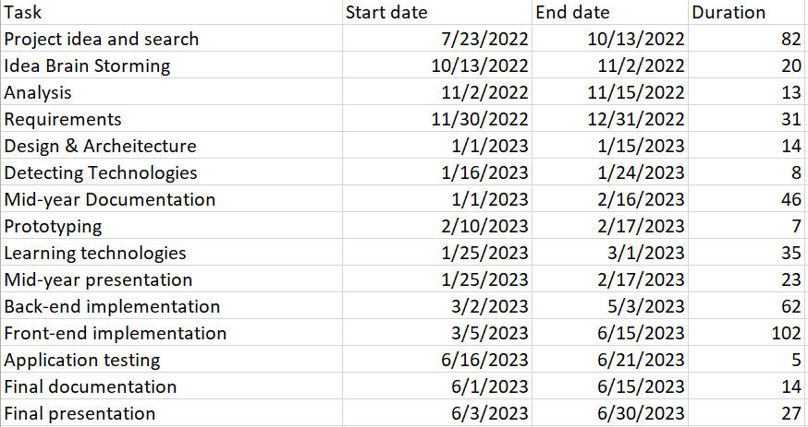

*Table 2: Gantt chart table*

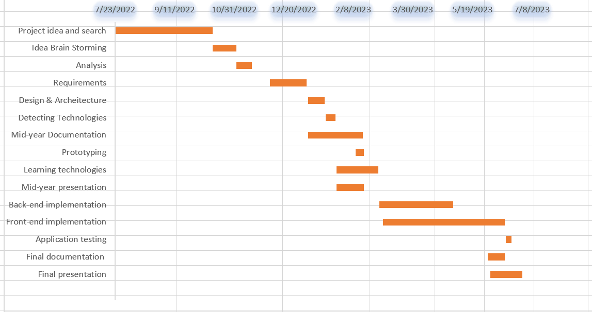

*Figure 1 : Gantt chart diagram*

**1.5 Project Development Methodology**

We used The Waterfall methodology which is a linear project development approach that follows a sequential, step-by-step process, Using this approach, each of our project phase was completed before moving on to the next phase. We chose this methodology because it is characterized by its emphasis on planning and documentation and our project had well-defined and stable requirements.

**1.6 Used Tools In The Project**

The Food Waste Management system is a web application that utilizes cutting-edge technologies to address the global food waste crisis.

* The front end is built using React JS, a popular JavaScript library, for a visually appealing and intuitive user experience.
* The back end is powered by Node.js, a versatile and scalable JavaScript runtime environment.
* MongoDB, a NoSQL document database, manages the dynamic nature of food listings, user information, and transactional data.

This combination of technologies ensures seamless communication, efficient data storage, and a responsive user interface, empowering food businesses and NGOs to combat food waste and alleviate hunger effectively.

**1.7 Report Organization**

In the following chapter we will be talking about the work related to our project.

After that in Chapter 3 we will be talking about the system analysis which includes functional , non-functional requirements and Use case diagrams and tables.

Chapter 4 will give a graphical overview of the system user interface which will include

**1-**System component diagram **2-**System class diagram **3-**Sequence diagrams **4-** SystemERD

**5-**System GUI

Finally Chapter 5 , will provide all the test cases used in our system.

**2-Related Work**

|  |  |  |
| --- | --- | --- |
|  | WASTELESS | TOO GOOD TO GO |
| Similarities: | * listing leftover food that would otherwise be thrown away. * Registration is free. * Both of them are ways to manage food waste | |
| Differences: | * Middleware between NGOs and Restaurants, hotels,etc.. * Each donor's listed food on the app is offered for free. * NGOs request specific food from the available food. | * Middleware between Restaurants and users. * the food displayed by each donator on the application its price is for a fraction of the original retail cost. * Users can then browse the map for food near them and pick up a ‘magic bag’ |

*Table 3: Wasteless VS Too Good To Go*

|  |  |  |
| --- | --- | --- |
|  | WASTELESS | FOODCLOUD |
| Similarities: | * Middleware between NGOs and Restaurants, hotels, etc... * All kinds of food businesses can use the technology to donate their leftover and surplus food. * food businesses simply upload a description of the leftover and surplus food they have, linked NGOs gets a notification that food can be collected. | |
| Differences: | * NGOs communicate with the food businesses through requesting their listed food from the website to get food and distribute it. | * Food Cloud team distribute food. |

*Table 4: Wasteless VS FoodCloud*

**3.System Analysis**

**3.1 Project Specifications**

**3.1.1 Functional Requirements**

***Admin’s functionalities:***

1. Sign in:

* Admin should be able to sign into the website by their email and password.

2.Sign out:

* Signed-in admin should be able to sign out of their current account at any given time.

3.List:

* Admin should be able to list all donators and NGO’s available either (approved-pending-rejected).

4.Approve:

* Admin should be able to approve New NGO or New Donator requests.

4.Reject:

* Admin should be able to reject New NGOs or New Donator requests if no legal documents provided.

5. View notifications:

* Admin should be able to view notifications whenever a new organization or donator is registered.

6. Search:

* Admin should be able to search for NGOs/Donators by username.

***Donator’s (Restaurants/Hotels) functionalities:***

1. Sign up:

* Donator should be able to create an account on our website with their full name, email, password, address, tax Id , tax number and phone number.

2. Sign in:

* Donator should be able to sign into the website by their Username and password.

3. Forget/change password:

* Donator should be able to forget password during the sign in process. Donator should be able to change password from their profile.

4. Sign out:

* Signed-in donator should be able to sign out of their current account at any given time.

5. View and Update donator's profile:

* Signed-in donator should be able to view and update any information in profile at any given time such as password, address, or phone number.

6. View requests’ notifications:

* Donator should be able to view notifications whenever organization request from its food list of each post.

7. Add new donation:

* Donator should be able to donate by adding extra food.

8. Remove from donations:

* Donator should be able to remove donations or donations will be automatically removed after 48 hours if no request occurred.

9. View All donations:

* Donators should be able to view their different donations.

10. Expand donation description:

* Donators should be able to view more about a specific donation post with a full description by clicking on it.

11.Chat with the requestor NGO:

* Donator can chat with requestor NGO as long as this NGO makes a request on any of this donator's posts, and the system allows those users to chat through the website.

12. Contact us:

* Donators should be able to contact us to solve any problem via email.

13.View History:

* Donator should be able to show all the donations with status removed or delivered.

14.Customized dashboards:

* Donators have customizable dashboards to allow them to view the data and analytics that are most relevant to their role

15.Filter:

* Donators should be able to filter their donations based on status (removed-available-requested-delivered) or delivery status (Delivery available – Not available).

***NGO's functionalities:***

1.Sign up:

* NGO’S should be able to create an account on our website with their full name, email, password, address, tax Id , tax number and phone number.

2. Sign in:

* NGO’S should be able to sign into the application by their Username and password.

3. Forget/change password:

* NGOs should be able to forget password during the sign in process. NGO’S should be able to change password from their profile.

4. Sign out:

* Signed-in NGO should be able to sign out of their current account at any given time.

5. Update NGO’s profile:

* Signed-in NGO should be able to update any information in profile such as password, address, and phone number.

6. View donations:

* NGO should be able to view the food requests made by donators.

7. Expand donations’ requests description:

* NGO should be able to view more about a specific post with full description by expanding it by clicking on it.

8. Request:

* NGO should be able to request donations published by the donators from dashboard.

9.Chat with donator:

* System will allow NGO to be able to chat with specific donator after making a request from his donation posts.

10. Contact us:

* NGO should be able to contact us to solve any problem via email.

11.View History:

* NGO should be able to show all requested donations.

12.Search:

* NGO should be able to search for different donations with tags.

13.Customized dashboards:

* NGOs have customizable dashboards to allow them to view the data and analytics that are most relevant to their role

**3.1.2 Non-Functional Requirements**

1. Portability:

• The website will be available for variety of web browsers (Google Chrome, Fire Fox, Safari)

2. Usability:

* Users can easily determine what a feature is and what it can do, also, users can easily navigate the website interface.

3. Authorization:

* The application will not accept any user from accessing the system without entering the specific username and password.

4. Security:

* The password should contain at least 8 characters including at least one uppercase letter, at least one lowercase letter and a digit.
* Donator should agree to the Terms of Services and Private Policy.

**3.2 Use Case Diagram**

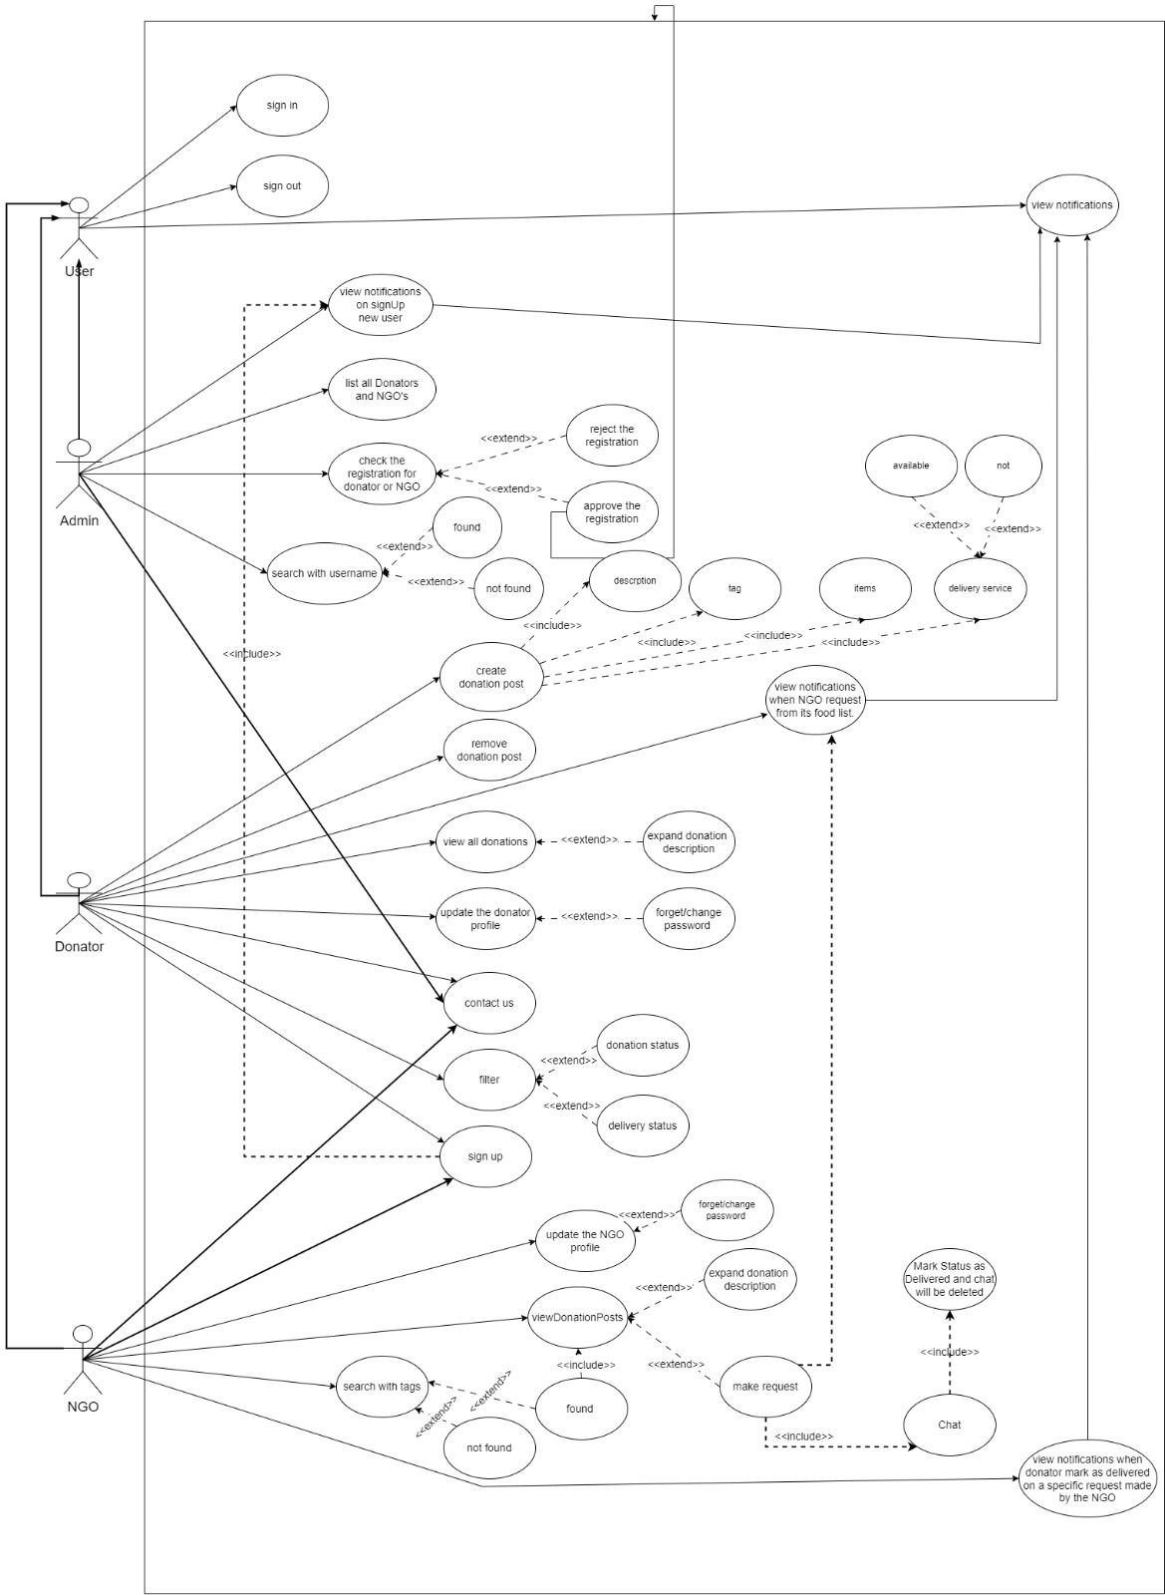

*Figure 2: Use Case Diagram*

Figure 2 Shows an illustration of all functionalities that a NGO or Donator or Admin Execute.

**3.3 Use Case Tables**

|  |  |  |
| --- | --- | --- |
| Use Case ID: | 1 | |
| Use Case Name: | Registration | |
| Actors: | Donator, NGO | |
| Pre-conditions: | Donators/NGOs enter the system Home Page | |
| Post-conditions: | The request is pending waiting for approval or rejection | |
| The flow of events: | User Action | System Action |
| 1- The Donator /NGO Visits the Home page, clicks on sign up button |  |
|  | 2- redirect the user to the registration page |
| 3- The user fills in the data needed, reads the terms and conditions then clicks on the signup button |  |
|  | 4- The system displays a success message of the request and that now the request is pending then notify the Admin with the Donator /NGO request to check their documents |
| Exceptions: | User Action | System Action |
| User does not fill in the required fields | System pops alert message to complete required fields |

*Table 5 : Use case table for registration function*

|  |  |  |
| --- | --- | --- |
| Use Case ID: | 2 | |
| Use Case Name: | Create Donation Post | |
| Actors: | Donator | |
| Pre-conditions: | Donator successfully Log into the system | |
| Post-conditions: | A new Donation is added to the system | |
| Flow of events: | User Action | System Action |
| 1- The donator clicks on Create new donation post button |  |
|  | 2- The system will prompt the relevant interface with the necessary options |
| 3- The user fills in the data needed and clicks on publish button |  |
|  | 4- The system displays a confirmation message |
| Exceptions: | User Action | System Action |
| The user does not fill in the required donation fields | The system pops an alert message to complete the required fields |

*Table 6: Use Case table for the creation of a donation post*

|  |  |  |
| --- | --- | --- |
| Use Case ID: | 3 | |
| Use Case Name: | Request Donation | |
| Actors: | NGO | |
| Pre-conditions: | NGO log into system / Donations posted and added to Database | |
| Post-conditions: | Chat opened between NGO and Donator | |
| Flow of events: | User Action | System Action |
| 1- NGO clicks on view donations |  |
|  | 2- The application shows all donation |
| 3- NGO clicks on the request donation button from desired Donation post |  |
|  | 4- The application will add the request to the database and show a success message and send Donator the donation notification that it is requested |
|  |  | 5-System automatically displays a chat icon to enable a chat between the NGO and Donator |

*Table 7 : Use Case table for requesting a donation by NGO*

**4.System Design**

**4.1 Component Design**

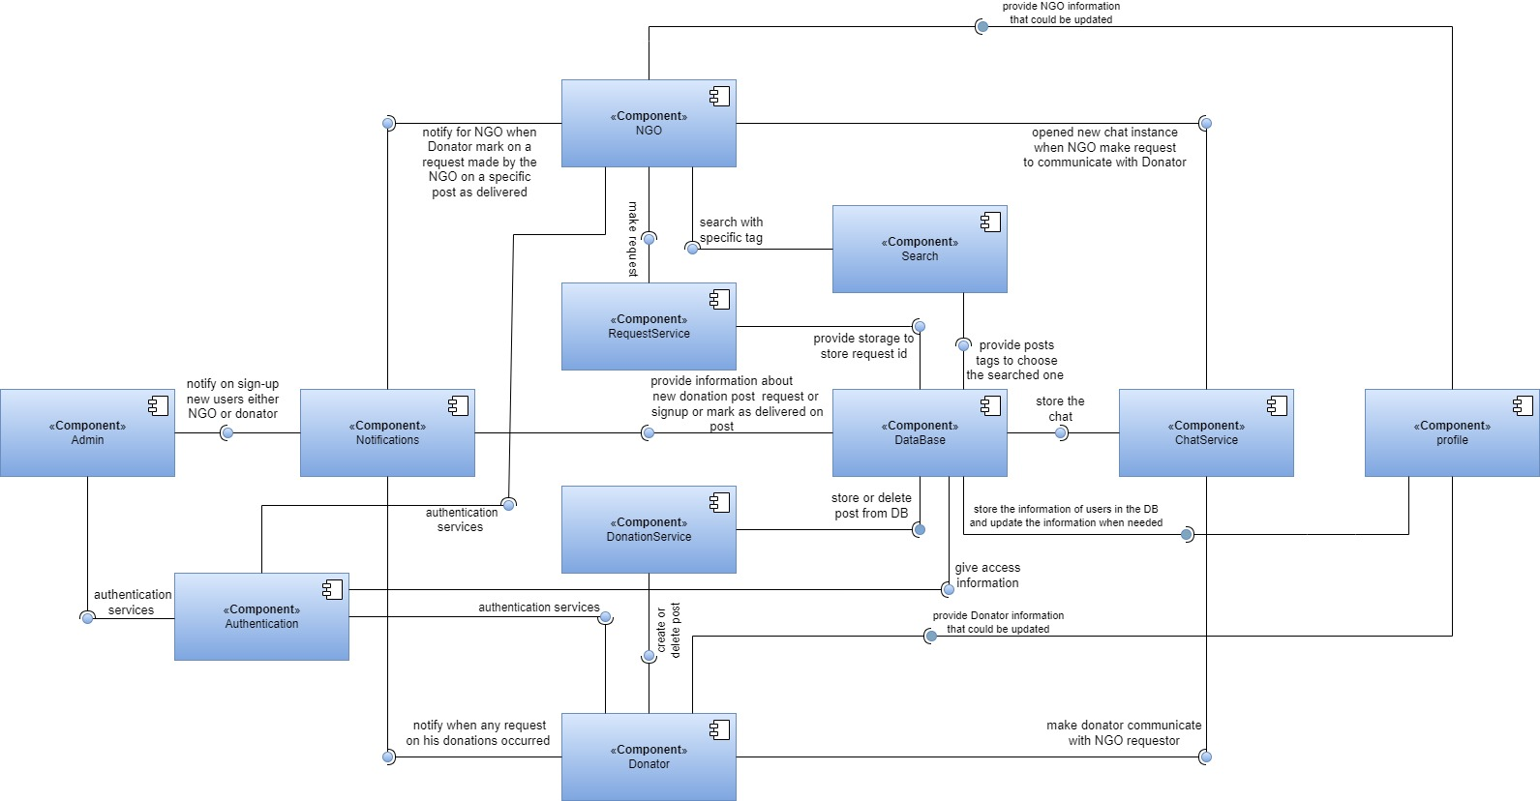

*Figure 3 : System Component Diagram*

In Figure 3 , the component diagram shows how the components of the system are wired together to form larger components.

**4.2 System Class Diagram**

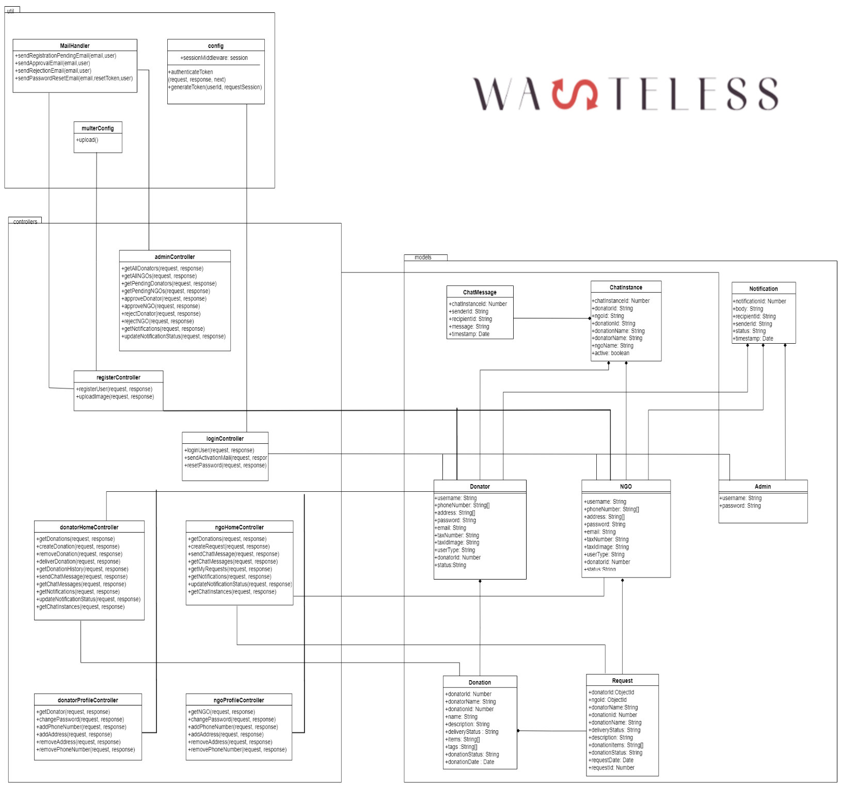

*Figure 4: System class Diagram*

In figure 4 the class diagrams shows the static view of the system

**4.3 System Sequence Diagrams**

**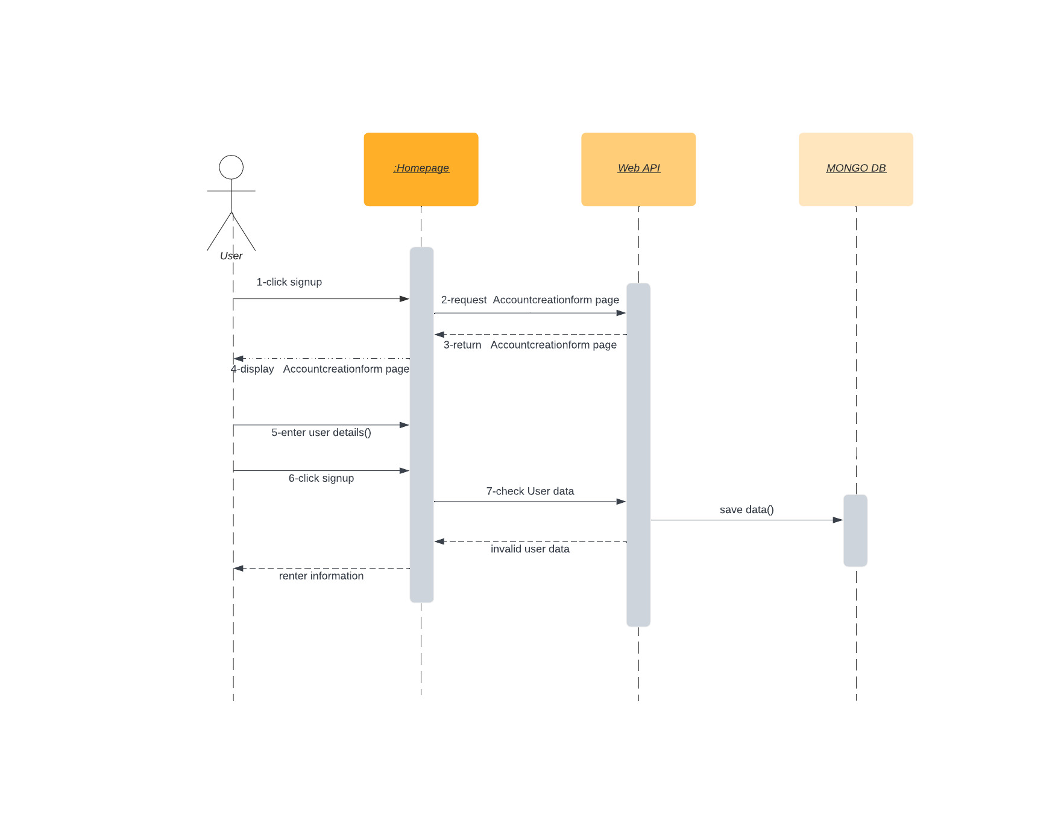***Figure 5: Sequence Diagram of Register* 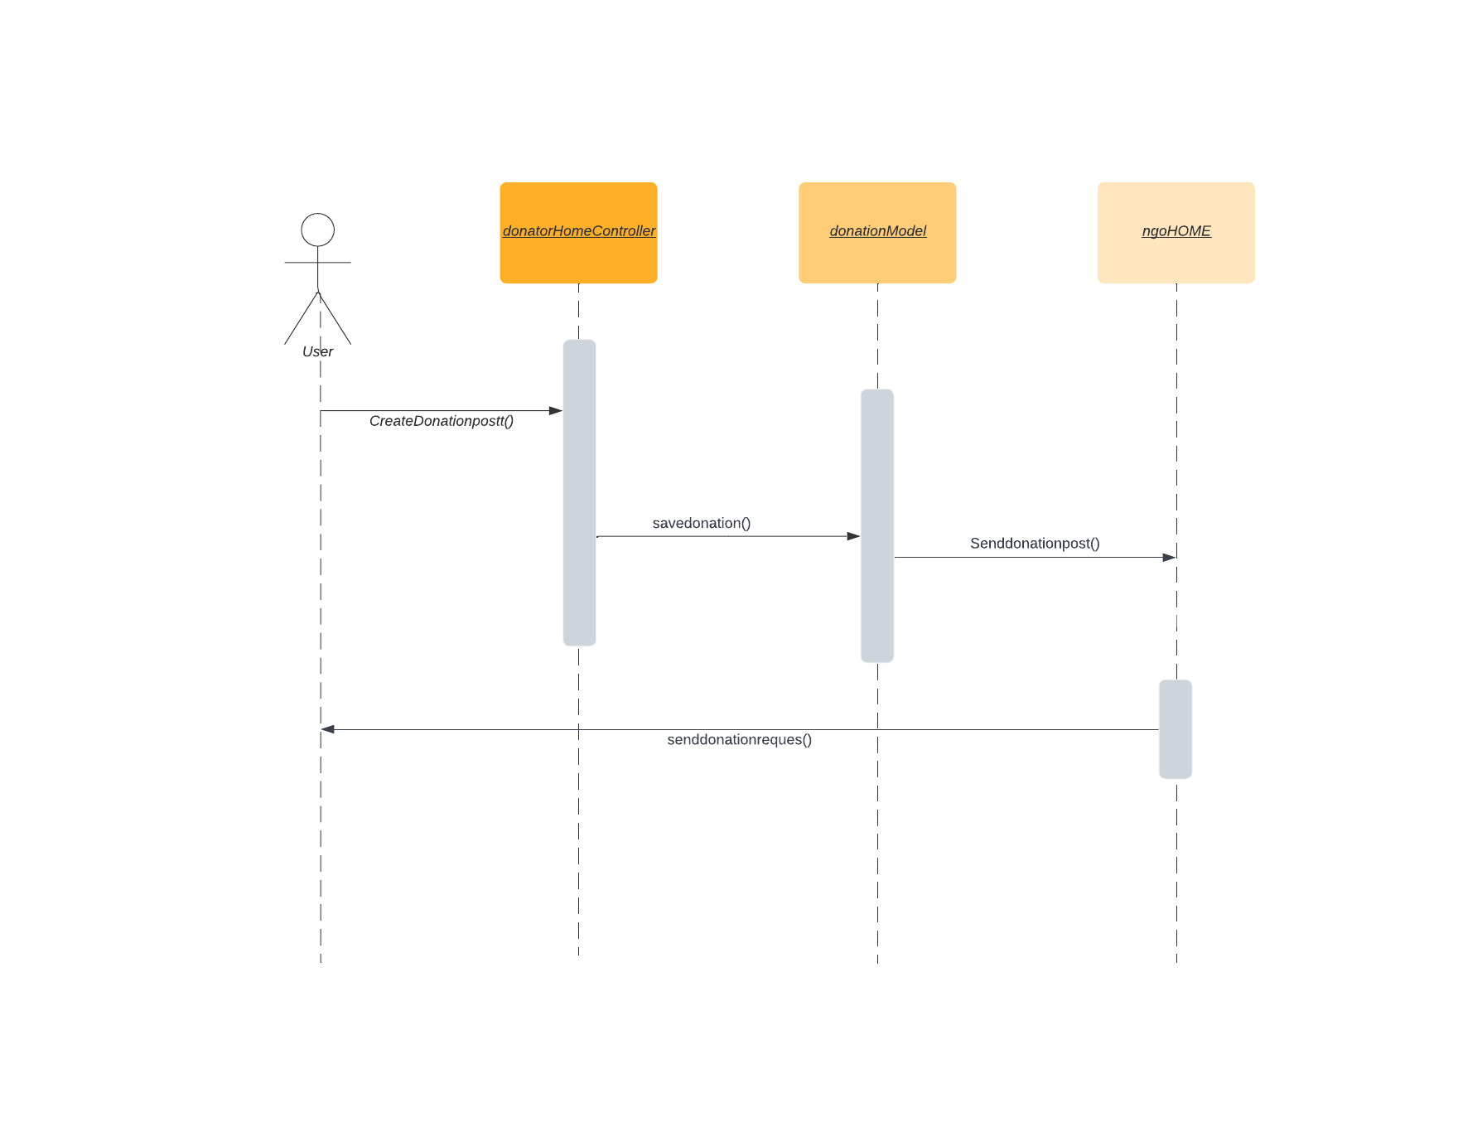

*Figure 6: Create Donation Post Sequence Diagram*

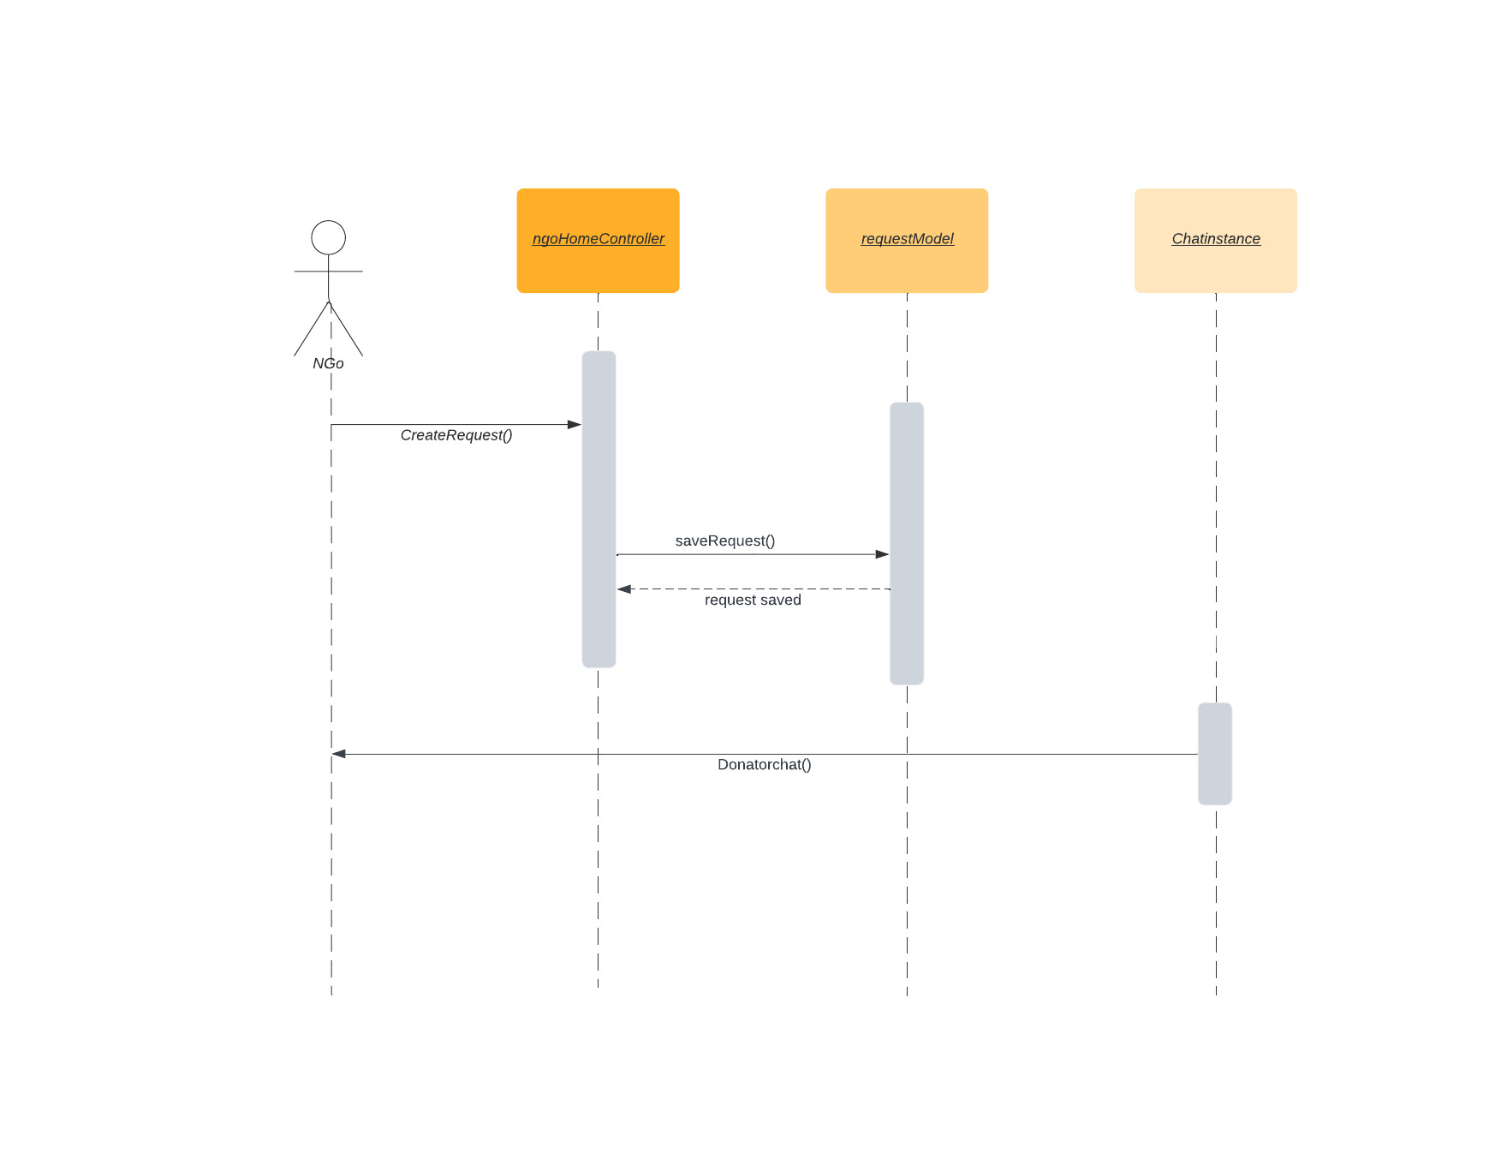

*Figure 7: Sequence Diagram for making request*

**4.4 System ER Diagram**

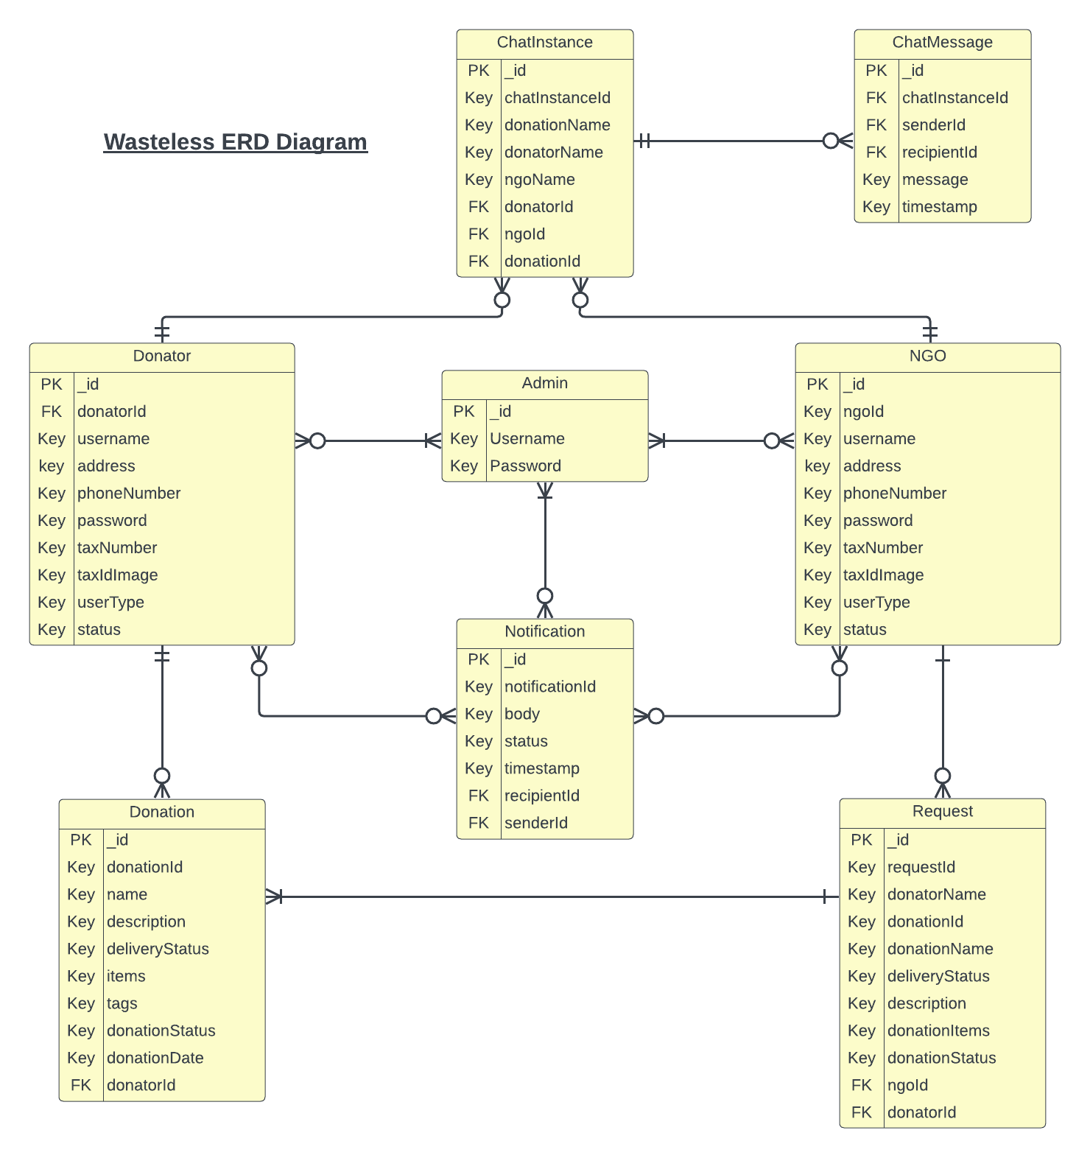

*Figure 8 : System ER Diagram*

In figure 8 the ER diagram shows The major entities within the system scope, and the inter-relationships among these entities.

**4.5 System GUI Design**

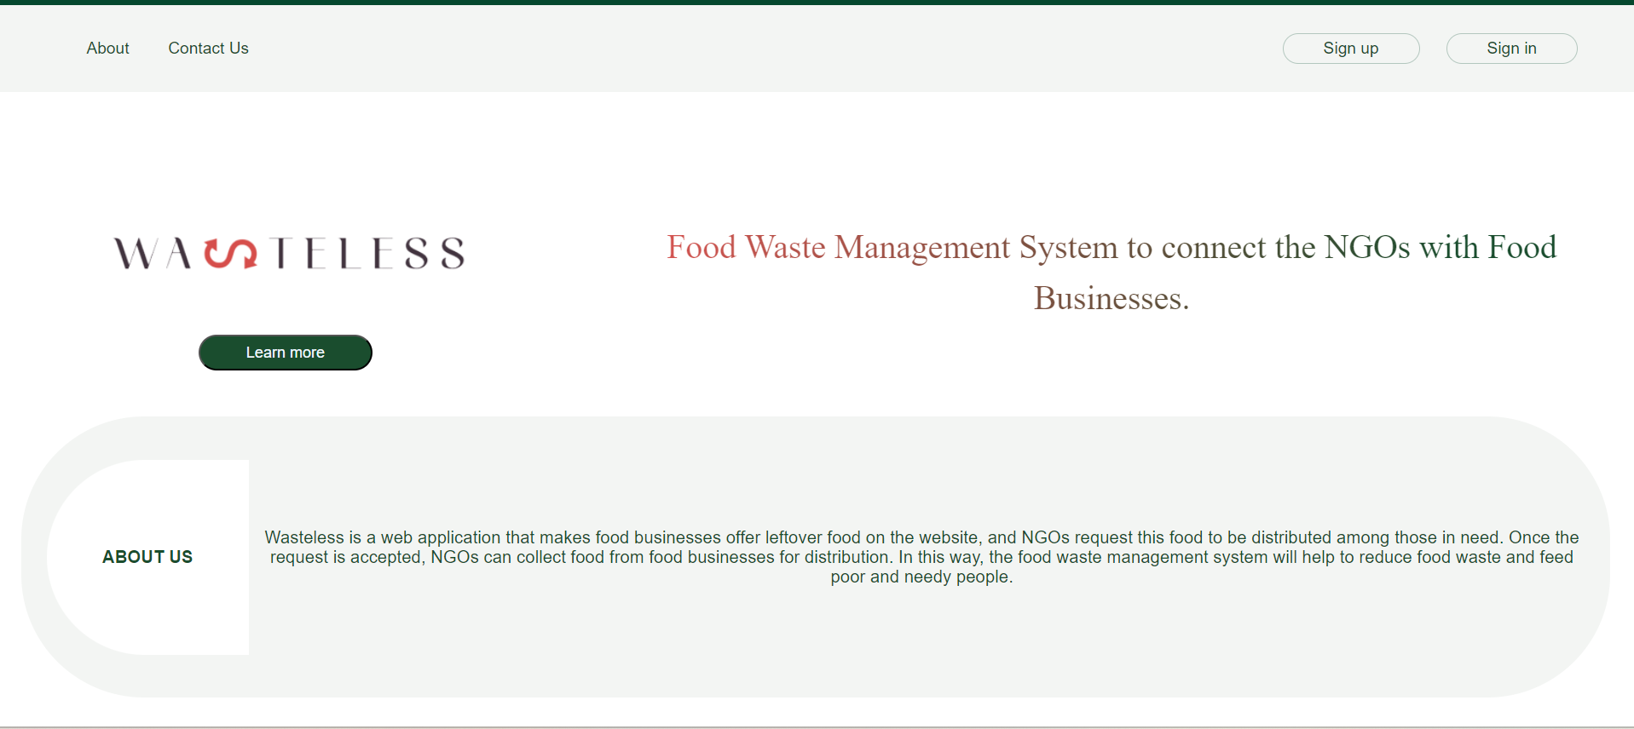

*Figure 9: System Home Page*



*Figure 10: Sign up Page*

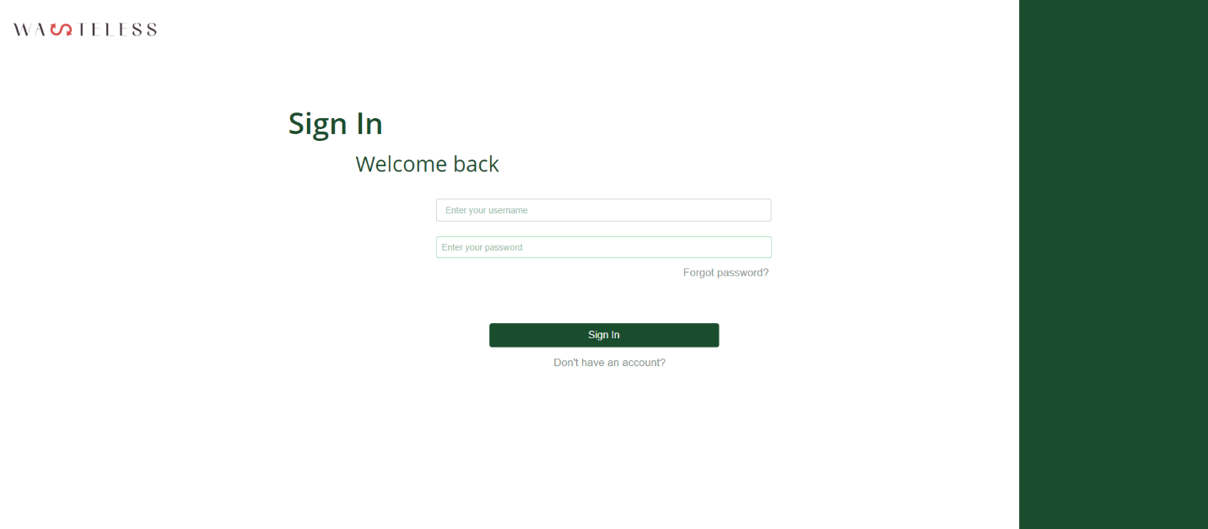

*Figure 11:Sign in page*

**4.5.1 NGO GUI Design**

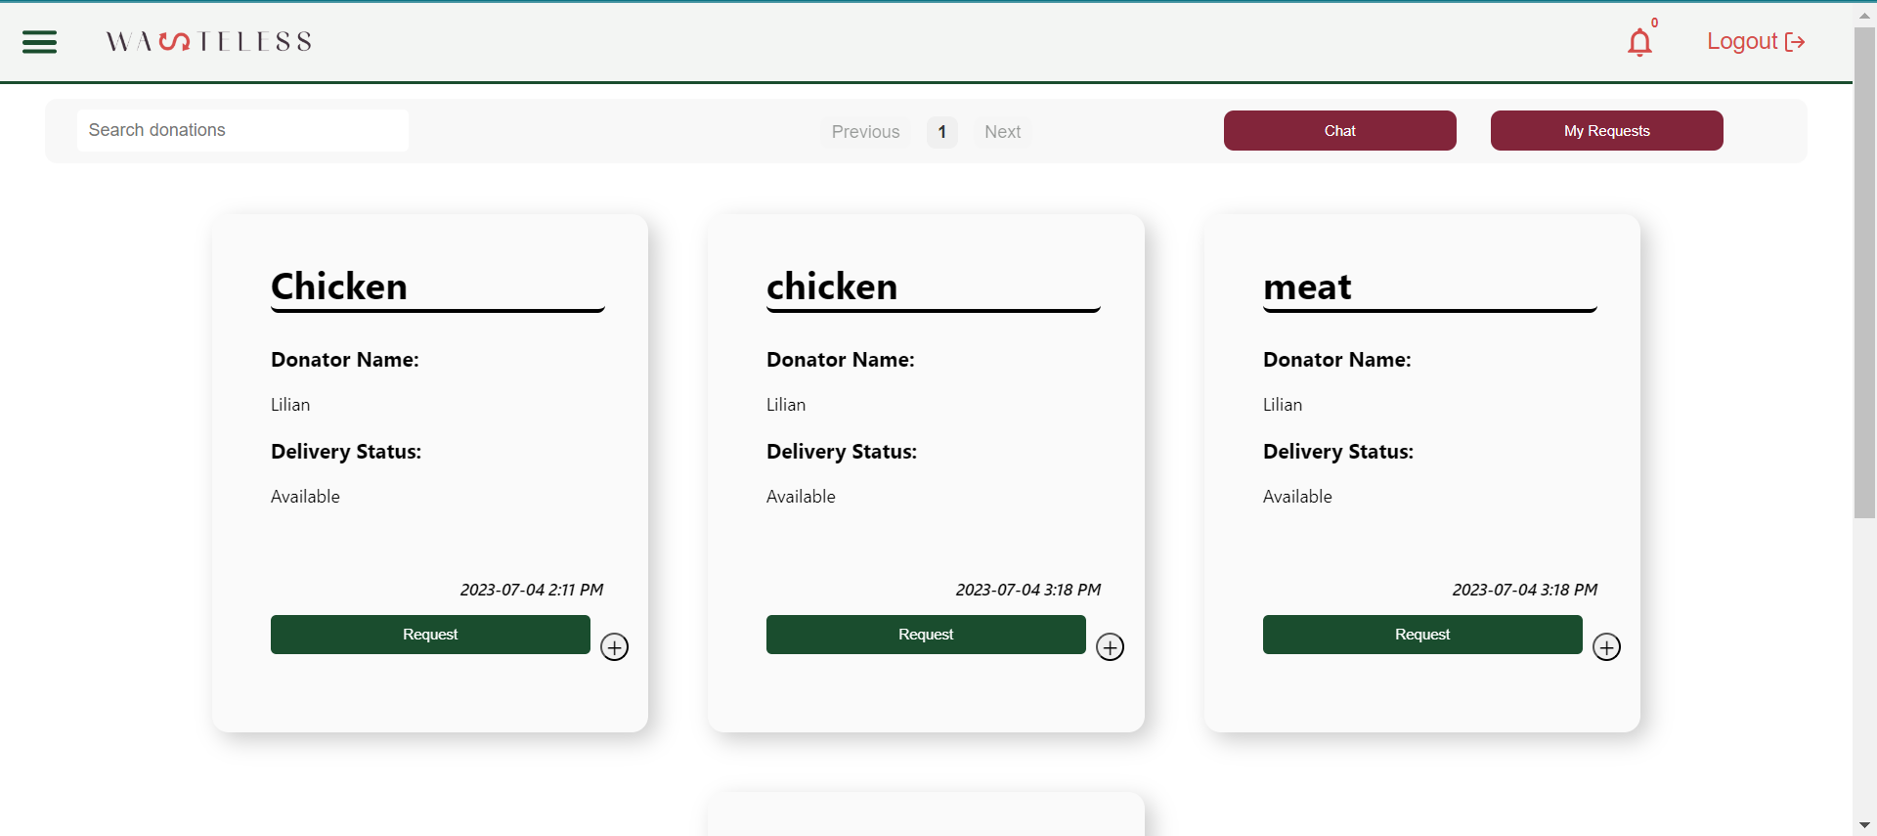

*Figure 12: NGO Home page*

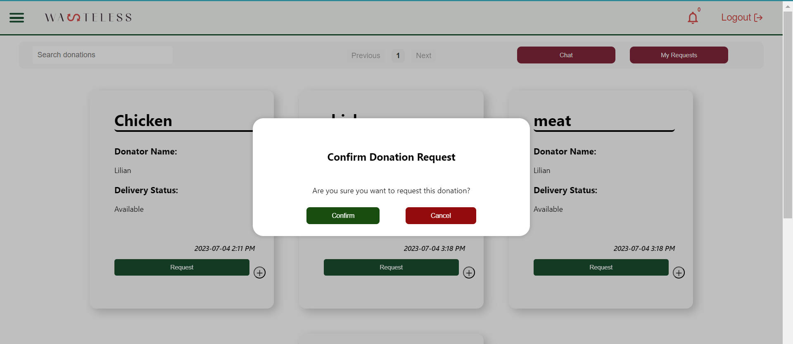

*Figure 13: NGO Confirm donation request*

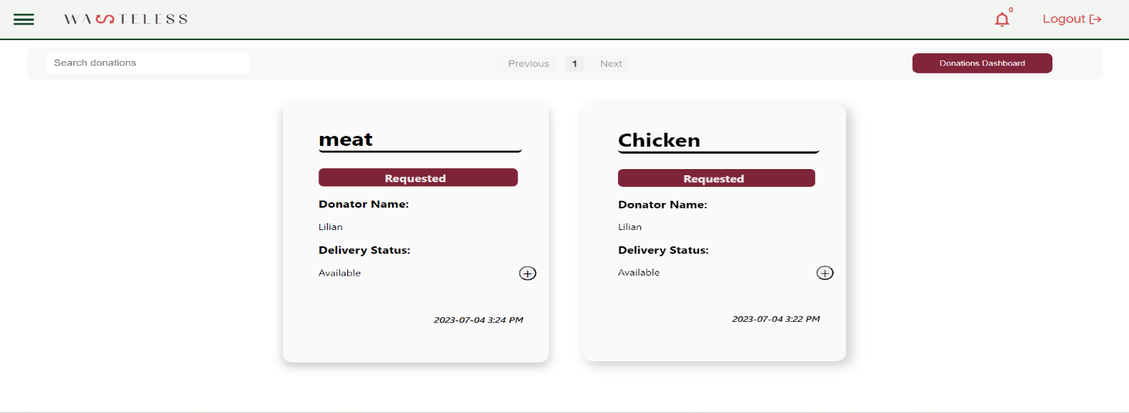

*Figure 14: Requests Page of NGO*

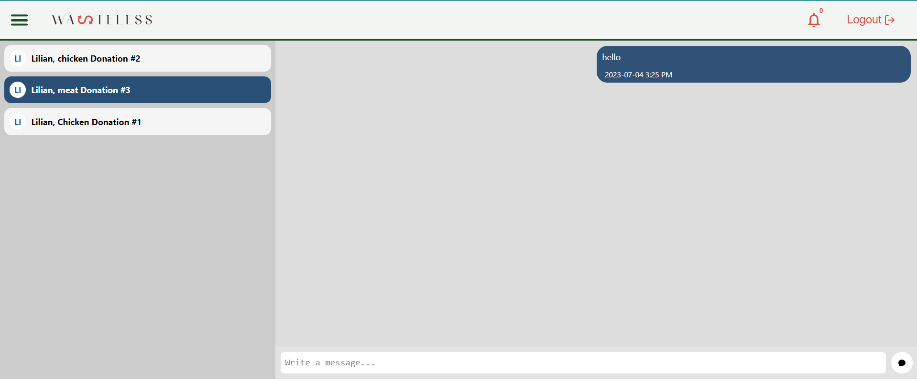

*Figure 15: Chat with dontor if donation is delivered by donator*

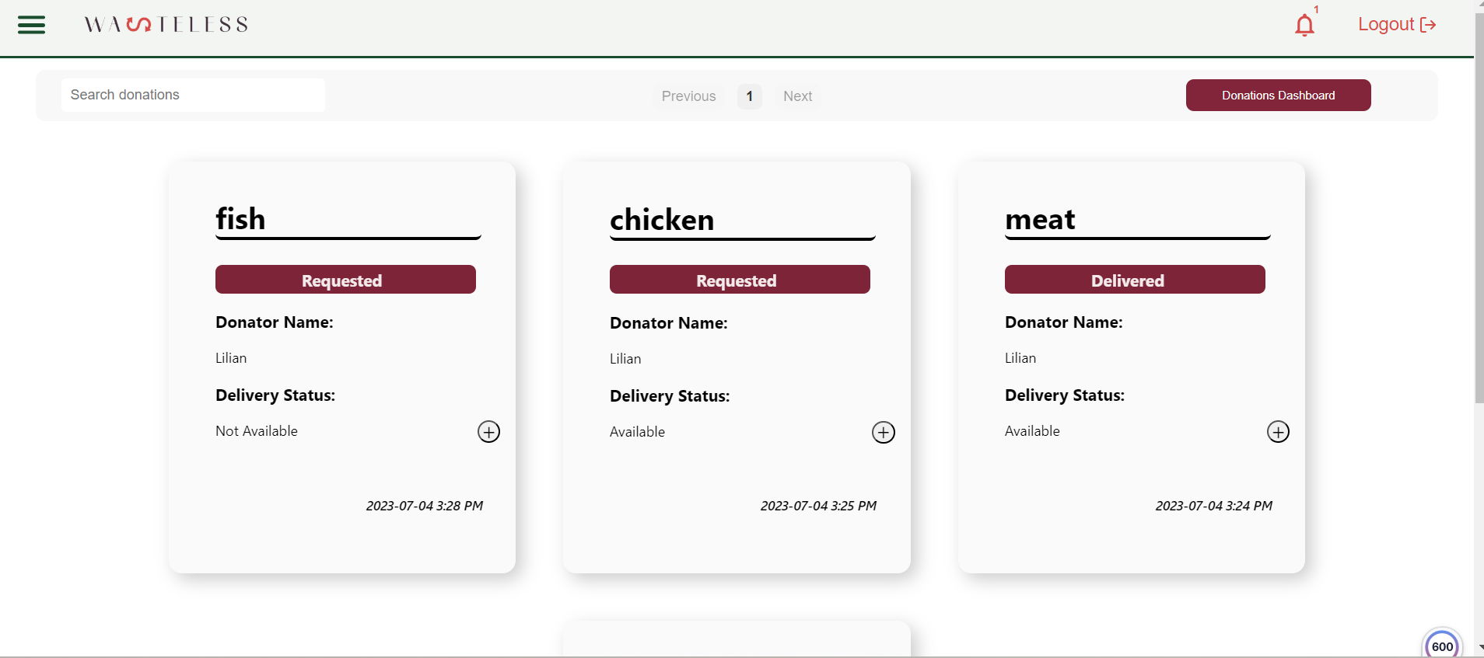

*Figure 16 : History of NGO Requests*

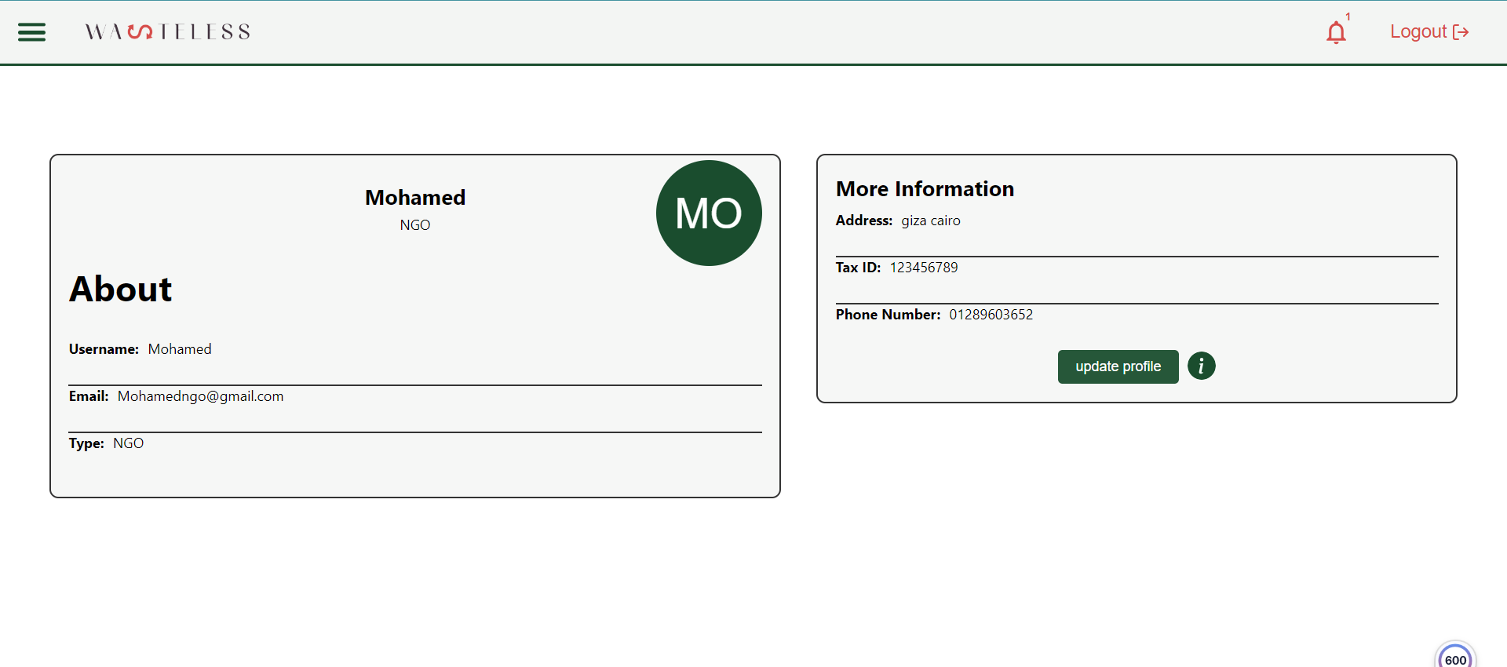

*Figure 18: NGO Profile Page*

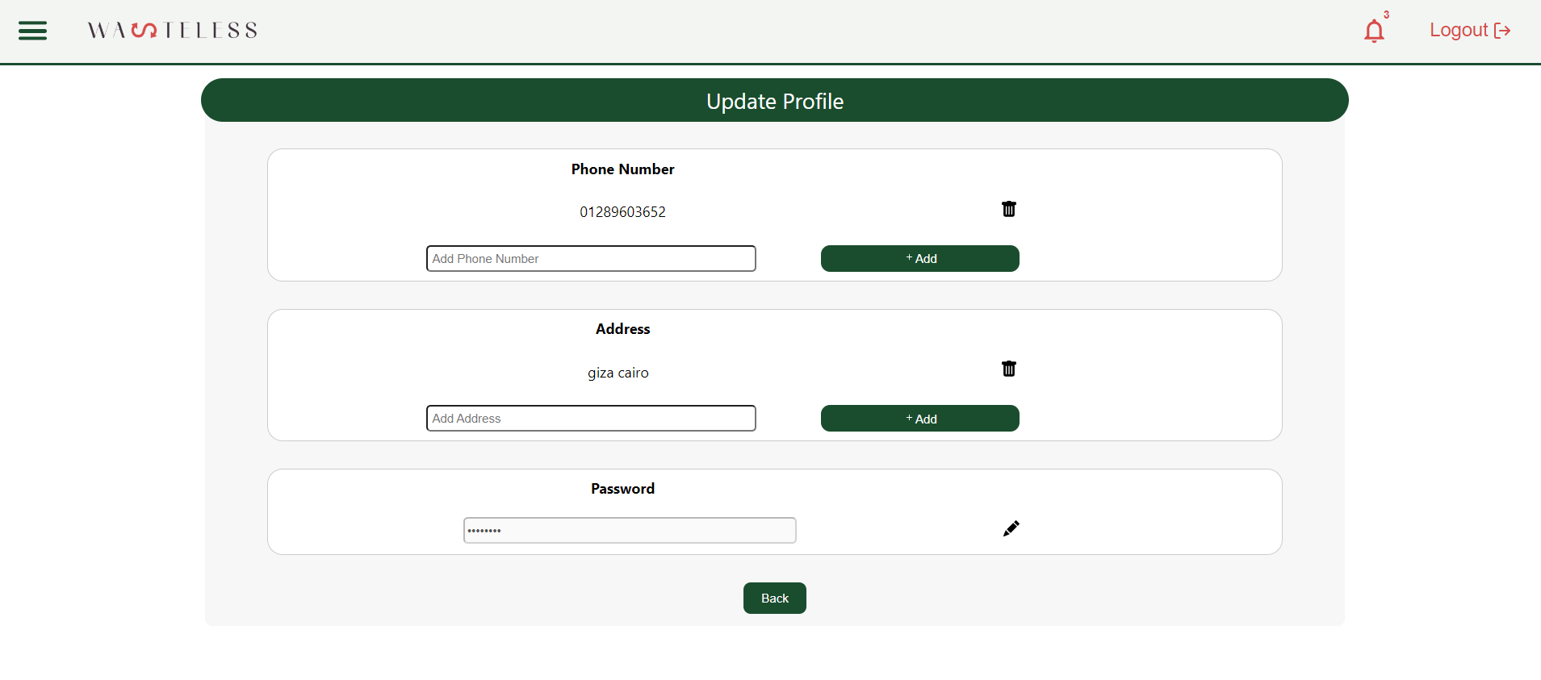

*Figure 19 : Update Profile Page*

**4.5.2 Donator GUI Design**

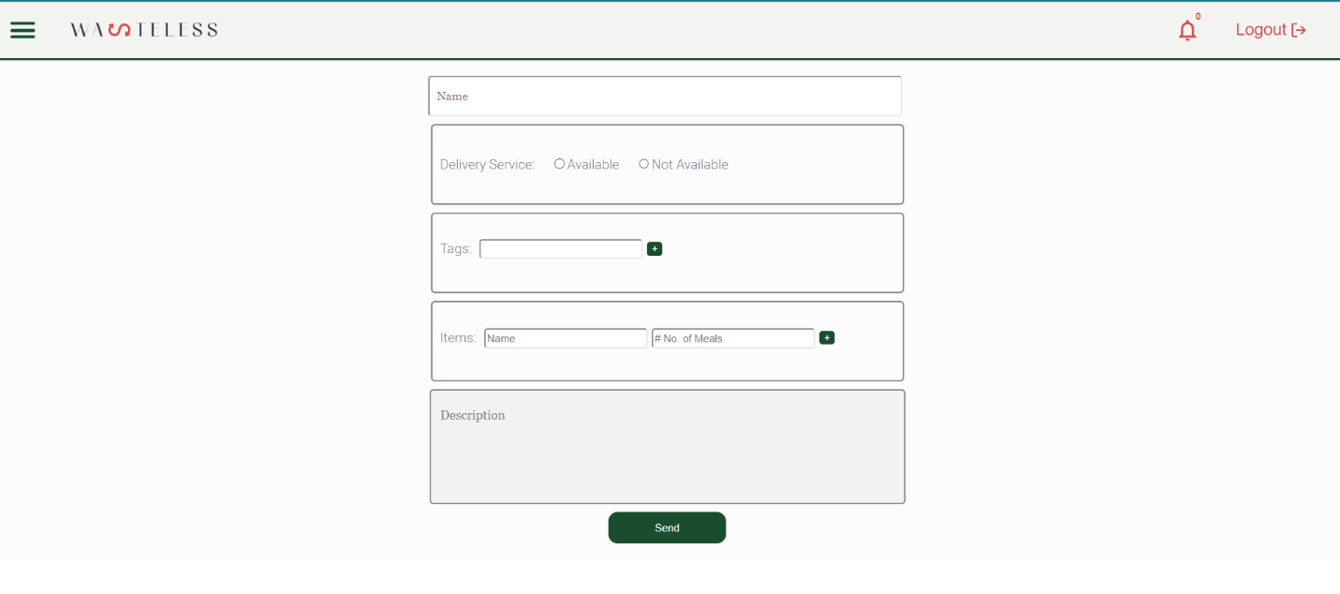

*Figure 20: Create Donation Post Page*

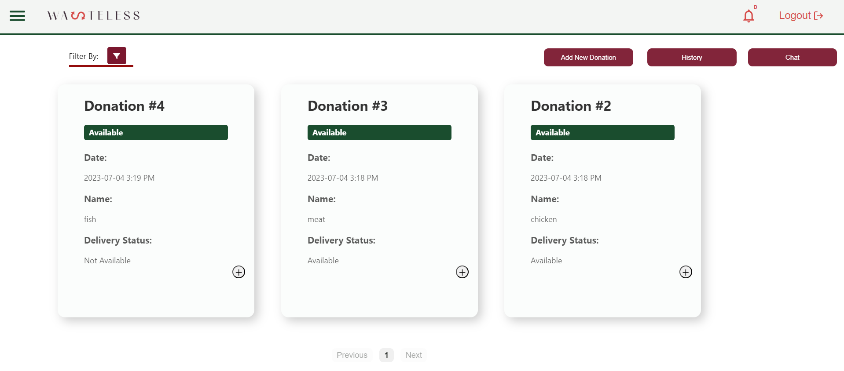

*Figure 21: Donator Home Page, Donations posted by Donator*

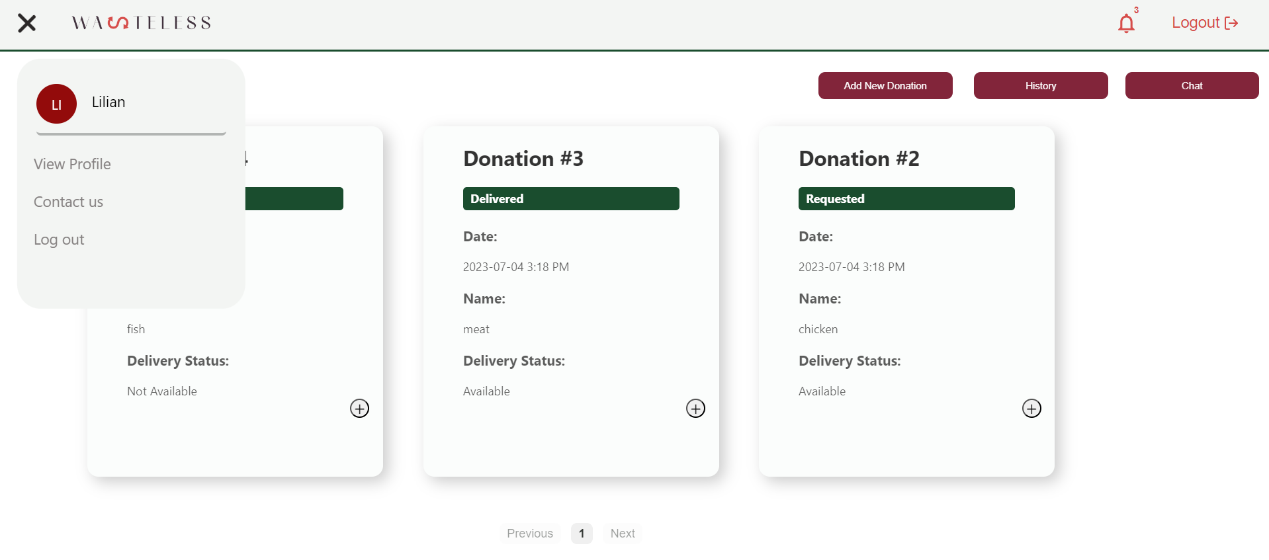

*Figure 22 : Donator menu to View Profile*

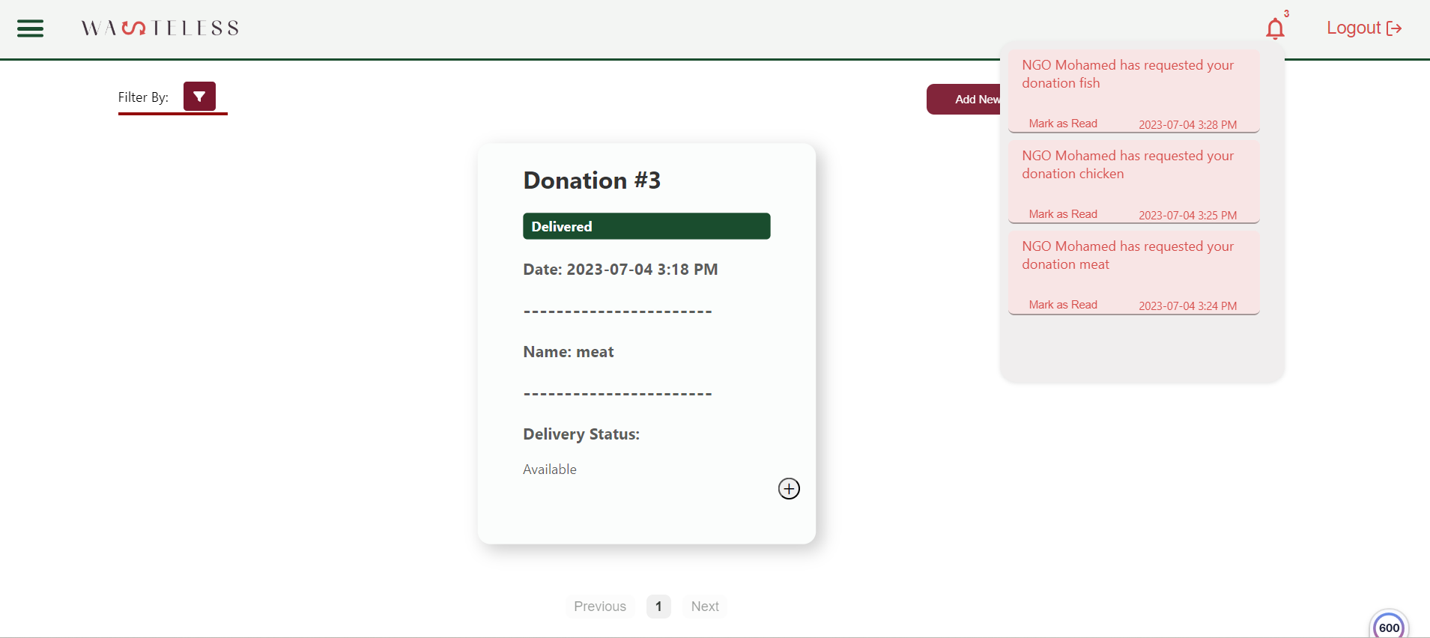

*Figure 23 : Notifications of donations request sent by NGOs*

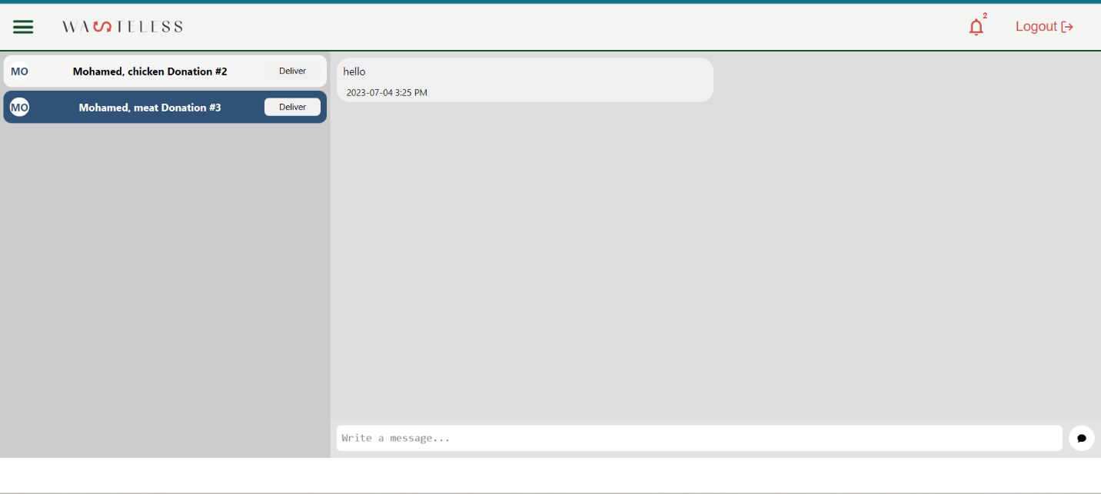

*Figure 24 : Chat with requested NGO , Button deliver*

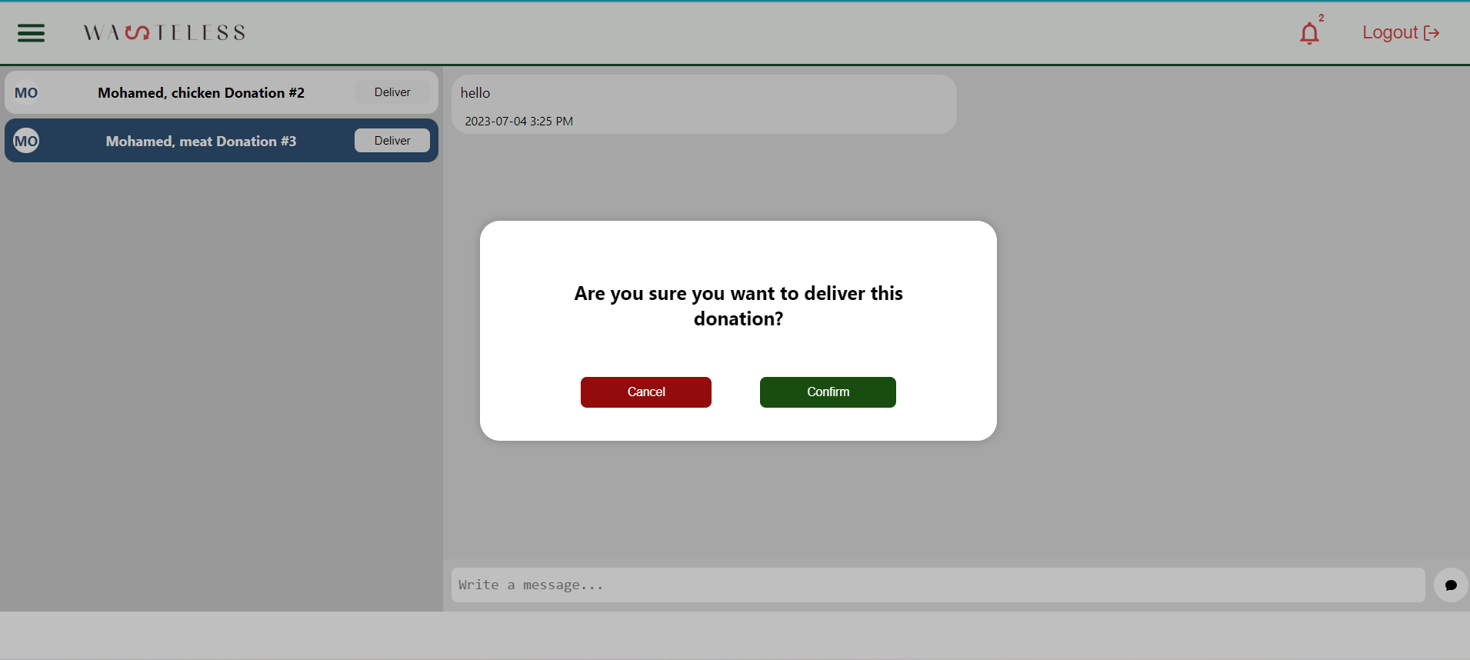

*Figure 25 : Confirm to deliver donation*

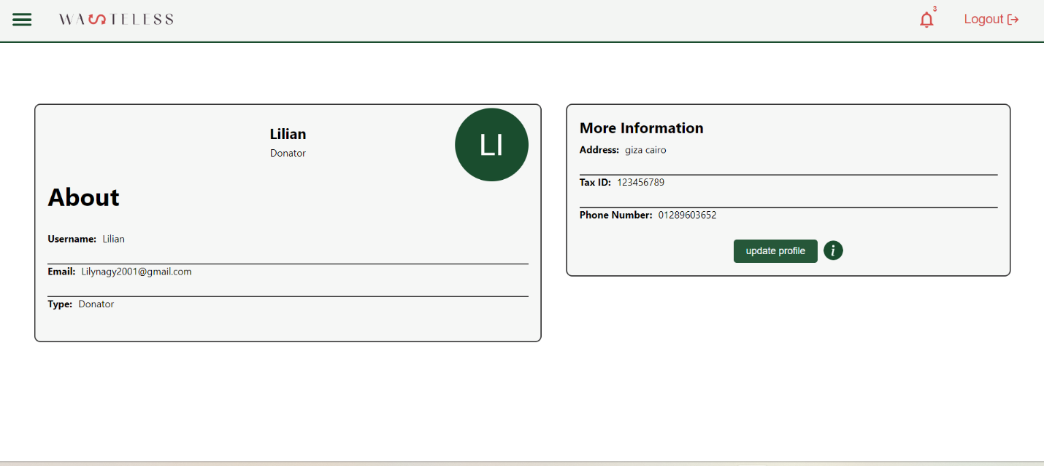

*Figure 26 : Profile page of donator*



*Figure 27 : Update Profile Page*

**4.5.3 Admin GUI Design**

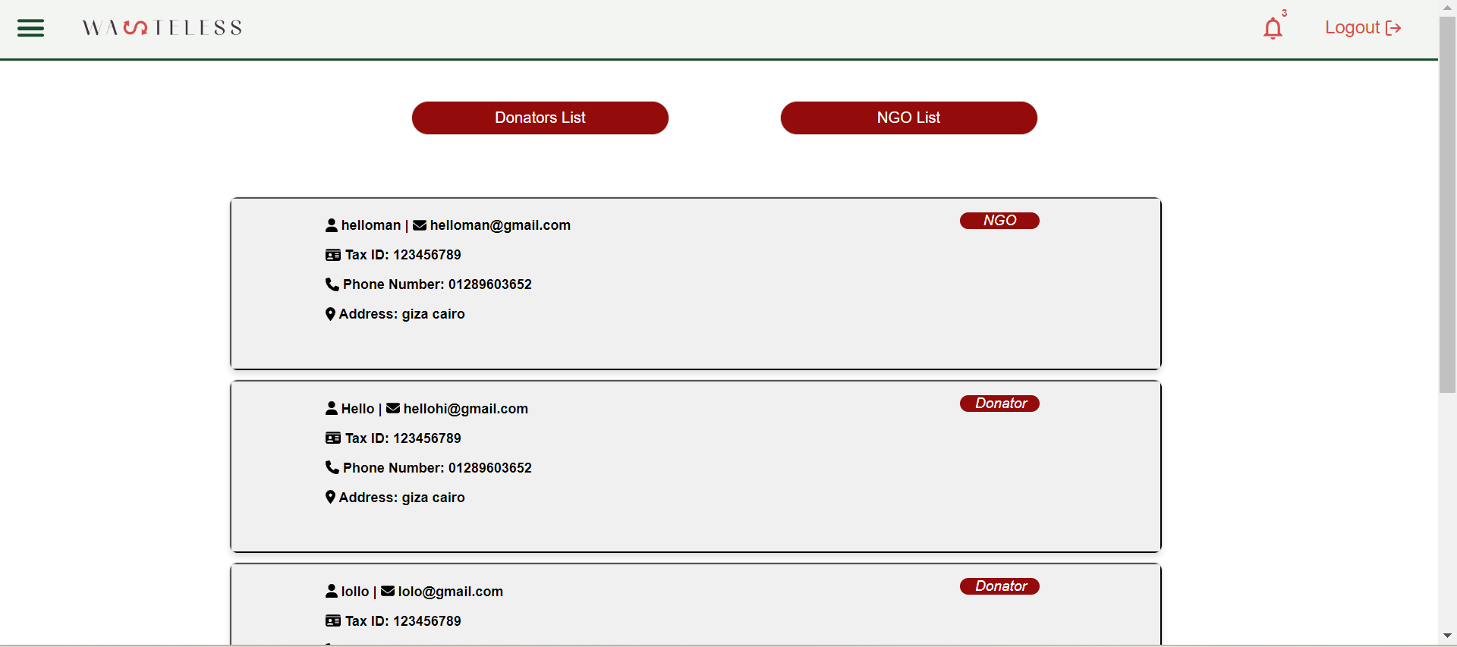

*Figure 28: Admin Dashboard*

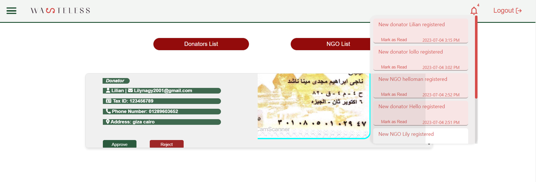

*Figure 29 : Request Opened to accept or reject by admin , Notifications of new Registration Requests*

**5. Implementation and Testing**

In this part, we are covering the test cases that we used to make sure that all the functionalities are operating as it is intended.

Some of the system’s main features and test scripts are included in this section.

To make sure that our test cases are traceable and comprehendible, our test cases included the following attributes:

1**. Test Case ID**: To give the test case a better traceability

2. **Test Scenario**: To identify the functionality being tested

3. **Test Priority**: Severity of Test Case

4. **Pre-condition**: Of the test functionality

5. **Test Case Description**: describe the scenario of the test case

6. **Test Data**: Data needed to complete the test case

7. **Test Steps**: Guided steps to follow to complete the test case

8. **Expected Output**: The output intended to be shown, evaluated against the test case result

**5.1 Donator Functionalities Test Cases**

|  |  |  |  |  |  |  |  |
| --- | --- | --- | --- | --- | --- | --- | --- |
| **Donator Sign up Positive scenario** | | | | | | | |
| **Test Scenario** | Sign Up | | | **Test Case ID** | | T-A1 | |
| **Test Case** | Sign up-positive scenario | | | **Test Priority** | | 1 | |
| **Pre-Condition** | Visit home page | | | | | | |
| **Description** | Donators sign up on the website using their User name, email, password, address, phone number, Tax number, and tax document. | | | | | | |
| **Test Steps** | **Test Data** | **Expected Output** | **Actual Output** | | **Test Result** | | **Comments** |
| 1.click on Sign up | Personal Information | A pending registration Page | A pending registration Page | | Pass | |  |
| 2.Donator enters personal information |

*Table 8: Test Case table for dontar sign up register positive scenario*

|  |  |  |  |  |  |  |  |
| --- | --- | --- | --- | --- | --- | --- | --- |
| **Donator Sign up Negative scenario** | | | | | | | |
| **Test Scenario** | Sign Up | | | **Test Case ID** | | T-A2 | |
| **Test Case** | Sign up-Negative scenario | | | **Test Priority** | | 1 | |
| **Pre-Condition** | Visit Home page | | | | | | |
| **Description** | Donators sign up on the website using their User name, email, password, address, phone number, Tax number, and tax document. | | | | | | |
| **Test Steps** | **Test Data** | **Expected Output** | **Actual Output** | | **Test Result** | | **Comments** |
| 1.click on Sign Up | Personal Information | Registration Failed pop-up message | Registration Failed pop-up message | | Pass | |  |
| 2.Donator enters personal information |

*Table 9: Test Case table for dontar sign up register negative scenario*

|  |  |  |  |  |  |  |  |
| --- | --- | --- | --- | --- | --- | --- | --- |
| **Donate Positive scenario** | | | | | | | |
| **Test Scenario** | Donate | | | **Test Case ID** | | T-A3 | |
| **Test Case** | Donate-positive scenario | | | **Test Priority** | | 1 | |
| **Pre-Condition** | Donator successfully Logged in | | | | | | |
| **Description** | Donators create a donation post giving all donation details such as name, quantity, given tags, and description. | | | | | | |
| **Test Steps** | **Test Data** | **Expected Output** | **Actual Output** | | **Test Result** | | **Comments** |
| 1. Donator clicks on Create a new donation | Donation Information | Donation is added to the donator dashboard | Donation is added to the donator dashboard | | Pass | |  |
| 2. Donator enters Donation information |

*Table 10: Test Case table for create donation post positive scenario*

|  |  |  |  |  |  |  |  |
| --- | --- | --- | --- | --- | --- | --- | --- |
| **Donate Negative scenario** | | | | | | | |
| **Test Scenario** | Donate | | | **Test Case ID** | | T-A4 | |
| **Test Case** | Donate-Negative scenario | | | **Test Priority** | | 1 | |
| **Pre-Condition** | Donator successfully Logged in | | | | | | |
| **Description** | Donators create a donation post giving all donation details such as name, quantity, given tags, and description. | | | | | | |
| **Test Steps** | **Test Data** | **Expected Output** | **Actual Output** | | **Test Result** | | **Comments** |
| 1. Donator clicks on Create a new donation | Donation Infromation | Donation is not added to the donator dashboard, Error pop-up appears | Donation is not added to the donator dashboard, Error pop-up appears | | Pass | |  |
| 2. Donator enters Donation information |

*Table 11: Test Case table for creating donation post negative scenario*

|  |  |  |  |  |  |  |  |
| --- | --- | --- | --- | --- | --- | --- | --- |
| **Remove Donation Post Positive scenario** | | | | | | | |
| **Test Scenario** | Remove Donation post | | | **Test Case ID** | | T-A4 | |
| **Test Case** | Remove Donation Post-Positive scenario | | | **Test Priority** | | 1 | |
| **Pre-Condition** | Donator successfully Logged in and was redirected to the dashboard | | | | | | |
| **Description** | Donators remove a donation post manually before 48 hours as it as automatically removed after 48 hours. | | | | | | |
| **Test Steps** | **Test Data** | **Expected Output** | **Actual Output** | | **Test Result** | | **Comments** |
| 1. Donator clicks on the desired published post. | - | Donation status will change to removed | Donation status will change to removed | | Pass | | After 48 hours donation posts status change to removed automatically |
| 2. Donator clicks on Remove post |

*Table 12: Test Case table for removing donation post positive scenario*

|  |  |  |  |  |  |  |  |
| --- | --- | --- | --- | --- | --- | --- | --- |
| **Remove Donation Post Negative scenario** | | | | | | | |
| **Test Scenario** | Remove Donation post | | | **Test Case ID** | | T-A6 | |
| **Test Case** | Remove Donation post-Negative scenario | | | **Test Priority** | | 1 | |
| **Pre-Condition** | Donator successfully Logged in and was redirected to the dashboard | | | | | | |
| **Description** | Donators remove a donation post manually before 48 hours as it as automatically removed after 48 hours. | | | | | | |
| **Test Steps** | **Test Data** | **Expected Output** | **Actual Output** | | **Test Result** | | **Comments** |
| 1. Donator clicks on the desired published post. | - | Donation status isn’t changed | Donation status isn’t changed | | Pass | | After 48 hours donation posts status change to removed automatically |
| 2. Donator clicks on Remove post |

*Table 13: Test Case table for removing donation post Negative scenario*

|  |  |  |  |  |  |  |  |
| --- | --- | --- | --- | --- | --- | --- | --- |
| **Filter Donation Posts positive scenario** | | | | | | | |
| **Test Scenario** | Filter Donation posts | | | **Test Case ID** | | T-A7 | |
| **Test Case** | Filter Donation posts -Negative scenario | | | **Test Priority** | | 2 | |
| **Pre-Condition** | Donator successfully Logged in and was redirected to the dashboard | | | | | | |
| **Description** | Donators filters donation post using the filter icon using status (removed-requested-delivered) or delivery status (delivery – no delivery). | | | | | | |
| **Test Steps** | **Test Data** | **Expected Output** | **Actual Output** | | **Test Result** | | **Comments** |
| 1. Donator clicks on the filter icon on the dashboard. | - | Donations filtered based on the chosen filter | Donations filtered based on the chosen filter | | Pass | | There are several filters (available-removed-requested-delivered) or delivery status (delivery – no delivery). |
| ­2. Donator clicks on desired filter. |

*Table 14: Test Case table for filtering donation post positive scenario*

|  |  |  |  |  |  |  |  |
| --- | --- | --- | --- | --- | --- | --- | --- |
| **Filter Donation Posts Negative scenario** | | | | | | | |
| **Test Scenario** | Filter Donation posts | | | **Test Case ID** | | T-A8 | |
| **Test Case** | Filter Donation posts -Negative scenario | | | **Test Priority** | | 2 | |
| **Pre-Condition** | Donator successfully Logged in and was redirected to the dashboard | | | | | | |
| **Description** | Donators filters donation post using the filter icon using status (removed-requested-delivered) or delivery status (delivery – no delivery). | | | | | | |
| **Test Steps** | **Test Data** | **Expected Output** | **Actual Output** | | **Test Result** | | **Comments** |
| 1. Donator clicks on the filter icon on top left of home page. | - | Donations are not filtered based on the chosen filter | Donations are not filtered based on the chosen filter | | Pass | | There are several filters (available-removed-requested-delivered) or delivery status (delivery – no delivery). |
| 2. Donator clicks on desired filter. |

*Table 15: Test Case table for filtering donation post negative scenario*

**5.2 Admin Functionalities Test cases**

|  |  |  |  |  |  |  |  |
| --- | --- | --- | --- | --- | --- | --- | --- |
| **Admin Sign in Positive scenario** | | | | | | | |
| **Test Scenario** | Sign In | | | **Test Case ID** | | T-B1 | |
| **Test Case** | Sign In-positive scenario | | | **Test Priority** | | 1 | |
| **Pre-Condition** | Visit home page | | | | | | |
| **Description** | Admin Sign in using username And password. | | | | | | |
| **Test Steps** | **Test Data** | **Expected Output** | **Actual Output** | | **Test Result** | | **Comments** |
| 1.click on Sign in | Personal Information | Directed to admins dashboard page | Directed to admins dashboard page | | Pass | | Admin given fixed username and password |
| 2.Admin enters personal information |

*Table 16: Test Case table for admin sign in positive scenario*

|  |  |  |  |  |  |  |  |
| --- | --- | --- | --- | --- | --- | --- | --- |
| **Admin Sign in Negative scenario** | | | | | | | |
| **Test Scenario** | Sign In | | | **Test Case ID** | | T-B2 | |
| **Test Case** | Sign In-Negative scenario | | | **Test Priority** | | 1 | |
| **Pre-Condition** | Visit home page | | | | | | |
| **Description** | Admin Sign in using username And password. | | | | | | |
| **Test Steps** | **Test Data** | **Expected Output** | **Actual Output** | | **Test Result** | | **Comments** |
| 1.click on Sign in | Personal Information | failed to log in pop-up message appears | failed to log in pop-up message appears | | Pass | | Admin given fixed username and password |
| 2.Admin enters personal information |

*Table 17: Test Case table for admin sign in negative scenario*

|  |  |  |  |  |  |  |  |
| --- | --- | --- | --- | --- | --- | --- | --- |
| **Admin Approve request Positive scenario** | | | | | | | |
| **Test Scenario** | Approve Request | | | **Test Case ID** | | T-B3 | |
| **Test Case** | Approve Request-positive scenario | | | **Test Priority** | | 1 | |
| **Pre-Condition** | Signed In successfully , redirected to dashboard. | | | | | | |
| **Description** | Admin Approve registration requests of NGOs and Donators. | | | | | | |
| **Test Steps** | **Test Data** | **Expected Output** | **Actual Output** | | **Test Result** | | **Comments** |
| 1.Sign in | - | Registration request moved to ngo/donator list with approved sign | Registration request moved to ngo/donator list with approved sign | | Pass | | A pop message appears when request approved successfully |
| 2. Admin clicks on registration request , then clicks on approve button |

*Table 18: Test case table for approving registration requests positive scenarion.*

|  |  |  |  |  |  |  |  |
| --- | --- | --- | --- | --- | --- | --- | --- |
| **Admin Approve request Negative scenario** | | | | | | | |
| **Test Scenario** | Approve Request | | | **Test Case ID** | | T-B4 | |
| **Test Case** | Approve Request-Negative scenario | | | **Test Priority** | | 1 | |
| **Pre-Condition** | Signed In successfully , redirected to dashboard. | | | | | | |
| **Description** | Admin Approve registration requests of NGOs and Donators. | | | | | | |
| **Test Steps** | **Test Data** | **Expected Output** | **Actual Output** | | **Test Result** | | **Comments** |
| 1.Sign in | - | Registration request is not moved to ngo/donator list with approved sign | Registration request is not moved to ngo/donator list with approved sign | | Pass | | A pop message appears when request approved successfully |
| 2. Admin clicks on registration request , then clicks on approve button |

*Table 19: Test case table for approving registration requests negative scenario*

|  |  |  |  |  |  |  |  |
| --- | --- | --- | --- | --- | --- | --- | --- |
| **Admin Reject Request Positive scenario** | | | | | | | |
| **Test Scenario** | Reject Request | | | **Test Case ID** | | T-B5 | |
| **Test Case** | Reject Request-positive scenario | | | **Test Priority** | | 1 | |
| **Pre-Condition** | Signed In successfully , redirected to dashboard. | | | | | | |
| **Description** | Admi Reject registration requests of NGOs and Donators. | | | | | | |
| **Test Steps** | **Test Data** | **Expected Output** | **Actual Output** | | **Test Result** | | **Comments** |
| 1.Sign in | - | Registration request moved to ngo/donator list with rejected sign | Registration request moved to ngo/donator list with rejected sign | | Pass | | Pop up message appears that request rejected successfully |
| 2. Admin clicks on registration request , then clicks on reject button |

*Table 20: Test case table for rejecting registration requests positive scenario.*

|  |  |  |  |  |  |  |  |
| --- | --- | --- | --- | --- | --- | --- | --- |
| **Admin Approve request Negative scenario** | | | | | | | |
| **Test Scenario** | Reject Request | | | **Test Case ID** | | T-B6 | |
| **Test Case** | Reject Request-Negative scenario | | | **Test Priority** | | 1 | |
| **Pre-Condition** | Signed In successfully , redirected to dashboard. | | | | | | |
| **Description** | Admin rejects registration requests of NGOs and Donators. | | | | | | |
| **Test Steps** | **Test Data** | **Expected Output** | **Actual Output** | | **Test Result** | | **Comments** |
| 1.Sign in | - | Registration request is not moved to ngo/donator list with rejected sign | Registration request is not moved to ngo/donator list with rejected sign | | Pass | | Pop up message appears that request rejected successfully |
| 2. Admin clicks on registration request , then clicks on reject button |

*Table 21: Test case table for rejecting registration requests negative scenario*

**5.3 NGOs Functionalities Test cases**

|  |  |  |  |  |  |  |  |  |
| --- | --- | --- | --- | --- | --- | --- | --- | --- |
| **NGO Sign in Positive scenario** | | | | | | | | |
| **Test Scenario** | Sign in | | | **Test Case ID** | | T-C1 | | |
| **Test Case** | Sign in Positive scenario | | | **Test Priority** | | 1 | | |
| **Pre-Condition** | Visit Home page | | | | | | | |
| **Description** | NGO should be able to sign in by their username and password | | | | | | | |
| **Test Steps** | **Test Data** | **Expected Output** | **Actual Output** | | **Test browser** | | **Test Result** | **Comments** |
| 2- click on Sign in | username and password | Display login succeeded message | Display login succeeded message | | chrome , Microsoft edge and Firefox | | pass | NGO should be approved by the admin |
| 2. NGO enters username and password. |

*Table 22: Test Case table for NGO sign in positive scenario*

|  |  |  |  |  |  |  |  |  |
| --- | --- | --- | --- | --- | --- | --- | --- | --- |
| **NGO Sign in Negative scenario** | | | | | | | | |
| **Test Scenario** | Sign in | | | **Test Case ID** | | T-C2 | | |
| **Test Case** | Sign in Negative scenario | | | **Test Priority** | | 1 | | |
| **Pre-Condition** | Visit home page | | | | | | | |
| **Description** | NGO should be able to sign in by their username and password that are | | | | | | | |
| **Test Steps** | **Test Data** | **Expected Output** | **Actual Output** | | **Test browser** | | **Test Result** | **Comments** |
| 2- click on Sign in | username and password | Display login failed message | Display login failed message | | chrome , Microsoft edge and Firefox | | pass | NGO Should be approved by the admin |
| 2. NGO enters username and password. |

*Table 23: Test Case table for NGO sign in negative scenario*

|  |  |  |  |  |  |  |  |  |
| --- | --- | --- | --- | --- | --- | --- | --- | --- |
| **Request positive scenario** | | | | | | | | |
| **Test Scenario** | Request | | | **Test Case ID** | | T-C3 | | |
| **Test Case** | Request positive scenario | | | **Test Priority** | | 1 | | |
| **Pre-Condition** | NGO Sign in successfully and navigate to the NGO home page | | | | | | | |
| **Description** | Signed-in NGO should be able to view donation posts and request donation  From the desired donation post | | | | | | | |
| **Test Steps** | **Test Data** | **Expected Output** | **Actual Output** | | **Test browser** | | **Test Result** | **Comments** |
| 1. NGO home page. |  | Donation post is added to the requests | Donation post is added to the requests | | chrome, Microsoft edge and Firefox | | pass | - |
| 2- NGO clicks on request button from a desired donation post |

|  |  |  |  |  |  |  |  |  |
| --- | --- | --- | --- | --- | --- | --- | --- | --- |
| **Request negative scenario** | | | | | | | | |
| **Test Scenario** | Request | | | **Test Case ID** | | T-C4 | | |
| **Test Case** | Request negative scenario | | | **Test Priority** | | 1 | | |
| **Pre-Condition** | NGO Sign in successfully and navigate to the NGO home page | | | | | | | |
| **Description** | Signed-in NGO should be able to view donation posts and request donation  From the desired donation post | | | | | | | |
| **Test Steps** | **Test Data** | **Expected Output** | **Actual Output** | | **Test browser** | | **Test Result** | **Comments** |
| 1. NGO home page. |  | The Donation post is **not** added to the requests | The Donation post is **not** added to the requests Page | | chrome, Microsoft edge and Firefox | | pass | - |
| 2- NGO clicks on request button from a desired donation post from home page donation posts |

*Table 24: Test Case table for Request positive scenario*

*Table 25: Test Case table for Request negative scenario*

|  |  |  |  |  |  |  |  |  |
| --- | --- | --- | --- | --- | --- | --- | --- | --- |
| **Search donation tags positive scenario** | | | | | | | | |
| **Test Scenario** | Search donation tags | | | **Test Case ID** | | T-C5 | | |
| **Test Case** | Search donation tags  Positive scenario | | | **Test Priority** | | 1 | | |
| **Pre-Condition** | NGO Sign in successfully | | | | | | | |
| **Description** | Signed-in NGO should be able to search for donations with desired tags | | | | | | | |
| **Test Steps** | **Test Data** | **Expected Output** | **Actual Output** | | **Test browser** | | **Test Result** | **Comments** |
| 1. Navigates to NGO home page. | Donation tag | Donation posts with the entered donation tag appear | Donation posts with the entered donation tag appear | | chrome, Microsoft edge and Firefox | | pass | - |
| 2- NGO and enter his desired donation tags in search bar |

*Table 26: Test Case table for search donation tag positive scenario*

|  |  |  |  |  |  |  |  |  |
| --- | --- | --- | --- | --- | --- | --- | --- | --- |
| **Search donation tags negative scenario** | | | | | | | | |
| **Test Scenario** | Search donation tags | | | **Test Case ID** | | T-C6 | | |
| **Test Case** | Search donation tags  negative scenario | | | **Test Priority** | | 1 | | |
| **Pre-Condition** | NGO Sign in successfully | | | | | | | |
| **Description** | Signed-in NGO should be able to search for donations with desired tags | | | | | | | |
| **Test Steps** | **Test Data** | **Expected Output** | **Actual Output** | | **Test browser** | | **Test Result** | **Comments** |
| 1. Navigates to NGO home page. | Donation tag | Donation posts with the entered donation tag doesn’t appear | Donation posts with the entered donation tag doesn’t appear | | chrome, Microsoft edge and Firefox | | pass | - |
| 2 NGO and enter his desired donation tags in search bar |

*Table 27: Test Case table for search donation tag negative scenario*

**5.4 NGO/Donator Functionalities Test Cases**

|  |  |  |  |  |  |  |  |  |
| --- | --- | --- | --- | --- | --- | --- | --- | --- |
| **Forget password Positive scenario** | | | | | | | | |
| **Test Scenario** | Forget password | | | **Test Case ID** | | T-D1 | | |
| **Test Case** | Forget password  Positive scenario | | | **Test Priority** | | 1 | | |
| **Pre-Condition** | Navigate to home page | | | | | | | |
| **Description** | NGO/Donator should be able to forget password during the sign in process. | | | | | | | |
| **Test Steps** | **Test Data** | **Expected Output** | **Actual Output** | | **Test browser** | | **Test Result** | **Comments** |
| 1.Click on Sign in button | - | Email is sent to email entered previously | Email is sent to email entered previously | | chrome, Microsoft edge and Firefox | | pass | - |
| 2. click on forget password in Sign in page |

*Table 28: Test Case table for* Forget/Change password Positive scenario

|  |  |  |  |  |  |  |  |  |
| --- | --- | --- | --- | --- | --- | --- | --- | --- |
| **Forget password Negative scenario** | | | | | | | | |
| **Test Scenario** | change password | | | **Test Case ID** | | T-D2 | | |
| **Test Case** | Forget password negative scenario | | | **Test Priority** | | 1 | | |
| **Pre-Condition** | Navigate to home Page | | | | | | | |
| **Description** | NGO/Donator should be able to forget password during the sign in process | | | | | | | |
| **Test Steps** | **Test Data** | **Expected Output** | **Actual Output** | | **Test browser** | | **Test Result** | **Comments** |
| 1.click on sign in  2.Click on forget password | Email and password | Email for reset is not sent | Email for reset not sent | | chrome,Microsoft edge and Firefox | | pass | Connection issue from the client side |

*Table 29: Test Case table for* Forget/Change password negative scenario

|  |  |  |  |  |  |  |  |  |
| --- | --- | --- | --- | --- | --- | --- | --- | --- |
| **Update profile Positive scenario** | | | | | | | | |
| **Test Scenario** | Update profile | | | **Test Case ID** | | T-C3 | | |
| **Test Case** | Update profile positive scenario | | | **Test Priority** | | 2 | | |
| **Pre-Condition** | User Sign in successfully and navigate to the update profile page | | | | | | | |
| **Description** | Signed-in user should be able to update specific information in the profile at any given time | | | | | | | |
| **Test Steps** | **Test Data** | **Expected Output** | **Actual Output** | | **Test browser** | | **Test Result** | **Comments** |
| 1. Update profile page. | Personal information | Display success message , | Display success message , | | chrome, Microsoft edge and Firefox | | pass | User can update phone , password and address |
| 2- user makes change to any information available to be modified |

*Table 30: Test Case table for update profile positive scenario*

|  |  |  |  |  |  |  |  |  |
| --- | --- | --- | --- | --- | --- | --- | --- | --- |
| **Update profile negative scenario** | | | | | | | | |
| **Test Scenario** | Update profile | | | **Test Case ID** | | T-D4 | | |
| **Test Case** | Update profile negative scenario | | | **Test Priority** | | 2 | | |
| **Pre-Condition** | Sign in successfully and navigate to the update profile page | | | | | | | |
| **Description** | Signed-in user should be able to update specific information in the profile at any given time | | | | | | | |
| **Test Steps** | **Test Data** | **Expected Output** | **Actual Output** | | **Test browser** | | **Test Result** | **Comments** |
| 1. Update profile page. | Personal information | Display error validation message | Display error validation message | | chrome, Microsoft edge and Firefox | | pass | User can update phone , password and address |
| 2- makes change to the information desired |

*Table 31: Test Case table for update profile Negative scenario*

**5.5 System Black Box Testing**

Black box testing measures the performance and quality of our application system as a donation application with different test cases , we are mostly concerned about this :

* Donator and NGOs must be authenticated when logging in using our MongoDB
* The Donation Post must be specified with the validated information
* Notifications pushed to the right component

Test Case Scenario:

* A Donator and NGO registers to the system with valid information
* Admin views the registration requests and approve and rejects requests according to the validation of documents
* Donator is able to create a new donation post once approved and provide enough information regarding the meal provided using specified tags
* The donation is saved in DB as a Donation post can be viewed by its donator and any NGO
* NGO is able to login and view donation posts once registration request approved
* NGO can choose a donation post and expand to view all details and request it if needed
* Donation Request is then moved to my requests page in NGO profile
* A notification is sent to donator of donation that an NGO requested the donation
* A deliver button appears in chat beside NGO name ( if donation is delivered by the donation) to be pressed on and delivered to NGO
* Donation post status changes to delivered in Donators home page
* NGO receives a notification that Donator delivered the donation

Input Details:

* Donator / NGO registrations information
* Admin approves or rejects registration request
* Donator adds donation post information
* NGO requests a donation

Output Details:

* Notification sent to Admin that new users registered
* Notification sent to Donator that an NGO requested donation

**Conclusion:**

* Food wastage is a global issue with significant environmental and economic impacts. Reducing food wastage is an important part of creating a more sustainable food system, and has several benefits, including reduced greenhouse gas emissions, improved food security, and improved public health.
* Reducing food wastage requires a multi-faceted approach that involves governments, businesses, and individuals. It is an opportunity to create jobs, reduce poverty, and improve access to nutritious food.
* Wasteless application can help in reducing food waste by connecting the donators (hotels, restaurants, shops, etc..) with the NGOs that would distribute this food to the needy.

**References :**

1-https://www.ucdavis.edu/food/news/why-is-one-third-our-food-wasted-worldwide

2-<https://www.wfp.org/fight-famine>

3-https://www.epa.gov/international-cooperation/international-efforts-wasted-food-recovery