**SQL TABLES QUERIES AND SCREENSHOTS**

SQL Stands for Structured Query Language.It allows us to create the databases for any E-commerce company for storing the data in a relational manner here, we are creating tables and Retrieving data using our business criteria using SQL queries.

**3.Creating Table Schema**

1. Customer Table

-- create a table

CREATE TABLE Customers (

  customer_id INTEGER PRIMARY KEY,

  org_person TEXT NOT NULL,

  org_name TEXT NOT NULL,

  gender TEXT NOT NULL,

  first_name TEXT NOT NULL,

  middle_initial TEXT  NULL,

  last_name TEXT NULL,

  email_address TEXT NOT NULL,

  login_name TEXT NOT NULL,

  login_pwd TEXT NOT NULL,

  ph_no TEXT NOT NULL,

  address_line_1 TEXT NOT NULL,

  address_line_2 TEXT NOT NULL,

  address_line_3 TEXT NOT NULL,

  address_line_4 TEXT NOT NULL,

  town_city TEXT NOT NULL,

  county TEXT NOT NULL,

  country TEXT NOT NULL

);

-- insert some values

INSERT INTO Customers VALUES (1, 'Haridas', 'Flipkartrt','M','Haridas','','','hari@gmail.com','hari','hari@123','+912333342345','Fliporganization','Cherukara','Malappuram','Kerala','Cherukara','Kerala','Kerala_North');

INSERT INTO Customers VALUES (2, 'Ramu', 'Amazon','M','Ramu','','','ram@gmail.com','ram','ram@123','+912333342345','AmazonOrganization','Cherukara','Kanyakumari','Tamilnadu','Cheruka','Tamilnadu','Tamilnadu_South');

INSERT INTO Customers VALUES (3, 'Abhijith', 'Myntra','M','Abhijith','','','abhi@gmail.com','abhi','abhi@123','+912333342345','Fliporganization','Cherukara','Trivandrum','Kerala','Cherukara','Kerala','Kerala_South');

INSERT INTO Customers VALUES (4, 'Kumar', 'Meesho','M','Kumar','','','kumar@gmail.com','kumar','kumar@123','+912333342345','Fliporganization','Cherukara','Calicut','Kerala','Chirakkal','Kerala','Kerala_North');

INSERT INTO Customers VALUES (5, 'Vishnu', 'Snapdeal','M','Vishnu','','','vishnu@gmail.com','vishnu','vishnu@123','+912333342345','Fliporganization','Cherukara','Malappuram','Kerala','Cherukara','Kerala','Kerala_North');

INSERT INTO Customers VALUES (6, 'Sreelakshmi', 'Flipkartrt','F','Sreelakshmi','','','sreelakshmi@gmail.com','sreelakshmi','sreelakshmi@123','+912333342345','Fliporganization','Cherukara','Malappuram','Kerala','Cherukara','Kerala','Kerala_North');

SELECT * FROM Customers;

Output:

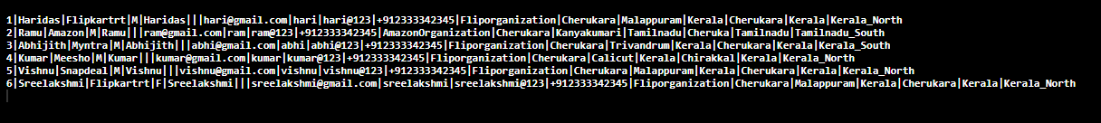

1. Products Table

-- create a table

CREATE TABLE Products (

  product_id INTEGER PRIMARY KEY,

  product_type_code INTEGER FOREIGN KEY REFERENCES Ref_Product_Types(product_type_code),

  return_merchandise_authorization_nr TEXT NOT NULL,

  product_name TEXT NOT NULL,

  product_price FLOAT NOT NULL,

  product_color TEXT  NOT NULL,

  product_size INTEGER NOT NULL,

  product_description TEXT NOT NULL,

  other_product_details TEXT NOT NULL

);

INSERT INTO Products VALUES (1001,'NR001','Shoe',999,'Grey',10,'Footwear','Large Size');

INSERT INTO Products VALUES (1002,'NR002','Computer',999,'White',10,'Electronics','Large Size');

INSERT INTO Products VALUES (1003,'NR003','Watch',1599,'Black',10,'Wearable','Large Size');

INSERT INTO Products VALUES (1004,'NR004','Mobile',12000,'SkyDark',10,'Mobile Phone','Large Size');

INSERT INTO Products VALUES (1005,'NR005','Shirt',200,'Light',10,'Men','Large Size');

INSERT INTO Products VALUES (1006,'NR006','Chappals',300.0,'Brown',10,'Footwear','Large Size');

SELECT * FROM Products;

Output:

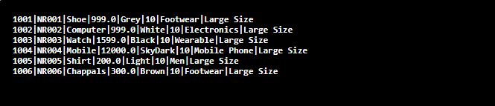

1. Ref Product Types Table

-- create a table

CREATE TABLE Ref_Product_Types (

  product_type_code INTEGER PRIMARY KEY,

  parent_product_type_code INTEGER FOREIGN KEY REFERENCES Ref_Product_Types(product_type_code),

  product_type_description TEXT NOT NULL

);

INSERT INTO Ref_Product_Types VALUES (1001,'desc1');

INSERT INTO Ref_Product_Types VALUES (1002,'desc2');

INSERT INTO Ref_Product_Types VALUES (1003,'desc3');

INSERT INTO Ref_Product_Types VALUES (1004,'desc4');

INSERT INTO Ref_Product_Types VALUES (1005,'desc5');

INSERT INTO Ref_Product_Types VALUES (1006,'desc6');

SELECT * FROM Ref_Product_Types;

Output:

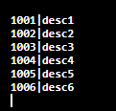

1. Orders Table

-- create a table

CREATE TABLE Orders (

  order_id INTEGER PRIMARY KEY,

  customer_id INTEGER FOREIGN KEY REFERENCES Customers(customer_id),

  order_status_code INTEGER FOREIGN KEY REFERENCES Ref_Order_Status_Codes(order_status_code),

  date_order_placed DATE NOT NULL,

  order_details TEXT NOT NULL

);

INSERT INTO Orders VALUES (1001,'12-03-2021','Completed');

INSERT INTO Orders VALUES (1002,'12-04-2021','Not Completed');

INSERT INTO Orders VALUES (1003,'12-05-2021','Not done Payment');

INSERT INTO Orders VALUES (1004,'12-06-2021','Not Completed');

INSERT INTO Orders VALUES (1005,'12-07-2021','Completed');

INSERT INTO Orders VALUES (1006,'12-08-2021','Completed');

SELECT * FROM Orders;

Output:

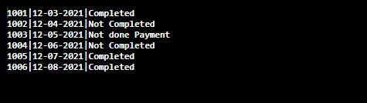

1. Ref_Order_Status_Code Table:

-- create a table

CREATE TABLE Ref_Order_Status_Codes (

  order_status_code INTEGER PRIMARY KEY,

  order_status_description TEXT NOT NULL

);

INSERT INTO Ref_Order_Status_Codes VALUES (1001,'Completed');

INSERT INTO Ref_Order_Status_Codes VALUES (1002,'Not Completed');

INSERT INTO Ref_Order_Status_Codes VALUES (1003,'Not done Payment');

INSERT INTO Ref_Order_Status_Codes VALUES (1004,'Not Completed');

INSERT INTO Ref_Order_Status_Codes VALUES (1005,'Completed');

INSERT INTO Ref_Order_Status_Codes VALUES (1006,'Completed');

SELECT * FROM Ref_Order_Status_Codes;

Output:

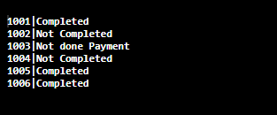

1. Customer_Payment_Methods Table:

-- create a table

CREATE TABLE Customer_Payment_Methods (

  customer_payment_id INTEGER PRIMARY KEY,

  customer_id INTEGER FOREIGN KEY REFERENCES Customers(customer_id),

  payment_method_code INTEGER FOREIGN KEY REFERENCES Ref_Payment_Methods(payment_method_code),

  credit_card_number TEXT NOT NULL,

  payment_method_details TEXT NOT NULL

);

INSERT INTO Customer_Payment_Methods VALUES (1001,'1111111111111111','Completed');

INSERT INTO Customer_Payment_Methods VALUES (1002,'1111111111111111','Not Completed');

INSERT INTO Customer_Payment_Methods VALUES (1003,'1111111111111111','Not done Payment');

INSERT INTO Customer_Payment_Methods VALUES (1004,'1111111111111111','Not Completed');

INSERT INTO Customer_Payment_Methods VALUES (1005,'1111111111111111','Completed');

INSERT INTO Customer_Payment_Methods VALUES (1006,'1111111111111111','Completed');

SELECT * FROM Customer_Payment_Methods;

Output:

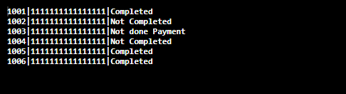

1. Ref_Payment_Methods:

-- create a table

CREATE TABLE Customer_Payment_Methods (

  payment_method_code INTEGER PRIMARY KEY,

  payment_method_description TEXT NOT NULL

);

INSERT INTO Customer_Payment_Methods VALUES (1001,'Completed');

INSERT INTO Customer_Payment_Methods VALUES (1002,'Not Completed');

INSERT INTO Customer_Payment_Methods VALUES (1003,'Not done Payment');

INSERT INTO Customer_Payment_Methods VALUES (1004,'Not Completed');

INSERT INTO Customer_Payment_Methods VALUES (1005,'Completed');

INSERT INTO Customer_Payment_Methods VALUES (1006,'Completed');

SELECT * FROM Customer_Payment_Methods;

Output:

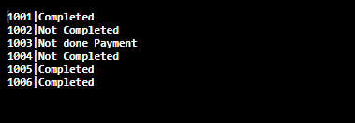

1. Invoice Table

-- create a table

CREATE TABLE Invoices (

  invoice_no INTEGER PRIMARY KEY,

  order_id INTEGER FOREIGN KEY REFERENCES Orders(order_id),

  invoice_status_code INTEGER FOREIGN KEY REFERENCES Ref_Invoice_Status_Codes(invoice_status_code),

  invoice_date DATE NOT NULL,

  invoice_details TEXT NOT NULL

);

INSERT INTO Invoices VALUES (10001,'10-11-2020','Completed');

INSERT INTO Invoices VALUES (10002,'11-11-2020','Not Completed');

INSERT INTO Invoices VALUES (10003,'12-11-2020','Not done Payment');

INSERT INTO Invoices VALUES (10004,'13-11-2020','Not Completed');

INSERT INTO Invoices VALUES (10005,'14-11-2020','Completed');

INSERT INTO Invoices VALUES (10006,'15-11-2020','Completed');

SELECT * FROM Invoices;

Output:

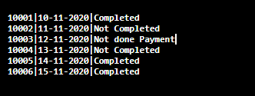

1. Ref_Invoice_Status_Codes Table:

-- create a table

CREATE TABLE Ref_Invoice_Status_Codes (

  invoice_status_code INTEGER PRIMARY KEY,

  invoice_status_description TEXT NOT NULL

);

INSERT INTO Ref_Invoice_Status_Codes VALUES (10001,'Completed');

INSERT INTO Ref_Invoice_Status_Codes VALUES (10002,'Not Completed');

INSERT INTO Ref_Invoice_Status_Codes VALUES (10003,'Not done Payment');

INSERT INTO Ref_Invoice_Status_Codes VALUES (10004,'Not Completed');

INSERT INTO Ref_Invoice_Status_Codes VALUES (10005,'Completed');

INSERT INTO Ref_Invoice_Status_Codes VALUES (10006,'Completed');

SELECT * FROM Ref_Invoice_Status_Codes;

Output:

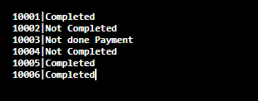

1. Payments:

-- create a table

CREATE TABLE Payments (

  invoice_no INTEGER PRIMARY KEY,

  invoice_no INTEGER FOREIGN KEY REFERENCES Invoices(invoice_no),

    payment_date DATE NOT NULL,

  payment_amount FLOAT NOT NULL

);

INSERT INTO Payments VALUES (10001,'10-11-2020',2000);

INSERT INTO Payments VALUES (10002,'11-11-2020',660);

INSERT INTO Payments VALUES (10003,'12-11-2020',199);

INSERT INTO Payments VALUES (10004,'13-11-2020',599);

INSERT INTO Payments VALUES (10005,'14-11-2020',300);

INSERT INTO Payments VALUES (10006,'15-11-2020',45.50);

SELECT * FROM Payments;

Output:

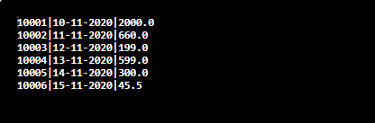

1. - Shipments:

-- create a table

CREATE TABLE Shipments (

  shipment_id INTEGER PRIMARY KEY,

  order_id INTEGER FOREIGN KEY REFERENCES Orders(order_id),

  invoice_no INTEGER FOREIGN KEY REFERENCES Invoices(invoice_no),

  shipment_trace_no INTEGER NOT NULL,

  shipment_date DATE NOT NULL,

  other_ship_details TEXT NOT NULL

);

INSERT INTO Shipments VALUES (10001,10,'10-11-2019','Completed');

INSERT INTO Shipments VALUES (10002,20,'11-11-2019','Not Completed');

INSERT INTO Shipments VALUES (10003,30,'12-11-2019','Not done Payment');

INSERT INTO Shipments VALUES (10004,40,'13-11-2019','Not Completed');

INSERT INTO Shipments VALUES (10005,50,'14-11-2019','Completed');

INSERT INTO Shipments VALUES (10006,60,'15-11-2019','Completed');

SELECT * FROM Shipments;

Output:

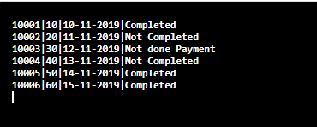

1. Order_Items Table:

-- create a table

CREATE TABLE Order_Items (

  order_item_id INTEGER PRIMARY KEY,

   product_id INTEGER FOREIGN KEY REFERENCES Products(product_id),

  order_id INTEGER FOREIGN KEY REFERENCES Orders(order_id),

   order_item_status_code INTEGER FOREIGN KEY REFERENCES Ref_Order_Item_Status_Codes(order_item_status_code),

  order_item_quantity INTEGER NOT NULL,

  order_item_price FLOAT NOT NULL,

  RMA_no TEXT NOT NULL,

  RMA_Issued_By TEXT NOT NULL,

  RMA_Issued_date DATE NOT NULL,

  Other_Order_item_details TEXT NOT NULL

);

INSERT INTO Order_Items VALUES (10001,10,999,'R01','Amazon','21-02-2020','NA');

INSERT INTO Order_Items VALUES (10002,20,2999,'R02','Amazon','22-02-2020','NA');

INSERT INTO Order_Items VALUES (10003,30,299,'R03','Amazon','23-02-2020','NA');

INSERT INTO Order_Items VALUES (10004,40,200,'R04','Amazon','24-02-2020','NA');

INSERT INTO Order_Items VALUES (10005,50,10000,'R05','Amazon','25-02-2020','NA');

INSERT INTO Order_Items VALUES (10006,60,3000,'R06','Amazon','26-02-2020','NA');

SELECT * FROM Order_Items;

Output:

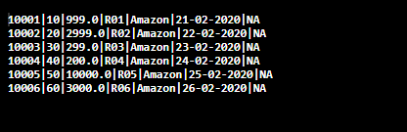

1. Ref_Order_Item_Status_Code:

-- create a table

CREATE TABLE Ref_Order_Item_Status_Codes (

  order_item_status_code INTEGER PRIMARY KEY,

  Order_item_status_description TEXT NOT NULL

);

INSERT INTO Ref_Order_Item_Status_Codes VALUES (100001,'Purchased');

INSERT INTO Ref_Order_Item_Status_Codes VALUES (100002,'Purchased');

INSERT INTO Ref_Order_Item_Status_Codes VALUES (100003,'Purchased');

INSERT INTO Ref_Order_Item_Status_Codes VALUES (100004,'Purchased');

INSERT INTO Ref_Order_Item_Status_Codes VALUES (100005,'Purchased');

INSERT INTO Ref_Order_Item_Status_Codes VALUES (100006,'Purchased');

SELECT * FROM Ref_Order_Item_Status_Codes;

Output:

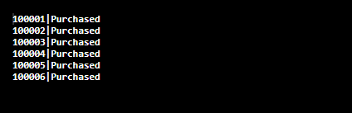

1. Shipment_items table:

-- create a table

CREATE TABLE Shipment_items (

  shipment_item_id INTEGER PRIMARY KEY,

   shipment_id INTEGER FOREIGN KEY REFERENCES Shipments(shipment_id),

  order_item_id INTEGER FOREIGN KEY REFERENCES Orders(order_id),

);

-- INSERT INTO Order_Items VALUES (10001,10,999,'R01','Amazon','21-02-2020','NA');

-- INSERT INTO Order_Items VALUES (10002,20,2999,'R02','Amazon','22-02-2020','NA');

-- INSERT INTO Order_Items VALUES (10003,30,299,'R03','Amazon','23-02-2020','NA');

-- INSERT INTO Order_Items VALUES (10004,40,200,'R04','Amazon','24-02-2020','NA');

-- INSERT INTO Order_Items VALUES (10005,50,10000,'R05','Amazon','25-02-2020','NA');

-- INSERT INTO Order_Items VALUES (10006,60,3000,'R06','Amazon','26-02-2020','NA');

SELECT * FROM Shipment_items;

Output:

1. **Data Retrieval Queries From The Table**

Select Statments are used to retrieve or pull the data from the data base.We can use SELECT statement for getting the data from the database.And also we can use select statement with other statement like Update, Delete etc.Here we are using some data retrieval queries for analyse the data.

1. **UPDATE**

Update statements are used to modify the existing data in a table.The important thing is we must specify the WHERE clause when using update statement.Otherwise all records will be updated.Normal case we are updating using the primary key column in the table.

And we can update multiple columns in a single update query.

UPDATE Customers

SET login_name = 'haridas', ph_no= '910333342345'

WHERE customer_id = 1;

SELECT * FROM Customers

1. **COUNT**

Count is an aggregate function in SQL like AVG(), SUM() functions.It returns number of rows that matches the condition we given in the query.If we omit the condition, it returns number of rows in the table.And also we have DISTINCT keyword for considering the unique records in the table.

For getting nomber of rows in the table we can use the query like:

SELECT COUNT(*)FROM Table_name;

SELECT DISTINCT(COUNT(product_name))

FROM Products

WHERE product_price >=100 AND product_size=10;

1. **INNER JOIN**

A Join means joining tables according to some criteria.We have four common joins in sql.Inner Join,left join,right join,Full join.For inner join, it selects the common rows in two tables.Then , Full Join it takes all rows from both table.For left join it takes all rows from the left table and common rows in the right table.At last, In right join it takes all the rows from the right table and common rows in the left table.

We can join multiple tables with single sql query.

SELECT *

FROM Orders

INNER JOIN Order_Items

ON Orders.order_id = Order_Items.order_id;

1. **GROUP BY WITH LEFT JOIN**

Group by statements are the statements for grouping one column according to another columns.For example, number of employees in each country.Group by statements are mostly used with aggregated functions like COUNT(),AVG(),SUM() etc. To group the result with one or more columns.

SELECT COUNT(customer_id), country

FROM Customers

GROUP BY country;

Here we are using the group by with LEFT JOIN.

SELECT Invoices.invoice_date, COUNT(Orders.order_id) AS NumberOfOrders FROM Orders

LEFT JOIN Invoices ON Orders.order_id = Invoices.order_id

GROUP BY date_order_placed;

1. **DELETE**

Delete statement is used to delete a record from the table using where clause.If we are not using the where clause, we can delete the table using the query like

DELETE FROM Products

When Products is a table name.

And for deleting one record we can use WHERE clause and the query like

DELETE FROM Products WHERE product_name='Shoe';