Step By Step Exploratory Data Analysis Of Titanic DataSet

Exploratory data analysis is one of the most important step for any data science project. Here we will do the data analysis of titanic dataset. To do the same we will use the Pandas,Seaborn and Matplotlib library..

Storytelling:

Let us try to understand the dataset first. It has 12 columns.

Here we have 11 features using which we shall predict the target variable which is ‘Survived’.

The target variable is the one which we are trying to predict. Others are the features. Our first step would be to polish the features so that it can be used to input to a machine learning model which we can use to do our required task.

To load the data into a dataframe we can use

train=pd.read_csv(‘titanic.csv’)

To get idea about the dataset we can use the head function of the dataframe. It will return the first 5 rows. So executing the *train.head()* will give us the first 5 rows. The picture given shows the output of it.

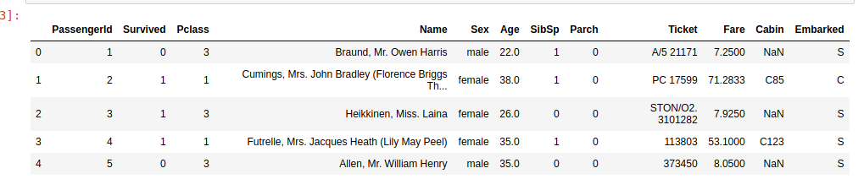

Similarly we can use the ***info*** and ***describe*** method to get detailed statistics about the data.

One of the important objective data preprocessing and eda is to get rid of the null data. To do so we need to know where we have got null values. We shall use heatmap inorder to have an idea on this. To implement it seaborn library will be used. The following code snippet will create a heatmap for it.

sns.heatmap(train.isnull(),yticklabels=False,cbar=False,cmap=’viridis’)

As we can see from the diagram the column ‘Age’ and ‘Cabin’ have got null values. While ‘Cabin’ has huge amount null values, ‘Age’ has moderate amount of null values.

Here we would drop the ‘Cabin’ column as it has got mostly NULL values.

To do so we shall use the following code snippet.

train.drop(‘Cabin’,axis=1,inplace=True)

Now comes the interesting part. We need to form a logic to impute the missing values of the ‘Age’ column. We shall come back to it later after understanding the relation between ‘Age’ and various other variables.

Let us try to know if the dependent variable ‘Survived’ has any relation with the variable ‘Sex’.

To do so we would use factorplot. The following code snippet would return us the required figure.

sns.factorplot(x=’Survived’,col=’Sex’,kind=’count’,data=train)

**Inference**: As we all know from the movie as well as the story of titanic females were given priority while saving passengers. The above graph also tells us the same story. More number of male passengers have died than female ones.

Similarly let us try to see how the variable ‘***Pclass***’ is related to the variable ‘***Survived***’

To do so we would draw a countplot using the following code snippet.

sns.countplot(x=’Survived’,hue=’Pclass’,data=train)

The output of the above code is the following figure

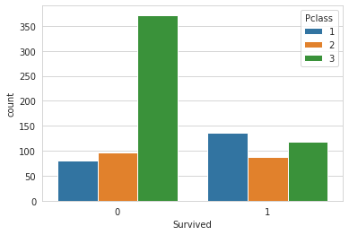

**Inference**: The graph tells us that Pclass 3 were more likely to be survived. It was meant for the richer people while Pclass 1 were the most likely victims which was relatively cheaper than class 3.

Let us try to understand the column ‘Sibsip’ in detail. To do so we would again use the countplot from seaborn. The following code snippet would achieve the same.

sns.countplot(x=’SibSp’,data=train)

The output of the above code is

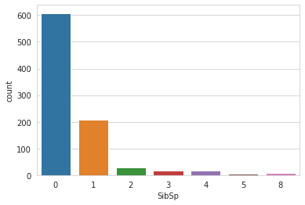

**Inference**: Here ‘SibSp’ variable refers to the number of sibling or spouse the person was accompanied with. We can see most of the people came alone.

Lastly we have to figure out a way to fill the missing value of the variable ‘Age’. Here we segregated the ‘Age’ variable according to the Pclass variable as it was found out that ‘Age’ and ‘Pclass’ column were related. We would draw a boxplot that would tell us the mean value each of the Pclass. To do so we can write the following code snippet.

sns.boxplot(x='Pclass',y='Age',data=train,palette='winter')

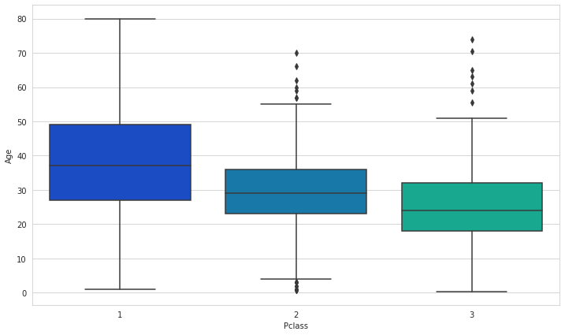

From this graph we can find out the mean age for each of the Pclass. We would impute the same for missing ‘Age’ values. We can write a simple python function to get the same.

Dealing With The Categorical Value:

We have to convert the categorical values into numbers so that it can be used as an input to the model. To do so we would use the following code snippet.  
  
*embark=pd.get_dummies(train[‘Embarked’],drop_first=****True****) sex=pd.get_dummies(train[‘Sex’],drop_first=****True****)*

Similarly we have to drop all the columns that do not provide any meaningful information like ‘Name’ and ‘Ticket’ along with the previous ‘Embarked’ and ‘Sex’ as they have been replaced. Also we need add the newly created *embark*and *sex* column.

train.drop(['Sex','Embarked','Name','Ticket'],axis=1,inplace=**True**)  
train=pd.concat([train,sex,embark],axis=1)

Now our dataset is ready to be used as input to a machine learning model. This was a detailed analysis of the titanic dataset.