

Minia University
Faculty of Engineering
Mechatronics & Industrial Robotics Programm

Electronic Circuits Report
Proteus Simulation Tasks

Course:
Electronic Circuits

Submitted to:
Dr. / Mona Sayed Abdelkarim

Prepared By:
- Muhammed Nasr | - Gehad Marwan
- Gerges Morzaq | - Mohrael Attia
- Habiba Ashraf
Academic Year
2025 – 2026
Table of Contents
Task 01: Parity Bit Circuit 2
Task 02: Half Adder Circuit 3
Task 03: Full Adder Circuit 4
Task 04: Subtractor Circuit and Applications 6
Task 05: 8-Bit Adder Using 74HC283 7
Task 06: 4-Bit Comparator from Scratch 8
Task 07: 2-Bit Comparator Circuit 9
Task 08: Decoder Circuit 10
Task 09: Encoder Circuit 11
Task 10: Multiplexer Circuit 12
Task 11: Demultiplexer Circuit 13
Task 12: S-R Latch Circuit 14
Task 13: R-S Latch Circuit 15
Task 14: D Latch Circuit 16
Task 15: J-K Latch Circuit 17
Appendices 18

Task 01: Parity Bit Circuit
Muhammed

Objective:
To design and simulate a 4-input parity bit generator using logic gates.

Theory:
A parity bit is used for error detection in digital communication. In even parity, the total number of 1s must be even.

Boolean Expression:
P = A ⊕ B ⊕ C ⊕ D

Components Used:
- LOGICSTATE
- XOR Gates / 74LS86
- LOGICPROBE

Truth Table

Task 02: Half Adder Circuit
Muhammed

Objective:
To design and simulate a half adder circuit using logic gates.

Theory:
A half adder is a combinational logic circuit used to add two single-bit binary numbers. It produces two outputs: Sum and Carry.

Boolean Expression:
Sum = A ⊕ B
Carry = A · B

Components Used:
- LOGICSTATE
- XOR Gate / 74LS86
- AND Gate / 74LS08
- LOGICPROBE

Truth Table

Task 03: Full Adder Circuit
Muhammed

Objective:
To design and simulate a full adder circuit using logic gates.

Theory:
A full adder is a combinational logic circuit used to add three binary inputs: A, B, and Cin. It produces two outputs: Sum and Cout.

Boolean Expression:
Sum = A ⊕ B ⊕ Cin
Cout = A · B + Cin · (A ⊕ B)

Components Used:
- LOGICSTATE
- XOR Gates / 74LS86
- AND Gates / 74LS08
- OR Gate / 74LS32
- LOGICPROBE

Truth Table

Task 04: Subtractor Circuit and Applications

Objective:

Theory:

Boolean Expression:

Components Used:

Truth Table

Task 05: 8-Bit Adder Using 74HC283

Objective:

Theory:

Boolean Expression:

Components Used:

Truth Table:

Task 06: 4-Bit Comparator from Scratch

Objective:

Theory:

Boolean Expression:

Components Used:

Truth Table:

Task 07: 2-Bit Comparator Circuit

Objective:

Theory:

Boolean Expression:

Components Used:

Truth Table:

Task 08: Decoder Circuit

Objective:

Theory:

Boolean Expression:

Components Used:

Truth Table:

Task 09: Encoder Circuit

Objective:

Theory:

Boolean Expression:

Components Used:

Truth Table:

Task 10: Multiplexer Circuit

Objective:

Theory:

Boolean Expression:

Components Used:

Truth Table:

Task 11: Demultiplexer Circuit

Objective:

Theory:

Boolean Expression:

Components Used:

Truth Table:

Task 12: S-R Latch Circuit

Objective:

Theory:

Boolean Expression:

Components Used:

Truth Table:

Task 13: R-S Latch Circuit

Objective:

Theory:

Boolean Expression:

Components Used:

Truth Table:

Task 14: D Latch Circuit

Objective:

Theory:

Boolean Expression:

Components Used:

Truth Table:

Task 15: J-K Latch Circuit

Objective:

Theory:

Boolean Expression:

Components Used:

Truth Table:

Appendices
A.1 Parity Bit Circuit Truth Table
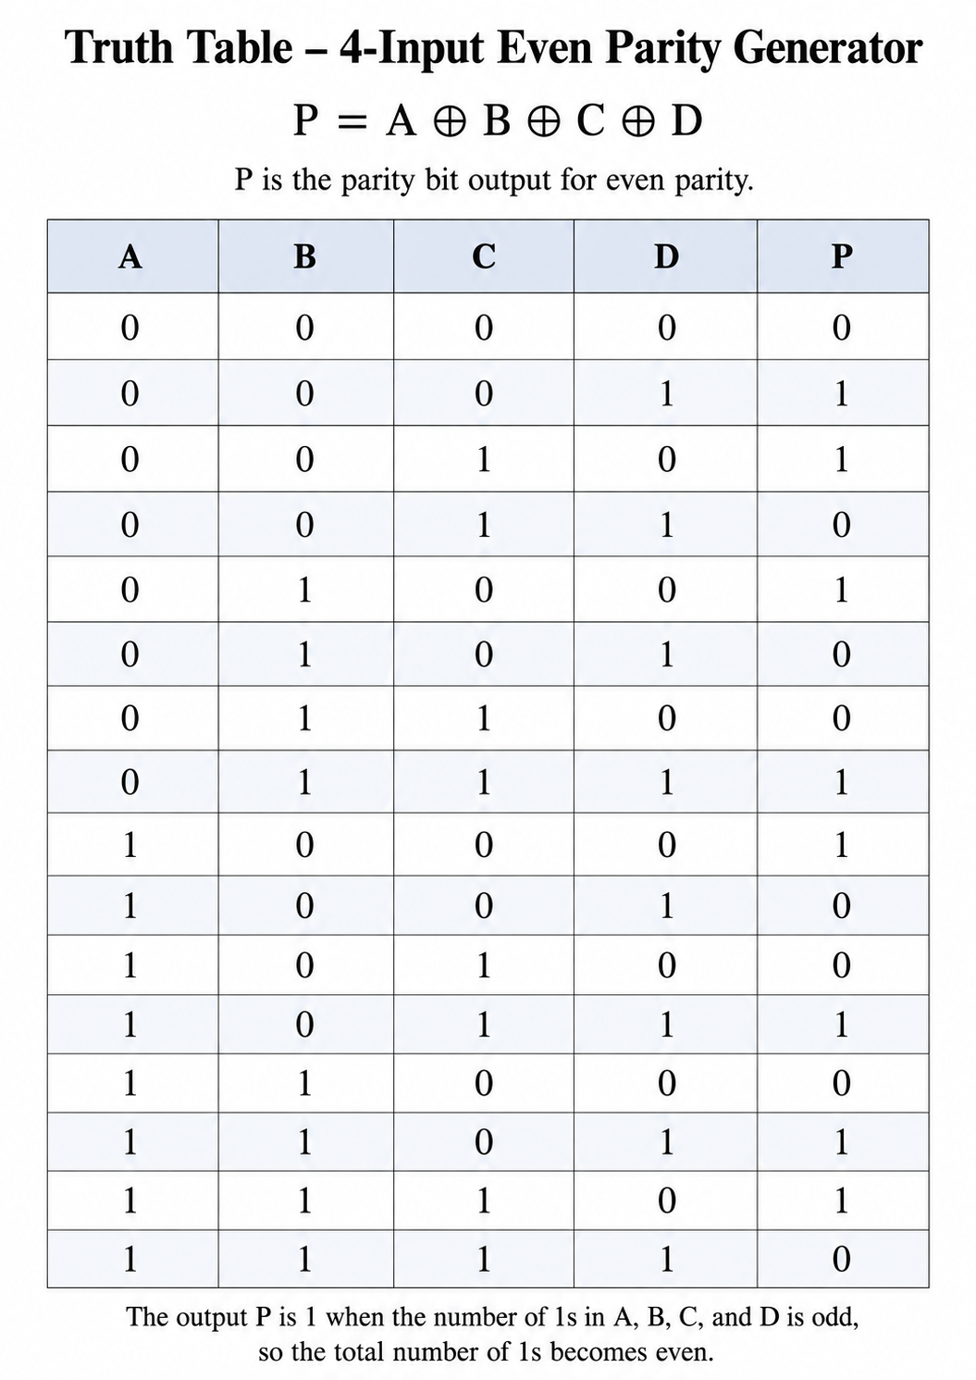

A.2 Half Adder Circuit Truth Table

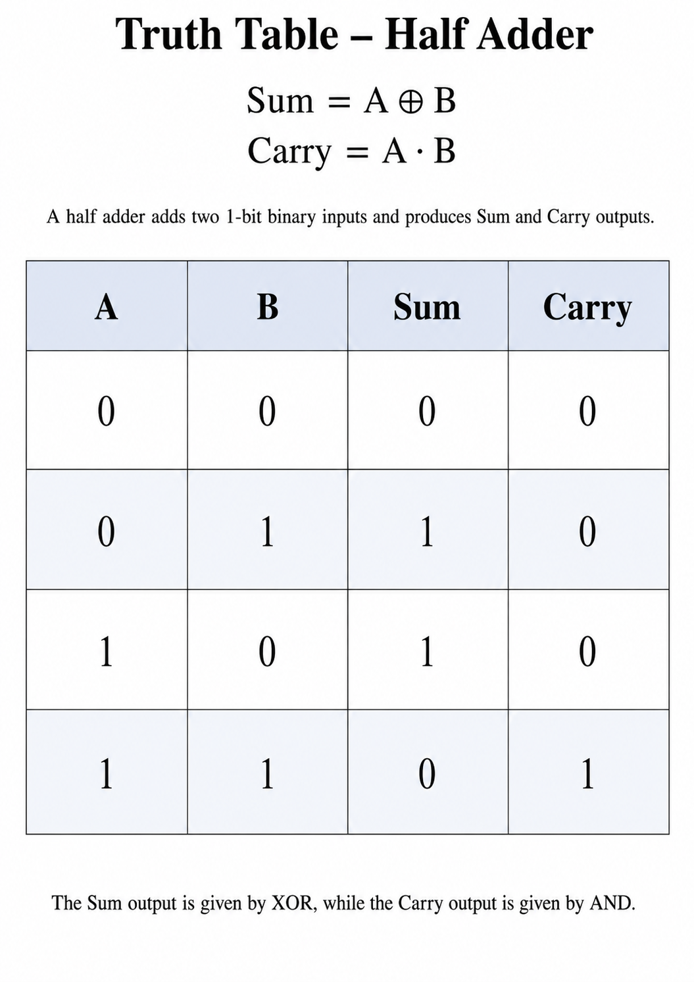
A.3 Full Adder Circuit Truth Table

