Project 1: Static Foundations
Feedback for Mindful Moments
Student: Muhammed Sanusi Course: CSC 436, Fall 2026 Reviewed at: 1b15099
Repo: github.com/muhammedsanusi890-oss/Modern-web-development- Live: GitHub Pages, quote.html

Grade: 75 / 100
Category | Points | Earned | One line
Semantic HTML | 20 | 17 | Both pages validate with zero messages; header, nav with a list, four sections, four articles, footer, one h1; no main, the tab title is "Document", quotes are bare paragraphs
CSS layout | 25 | 21 | Flexbox throughout and a real Grid with named areas, a calm and consistent palette; layout hangs off bare div and section selectors, no focus styles, hover effects on things that are not clickable
Responsive design | 15 | 12 | No horizontal scroll from 320 to 1280, grid collapses, nav stacks; the stacked header is sticky and takes a quarter of a phone screen, desktop-first, the About block never uses its width
JavaScript interaction | 15 | 11 | A working random-quote button that meets the requirement; five quotes, back-to-back repeats, nothing announced, a console.log left in
Repository and deployment | 15 | 7 | Started nine days early and the deploy matches the repo; hosted on GitHub Pages where the brief says Netlify, README has two of four items, the first commit is 70 percent of the site
Content and polish | 10 | 7 | A cohesive, genuinely calming page; a 1.57 MB 4K photo drawn larger than the hero, "© 2024 Your Company" in the footer, and not much content
Total | 100 | 75 | A pleasant, valid, working page. Most of what came off is paperwork and one afternoon of finishing.

How this review was made
Your instructor reviewed this project with Claude (Anthropic's AI) as a second set of eyes. Claude cloned the repo, read every line of both HTML files, both stylesheets and the script, ran the W3C validator on both pages, and loaded the live site in real phone and desktop viewports (375 by 667 and 1280 by 800, plus 320 and 768 for overflow). It measured the sticky header while scrolling, checked which of your five font families are actually used, clicked New Quote sixty times and counted repeats, measured the page weight, compared the live site to the repo, and read all six commits. Every note and every point in this document was read and approved by your instructor. The late submission was approved ahead of time and costs nothing.

The short version
The page does what it sets out to do: it feels calm. The mint gradient, the soft off-white, the rounded cards and the playful display font all belong together, and that kind of consistency is harder than it looks. Underneath, the HTML is clean. Both files validate with zero messages. You have a header, a nav holding a real list, four sections, an article for each tip, a footer, and exactly one h1. Flexbox does most of the layout and the tips use CSS Grid with named areas, which most of the class never touched: one wide card, two side by side, one wide card, collapsing to a single column on a phone. Nothing scrolls sideways at any width from 320 to 1280. The quote button works.
The biggest loss is in the repository category, and almost all of it is paperwork. The brief says "Deployed on Netlify" in three places and the site is on GitHub Pages. The README has a title and one sentence, with no instructions for running it and no live link. The first commit contains 327 of the project's 464 lines. None of that is about your code, and the first two are a fifteen-minute fix.
In the code itself there are three things to look at. Your stylesheet styles every div and every section on the page by tag name, which works today and will fight you the moment you add a div you did not want padded. On a phone the header stacks into a column and stays pinned, so a quarter of the screen is permanently the menu. And the JavaScript is the minimum that satisfies the brief: five quotes and one three-line handler.

What Claude measured
Check | Result
W3C HTML validator | 0 messages on quote.html, 0 on index.html
Horizontal scroll at 320 / 375 / 768 / 1280 px | None
Heading order | h1 > h2 > h3, no skipped levels, one h1
Semantic elements | header, nav (ul of 4), 4 section, 4 article, footer; no main
Page title | "Document" on quote.html (the submitted link); "Mindful Moments" on index.html
Layout | Flexbox on header, nav, every section and every div; 1 Grid with grid-template-areas
Media queries | 2, both max-width: 768px (desktop-first)
Header on a 375 by 667 phone | 176 px tall, still pinned after scrolling 1,200 px: 26 percent of the screen
Section heights at 375 by 667 | 400 / 400 / 827 / 400 px
Fonts | 5 Google families requested; text uses 1 (DynaPuff)
New Quote, 60 clicks | 5 distinct quotes; 7 times the same quote came up twice in a row
Console errors | 0 (one console.log per click is still in the script)
Image | nature.jpg is 3840 by 2160 and 1.57 MB; drawn at 1158 by 651 on a desktop, 253 by 142 on a phone
Page weight | 1,641 KB in total; the photo is 94 percent of it
Unused files | calm.jpg (214 KB) is committed and referenced nowhere
Commits | 6: four on Sep 6 and 7, two on Sep 17; the first is 327 of 464 lines
README | Title and one sentence; no run instructions, no live URL (2 of 4)
Hosting | GitHub Pages from main; the brief specifies Netlify
Live vs repo | Identical, all five files

The whole page, phone and desktop
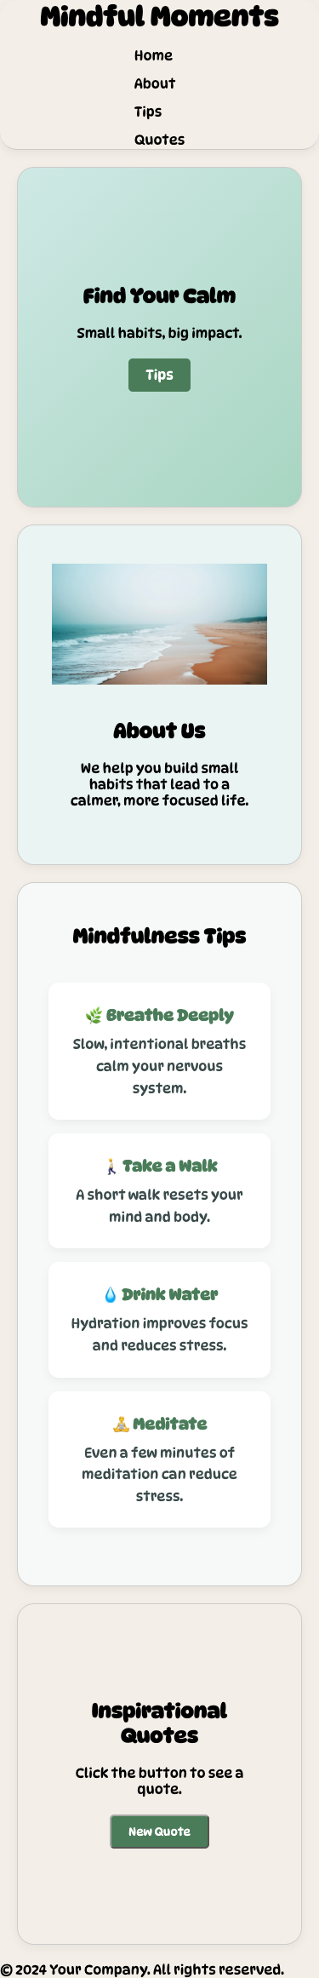  Phone, 375 by 667, full page. The stacked header at the top stays pinned while scrolling. | 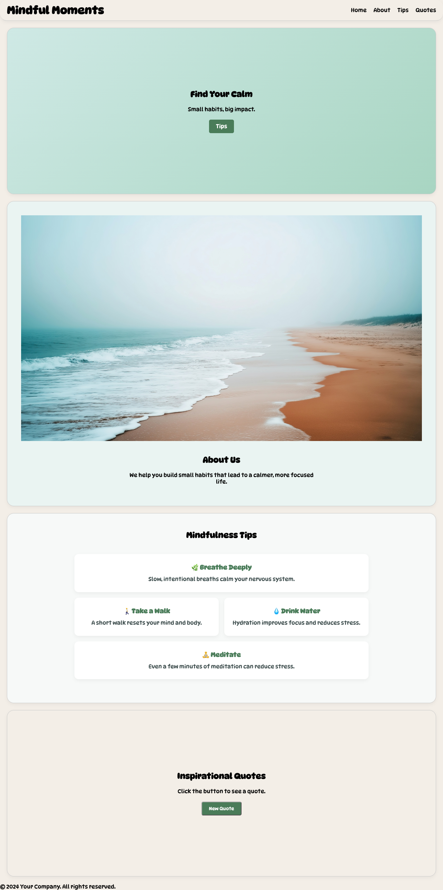  Desktop, 1280 by 800, full page. The photo is drawn 1158 px wide, larger than the hero above it.

Semantic HTML: 17 / 20

What is working
- Both pages validate with zero messages, which most of the class did not manage. The structure is what the brief asks for: header, a nav with a ul of links (quote.html lines 17 to 28), four sections each with an h2, an article with an h3 for each tip (lines 54 to 74), and a footer. One h1. lang="en" and a viewport tag. The image has real alt text. The script loads with defer.

What to change
- There is no main. The sections sit directly in body between the header and the footer. Open main after the header closes on line 28 and close it before the footer on line 86. It is the landmark a screen reader user jumps to, and the brief lists it by name.
- The browser tab says "Document" (line 14). That is the placeholder your editor wrote. You fixed it in index.html ("Mindful Moments"), but the link you submitted is quote.html, so that is the one people see in the tab, in bookmarks and in search results.
- The quotes are not marked up as quotes (line 80). A quote site should use blockquote with a cite for who said it. Your five have no attribution at all, and several are famous lines with known or disputed authors. Add the author to each entry and show it. Put aria-live="polite" on the container too, so a screen reader announces the new quote; right now the text changes silently.
- Small: the h1 sits inside the nav (lines 18 to 19). The site name is not navigation. Make it a sibling of the nav, both inside header, and keep your flex rule on the header instead.

CSS layout: 21 / 25

What is working
- A real Grid, used with intent. grid-template-areas lays the four tips out as wide, two-up, wide (quote.css lines 72 to 96), and the media query redraws the same areas as one column (lines 127 to 135). Named areas are the most readable way to describe a layout in CSS, and you are one of very few students who used them. Flexbox handles the nav with space-between and gap (general.css lines 40 to 52) and centers the content of every section.
- The palette is small and disciplined: two greens for actions, a mint gradient, three off-whites. border-box, a reset, img { max-width: 100% }, soft shadows used consistently. It looks like one designer made it.

What to change
- Every div and every section on the page is styled by tag name (general.css lines 82 to 103). div { display: flex; flex-direction: column; padding: 20px; gap: 20px; } applies to .hero-container, .about-container, .about-text, .tips-grid, .quotes-container, and to every div you ever add. It is why .tips-grid has 20px of padding you never asked for, and inside the media query div { text-align: center } (lines 74 to 76) recenters all of them again. This works until the day you add a wrapper div for some other reason and it arrives pre-padded and flexed. Delete both tag rules, move those declarations to a class such as .stack, and put the class only where you mean it.
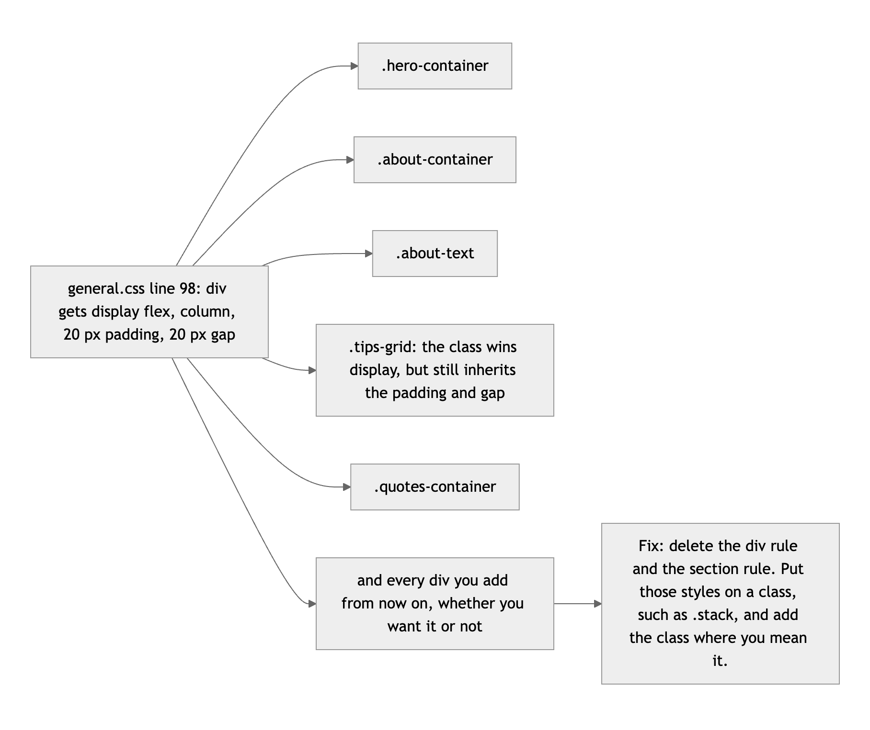
Diagram 1. One rule on the div tag, and everything it touches.
- The tip cards promise a click they cannot deliver (quote.css lines 119 to 125). On hover they lift, change color and show cursor: pointer, but they are not links or buttons. Either make them go somewhere or drop the pointer. Also, the transition is declared only inside :hover, so the card eases up and then snaps back; move the transition line to .tip-card and it eases both ways. The same hover block is pasted a second time inside the media query (lines 137 to 143), where it changes nothing.
- There are no focus styles. Tab through the page: the links and the button get only the browser default. One rule covers it: :focus-visible { outline: 3px solid #4A7C59; outline-offset: 3px; }.
- Five font families are requested and one is used (quote.html line 12). body asks for SN Pro, but the very next rule sets DynaPuff on h1, h2, h3, p, a and button, which is every piece of text on the page (general.css lines 7 to 19). Caveat Brush, Henny Penny and UnifrakturMaguntia are never referenced. Trim the link to the families you use, and delete the duplicated preconnect pair on lines 10 and 11. A display font on body text is also tiring to read; consider keeping DynaPuff for headings and letting SN Pro do the paragraphs, which looks like what you first intended.

Responsive design: 12 / 15

What is working
- No horizontal scroll at 320, 375, 768 or 1280. The grid drops to one column, the nav stacks, the image scales with its container. Section heights on a real phone are sensible (400 px for the hero, about and quotes).

What to change
- On a phone the header takes a quarter of the screen and never leaves. Below 768px the nav becomes a column, so the header grows from 60px to 176px, and it is position: sticky (general.css lines 28 to 38 and 59 to 72). Claude scrolled 1,200px down a 375 by 667 screen and the header was still pinned at the top: 176 of 667 pixels, 26 percent, on every screen of the page. Keep the four links in one wrapping row on phones (they fit), or make the header sticky only inside a min-width query.
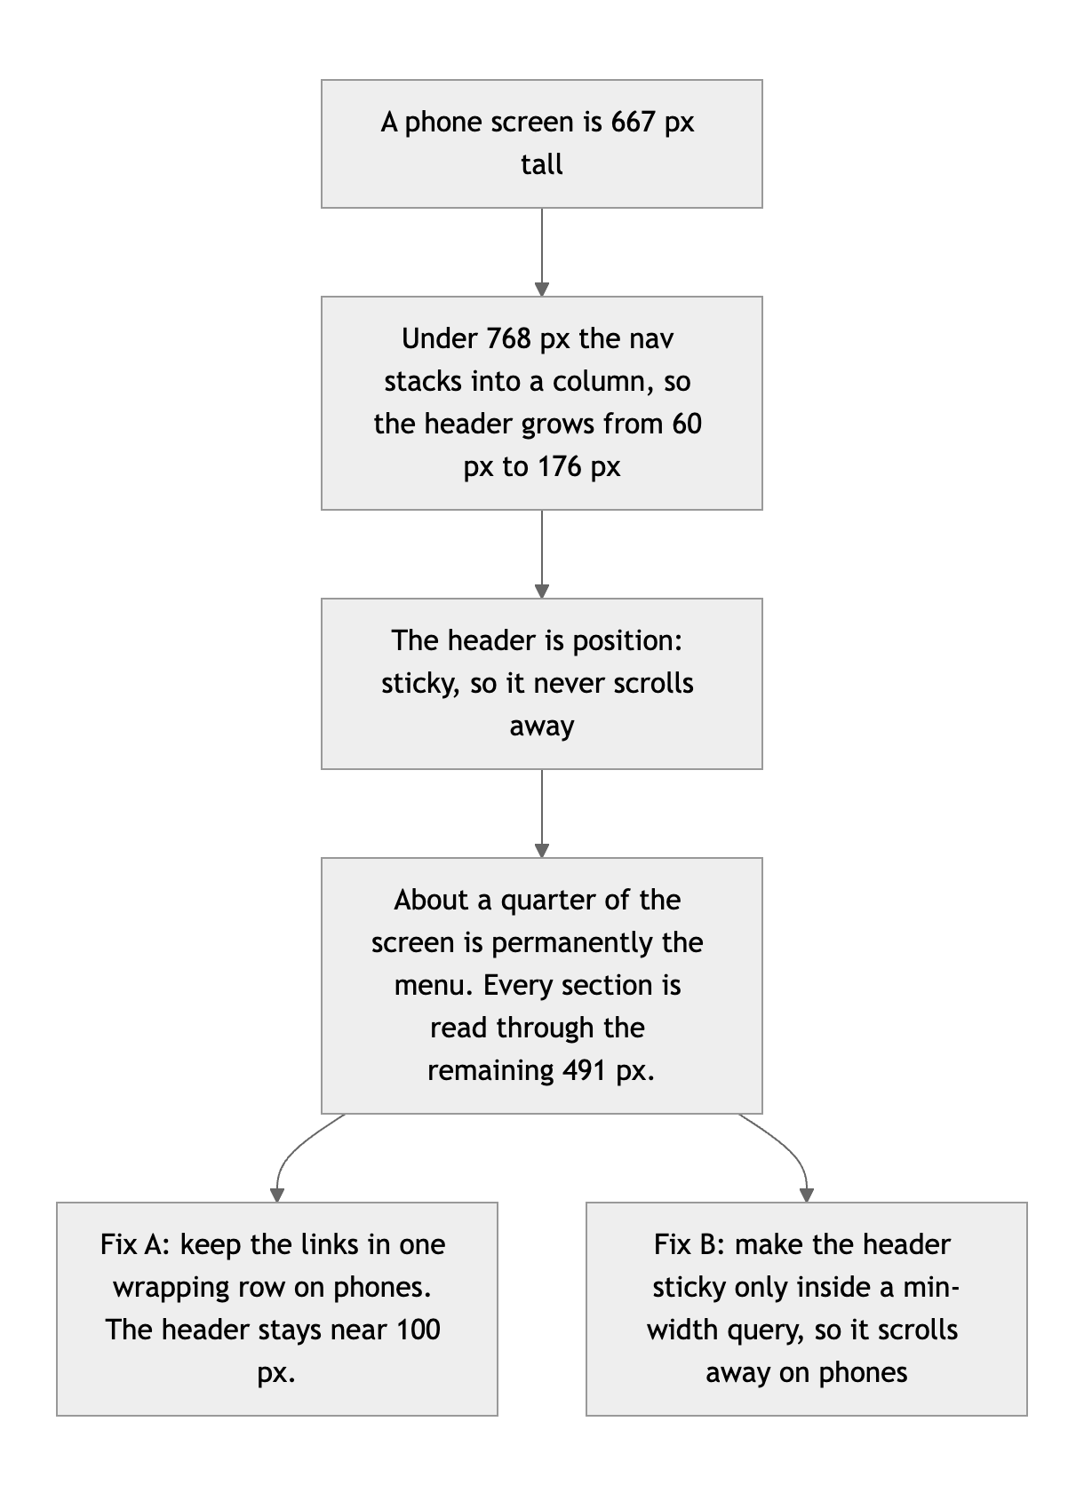
Diagram 2. Why the phone header costs a quarter of the screen, and two ways out.
- Desktop-first. Both queries are max-width: 768px. The brief asks for mobile-first: write the phone layout as your base rules and add columns inside min-width queries. With only two queries this is a ten-minute flip.
- The About block is the same on every screen. .about-container is a column at all widths (quote.css lines 51 to 56), so on a desktop the photo is drawn 1158px wide, taller than the hero, with one sentence underneath. At 768px and up, make it a row: photo on the left capped at about 500px, text on the right. That single change makes the desktop look designed.

JavaScript interaction: 11 / 15

What is working
- It meets the brief and it is clean. You select two elements, listen for a click, and change the page with textContent (quote.js lines 16 to 19). getRandomQuote is a tidy one-liner (line 4), the starting message is set from the script, and there are zero console errors. Claude clicked sixty times and saw all five quotes.

What to change
- The same quote often comes up twice in a row. With five quotes, one click in five picks the one already showing; in sixty clicks it happened seven times. To the visitor that looks like the button did nothing. This version never repeats back to back. Claude ran it 2,000 times before giving it to you: zero repeats, and all five quotes still come up.
let last = -1;

function nextQuote() {
let i;
do {
i = Math.floor(Math.random() * quotes.length);
} while (i === last);
last = i;
return quotes[i];
}

- One small handler is the floor, not the target. The brief asks for at least one interaction, and you have exactly one, three lines long. Give it somewhere to go: store each quote as { text, author } and show both; add a "save this one" button that keeps favorites in localStorage; or build a one-minute breathing timer, which would suit this site perfectly.
- Small: quote and quotebutton never change, so they should be const, not let (lines 1 to 2). Take out the console.log on line 18.

Repository and deployment: 7 / 15

What is working
- You started on September 6, nine days before the deadline, which is the opposite of the last-minute dump the brief warns about. The live site is public and matches the repo file for file. Your later messages say what changed: "Added google fonts to texts for better styling," "Added grid styling to the tips section."

What to change
- The brief says Netlify, and this is on GitHub Pages. The assignment lists "Deploy target: Netlify," says "Deployed on Netlify. The live URL must load your current work," and asks for "your live Netlify URL." Your site works and it is public, so this is a small deduction, not a large one. But connecting a repo to Netlify is a skill the rest of the semester builds on, and it takes five minutes: Add new site, Import an existing project, pick this repo, no build settings.
- The README has two of the four required items. Title and one sentence. Add how to run it ("Clone the repo and open index.html in a browser") and the live link. These are the cheapest three points in this document.
- The first commit is most of the site. 327 of the project's 464 lines arrived in "First commit for the static foundation project," and the next one is also called "first commit." The brief asks for a history that shows the project being built. Commit when the header works, again when the hero works, again when the grid works.
- Housekeeping. quote.html and index.html are the same page twice, and they have already drifted apart (one has the right title, one does not). Keep index.html and delete the other. calm.jpg is 214 KB and used nowhere. .vscode/settings.json is committed and there is no .gitignore; add one with .vscode/ and .DS_Store in it.
- Small: your README is saved as UTF-16, which usually means it was created with echo in PowerShell. GitHub displays it fine, but many tools show it as garbage. Re-save it as UTF-8 from VS Code (click the encoding in the status bar).

Content and polish: 7 / 10

What is working
- The site has a mood and keeps it. The colors, the rounded shapes, the emoji on each tip, and the beach photo all say the same thing. The copy is short and readable, and the call-to-action button takes you straight to the tips.

What to change
- The photo is a 4K file. nature.jpg is 3840 by 2160 and 1.57 MB (quote.html line 42), which is 94 percent of the 1,641 KB the page downloads. On a phone it is drawn at 253px wide. Resize it to 1600px wide and export as JPEG at 80 percent or WebP, and it will be under 200 KB with no visible difference.
- "© 2024 Your Company. All rights reserved." (line 87). That is template text, and it is 2026. Put your name there. "About Us" and "We help you build small habits" read the same way; say who is behind the page and why, in a sentence or two of your own. The footer is also the one unstyled part of the page, sitting flush against the left edge.
- There is not much here. Four one-line tips, five quotes without authors, one photo. Eight to ten tips with two sentences each, and a dozen attributed quotes, would make it feel like a finished site.

Your next moves
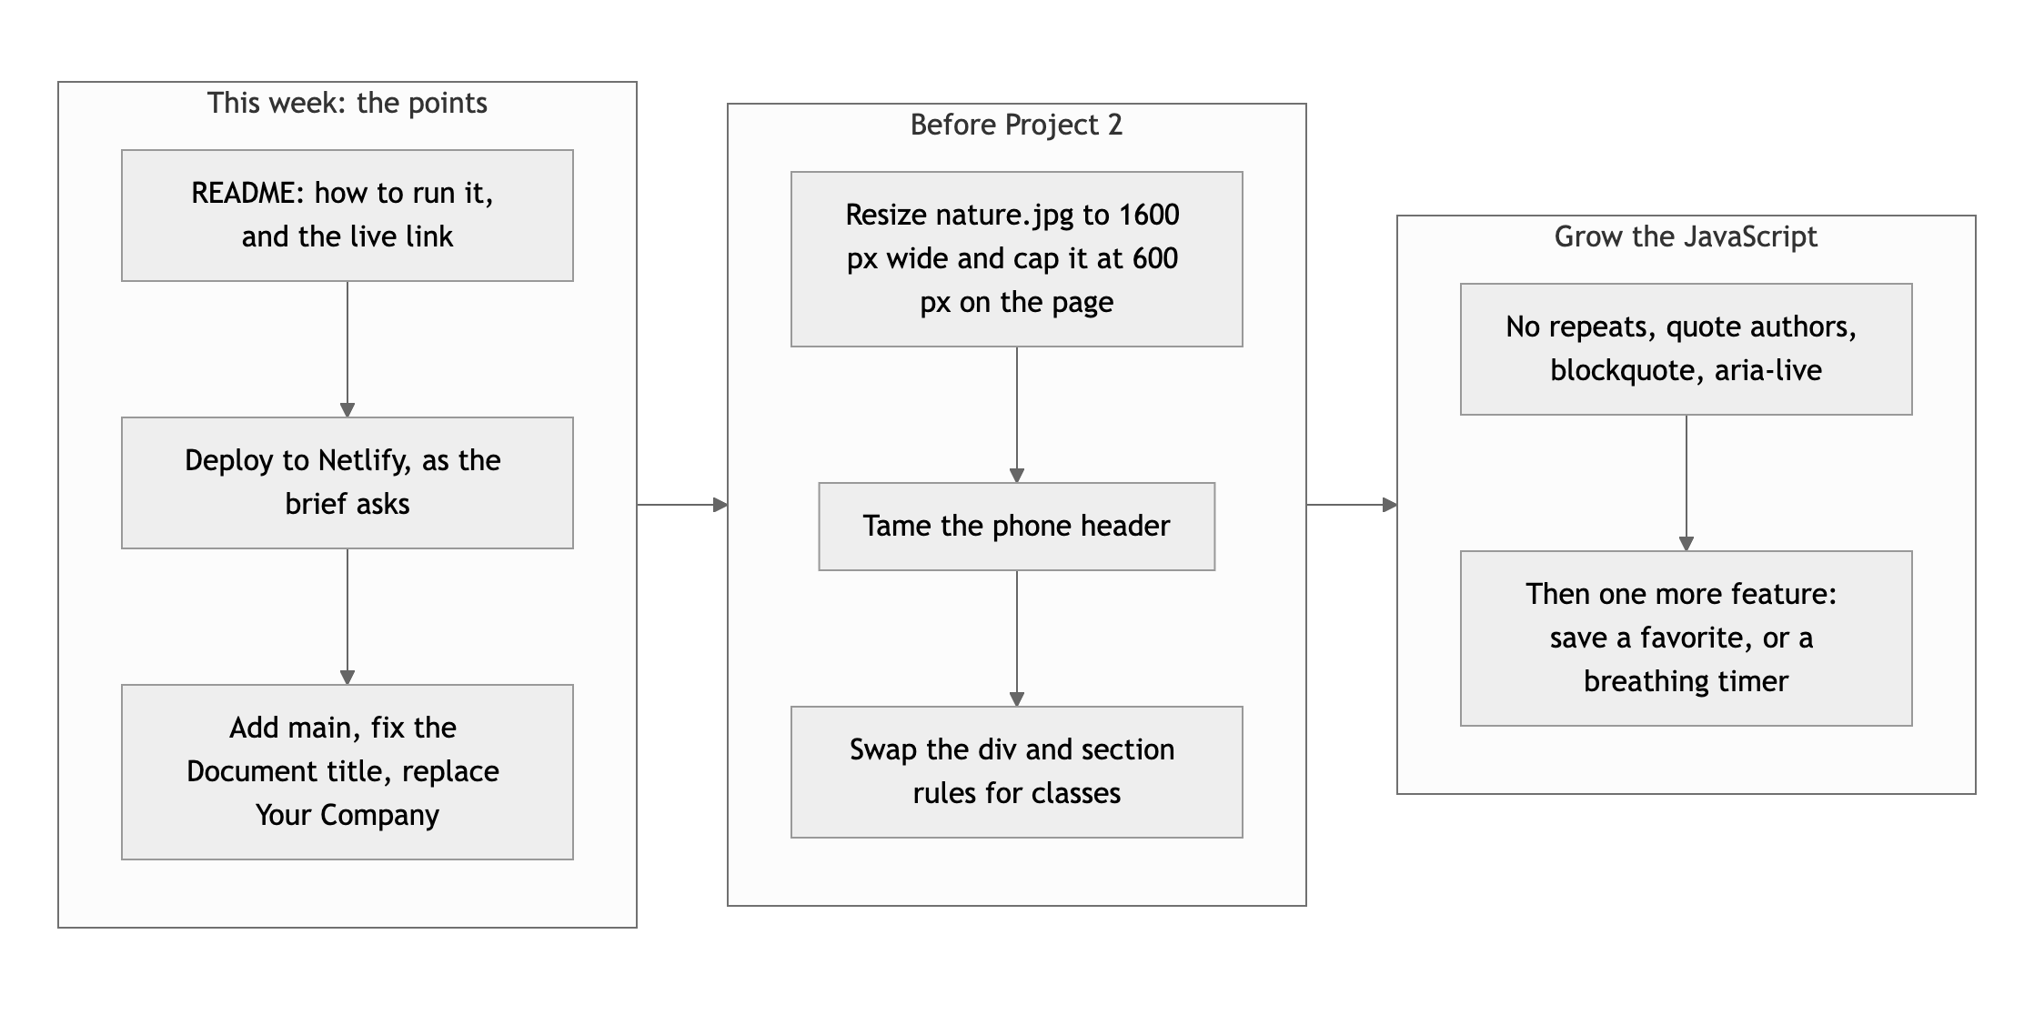
Diagram 3. The points first, then the layout, then the JavaScript.
- Do the paperwork. README, Netlify, main, the page title, your name in the footer, delete the duplicate page and the unused image. About half an hour, and it is most of the points that came off.
- Fix the phone header and the photo. One wrapping row of links, and a 1600px image laid out beside its text on wide screens.
- Give the JavaScript something to do. No repeats, real attributions, and one more feature that fits the theme.

The design sense is already there, Muhammed. The next step is finishing the edges.
This review lives in a pull request on your repo. It only adds feedback files and does not touch your code. Merge it, close it, or just read it. Questions go to office hours or the Brightspace board.

