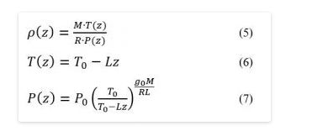

P(z) = hava yoğunluğu

Gas law dan bulunuyor air density

Atmosferik basınç ve sıcaklık yüksekliğe göre değişiyor

R = gas constane

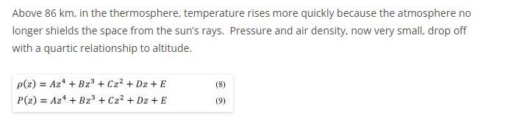

Prandtl-Glauert Rule

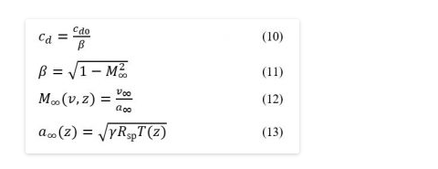

that **wave drag depends both on velocity and altitude** just as atmospheric drag does

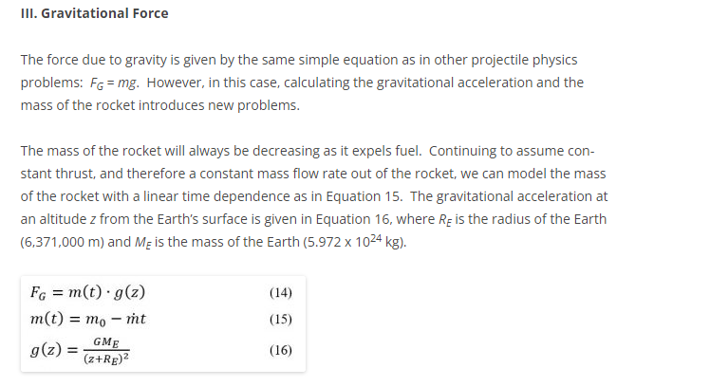

The mass flow rate can be calculated from the Tsiolkovsky Rocket Equation, given the thrust force and the specific impulse of the rocket

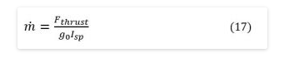

Because mass is decreasing over time, and gravity is decreasing with altitude, **gravitational force depends on time and altitude**.

  We can now apply the Euler-Cromer method to solve for altitude and velocity and determine the rocket’s one-dimensional trajectory.