**How To Use Whatsapp Mami?**

This document is designed to explain how to use whatsapp mami application.

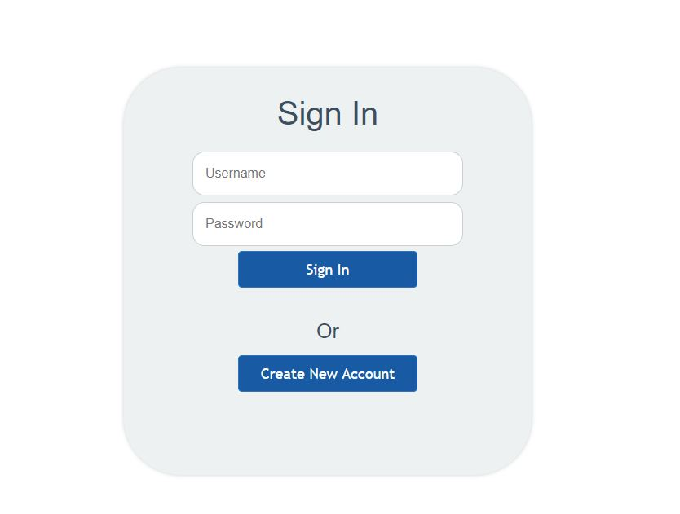

The user must log in first.

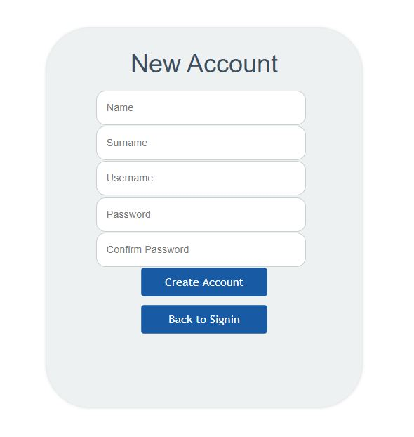

If you do not have an account you can register using here.

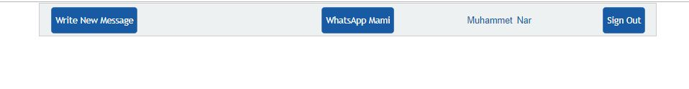

After login, the top menu opens. The name of the logged in user, exit button and writing new message button are displayed.

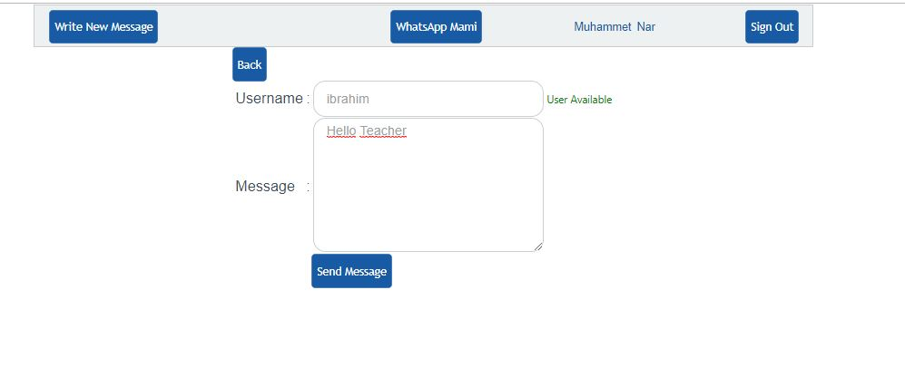

After you click the write new message button, the message writing section opens. Here the user name of the user to write a message is mandatory. Clicking the send button will send the message.

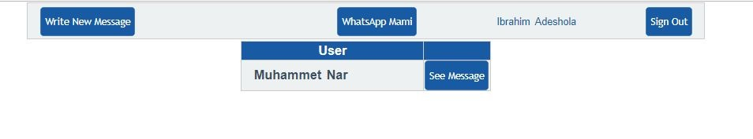

The user receiving the message encounters this screen. Here you see who the message came from. Click on the message to see the incoming message.

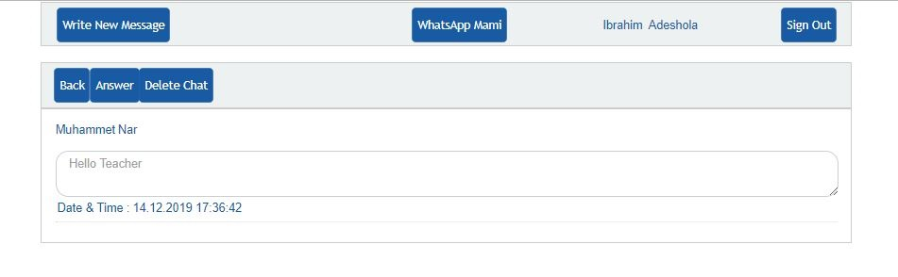

Here you can see the message sent with date and time. If the answer button is clicked, the message can be answered.

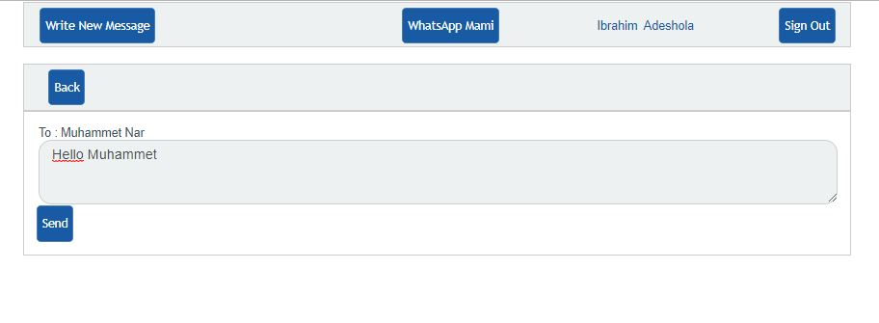

The message is answered on this screen.

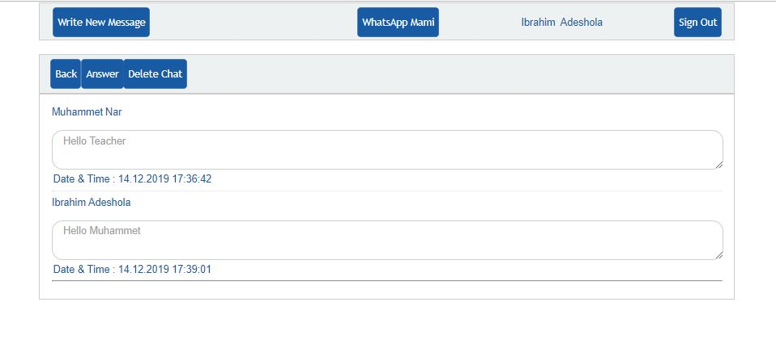

After replying, the message looks like this.

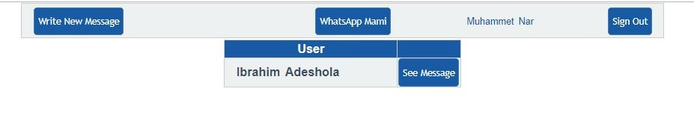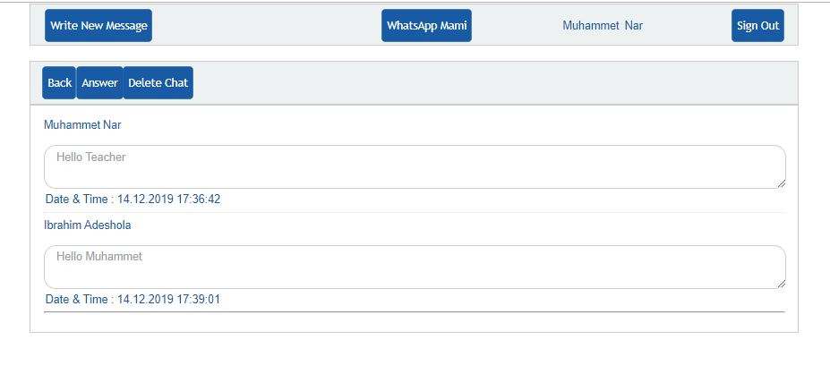

The same screen appears for the first user to send the message.